**Week-08 Handson**

1. **Setup your machine with Git Configuration**

**Integrate notepad++.exe to Git and make it a default editor**

**Add a file to source code repository**

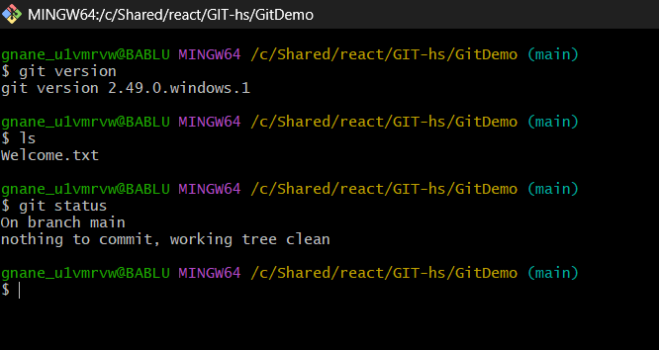

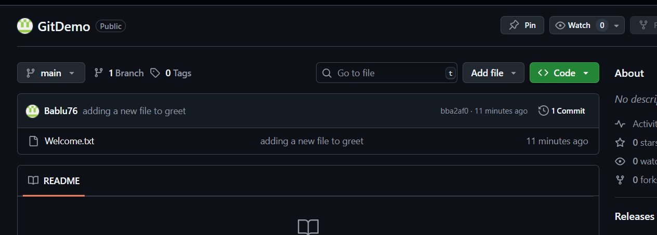

1. **Create a “.log” file and a log folder in the working directory of Git. Update the .gitignore file in such a way that on committing, these files (.log extensions and log folders) are ignored.Verify if the git status reflects the same about working directory, local repository and git repository.**

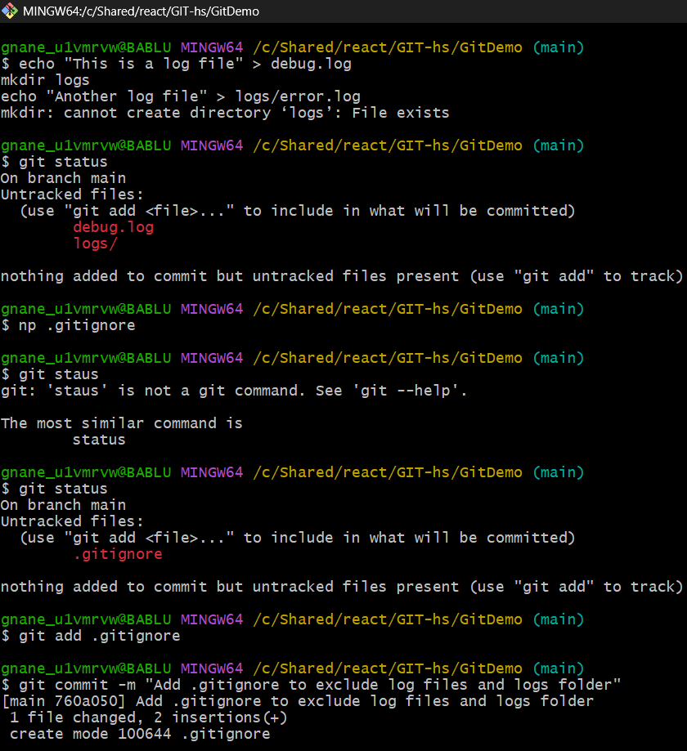 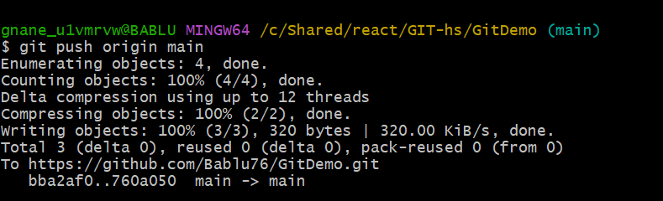

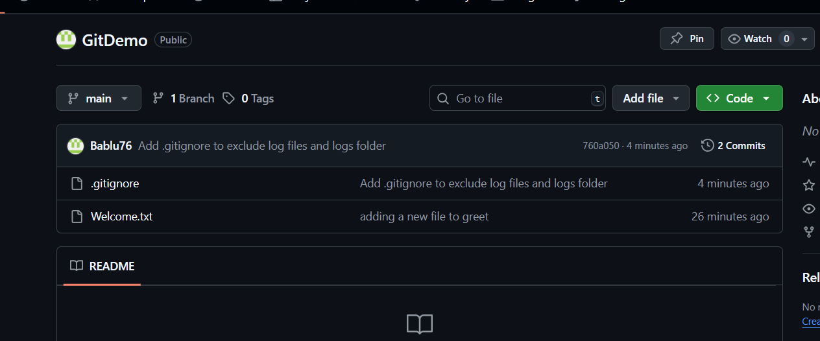

1. **Branching and Merging**

**Branching:**

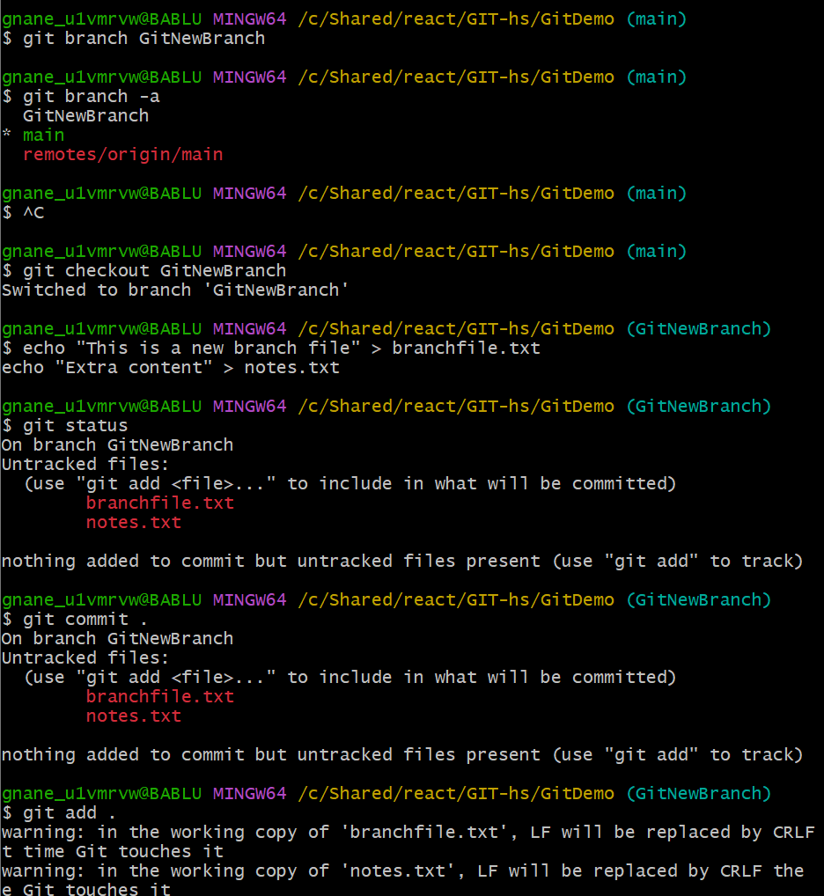

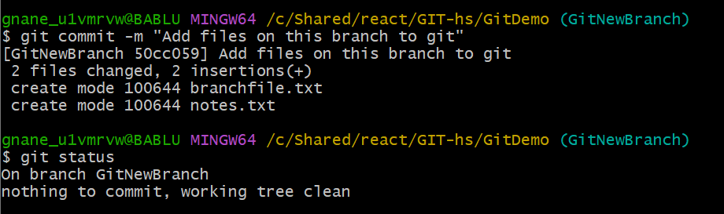

**Merging:**

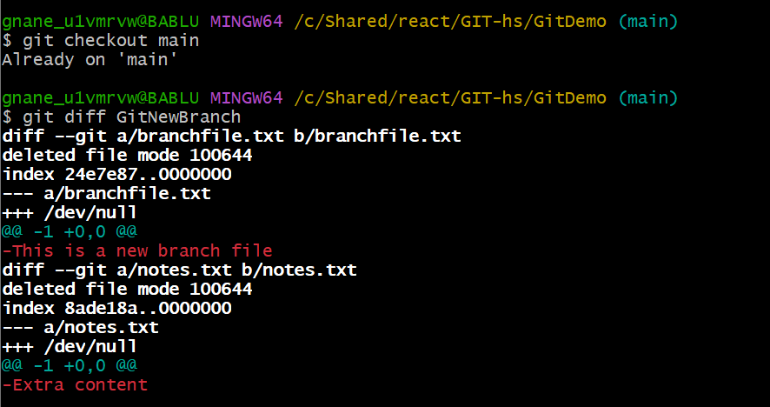 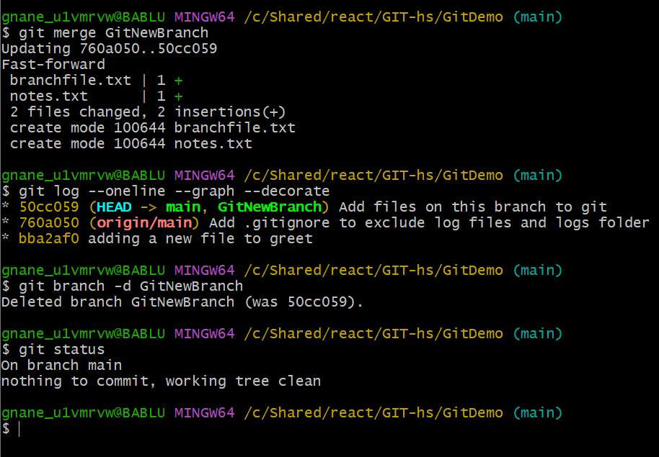

1. **Conflict Resolving in merging**

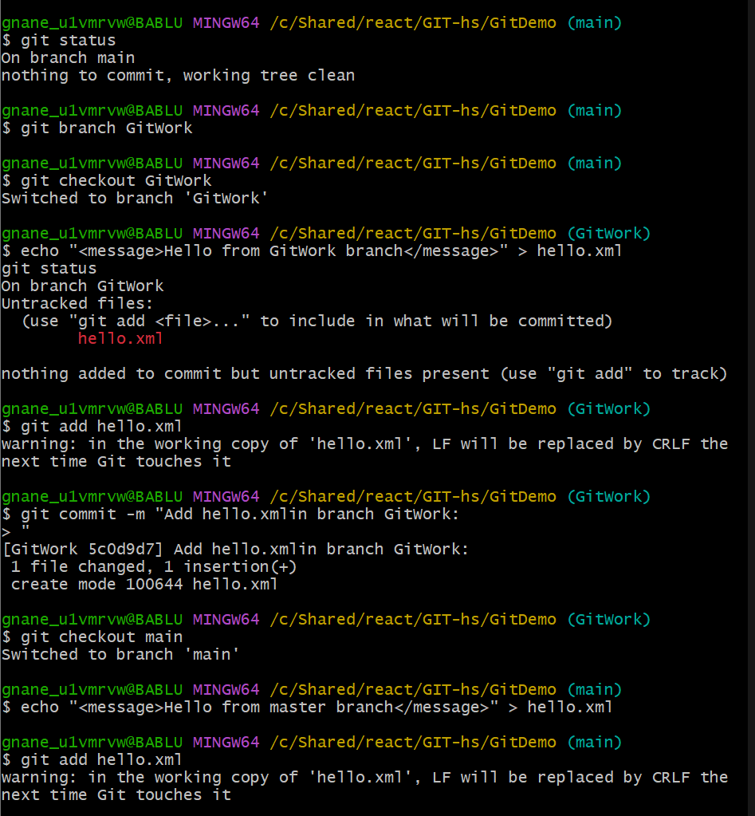 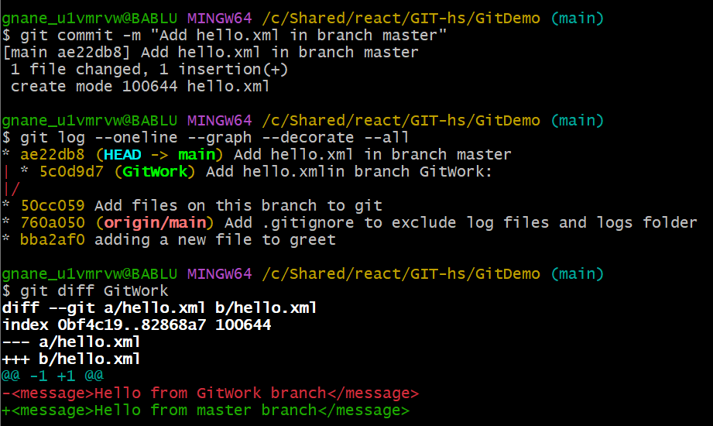

 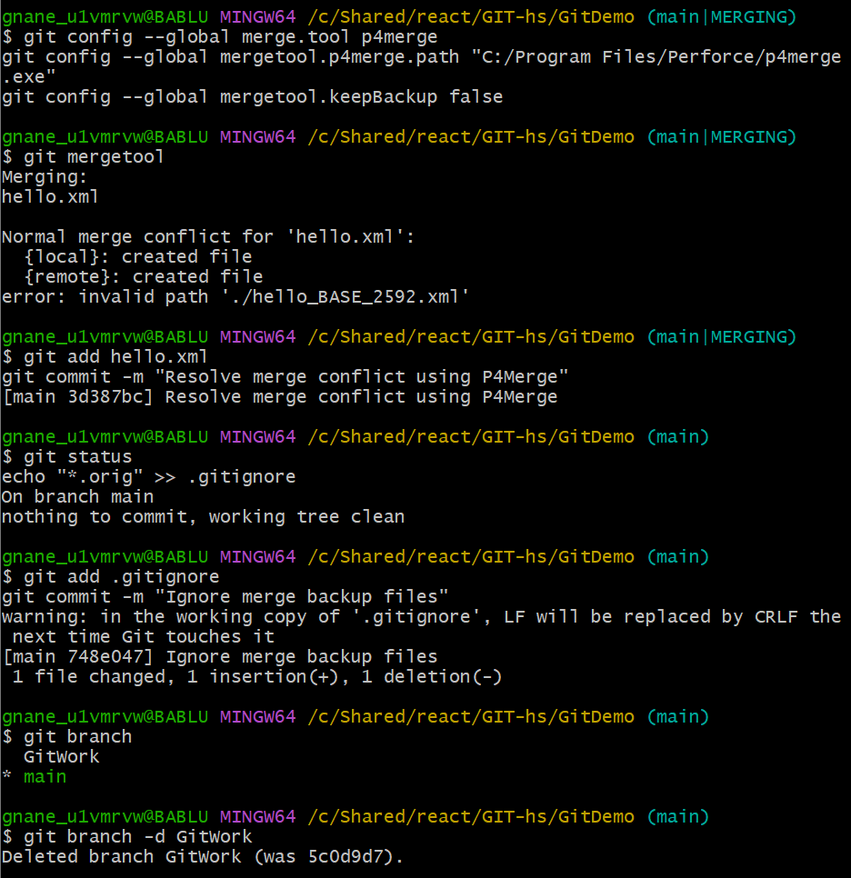 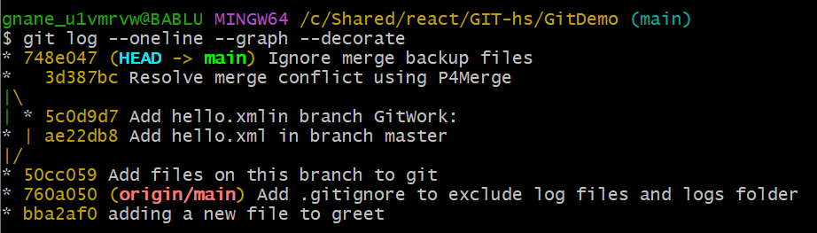

**5.**

