Permissions

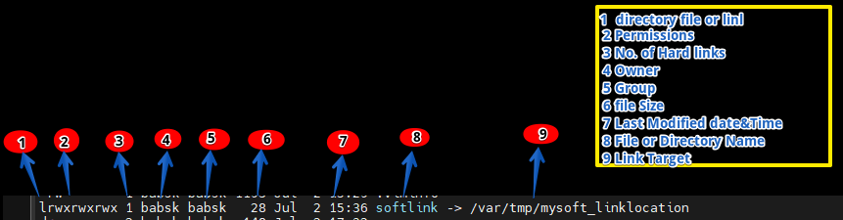
Explanation of each column

1 Indicates (d )= directory (-) file and l - link soft or hard link

2 file permissions (rwxrwxrwx) this shows the permissions for the file directory or link

3 Number of hard links (1) this show the number of hard links pointing to the file

4 Owner (babsk) This is the owner of the file or directory.

5 Group (babsk) This is the group associated with the file or directory

6 File Size (28) This is the size of the file in bytes

7 Last Modified Date and Time (Jul 2 @ 15:36) This shows the last mod. date and time of the file or dir.

8 File, Directory or Link Name (softlink) This is the name of the file or directory or link

9 Link Target (/var/tmp/mysoft_linklocation) For symbolic link this shows the target file or directory

