Splunk assignment
To connect a search head and three indexers 27/06/2024

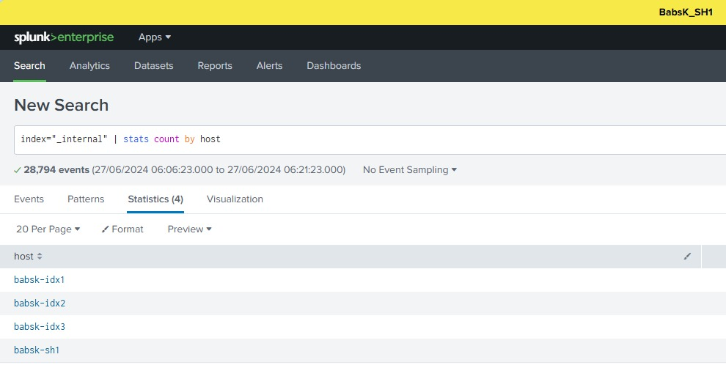

Connection established between the search head and the three indexers

SH!, IDX1, IDX2 and IDX3

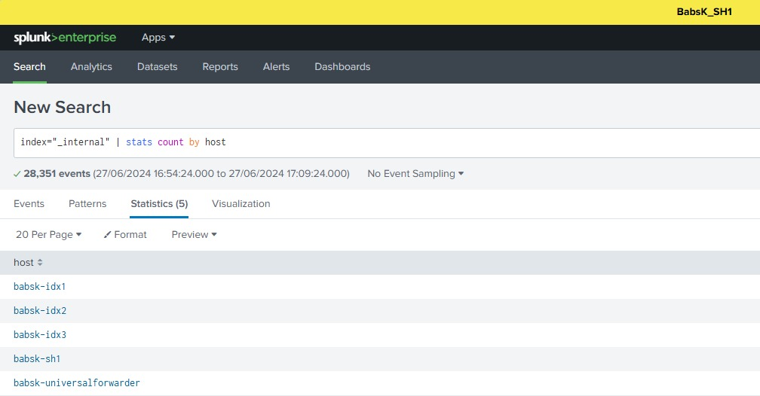

Here the Universal forwarder is now forwarding data to the Indexers

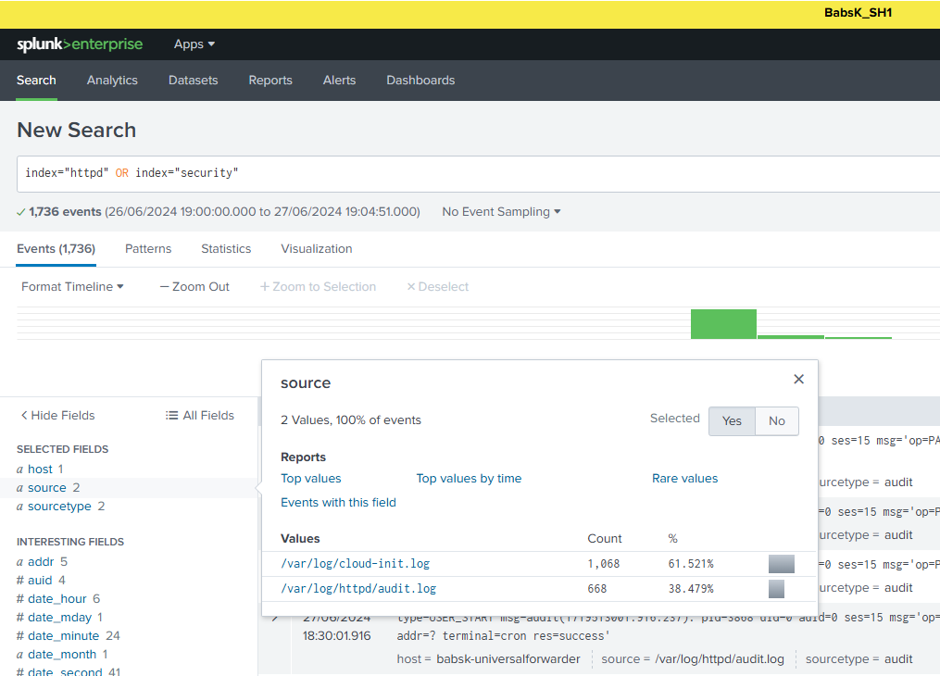

Back end logs being monitored on the front end of splunk

Search head port 8089 Indexer port 9997 Universal forwarder

GUI On search head distributed search > search peer > Private IP of Indexer:8089

GUI On the indexer forwarding and receiving > receiving port 9997 from universal forwarder
> forwarding port 8089 to search head

Back End On Universal forwarder outputs.conf private IP of indexer:8089
#outputs.conf#
[tcpout:babs]
server=172.31.47.46:9997, 172.31.45.122:9997,172.31.47.224:9997
[tcpout:indexer_cluster]
server = 172.31.28.223:9997,172.31.39.185:9997,172.31.13.169:9997

Back End On Universal forwarder inputs.conf to monitor a directory
#inputs.conf#
[monitor:///var/log/httpd/audit.log]
sourcetype =
index=httpd

[monitor:///var/log/cloud-init.log]
sourcetype =
index=security

/opt/splunkforwarder/bin/splunk set deploy-poll 172.31.43.73:8089 -auth admin:welcome90

