Survey Management Application
Internal Survey and Performance Management Platform
Application Documentation

Application Overview
The application is an internal survey and performance management platform designed to help organizations create, manage, distribute, complete, review, and monitor surveys through a centralized system. The application provides different levels of access for Admins, Managers, and Users, allowing each role to perform specific activities based on their responsibilities. The main objective of the application is to replace manual survey processes and provide a structured workflow where surveys can be created, assigned, completed, reviewed, approved or rejected, and tracked from a single platform. The system also provides notifications, survey status tracking, scoring, performance analysis, and reporting capabilities.

Purpose of the Application
The primary purpose of the application is to simplify and standardize the organization's internal survey process. Instead of managing surveys through spreadsheets, emails, documents, or multiple independent tools, the application provides one centralized platform for the complete survey lifecycle. It enables administrators to control users and surveys, managers to manage and review assigned surveys, and users to complete surveys assigned to them. The system also improves visibility by allowing authorized users to monitor pending, completed, rejected, and expired surveys.

Technology Stack
The application is developed using a modern web application technology stack consisting of a frontend, backend, database, authentication mechanism, APIs, and supporting services. The frontend is responsible for providing the user interface and interactive screens through which Admins, Managers, and Users interact with the system. The backend handles business logic, user authentication, survey processing, scoring, validation, notifications, and communication with the database. The database stores user information, survey configurations, questions, responses, scores, assignments, notifications, and other application data. APIs provide communication between the frontend and backend, while role-based authentication and authorization ensure that users can access only the features permitted for their role. The application can be deployed on an organization's internal or cloud infrastructure depending on its security and operational requirements.

Implemented Stack
Layer | Technology
Frontend | React 19 with Vite, React Router, Zustand state management
Backend | FastAPI (Python) with SQLAlchemy ORM
Database | PostgreSQL
Authentication | JWT-based email and password login, with optional Authentik single sign-on
Notifications | In-application notifications and SMTP email delivery
Live updates | WebSocket connection used by the live monitoring screen

Why This Application Is Required
Existing tools such as Google Forms, SurveyMonkey, and KoboToolbox are useful for general-purpose data collection and surveys, but an organization may require a more customized workflow for internal operations. This application is designed specifically around organizational requirements such as Admin, Manager, and User roles, survey assignment, review and approval, rejection and resubmission, performance scoring, notifications, survey validity, and centralized monitoring. The application therefore provides greater control over the complete survey lifecycle and can be customized according to the organization's business process rather than requiring the organization to adapt its workflow to a generic survey platform.

Comparison With Similar Applications
Applications such as Google Forms provide a simple and effective way to create forms and collect responses, while SurveyMonkey provides more advanced survey creation, analysis, and reporting capabilities. KoboToolbox is particularly useful for structured data collection and field-based surveys. However, these platforms are primarily designed as general-purpose survey or data-collection solutions. The proposed application focuses more strongly on an organization's internal workflow, where surveys are connected to specific users and managers and where submissions may require review, approval, rejection, resubmission, scoring, and performance monitoring. This makes the application more suitable for organizations that require a controlled survey management process rather than only collecting survey responses.

Application Architecture
The application follows a standard multi-layer web application architecture. The frontend provides the user interface and communicates with the backend through APIs. The backend processes requests, applies business rules, performs authentication and authorization, manages survey workflows, and communicates with the database. The database stores all persistent application information. When a user performs an action, such as logging in, opening a survey, submitting a response, or approving a submission, the request is processed by the backend and the appropriate information is returned to the frontend. This architecture provides separation between the user interface, business logic, and data layer and makes the application easier to maintain and extend.

Authentication and Access
All access to the application begins at the sign-in screen. A user signs in with their registered email address and password, and the backend validates the credentials before issuing an access token. The application also supports single sign-on through Authentik, which allows the organization to manage accounts centrally. Once signed in, the user is directed to the dashboard that corresponds to their role, and the navigation menu presents only the screens their role is permitted to use.
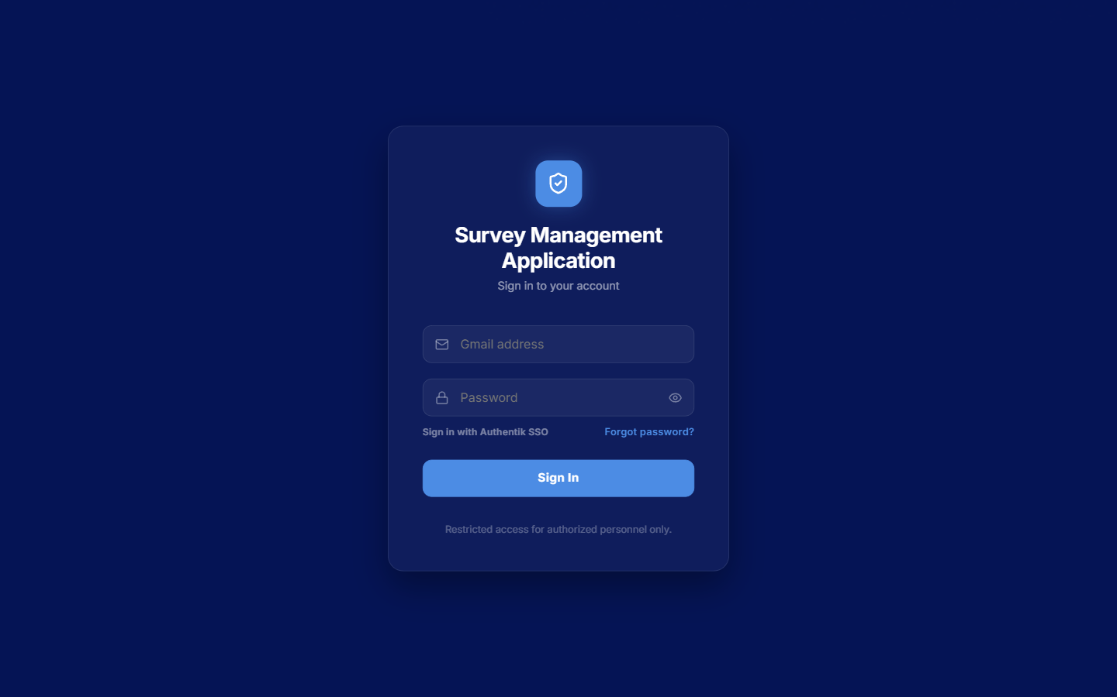
Figure 1: Sign-in screen with email, password, and Authentik single sign-on options
If a user cannot remember their password, the password recovery screen allows them to request a one-time passcode by email. The system sends the passcode to the registered address and returns a generic confirmation message regardless of whether the address is registered, so that account existence is not disclosed. The user then enters the passcode and sets a new password. Users signing in for the first time are required to change their initial password before they can reach any other screen.
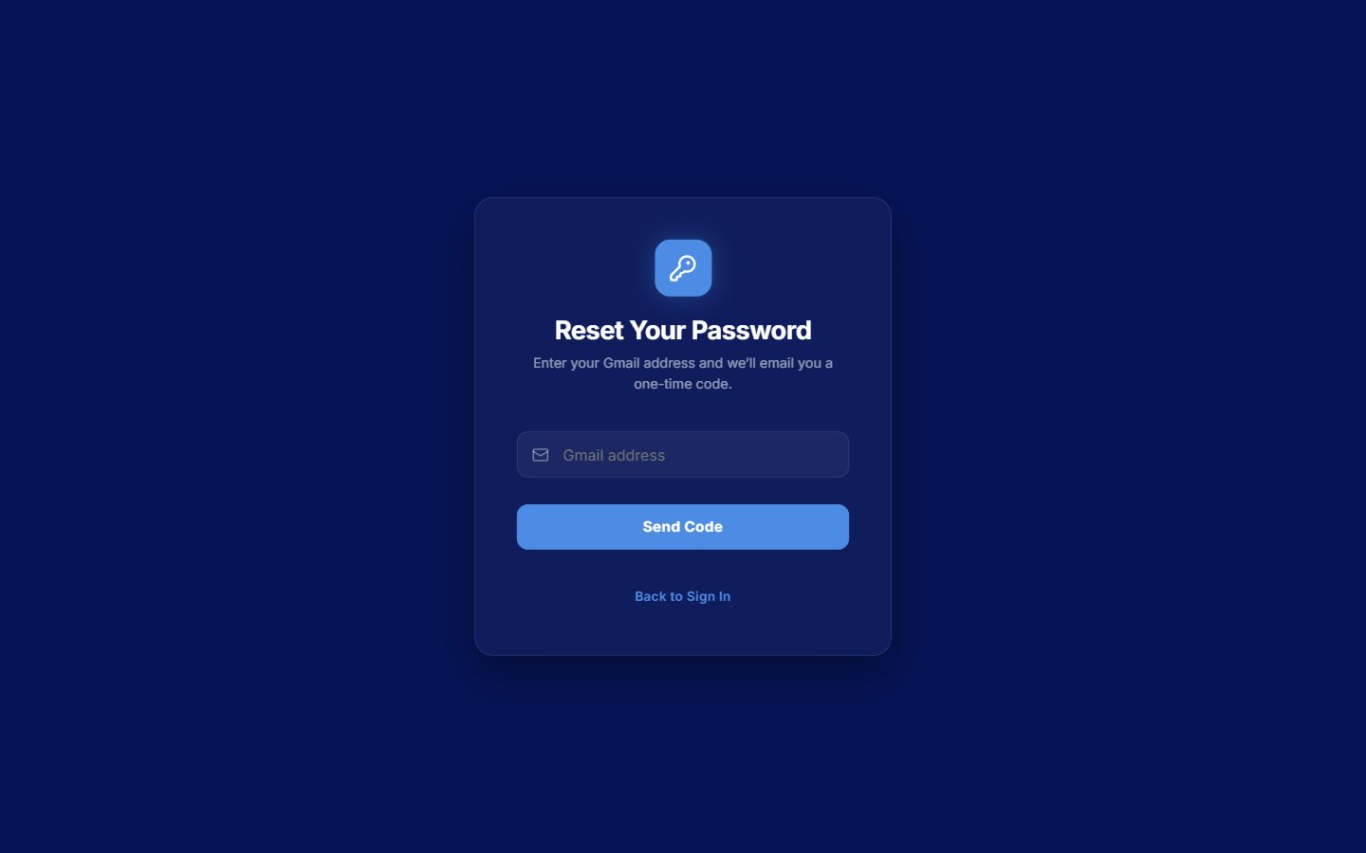
Figure 2: Password recovery screen requesting a one-time passcode by email

Admin Role
The Admin has the highest level of access within the application and is responsible for managing the overall system. The Admin can manage users, managers, surveys, survey configurations, assignments, and application-level information. The Admin dashboard provides an overall view of the system, including active surveys, completed surveys, pending surveys, rejected submissions, and other relevant performance information. The Admin can create or configure surveys, activate or deactivate surveys, manage users and managers, monitor survey activity, and review overall performance. The Admin can also receive notifications related to important system activities and monitor whether surveys are being completed within the required period. Through the Admin interface, the organization can maintain centralized control over the entire survey process.
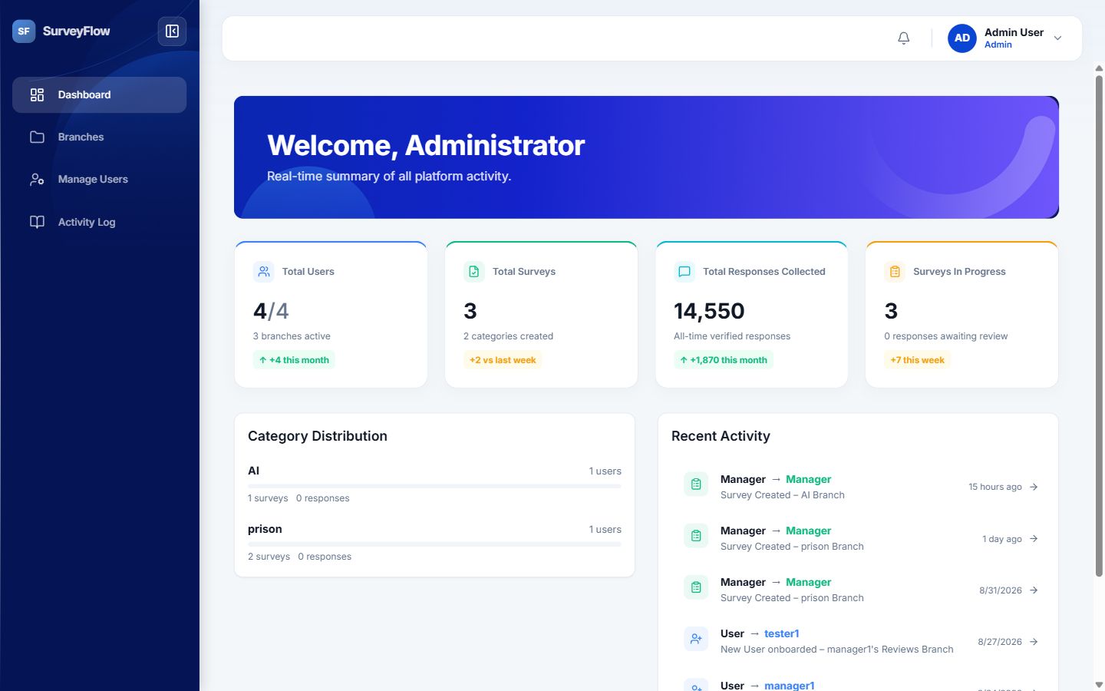
Figure 3: Admin dashboard showing overall survey and system activity
The Admin manages the people in the system from the users area, where every account is listed with its role and status. From here the Admin can open an individual account to review its details and the surveys connected to it.
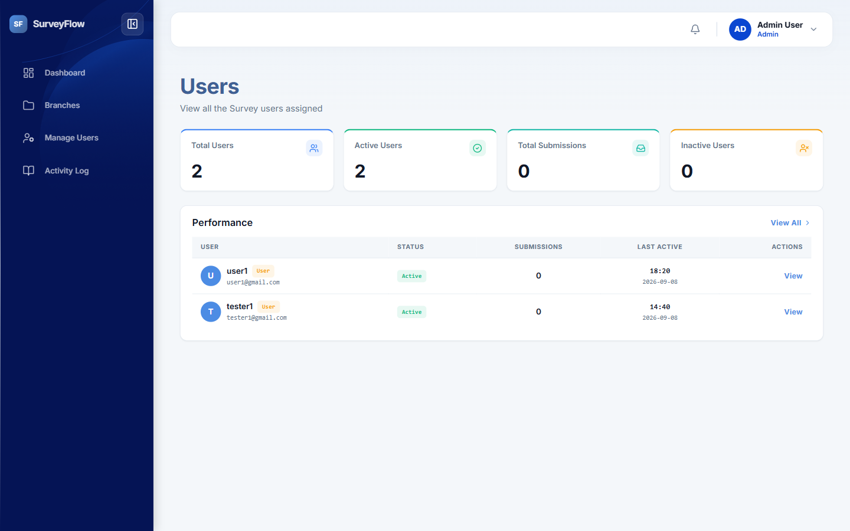
Figure 4: Users overview listing all accounts with their roles and status
The activity log gives the Admin a record of actions performed in the system, which supports auditing and helps identify when a survey was assigned, opened, submitted, or reviewed.
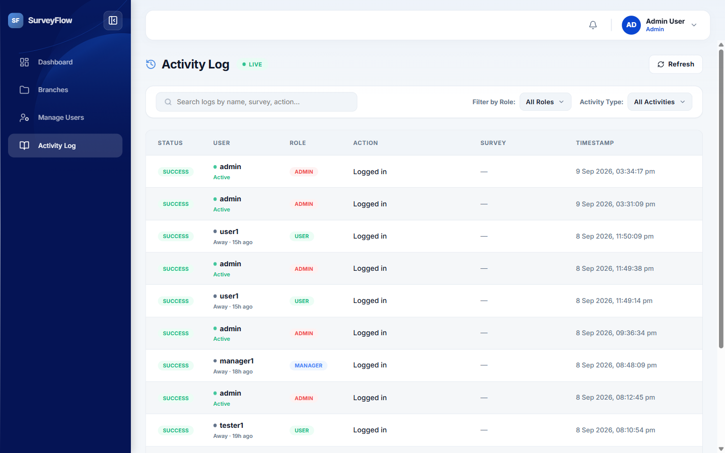
Figure 5: Activity log recording user actions across the system

Administrator Guide
This part of the document is a step-by-step guide for the Administrator. It covers how to create and manage user accounts, how to connect users to a Manager and to the surveys they must complete, and how to build a survey from beginning to end in the survey builder. Each section follows the screens in the order the Administrator uses them.

Navigating the Administrator Menu
The Administrator menu on the left of every screen contains four entries. Understanding what each one is for makes the rest of this guide easier to follow.
Menu entry | What it is used for
Dashboard | The overall view of survey activity, completion, and system status.
Branches | Surveys grouped by their category, and the place where a new survey is started.
Manage Users | Creating user accounts, editing them, assigning managers and surveys, and managing groups.
Activity Log | The record of user actions across the system, used for auditing.

Creating a User Account
All account management is done from the Manage Users screen. The screen lists every account in the system with its role, the date it was created, and its current status. The search box finds an account by name, and the two dropdowns filter the list by role and by status.
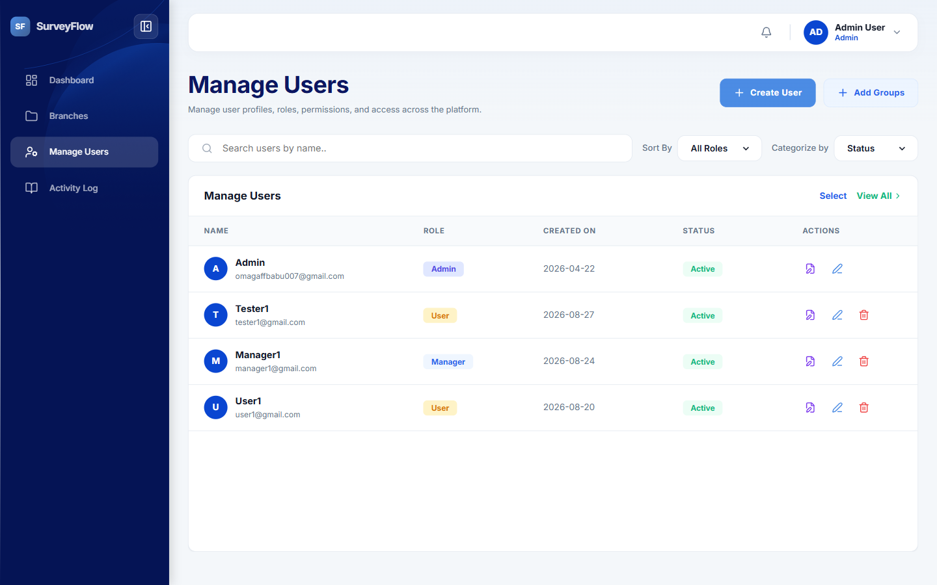
Figure 6: Manage Users screen listing every account with its role, status, and actions
To create a new account, follow these steps.
- On the Manage Users screen, select Create User in the top right corner. The Create Credential User dialog opens.
- Enter the Full Name of the person the account belongs to. This is the name shown throughout the application.
- Enter the Email Address. This is the address the person signs in with, and the address the system sends notifications and password-reset passcodes to, so it must be correct and must not already be in use.
- Enter an initial Password of at least eight characters. The person is required to change this password the first time they sign in, so it is only ever used once.
- Choose the Role. This decides which screens the account can reach and is explained in the table below.
- Optionally choose a Survey Field to assign a survey to the account at the moment it is created. This can also be done later, and is described in the next section.
- Select Create User. The account is created immediately and appears in the list.
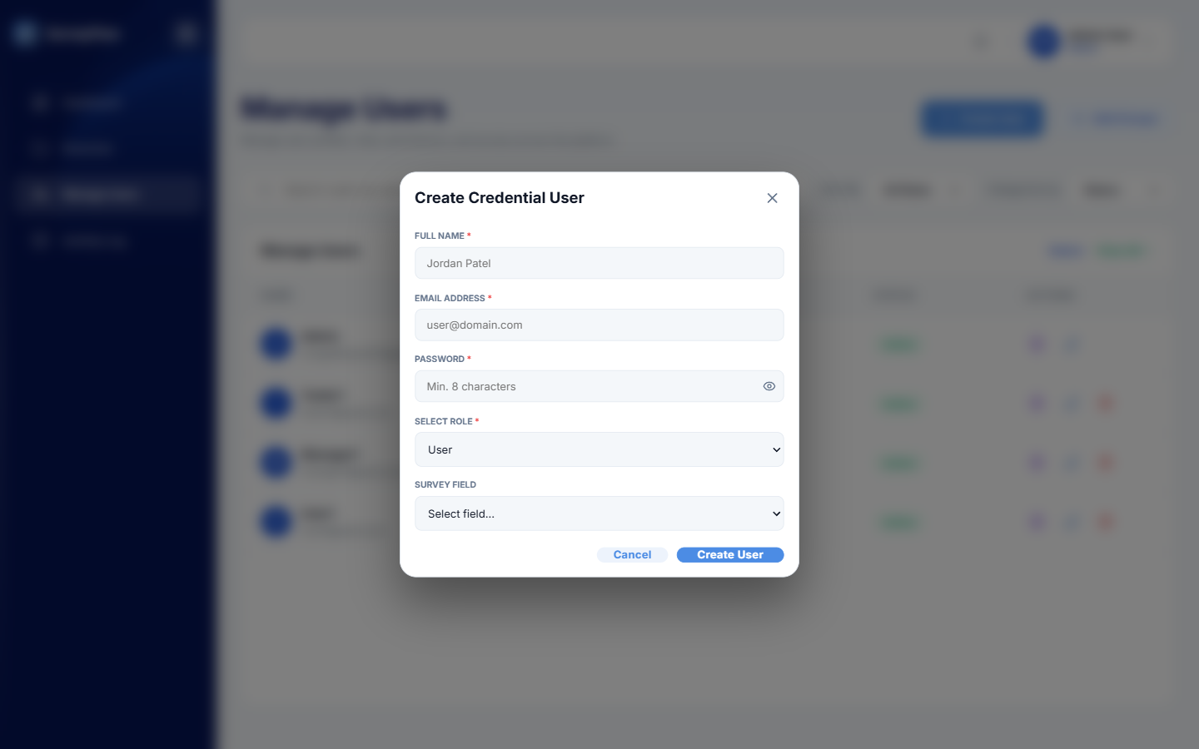
Figure 7: Create Credential User dialog with name, email, password, role, and survey field
The Role chosen here is the single most important setting on the account, because it determines what the person can see and do.
Role | What the account can do
Admin | Full access. Creates and edits surveys, manages all accounts and groups, assigns surveys, reviews submissions, and sees the activity log.
Manager | Monitors and reviews. Sees the users in their groups, watches the live monitor, and approves or rejects submissions. Cannot build surveys.
User | Completes surveys. Sees only the surveys assigned to them and their own submission history.

Because the initial password is set by the Administrator and must be changed by the person on first sign-in, the password should be communicated to them through a secure channel and should not be reused across accounts.

Editing and Removing an Account
Every row in the user list carries its own actions on the right-hand side. Edit User reopens the account so that the name, email address, phone number, and role can be corrected, and a new password can be set if the person has lost access. Delete User removes the account permanently and should be used only when the person no longer belongs to the organization; the Administrator account itself cannot be deleted. Assign Manager / Survey opens the assignment dialog described in the next section.

Assigning a Manager and Surveys to a User
A newly created User account cannot do anything useful until two connections are made: it must be given a Manager who will review its submissions, and it must be given at least one survey to complete. Both are done in the same dialog.
- On the Manage Users screen, find the account in the list.
- Select the Assign Manager / Survey action on that row. The Assign Survey dialog opens and shows the account name, email address, and role at the top so that the correct account is confirmed before anything is changed.
- In the Manager dropdown, choose the Manager who is responsible for this person. This Manager is the one who will see the submissions and approve or reject them.
- Under Assigned Surveys, use the Assign another survey dropdown to pick a survey, then select Assign. The survey is added to the list above.
- Repeat for each additional survey the person must complete. A survey already in the list can be removed with the cross beside it.
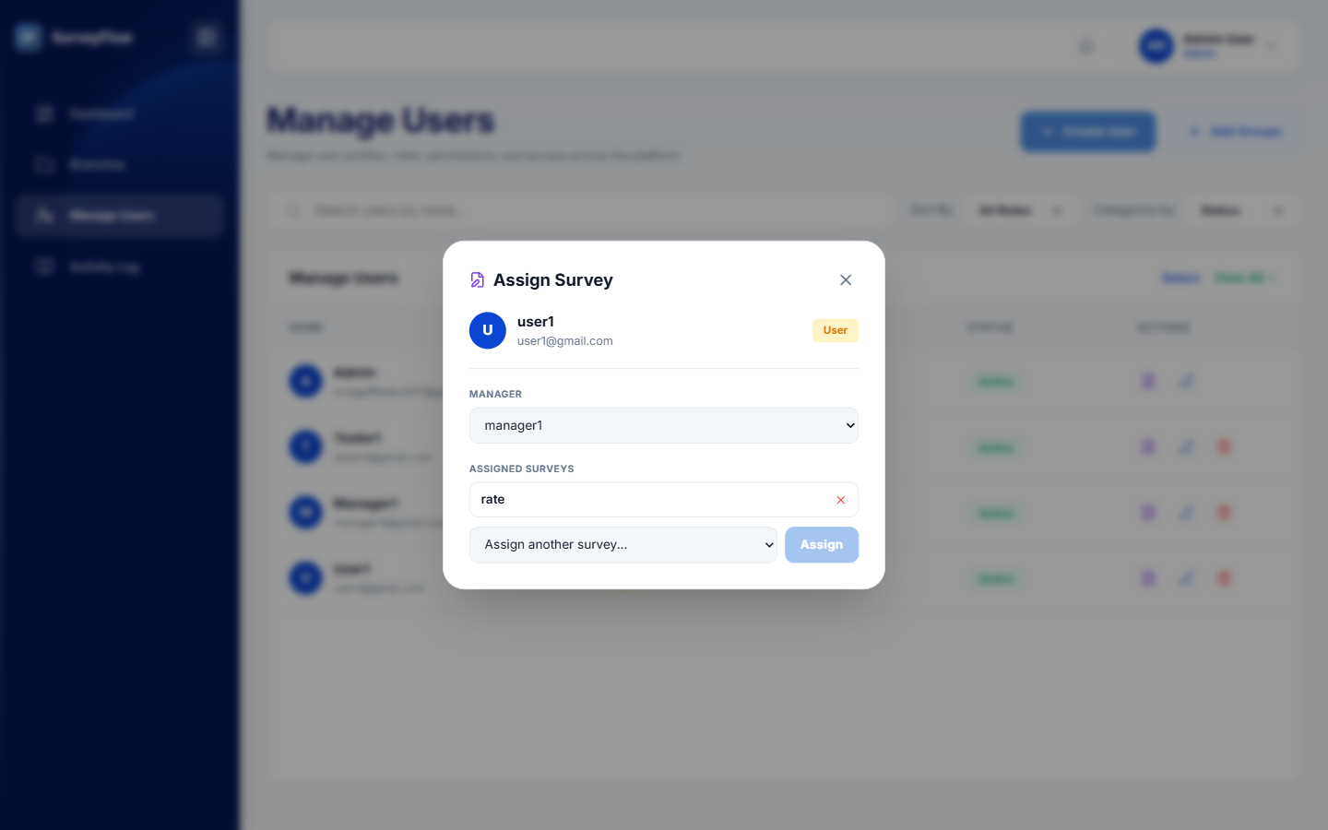
Figure 8: Assign Survey dialog connecting a user to a Manager and to one or more surveys
As soon as a survey is assigned, it appears on that person's dashboard the next time they sign in, and they are notified that a survey requires their attention.

Managing Groups
Groups are the way a Manager is given responsibility for a set of people at once, rather than user by user. A group has one Manager, a list of members, and optionally a survey assigned to the whole group. Select Add Groups on the Manage Users screen to open group management.
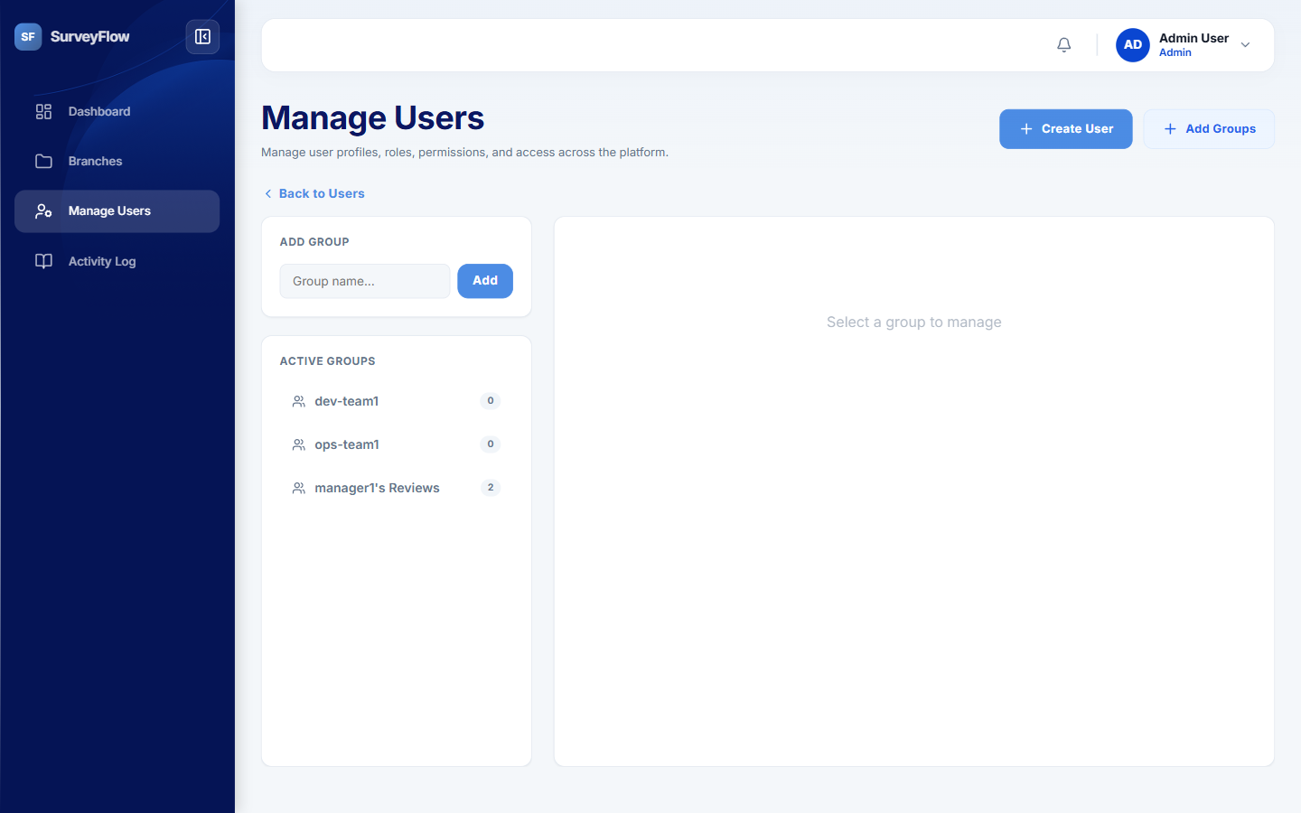
Figure 9: Group management showing the group creation box and the list of active groups
- Type a name into the Group name box and select Add. The new group appears in the Active Groups list, with the number of members shown beside it.
- Select the group to open it. The panel on the right shows the group's Manager, the survey assigned to the group, and the current members.
- Use the Group Manager field to set which Manager is responsible for the group.
- Use the Assigned Survey dropdown and the Assign button to give the same survey to every member of the group at once.
- Switch between the Members and Add Users tabs to see who is in the group and to add more people to it. Remove takes a person out of the group.
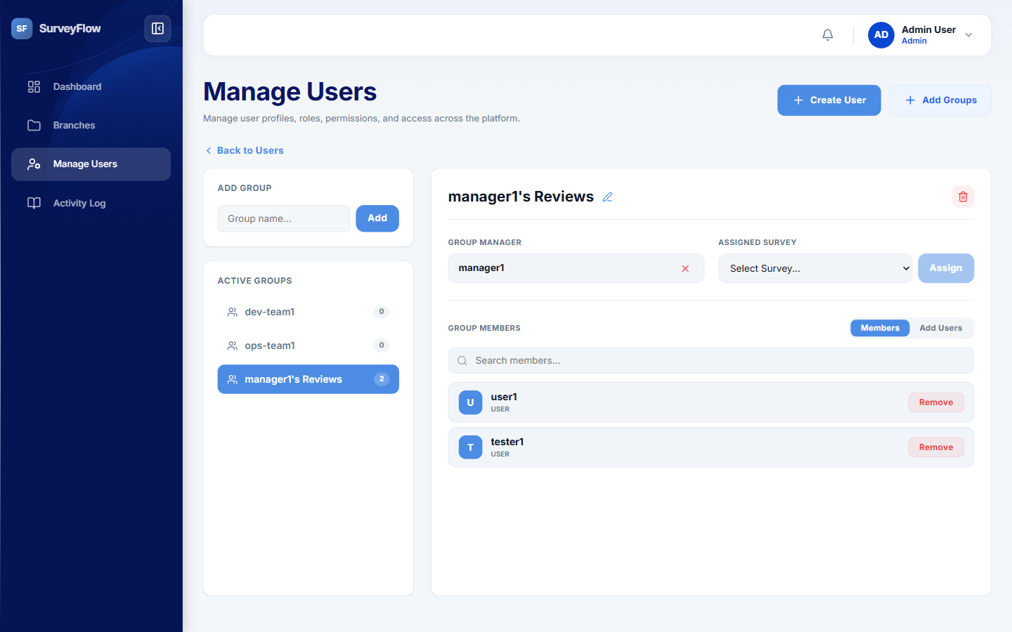
Figure 10: An open group showing its Manager, assigned survey, and member list
Because a Manager only sees the accounts that fall inside their groups, group membership is what controls the scope of the Manager dashboard, the live monitor, and the review area. A user who has not been placed in any group will not appear for any Manager.

Creating a Survey
Surveys are created in the survey builder. A survey is made up of a small amount of survey-level information, followed by any number of questions that can be grouped into sections. The builder is reached by selecting Branches in the menu and then New Survey.

Step 1 - Survey Details
The builder opens on an empty Create Survey screen. Three pieces of information are required before the survey can be saved.
Field | What to enter
Survey Name | The title the respondent sees, for example "Technical Skills Assessment".
Survey Branch | The category the survey belongs to. Existing categories are listed in the dropdown, and "+ Add New Category..." creates a new one. Categories are how surveys are grouped on the Branches screen.
Survey Description | A short explanation of what the survey is for and how the responses will be used.

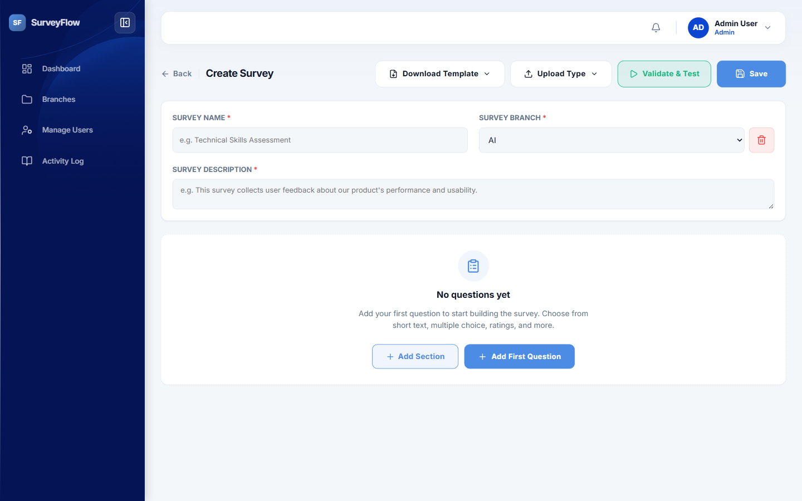
Figure 11: Step 1: the empty survey builder with the survey name, branch, and description fields

Step 2 - Adding Questions
Select Add First Question, or Add Question once the survey already has questions, to add a question to the survey. Each question is a card containing the question text, an optional media attachment, and the answer type. Add Section instead inserts a section heading, which groups the questions that follow it and gives the respondent a sense of structure in a long survey. Questions can be dragged by the handle on the left of the card to reorder them or to move them into a different section, and the icons in the top right of the card duplicate or delete the question.
- Select Add Question. A new empty question card appears, numbered in the order it will be asked.
- Type the question into the Question field. This is the wording the respondent sees, so it should be unambiguous.
- Optionally use Media Attachments to add an image or an audio clip to the question, for example a screenshot or a diagram the question refers to.
- Choose the Answer Type from the dropdown. The available types are listed in the reference table below, and the rest of the card changes to match the type chosen.
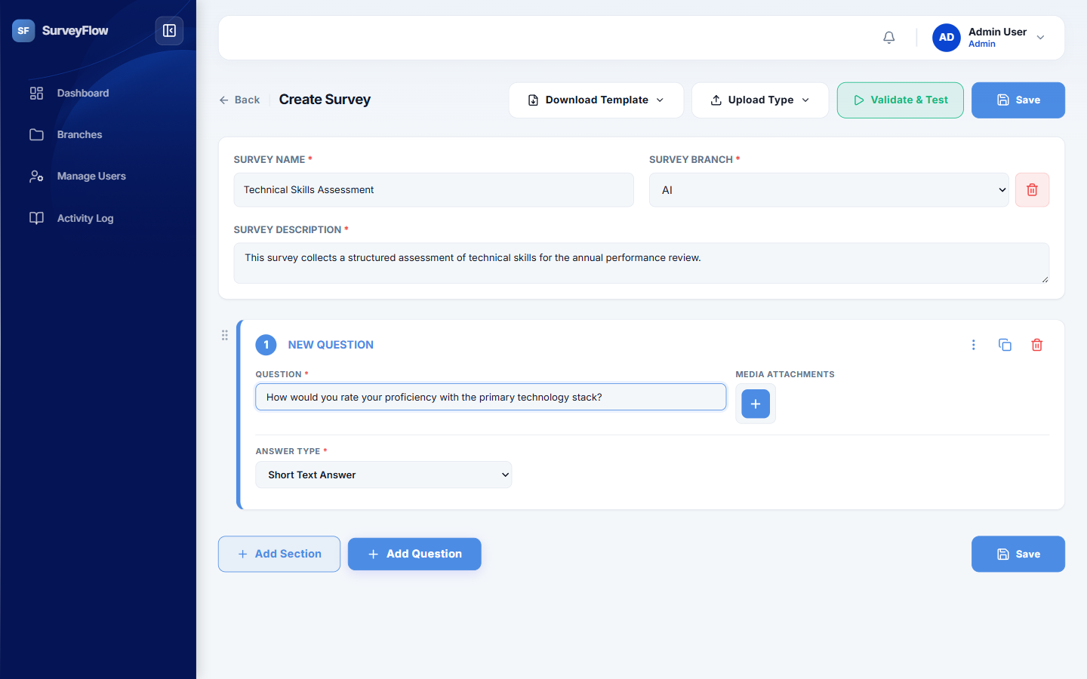
Figure 12: Step 2: a question card with the question text entered and the answer type dropdown

Answer Type Reference
The Answer Type controls how the respondent answers the question, and therefore what can be done with the answer afterwards. Ten types are available.
Answer type | Use it for
Short Text Answer | A single line of free text, such as a name, a job title, or a short comment.
Paragraph Answer | Longer free text where the respondent needs several sentences to explain something.
Number Input | A numeric answer, such as a quantity or a number of years.
Phone Number (10 digits) | A telephone number. The application checks that exactly ten digits are entered.
Single Choice (Radio Buttons) | A fixed list of options from which the respondent picks exactly one. This type supports scoring and per-answer routing.
Multiple Choice (Checkboxes) | A fixed list of options from which the respondent may pick several. This type also supports scoring.
Rating Scale | A scale, for example one to five, presented in one of five visual styles - numbers, stars, faces, a colour bar, or worded options. Described in detail below.
Ranking (Drag to Order) | A list the respondent drags into their own order of preference or priority.
Matrix / Grid | A grid that asks several statements against one shared scale in a single question. It can be set to one answer per row or several answers per row, and is described in detail below.
Media Upload | An answer where the respondent uploads a file, such as a photograph or a document, as evidence.

Step 3 - Choice Options
When the answer type is Single Choice, Multiple Choice, Ranking, or Matrix, a Choice Options panel appears. Select Add Option once for each answer the respondent should be able to pick, and type the wording of that answer into the box. Each option carries three further controls of its own.
- Jump Route decides where the respondent goes after picking this particular answer. Leaving it on Next Question continues in order; choosing a specific question sends the respondent there; choosing End of Survey finishes the survey. This is how one question can lead different people down different paths.
- + Sub Section attaches a group of follow-up questions that are asked only when this answer is picked.
- Media attaches an image or audio clip to the option itself, which is useful when the respondent is choosing between pictures rather than words.
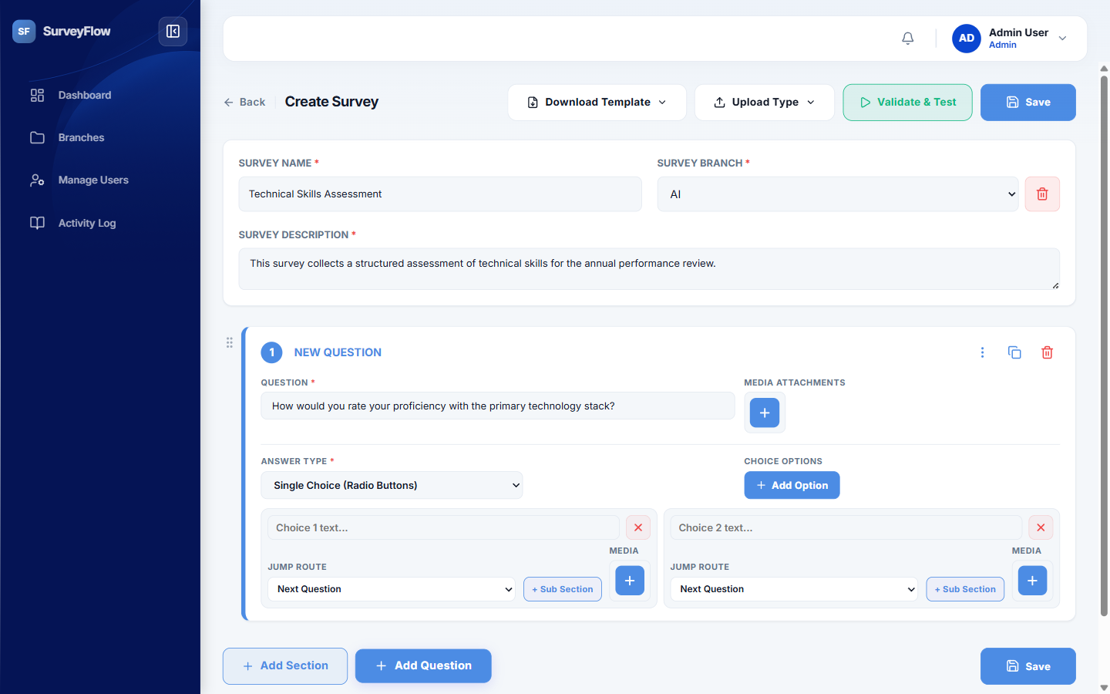
Figure 13: Step 3: choice options, each with its own jump route, sub-section, and media controls
It is worth being clear about how a Single Choice or Multiple Choice question is presented to the respondent, because it is not a grid. Each question is shown on its own, and its options appear as a row of selectable cards. A Single Choice question allows exactly one card to be selected; a Multiple Choice question allows several. If the same scale needs to be applied to a list of statements, the Matrix / Grid type described in the next section is the type to use instead, because it asks all of the statements within a single question.
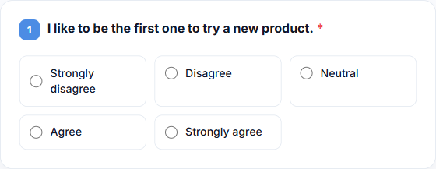
Figure 14: A Single Choice question as the respondent sees it: one question, options shown as cards

Matrix / Grid Questions
A Matrix / Grid question asks several statements against one shared scale, laid out as a table: the statements run down the left as rows, and the scale runs across the top as columns. It is the right type whenever the same set of answers applies to a list of items, because it replaces what would otherwise be many separate questions with one.
Choosing Matrix / Grid as the answer type opens a Matrix / Grid Settings panel with two text boxes and one switch.
Setting | What to enter
Rows - statements | One statement per line. Each line becomes a row of the grid. The panel counts the lines as they are typed.
Columns - choices | One choice per line. Each line becomes a column of the grid. Two preset buttons fill this in with a ready-made five-point scale: "Very Bad ... Very Good" and "Very Dissatisfied ... Very Satisfied".
Allow multiple answers per row | Left off, the respondent picks exactly one column per row and the grid is drawn with radio buttons. Switched on, the respondent may pick any number of columns per row and the grid is drawn with checkboxes.

A line beneath the panel confirms the result in words, for example "Respondents will answer 4 rows against 5 choices, picking one per row", which is a quick way to check the grid before testing it.
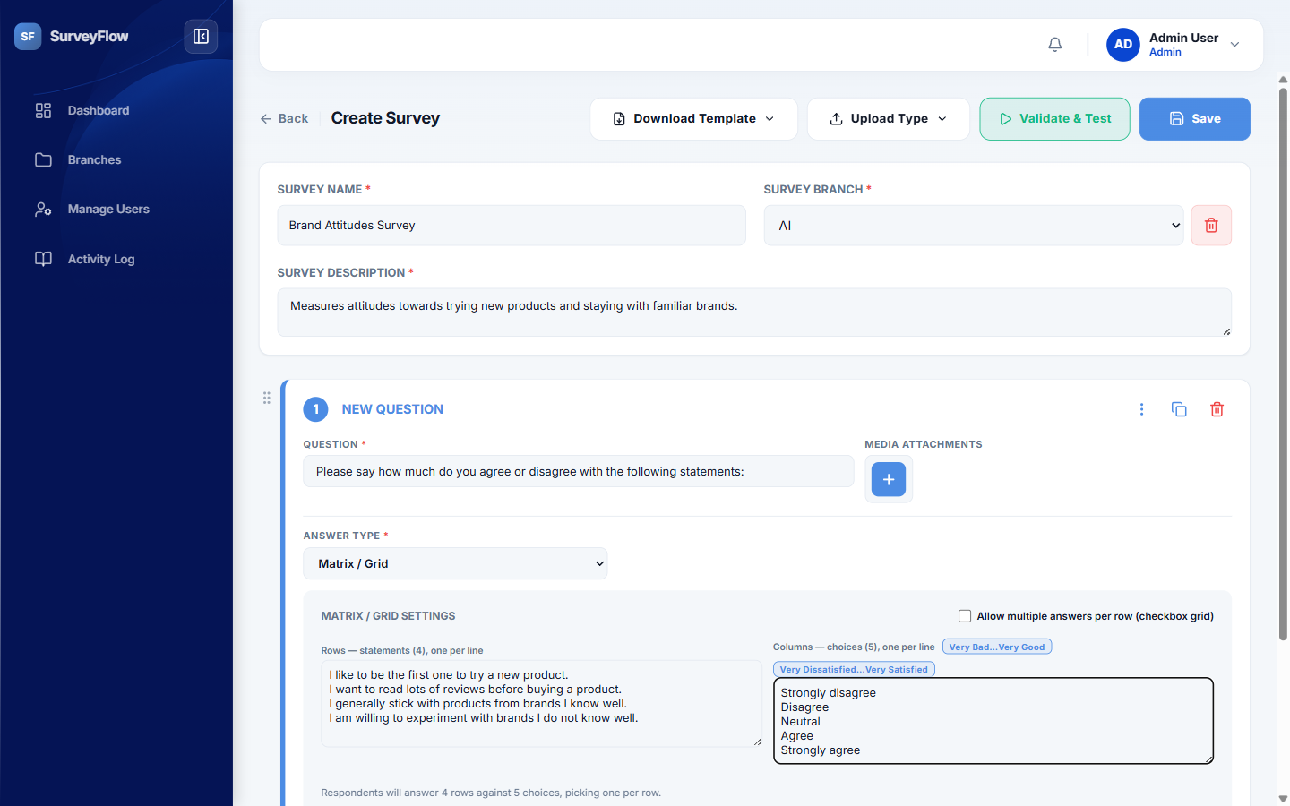
Figure 15: Matrix / Grid Settings: the row and column boxes, the scale presets, and the multiple-answer switch
With the switch left off, the respondent sees a grid of radio buttons and selects one answer on each row. This is the usual arrangement for an agreement or satisfaction scale. Rows are shaded alternately so that the eye stays on the correct line, and a row that has been answered is marked with a coloured bar on its left edge. Selecting an already-selected button clears that row again, so a respondent can undo an answer to a question that is not required.
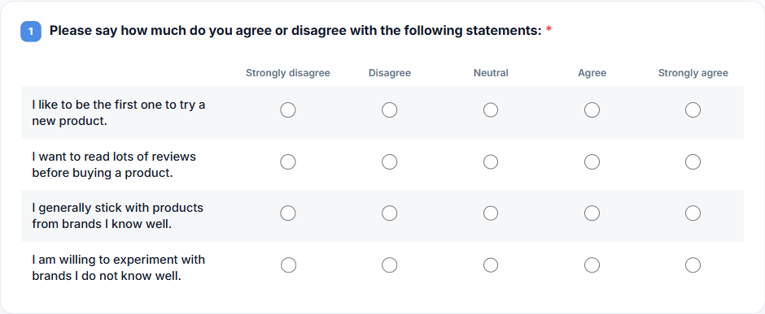
Figure 16: A Matrix / Grid question with one answer per row, as the respondent sees it
With the switch turned on, the same grid is drawn with checkboxes and the respondent may tick several columns on the same row. This suits questions where more than one answer can be true of a statement at the same time.
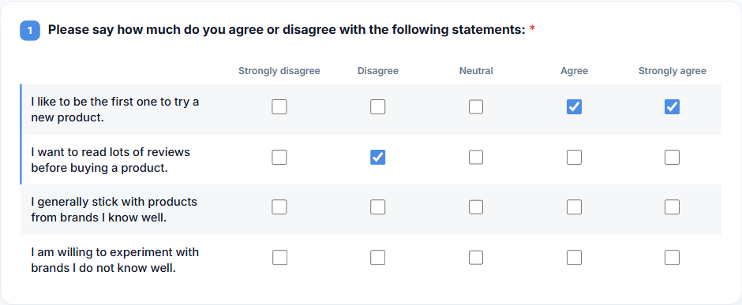
Figure 17: The same grid with multiple answers per row enabled, drawn with checkboxes
A Matrix / Grid question that is marked as Required is not treated as answered until every row has a selection, so a respondent cannot continue by filling in only part of the grid. Because a grid needs more room than a single-answer question, the survey widens the question card when a Matrix / Grid question is shown, so that a normal five-point scale is fully visible without scrolling. On a narrow screen, such as a phone, a wide grid scrolls sideways within the question rather than stretching the page.

Rating Scale Questions
A Rating Scale question asks for a single point on a scale. The scale itself is always the same underneath - the answer is recorded as the position chosen, so results stay comparable and scoring keeps working even if the appearance is changed later - but it can be presented to the respondent in five different visual styles. Choosing Rating Scale as the answer type opens a Rating Settings panel containing the Rating Style, the number of points on the scale, and optional captions for the low and high ends.
Rating style | How it is presented
Number Scale | A single strip of numbered cells. Suits longer scales such as a nought-to-ten recommendation question, where the end captions carry the meaning.
Star Rating | A row of stars that fill up to the point chosen. The familiar way to ask for an overall quality score.
Emoji Rating | A row of faces running from unhappy to delighted, each of which can carry its own caption.
Horizontal Bar | A single segmented bar coloured red at the low end and green at the high end, filled up to the point chosen.
Word Scale | The points listed as worded options, one per line, with the position shown beside each. Suits scales where the wording matters more than the number.

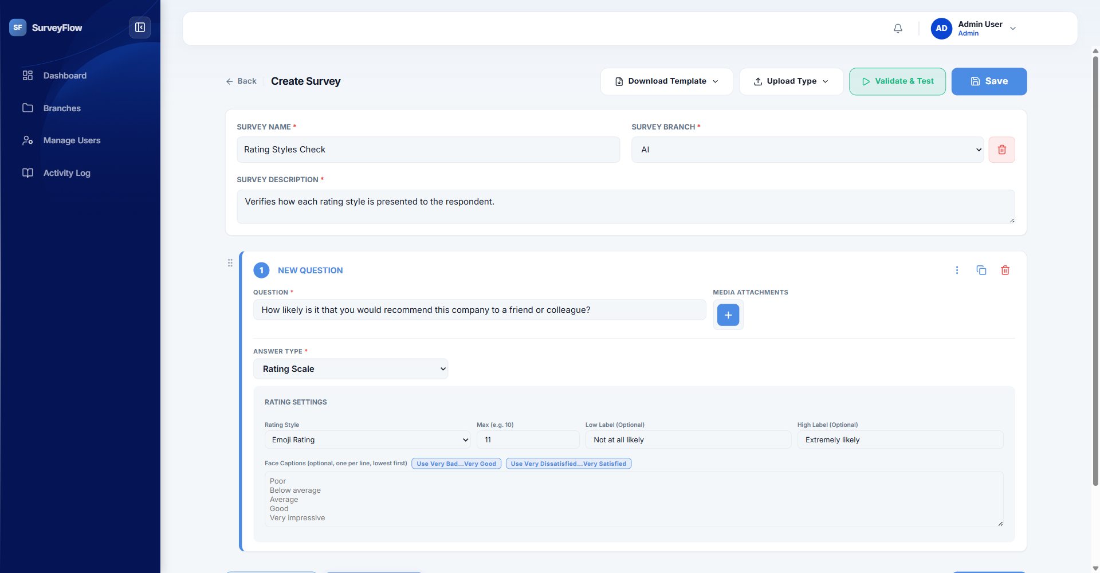
Figure 18: Rating Settings with the style, point count, end captions, and face captions
The Number Scale draws the points as one continuous strip rather than as separate tiles, so a long scale stays on a single line. The low and high captions sit above the two ends of the strip, and the point the respondent chooses is filled in.
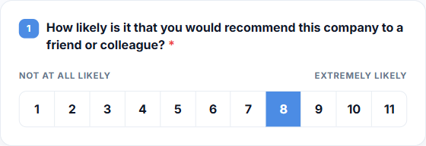
Figure 19: Number Scale: an eleven-point strip with end captions and the chosen point filled
The Star Rating fills every star up to the point chosen and leaves the rest as outlines, so the rating can be read at a glance.

Figure 20: Star Rating: three of five stars selected
The Emoji Rating shows one face per point. Where the Administrator has filled in the Face Captions box, each face is labelled underneath, and the chosen face is marked with a highlighted tile. The captions are optional; without them the faces stand on their own.
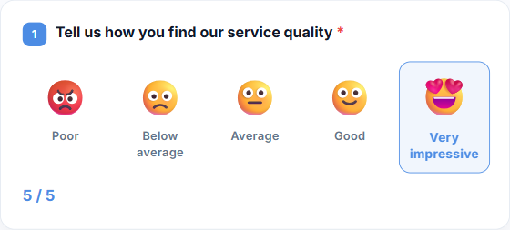
Figure 21: Emoji Rating: five captioned faces with the highest one selected
The Horizontal Bar shows the whole scale as a single coloured bar before anything is chosen. Once the respondent picks a point, the bar fills up to it and the rest fades back.
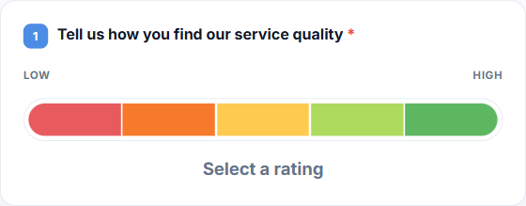
Figure 22: Horizontal Bar before a choice is made, showing the full range
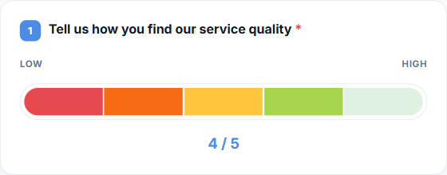
Figure 23: Horizontal Bar filled to the fourth of five points
The Word Scale lists the points as worded options. Because a word scale is defined by its captions, the number of points follows the number of lines typed into the captions box rather than being set separately.
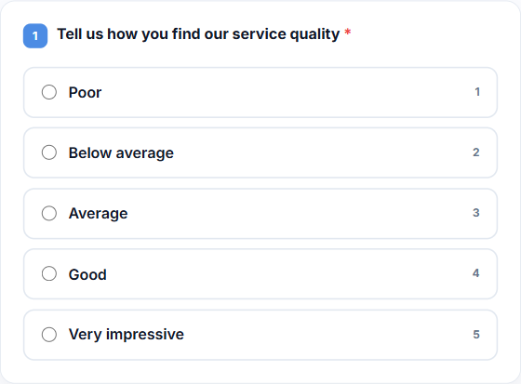
Figure 24: Word Scale: the points listed as worded options

Question Settings
The three-dot Question Options button in the top right of each question card opens the settings that apply to the question as a whole.
Setting | What it does
Required | When switched on, the respondent must answer this question before they can continue. Required questions are marked with an asterisk in the survey.
Backward Route | Sends the respondent to a chosen question once this one is answered, whatever answer was given. It overrides the question's own jump routes. The questions that were skipped are still asked afterwards, and the survey finishes only when nothing unanswered is left on the respondent's path.
Enable Score | Turns on scoring for this question. A points box appears on every choice option, and a Score-Based Routing panel appears at the bottom of the question.

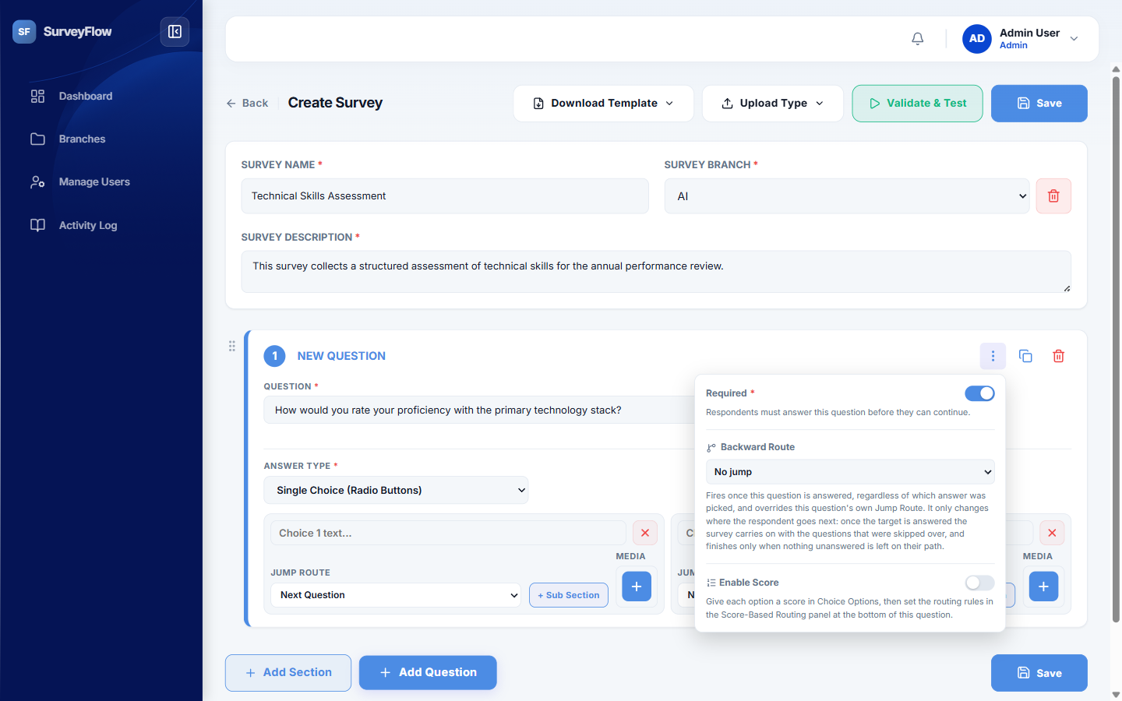
Figure 25: Question settings: the Required switch, Backward Route, and Enable Score

Scoring and Score-Based Routing
Scoring is what turns a survey into an assessment. Once Enable Score is switched on for a question, a small points field appears beside every choice option, and the Administrator gives each option the number of points it is worth. The points from the answers the respondent picks are added together, and that total is what the reporting and performance analysis are based on.
The Score-Based Routing panel at the bottom of the question then uses that total to decide where the respondent goes next. Combine Scores From selects which questions contribute to the total, so a rule can be based on this question alone or on several questions together. Each score rule is read as "if the combined score is at least this number, go to this question", which allows a survey to branch on overall performance rather than on a single answer. A rule with a threshold but no chosen destination is reported as a warning when the survey is validated.
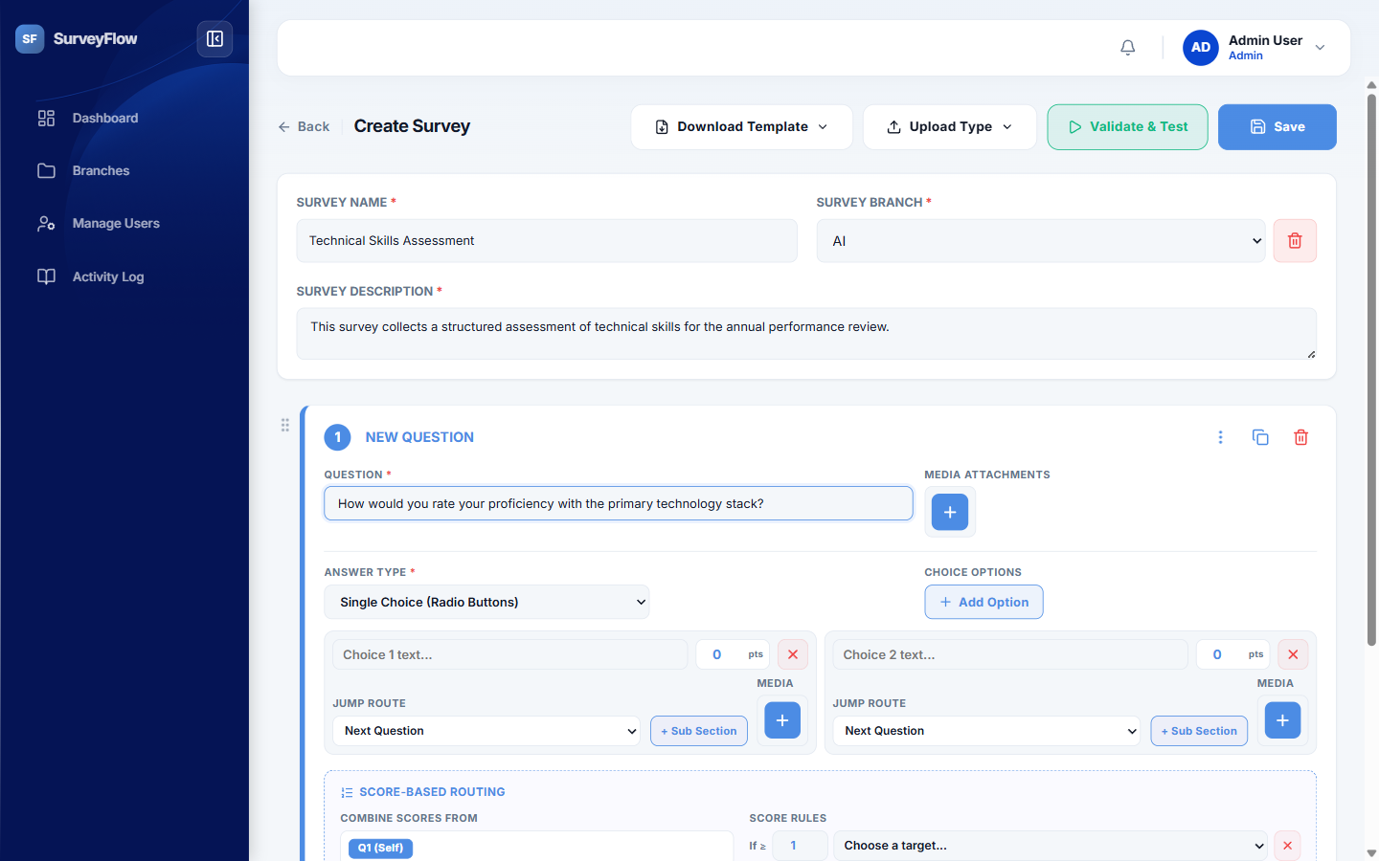
Figure 26: Scoring enabled: points on each option and the score-based routing panel

Step 4 - Validating and Testing
Validate & Test checks the whole survey before it is used and opens a Validation Report. The report separates what it finds into errors, which must be fixed, and warnings, which should be reviewed, and shows how many of its checks passed. Typical findings are answer options that were left empty, routing that points at a question that no longer exists, and score rules with no destination.
Back to Fix returns to the builder with the problems still listed so they can be corrected. Once there are no errors, Start Test Mode becomes available and runs the survey exactly as a respondent would see it, so the Administrator can walk the routing and confirm that each answer leads where it was meant to. Nothing entered in test mode is recorded as a real submission.
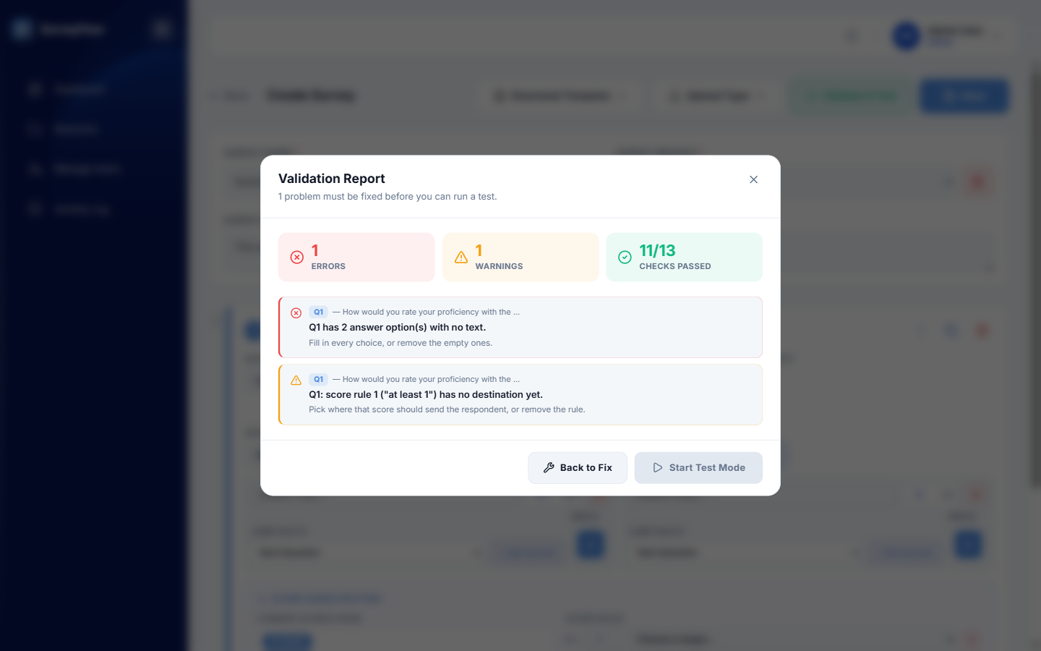
Figure 27: The Validation Report listing errors, warnings, and checks passed

Step 5 - Saving the Survey
Select Save to store the survey. A survey can be saved while it is still incomplete and reopened later from the Branches screen, so a long survey does not have to be built in one sitting. Saving does not make the survey available to anyone: it must still be activated and assigned, which is covered below.

Building a Survey from a Spreadsheet
A long survey does not have to be typed in question by question. Download Template provides a spreadsheet laid out in the format the builder expects, which can be filled in offline and then brought back in through Upload Type. Two upload modes are offered: Upload Automation takes a single sheet and translates it into the survey structure automatically, while Upload Manually takes the full thirteen-sheet workbook where every part of the survey is specified by hand. After an upload, the imported questions appear in the builder as normal and can be edited, validated, and saved in the usual way.
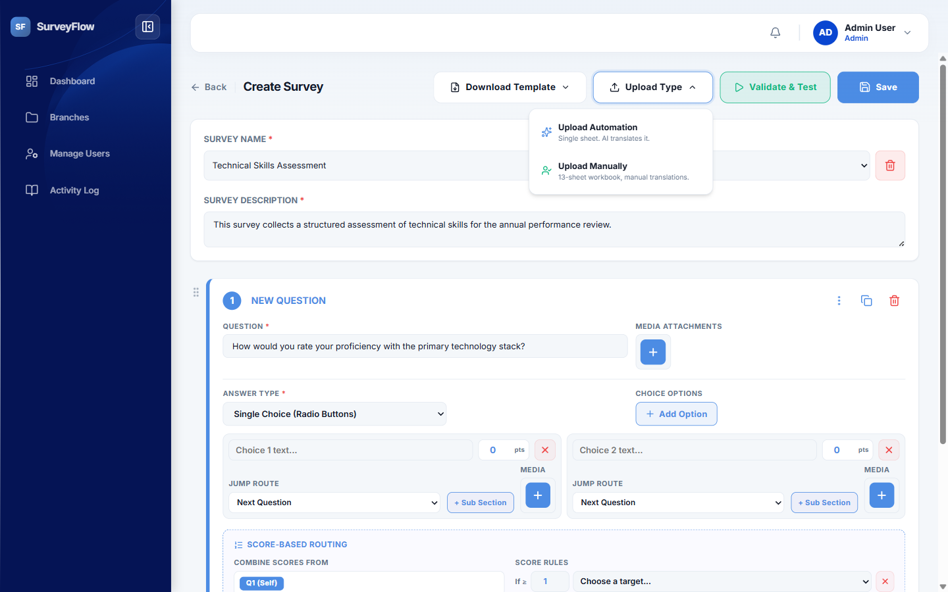
Figure 28: The Upload Type menu offering automatic and manual spreadsheet import

Activating and Distributing a Survey
The Branches screen lists the survey categories, with the number of users, surveys, and responses in each. Selecting a branch opens the surveys inside it, each shown with its question count, its response count, and a completion bar.
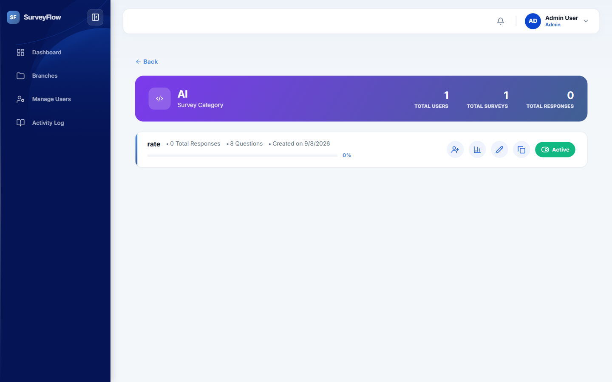
Figure 29: A survey branch showing each survey with its actions and its active status toggle
Each survey row carries the actions the Administrator needs once the survey is built.
Action | What it does
Assign users | Gives the survey to the people who must complete it.
View report | Opens the collected responses and the resulting scores for that survey.
Edit | Reopens the survey in the builder so its questions and routing can be changed.
Duplicate | Creates a copy of the survey, which is the quickest way to start a similar one.
Active / Inactive | Switches the survey on or off. An inactive survey cannot be opened or completed by anyone, which is how a survey is retired without deleting the responses already collected.

The recommended order of work is therefore: build the survey, validate and test it, save it, switch it to Active, and only then assign it to users or to a group. Assigning a survey that is still inactive means the people who receive it will not be able to open it.

Manager Role
The Manager is responsible for managing surveys assigned to them and monitoring the progress of users under their responsibility. A Manager can view assigned surveys, send or assign surveys to users, monitor submission status, and review completed responses. When a user submits a survey, the Manager can review the response and determine whether it should be accepted or rejected based on the organization's process. If a submission is rejected, the system can notify the user so that the required changes can be made and the survey can be resubmitted. The Manager can also monitor user performance and survey completion status through the available dashboard and reporting features.
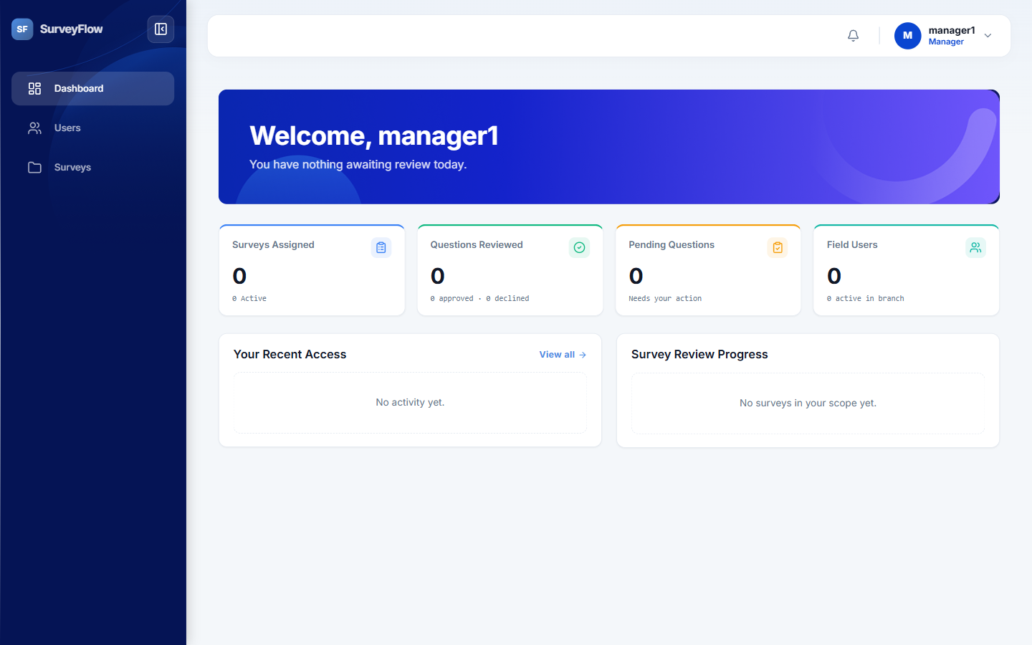
Figure 30: Manager dashboard summarising assigned surveys and their progress
The live monitor gives the Manager an up-to-date view of survey activity as it happens. The screen maintains a live connection to the backend so that submissions and status changes appear without the Manager needing to refresh the page.
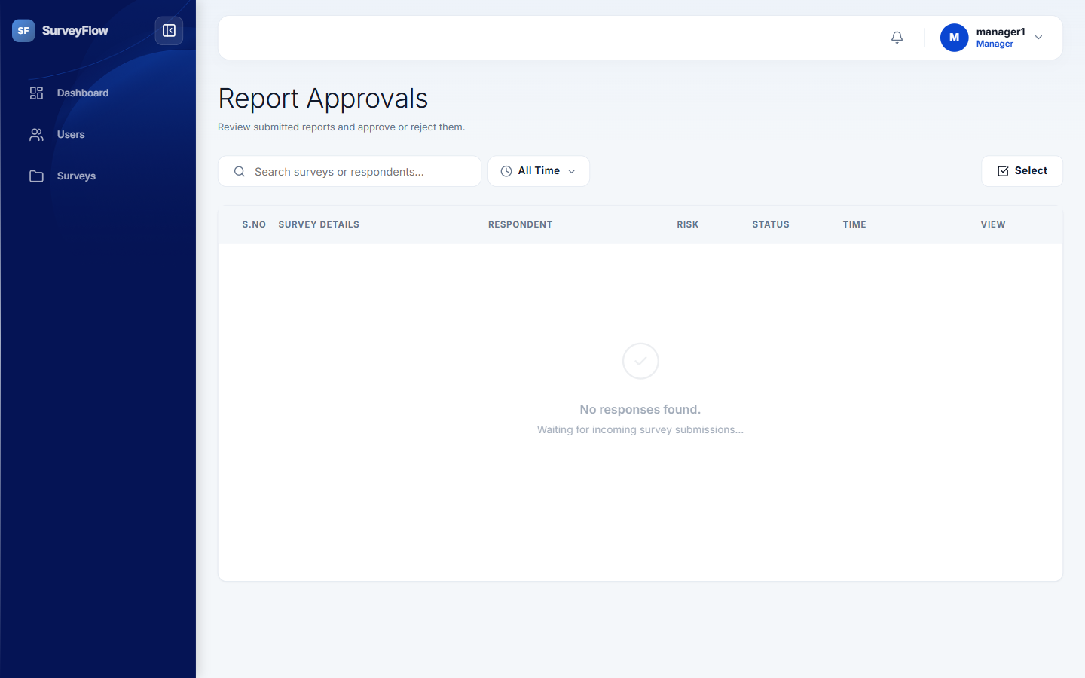
Figure 31: Live monitor showing survey activity in real time
Submitted responses reach the Manager through the review area. The Manager opens a submission, examines the answers, and either approves it or rejects it with the reason for rejection. The decision is recorded against the submission and the user is notified of the outcome.
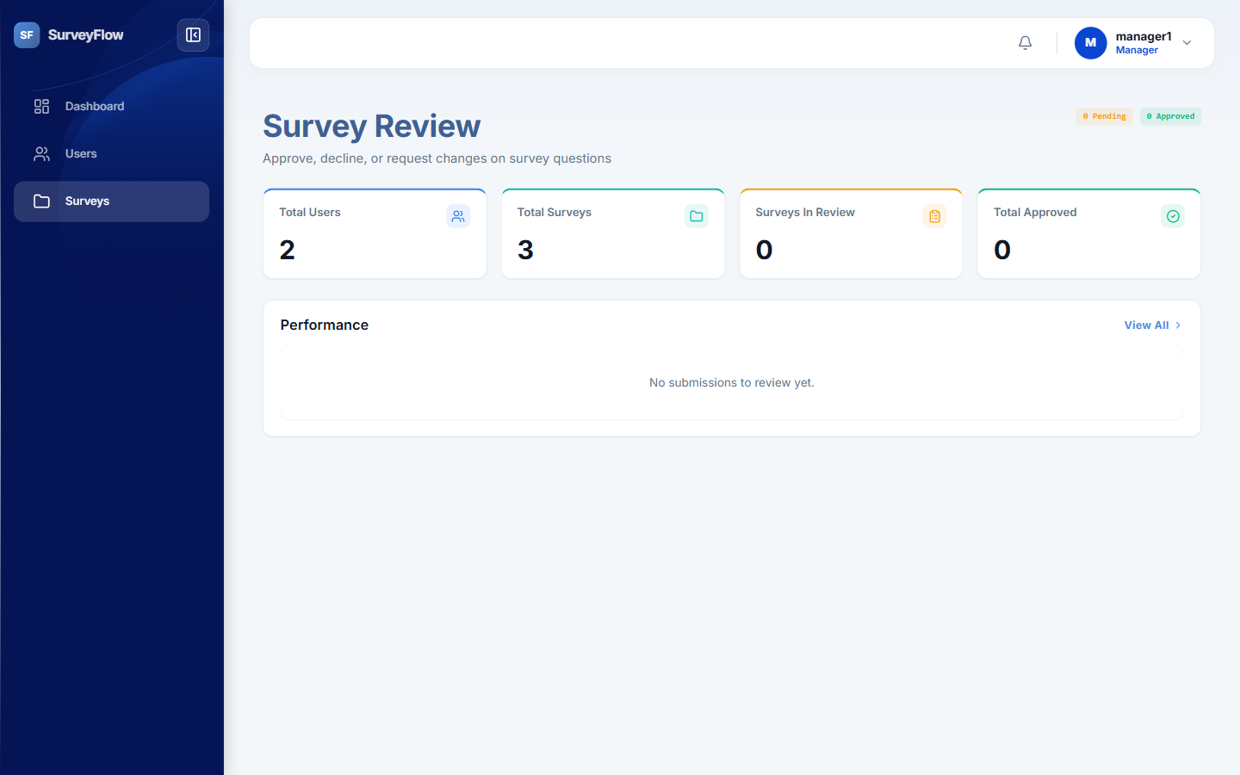
Figure 32: Review area listing submissions awaiting a decision

User Role
The User is the person who completes the survey assigned by the Manager or organization. After logging into the application, the User can view available and assigned surveys and open the required survey. The User can answer the questions, navigate through the survey according to the configured flow, and submit the completed response. The system validates the information before submission and records the response in the database. The User can also receive notifications when a new survey is assigned, when a submission is rejected, or when action is required. The User can track the status of their surveys and complete any required resubmission within the permitted period.
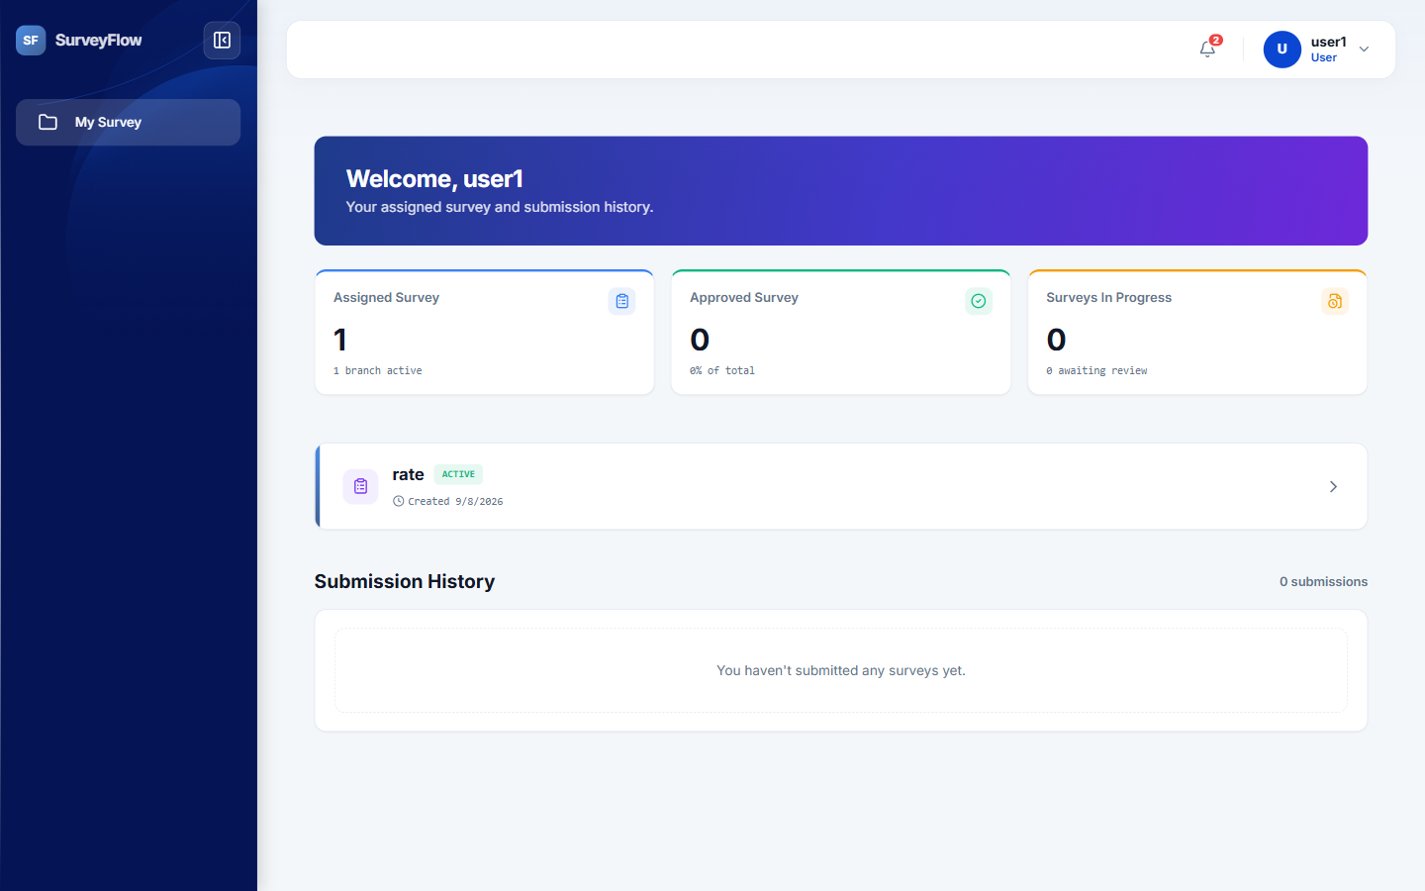
Figure 33: User dashboard listing assigned surveys and their current status
Opening an assigned survey first presents a start screen that confirms the respondent, so that the progress and the results are recorded against the correct account.
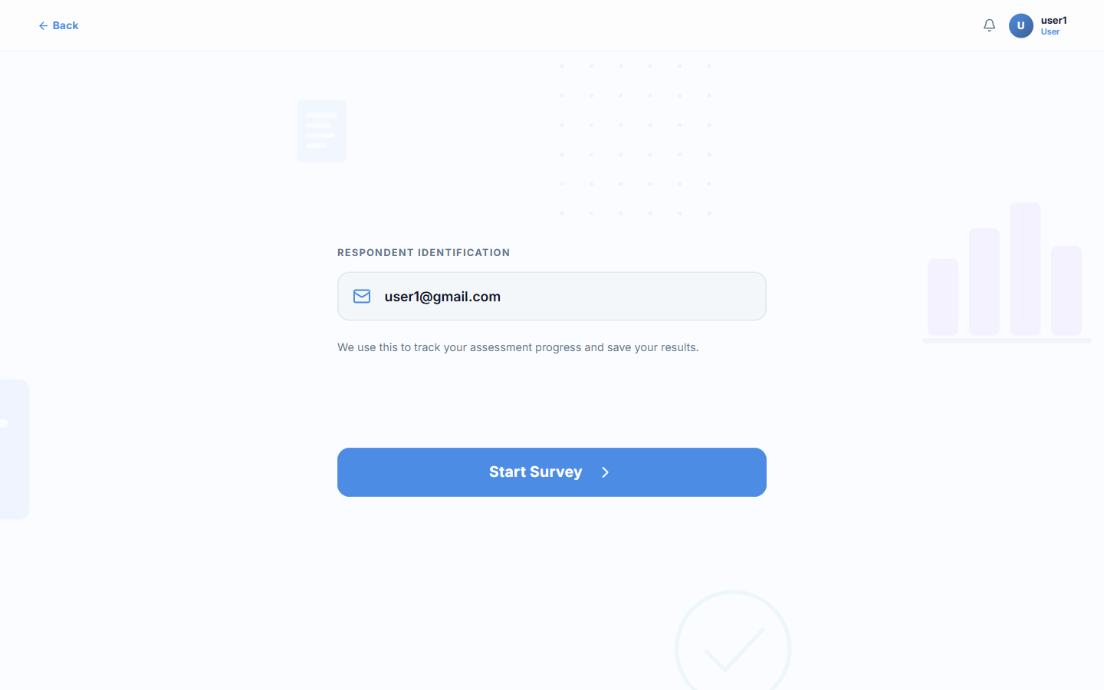
Figure 34: Survey start screen confirming the respondent before the survey begins
The survey is then presented one question at a time. A progress indicator shows how far the user has advanced, the navigation controls allow the user to move backward and forward through the questions, and required questions must be answered before the survey can continue. When every question has been answered the user submits the response for review.
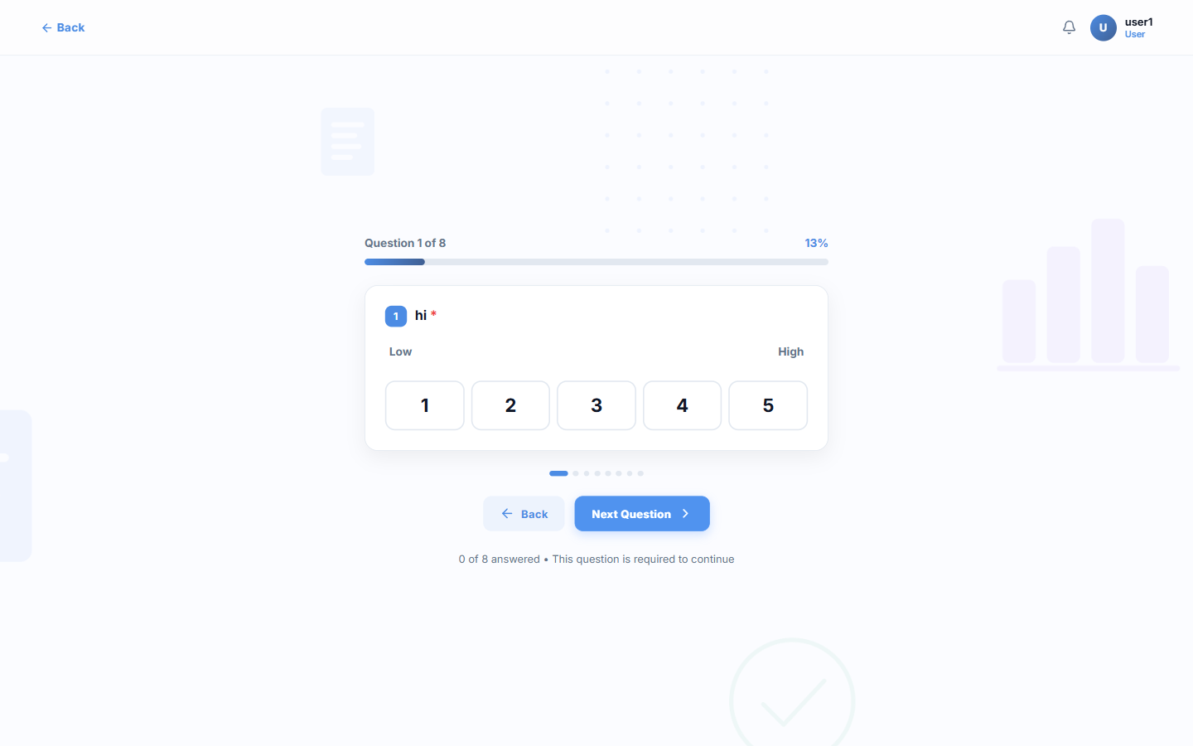
Figure 35: Survey question screen with progress indicator and navigation controls

Survey Management
The survey management module allows authorized users to create and maintain surveys according to organizational requirements. A survey can contain multiple sections, questions, answer types, scoring rules, validation rules, and routing conditions. Administrators can configure the survey before making it available to users. Surveys can be activated when they are ready for use and deactivated when they are no longer required. The system maintains the survey status so that administrators and managers can easily identify which surveys are currently active, inactive, pending, completed, or otherwise requiring attention.
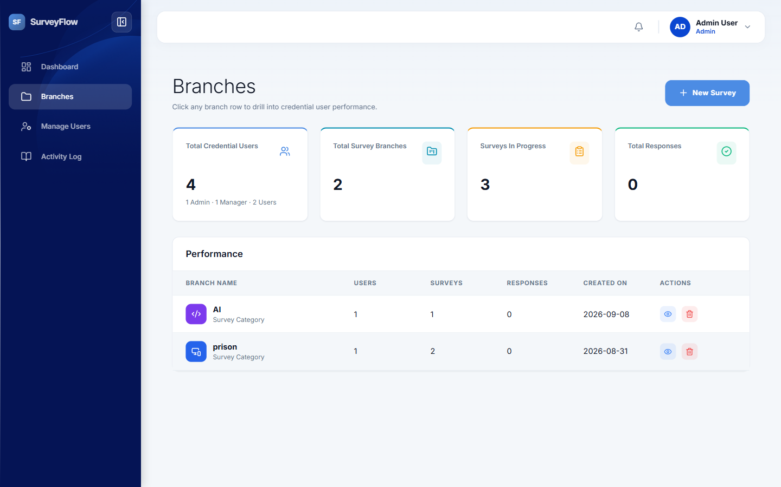
Figure 36: Branches screen grouping surveys by category, with totals for each branch
Surveys are built in the survey builder, where the Admin defines the sections and questions, chooses the answer type for each question, and configures scoring, validation, and the conditions that control how the survey moves from one question to the next. Once a survey is ready it is activated and assigned to the users who are required to complete it. The Administrator Guide earlier in this document describes each of these steps in full, together with the settings available on every question.

Survey Workflow
The survey workflow begins when an authorized Admin creates and activates a survey. The survey is then made available to the appropriate Manager, who can assign or send it to the required Users. The User receives a notification and completes the survey. After submission, the response is made available to the Manager for review. The Manager can approve the submission or reject it when corrections are required. If the response is rejected, the User receives a notification and can make the necessary changes before resubmitting it. Once the response is successfully approved, the final information can be used for scoring, reporting, and performance analysis. This workflow provides a controlled process from survey creation to final completion.

Workflow Stages
Stage | Description
1. Creation | Admin creates the survey and defines sections, questions, scoring, and validation rules.
2. Activation | Admin activates the survey so that it becomes available for distribution.
3. Assignment | Admin or Manager assigns the survey to the required users with a completion period.
4. Notification | The assigned user is notified that a survey requires their attention.
5. Completion | The user answers the questions and submits the response for review.
6. Review | The Manager examines the submission and approves or rejects it.
7. Resubmission | A rejected submission returns to the user, who corrects it and submits it again.
8. Reporting | Approved responses feed scoring, reporting, and performance analysis.

