**BRAND NAME CREATION**

BRAND NAME : SCHOOL OF BUSINESS ORGANIZATION

CATEGORY : DIGITAL MARKETING

TARGET AUDIENCE : ALL

E-MAIL : [schoolofbusinessorganization@gmail.com](mailto:schoolofbusinessorganization@gmail.com)

LOGO THEME : RELATED TO DIGITAL MARKETING – VIOLET



**DOCUMNENTATION**

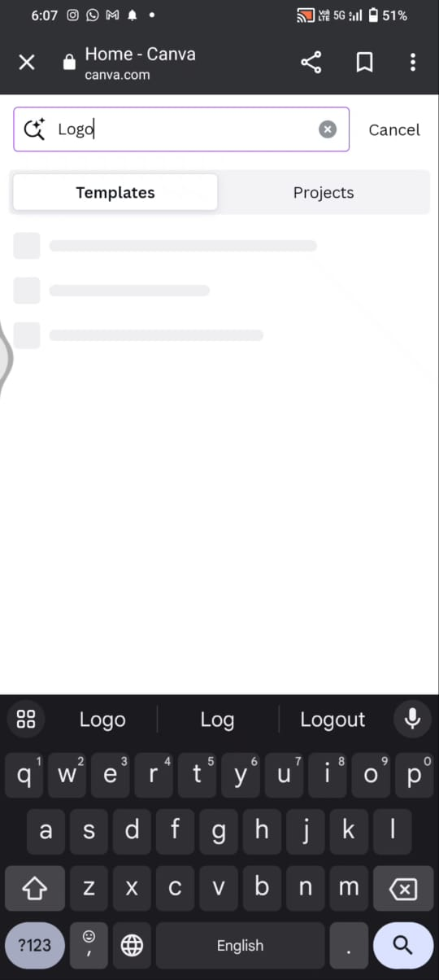

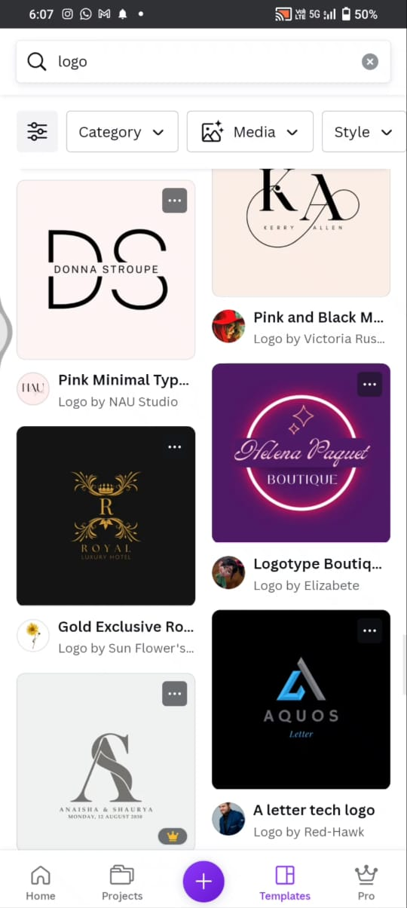

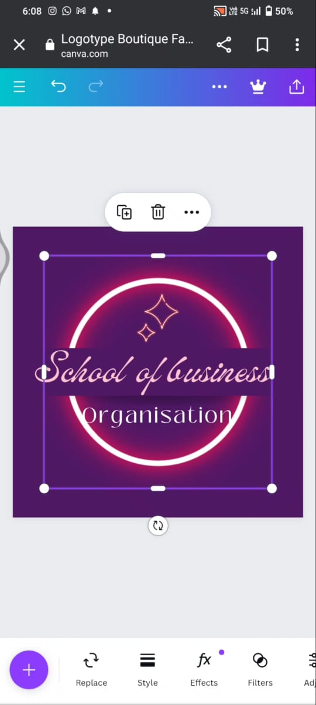

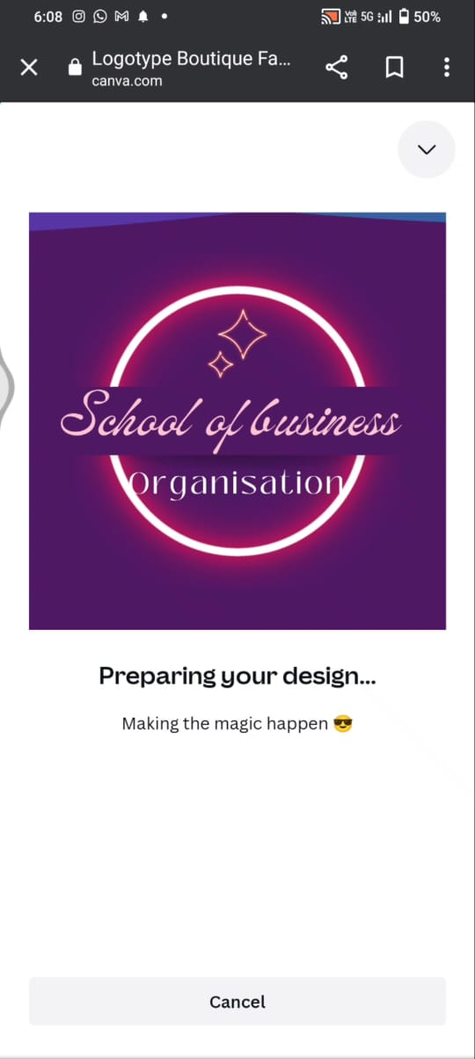

VIDEO LINK : <https://photos.app.goo.gl/67n3zHW1CgGVNYZP6>

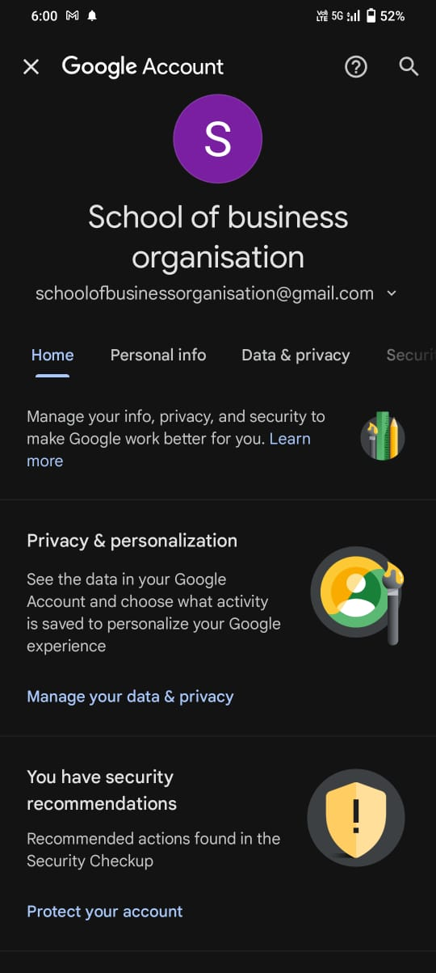**MAIL SCREENSHOT**