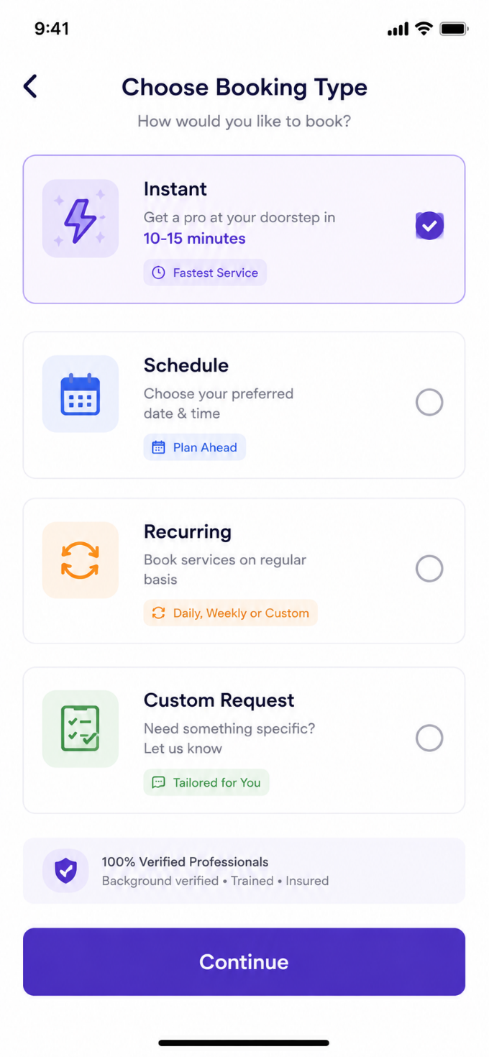
User Story: Choose Booking Type Screen
Epic: Service Booking Configuration
This screen allows customers to choose how they want the service to be delivered before selecting address, schedule, and payment.

Business Objective
Allow customers to:
- Book instantly
- Schedule for a future date/time
- Create recurring bookings
- Submit custom cleaning requirements
- Increase booking flexibility
- Improve customer retention through recurring subscriptions

Booking Types
1. Instant Booking
Get a professional assigned immediately.
Example:
- Maid
- Cleaner
- Cook
- Babysitter
Arrival Time:
10–15 Minutes

2. Schedule Booking
Book service for a future date and time.
Example:
- Tomorrow 10 AM
- Sunday 2 PM

3. Recurring Booking
Repeated service automatically.
Options:
- Daily
- Weekly
- Monthly
- Custom Days

4. Custom Request
Customer defines special requirements not covered in standard services.
Example:
- Deep cleaning after party
- Elder care assistance
- Move-in cleaning
- Custom maid requirements

User Story 1: Select Instant Booking
As a Customer
I want immediate service
So that a professional can arrive quickly.
Acceptance Criteria
✅ User can select Instant option
✅ Only one booking type can be selected at a time
✅ Instant card becomes highlighted
✅ Checkmark appears
✅ Continue button enabled
✅ System verifies provider availability nearby

User Story 2: Select Schedule Booking
As a Customer
I want to choose my preferred date and time
So that service is delivered when convenient.
Acceptance Criteria
✅ User selects Schedule option
✅ Date picker opens on next screen
✅ Time slot selection available
✅ Future date only allowed

User Story 3: Select Recurring Booking
As a Customer
I want regular services automatically
So that I don't need to book every time.
Acceptance Criteria
✅ User selects Recurring option
✅ Frequency options displayed
- Daily
- Weekly
- Monthly
- Custom
✅ Recurring plan saved

User Story 4: Select Custom Request
As a Customer
I want to describe special requirements
So that service can be customized.
Acceptance Criteria
✅ User selects Custom Request
✅ Notes field displayed
✅ Customer can enter requirement details
✅ Requirement saved with booking

User Story 5: Continue Booking
As a Customer
I want to proceed after choosing booking type
So that I can complete booking.
Acceptance Criteria
✅ Continue button enabled after selection
✅ User navigates to next step

Functional Requirements
Booking Type Selection
Booking Type | Multiple Selection
Instant | No
Schedule | No
Recurring | No
Custom Request | No
Only one booking type allowed.
Radio-button behavior.

Instant Booking Functionality
System Checks
Before Continue:
Check:
- Service availability
- Worker availability
- Service area coverage
If unavailable:
Show:
"No professionals available currently."

Schedule Booking Functionality
Required Inputs
Field | Mandatory
Date | Yes
Time Slot | Yes
Allowed:
Today + future dates
Not Allowed:
Past dates

Recurring Booking Functionality
Frequency Options
Daily
Every day
Weekly
Mon-Fri
Weekends
Specific days
Monthly
1st of month
15th of month
Custom date

Custom Request Functionality
Inputs
Field | Mandatory
Description | Yes
Photo Upload | Optional
Notes | Optional
Maximum description:
500 Characters

Test Cases
TC-01 Screen Load
Scenario
User opens booking type screen.
Expected Result
All 4 booking types displayed.
Continue button visible.

TC-02 Select Instant
Action
Tap Instant.
Expected Result
Instant selected.
Checkmark visible.
Others unselected.

TC-03 Select Schedule
Action
Tap Schedule.
Expected Result
Schedule selected.
Instant deselected.

TC-04 Select Recurring
Action
Tap Recurring.
Expected Result
Recurring selected.
Only one option active.

TC-05 Select Custom Request
Action
Tap Custom Request.
Expected Result
Custom Request selected.
Others deselected.

TC-06 Continue Without Selection
Action
Click Continue.
Expected Result
Error:
"Please select booking type."

TC-07 Instant Booking Available
Action
Select Instant and Continue.
Expected Result
Move to Address/Confirmation screen.

TC-08 Instant Booking Unavailable
Action
No providers available.
Expected Result
Display:
"No professionals available nearby."

TC-09 Schedule Booking
Action
Select Schedule.
Choose future date.
Continue.
Expected Result
Booking created successfully.

TC-10 Past Date Selection
Action
Select yesterday.
Expected Result
System blocks selection.

TC-11 Recurring Daily
Action
Select Daily recurring.
Expected Result
Recurring plan created.

TC-12 Recurring Weekly
Action
Select Monday, Wednesday, Friday.
Expected Result
Selected days saved.

TC-13 Custom Request Text
Action
Enter custom requirement.
Expected Result
Text saved.

TC-14 Character Limit Validation
Action
Enter >500 characters.
Expected Result
Validation error shown.

TC-15 Back Navigation
Action
Tap Back.
Expected Result
Return to previous screen.
Selections retained as per business rule.

Edge Cases
EC-01 Rapid Selection
User taps multiple options quickly.
Expected:
Only last selected option remains active.

EC-02 Worker Availability Changes
Worker becomes unavailable after selection.
Expected:
System recalculates availability before confirmation.

EC-03 Recurring Service Not Supported
Expected:
Display:
"Recurring service unavailable in your area."

EC-04 Custom Request With No Description
Expected:
Error:
"Please describe your requirement."

Security & Validation
Input Validation
- Prevent script injection
- Prevent HTML tags
- Sanitize custom request text
Booking Validation
- Verify service area
- Verify active customer account
- Verify worker availability

Analytics Events
Track:
- Booking Type Selected
- Instant Booking Chosen
- Scheduled Booking Chosen
- Recurring Booking Chosen
- Custom Request Chosen
- Continue Clicked
- Booking Type Abandoned

Navigation Flow
Login
↓
Select Services
↓
Choose Booking Type
↓
Address Selection
↓
Date & Time (if Schedule)
↓
Recurring Setup (if Recurring)
↓
Custom Requirement (if Custom)
↓
Booking Summary
↓
Payment
↓
Booking Confirmed
Additional Business Rules
Instant Booking
- Higher convenience fee may apply.
- ETA must be shown (10–15 mins).
Schedule Booking
- Time slots configurable by admin.
- Block fully booked slots.
Recurring Booking
- Subscription discounts can be applied.
- Auto-renewal option supported.
Custom Request
- Admin review may be required before assigning a worker.
- Customer may receive a revised quotation based on requirements.

