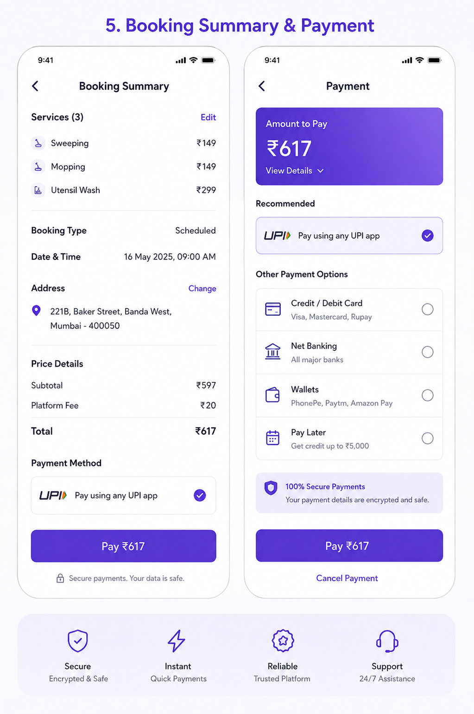User Story: Booking Summary & Payment
Epic: Booking Confirmation & Payment Processing
This screen allows customers to:
- Review booking details
- Verify services selected
- Confirm address
- Review pricing
- Choose payment method
- Complete payment
- Generate booking confirmation

Business Objective
Allow customers to:
✅ Verify booking before payment
✅ Reduce booking errors
✅ Support multiple payment methods
✅ Improve payment success rate
✅ Generate confirmed bookings
✅ Handle payment failures gracefully

Screen 1: Booking Summary
User Story 1: Review Selected Services
As a Customer
I want to review selected services
So that I can verify my booking before payment.
Acceptance Criteria
✅ All selected services displayed
✅ Individual service prices shown
✅ Total service count displayed
✅ Edit option available

Example
Sweeping ₹149
Mopping ₹149
Utensil Wash ₹299

User Story 2: Review Booking Details
As a Customer
I want to verify booking details
So that service is scheduled correctly.
Acceptance Criteria
Display:
- Booking Type
- Date
- Time
- Address

Example
Booking Type: Scheduled
Date: 16 May 2025
Time: 09:00 AM

User Story 3: Change Address
As a Customer
I want to modify my address
So that service is delivered to the correct location.
Acceptance Criteria
✅ Change button visible
✅ Address selection screen opens
✅ Updated address reflected

User Story 4: Review Price Breakdown
As a Customer
I want to understand the charges
So that pricing is transparent.
Acceptance Criteria
Display:
- Subtotal
- Platform Fee
- Taxes (if applicable)
- Discounts
- Total Amount

Example
Subtotal ₹597
Platform Fee ₹20

Total ₹617

User Story 5: Continue To Payment
As a Customer
I want to proceed to payment
So that my booking can be confirmed.
Acceptance Criteria
✅ Payment method selected
✅ Booking data saved
✅ Redirect to payment screen

Screen 2: Payment

User Story 6: Select Payment Method
As a Customer
I want to choose my preferred payment method
So that I can pay conveniently.
Acceptance Criteria
Customer can choose:
- UPI
- Credit Card
- Debit Card
- Net Banking
- Wallet
- Pay Later
- Cash on Service (if enabled)
Only one method selectable.

User Story 7: Pay Using UPI
As a Customer
I want to pay using UPI
So that payment is completed instantly.
Acceptance Criteria
✅ UPI apps displayed
✅ Deep link opens UPI app
✅ Payment status tracked

User Story 8: Pay Using Card
As a Customer
I want to pay using card
So that payment is processed securely.
Acceptance Criteria
Capture:
- Card Number
- Expiry Date
- CVV
- Name
PCI compliant processing required.

User Story 9: Pay Later
As a Customer
I want flexible payment options
So that I can pay after service.
Acceptance Criteria
Eligibility checked.
Credit limit verified.
Terms displayed.

User Story 10: Payment Success
As a Customer
I want confirmation after payment
So that I know booking is secured.
Acceptance Criteria
Booking ID generated.
Payment receipt generated.
Confirmation sent.

Functional Requirements
Booking Summary Module
Display
Field | Mandatory
Services | Yes
Service Count | Yes
Booking Type | Yes
Date | Yes
Time | Yes
Address | Yes
Total Amount | Yes

Price Calculation
Service Charges
+
Platform Fee
+
Taxes
-
Discounts
=
Grand Total

Payment Module
Supported Payment Modes:
UPI
- Google Pay
- PhonePe
- Paytm
- BHIM
Cards
- Visa
- Mastercard
- RuPay
- Amex
Net Banking
All major banks
Wallets
- PhonePe Wallet
- Paytm Wallet
- Amazon Pay
Pay Later
- Simpl
- LazyPay
- Amazon Pay Later

Test Cases

TC-01 Load Booking Summary
Expected Result
Booking details displayed correctly.

TC-02 Verify Services
Action
Review service list.
Expected Result
All selected services displayed.
Correct prices shown.

TC-03 Edit Services
Action
Click Edit.
Expected Result
Navigate to Service Selection screen.

TC-04 Change Address
Action
Click Change Address.
Expected Result
Address selection screen opens.

TC-05 Verify Total Calculation
Expected Result
Subtotal + Fees + Taxes - Discount
=
Total
Calculation accurate.

TC-06 Continue To Payment
Action
Click Pay ₹617.
Expected Result
Payment screen opens.

TC-07 Select UPI
Action
Choose UPI.
Expected Result
UPI selected.
Other methods deselected.

TC-08 Select Card
Action
Choose Card.
Expected Result
Card option selected.

TC-09 Select Wallet
Action
Choose Wallet.
Expected Result
Wallet selected.

TC-10 Select Pay Later
Action
Choose Pay Later.
Expected Result
Eligibility verified.

TC-11 Successful UPI Payment
Action
Complete UPI payment.
Expected Result
Payment Success screen displayed.
Booking confirmed.

TC-12 Failed UPI Payment
Action
Cancel payment.
Expected Result
Booking remains pending.
Retry option available.

TC-13 Payment Timeout
Action
User closes UPI app.
Expected Result
Payment status verification triggered.

TC-14 Duplicate Payment Prevention
Action
Double-click Pay button.
Expected Result
Single payment request processed.

TC-15 Network Failure
Action
Internet disconnected during payment.
Expected Result
Payment status reconciliation performed.

Edge Cases
EC-01 Price Changed Before Payment
Scenario:
Admin updates pricing.
Expected:
Latest pricing shown before payment.
Customer approval required.

EC-02 Slot Expired During Payment
Scenario:
Another customer books slot.
Expected:
Show:
Selected slot is no longer available.
Allow rescheduling.

EC-03 Service Removed
Scenario:
Service unavailable.
Expected:
Recalculate booking.
Notify customer.

EC-04 Payment Success But Callback Failed
Scenario:
Gateway success.
Webhook failed.
Expected:
Background reconciliation confirms booking.

EC-05 Partial Payment
Scenario:
Wallet balance insufficient.
Expected:
Allow alternate payment.

Payment Gateway Integration
Create Order
POST /payments/create-order

{
"bookingId":"BK1001",
"amount":617
}

Verify Payment
POST /payments/verify

{
"paymentId":"PAY123",
"orderId":"ORD123"
}

Payment Response
{
"status":"SUCCESS",
"bookingId":"BK1001",
"transactionId":"TXN987654"
}

Booking Status Flow
Draft Booking
↓
Payment Initiated
↓
Payment Success
↓
Booking Confirmed
↓
Worker Assigned
↓
Professional Arriving
↓
Service Started
↓
Service Completed

Admin Features Required
Pricing Management
- Platform fee configuration
- Tax configuration
- Discount configuration
- Coupon management
Payment Management
- Payment gateway setup
- Refund processing
- Failed payment monitoring
- Reconciliation reports
Booking Management
- Confirmed bookings
- Pending payments
- Abandoned bookings
- Cancelled bookings

Analytics Events
Track:
- Booking Summary Viewed
- Edit Services Clicked
- Address Changed
- Payment Method Selected
- Payment Started
- Payment Success
- Payment Failed
- Payment Cancelled
- Booking Confirmed
- Revenue Generated

Success Flow
Select Services
↓
Choose Booking Type
↓
Select Date & Time
↓
Address Selection
↓
Booking Summary
↓
Payment
↓
Payment Success
↓
Booking Confirmed
↓
Worker Assignment
↓
Track Professional
This is one of the most critical flows in the HomeHelp platform because it directly impacts conversion rate, payment success rate, revenue collection, refunds, and customer trust.

