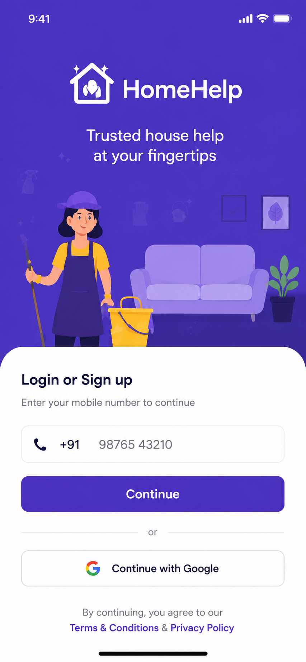

Below is the **full user story + functionality + test case criteria** for the **HomeHelp Login / Sign up screen**.

## 1. Screen Purpose

This screen allows customers to **login or create account** using:

**Mobile number + OTP**

**Google login**

It is the first entry point for the HomeHelp customer app.

---

# User Story

## Epic: Customer Authentication

### User Story 1: Login / Sign up with Mobile Number

**As a customer,**
I want to enter my mobile number and continue,
so that I can login or create a new account using OTP.

### Acceptance Criteria

The screen should display:

Login or Sign up title

Mobile number input

India country code `+91`

Phone icon

Continue button

Google login option

Terms & Conditions and Privacy Policy links

When user enters a valid mobile number and clicks **Continue**, system should send OTP.

If user is new, account should be created after OTP verification.

If user already exists, user should be logged in after OTP verification.

Invalid mobile number should show proper error.

---

## User Story 2: Continue with Google

**As a customer,**
I want to login using Google,
so that I can access the app faster without entering mobile number.

### Acceptance Criteria

Google button should be visible.

On click, Google authentication popup should open.

After successful Google login:

If user exists → go to Home screen

If new user → ask for mobile number or profile completion

If Google login fails → show error message.

---

## User Story 3: Terms and Privacy Agreement

**As a customer,**
I want to view Terms & Conditions and Privacy Policy,
so that I understand the platform rules before continuing.

### Acceptance Criteria

Terms & Conditions text should be clickable.

Privacy Policy text should be clickable.

Click should open respective page/webview.

User should not be blocked from viewing them.

---

# Functional Requirements

## Mobile Login

User can enter only 10-digit mobile number.

Country code default should be `+91`.

Only numeric input allowed.

Continue button should be disabled until valid number is entered.

System should send OTP to entered mobile number.

User should move to OTP verification screen.

## Google Login

Google login should support Android and iOS.

System should fetch user name, email, and profile image if available.

If mobile number is missing, app should ask mobile verification later.

## Validation Rules

| Field | Rule |
| -------------------- | ------------------------------ |
| Mobile Number | Required |
| Mobile Number Length | 10 digits |
| Country Code | Default +91 |
| Input Type | Numbers only |
| Continue Button | Active only after valid number |
| Terms Links | Must open correctly |

---

# Test Case Scenarios

## TC-01: Screen Load

**Scenario:** User opens app
**Expected Result:** Login screen should load with logo, title, mobile input, continue button, Google login, and terms text.

---

## TC-02: Empty Mobile Number

**Action:** Click Continue without mobile number
**Expected Result:** Show error: “Please enter mobile number.”

---

## TC-03: Invalid Mobile Number

**Action:** Enter less than 10 digits
**Expected Result:** Show error: “Enter valid 10-digit mobile number.”

---

## TC-04: Alphabet Input

**Action:** Try entering letters in mobile field
**Expected Result:** Letters should not be accepted.

---

## TC-05: Valid Mobile Number

**Action:** Enter valid 10-digit number and click Continue
**Expected Result:** OTP should be sent and user should move to OTP screen.

---

## TC-06: Existing User Login

**Action:** Existing user enters mobile and verifies OTP
**Expected Result:** User should land on Home screen.

---

## TC-07: New User Sign up

**Action:** New user enters mobile and verifies OTP
**Expected Result:** User should move to profile setup or home screen based on app flow.

---

## TC-08: OTP Send Failure

**Action:** Click Continue when SMS service fails
**Expected Result:** Show message: “Unable to send OTP. Please try again.”

---

## TC-09: Google Login Success

**Action:** Click Continue with Google and select account
**Expected Result:** User should login successfully.

---

## TC-10: Google Login Cancelled

**Action:** User cancels Google login
**Expected Result:** Stay on same login screen.

---

## TC-11: Terms Link

**Action:** Click Terms & Conditions
**Expected Result:** Terms page should open.

---

## TC-12: Privacy Policy Link

**Action:** Click Privacy Policy
**Expected Result:** Privacy Policy page should open.

---

# Edge Cases

Poor internet connection

OTP service down

Mobile number already blocked

Google email already linked with another mobile

User closes app during OTP process

Multiple OTP requests in short time

Wrong country code selected

---

# Security Criteria

OTP should expire after 5 minutes.

Maximum OTP attempts: 3 or 5.

Rate limit OTP resend.

Do not expose OTP in logs.

Secure Google token validation from backend.

Mobile number should be encrypted or masked in logs.

---

# Final Flow

**Open App → Enter Mobile Number → Continue → OTP Screen → Verify OTP → Home Screen**

OR

**Open App → Continue with Google → Authenticate → Home/Profile Setup**

