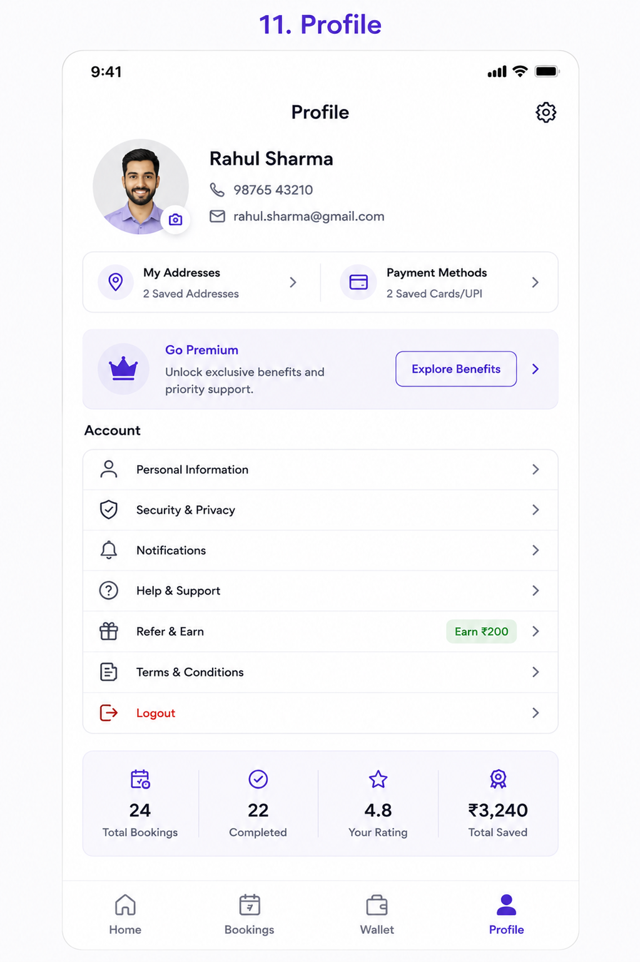
User Story: Profile Screen
Epic: Customer Account & Profile Management
This screen allows customers to:
- Manage personal profile information
- Manage saved addresses
- Manage payment methods
- Configure account settings
- Access support
- Refer friends
- View booking statistics
- Logout securely

Business Objective
Allow customers to:
✅ Maintain accurate profile information
✅ Manage addresses for faster booking
✅ Manage payment methods
✅ Increase customer retention through premium plans
✅ Improve referral-driven growth
✅ Provide self-service account management

User Story 1: View Profile Information
As a Customer
I want to view my profile details
So that I can verify my account information.
Acceptance Criteria
✅ Profile picture displayed
✅ Customer name displayed
✅ Mobile number displayed
✅ Email address displayed
✅ Edit profile option available

User Story 2: Update Profile Picture
As a Customer
I want to update my profile photo
So that my account reflects my identity.
Acceptance Criteria
✅ Camera icon visible
✅ Upload from gallery supported
✅ Take photo supported
✅ Updated image displayed immediately

User Story 3: Manage Saved Addresses
As a Customer
I want to manage multiple addresses
So that I can book services quickly.
Acceptance Criteria
✅ View saved addresses
✅ Add address
✅ Edit address
✅ Delete address
✅ Set default address

Address Fields
Field | Mandatory
Address Line 1 | Yes
Landmark | Optional
City | Yes
State | Yes
Pincode | Yes
Address Type | Yes

User Story 4: Manage Payment Methods
As a Customer
I want to save payment methods
So that checkout becomes faster.
Acceptance Criteria
✅ View saved cards
✅ Add card
✅ Remove card
✅ Save UPI ID
✅ Set default payment method

User Story 5: Explore Premium Membership
As a Customer
I want to see premium benefits
So that I can decide whether to subscribe.
Acceptance Criteria
✅ Premium banner displayed
✅ Benefits page opens
Premium Benefits Example
- Free cancellations
- Priority booking
- Dedicated support
- Cashback rewards
- Exclusive discounts

User Story 6: Manage Personal Information
As a Customer
I want to edit my personal details
So that my information remains current.
Acceptance Criteria
Customer can update:
- Name
- Email
- Gender
- Date of Birth
- Alternate Number

User Story 7: Manage Security & Privacy
As a Customer
I want to control my account security
So that my account remains safe.
Acceptance Criteria
Options available:
- Change mobile number
- Change email
- Manage devices
- Delete account
- Privacy preferences

User Story 8: Manage Notifications
As a Customer
I want to configure notifications
So that I receive only relevant updates.
Acceptance Criteria
Enable/Disable:
- Push Notifications
- SMS
- WhatsApp
- Email
- Promotions

User Story 9: Access Help & Support
As a Customer
I want quick access to support
So that I can resolve issues.
Acceptance Criteria
Support options:
- Chat Support
- Call Support
- Email Support
- FAQs
- Raise Ticket

User Story 10: Refer & Earn
As a Customer
I want to refer friends
So that I can earn rewards.
Acceptance Criteria
✅ Referral code displayed
✅ Share via WhatsApp
✅ Share via SMS
✅ Referral reward displayed

Example
Refer a Friend
Earn ₹200

User Story 11: View Account Statistics
As a Customer
I want to view my service activity
So that I can track usage.
Acceptance Criteria
Display:
Metric | Example
Total Bookings | 24
Completed Services | 22
Customer Rating | 4.8
Total Savings | ₹3,240

User Story 12: Logout
As a Customer
I want to logout securely
So that my account remains protected.
Acceptance Criteria
✅ Logout confirmation popup
✅ Session terminated
✅ Redirect to Login screen

Functional Requirements
Profile Dashboard
Display Information
Field | Required
Profile Picture | Yes
Name | Yes
Mobile Number | Yes
Email | Yes
Membership Status | Yes
Booking Stats | Yes

Profile Navigation Structure
Profile
├── Personal Information
├── My Addresses
├── Payment Methods
├── Security & Privacy
├── Notifications
├── Help & Support
├── Refer & Earn
├── Terms & Conditions
├── Premium Membership
└── Logout

Test Cases
TC-01 Load Profile Screen
Expected Result
Profile information displayed successfully.

TC-02 Edit Profile Photo
Action
Upload new photo.
Expected Result
Photo updated successfully.

TC-03 View Saved Addresses
Action
Open My Addresses.
Expected Result
All saved addresses displayed.

TC-04 Add New Address
Action
Add address.
Expected Result
Address saved successfully.

TC-05 Edit Address
Action
Modify existing address.
Expected Result
Updated address saved.

TC-06 Delete Address
Action
Delete address.
Expected Result
Address removed.

TC-07 View Payment Methods
Action
Open Payment Methods.
Expected Result
Saved cards/UPIs displayed.

TC-08 Add Payment Method
Action
Add new card.
Expected Result
Card saved successfully.

TC-09 Open Premium Benefits
Action
Click Explore Benefits.
Expected Result
Premium screen opens.

TC-10 Update Personal Information
Action
Change email address.
Expected Result
Email updated after verification.

TC-11 Notification Preferences
Action
Disable promotional notifications.
Expected Result
Preference saved.

TC-12 Open Help & Support
Action
Click Help & Support.
Expected Result
Support options displayed.

TC-13 Refer Friend
Action
Share referral code.
Expected Result
Referral link shared successfully.

TC-14 View Statistics
Expected Result
Booking metrics displayed correctly.

TC-15 Logout
Action
Click Logout.
Expected Result
Logout confirmation shown.

TC-16 Confirm Logout
Action
Confirm logout.
Expected Result
User redirected to Login screen.

Edge Cases
EC-01 Invalid Email
Action
Enter invalid email.
Expected Result
Validation error displayed.

EC-02 Duplicate Mobile Number
Action
Update mobile number already registered.
Expected Result
System rejects update.

EC-03 Delete Default Address
Action
Delete default address.
Expected Result
Prompt to select another default address.

EC-04 Expired Card
Action
Use expired payment card.
Expected Result
Card marked invalid.

EC-05 Referral Abuse
Action
Refer same user multiple times.
Expected Result
Duplicate referral blocked.

API Requirements
Get Profile
GET /profile

Response:
{
"name":"Rahul Sharma",
"mobile":"9876543210",
"email":"rahul.sharma@gmail.com"
}

Update Profile
PUT /profile

{
"name":"Rahul Sharma",
"email":"new@email.com"
}

Get Addresses
GET /profile/addresses

Get Payment Methods
GET /profile/payment-methods

Logout
POST /logout

Notifications
Profile Updated
Your profile has been updated successfully.
New Address Added
Address saved successfully.
Referral Reward Earned
Congratulations! ₹200 referral bonus added.
Password/Mobile Changed
Your account security settings were updated.

Analytics Events
Track:
- Profile Viewed
- Profile Updated
- Address Added
- Address Edited
- Address Deleted
- Payment Method Added
- Premium Viewed
- Referral Shared
- Support Opened
- Logout Clicked

Admin Features Required
Customer Profile Management
- View customer profiles
- View addresses
- View payment methods
- View referral history
- View membership status
Premium Management
- Membership plans
- Benefits configuration
- Subscription tracking
Referral Management
- Referral rewards
- Referral fraud detection
- Referral payout reports

Navigation Flow
Home
↓
Profile
├── Personal Information
├── Addresses
├── Payment Methods
├── Security & Privacy
├── Notifications
├── Help & Support
├── Refer & Earn
└── Logout
Additional Business Rules
Address Management
- Maximum 20 saved addresses
- One default address required
Payment Methods
- Maximum 10 saved cards
- One default payment method
Premium Membership
- Monthly/Yearly plans
- Auto-renew option
Security
- OTP verification for sensitive changes
- Device management
- Account deletion workflow
This Profile screen acts as the customer's central account hub and supports identity management, payments, referrals, support, security, loyalty programs, and long-term customer engagement.

