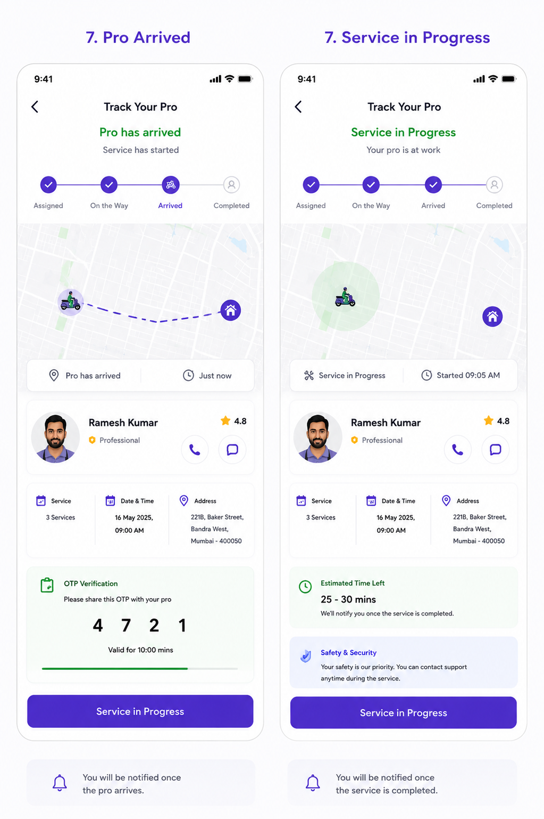
User Story: Pro Arrived & Service in Progress
Epic: Service Execution & Customer Verification
This stage covers:
- Professional Arrival
- OTP Verification
- Service Start
- Service Progress Tracking
- Service Monitoring
- Customer Safety & Transparency

Screen 1: Pro Arrived
Business Objective
Ensure:
✅ Right professional reaches the location
✅ Customer verifies professional
✅ Unauthorized service start prevented
✅ OTP-based secure service initiation

User Story 1: Professional Arrival Notification
As a Customer
I want to know when the professional arrives
So that I can prepare for service.
Acceptance Criteria
✅ Customer receives push notification
✅ App status changes to "Arrived"
✅ Timeline updated
✅ Arrival timestamp recorded

Status Flow
Assigned
↓
On The Way
↓
Arrived

User Story 2: OTP Verification
As a Customer
I want to verify the professional using OTP
So that only the assigned professional can start service.
Acceptance Criteria
✅ OTP generated automatically
✅ OTP displayed on customer screen
✅ OTP valid for configurable duration
✅ Professional enters OTP in worker app
✅ Service starts only after successful verification

OTP Rules
Rule | Value
OTP Length | 4 Digits
OTP Expiry | 10 Minutes
Max Attempts | 3
Regenerate OTP | Allowed
Reuse OTP | Not Allowed

User Story 3: View Professional Details
As a Customer
I want to see professional details
So that I know who arrived.
Acceptance Criteria
Display:
- Name
- Profile Picture
- Rating
- Professional Badge
- Call Option
- Chat Option

User Story 4: Start Service
As a Customer
I want service to start after OTP verification
So that work begins securely.
Acceptance Criteria
✅ OTP verified
✅ Service status changes
Arrived
↓
Service Started
✅ Start timestamp captured

Functional Requirements (Pro Arrived)
Arrival Detection
Professional arrival detected by:
Method 1
GPS Geofencing
Distance < 100 meters

Method 2
Worker manually clicks:
I've Arrived

OTP Verification Workflow
Worker Arrived
↓
System Generates OTP
↓
Customer Shares OTP
↓
Worker Enters OTP
↓
OTP Validation
↓
Service Started

Test Cases (Pro Arrived)
TC-01 Professional Arrives
Action
Worker reaches customer location.
Expected Result
Status changes to Arrived.

TC-02 Arrival Notification
Expected Result
Customer receives notification.

TC-03 OTP Generated
Expected Result
4-digit OTP displayed.

TC-04 Correct OTP
Action
Worker enters valid OTP.
Expected Result
Verification successful.

TC-05 Wrong OTP
Action
Worker enters invalid OTP.
Expected Result
Error displayed.

TC-06 OTP Expired
Action
Use OTP after expiry.
Expected Result
OTP rejected.

TC-07 Multiple Wrong Attempts
Action
Enter incorrect OTP 3 times.
Expected Result
OTP blocked.
New OTP required.

TC-08 Start Service
Action
OTP verified.
Expected Result
Service status changes to Started.

Screen 2: Service in Progress

Business Objective
Provide transparency while service is ongoing.
Allow customer to:
- Track service status
- Monitor expected completion
- Contact professional
- Raise support requests

User Story 5: View Service Progress
As a Customer
I want to know that work is in progress
So that I know service is actively being performed.
Acceptance Criteria
✅ Status shows:
Service in Progress
✅ Timeline updated

User Story 6: View Estimated Completion Time
As a Customer
I want to know when service is likely to finish
So that I can plan accordingly.
Acceptance Criteria
Display:
Estimated Time Left
25-30 Minutes
Updates dynamically.

User Story 7: Contact Professional During Service
As a Customer
I want to contact the professional
So that I can communicate additional requirements.
Acceptance Criteria
✅ Call button available
✅ Chat button available

User Story 8: Safety & Support
As a Customer
I want access to support during service
So that I can report issues if needed.
Acceptance Criteria
Support option available.
Emergency escalation available.

Functional Requirements (Service in Progress)
Status Workflow
Assigned
↓
On The Way
↓
Arrived
↓
Service Started
↓
Service In Progress
↓
Completed

Service Timer
System captures:
Field | Example
Started At | 09:05 AM
Estimated Duration | 2 Hours
Remaining Time | 55 Minutes
Completion ETA | 11:05 AM

Progress Tracking Logic
Service Started
↓
Track Duration
↓
Calculate ETA
↓
Update Customer

Test Cases (Service in Progress)
TC-09 Service Started
Expected Result
Status changes to Service In Progress.

TC-10 Timer Starts
Expected Result
Service start time recorded.

TC-11 ETA Calculation
Expected Result
Estimated completion displayed.

TC-12 ETA Updates
Action
Service duration changes.
Expected Result
ETA recalculated.

TC-13 Call Professional
Action
Tap Call button.
Expected Result
Phone dialer opens.

TC-14 Chat Professional
Action
Tap Chat button.
Expected Result
Chat opens.

TC-15 Refresh Screen
Action
Refresh app.
Expected Result
Current progress restored.

TC-16 Service Delayed
Action
Service exceeds estimated duration.
Expected Result
Updated ETA displayed.
Customer notified.

TC-17 Raise Support Ticket
Action
Customer reports issue.
Expected Result
Support ticket created.

Edge Cases
EC-01 Worker Arrives at Wrong Address
Expected:
Customer can report incorrect location.
Operations notified.

EC-02 OTP Shared with Wrong Worker
Expected:
OTP linked to assigned booking only.
Verification fails.

EC-03 Customer Not Available
Expected:
Worker marks:
Customer Not Available
Operations alerted.

EC-04 Service Interrupted
Example:
Power failure
Customer request
Professional emergency
Expected:
Pause status available.

EC-05 Worker Leaves Mid-Service
Expected:
Alert generated.
Operations team notified.

APIs Required
Generate OTP
POST /booking/generate-otp

{
"bookingId":"BK1001"
}

Verify OTP
POST /booking/verify-otp

{
"bookingId":"BK1001",
"otp":"4721"
}

Update Status
POST /booking/status

{
"bookingId":"BK1001",
"status":"IN_PROGRESS"
}

Get Service Progress
GET /booking/progress/BK1001

Response:
{
"status":"IN_PROGRESS",
"startedAt":"09:05 AM",
"estimatedCompletion":"09:35 AM"
}

Notifications
Professional Arrived
Your professional has arrived.
Please verify using OTP.
OTP Verified
Verification successful.
Service has started.
Service In Progress
Your service is currently in progress.
Estimated completion: 30 minutes.
Service Delayed
Service is taking longer than expected.
New ETA: 20 minutes.

Analytics Events
Track:
- Professional Arrived
- OTP Generated
- OTP Verified
- OTP Failed
- Service Started
- Service In Progress Viewed
- Call Professional
- Chat Professional
- Support Request Raised
- Service Delay Detected

Operations Dashboard Requirements
Real-Time Monitoring
- Arrived Jobs
- OTP Pending Jobs
- In Progress Jobs
- Delayed Jobs
- Escalated Jobs
SLA Monitoring
Stage | SLA
Assigned → Arrived | ≤ 15 mins
OTP Verification | ≤ 10 mins
Service Start | ≤ 5 mins after arrival
Service Completion | Based on service duration

End-to-End Flow
Booking Confirmed
↓
Professional Assigned
↓
On The Way
↓
Arrived
↓
OTP Verification
↓
Service Started
↓
Service In Progress
↓
Service Completed
↓
Rate & Review
This stage is critical because it validates the worker, secures service initiation, tracks active work, and creates the operational foundation for completion, invoicing, ratings, disputes, and customer satisfaction measurement.

