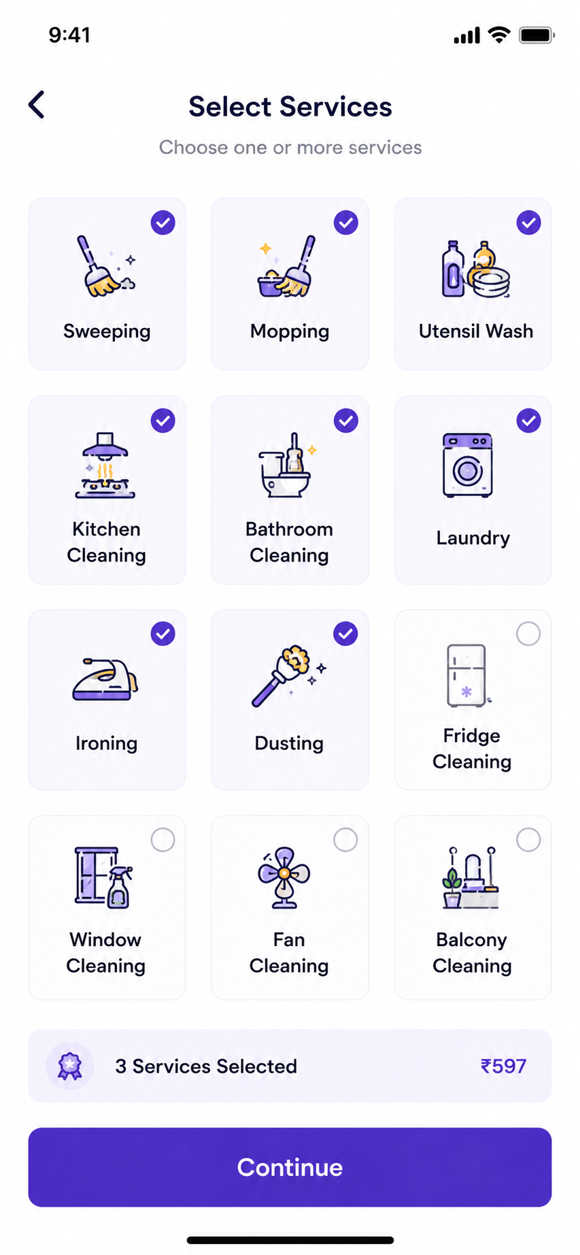

User Story: Select Services Screen
Epic: Service Selection & Booking
This screen allows customers to select one or more home services before proceeding to booking details.

Business Objective
Allow customers to:
- Choose required services
- View selected service count
- View dynamic pricing
- Proceed to booking
- Create customized cleaning packages

User Story 1: Select Service
As a Customer
I want to select one or more services
So that I can book exactly what I need.
Acceptance Criteria
✅ User can select multiple services
✅ Selected service card should highlight
✅ Checkmark icon should appear
✅ Total selected count should update
✅ Total amount should update automatically

User Story 2: Deselect Service
As a Customer
I want to remove selected services
So that I can modify my booking.
Acceptance Criteria
✅ Clicking selected service again removes selection
✅ Checkmark disappears
✅ Count updates
✅ Price recalculates

User Story 3: Dynamic Pricing
As a Customer
I want to see the updated booking price
So that I know how much I will pay.
Acceptance Criteria
✅ Total price updates instantly
✅ Price reflects selected services
✅ Price never shows negative value

User Story 4: View Selected Service Count
As a Customer
I want to see how many services are selected
So that I can verify my package.
Acceptance Criteria
✅ Selected count updates instantly
Example:
- 1 Service Selected
- 3 Services Selected
- 8 Services Selected

User Story 5: Continue Booking
As a Customer
I want to continue after selecting services
So that I can choose schedule and address.
Acceptance Criteria
✅ Continue button enabled when at least 1 service selected
✅ Continue button disabled when no service selected
✅ User navigates to next booking screen

Functional Requirements
Available Services
Basic Cleaning
- Sweeping
- Mopping
- Dusting
Kitchen Services
- Kitchen Cleaning
- Utensil Wash
Bathroom Services
- Bathroom Cleaning
Laundry Services
- Laundry
- Ironing
Deep Cleaning
- Fridge Cleaning
- Window Cleaning
- Fan Cleaning
- Balcony Cleaning

Service Selection Logic
Example
Service | Price
Sweeping | ₹99
Mopping | ₹99
Utensil Wash | ₹199
Selected:
Sweeping + Mopping + Utensil Wash
Expected Total:
₹397

Validation Rules
Validation | Expected Result
No Service Selected | Continue Disabled
Minimum Service | 1
Maximum Services | All Services
Duplicate Selection | Not Allowed
Price Calculation | Real-time
Selected Count | Real-time

Test Cases
TC-01 Screen Load
Scenario
Customer opens service selection screen.
Expected Result
All service cards displayed.
Continue button visible.
Price section visible.

TC-02 Select Single Service
Action
Select Sweeping.
Expected Result
Service selected.
Checkmark displayed.
Selected count = 1.
Price updated.

TC-03 Select Multiple Services
Action
Select:
- Sweeping
- Mopping
- Dusting
Expected Result
All selected.
Count = 3.
Total price updated.

TC-04 Deselect Service
Action
Remove Dusting.
Expected Result
Count decreases.
Price recalculates.

TC-05 Select All Services
Action
Select all services.
Expected Result
All cards selected.
Total amount calculated correctly.

TC-06 Continue Without Selection
Action
Click Continue without selecting service.
Expected Result
Error displayed.
Continue disabled.

TC-07 Continue With Selection
Action
Select 2 services.
Click Continue.
Expected Result
Navigate to Schedule screen.

TC-08 Dynamic Price Update
Action
Add and remove services repeatedly.
Expected Result
Price recalculates correctly every time.

TC-09 Network Failure During Pricing
Action
Price API unavailable.
Expected Result
Show:
"Unable to calculate price. Please try again."

TC-10 Refresh Screen
Action
Refresh page.
Expected Result
Selected services retained (if draft booking exists).
OR
Selection reset based on business rule.

Edge Cases
EC-01 Rapid Selection
User taps multiple cards rapidly.
Expected:
No duplicate services.

EC-02 All Services Removed
Expected:
Count = 0
Price = ₹0
Continue disabled

EC-03 Service Unavailable
Expected:
Service card disabled
"Currently Unavailable"
badge displayed

EC-04 Price Changed
Expected:
Updated pricing shown
User notified

API Validation
Get Services API
GET /services

Response:
[
{
"id": 1,
"name": "Sweeping",
"price": 99
},
{
"id": 2,
"name": "Mopping",
"price": 99
}
]

Calculate Price API
POST /calculate-price

{
"services":[1,2,3]
}

Response

{
"serviceCount":3,
"totalPrice":597
}

Analytics Events
Track:
- Service Selected
- Service Deselected
- Most Selected Service
- Continue Clicked
- Booking Abandoned
- Average Service Count Per Booking
- Average Order Value

Next Screen Navigation
Login
↓
Select Services
↓
Choose Property Type
↓
Choose Address
↓
Select Date & Time
↓
Booking Summary
↓
Payment
↓
Booking Confirmed
This screen is one of the highest revenue-impact screens because service combinations directly influence the average booking value (AOV), so pricing, selection state, and responsiveness should be thoroughly tested.

