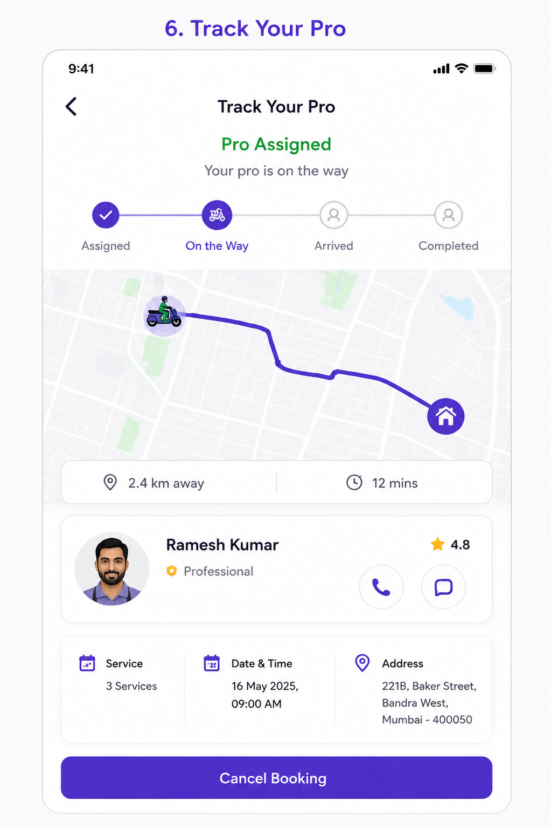User Story: Track Your Pro (Live Tracking Screen)
Epic: Service Execution & Real-Time Tracking
This screen allows customers to:
- Track assigned professional in real-time
- View booking status
- Monitor ETA and distance
- Contact the professional
- View booking details
- Cancel booking (before service starts)

Business Objective
Allow customers to:
✅ Know exactly where the professional is
✅ Reduce customer anxiety
✅ Improve service transparency
✅ Reduce support calls
✅ Enable direct communication
✅ Increase trust and booking completion rates

User Story 1: View Professional Assignment
As a Customer
I want to know when a professional is assigned
So that I know my booking is confirmed.
Acceptance Criteria
✅ Assigned professional displayed
✅ Name displayed
✅ Profile photo displayed
✅ Rating displayed
✅ Professional badge displayed
✅ Status changes from "Searching" to "Assigned"

User Story 2: Track Professional Location
As a Customer
I want to track the professional's live location
So that I know when they will arrive.
Acceptance Criteria
✅ Map displayed
✅ Professional location shown
✅ Customer location shown
✅ Route displayed
✅ Location updates every 10-30 seconds
✅ ETA displayed

User Story 3: View Booking Status
As a Customer
I want to know the current booking stage
So that I know what is happening.
Acceptance Criteria
Booking progress should show:
Assigned
↓
On The Way
↓
Arrived
↓
Service Started
↓
Completed
Only current stage highlighted.

User Story 4: Contact Professional
As a Customer
I want to call or message the professional
So that I can provide instructions if needed.
Acceptance Criteria
✅ Call button visible
✅ Chat button visible
✅ Clicking call opens dialer
✅ Clicking chat opens in-app chat

User Story 5: View ETA & Distance
As a Customer
I want to know how far the professional is
So that I can prepare for arrival.
Acceptance Criteria
Display:
- Distance (KM)
- ETA (Minutes)
Example:
2.4 KM Away
12 Minutes
Updates automatically.

User Story 6: View Booking Information
As a Customer
I want to review my booking details
So that I can verify the service.
Acceptance Criteria
Display:
- Number of services
- Date
- Time
- Address

User Story 7: Cancel Booking
As a Customer
I want to cancel before service starts
So that I can avoid unwanted bookings.
Acceptance Criteria
✅ Cancel button visible
✅ Confirmation popup shown
✅ Cancellation policy displayed
✅ Booking cancelled successfully

Functional Requirements
Booking Status Workflow
Status 1: Assigned
Booking Created
↓
Professional Assigned
Customer receives:
- Push Notification
- SMS
- WhatsApp Update

Status 2: On The Way
Professional clicks:
Start Journey
System:
- Starts live tracking
- Calculates ETA
- Shows route

Status 3: Arrived
Professional reaches location.
System:
Distance < 100 meters
Status automatically changes.
OR
Worker manually clicks "Arrived".

Status 4: Service Started
Worker enters OTP.
Customer verifies.
Status changes:
Arrived
↓
Service Started

Status 5: Completed
Worker completes service.
Customer receives:
- Completion notification
- Invoice
- Rating request

Professional Details Section
Display Fields
Field | Mandatory
Profile Photo | Yes
Name | Yes
Rating | Yes
Experience | Optional
Mobile Number | Masked
Status | Yes

Live Tracking Requirements
GPS Refresh
Event | Frequency
Driver Location | Every 10 sec
ETA Refresh | Every 15 sec
Distance Refresh | Every 15 sec

Map Features
Display:
- Worker marker
- Customer marker
- Route line
- ETA badge

Test Cases
TC-01 Screen Load
Action
Open tracking screen.
Expected Result
Map loads successfully.

TC-02 Assigned Professional
Action
Professional assigned.
Expected Result
Professional details displayed.

TC-03 Live Location Update
Action
Professional moves.
Expected Result
Marker updates on map.

TC-04 ETA Update
Action
Professional gets closer.
Expected Result
ETA decreases.

TC-05 Distance Update
Action
Professional moves.
Expected Result
Distance recalculated.

TC-06 Call Professional
Action
Tap Call button.
Expected Result
Phone dialer opens.

TC-07 Chat Professional
Action
Tap Chat button.
Expected Result
Chat window opens.

TC-08 Professional Arrived
Action
Professional reaches destination.
Expected Result
Status changes to "Arrived".

TC-09 Start Service
Action
OTP verified.
Expected Result
Status changes to "Service Started".

TC-10 Complete Service
Action
Worker completes service.
Expected Result
Status changes to "Completed".

TC-11 Cancel Booking
Action
Tap Cancel Booking.
Expected Result
Confirmation popup displayed.

TC-12 Confirm Cancellation
Action
Confirm cancellation.
Expected Result
Booking cancelled.
Refund process initiated if applicable.

TC-13 GPS Lost
Action
Worker internet disconnected.
Expected Result
Display:
Live location temporarily unavailable.
Last known location shown.

TC-14 App Refresh
Action
Refresh app.
Expected Result
Current tracking state restored.

TC-15 Multiple Tracking Sessions
Action
Customer logs in on multiple devices.
Expected Result
Tracking synchronized across devices.

Edge Cases
EC-01 Professional Rejects Job
Expected:
New professional assigned automatically.
Customer notified.

EC-02 Professional Delayed
Expected:
ETA recalculated.
Customer notified.

EC-03 Wrong Location
Expected:
Support escalation available.

EC-04 Worker Cancels
Expected:
Auto reassign another professional.

EC-05 Customer Not Reachable
Expected:
Professional can mark:
Customer Unreachable
Operations team notified.

API Requirements
Get Booking Status
GET /booking/{bookingId}/status

Response:
{
"status":"ON_THE_WAY",
"eta":"12 mins",
"distance":"2.4 km"
}

Get Live Location
GET /booking/{bookingId}/tracking

Response:
{
"lat":19.0760,
"lng":72.8777,
"eta":"12 mins"
}

Cancel Booking
POST /booking/cancel

{
"bookingId":"BK1001",
"reason":"No longer required"
}

Notifications
Professional Assigned
Your professional Ramesh Kumar has been assigned.
On The Way
Your professional is on the way.
ETA: 12 minutes.
Arrived
Your professional has arrived.
Service Started
Service has started successfully.
Service Completed
Service completed successfully.
Please rate your experience.

Analytics Events
Track:
- Tracking Screen Viewed
- Professional Assigned
- Call Professional Clicked
- Chat Professional Clicked
- Booking Cancelled
- ETA Viewed
- Service Started
- Service Completed
- Tracking Abandoned

Navigation Flow
Booking Confirmed
↓
Professional Assigned
↓
Track Your Pro
↓
Professional Arrived
↓
OTP Verification
↓
Service Started
↓
Service Completed
↓
Rate & Review
Admin & Operations Requirements
Operations Dashboard
- Live worker tracking
- Active jobs
- Delayed jobs
- Cancelled jobs
- Worker reassignment
- Emergency support
SLA Monitoring
Status | SLA
Assignment | < 2 mins
On The Way | ETA based
Arrival | Within committed time
Completion | Based on service duration
This screen is one of the most important operational screens because it directly impacts customer trust, service completion rates, support ticket reduction, and worker productivity.

