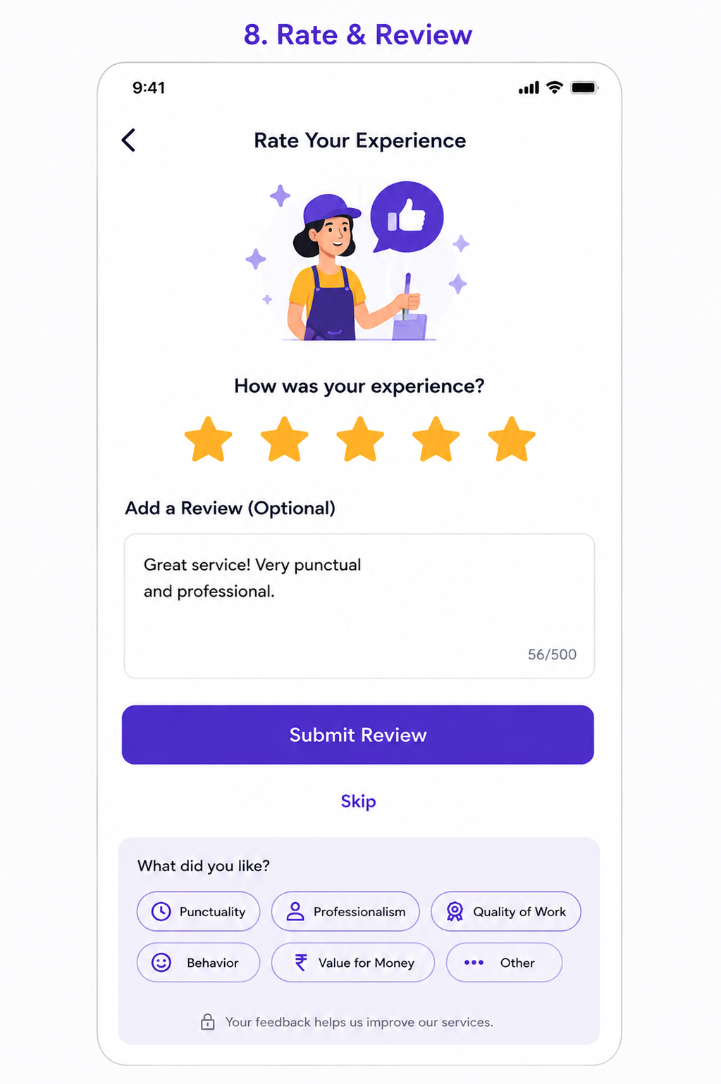
User Story: Rate & Review Screen
Epic: Customer Feedback & Quality Management
This screen allows customers to:
- Rate the completed service
- Submit written feedback
- Select predefined feedback tags
- Skip feedback submission
- Help improve service quality
- Influence professional ratings and rewards

Business Objective
Allow customers to:
✅ Share service experience
✅ Measure customer satisfaction
✅ Improve worker performance
✅ Identify service issues
✅ Reward top-performing professionals
✅ Increase trust through reviews

User Story 1: Rate Service Experience
As a Customer
I want to rate the completed service
So that I can share my overall satisfaction.
Acceptance Criteria
✅ Customer can select 1-5 stars
✅ Rating updates visually
✅ Only one rating value stored
✅ Rating mandatory for review submission

Rating Scale
Rating | Meaning
⭐ 1 | Very Poor
⭐ 2 | Poor
⭐ 3 | Average
⭐ 4 | Good
⭐ 5 | Excellent

User Story 2: Submit Written Review
As a Customer
I want to add comments
So that I can provide detailed feedback.
Acceptance Criteria
✅ Review field available
✅ Review optional
✅ Maximum 500 characters
✅ Character counter displayed
✅ Review saved with booking

Example
Great service! Very punctual and professional.

User Story 3: Select Feedback Tags
As a Customer
I want to quickly select feedback options
So that I don't need to type everything manually.
Acceptance Criteria
Customer can select multiple tags:
- Punctuality
- Professionalism
- Quality of Work
- Behavior
- Value for Money
- Other
Multiple tags allowed.

User Story 4: Skip Review
As a Customer
I want to skip feedback
So that I can complete the process later.
Acceptance Criteria
✅ Skip button available
✅ Booking remains completed
✅ User redirected to Home/Bookings

User Story 5: Submit Review
As a Customer
I want to submit my feedback
So that it contributes to service quality improvement.
Acceptance Criteria
✅ Rating captured
✅ Review saved
✅ Tags saved
✅ Thank You screen displayed

Functional Requirements
Rating Section
Inputs
Field | Required
Star Rating | Yes
Review Text | No
Feedback Tags | No

Review Text Rules
Rule | Value
Minimum Characters | 0
Maximum Characters | 500
Special Characters | Allowed
HTML Scripts | Blocked
Offensive Content | Filtered

Feedback Tags
Positive Tags
Punctuality
Professionalism
Quality of Work
Behavior
Value for Money

Negative Tags (Auto-show for Low Ratings)
If rating ≤ 3:
Late Arrival
Poor Quality
Unprofessional
Incomplete Work
Overpriced
Other

Review Workflow
Service Completed
↓
Show Rating Screen
↓
Customer Rates Service
↓
Optional Comments
↓
Submit Review
↓
Update Professional Rating
↓
Thank You Screen

Worker Rating Calculation
Example
Current Rating
4.7
New Review
5 Star
System recalculates:
New Average Rating

Test Cases
TC-01 Screen Load
Expected Result
Rating screen loads successfully.

TC-02 Select 1 Star
Action
Tap first star.
Expected Result
1-star rating selected.

TC-03 Select 5 Stars
Action
Tap fifth star.
Expected Result
All 5 stars highlighted.

TC-04 Change Rating
Action
Select 3 stars then 5 stars.
Expected Result
Latest rating retained.

TC-05 Submit Rating Only
Action
Select 5 stars.
Click Submit.
Expected Result
Review submitted successfully.

TC-06 Submit Rating + Review
Action
Select rating.
Enter review.
Submit.
Expected Result
Feedback stored.

TC-07 Character Counter
Action
Type review.
Expected Result
Counter updates.
Example:
56/500

TC-08 Review Length Limit
Action
Enter >500 characters.
Expected Result
Input blocked.
Validation shown.

TC-09 Select Feedback Tags
Action
Select:
- Professionalism
- Punctuality
Expected Result
Both tags selected.

TC-10 Deselect Tag
Action
Tap selected tag.
Expected Result
Tag removed.

TC-11 Submit Without Rating
Action
Click Submit.
Expected Result
Error:
Please provide a rating.

TC-12 Skip Review
Action
Tap Skip.
Expected Result
Navigate to Home screen.

TC-13 Refresh Screen
Action
Refresh app.
Expected Result
Draft review retained until submission.

TC-14 Network Failure
Action
Submit review without internet.
Expected Result
Retry option displayed.

TC-15 Duplicate Submission
Action
Double click Submit.
Expected Result
Single review stored.

Edge Cases
EC-01 Low Rating
Scenario
Customer gives:
1 Star
Expected:
Show escalation questions.
Example:
What went wrong?
- Late Arrival
- Poor Quality
- Unprofessional Behavior
- Other

EC-02 Offensive Content
Scenario
Customer enters abusive words.
Expected:
Content moderation applied.
Flag review.

EC-03 Empty Review
Scenario
Rating only.
Expected:
Submission allowed.

EC-04 Multiple Devices
Scenario
Review submitted from one device.
Expected:
Review unavailable for second submission.

EC-05 Service Dispute
Scenario
Customer gives 1-star review.
Expected:
Support ticket auto-created.
Operations team notified.

API Requirements
Submit Review
POST /reviews

{
"bookingId":"BK1001",
"workerId":"WR101",
"rating":5,
"review":"Great service. Very professional.",
"tags":[
"Professionalism",
"Punctuality"
]
}

Get Review
GET /reviews/BK1001

Response:
{
"rating":5,
"review":"Great service",
"tags":["Professionalism"]
}

Notification Flow
Review Submitted
Thank you for your feedback.

Worker Notification
You received a new 5-star rating.

Low Rating Alert
Customer reported service issues.
Please review immediately.

Analytics Events
Track:
- Rating Screen Viewed
- Rating Selected
- Review Submitted
- Review Skipped
- Tag Selected
- Low Rating Submitted
- High Rating Submitted
- Review Failed
- Review Retried

Admin Features Required
Review Management
- View all reviews
- Filter by rating
- Filter by worker
- Flagged reviews
- Hidden reviews
- Review moderation

Worker Performance Dashboard
Display:
Metric | Example
Average Rating | 4.8
Total Reviews | 350
5-Star Reviews | 280
Complaints | 5
Cancellation Rate | 2%

SLA & Escalation Rules
Rating | Action
⭐⭐⭐⭐⭐ | Reward worker
⭐⭐⭐⭐ | Normal
⭐⭐⭐ | Monitor
⭐⭐ | Supervisor review
⭐ | Immediate escalation

Navigation Flow
Service Completed
↓
Invoice Generated
↓
Rate & Review
↓
Feedback Submitted
↓
Thank You Screen
↓
Booking History
↓
Home Dashboard
Additional Business Rules
For 5-Star Ratings
- Ask customer to refer friends.
- Offer loyalty points.
For 1-2 Star Ratings
- Automatically create complaint ticket.
- Notify operations manager.
- Allow customer support callback request.
For Repeat Customers
- Track customer satisfaction trends.
- Calculate Net Promoter Score (NPS).
This screen is critical because it drives service quality monitoring, worker performance scoring, customer retention, referrals, dispute management, and overall marketplace trust.

