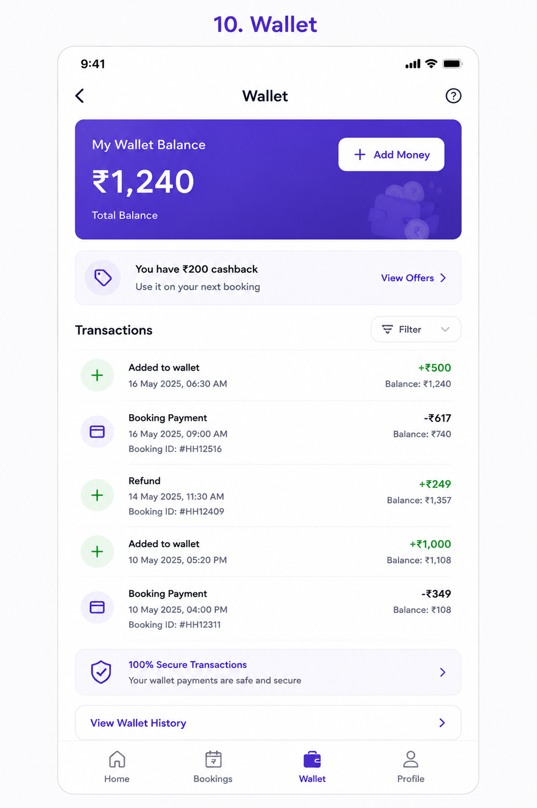
User Story: Wallet
Epic: Wallet Management & Digital Payments
This screen allows customers to:
- View wallet balance
- Add money to wallet
- Use wallet balance for bookings
- View cashback rewards
- Track wallet transactions
- View refunds
- Filter wallet history

Business Objective
Allow customers to:
✅ Make faster payments
✅ Increase repeat bookings
✅ Reduce payment failures
✅ Manage refunds efficiently
✅ Encourage wallet top-ups
✅ Improve customer retention through cashback

User Story 1: View Wallet Balance
As a Customer
I want to see my current wallet balance
So that I know how much money is available.
Acceptance Criteria
✅ Wallet balance displayed prominently
✅ Balance updated in real-time
✅ Currency displayed correctly
Example
Wallet Balance: ₹1,240

User Story 2: Add Money to Wallet
As a Customer
I want to add money to my wallet
So that I can use it for future bookings.
Acceptance Criteria
✅ Add Money button visible
✅ Customer can enter amount
✅ Payment methods available
- UPI
- Card
- Net Banking
- Wallet
✅ Balance updated after successful payment

User Story 3: View Cashback Offers
As a Customer
I want to see cashback offers
So that I can maximize savings.
Acceptance Criteria
✅ Cashback section visible
✅ Available cashback displayed
✅ View Offers screen accessible

Example
You have ₹200 Cashback
Use it on your next booking

User Story 4: View Transaction History
As a Customer
I want to see wallet transactions
So that I can track money movement.
Acceptance Criteria
Display:
- Transaction Type
- Date & Time
- Amount
- Balance After Transaction
- Reference Number

Transaction Types
Credit Transactions
Added to Wallet
Cashback
Refund
Referral Bonus
Promotional Credit
Debit Transactions
Booking Payment
Wallet Transfer
Penalty Deduction
Expired Cashback

User Story 5: Filter Transactions
As a Customer
I want to filter wallet transactions
So that I can find specific records.
Acceptance Criteria
Filter by:
- Credits
- Debits
- Refunds
- Cashback
- Date Range

User Story 6: View Refunds
As a Customer
I want to see refund transactions
So that I know refund status.
Acceptance Criteria
Display:
- Refund Amount
- Booking ID
- Refund Date
- Refund Status

User Story 7: Use Wallet for Booking
As a Customer
I want to pay using wallet balance
So that checkout is faster.
Acceptance Criteria
✅ Wallet appears during checkout
✅ Customer can select wallet
✅ Amount deducted correctly

User Story 8: View Wallet History
As a Customer
I want detailed wallet records
So that I can audit my transactions.
Acceptance Criteria
View Wallet History option available.
Detailed ledger accessible.

Functional Requirements
Wallet Summary Card
Display Fields
Field | Required
Current Balance | Yes
Cashback Balance | Yes
Add Money Button | Yes
Wallet Status | Yes

Wallet Transaction Record
Display Fields
Field | Required
Transaction Type | Yes
Date & Time | Yes
Amount | Yes
Balance After Transaction | Yes
Reference ID | Optional

Wallet Flow
Add Money
↓
Payment Gateway
↓
Wallet Credit
↓
Wallet Balance Updated
↓
Use For Booking
↓
Wallet Debit

Refund Flow
Booking Cancelled
↓
Refund Approved
↓
Wallet Credit
↓
Customer Notification

Test Cases
TC-01 Wallet Screen Load
Expected Result
Wallet balance displayed correctly.

TC-02 View Balance
Expected Result
Current balance matches backend balance.

TC-03 Add Money Button
Action
Click Add Money.
Expected Result
Add Money screen opens.

TC-04 Successful Wallet Top-Up
Action
Add ₹500.
Expected Result
Balance increases by ₹500.
Transaction created.

TC-05 Failed Wallet Top-Up
Action
Payment fails.
Expected Result
Balance unchanged.
Error message displayed.

TC-06 Cashback Display
Expected Result
Cashback amount displayed correctly.

TC-07 View Offers
Action
Click View Offers.
Expected Result
Offer screen opens.

TC-08 Transaction History
Expected Result
All wallet transactions displayed.

TC-09 Credit Transaction
Action
Refund credited.
Expected Result
Positive amount displayed.
Example:
+₹249

TC-10 Debit Transaction
Action
Booking payment deducted.
Expected Result
Negative amount displayed.
Example:
-₹617

TC-11 Filter Credits
Action
Select Credits filter.
Expected Result
Only credit transactions displayed.

TC-12 Filter Refunds
Action
Select Refund filter.
Expected Result
Only refund transactions displayed.

TC-13 Wallet Payment During Booking
Action
Pay using wallet.
Expected Result
Booking completed.
Balance deducted.

TC-14 Insufficient Wallet Balance
Action
Wallet balance ₹100.
Booking amount ₹500.
Expected Result
Prompt customer for additional payment method.

TC-15 Refresh Wallet
Action
Pull to refresh.
Expected Result
Latest balance loaded.

Edge Cases
EC-01 Duplicate Payment Callback
Scenario
Gateway sends duplicate success response.
Expected Result
Wallet credited only once.

EC-02 Negative Balance
Scenario
System error attempts negative balance.
Expected Result
Transaction blocked.

EC-03 Refund After Booking Cancellation
Scenario
Cancelled booking eligible for refund.
Expected Result
Refund automatically credited.

EC-04 Cashback Expiry
Scenario
Cashback validity expired.
Expected Result
Expired cashback removed.
Customer notified.

EC-05 Concurrent Transactions
Scenario
Two wallet operations occur simultaneously.
Expected Result
Atomic transaction handling.
Correct balance maintained.

APIs Required
Get Wallet Balance
GET /wallet/balance

Response:
{
"balance":1240,
"cashback":200
}

Add Money
POST /wallet/add-money

{
"amount":500
}

Wallet Transactions
GET /wallet/transactions

Response:
[
{
"type":"CREDIT",
"amount":500
},
{
"type":"DEBIT",
"amount":617
}
]

Refund Credit
POST /wallet/refund

{
"bookingId":"BK1001",
"amount":249
}

Notifications
Money Added
₹500 has been added to your wallet successfully.
Refund Credited
₹249 refund has been credited to your wallet.
Cashback Earned
Congratulations! ₹200 cashback added.
Low Wallet Balance
Your wallet balance is running low.
Add money for faster checkout.

Analytics Events
Track:
- Wallet Viewed
- Add Money Clicked
- Wallet Top-Up Success
- Wallet Top-Up Failed
- Cashback Viewed
- Offer Viewed
- Wallet Payment Used
- Refund Credited
- Transaction Filter Applied

Admin Features Required
Wallet Management
- View customer wallet balance
- Credit wallet manually
- Debit wallet manually
- View wallet ledger
- Freeze wallet
- Unfreeze wallet
Cashback Management
- Create cashback campaigns
- Cashback expiry rules
- Referral rewards
- Promotional credits
Refund Management
- Refund approval
- Refund tracking
- Refund audit logs

Navigation Flow
Profile
↓
Wallet
↓
Add Money
↓
Payment Gateway
↓
Wallet Updated
↓
Use Wallet During Booking
Additional Business Rules
Wallet Limits
Rule | Example
Minimum Top-Up | ₹100
Maximum Top-Up | ₹50,000
Maximum Wallet Balance | ₹1,00,000
Cashback Expiry | 90 Days
Security
- OTP verification for sensitive actions (optional)
- Transaction encryption
- Fraud detection checks
- Duplicate transaction prevention
Loyalty Features
- Cashback on bookings
- Referral rewards
- Promotional credits
- Subscription wallet benefits
This Wallet module acts as the financial hub of the customer app and supports bookings, refunds, cashback, loyalty rewards, and faster checkout experiences.

