Git Commands – Complete Explanation with Real-Time Examples

What is Git?
Git is a distributed version control system used to:
- Track code changes
- Collaborate with teams
- Maintain project history
- Manage branches and releases
Popular platforms using Git:
- GitHub
- GitLab
- Bitbucket

1. Install Git

Check Git Version
git --version
Example:
git version 2.45.0

2. Configure Git

Set Username
git config --global user.name "Babu"

Set Email
git config --global user.email "babu@gmail.com"

Check Configuration
git config --list

3. Create Repository

Initialize Git Repository
git init
Example:
mkdir employee-app
cd employee-app
git init
Output:
Initialized empty Git repository

4. Check Status

View File Status
git status
Shows:
- Untracked files
- Modified files
- Staged files
Example:
git status
Output:
modified: EmployeeService.java

5. Add Files

Add Single File
git add EmployeeService.java

Add All Files
git add .

Add Multiple Files
git add file1.java file2.java

6. Commit Changes

Commit with Message
git commit -m "Added employee service"
Real-Time Example:
git commit -m "Implemented JWT authentication"

7. View Commit History

Show Logs
git log

One Line Log
git log --oneline
Example:
a1234 Added login API
b2345 Fixed JWT issue

8. Clone Repository

Copy Remote Repository
git clone https://github.com/company/project.git
Example:
git clone https://github.com/babu/employee-management.git

9. Remote Repository Commands

Add Remote
git remote add origin https://github.com/babu/project.git

Check Remote
git remote -v

Remove Remote
git remote remove origin

10. Push Code

Push to GitHub
git push origin main

Push First Time
git push -u origin main
Real-Time:
git push origin feature/jwt-security

11. Pull Latest Changes

Pull Changes
git pull origin main
Used when team members changed code.

12. Fetch Changes

Fetch Without Merge
git fetch
Difference:
Command | Action
git fetch | Downloads changes only
git pull | Downloads + merges

13. Branch Commands

Create Branch
git branch feature-login

View Branches
git branch

Switch Branch
git checkout feature-login
OR
git switch feature-login

Create + Switch
git checkout -b feature-payment

14. Merge Branch

Merge Feature Branch
git merge feature-login
Real-Time Flow:
git checkout main
git merge feature-login

15. Delete Branch

Delete Local Branch
git branch -d feature-login

Force Delete
git branch -D feature-login

16. Git Diff

Show Changes
git diff

Compare Commits
git diff commit1 commit2

17. Undo Changes

Undo Modified File
git checkout -- Employee.java
OR
git restore Employee.java

18. Remove File

Remove from Git
git rm Employee.java

Remove Cached File
git rm --cached application.properties
Used for:
- Removing secrets
- Ignoring config files

19. Git Ignore

Create .gitignore
Example:
target/
*.class
application.properties
node_modules/
Used to ignore:
- Build files
- Logs
- Secret configs

20. Stash Commands

Save Temporary Changes
git stash

View Stashes
git stash list

Apply Stash
git stash apply

Remove Stash
git stash drop
Real-Time:
Developer pauses feature work and fixes production bug.

21. Reset Commands

Soft Reset
git reset --soft HEAD~1
Keeps files staged.

Mixed Reset
git reset HEAD~1
Keeps code but unstaged.

Hard Reset
git reset --hard HEAD~1
Deletes changes completely.
⚠ Use carefully.

22. Revert Commit

Undo Commit Safely
git revert commitId
Used in production projects.

23. Cherry Pick

Copy Commit from Another Branch
git cherry-pick commitId
Real-Time:
Move bug fix from testing branch to production branch.

24. Tag Commands

Create Tag
git tag v1.0

Push Tag
git push origin v1.0
Used for releases.

25. Git Rebase

Rebase Branch
git rebase main
Used to maintain clean history.

26. View Changes by Author
git blame EmployeeService.java
Shows:
- Who changed code
- Which line changed

27. Show Specific Commit
git show commitId

28. Rename Branch
git branch -m oldName newName

29. Clean Untracked Files
git clean -f
Deletes temporary files.

30. Git Workflow – Real-Time Example

Spring Boot Team Workflow

Step 1: Clone Project
git clone https://github.com/company/ems.git

Step 2: Create Branch
git checkout -b feature/jwt-auth

Step 3: Develop Code
git add .
git commit -m "Implemented JWT authentication"

Step 4: Push Code
git push origin feature/jwt-auth

Step 5: Create Pull Request
In:
- GitHub Pull Requests

Step 6: Merge to Main
git checkout main
git pull origin main
git merge feature/jwt-auth

31. Git Conflict Example

Conflict Scenario
Two developers edit same file.

Resolve Steps
git pull
Conflict appears:
<<<<<<< HEAD
Your Code
=======
Other Developer Code
>>>>>>> branch
Fix manually:
git add .
git commit -m "Resolved merge conflict"

32. GitHub Authentication Using Token

Push with Token
git remote set-url origin https://TOKEN@github.com/user/repo.git
Better approach:
Use:
- Personal Access Token
- SSH Keys
GitHub:
GitHub Tokens Documentation

33. SSH Setup

Generate SSH Key
ssh-keygen -t rsa -b 4096

Add SSH Key to GitHub
cat ~/.ssh/id_rsa.pub
GitHub SSH:
GitHub SSH Setup

34. Git Commands Cheat Sheet
Command | Purpose
git init | Initialize repository
git clone | Copy repository
git status | Check status
git add | Stage files
git commit | Save changes
git push | Upload changes
git pull | Download changes
git branch | Manage branches
git checkout | Switch branch
git merge | Merge branches
git stash | Temporary save
git reset | Undo commits
git revert | Reverse commit
git log | View history
git diff | Compare changes

35. Real-Time Industry Usage

Banking Project
Branches:
main
develop
uat
feature/payment-api
bugfix/jwt-issue
release/v1.0
Flow:
Developer → Feature Branch
Testing → UAT Branch
Production → Main Branch

36. Important Best Practices

Good Commit Messages
✅ Good:
git commit -m "Added employee search API"
❌ Bad:
git commit -m "changes"

Pull Before Push
git pull origin main
git push origin main

Never Commit
- Passwords
- API keys
- Secret configs
Use .gitignore

37. Advanced Commands

Interactive Rebase
git rebase -i HEAD~3

Squash Commits
Combine multiple commits.

Amend Last Commit
git commit --amend -m "Updated message"

38. Git Flow Architecture
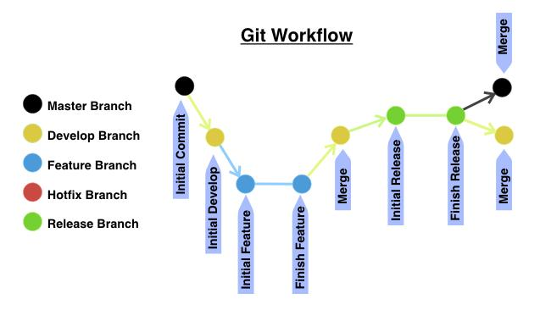
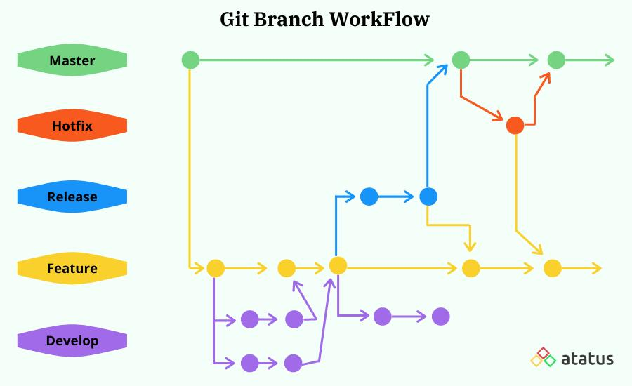
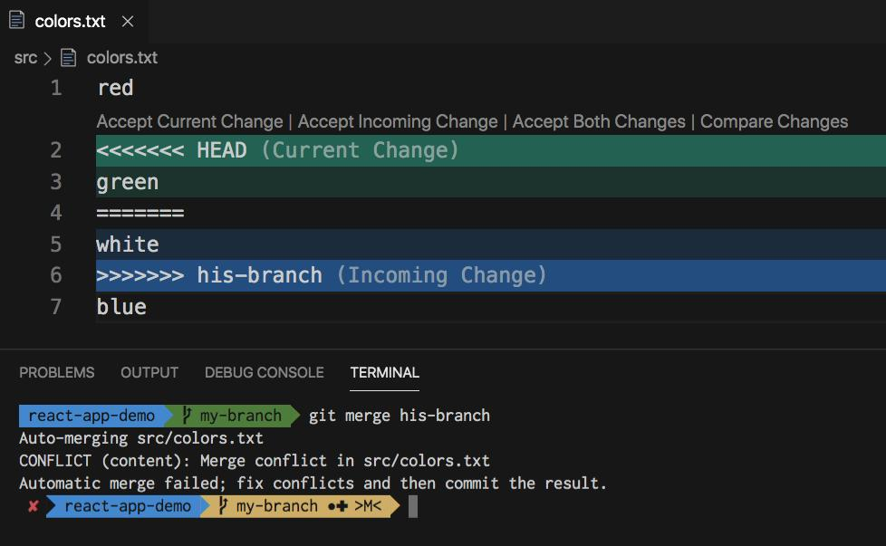
7

39. Learn More
- Official Git Documentation
- GitHub Docs
- Atlassian Git Tutorials
more

Advanced Git Commands and Real-Time Examples

1. Git Reflog

What is Reflog?
Tracks all Git movements:
- commits
- resets
- checkouts
- rebases
Useful for recovering deleted commits.

View Reflog
git reflog
Example:
a1b2c3 HEAD@{0}: reset: moving to HEAD~1
d4e5f6 HEAD@{1}: commit: Added JWT security

Recover Deleted Commit
git checkout d4e5f6
OR
git reset --hard d4e5f6

2. Git Alias

Create Shortcuts

Alias for Status
git config --global alias.st status
Use:
git st

Alias for Commit
git config --global alias.cm "commit -m"
Use:
git cm "Added login API"

3. Git Hooks

What are Hooks?
Scripts executed automatically before/after Git events.
Examples:
- pre-commit
- post-commit
- pre-push

Pre-Commit Hook Example
Path:
.git/hooks/pre-commit
Example:
#!/bin/sh
echo "Running tests..."
mvn test
if [ $? -ne 0 ]; then
echo "Tests failed"
exit 1
fi
Use Case:
Prevent buggy code from committing.

4. Git Squash

Combine Multiple Commits
Before:
Added login API
Fixed login issue
Updated login validation
After squash:
Implemented login module

Squash Using Rebase
git rebase -i HEAD~3
Change:
pick a1b2 Added login API
pick b2c3 Fixed issue
pick c3d4 Validation
To:
pick a1b2 Added login API
squash b2c3 Fixed issue
squash c3d4 Validation

5. Git Bisect

Find Bug Automatically
Suppose:
- Yesterday code worked
- Today application fails
Git can locate bad commit.

Start Bisect
git bisect start

Mark Current Commit Bad
git bisect bad

Mark Older Commit Good
git bisect good a1b2c3
Git automatically checks commits.

6. Git Archive

Create ZIP from Repository
git archive --format zip --output project.zip main
Useful for deployments.

7. Git Submodule

What is Submodule?
Repository inside another repository.
Example:
Main Project
|
--> Common Library Repo

Add Submodule
git submodule add https://github.com/company/common-lib.git

Clone with Submodules
git clone --recurse-submodules repo-url

8. Git Worktree

Multiple Branches Simultaneously
Example:
Folder1 → main branch
Folder2 → feature branch

Create Worktree
git worktree add ../feature-login feature-login

9. Git Sparse Checkout

Download Partial Repository
Useful for huge monorepo projects.

Enable Sparse Checkout
git sparse-checkout init

Select Folder
git sparse-checkout set backend-service

10. Git Tagging – Real-Time Releases

Lightweight Tag
git tag v1.0

Annotated Tag
git tag -a v1.0 -m "Production Release"

View Tags
git tag

Push Tags
git push origin --tags

11. Git Cherry-Pick Real-Time Example

Scenario
Bug fixed in:
feature-payment
Need same fix in:
production

Steps
git checkout production
git cherry-pick commitId

12. Git Interactive Staging

Stage Partial Changes
git add -p
Useful when one file contains:
- bug fix
- new feature
Commit separately.

13. Git Detached HEAD

Checkout Specific Commit
git checkout commitId
Now:
Detached HEAD state
Meaning:
You are not on any branch.

Create Branch from Detached HEAD
git checkout -b recovery-branch

14. Git Restore

Restore File
git restore Employee.java

Restore Staged File
git restore --staged Employee.java

15. Git Clean

Remove Untracked Files
git clean -f

Remove Directories
git clean -fd

Preview Before Delete
git clean -n

16. Git Show

Show Commit Details
git show commitId
Displays:
- author
- date
- changes

17. Git Describe

Show Latest Tag
git describe
Example:
v1.0-3-gd4e5f6
Meaning:
- 3 commits after v1.0

18. Git Blame

Track Line Changes
git blame EmployeeService.java
Shows:
- who changed line
- when changed
Useful in debugging.

19. Git Grep

Search Inside Repository
git grep "JWT"
Example Output:
SecurityConfig.java: JWT validation logic

20. Git Shortlog

Contributors Summary
git shortlog -sn
Example:
120 Babu
95 Kumar
60 John

21. Git Verify Branch Differences

Compare Branches
git diff main feature-login

22. Git Merge Strategies

Fast Forward Merge
git merge feature-login

No Fast Forward
git merge --no-ff feature-login
Creates merge commit.

23. Git Rebase vs Merge
Merge | Rebase
Maintains history | Cleaner history
Extra merge commits | Linear history
Safer | Powerful but risky

24. Git Workflow Types

Centralized Workflow
Single branch.

Feature Branch Workflow
Every feature in separate branch.

Git Flow Workflow
Production-grade workflow.
Branches:
main
develop
feature/*
release/*
hotfix/*

25. GitHub Pull Request Workflow
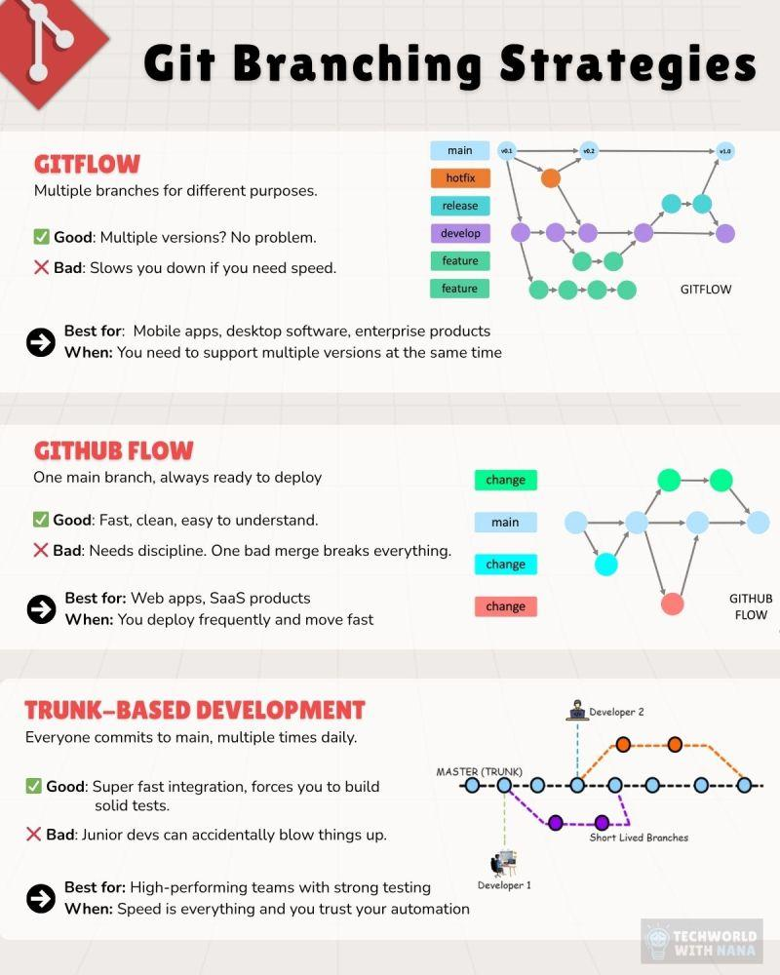
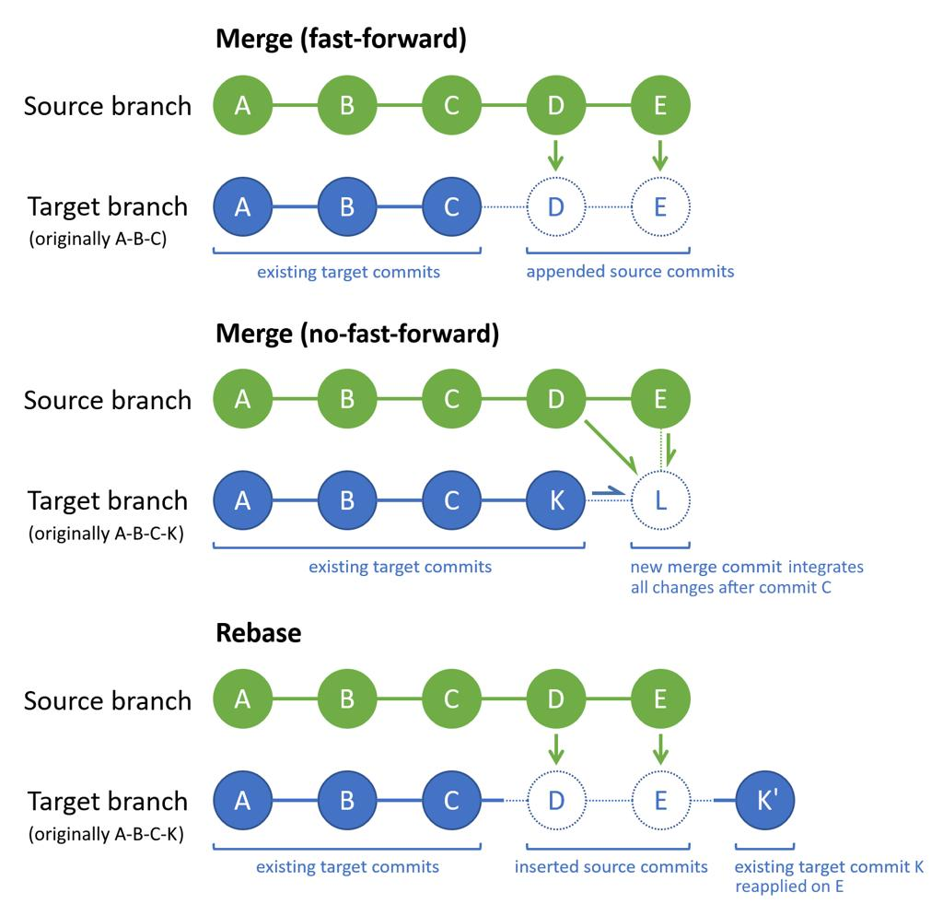
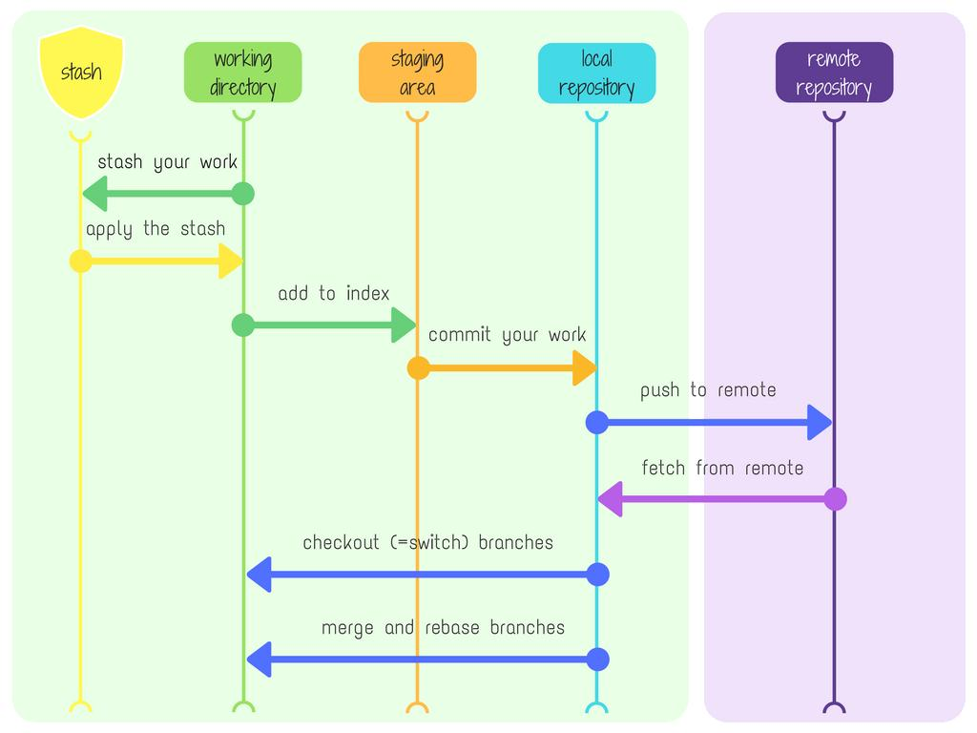
7

26. Enterprise Real-Time Git Example

Banking Application

Developer Flow
git clone repo-url
git checkout develop
git checkout -b feature/account-api
git add .
git commit -m "Implemented account creation API"
git push origin feature/account-api

Team Lead Review
Using:
- GitHub Code Review

QA Testing
Merged into:
uat branch

Production Release
git checkout main
git merge release/v2.0
git tag v2.0

27. GitLab CI/CD Example

.gitlab-ci.yml
stages:
- build
- test
build-job:
stage: build
script:
- mvn clean install
test-job:
stage: test
script:
- mvn test
GitLab:
GitLab CI/CD Docs

28. GitHub Actions Example

.github/workflows/build.yml
name: Java Build
on:
push:
branches:
- main
jobs:
build:
runs-on: ubuntu-latest
steps:
- uses: actions/checkout@v4
- name: Set up Java
uses: actions/setup-java@v4
with:
java-version: '21'
- name: Build
run: mvn clean install
GitHub Actions:
GitHub Actions

29. Git Best Practices in Real Projects

Use Feature Branches
feature/jwt-auth
feature/payment-api
bugfix/login-error

Commit Frequently
Small commits are better.

Pull Before Push
git pull origin develop

Use Meaningful Commit Messages
✅ Good:
Fixed JWT token expiration issue
❌ Bad:
updated code

Never Push Directly to Production
Use:
- Pull Requests
- Code Review
- CI/CD pipelines

30. Git Internal Architecture

Git Objects
Git stores:
- blobs → file content
- trees → folders
- commits → snapshots
- tags → versions

Git Areas
Working Directory
↓
Staging Area
↓
Local Repository
↓
Remote Repository

31. Git Complete Lifecycle
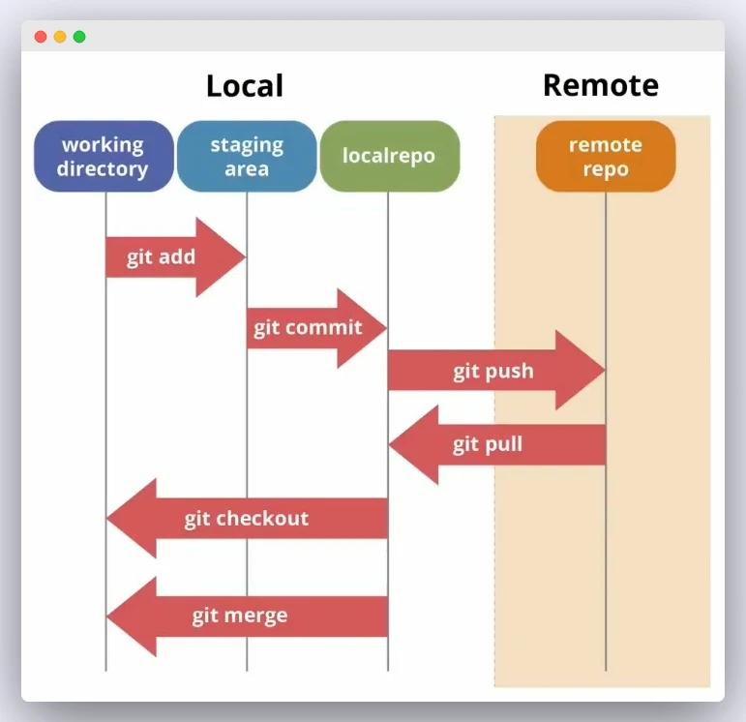
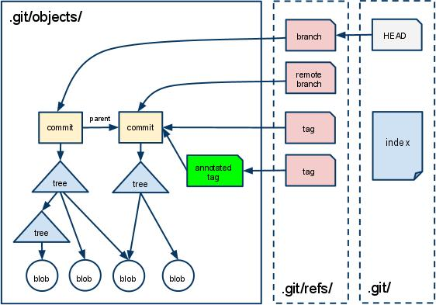
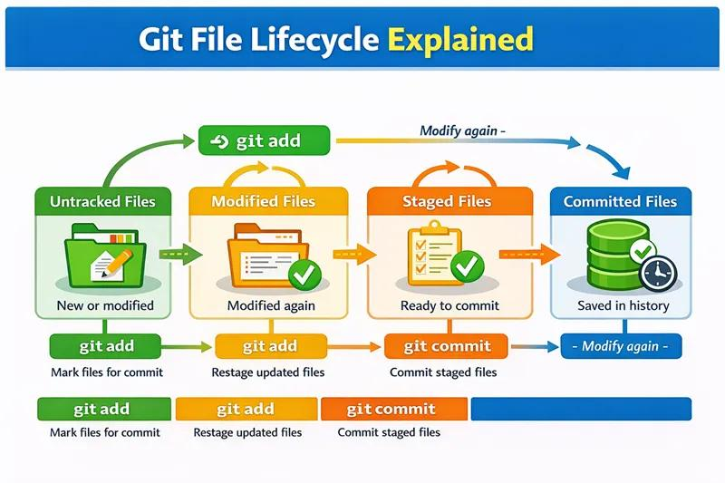
7

32. Important Interview Commands
Command | Interview Importance
git rebase | High
git stash | High
git cherry-pick | High
git reflog | High
git bisect | Medium
git blame | High
git hooks | Medium
git submodule | Medium

33. Official References
- Official Git Website
- Git Documentation
- GitHub Learning Lab
- Atlassian Advanced Git Tutorials
give me complete examples

Complete Git Real-Time Example Project

Scenario
We will create a complete Git workflow for a real-time:

Employee Management System
Technologies:
- Java
- Spring Boot
- React
- MySQL
- Git
- GitHub

1. Create Project Folder
mkdir employee-management-system
cd employee-management-system

2. Initialize Git Repository
git init
Output:
Initialized empty Git repository

3. Create Spring Boot Files

Create Files
touch EmployeeController.java
touch EmployeeService.java
touch application.properties

4. Check Git Status
git status
Output:
Untracked files:
EmployeeController.java
EmployeeService.java
application.properties

5. Add Files to Staging

Add All Files
git add .

6. Commit Files
git commit -m "Initial Spring Boot setup"

7. Create GitHub Repository
Using:
- GitHub Repository Creation
Example Repository:
employee-management-system

8. Connect Local Project to GitHub

Add Remote
git remote add origin https://github.com/babu/employee-management-system.git

9. Push Code to GitHub
git branch -M main
git push -u origin main

10. Create Feature Branch

JWT Authentication Feature
git checkout -b feature/jwt-authentication

11. Add JWT Code

Example Code

EmployeeController.java
@RestController
@RequestMapping("/employee")
public class EmployeeController {
@GetMapping
public String getEmployees() {
return "Employee List";
}
}

12. Add Changes
git add .

13. Commit JWT Feature
git commit -m "Implemented JWT authentication module"

14. Push Feature Branch
git push origin feature/jwt-authentication

15. Create Pull Request
Using:
- GitHub Pull Requests
Flow:
feature/jwt-authentication
↓
Pull Request
↓
Code Review
↓
Merge into main

16. Merge Branch Locally
git checkout main
git merge feature/jwt-authentication

17. Delete Feature Branch
git branch -d feature/jwt-authentication

18. Real-Time Git Conflict Example

Developer 1
Changes:
return "Employee Details";

Developer 2
Changes:
return "Employee Information";

Pull Latest Code
git pull origin main
Conflict:
<<<<<<< HEAD
Employee Details
=======
Employee Information
>>>>>>> main

19. Resolve Conflict
return "Employee Information";

Commit After Resolve
git add .
git commit -m "Resolved merge conflict"

20. Git Stash Complete Example

Working on Feature
public void payment() {
}
Suddenly production bug comes.

Save Current Work
git stash

Fix Bug
git checkout main
git checkout -b bugfix/login-issue

After Bug Fix
git stash pop
Restores saved code.

21. Git Revert Example

Wrong Commit Added
git log --oneline
Example:
a123 Added wrong API

Revert Safely
git revert a123

22. Git Reset Example

Remove Last Commit
git reset --soft HEAD~1

Completely Delete Commit
git reset --hard HEAD~1

23. Git Cherry Pick Example

Copy Bug Fix
Feature branch:
feature/payment
Production needs same fix.

Cherry Pick Commit
git checkout production
git cherry-pick commitId

24. Git Rebase Complete Example

Feature Branch Behind Main
git checkout feature/payment
git rebase main
Result:
Cleaner linear history

25. Git Log Visualization
git log --oneline --graph --all
Example:
* JWT feature
* Login API
* Initial commit

26. Complete .gitignore
target/
.idea/
*.class
*.log
application.properties
node_modules/
dist/

27. Complete GitHub Actions CI/CD Example

.github/workflows/build.yml
name: Spring Boot CI
on:
push:
branches:
- main
jobs:
build:
runs-on: ubuntu-latest
steps:
- name: Checkout
uses: actions/checkout@v4
- name: Setup Java
uses: actions/setup-java@v4
with:
distribution: 'temurin'
java-version: '21'
- name: Build
run: mvn clean install

28. Git Hooks Real-Time Example

Pre-Commit Validation

.git/hooks/pre-commit
#!/bin/sh
echo "Running tests"
mvn test
if [ $? -ne 0 ]; then
echo "Tests failed"
exit 1
fi

29. Complete Team Workflow

Developer Workflow
Clone Project
↓
Create Feature Branch
↓
Develop Code
↓
Commit Changes
↓
Push Branch
↓
Create Pull Request
↓
Code Review
↓
Merge
↓
Deploy

30. Git Branching Strategy

Enterprise Banking Project
main
develop
feature/*
release/*
hotfix/*

31. Real-Time Deployment Flow
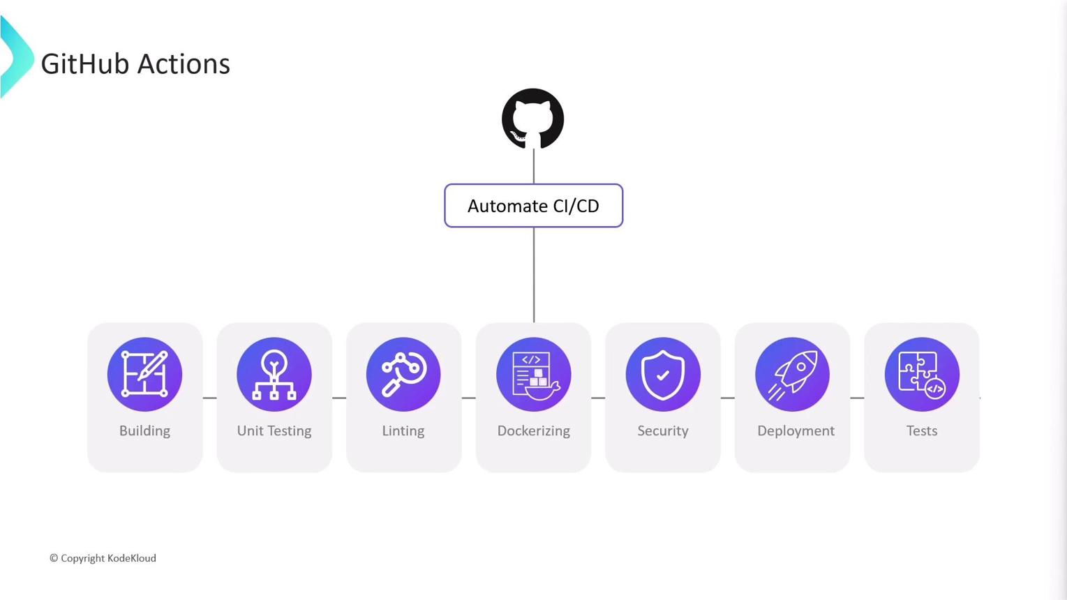
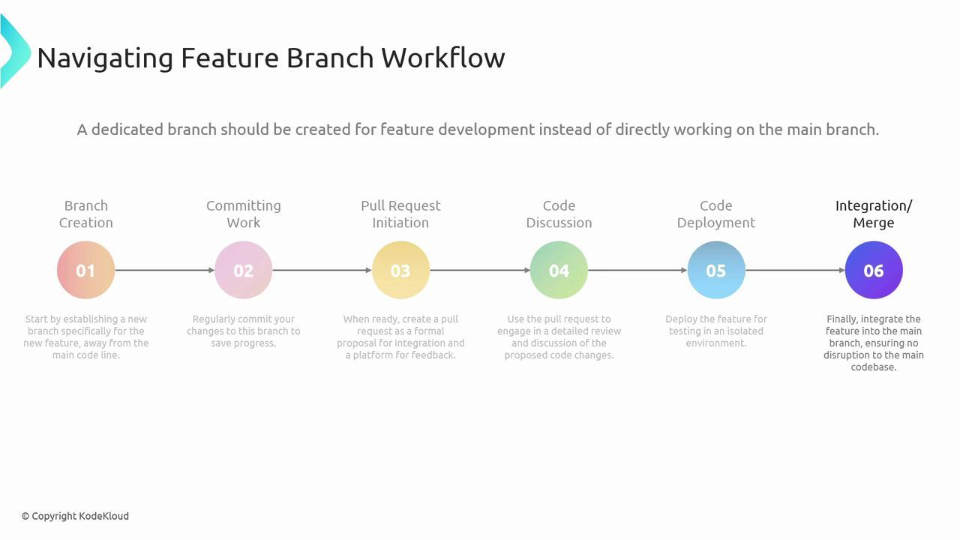
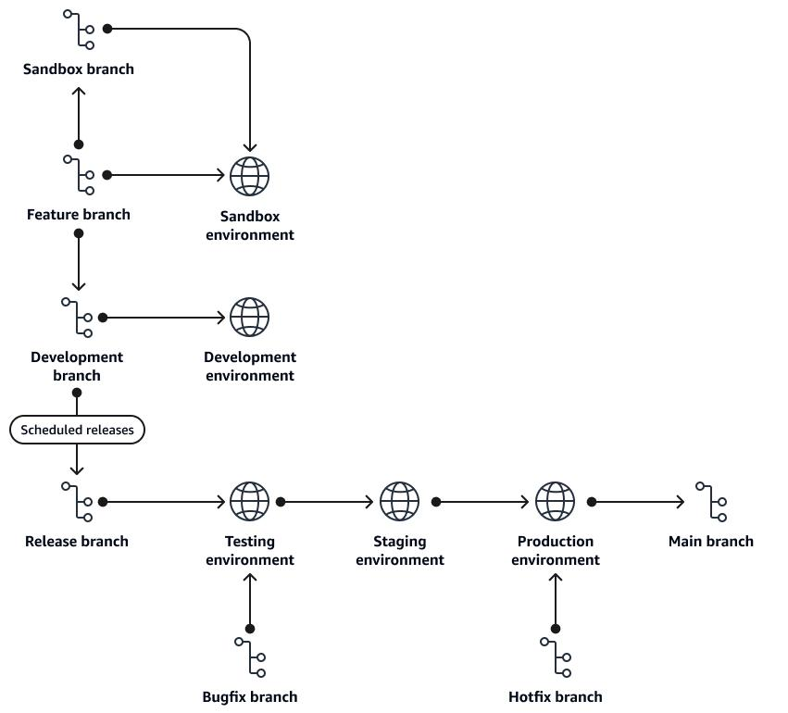
6

32. Complete Git Commands Used Daily
Daily Command | Purpose
git clone | Download project
git pull | Get latest code
git checkout -b | Create feature branch
git status | Check files
git add | Stage files
git commit | Save changes
git push | Upload code
git merge | Merge branch
git stash | Temporary save
git log | View history

33. Full Real-Time Workflow Commands

Morning
git pull origin develop

Create Feature
git checkout -b feature/employee-search

Develop
git add .
git commit -m "Implemented employee search API"

Upload
git push origin feature/employee-search

Update Feature Branch
git pull origin develop

Merge
git checkout develop
git merge feature/employee-search

34. Git Internal Flow
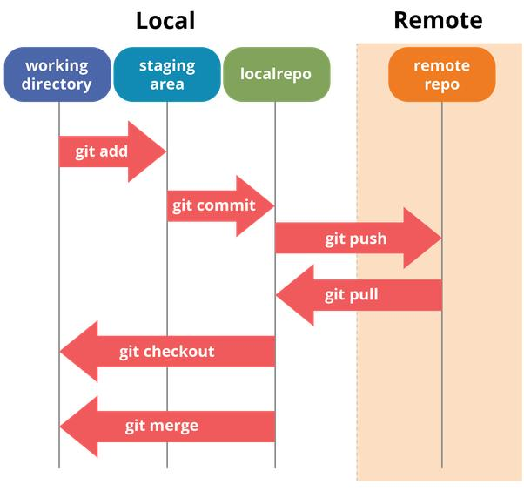
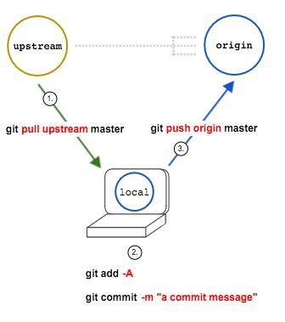
6

35. Important Production Tips

Never Use
git push --force
On production branches.

Always Pull Before Push
git pull origin main

Use Meaningful Branch Names
✅ Good:
feature/jwt-security
bugfix/login-error
❌ Bad:
test123
newbranch

36. GitHub Useful Features
- GitHub Issues
- GitHub Actions
- GitHub Discussions
- GitHub Security
how to create new branch

How to Create a New Branch in Git
A branch is used to develop features independently without affecting the main code.
Example:
main branch → Production code
feature/login → Login feature development
bugfix/jwt-error → Bug fixing

1. Check Current Branch
git branch
Example Output:
* main
* indicates current branch.

2. Create New Branch

Syntax
git branch branch-name

Example
git branch feature/login
This creates the branch but does NOT switch to it.

3. Switch to New Branch

Using checkout
git checkout feature/login

Using switch (Recommended)
git switch feature/login

4. Create and Switch in One Command

Using checkout
git checkout -b feature/login

Using switch
git switch -c feature/login
This:
- Creates branch
- Switches to branch

5. Verify Current Branch
git branch
Example:
* feature/login
main

6. Real-Time Example

Step 1: Clone Project
git clone https://github.com/company/employee-management.git

Step 2: Go to Project
cd employee-management

Step 3: Create Feature Branch
git checkout -b feature/jwt-authentication

Step 4: Add Code
@RestController
public class AuthController {
@GetMapping("/login")
public String login() {
return "JWT Login";
}
}

Step 5: Commit Changes
git add .
git commit -m "Implemented JWT authentication"

Step 6: Push Branch to GitHub
git push origin feature/jwt-authentication

7. View All Branches

Local Branches
git branch

Remote Branches
git branch -r

All Branches
git branch -a

8. Rename Branch

Current Branch Rename
git branch -m new-branch-name
Example:
git branch -m feature/security

9. Delete Branch

Delete Local Branch
git branch -d feature/login

Force Delete
git branch -D feature/login

10. Delete Remote Branch
git push origin --delete feature/login

11. Branch Workflow in Real Projects

Banking Project Example
main
develop
feature/payment-api
feature/jwt-security
bugfix/login-error
release/v1.0

12. Enterprise Developer Workflow

Morning Work

Get Latest Code
git pull origin develop

Create New Branch
git checkout -b feature/employee-search

Develop Feature
git add .
git commit -m "Implemented employee search"

Push Feature Branch
git push origin feature/employee-search

Create Pull Request
Using:
- GitHub Pull Requests

13. Branch Architecture
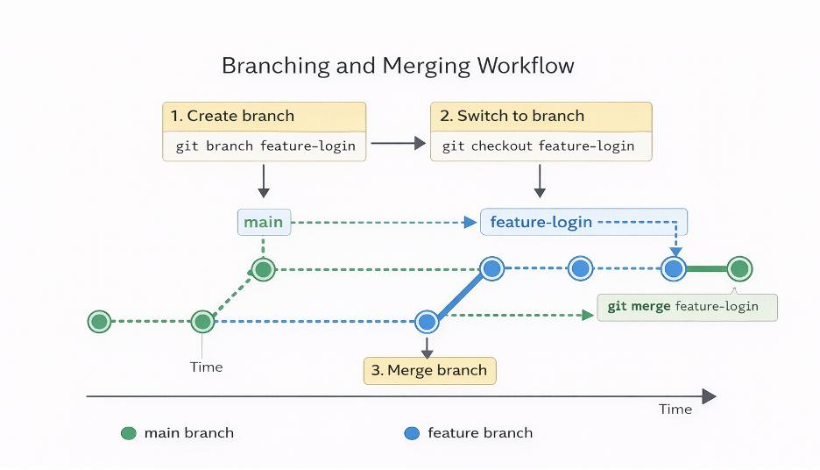
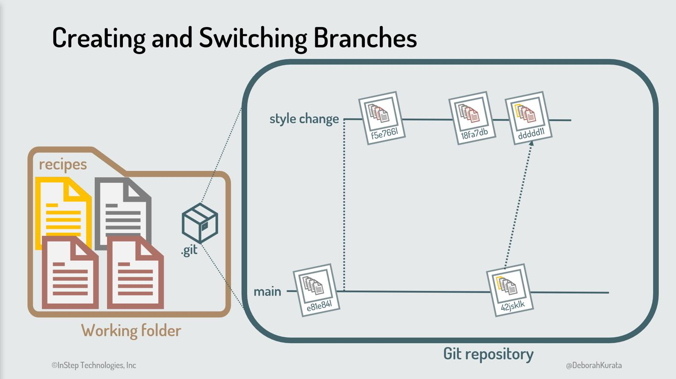
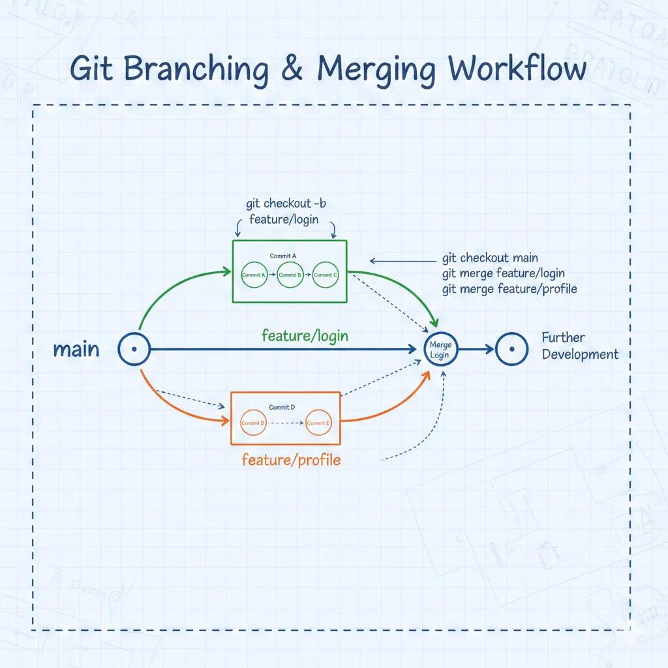
7

14. Important Branch Commands
Command | Purpose
git branch | View branches
git branch name | Create branch
git checkout name | Switch branch
git checkout -b name | Create + switch
git switch -c name | Modern create + switch
git branch -d name | Delete branch
git push origin branch | Push branch

15. Best Practices

Use Meaningful Branch Names
✅ Good:
feature/jwt-authentication
feature/payment-api
bugfix/login-error
❌ Bad:
test
newbranch
temp123

16. GitHub Branch Protection
Production branches like:
main
master
Should be protected.
GitHub Settings:
- GitHub Branch Protection
pull command complete example

Git Pull Command – Complete Explanation with Real-Time Examples

What is git pull?
git pull is used to:
- Download latest code from remote repository
- Merge it into your local branch
It combines:
git fetch + git merge

Basic Syntax
git pull <remote-name> <branch-name>
Example:
git pull origin main

1. Complete Real-Time Example

Scenario
Team Project:
Employee Management System
Developer A pushed latest code.
Developer B needs latest updates.

Step 1: Clone Repository
git clone https://github.com/company/employee-management.git

Step 2: Enter Project
cd employee-management

Step 3: Check Current Branch
git branch
Output:
* main

Step 4: Pull Latest Code
git pull origin main

Output Example
Updating a1b2c3..d4e5f6
Fast-forward
EmployeeService.java | 10 ++++++++
Meaning:
- New code downloaded
- Local branch updated

2. Pull in Feature Branch

Scenario
Working on:
feature/jwt-authentication
Need latest develop branch updates.

Step 1: Switch Branch
git checkout feature/jwt-authentication

Step 2: Pull Latest Changes
git pull origin develop

3. Pull Without Merge Conflict

Example
Developer A added:
public String getEmployees() {
return "Employees";
}
Developer B added different file.
Now:
git pull origin main
Works successfully.

4. Pull With Merge Conflict

Scenario
Two developers changed same line.

Developer A
return "Employee Details";

Developer B
return "Employee Information";

Pull Command
git pull origin main

Conflict Appears
<<<<<<< HEAD
Employee Details
=======
Employee Information
>>>>>>> main

Resolve Conflict
return "Employee Information";

Add and Commit
git add .
git commit -m "Resolved merge conflict"

5. Pull All Remote Branch Updates
git pull --all

6. Pull Using Rebase
Instead of merge:
git pull --rebase origin main
Benefits:
- Cleaner history
- No extra merge commits

Before Rebase
A---B---C main
\
D---E feature

After Rebase
A---B---C---D---E

7. Pull Latest Code Daily Workflow

Morning Developer Workflow

Step 1
git checkout develop

Step 2
git pull origin develop

Step 3
git checkout -b feature/payment-api

8. Pull Command in Enterprise Projects

Banking Project Flow
Branches:
main
develop
feature/*
release/*
hotfix/*

Developer Updates Branch
git checkout develop
git pull origin develop

Create Feature Branch
git checkout -b feature/account-service

9. Difference Between Fetch and Pull
Command | Action
git fetch | Downloads changes only
git pull | Downloads + merges

Example

Fetch
git fetch origin
Does NOT update local branch.

Pull
git pull origin main
Downloads + updates local branch.

10. Pull Specific Remote Branch
git pull origin feature/login

11. Auto-Stash During Pull
If local changes exist:
git pull --autostash
Git temporarily saves changes.

12. Pull Tags
git pull --tags
Downloads release tags.

13. Pull Single Commit History
git pull --depth=1 origin main
Used for:
- Faster CI/CD pipelines

14. Real-Time Full Example

Developer Daily Workflow

Get Latest Code
git checkout develop
git pull origin develop

Create Feature
git checkout -b feature/employee-search

Add Code
@GetMapping("/search")
public String searchEmployee() {
return "Search API";
}

Commit
git add .
git commit -m "Implemented employee search API"

Push
git push origin feature/employee-search

15. Git Pull Architecture
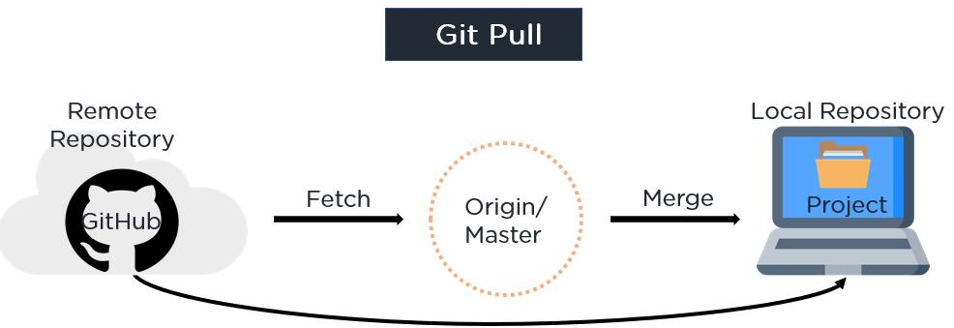
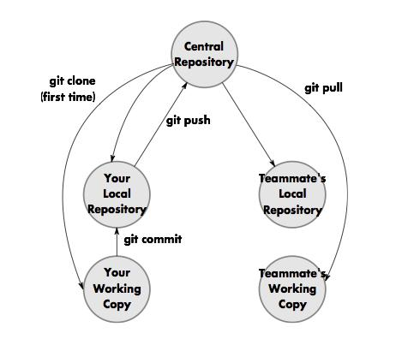
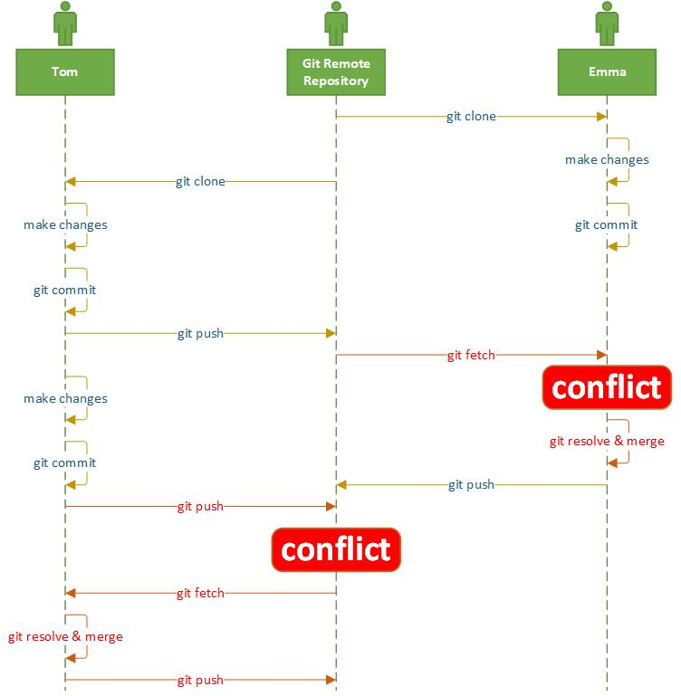
5

16. Common Pull Errors

Error 1
Your local changes would be overwritten

Solution
git stash
git pull origin main
git stash pop

Error 2
Merge conflict

Solution
- Resolve manually
- Add files
- Commit

Error 3
fatal: not a git repository

Solution
Go inside project folder.

17. Important Pull Commands
Command | Purpose
git pull origin main | Pull latest main branch
git pull --rebase | Pull with rebase
git pull --all | Pull all remotes
git pull --tags | Pull tags
git pull --autostash | Auto stash local changes

18. Best Practices

Always Pull Before Push
git pull origin main
git push origin main

Pull Daily
Avoid large merge conflicts.

Use Rebase in Feature Branches
git pull --rebase origin develop

19. Complete Git Pull Lifecycle
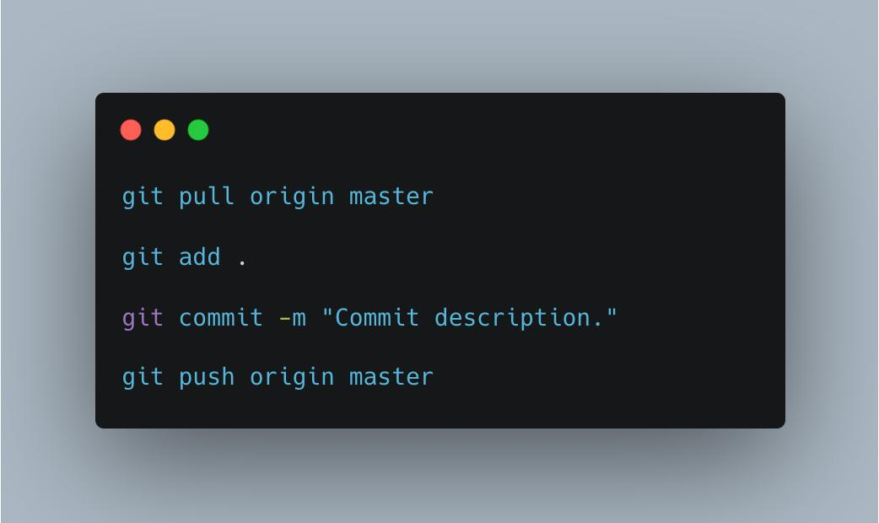
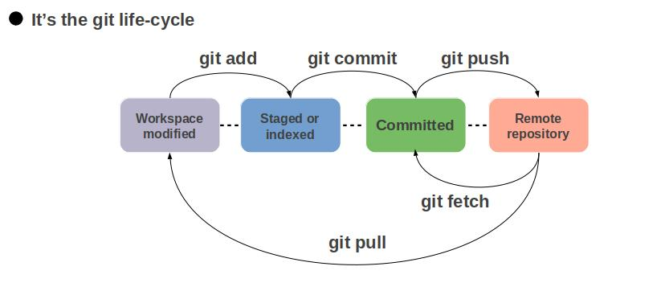
7
merge complete example

Git Merge – Complete Real-Time Example

What is Git Merge?
git merge combines changes from one branch into another branch.
Example:
feature/login → merged into → main
Used in:
- Feature development
- Bug fixing
- Release management
- Team collaboration

Basic Syntax
git merge branch-name
Example:
git merge feature/login

1. Complete Real-Time Example

Scenario
Project:
Employee Management System
Developer creates:
feature/employee-api
After development, merge into:
main

Step 1: Create Project
mkdir employee-management
cd employee-management

Step 2: Initialize Git
git init

Step 3: Create File
touch EmployeeController.java

Step 4: Add Initial Code
public class EmployeeController {
public String getEmployees() {
return "Employee List";
}
}

Step 5: Commit Initial Code
git add .
git commit -m "Initial employee controller"

Step 6: Create Feature Branch
git checkout -b feature/employee-api

Step 7: Add New Feature
public String addEmployee() {
return "Employee Added";
}

Step 8: Commit Feature
git add .
git commit -m "Implemented add employee API"

Step 9: Switch to Main Branch
git checkout main

Step 10: Merge Feature Branch
git merge feature/employee-api

Merge Output
Updating a1b2c3..d4e5f6
Fast-forward
EmployeeController.java
Meaning:
Feature successfully merged.

2. Verify Merge

Check Log
git log --oneline
Example:
d4e5f6 Implemented add employee API
a1b2c3 Initial employee controller

3. Push Merged Code
git push origin main

4. Merge Conflict Complete Example

Scenario
Two developers changed same line.

Main Branch Code
return "Employee Details";

Feature Branch Code
return "Employee Information";

Try Merge
git merge feature/employee-api

Conflict Output
CONFLICT (content): Merge conflict in EmployeeController.java
Automatic merge failed

Conflict File
<<<<<<< HEAD
return "Employee Details";
=======
return "Employee Information";
>>>>>>> feature/employee-api

Resolve Conflict
return "Employee Information";

Complete Merge After Conflict
git add .
git commit -m "Resolved merge conflict"

5. Fast Forward Merge

Before Merge
A---B main
\
C feature

Merge
git merge feature

After Merge
A---B---C main
No extra merge commit.

6. No Fast Forward Merge

Command
git merge --no-ff feature

Result
A---B-------M main
\ /
C---D
Creates merge commit.
Used in enterprise projects.

7. Real-Time Team Workflow

Developer Workflow

Get Latest Code
git checkout develop
git pull origin develop

Create Branch
git checkout -b feature/payment-api

Develop Feature
git add .
git commit -m "Implemented payment API"

Push Feature
git push origin feature/payment-api

Create Pull Request
Using:
- GitHub Pull Requests

Merge into Develop
git checkout develop
git merge feature/payment-api

8. Merge Using Rebase

Instead of Merge
git rebase main

Before Rebase
A---B---C main
\
D---E feature

After Rebase
A---B---C---D---E
Cleaner history.

9. Merge Abort
If merge problem occurs:
git merge --abort
Restores previous state.

10. Merge Specific File Changes
Using checkout:
git checkout feature/login -- EmployeeController.java
Copies file from branch.

11. Enterprise Banking Workflow

Branches
main
develop
feature/*
release/*
hotfix/*

Merge Flow
feature → develop
develop → release
release → main
hotfix → main

12. Git Merge Architecture
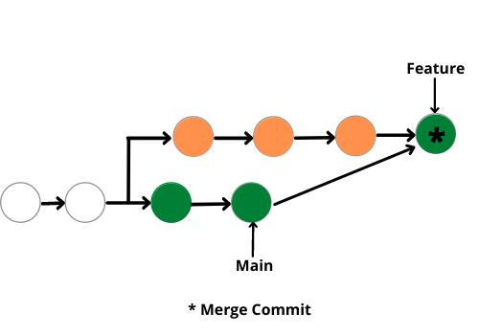
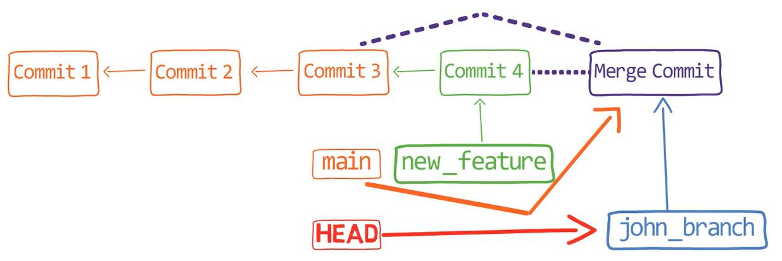
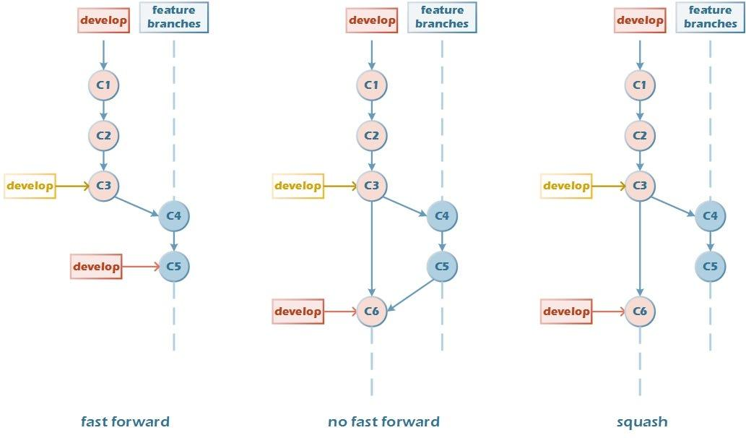
6

13. Important Merge Commands
Command | Purpose
git merge branch | Merge branch
git merge --no-ff | Create merge commit
git merge --abort | Cancel merge
git log --graph | Visualize merge history

14. Visualize Merge History
git log --oneline --graph --all
Example:
* Merge feature branch
|\
| * Added payment API
|/
* Initial commit

15. Complete Merge Lifecycle
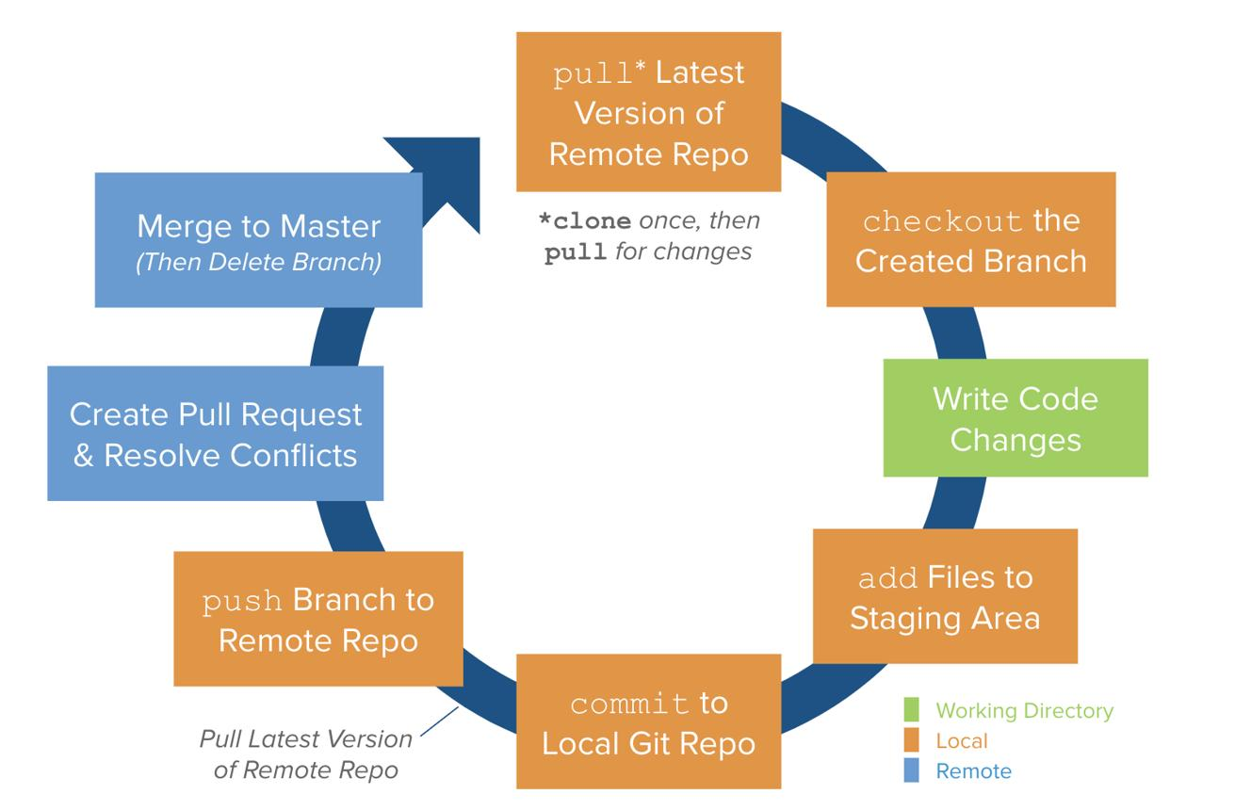
6

16. Best Practices

Pull Before Merge
git pull origin main

Use Feature Branches
feature/jwt-auth
feature/payment-api

Resolve Conflicts Carefully
Never blindly delete code.

Use Pull Requests
For:
- Code review
- Security checks
- CI/CD validation
GitHub:
- GitHub Code Review
how to merge more than one branch

How to Merge More Than One Branch in Git
You can merge multiple branches into one branch (usually main or develop).
Example:
feature/login
feature/payment
feature/jwt
↓
develop

Method 1: Merge Branches One by One
This is the most common enterprise approach.

Complete Real-Time Example

Scenario
Project:
Employee Management System
Branches:
feature/login
feature/payment
feature/jwt
Need to merge all into:
develop

Step 1: Create Project
mkdir employee-management
cd employee-management

Step 2: Initialize Git
git init

Step 3: Initial Commit
touch app.java
git add .
git commit -m "Initial commit"

Step 4: Create Login Branch
git checkout -b feature/login

Add Login Code
public void login() {
System.out.println("Login");
}

Commit
git add .
git commit -m "Added login feature"

Step 5: Create Payment Branch
git checkout main
git checkout -b feature/payment

Add Payment Code
public void payment() {
System.out.println("Payment");
}

Commit
git add .
git commit -m "Added payment feature"

Step 6: Create JWT Branch
git checkout main
git checkout -b feature/jwt

Add JWT Code
public void jwt() {
System.out.println("JWT");
}

Commit
git add .
git commit -m "Added JWT feature"

Step 7: Merge All Branches into Develop

Create Develop Branch
git checkout main
git checkout -b develop

Merge Login Branch
git merge feature/login

Merge Payment Branch
git merge feature/payment

Merge JWT Branch
git merge feature/jwt

Final Result
develop branch contains:
- login feature
- payment feature
- jwt feature

2. Merge Multiple Branches in Single Command
Git supports merging multiple branches together.

Syntax
git merge branch1 branch2 branch3

Example
git checkout develop
git merge feature/login feature/payment feature/jwt

Result
All branches merged into:
develop

3. Real-Time Enterprise Workflow

Banking Project
Branches:
feature/account-api
feature/loan-api
feature/security
feature/notification
Merge into:
develop

Team Lead Workflow
git checkout develop
git pull origin develop
git merge feature/account-api
git merge feature/loan-api
git merge feature/security
git merge feature/notification

Push Final Code
git push origin develop

4. Merge Conflict Example with Multiple Branches

Scenario
Two branches changed same method.

Branch 1
return "Login Success";

Branch 2
return "Authentication Success";

Merge Conflict Appears
git merge feature/login feature/security

Conflict File
<<<<<<< HEAD
Login Success
=======
Authentication Success
>>>>>>> feature/security

Resolve Conflict
return "Authentication Success";

Complete Merge
git add .
git commit -m "Resolved multiple branch conflicts"

5. Merge Branches Using No Fast Forward

Command
git merge --no-ff feature/login feature/payment

Result
Creates merge commits.
Enterprise projects prefer this.

6. Visualize Multiple Branch Merge

Command
git log --oneline --graph --all

Example Output
* Merge feature/payment
|\
| * Payment feature
* Merge feature/login
|\
| * Login feature
* Initial commit

7. Merge Workflow Architecture
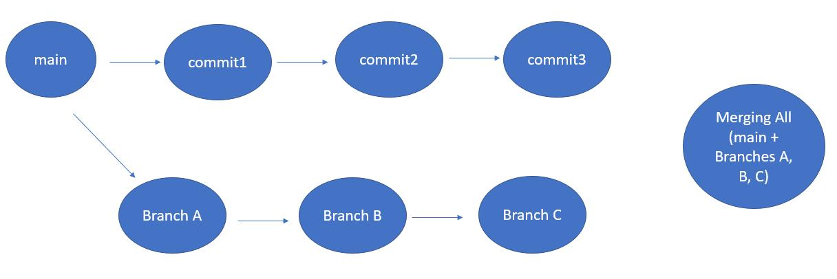
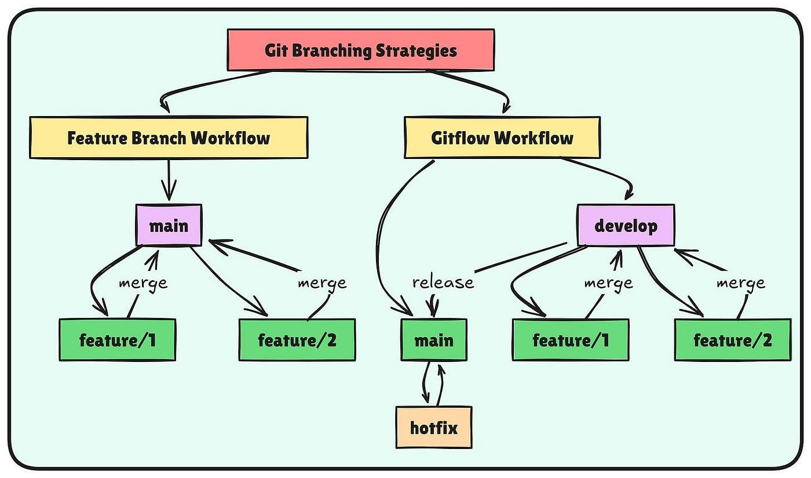
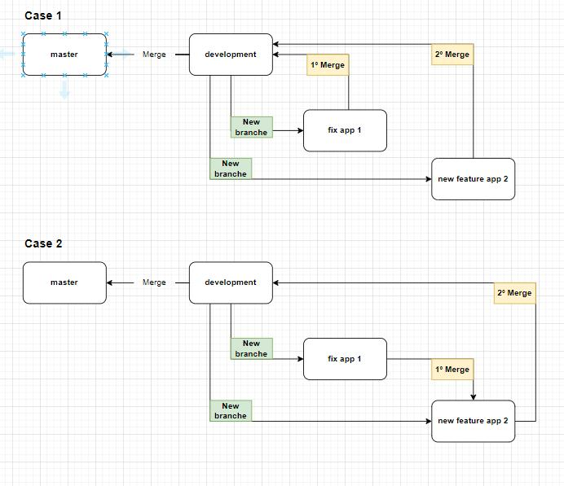
6

8. Best Practice Workflow

Recommended Enterprise Flow
feature branch
↓
develop branch
↓
release branch
↓
main branch

9. Important Commands
Command | Purpose
git merge branch1 | Merge single branch
git merge b1 b2 b3 | Merge multiple branches
git merge --abort | Cancel merge
git log --graph | View merge graph

10. Production Best Practices

Pull Latest Code Before Merge
git pull origin develop

Use Pull Requests
Using:
- GitHub Pull Requests

Resolve Conflicts Carefully
Never overwrite production code blindly.

Test After Merge
Run:
mvn clean install
OR
npm test

11. Complete Enterprise Merge Lifecycle
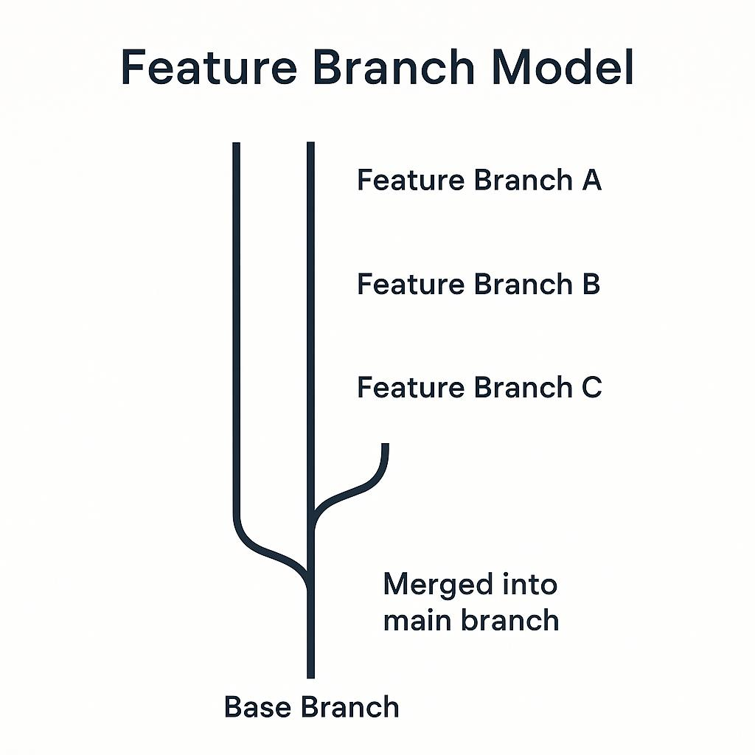
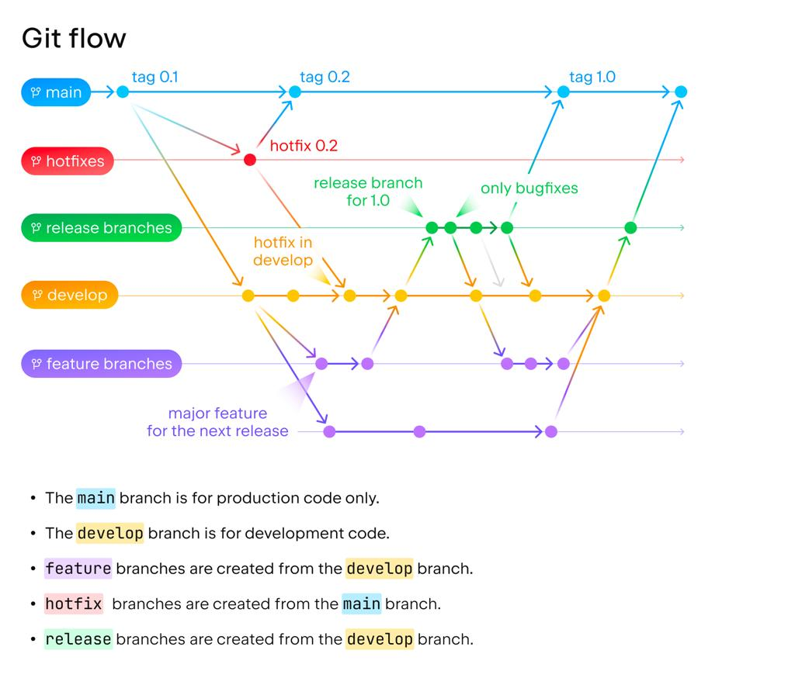
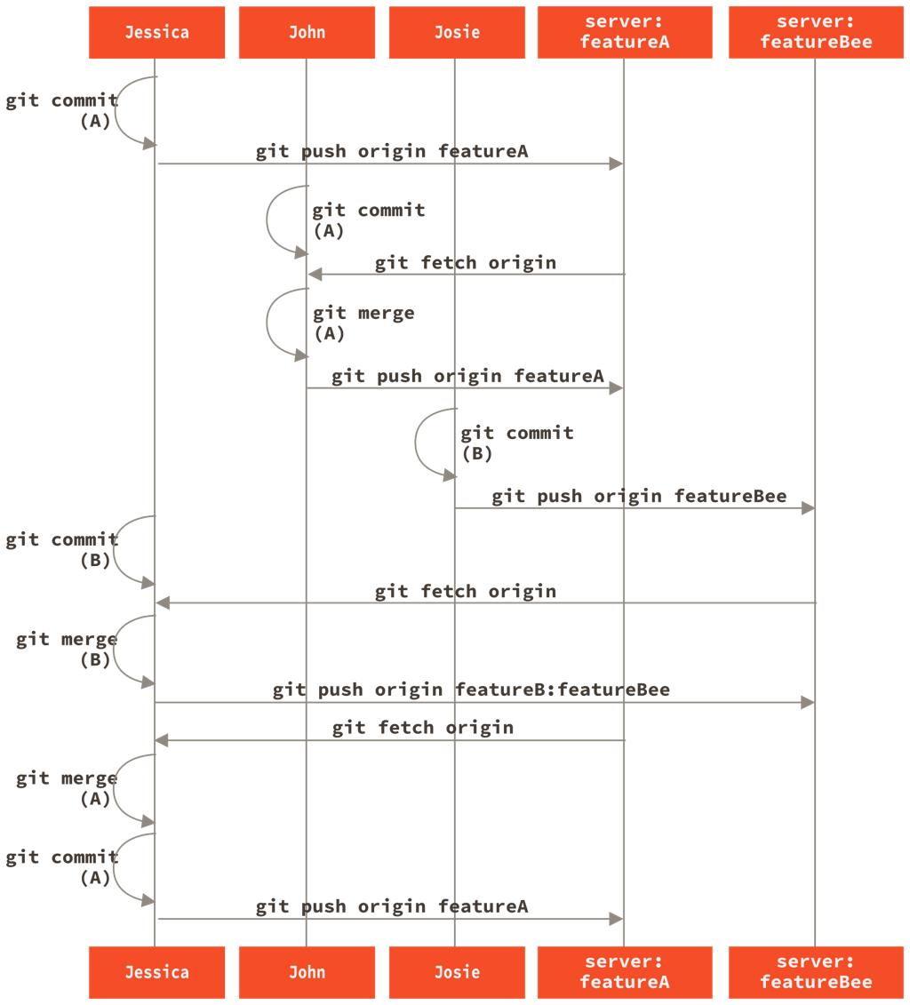
6
how to sub branch from local to Remote Repository

How to Push a Local Sub Branch to Remote Repository in Git
A sub branch means a feature branch created from another branch.
Example:
main
↓
develop
↓
feature/login
↓
feature/login-ui
You can push any local branch to remote repository like GitHub.

Complete Real-Time Example

Scenario
Project:
Employee Management System
Branch hierarchy:
main
↓
develop
↓
feature/jwt-authentication
Need to push:
feature/jwt-authentication
to remote repository.

1. Clone Repository
git clone https://github.com/company/employee-management.git

2. Go to Project Folder
cd employee-management

3. Check Existing Branches
git branch
Example Output:
* main

4. Create Develop Branch
git checkout -b develop

5. Push Develop Branch to Remote
git push -u origin develop

6. Create Sub Branch from Develop

Create Feature Branch
git checkout -b feature/jwt-authentication
This branch is created from:
develop

7. Add Code Changes

Example
@RestController
public class AuthController {
@GetMapping("/login")
public String login() {
return "JWT Login";
}
}

8. Check Status
git status

9. Add Files
git add .

10. Commit Changes
git commit -m "Implemented JWT authentication"

11. Push Sub Branch to Remote Repository

Command
git push -u origin feature/jwt-authentication

Output Example
Branch 'feature/jwt-authentication' set up to track remote branch.
Meaning:
- Local branch pushed
- Remote tracking established

12. Verify Remote Branch

Check Remote Branches
git branch -r
Example:
origin/main
origin/develop
origin/feature/jwt-authentication

13. Push Another Sub Branch

Example
Create UI branch from JWT branch.

Create Sub-Sub Branch
git checkout -b feature/jwt-ui

Push to Remote
git push -u origin feature/jwt-ui

Branch Structure
main
└── develop
└── feature/jwt-authentication
└── feature/jwt-ui

14. Real-Time Enterprise Workflow

Banking Project Example

Branches
main
develop
feature/account-api
feature/security
feature/security-ui

Developer Workflow

Pull Latest Develop Code
git checkout develop
git pull origin develop

Create Feature Branch
git checkout -b feature/security

Push Branch
git push -u origin feature/security

Create Sub Feature Branch
git checkout -b feature/security-ui

Push Sub Branch
git push -u origin feature/security-ui

15. Push Existing Local Branch
If branch already exists locally:
git push origin branch-name
Example:
git push origin feature/payment-api

16. Set Upstream Branch

First Time Push
git push -u origin feature/login

After Upstream Set
You can simply use:
git push

17. Delete Remote Branch

Command
git push origin --delete feature/jwt-ui

18. Fetch Remote Branches
git fetch

19. Pull Remote Sub Branch
git pull origin feature/jwt-authentication

20. Branch Push Architecture
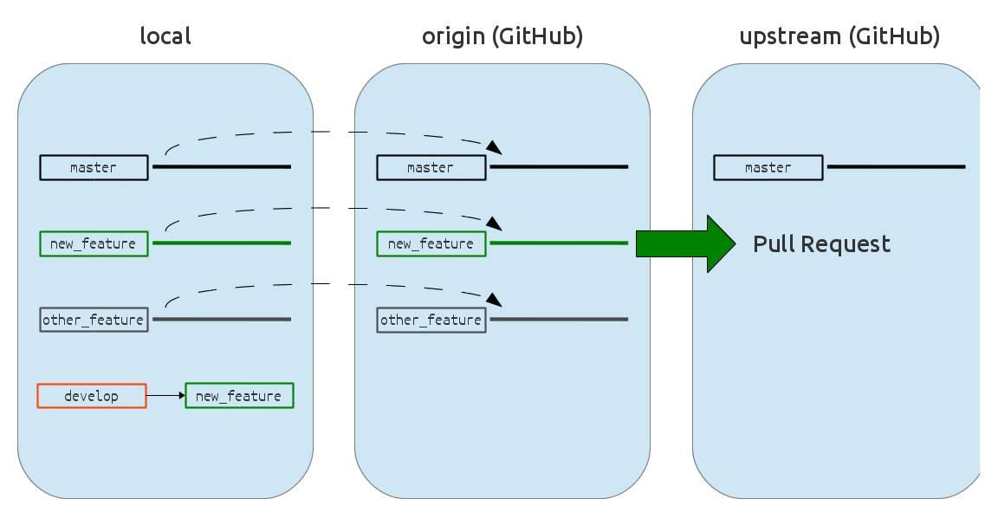
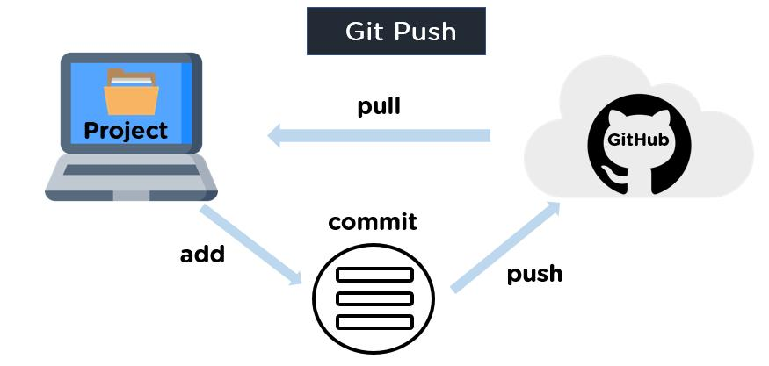
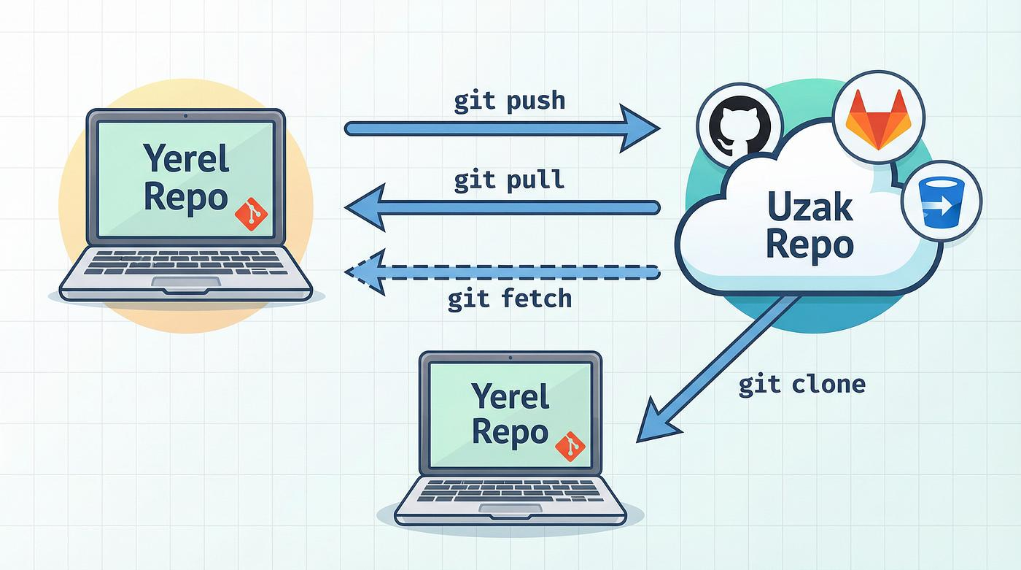
6

21. Important Commands
Command | Purpose
git checkout -b branch | Create branch
git push origin branch | Push branch
git push -u origin branch | Push + tracking
git branch -r | View remote branches
git fetch | Get remote updates

22. Common Errors

Error 1
fatal: The current branch has no upstream branch

Solution
git push -u origin branch-name

Error 2
rejected non-fast-forward

Solution
git pull origin branch-name
Then:
git push

23. GitHub Branch Visualization
Using:
- GitHub Branches
You can view:
- Local branches
- Remote branches
- Pull requests
- Merge history

24. Best Practices

Use Meaningful Branch Names
✅ Good:
feature/jwt-authentication
feature/payment-api
bugfix/login-error

Push Frequently
Avoid losing code.

Pull Before Push
git pull origin develop

Use Pull Requests Before Merge
GitHub:

