Assignment

NCP LAB

14-08-2020

1) <!DOCTYPE html>

<html>

<head>

</head>

<body>

<script type="text/javascript">

var num=prompt("Enter a paragraph");

text_to_array();

function text_to_array()

{

try{

if(num=="")

{

throw e;

}

else

{

word=num.split(' ');

document.write("Word array is: "+word+"<br>");

}

}

catch(e)

{

document.write("Enter a valid paragraph");

}

}

</script>

</body>

</html>

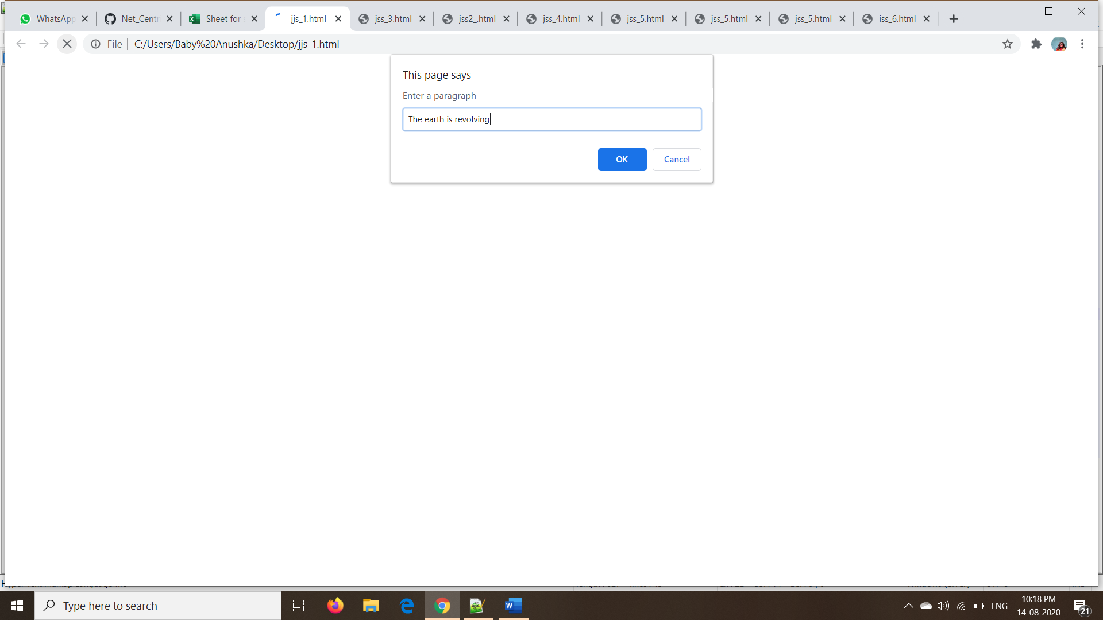

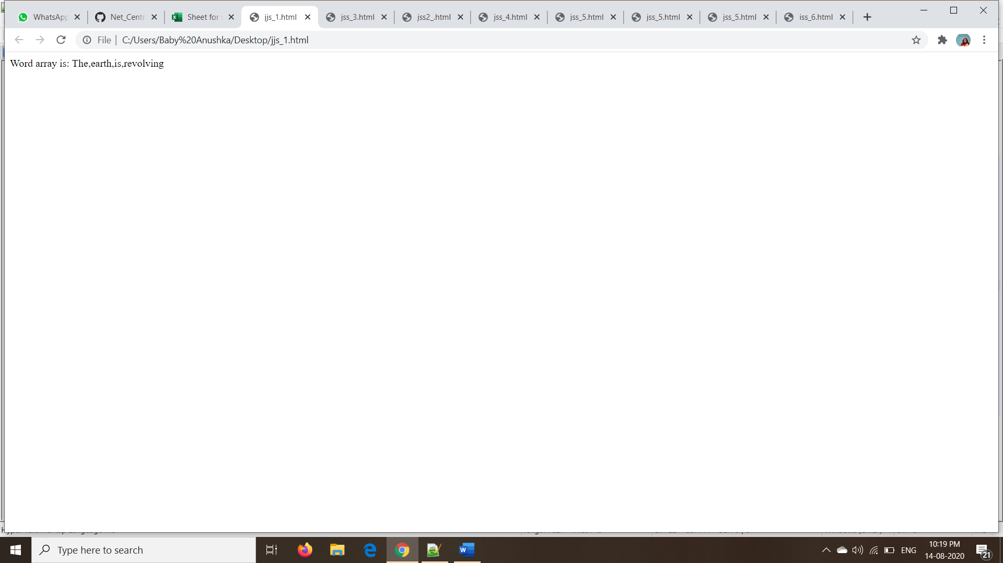

2) <!DOCTYPE html>

<html>

<head>

</head>

<body>

<script type="text/javascript">

var words=prompt("Enter a paragraph");

reverse_sort(words);

function reverse_sort(words)

{

try{

if(words==" ")

{

throw e;

}

else

{

word=words.split(' ');

document.write("Word array is: "+word.sort().reverse()+"<br>");

}

}

catch(e)

{

document.write("Enter a valid paragraph");

}

}

</script>

</body>

</html>

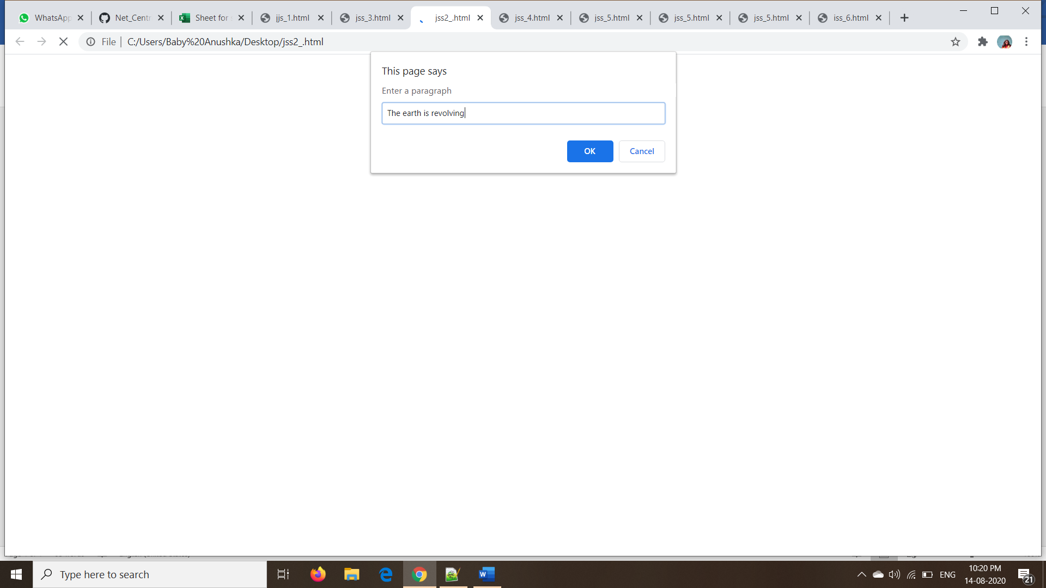

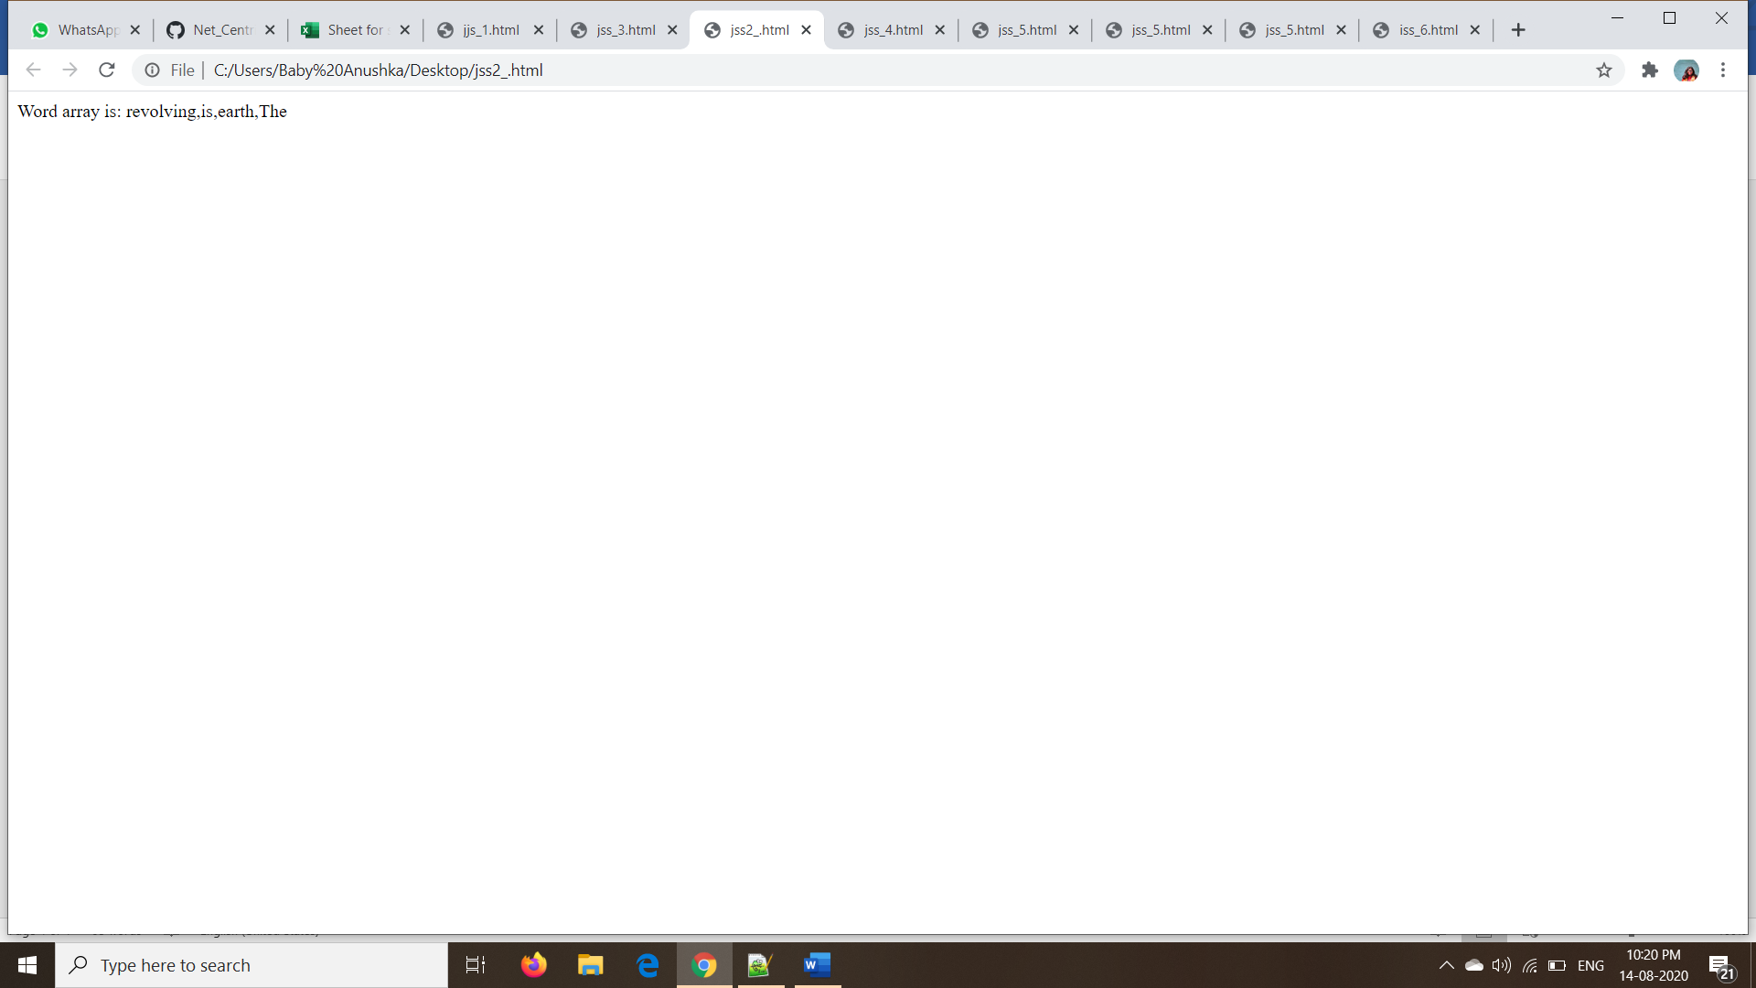

3) <!DOCTYPE html>

<html>

<head>

</head>

<body>

<script type="text/javascript">

// var i=window.prompt("Enter a value");

var flag=true;

list1=[]

document.write(hist());

function histn(num)

{

var strin="";

for(var i=0;i<num;i++)

{

strin+="*"

}

return strin

}

function hist()

{

do{

var i=window.prompt("Enter a value");

if(i!=null)

{

list1.push(i);

}

else

{

flag=false;

}

}while(flag==true)

str=" ";

for (var j=0;j<list1.length;j++)

{

str=str+"<div>"+histn(list1[j])+"</div>";

}

// str=str+"</ul>";

return str;

}

</script>

</body>

</html>

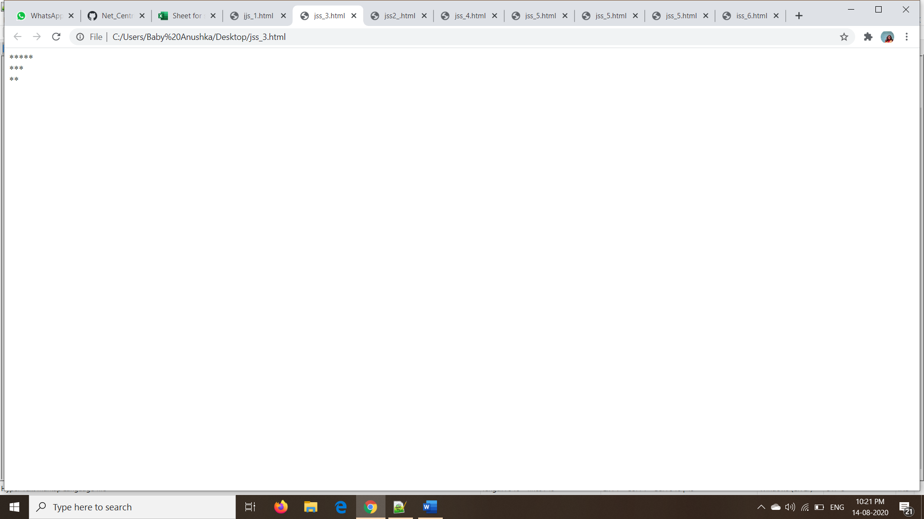

4) <!DOCTYPE html>

<html>

<head>

</head>

<body>

<script type="text/javascript">

var words=prompt("Enter a date in format dd-mm-yyyy");

date(words);

function date(words)

{

try{

if(words==" ")

{

throw e;

}

else

{

word=words.split('-');

list1=[1,3,5,7,8,10,12]

if(word[1] ==1 || word[1] ==3 ||word[1] ==5 ||word[1] ==7 ||word[1] ==8 ||word[1] ==10 ||word[1] ==12)

{

if(word[0]>0 && word[0]<=31)

{

document.write("Valid Date")

}

else

{

document.write("Invalid Date")

}

}

else if(word[1]==2)

{

if((!word[2]%4 && word[2]%100) || !word[2]%400)

{

if(word[0]>0 && word[0]<=29)

{

document.write("Valid Date")

}

else

{

document.write("Invalid Date")

}

}

else{

if(word[0]>0 && word[0]<=28)

{

document.write("Valid Date")

}

else

{

document.write("Invalid Date")

}

}

}

else if(word[1] ==4 || word[1] ==6 ||word[1] ==9 ||word[1] ==11)

{

if(word[0]>0 && word[0]<=30)

{

document.write("Valid Date")

}

else

{

document.write("Invalid Date")

}

}

else

{

document.write("Invalid Date")

}

}}

catch(e)

{

document.write("Invalid");

}

}

</script>

</body>

</html>

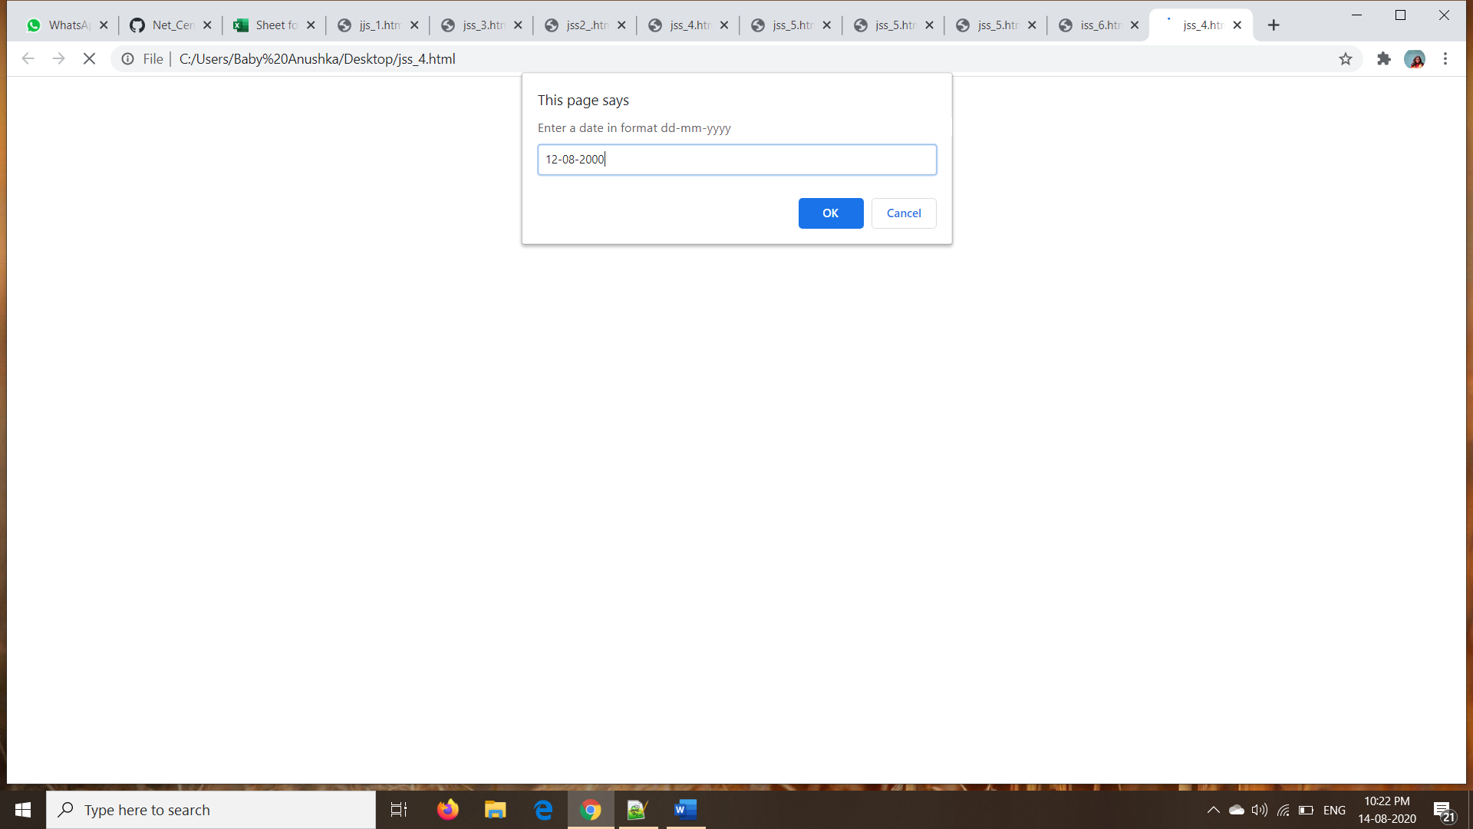

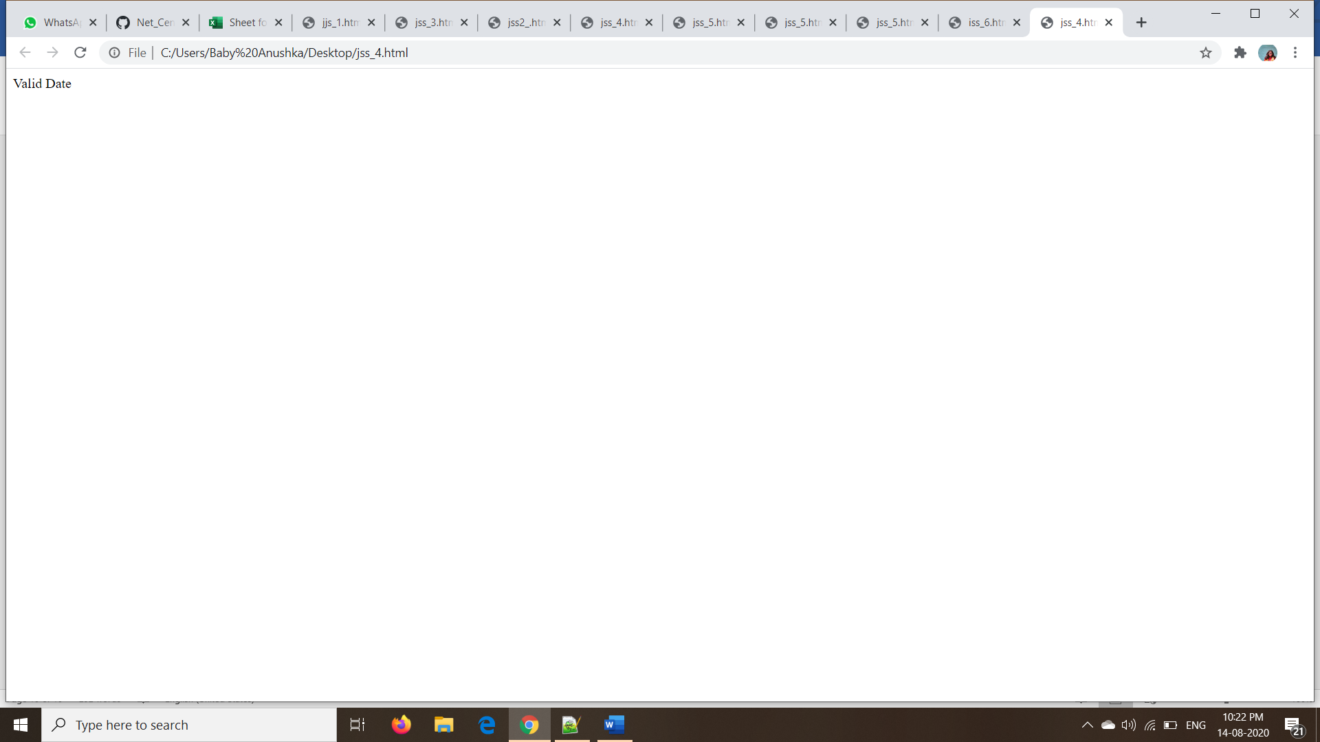

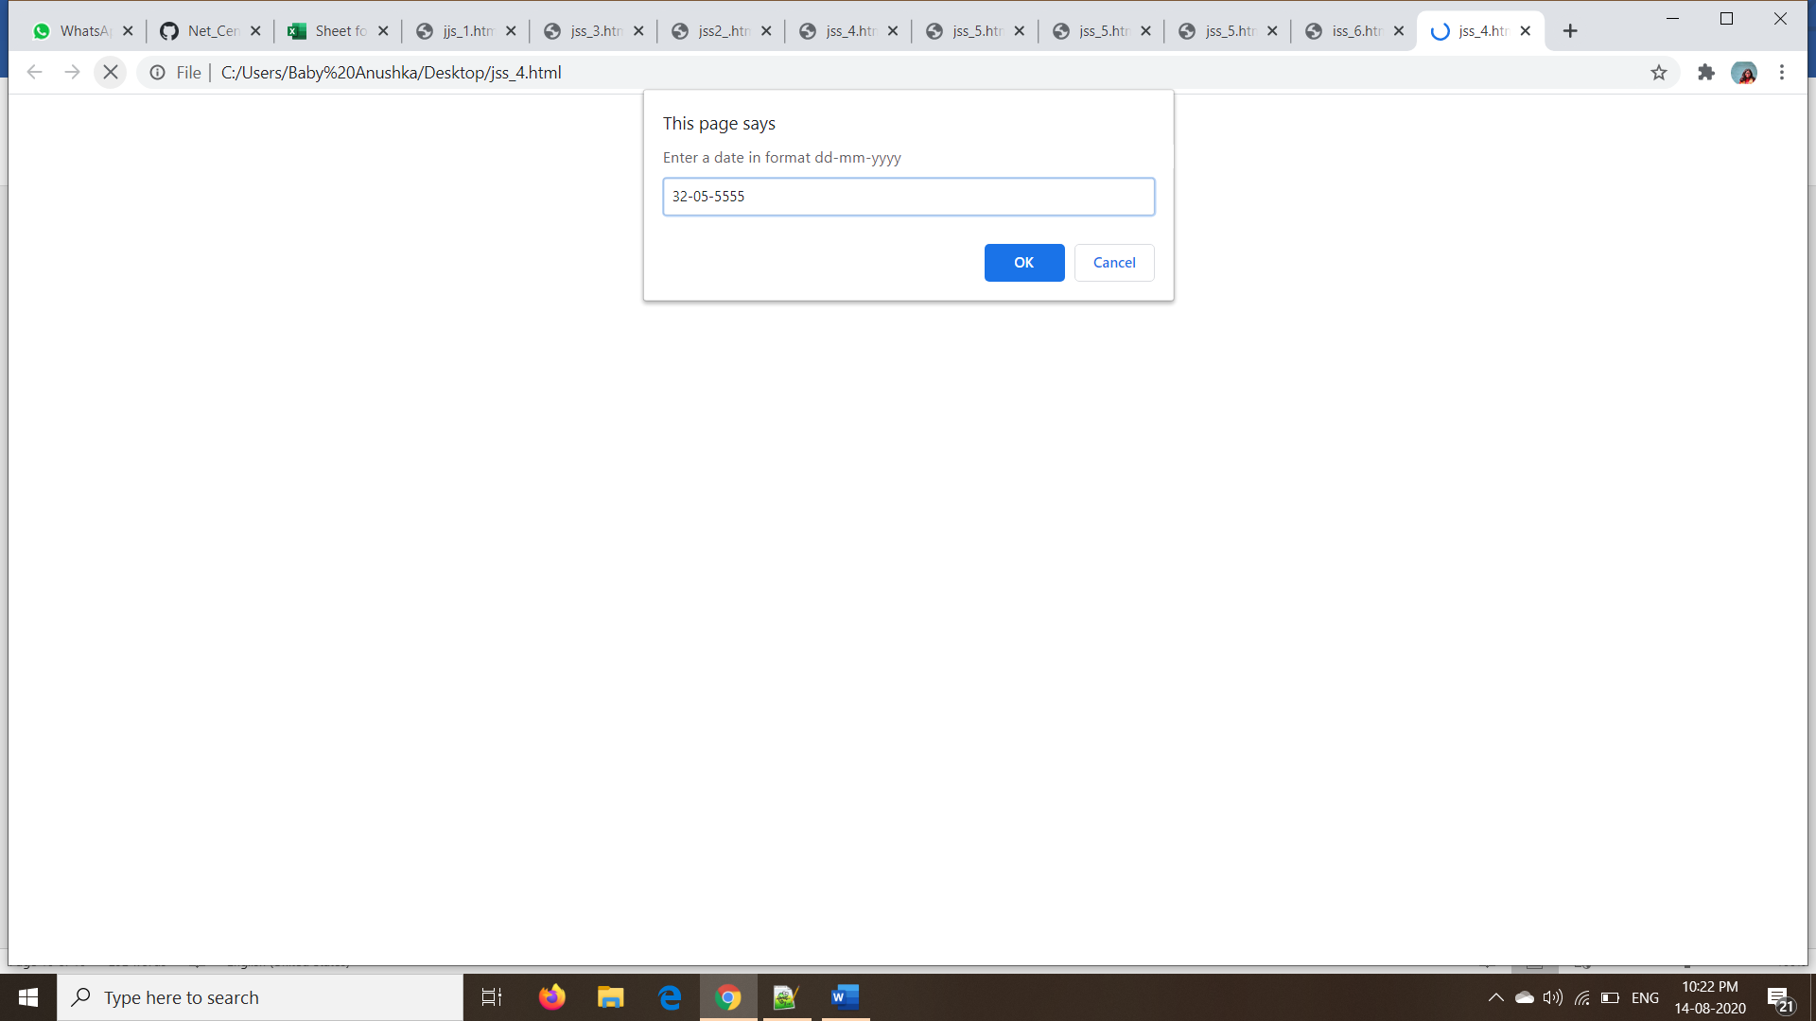

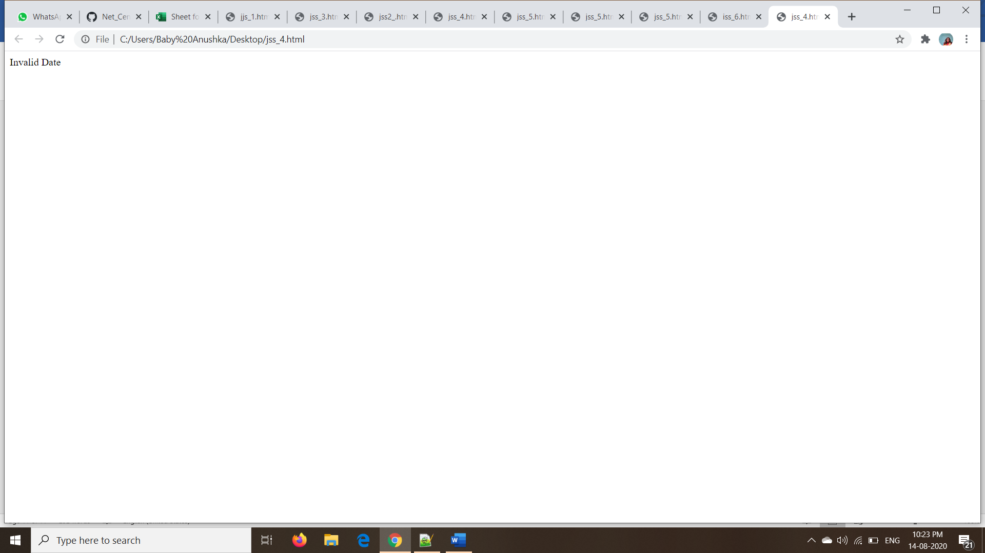

5)

<!DOCTYPE html>

<html>

<head>

</head>

<body>

<script type="text/javascript">

fizzbuzz();

function fizzbuzz()

{

try{

for(var i =1;i<=100;i++)

{

if(i%3==0 && i%5==0)

{

document.write("FizzBuzz"+'<br>');

}

else if (i%3==0)

{

document.write("Fizz"+'<br>');

}

else if (i%5==0)

{

document.write("Buzz"+'<br>');

}

else

{

document.write(i+'<br>');

}

}

}

catch(e)

{

document.write("Invalid");

}

}

</script>

</body>

</html>

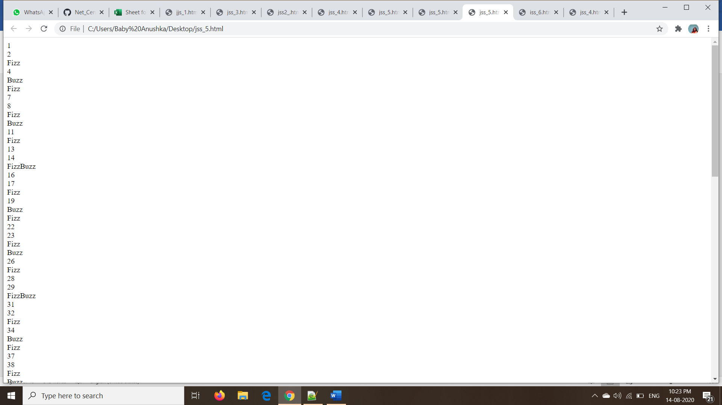

6)

<!DOCTYPE html>

<html>

<head>

</head>

<body>

<script type="text/javascript">

var avg=window.prompt("Enter exam score");

document.write(assignGrade(avg));

for(i=0;i<5;i++)

{

for(var j =60;j<=100;j++)

{

console.log("For"+ j+ " you got a "+ assignGrade(j));

}

}

function assignGrade(avg)

{

try{

if (avg < 60){

return 'F' ;

}

else if (avg < 70) {

return 'D';

}

else if (avg < 80)

{

return 'C';

}

else if (avg < 90) {

return 'B';

}

else if (avg <= 100) {

return 'A'

}

}

catch(e)

{

document.write("Invalid");

}

}

</script>

</body>

</html>

