**Game Sound: Audio Game Report**

INFR 2370 - U

Bill Kapralos

April 12, 2021

Kimberly Hansuwan 100752265

Farhan Irani 100748418

Ayi Pranayanda 100765502

Seshawn Suresh 100752981

Mrinank Sivakumar 100748771

Game Overview

In this Audio-Only game you must try to escape the dire situation that's been placed upon you. In order to escape, the player has to utilize all of the clues given from checking around the environment, and piece together the right solution. As the player you have certain actions to do within the game to help operate your escape. You can press the key ‘U’ to use an item when looking at a direction. You can press ‘I’ to inspect the direction you are looking at. You can press any of the arrow keys on the keyboard to look in the respective directions, left arrow key for left, right arrow for right, up arrow for up, down arrow key for down, however the space bar is to look forward. The number keys from 1 to 9 represent the order of inventory slots you can have. Automatically the items you find throughout the game will be placed in the inventory slots.

In order to make an audio only game, we had to follow a script that made logical sense and have the responses for each compatible interaction in the game. Without the voice overs it would have been nearly impossible to know if you are interacting in the game the right way as it is the core type of sounds in this audio-only game. Binding each look option to a control, we describe the player what they see and give hints throughout the voice over with sudden changes in emotion while speaking to solve the puzzle. We make sure we repeat the option they chose so they can mentally categorize the choices so they would not feel confused. For example the look options and the use options. As you can see because we used storytelling as our primary audio, we must portray emotions through words and vocalize the world.

|  |
| --- |
| Script |
| Introduction:  Hello player! , in this audio only escape room you have 4 core functions to help operate the game. The look function allows you to look up, down, left, and right using the respective arrow keys, pressing the spacebar makes you look forward. I represent inspection and U represents using a tool. Using the numbers 1 to 9 represents inventory slots obtained in the specific escape room.  Scenario 1: Buried alive  You awaken feeling dizzy and your head aches. You hear birds chirping and trees rustling. You open -your eyes and assess the situation around you, realizing that you have fell inside a hole. You get up and try to climb out, but the walls are too slippery, and you fall again and got your foot stuck on something. You check your pockets and find that you have no possessions of anything. What would you like to do?  **Look left option:** You look to your left and see your bag torn apart, must have been from the fall. You check to see what is inside and found only a Pocket Saw. Pocket Saw to inventory slot 1. What would you like to do?  **Look Left option 2:** You look left again and see your empty torn bag sitting there, must not be useful anymore. What would you like to do?    **Look right option:** You look to your right and hear rushing water on the other side of the wall, there seems to be the root of a plant sticking out, you give it a tug but its really stuck in there. What would you like to do?  *USE BRANCH*: You use the branch and dig around the root of the plant, the water seems closer, you pull on the root and water starts rushing out flooding the hole. You think you are going to die, but the water starts pushing you up. You swim up and get out of the hole. You think back to the clover and smile again, you’ve escaped.    **Look up option:** You look up and see a tree growing halfway up the wall, seems out of my arms reach. What would you like to do?  *USE GRAPPLE:* You use the grapple on the tree hoping you can pull yourself out, but it broke a branch off, Branch added to inventory slot 4.  **Look down option:** You look down and find a large rock. What would you like to do?  *INSPECT ROCK:* You closely examine the rock and see a 4-leaf clover next to it, you laugh mumbling to yourself, “not so lucky now huh?”. You pick up the clover, put it in your pocket and notice the rock moved, might not be so heavy. What would you like to do?  *USE VINES:* You tied the vines to the rock, Rock weighted Grapple added to inventory slot 3  **Look forward option:** You see your foot tangled between some vines. What would you like to do?  *USE SAW*: You used the saw to cut the vines off, looks sturdy, kind of like rope. Vines added to inventory slot 2. What would you like to do?  Thanks for Playing - You have escaped the buried alive scenario. Good job! Thanks for playing! |

SFX

The sound effects that we chose in the game really emphasised outdoors, and we wanted to announce the importance of textures in the sounds. For example, we have sound effects of a branch being dropped, and the branch falling has a wooden sound to it as it is collating with the ground. In addition, we wanted to tell a story, not only by voice over but also by sound effect to give the player’s an imaginary scenario in their head for example, cutting vines or swimming. We want the player to feel as if they were there making their own decisions and also feeling their environment around them. We also wanted realistic sounds or sounds that would be similar to real life sounds so that it would not be hard to distinguish and the player is able to adapt and relate to these sounds as they are sounds that they’ve probably heard before. Furthermore, these sound effects were very great at immersing the player and without these sounds then the game would feel like it’s a speech only game.

The disadvantages of Audio-Only Escape Rooms

Experiencing an escape room in person is a lot different than playing it audio only for multiple reasons. In a real one of course you can see what is around you, you can feel immersed with most of your senses being stimulated in the situation. What you hear, feel, see, smell and maybe sometimes taste. With audio only, you only get the hearing sense put to the test. When playing the Alexa app as a group, we understood that there were drawbacks we could not fix due to the nature of its functionality. Specific commands can only be taken from the AI because they could not understand what you are saying otherwise. The AI is expecting something specifically said from its own understanding. For example, asking to see a trash can would not be the same as saying the garbage can. There's also the unintuitive aspect of execution in commands with gameplay. If you look in a direction, but want to utilize a tool you just received in another direction, you have to reexamine the specific location in order to have the choice to use the tool. If you fail the examination then you would have to restart from the beginning to visit the location intended and try again.

Since we are not using a speaking AI to direct our game, we had to break it down a bit further. Fortunately we have a control scheme to operate our game instead of speaking to an AI that can only hear specific words as triggers. With the abundance of words in a language, having controls simplifies that issue to something easy.

Inspirations found from other games

Ayi:

A game that I played on audiogames.net was a game that was similar to Tetris and Candy Crush Saga called Blindfold Color Crush. What stood out to me the most was that choosing or arranging the candy is replaced with not words, but sounds to replace them. For the inspiration of our game I suggested that sounds will portray the story better when doing tasks and the game will feel more like a game if we added sound effects instead of just voice lines. Some sounds that they used were gem sounds, sport teams sounds, wild west sounds, space sounds. They all have a very distinct sound.

Seshawn:

A game that I found similar to our game was Starfinder, Dead Suns. This game is actually available on the Alexa and I got to give it a try from my Alexa. This game has a ⅘ star rating which is pretty high since amazon alexa skills tend to be rated brutally. This game is basically a role playing game where you pretend to be in a foreign universe with unique atmospheric sounds and unique voice actors that were enthusiastic. When we made Kimberly do the voice acting, we told her to have a similar happy voice as it is more cultivating.

Mrinank:

My game that I got inspired by was Club Penguin Spy Missions because they have a similar storyline that I picked up while helping create the script. In Club Penguin Spy Missions you have to collect and solve items to put together and join items found in your inventory. Not to mention, there are many puzzles before collecting pieces and hidden areas and places you have to hide. It’s not an escape room by any means, however it does carry key elements such as searching, finding, combining materials to rescue yourself.

Kimberly:

The game that I was inspired by was a game called New Tia Story. While we were all doing a group session of playing audio games, this game was rather unique compared to the other games because it was based on crafting equipment based on the pieces collected. The interesting bit about this game is that there are 10 different classes and skill sets based on acquired items. I suggested that we base crafting to a more puzzle based and hoping that the player would use their brain to connect two and two together with their given abilities.

Work Distribution



20% Kimberly Hansuwan, 100752265

Voiced over the script and edited

-------------------------------------------------------------

20% Farhan Irani, 100748418

Created the program

-------------------------------------------------------------

20% Ayi Pranayanda, 100765502

Created the program

-------------------------------------------------------------

20% Seshawn Suresh, 100752981

Wrote Script and edited

-------------------------------------------------------------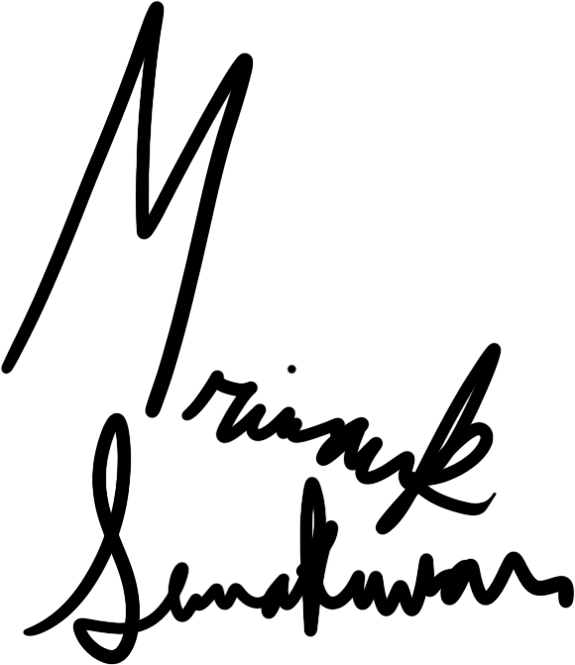

20% Mrinank Sivakumar, 100748771

Found sound effects & created sound effects