Lab 13 – Ansible Playbook and AWS Ubuntu EC2

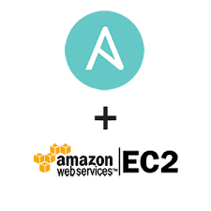

Prerequisite:
Setup NEW AWS EC2 OR Azure VM instance with Ubuntu Server. Refer previous week-12 class work and recording

NOTE: If no Azure/AWS credit available then you can use Virtual Box to complete your exercise

After you are ready with your virtual machine instance login using ssh and then follow below given steps.

Step 1: Install Ansible on AWS Ubuntu EC2 instance

- System Update

$ sudo apt update
$ sudo apt install software-properties-common
$ sudo apt-add-repository --yes --update ppa:ansible/ansible

Press Ctrl + c to exit when you get 404 error

- Install Ansible
$ sudo apt install ansible

- Verify ansible version
$ sudo ansible --version

Take a screenshot and name file as ansible_install.jpg

Step 2: Clone following GitHub reposotiry

$ git clone https://github.com/pritamworld/devops_ansible_playbooks.git

Step 3: Run barebones_ansible.yaml to install java, docker and Jenkins

- Change directory using
$ cd tiger

- Run barebones_ansible.yaml
$ sudo ansible-playbook barebones_ansible.yml

Take a screenshot and name file as barebones_ansible.jpg

Step 4: Run sample PlayBook1.yml
- Change directory using
$ cd lion

- Run PlayBook1.yaml
$ sudo ansible-playbook PlayBook1.yml

Take a screenshot and name file as PlayBook1.jpg

Step 5: Run sample part1.yaml for Assignment 2
- Change directory using
$ cd assignment2

- Run part1.yaml
$ sudo ansible-playbook part1.yml

Take a screenshot and name file as assigmment2-part1.jpg

Submission

Upload all 4 screenshots on singe PDF file with appropriate title.

