Lab 11 – Containerization


PART – I: Creating our own Docker image using Dockerfile
PART – II: Deploying existing nginx image using Kubernetes deployment and services

PART – I: Creating our own Docker image using Dockerfile
Moving forward with our Docker setup, this week we will take a deeper dive in creating containers by creating an instance of a Docker image. Before moving forward, please give your setup a quick test run to make sure you’re all set up by running the following command:
`docker run hello-world`

When building apps with Docker, the process is typically started at the bottom of the apps architecture which means the process is started with a container.

Portability with Docker
If you’ve ever had the task of creating a Python app, your first order of business was to install the version runtime onto your local dev environment. Doing this creates a situation where the execution of the script requires the same runtime for it to have the assurance of successfully running if it were ported over to a different environment. Essentially the local developer environment needs to mirror a production environment to assure the application will run as expected.

Docker allows a developer to grab a portable Python runtime as an image with absolutely no installation needed. This creates an environment where the app can build run right alongside the specific version of python chosen and set in the Dockerfile. This ensures that the app has the needed dependencies, and the runtime all travel together when switching to a new environment.

Defining containers with Dockerfile’s
A container is defined through a special configuration file unique to Docker. Docker’s configuration file is appropriately referred to as a Dockerfile. Dockerfile’s define the contents of a container's dependencies – everything from the flavor of Linux that the application is to run, runtime environment specifics, network configurations and so forth. It’s with this file that provides the guarantee of identical configurations and runtimes when the Dockerfile is used to produce a container.

Open up a terminal and create a new directory in your home name lab11_Docker. Please change to the newly created directory. Using the `touch` command, please create a new file titled ‘Dockerfile. You can see an image of how I completed this but please take note of the commands used. You’ll want to then copy and paste the following:
`
# Use an official Python runtime as a parent image
FROM python:3.11-slim
# Set the working directory to /app
WORKDIR /app
# Copy the current directory contents into the container at /app
COPY . /app
# Install any needed packages specified in requirements.txt
RUN pip install --trusted-host pypi.python.org -r requirements.txt
# Make port 80 available to the world outside this container
EXPOSE 80
# Define environment variable
ENV NAME World
# Run app.py when the container launches
CMD ["python", "app.py"]
`

As for the commands used to generate the file and what it looks like after pasting the above into my editor, please refer to the below images.
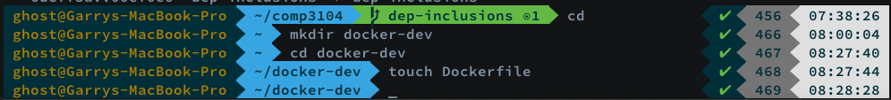
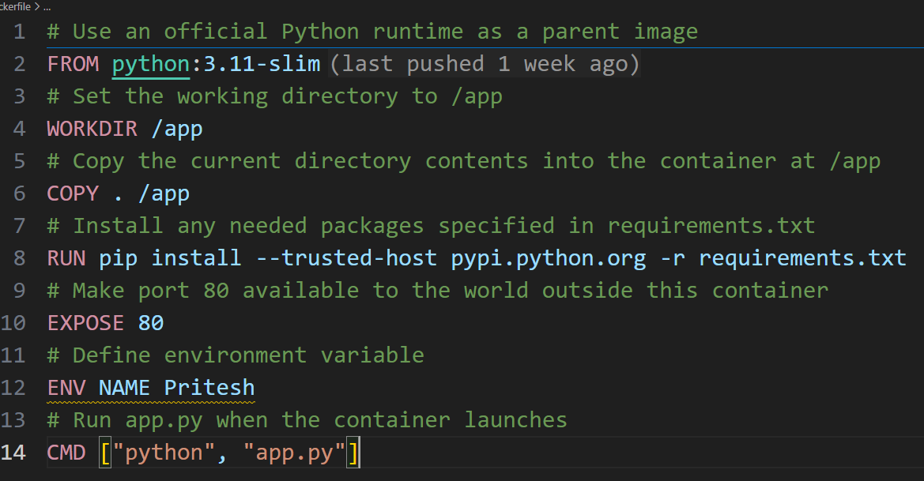
If you noticed on line 11, we’re instructing Docker to run a file that does not exist. On line 20, we are again running Docker syntax to interface with a file that does not exist. Line 11 expects there to be a `requirements.txt` file and line 20 wants there to by an `app.py`. We’ll get into the syntax but first, let’s create these files and write some code.

Writing our containerized application
We’re going to be creating two more files, requirements.txt and app.py. Let’s create these two files in our newly created directory where our Dockerfile lives. The application source itself is quite simple coming in at under 25 lines. If you’re not familiar with Python, one thing to know is that the language uses whitespace to denote blocks. As JavaScript uses curly braces to denote this, the Python interpreter relies on whitespace to delineate blocks of logic.
Our requirements file is going to contain our applications requirements, AKA it’s dependencies. Which the app only has two, making our requirements file only two lines. Let’s start with what we’ll be populating our requirements.txt file with:
`
Flask
Redis
`
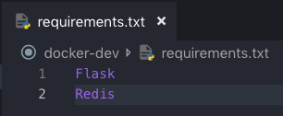
Please take note of these two lines as you’ll see the same keywords found in the source code for our applications dependency import statements. Here is the application source, please not lines 1 and 2:
`
from flask import Flask
from redis import Redis, RedisError
import os
import socket

# Connect to Redis
redis = Redis(host="redis", db=0, socket_connect_timeout=2, socket_timeout=2)

app = Flask(__name__)

@app.route("/")
def hello():
try:
visits = redis.incr("counter")
except RedisError:
visits = "<i>cannot connect to Redis, counter disabled</i>"
html = "<h3>Hello {name}!</h3>" \
"<b>Hostname:</b> {hostname}<br/>" \
"<b>Visits:</b> {visits}"
return html.format(name=os.getenv("NAME", "world"), hostname=socket.gethostname(), visits=visits)

if __name__ == "__main__":
app.run(host='0.0.0.0', port=80)
`
To clear up any questions of whitespace, here is a screen grab of the source correctly defined in my editor:
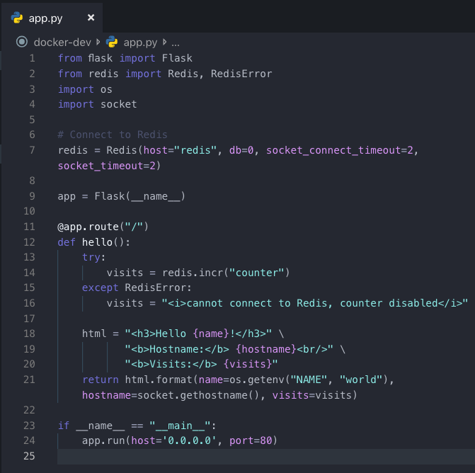
On line 11 of our Dockerfile, we see that `pip install –r requirements.txt` command is used to install Python libraries for Flask and Redis. Flask is a lightweight HTTP server used to create web servers and applications with Python. Redis is a caching system commonly used to improve the performance of web applications. Redis works with key/value data structures and stores them in-memory for fast data reads.

On line 21 of our Python script, we are looking for an environment variable called NAME, as well as an output of the call made with `socket.gethostname()` to retrieve the ID of the container that is running the code. Finally, because Redis isn’t running as we haven’t installed the service, only a library used to interface with the service, we should expect the attempt on line 14 to fail and a resulting exception message to be displayed.

Now, we have a Python script and a couple dependencies listed in a requirements file but take notice that we haven’t been asked to install Python, Redis or Flask. All we need is a Dockerfile to list our dependencies and on line 2, we can see that Python 2.7 is being used for the image which will be used to create a container instance. The container instance will have Python installed, our host machine doesn’t even need to know what Python is. Let’s try building the app and see what happens.

Be sure that your terminal is opened in our projects directory and when listed the directory contents, it appears as below with each file containing the contents illustrated above:
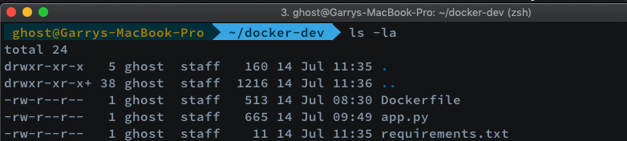

Now that we’ve confirmed we’re in the project directory in our terminal and have our files properly populated, it’s time to build our first Docker container, let’s run the following command and follow the output:
`docker build --tag=hellodocker .`

After executing the above command, we should see a success message as shown in the following screengrab which shows that the container was ‘Successfully built’.
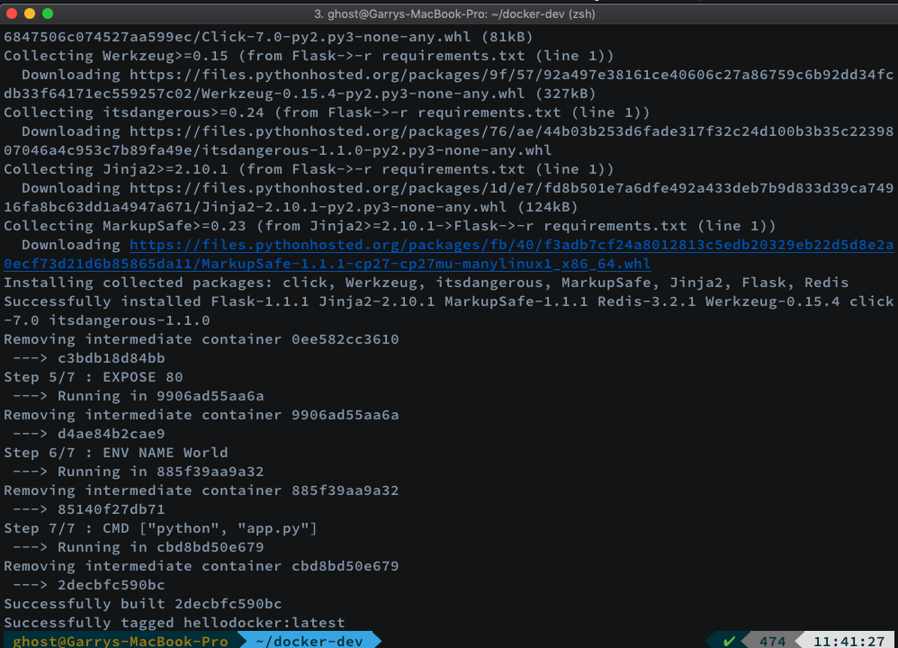
Okay, but where is the instance of our image AKA our container? It’s in your machine’s local Docker image registry:
When we executed our build command, we defined a tag name called ‘hellodocker’. We can see the tag name in the above image when executing ‘docker image’

Running our app
The time has come to run our Docker container which contains our Python script, a Python image and our dependencies. The following command is going to interact with our container, using port 80 where the application is hosted and we’ll map it to a defined port on our host machine, 4000.
`docker run -p 4000:80 hellodocker`
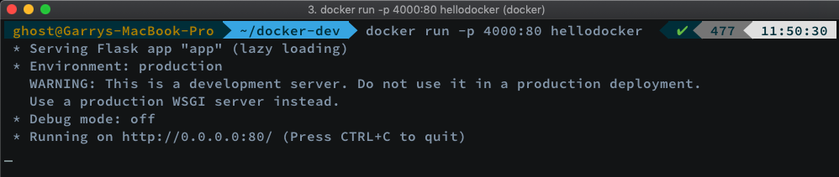
To break down the above command a bit, `docker run` is used to run a container that is listed in our registry. We are then using the `-p` switch to map some ports. The ports being mapped is port 80 from our container where the application is hosted. Port 80 is mapped to port 4000 on our host machine. This means that we should be able to request the Flask application defined in our app.py script by requesting localhost:4000 in a browser on our host machine and be presented with the HTML from our app.py script.
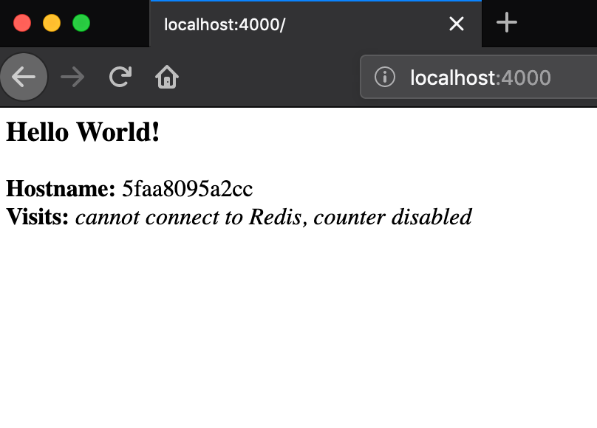We’ll also see the Redis coutner is not working as we weren’t able to increment since we don’t have the service installed... yet.

If you’re not feeling like opening a browser and wanting to make the request from the command line, don’t forget about the power of curl which is very useful when debugging web requests in your terminal.
`curl http://localhost:4000`
As the above terminal screengrab shows, we weren’t able to connect to Redis as the service is not yet set up. In our next lab, we’ll see how services can be used in our Docker container.

Before finishing this lab, let’s stop our container from running. Go back to your terminal where the `docker run` command was issued on our containers tag name. You should notice some logged web requests if you requested the application hosted on port 80 inside the container.
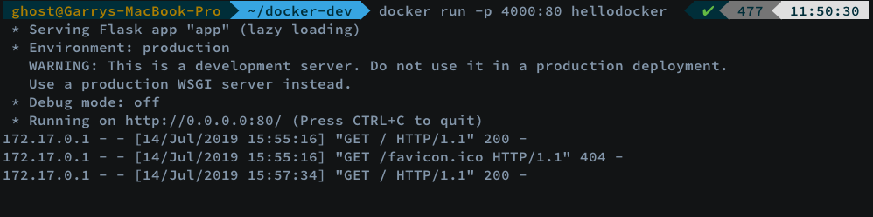
Let’s cancel this by issuing a `ctrl-c` in the terminal running our docker container. If you wanted to ensure the container is no longer running, `docker container ls` can be executed for confirmation. If you see a container ID, you can stop it by running:
`docker container stop CONTAINER_ID`

CONTAINER_ID is to be replaced with the ID outputted when executing `docker container ls`

PART – II: Deploying existing nginx image using Kubernetes deployment and services
Login to Github and fork following repo and clone repo on your computer
https://github.com/pritamworld/DevOps_Kubernetes_exercise9

Follow class or class recording to execute following commands step by step and take screenshots for each steps

Apply & verify:
kubectl apply -f nginx-deploy.yaml
kubectl apply -f nginx-service.yaml
kubectl rollout status deployment/nginx
kubectl get pods -l app=nginx -o wide
kubectl get svc nginx-nodeport

Access it from Minikube:
# Easiest (prints a URL and opens a tunnel if needed):
minikube service nginx-nodeport --url

# Or hit the NodePort directly:
MINIKUBE_IP=$(minikube ip)
curl http://$MINIKUBE_IP:30080

Cleanup
kubectl delete -f nginx-deploy.yaml
kubectl delete -f nginx-service.yaml
# or, if you used the one-liners:
kubectl delete svc nginx-nodeport
kubectl delete deploy nginx

