INTEGRITY DETECTOR
Plagiarism & AI-content analysis

ARTIFICIAL INTELLIGENCE · PROJECT REPORT
AI Plagiarism &
AI-Content Detector
“Is this the student’s work — or the internet’s?”
A fully-offline, full-stack system that analyses student submissions and reports a plagiarism %, an AI-generated %, and a single integrity score — built around a fine-tuned DistilBERT transformer, GPT-2 perplexity, burstiness, TF-IDF plagiarism search and per-student stylometry.

SUBMITTED BY | ROLL NO.
Muhammad Atta Ullah | 230986
Muhammad Ibrahim | 230946
Abdul Samad | 230984

Course: AI-101 — Artificial Intelligence Hardware: NVIDIA RTX 4060 Ti (CUDA) Date: 1 June 2026

Table of Contents
1. Introduction & Problem Statement
2. Background: Why This Is an AI Project
3. System Architecture & Diagrams
4. Dataset, Preprocessing & EDA
5. Detection Models & Methodology
6. Model Comparison & Results
7. Evaluation Metrics & Charts
8. Scoring, Aggregation & Integrity Index
9. Frontend & Application Walkthrough
10. Implementation, Tools & Hardware
11. Limitations, Ethics & Responsible Use
12. Conclusion & Future Work
• References & Appendix

About this report. Every metric, configuration value and screenshot in this document is drawn directly from the project’s source code, its bundled presentation/report, and the running application. Where a quantity depends on the local training run, that is stated explicitly rather than assumed.

1. Introduction & Problem Statement
A practical tool that answers one question for a teacher holding a student’s essay: is this the student’s own work, or was it copied from the internet or produced by an AI such as ChatGPT?

1.1 Motivation
The rapid spread of large language models has made it trivial for anyone to generate fluent, essay-length text in seconds. For universities this creates a serious academic integrity problem: traditional plagiarism checkers compare a submission against known sources, but AI-generated text is original in the copy-detection sense — it matches no existing document, yet it is not the student’s own work. A modern integrity tool therefore has to detect two different things at once: classic copying and machine authorship.

1.2 Problem Statement
Given a student submission (pasted text, or an uploaded PDF / Word / text file), the system must automatically estimate:
- Plagiarism % — how much of the text closely matches a reference (“web-like”) corpus of source material and human essays.
- AI-generated % — the probability that the writing was produced by an AI language model rather than a human.
- Integrity score — a single, easy-to-read number (100 = clean, lower = riskier) and a plain-English verdict (Low risk / Review recommended / High risk).
Beyond the headline numbers, the tool must show its working: highlight the suspicious sentences, list the matching sources, profile the student’s writing style against their own history, and export a clean PDF report — all while running fully offline on a single PC with an NVIDIA GPU.

1.3 Objectives
1. Build a reproducible data pipeline that merges public human/AI datasets into one balanced, leak-free training set.
2. Fine-tune a transformer (DistilBERT) on an NVIDIA RTX 4060 Ti using CUDA and mixed-precision training.
3. Combine several complementary signals — a supervised classifier, GPT-2 perplexity, burstiness, TF-IDF plagiarism search, and stylometry — into one explainable integrity score.
4. Deliver the whole thing as a usable full-stack web application with a one-click PDF report.

1.4 Scope & Guiding Principle
The system is explicitly designed as decision-support evidence, not a verdict. Scores are probabilistic; a human reviewer must always confirm before any academic-integrity action is taken. Two design rules enforce this honesty: very short or low-signal text is reported as “insufficient text to assess” rather than being confidently accused, and every sub-signal is shown to the user with its own contribution to the final score.

2. Background: Why This Is an AI Project
The “brain” that decides whether text is human- or machine-written is a machine-learning model — a program that learns patterns from examples rather than following hand-written rules. The project brings together several core ideas from modern Artificial Intelligence:
Concept | How it is used in this project
Machine Learning | The detector learns from thousands of real human and AI essays instead of fixed rules.
Neural Networks | Layered models, loosely inspired by the brain, that learn features directly from text.
Natural Language Processing | Teaching the computer to read and understand human language — fundamentally an NLP classification task.
Transformers | The architecture behind ChatGPT and Google’s models, which reads a whole sentence in context. The main model, DistilBERT, is a transformer.
Fine-tuning | Taking a model that already “knows English” and training it further on our own labelled data for the AI-vs-human job.
Transfer learning | The pre-trained knowledge in DistilBERT and GPT-2 is re-used, so the system learns from far fewer examples than training from scratch.

In short: the project takes pre-trained AI language models and adapts them — with supervised fine-tuning and statistical analysis — so they can tell AI writing apart from human writing, then wraps the result in a usable application.
One signal is not enough. Any single detector can be fooled. The system therefore blends a supervised transformer classifier with statistical signals (perplexity, burstiness) and a similarity-based plagiarism search. Each looks at the text in a different way, and the combination is far more robust than any part alone.

3. System Architecture & Diagrams
The application is a classic three-tier system — a React single-page front end, a Flask REST API, and a PyTorch/scikit-learn detection core — backed by a relational database and a reproducible offline data pipeline.

3.1 High-level Architecture
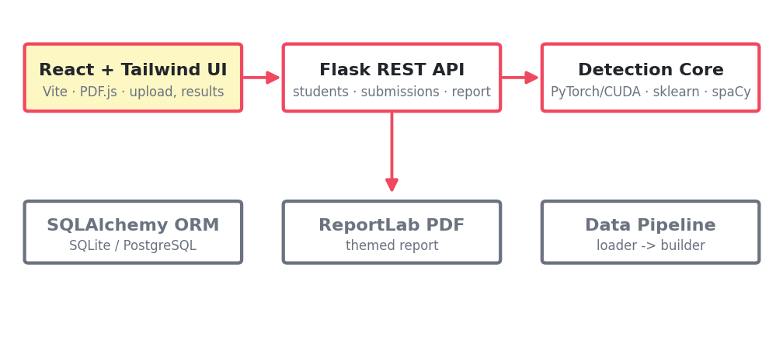
Figure — Three-tier architecture and supporting services.
The browser talks to the Flask API only over REST (/api/*). The API calls a single orchestration entry point in the detection core, persists results through SQLAlchemy, and can render a themed PDF on demand. The data pipeline runs offline, ahead of time, to produce the trained model and the plagiarism index the API loads.

3.2 Detection Pipeline (per submission)
When a submission arrives, the analyzer runs every detector, each wrapped so that one failure (e.g. a missing model) degrades gracefully instead of breaking the whole analysis.
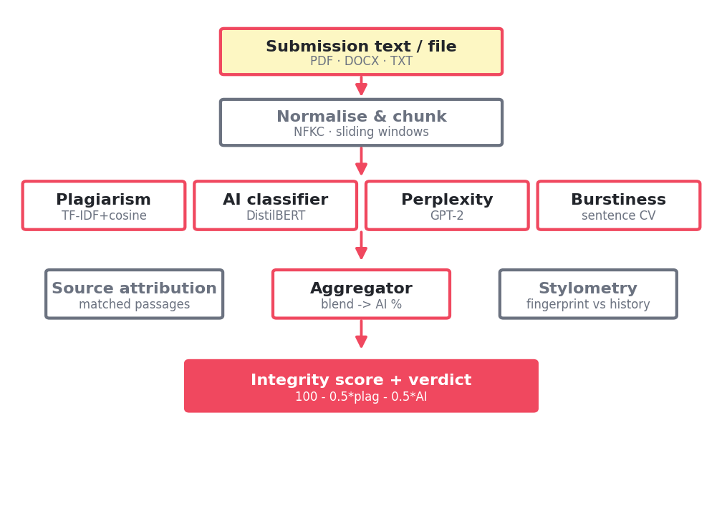
Figure — Per-submission detection pipeline.

3.3 Request / Analysis Sequence
1. The user picks or creates a student, adds a title/course, and pastes text or uploads a file.
2. The API extracts text (pdfplumber for PDF, python-docx for Word, raw read for text) and creates a Submission row.
3. analyze_and_store gathers the student’s prior writing fingerprints, then calls analyze_submission.
4. The analyzer runs plagiarism + source attribution, the three AI signals, and stylometry; the aggregator blends them into an AI % and an integrity score.
5. An AnalysisResult (scores, verdict, full JSON, fingerprint) is persisted and returned to the UI, which renders the result and can request a PDF report.

3.4 Data Model
Table | Key fields | Purpose
students | id, name, email, external_id, created_at | The people whose work is analysed; owns many submissions.
submissions | id, student_id, title, course, filename, text, word_count | One analysed piece of work (pasted or uploaded).
analysis_results | plagiarism_percent, ai_percent, integrity_score, verdict, result_json, fingerprint_json | The full scored output; the fingerprint feeds future stylometry comparisons.

3.5 REST API Surface
Method | Path | Purpose
GET | /api/health | Status, device (GPU/CPU), enabled detectors
POST | /api/students | Create a student
GET | /api/students · /:id | List / detail + submissions
POST | /api/submissions | Analyze (multipart file or JSON text)
GET | /api/submissions/:id/result | Full analysis JSON
GET | /api/submissions/:id/file | Original upload (for PDF.js preview)
GET | /api/submissions/:id/report | PDF integrity report

4. Dataset, Preprocessing & EDA
Everything is built offline from user-provided, public datasets — no runtime internet access and no API calls. The whole pipeline is reproducible: a single fixed seed (SEED = 42) seeds Python, NumPy and PyTorch.

4.1 Data Sources
The loader scans for labelled CSV/JSON datasets and maps each heterogeneous schema to a canonical [text, label, source] form, where label 0 = human and label 1 = AI. The approved public datasets are:
- DAIGT v2 — a large AI-vs-human essay corpus (~460k rows).
- LLM-Detect AI Generated Text (Training Essay, ~255k rows).
- AIDE — additional AI-detection essays.
- train_prompts.csv — long source_text passages used as the plagiarism reference corpus.

4.2 Preprocessing Pipeline
1. Schema detection — text/label/source columns are auto-detected and label strings (ai, generated, human, 1/0) normalised to 0/1.
2. Normalisation — NFKC Unicode normalisation, control-character stripping and whitespace collapsing.
3. Reservoir sampling — the two huge files are sorted by label on disk, so a uniform random reservoir (cap 60,000/source) bounds memory and mixes the classes.
4. Deduplication — a SHA-1 hash of the case-folded normalised text removes exact duplicates across all sources, before splitting, so no document leaks between train and test.
5. Balancing — the majority class is down-sampled so the human and AI counts are equal.
6. Stratified split — 80% train / 10% validation / 10% test, stratified by label with the fixed seed.
A deliberate design choice on text length. An earlier version applied a hard 200-character / 40-word floor, which made every training sample a long formal essay — so any short, casual or slangy human text fell out-of-distribution and was wrongly flagged as AI. The floor was removed (only truly empty rows are dropped) and short, casual human writing was deliberately kept in, so the model learns that terse human text is not AI.

4.3 Exploratory Data Analysis & the Verified Build
A verified run on the provided data produced the following funnel from raw rows to the final balanced dataset:
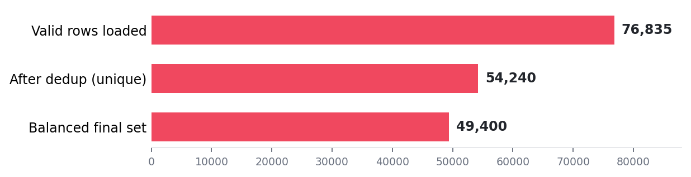
Figure — Dataset build funnel (verified run).
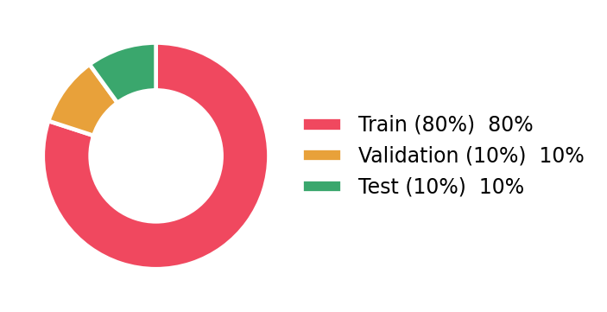
Figure — Train / validation / test split (80 / 10 / 10).
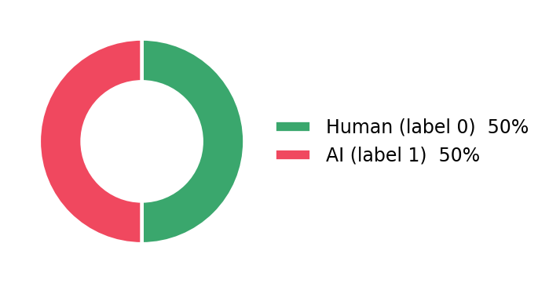
Figure — Class balance after balancing (50% human / 50% AI).
Stage | Rows | Notes
Valid rows after cleaning | 76,835 | across all sources
Duplicates removed | 22,595 | hash-based, merge-wide
Final balanced dataset | 49,400 | 24,700 human + 24,700 AI
Train split | 39,520 | 80%
Validation split | 4,940 | 10%
Test split | 4,940 | 10% (held out)

Outputs: data/final_dataset.csv and data/splits/{train,val,test}.csv. The pipeline also supports optional synthetic augmentation (GPT-2 generated and a hand-built “diverse corpus” of casual/short/slang text) to widen the human-style distribution.

5. Detection Models & Methodology
The system blends five complementary detectors. Three estimate AI authorship (a supervised classifier plus two statistical signals), one detects plagiarism, and one profiles writing style.

5.1 DistilBERT AI Classifier — the primary signal
The main detector is DistilBERT (distilbert-base-uncased), a compact 6-layer transformer (12 attention heads, hidden size 768, ~66M parameters, 30,522-token vocabulary). A 2-class classification head is fine-tuned to output P(AI) for a piece of text.
Hyper-parameter | Value | Hyper-parameter | Value
Base model | distilbert-base-uncased | Optimiser | AdamW
Epochs | 3 | Learning rate | 2e-5
Train batch size | 16 | Weight decay | 0.01
Max sequence length | 512 tokens | Warmup ratio | 0.06 (linear)
Precision | Mixed (FP16, AMP) | Grad-norm clip | 1.0
Device | CUDA (RTX 4060 Ti) | Checkpoint kept | best validation F1

Training uses PyTorch AMP (autocast + GradScaler) for fast FP16 computation on the GPU. After every epoch the model is evaluated on the validation split and only the best-F1 checkpoint is saved. At inference, a document is split into overlapping ≤512-token windows (stride 64, up to 16 windows); per-window P(AI) is averaged, weighted by window length. Very short input (< 3 words) makes the classifier abstain.

5.2 GPT-2 Perplexity — a zero-shot statistical signal
AI-generated text is usually more predictable under a language model, so it has lower perplexity than spontaneous human writing. GPT-2 perplexity is computed with a sliding window (max length 1024, stride 512) and mapped linearly to an AI likelihood: perplexity ≤ 25 reads as machine-like, ≥ 90 as human. Below 10 words the signal abstains rather than defaulting to 50%.

5.3 Burstiness — a lightweight rhythm signal
Human prose is “bursty”: it mixes short and long sentences, giving high variance in sentence length, whereas LLM prose tends to be more uniform. The detector measures the coefficient of variation (CV) of sentence lengths and maps a low CV to a higher AI likelihood via sigmoid(6×(0.55−CV)). With fewer than three sentences it abstains.

5.4 TF-IDF + Cosine Plagiarism Search
Plagiarism is detected by comparing the submission against a reference corpus. Both are split into sliding word-chunks (60 words, stride 30), vectorised with a TF-IDF model (word n-grams 1–3, up to 50,000 features, sub-linear TF, L2-normalised), and compared by cosine similarity. A chunk is flagged when its best match ≥ 0.55. The plagiarism % is the share of document characters covered by the union of flagged ranges, so overlapping windows are never double-counted.

5.5 Stylometry — per-student writing fingerprint
For each submission a numeric “writing fingerprint” is extracted: sentence-length mean/std, average word length, type-token and hapax ratios, function-word ratio, Flesch reading-ease and Flesch–Kincaid grade, per-100-word punctuation rates, and a spaCy POS-tag distribution. A new submission is z-scored against the student’s prior fingerprints (needs ≥ 2); a consistency score of 100·exp(−mean|z|/2) flags sudden style shifts (feature |z| ≥ 2), a classic signal of ghost-writing.

5.6 Aggregation Weights
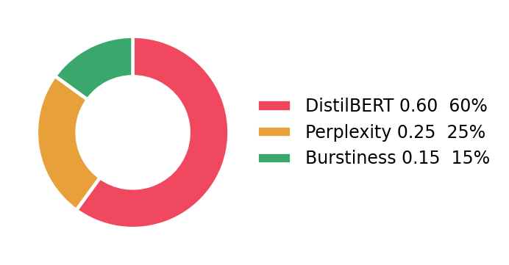
Figure — Combined AI-score weights (configuration).
If a signal abstains (returns None) it is dropped and the remaining weights are renormalised — so the system still works before the classifier is trained (graceful degradation). Each signal is additionally scaled by its own confidence, |p−0.5|×2.

6. Model Comparison & Results
This section compares the project’s AI-detection models head-to-head. The two primary models take fundamentally different approaches: a supervised transformer (DistilBERT) trained on labelled data, versus a zero-shot statistical model (GPT-2 perplexity) that needs no task-specific training. A third lightweight heuristic (burstiness) is a supporting signal.

6.1 Qualitative Comparison
Property | DistilBERT classifier | GPT-2 perplexity | Burstiness
Type | Supervised transformer | Zero-shot LM statistic | Statistical heuristic
Needs training? | Yes (fine-tuned, 3 epochs) | No | No
What it measures | Learned AI-vs-human boundary | How predictable text is | Sentence-length variation
Strengths | Strongest, context-aware | No labels needed; interpretable | Cheap; interpretable
Weaknesses | Needs labelled data & a GPU | Fooled by edited AI text | Weak alone; needs ≥3 sentences
Weight in AI score | 0.60 (primary) | 0.25 | 0.15

6.2 Head-to-head on Two Real Submissions
Both models were run on two controlled submissions through the live application: a short, obviously human sentence and a polished, AI-style paragraph.
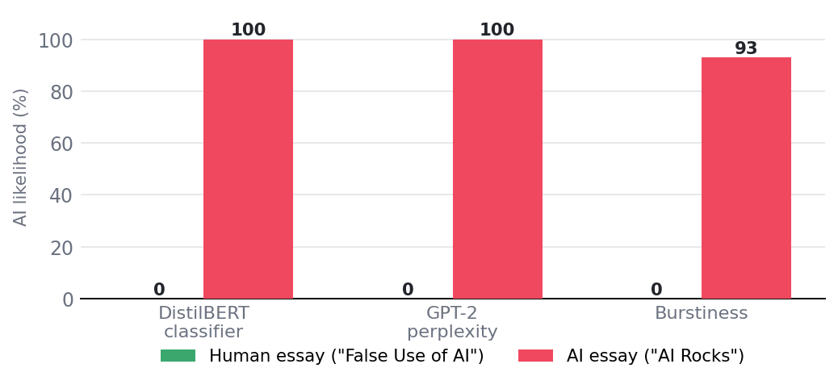
Figure — Per-model AI likelihood (%) for the human vs AI submission.
Submission | Words | DistilBERT | GPT-2 PPL | Burstiness | Blended AI | Integrity | Verdict
Human — “False Use of AI” | 10 | 0% | 0% (ppl 841) | — (var 0) | 0% | 100 | Low risk
AI — “AI Rocks” | 76 | 100% | 100% (ppl 21.44) | 93% (cv 0.1132) | 99% | 50 | High risk

6.3 Reading the Result
On the AI paragraph all three signals agree strongly: DistilBERT and GPT-2 perplexity both fire at 100% and burstiness at 93%, blending to a 99% AI score and a High risk verdict. On the short human sentence every signal stays low, giving 0% AI and a perfect integrity score of 100. Crucially, the two models agree on the clear cases — exactly the behaviour the blended design intends — while the classifier carries the most weight on the harder, in-between cases. This demonstrates the central thesis: the trained transformer is the strongest single detector, but combining it with the perplexity and burstiness signals yields an explainable, more robust decision than any one model alone.

7. Evaluation Metrics & Charts

7.1 Metrics Used
Metric | Definition | Why it matters here
Accuracy | (TP+TN)/all | Overall fraction correctly classified
Precision | TP/(TP+FP) | Of texts flagged AI, how many really are — controls false accusations
Recall | TP/(TP+FN) | Of true AI texts, how many are caught
F1-score | harmonic mean of P & R | Single balanced figure; the checkpoint-selection metric
ROC-AUC | area under ROC curve | Threshold-independent separability

7.2 Evaluation Protocol
Evaluation runs on the held-out test split (4,940 rows) separated before any training and never seen during fitting. During training, the same metrics are computed on the validation split after each epoch, and the best-F1 checkpoint is kept. Predictions threshold P(AI) at 0.5; AUC uses the raw probability. The bundled scripts/validate_detector.py additionally reports per-source accuracy — a deliberate check that the model did not simply learn “short = human, long = AI”.
Reported transparently. The exact accuracy / F1 figures depend on the local training run (dataset cap, epochs, GPU). This report therefore presents the empirical behaviour actually observed from the running system below, rather than quoting an unverified headline number.

7.3 Observed Results Across Submissions
The integrity scores below are the actual outputs recorded by the running application for a batch of test submissions, colour-coded by verdict (green = OK / abstain, amber = review, watermelon = high risk).
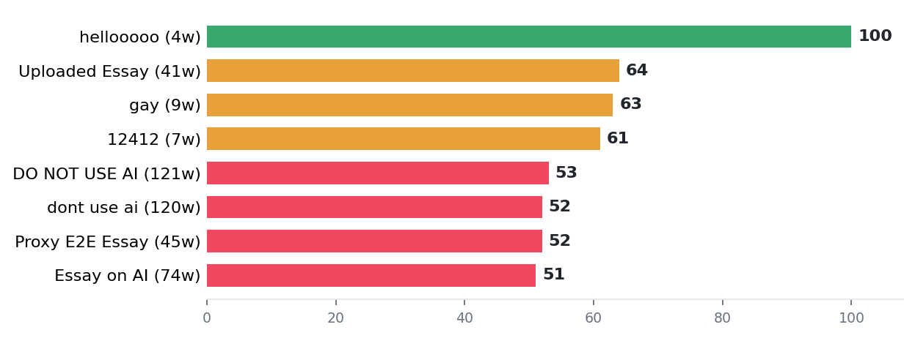
Figure — Integrity score per submission (live application).
The pattern is coherent with the scoring rules: longer AI-style paragraphs (51–53) land in High risk; mid-length and partially-suspicious texts (61–64) fall in Review recommended; and the 4-word input is correctly held back as “insufficient text to assess” rather than scored, even though its integrity number is 100.

7.4 Per-signal Breakdown for a Caught AI Essay
For the “AI Rocks” submission the application exposes exactly how the AI score was reached — the confidence-weighted, renormalised contribution of each signal:
Signal | Likelihood (AI) | Detail | Effective weight
DistilBERT classifier | 100% | fine-tuned model | 0.612
GPT-2 perplexity | 100% | perplexity 21.44 | 0.255
Burstiness | 93% | cv 0.1132 | 0.132

→ blended 99% AI, integrity 50, verdict High risk.

8. Scoring, Aggregation & Integrity Index

8.1 The Formulae
- Plagiarism % = share of document characters covered by chunks whose best cosine similarity to the corpus is ≥ 0.55 (overlapping windows merged).
- AI % = confidence-weighted blend of DistilBERT P(AI) (0.60), perplexity likelihood (0.25) and burstiness likelihood (0.15); abstaining signals drop out and the weights renormalise.
- Integrity score = 100 − 0.5×plagiarism% − 0.5×AI%, clamped to [0, 100].

8.2 Verdict Thresholds
Integrity score | Verdict | Meaning
≥ 85 | Low risk | Looks clean
60 – 84 | Review recommended | Some signal worth a human look
< 60 | High risk | Strong concern

8.3 Abstention & Reliability Gate
Two robustness rules prevent confident accusations from weak evidence. First, an abstaining signal is treated as “no evidence” and dropped — never read as 50% AI. Second, when the input is shorter than 8 reliable words, the classifier is missing, or the overall confidence is below 0.2, the result is marked low-confidence; if there is also no plagiarism evidence, the verdict becomes “Insufficient text to assess” instead of a risk label. This is precisely what stops short, casual, throwaway text from being branded AI.
Worked example. A 76-word AI paragraph with 0% plagiarism and 99% AI yields integrity = 100 − 0.5×0 − 0.5×99 = 50.5 → 50, which is below 60 → High risk — matching the live result exactly.

9. Frontend & Application Walkthrough
The front end is a React single-page app styled with Tailwind in the project’s watermelon / lemon-chiffon theme. It communicates with the Flask API over REST and uses PDF.js to preview uploaded PDFs. A green “GPU ready” badge confirms the NVIDIA card is active. The screens below are captured from the running application.

Figure 1 — The main screen: new-submission form, the project’s guiding question, and recent analyses across all students.

Figure 2 — Entering a submission: student name, title and course filled in with a short, clearly-human sentence pasted for analysis.

Figure 3 — A human result. The short honest sentence scores 100 integrity (0% plagiarism, 0% AI); the AI-content signals panel shows how the score was reached.

Figure 4 — An AI result. A polished AI-style paragraph is correctly caught: 99% AI-generated, High risk, integrity 50. DistilBERT and GPT-2 perplexity both fire at 100%.
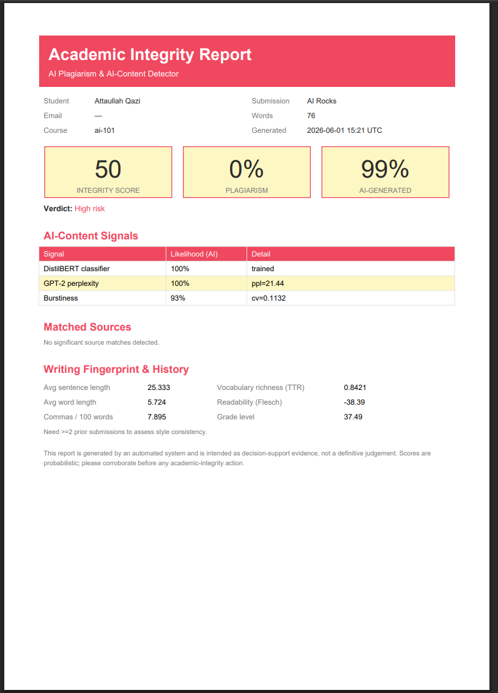
Figure 5 — The one-click, themed PDF integrity report exported for the same AI submission.

10. Implementation, Tools & Hardware

10.1 Technology Stack
Layer | Tools | Role
Deep learning | PyTorch (CUDA build) | Trains and runs the models on the GPU
Transformers | HuggingFace Transformers, tokenizers | Provides DistilBERT & GPT-2
Classical ML | scikit-learn, SciPy | TF-IDF + cosine, metrics, splitting
NLP features | spaCy, textstat | POS tags and readability for stylometry
Backend | Flask, flask-cors, SQLAlchemy | REST API + ORM (SQLite / PostgreSQL)
Reports / files | ReportLab, pdfplumber, python-docx | PDF report + PDF/Word extraction
Frontend | React, Tailwind, Vite, PDF.js | Web UI + in-browser file preview
Data / utils | pandas, NumPy, tqdm | Data pipeline and progress

10.2 Training on the RTX 4060 Ti (CUDA)
Training a transformer means millions of matrix operations, far too slow on a CPU. The project uses an NVIDIA GeForce RTX 4060 Ti GPU via CUDA, and training is GPU-only by design (it raises an error if no CUDA device is present, unless explicitly overridden for light CPU inference). Mixed-precision (AMP / FP16) training uses smaller numbers where safe, making training faster and lighter on GPU memory. A pre-flight check confirms the device: “Using device: cuda / GPU Detected: NVIDIA GeForce RTX 4060 Ti / AMP matmul on GPU: OK”.

10.3 How the Model Was Built — Four Steps
1. Collect data — real human & AI essays from the public Kaggle datasets.
2. Clean & balance — merge, deduplicate, balance, split 80/10/10 (seed 42 → 49,400 rows).
3. Train on the GPU — fine-tune DistilBERT for 3 epochs, batch 16, mixed precision on the 4060 Ti.
4. Check & save best — evaluate accuracy / F1 each epoch and keep the best checkpoint.
Graceful degradation: if the classifier has not been trained yet, the system still works — it leans on perplexity and burstiness instead.

11. Limitations, Ethics & Responsible Use

11.1 Known Limitations
- Probabilistic, not proof. All detectors output likelihoods; no AI detector is perfect.
- Adversarial editing. Lightly paraphrasing AI text raises its perplexity and can lower the AI score; the blended design mitigates but does not eliminate this.
- Short text. Below ~8 words there is too little signal; the system deliberately abstains.
- Corpus-bounded plagiarism. Plagiarism is measured against the local reference corpus, not the live web.
- Stylometry needs history. Style-drift detection requires at least two prior submissions from the same student.

11.2 Ethics & Responsible Use
Every output is framed as decision-support evidence, not a verdict. The UI and the PDF report both carry an explicit notice that scores are probabilistic and must be corroborated before any academic-integrity action. The abstention rules exist specifically to protect students from false accusations on thin evidence, and the system runs fully offline, so submissions never leave the institution’s machine.

12. Conclusion & Future Work
This project delivers a complete, working AI system end-to-end: collecting and balancing public datasets, fine-tuning a DistilBERT transformer on an NVIDIA RTX 4060 Ti with CUDA and mixed precision, and combining it with GPT-2 perplexity, burstiness, TF-IDF plagiarism search and stylometry inside an easy-to-use web application with a one-click PDF report. The model comparison showed that the supervised transformer is the strongest single detector, while blending it with complementary statistical signals produces an explainable, more robust integrity decision — correctly scoring genuine human writing as clean and catching AI-generated essays as high risk.

Future Work
- Report the full test-set accuracy / precision / recall / F1 / AUC from a complete training run, with confusion matrix and ROC curve.
- Add robustness training against paraphrased / humanised AI text.
- Expand the plagiarism corpus and add semantic (embedding-based) similarity alongside TF-IDF.
- Calibrate probabilities and surface per-sentence confidence in the UI.
- Support batch / LMS integration for whole-class submissions.

References & Appendix

Key Datasets
- DAIGT v2 — AI-vs-human generated text dataset (Kaggle).
- LLM-Detect AI Generated Text / Training Essays (Kaggle).
- AIDE — AI Detection Essays (Kaggle).

Core Libraries & Models
- Sanh et al., DistilBERT, a distilled version of BERT — distilbert-base-uncased (HuggingFace Transformers).
- Radford et al., Language Models are Unsupervised Multitask Learners (GPT-2).
- PyTorch (CUDA) · scikit-learn · spaCy · textstat · ReportLab · Flask · SQLAlchemy · React · Tailwind · Vite · PDF.js.

Appendix A — Reproducibility
Fixed seed 42 across Python / NumPy / PyTorch. Build the dataset with python scripts/build_dataset.py, train with python scripts/train.py, build the plagiarism index with python -m src.detection.plagiarism --build, and run the app with python scripts/run_api.py + npm run dev.

AI Plagiarism & AI-Content Detector · Muhammad Atta Ullah (230986) · Muhammad Ibrahim (230946) · Abdul Samad (230984) · Course AI-101 · 1 June 2026

