AI Plagiarism & AI-Content Detector
An Artificial Intelligence Project
“Is this the student’s work — or the internet’s?”

Prepared by: Muhammad Attaullah Qazi, Muhammad Ibraim, Abdul Samad
Course: AI-101
Hardware: NVIDIA GeForce RTX 4060 Ti (CUDA)

1. What Is This Project?
This project is a smart tool that checks a student’s written work and answers one question: is the writing really the student’s own, or was it copied from the internet or written by an AI like ChatGPT?
When a student pastes text or uploads a file (PDF, Word, or text), the system reads it and gives three results:
- Plagiarism % — how much of the text looks copied from other sources.
- AI-generated % — how likely the text was written by an AI.
- Integrity score — one simple score (100 = clean, lower = riskier) plus a verdict.
It also highlights suspicious sentences, shows matching sources, studies the student’s writing style, and can download a clean PDF report. It runs fully offline on a normal PC with an NVIDIA graphics card.
2. How This Is an AI Project
This is an Artificial Intelligence (AI) project because the “brain” that decides whether text is human or AI is a machine-learning model — a program that learns from examples instead of following fixed rules. A few key AI ideas used here:
- Machine Learning — the field where computers learn patterns from data (here: thousands of human and AI essays).
- Neural Networks — software inspired by the brain, made of layers that learn features from text.
- Natural Language Processing (NLP) — teaching computers to understand human language. This is an NLP task.
- Transformers — the modern AI design (used by ChatGPT and Google) that reads a whole sentence at once and understands context. Our main model, DistilBERT, is a transformer.
- Fine-tuning — taking a model that already knows English and teaching it our specific job (“is this AI or human?”) using our own data.
In short: we took a pre-trained AI language model and trained it further on real examples so it could learn to tell AI writing apart from human writing.
3. The AI Models Used
The system blends several AI signals instead of trusting just one. Each looks at the text in a different way:
- DistilBERT classifier — the main model. A small, fast version of Google’s BERT transformer. We fine-tuned it to read text and output the chance that it is AI-written. It is the strongest signal (60% of the AI score).
- GPT-2 perplexity — GPT-2 measures how “surprised” it is by the text. AI writing is very smooth and predictable (low perplexity); humans are messier. (25% of the score).
- Burstiness — humans change sentence length a lot; AI keeps a steady rhythm. We measure this variation (15% of the score).
- TF-IDF + cosine similarity — for plagiarism, we turn text into number vectors (TF-IDF) and compare them to a library of sources using cosine similarity. A high match = likely copied.
- Stylometry — the system builds a “writing fingerprint” (sentence length, vocabulary richness, readability) and compares each new submission to the student’s past work to catch sudden style changes.
4. The Hardware: Training on an RTX 4060 Ti
Training an AI model means doing millions of math calculations. A normal CPU is too slow for this, so we used an NVIDIA GeForce RTX 4060 Ti graphics card (GPU), which can do many calculations at the same time.
- CUDA — NVIDIA’s technology that lets our code run on the GPU. The whole training is built to be GPU-only by design.
- Mixed precision (AMP) — we used “mixed precision” (FP16) training. This uses smaller numbers where safe, so training is faster and uses less GPU memory — perfect for the 4060 Ti.
Before training, a check script confirms the GPU is ready. Its output looks like this:
Using device: cuda
GPU Detected: NVIDIA GeForce RTX 4060 Ti
AMP matmul on GPU: OK
5. What Was Installed (Tools & Software)
The project uses free, open-source tools. The main ones:
Tool | What it does
PyTorch (CUDA build) | The deep-learning engine; runs the model on the GPU
HuggingFace Transformers | Provides DistilBERT and GPT-2 models
scikit-learn | TF-IDF and cosine similarity for plagiarism
spaCy | Language analysis for the writing-style features
Flask + SQLAlchemy | The backend server and database (stores students & results)
React + Tailwind | The web page the user sees and clicks
ReportLab / PDF.js | Makes the PDF report and previews uploaded files
Installation order matters: the CUDA build of PyTorch is installed first, then the rest with pip install -r requirements.txt, then the spaCy English model.
6. How the Model Was Created (Training)
The AI detector was built in clear steps:
- Step 1 – Collect data: we gathered real datasets of human-written and AI-written text (Kaggle sets like DAIGT v2 and LLM-Detect AI Generated Text).
- Step 2 – Clean & balance: the build script merges the files, removes duplicates, balances the human/AI counts, and splits them 80/10/10 into train, validation, and test sets (fixed seed = 42 so results are repeatable). A verified run produced 49,400 balanced rows.
- Step 3 – Train on the GPU: we fine-tuned DistilBERT on the training set for 3 epochs (3 full passes) using batches of 16, on the RTX 4060 Ti with mixed precision. The model learns by adjusting itself to reduce its mistakes each pass.
- Step 4 – Check & save the best: after each pass we test on the validation set (accuracy, precision, recall, F1) and keep the best version, saved to the checkpoints folder.
If the model has not been trained yet, the system still works — it simply leans on perplexity and burstiness instead. This is called graceful degradation.

7. How the App Works (Step by Step)
a) The main screen. The user picks or creates a student, adds a title, and pastes text or uploads a file. The green “GPU ready” badge shows the graphics card is active.
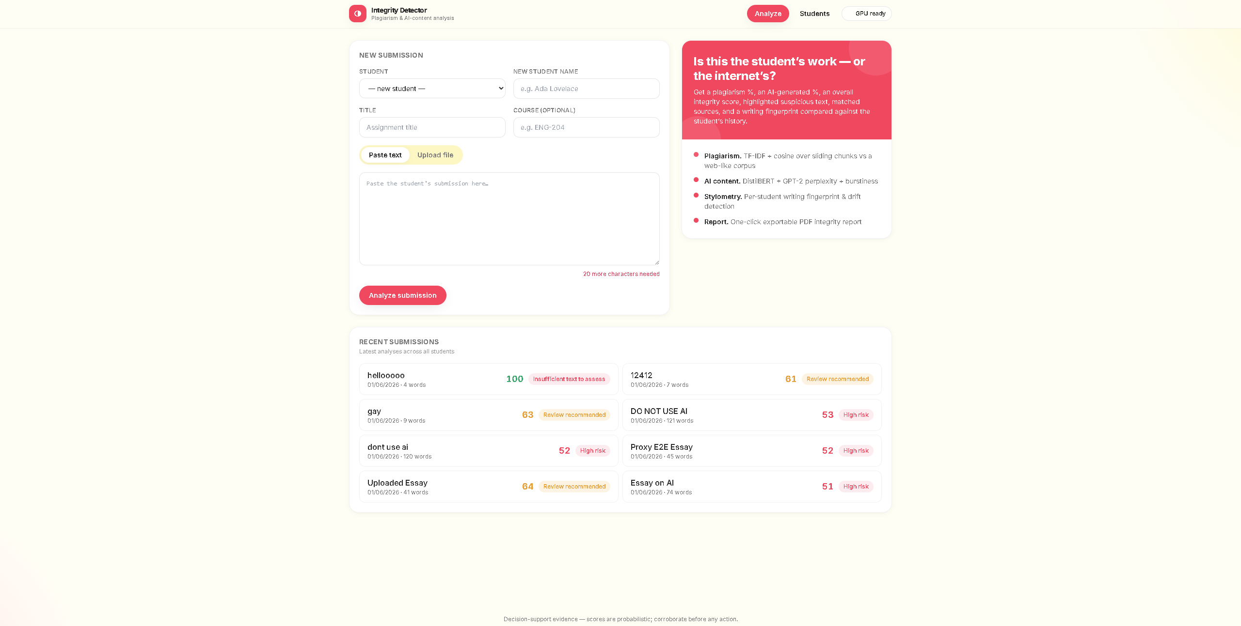
Figure 1 — The main screen: new submission form and recent results.
b) Entering a submission. Here student “Attaullah Qazi” adds a short, clearly human sentence for the course ai-101.
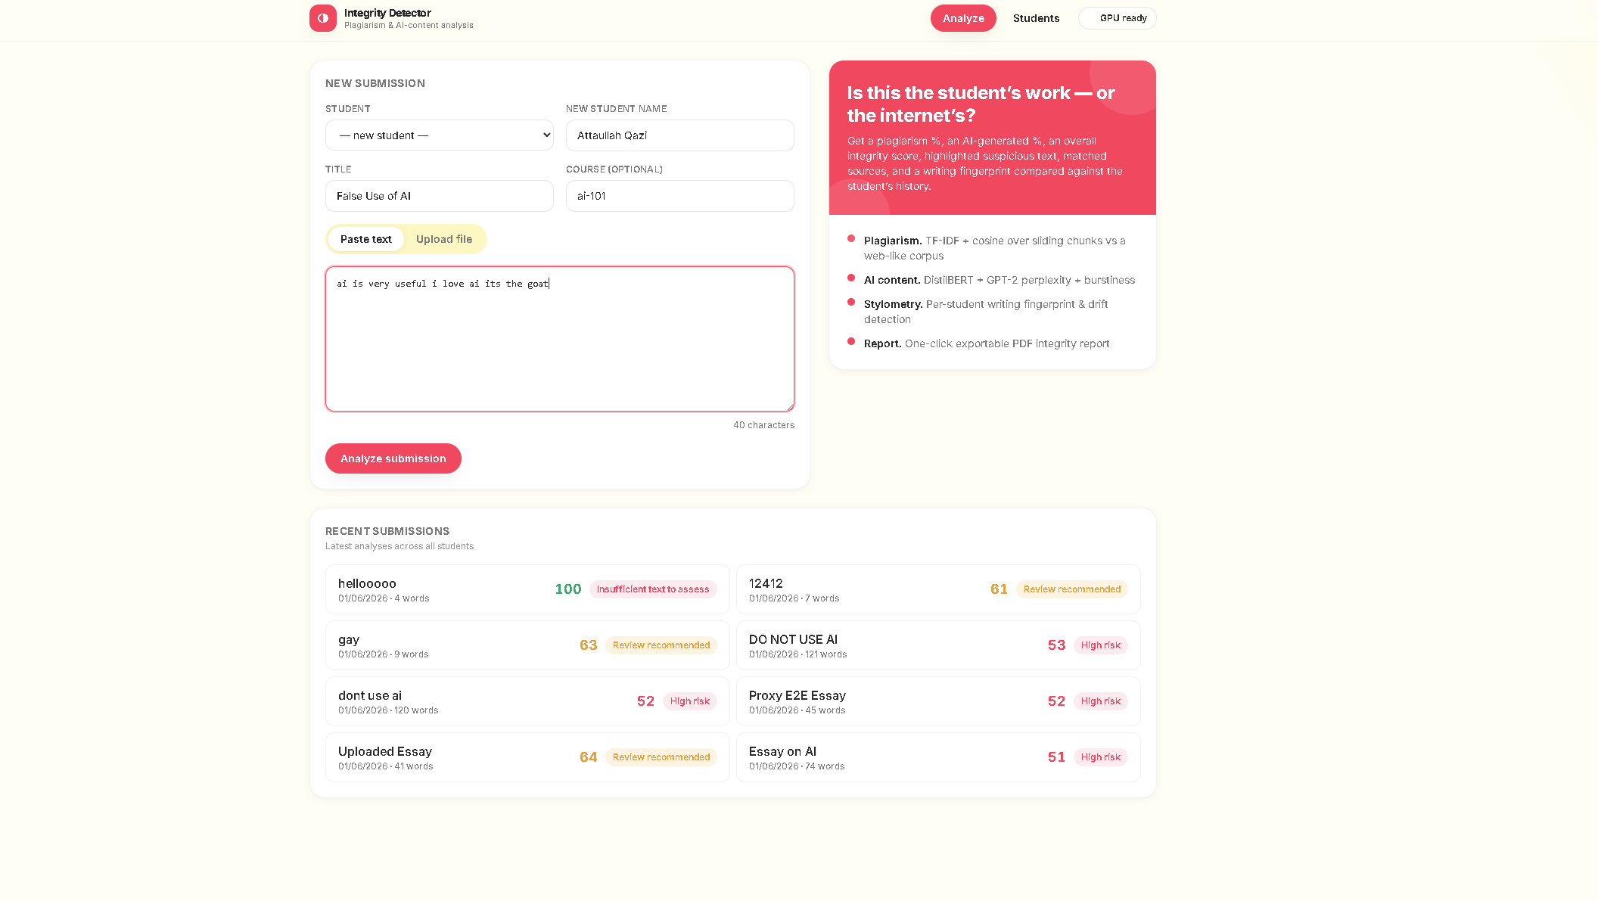
Figure 2 — Filling in the student details and pasting the text.
c) A human result. The short honest sentence scores 100 integrity — 0% plagiarism and 0% AI. The AI signals panel shows exactly how the score was reached.

Figure 3 — Human writing: 100 integrity, low risk.
d) An AI result. A polished, AI-style paragraph is correctly caught: 99% AI-generated, “High risk.” The DistilBERT classifier and GPT-2 perplexity both fire at 100%.
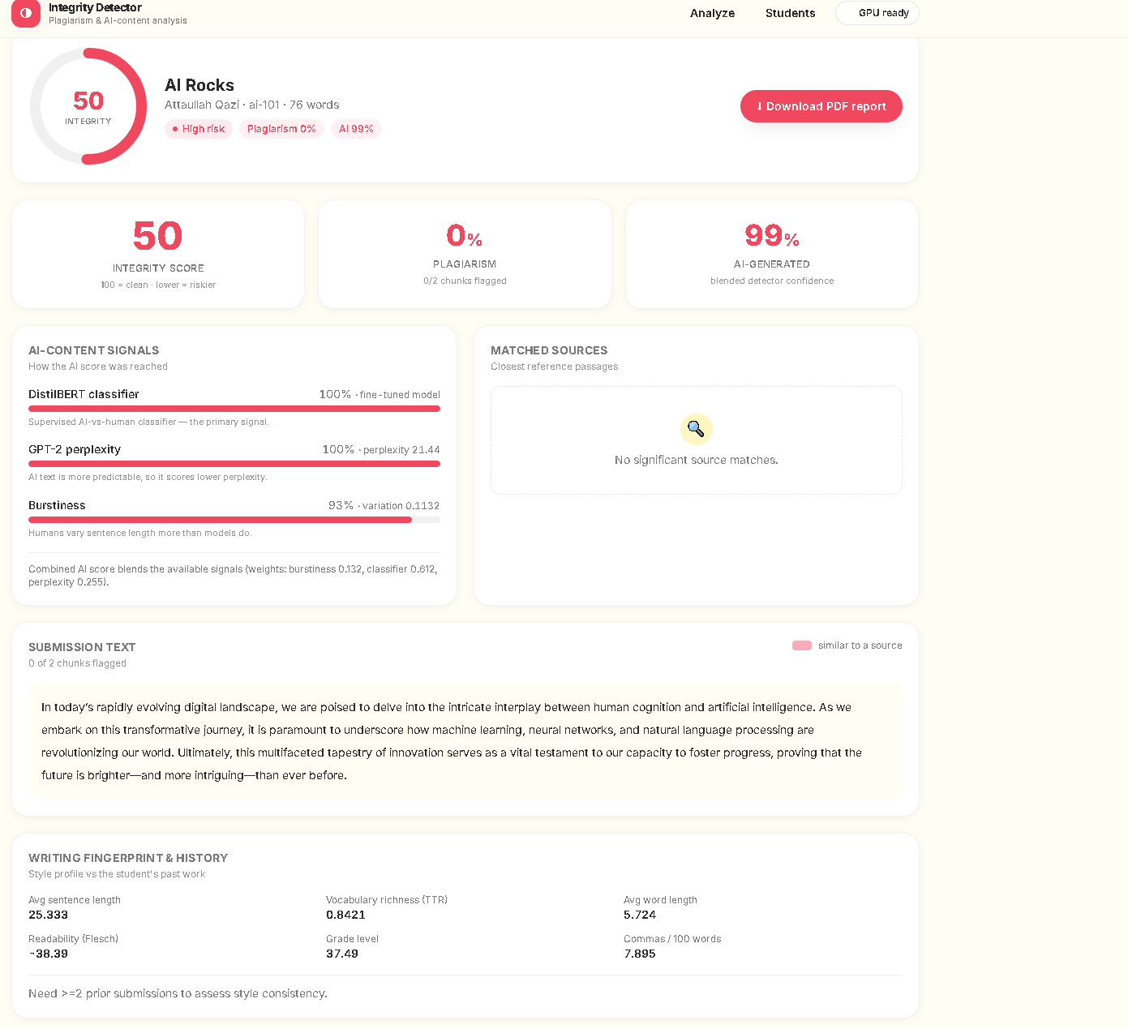
Figure 4 — AI writing detected: 99% AI, high risk.
e) PDF and file uploads work too. The same analysis is exported as a clean, themed PDF integrity report — and PDF/Word/text uploads are read automatically.
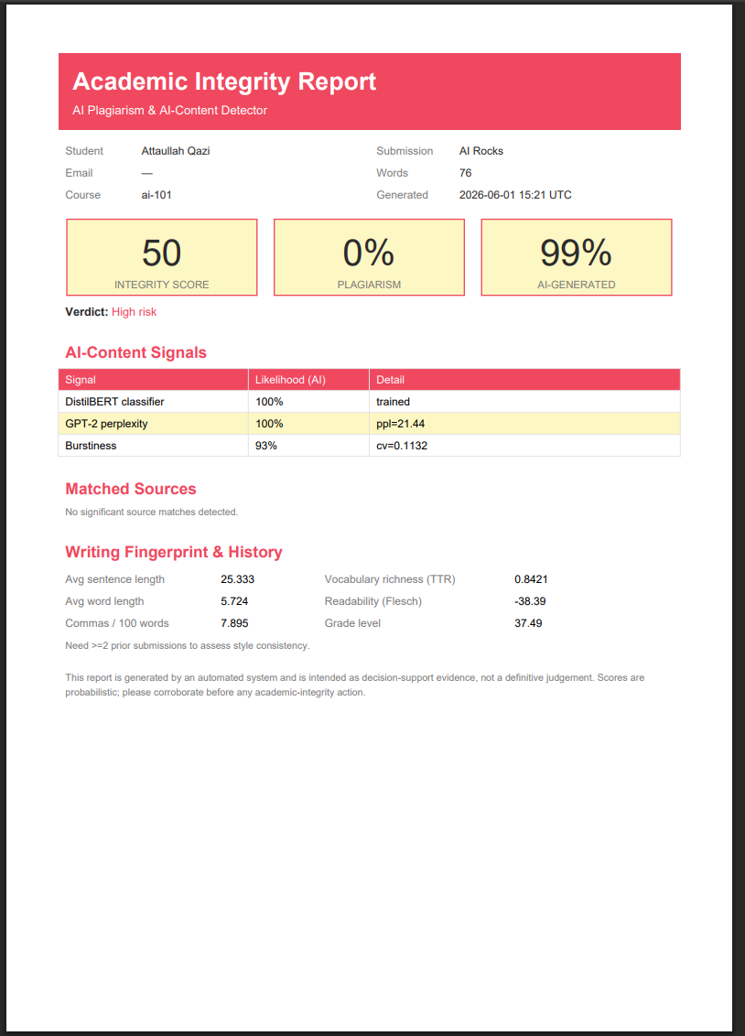
Figure 5 — The downloadable PDF integrity report.
8. How the Scores Are Calculated
- Plagiarism % = share of the text that closely matches a known source.
- AI % = blend of DistilBERT (0.60) + perplexity (0.25) + burstiness (0.15).
- Integrity = 100 − (0.5 × plagiarism%) − (0.5 × AI%).
Very short text (under 8 words) is marked “insufficient text to assess” instead of being wrongly accused. The report is decision-support evidence, not a final verdict — a teacher should always confirm before acting.
9. Summary
This project shows a complete, working AI system from start to finish: collecting data, fine-tuning a transformer model (DistilBERT) on an NVIDIA RTX 4060 Ti with CUDA and mixed precision, and putting it inside an easy web app. It combines several AI techniques — a trained classifier, perplexity, burstiness, similarity search, and stylometry — to help universities protect academic integrity in the age of AI writing.

