Game Design Document

Fill up the Following document

1. Write the title of your project.

The Redemption Goal

1. What is the goal of the game?

To get 20

1. Write a brief story of your game?

Last year Johnny was in the last minutes of the game, he only needed one more goal but if he missed he’d lose it all. The announcer went “Thee, Two, One, SHOOT!” and Johnny took the shot, it was perfectly on target and it just slipped past the defenders. It was about to go in, but it came to a rolling stop just inches from the goal. Johnny ran away in anger, vowing he’d win next year. Now, he’s back and ready to win it all.

1. Which are the playing characters of this game?

* Playing characters are the ones which respond to the user based on the input from the user
* Cars, monkeys, dinos, wizards etc, are the playing characters in the game.

|  |  |  |
| --- | --- | --- |
| Number | Character Name | What can this character do? |
| 1 | Johnny (You) | Kick the ball |
| 2 |  |  |
| 3 |  |  |
| 4 |  |  |
| 5 |  |  |
| 6 |  |  |
| 7 |  |  |
| 8 |  |  |

1. Which are the Non Playing Characters of this game?

* Non Playing characters are the ones which don't have an action or a behaviour when the user interacts with the game.
* Hurdles, stones, bananas, coins, etc are non playing characters in the game.

|  |  |  |
| --- | --- | --- |
| Number | Character Name | What can this character do? |
| 1 | Ball | Get scored, get stopped by defender, get kicked by Johnny |
| 2 | Goal | Can be scored on |
| 3 | Defenders | Can block the ball from going into the goal by moving side to side |
| 4 |  |  |
| 5 |  |  |
| 6 |  |  |
| 7 |  |  |
| 8 |  |  |

Draw your imagination of this game. What does this game look like?

* Draw the game either on your computer or on paper,
* Add images of scenes of the game to show each of the playing and non-playing characters at least once.

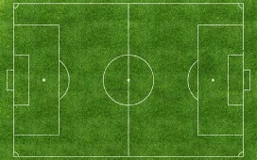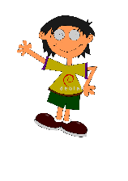

How do you plan to make your game engaging?

By making it harder as the game progresses, and by giving instant reward/feedback.