EduGenie
Google Gemini Powered Learning Assistant
Phase 3: Project Design
Field | Details
Project Title | EduGenie: Google Gemini Powered Learning Assistant
Phase | Phase 3: Project Design
Prepared by | Baby kiruthika N
Mentor | Durga D
College / Team ID | Government Arts College(Autonomous) Salem-7
Date | 28/09/2026

1. Solution Architecture
EduGenie follows a simple client-server design. The browser shows the interface, the FastAPI backend receives requests and builds prompts, and the Google Gemini API generates the response, which flows back to the browser.

User / Browser | ↔ | Frontend (HTML, CSS, JS) | ↔ | Backend (FastAPI) | ↔ | Google Gemini API
Fig. 3.1 Solution architecture of EduGenie

2. Components
Component | File | Responsibility
Frontend | frontend/index.html | Tabs, input boxes, buttons, result display and quiz scoring
Backend | backend/main.py | API endpoints, prompt building, Gemini API calls, error handling
Dependencies | backend/requirements.txt | List of Python libraries to install
AI Service | Google Gemini API | Generates answers, summaries and quiz questions

3. Data Flow
- Step 1: The user types input in a tab (Q&A, Summarize or Quiz) and clicks the button.
- Step 2: JavaScript sends a POST request with JSON to the matching backend endpoint using fetch().
- Step 3: FastAPI validates the JSON with Pydantic models and builds a prompt for Gemini.
- Step 4: The backend calls the Gemini API and receives the generated text.
- Step 5: For the quiz, the text is cleaned and parsed as JSON; other modules return the text directly.
- Step 6: The backend returns a JSON response, and the frontend displays it in the result box.

4. API Design
Endpoint | Method | Request Body | Response
/ | GET | None | Serves the index.html page
/api/qa | POST | { "question": "..." } | { "answer": "..." }
/api/summarize | POST | { "text": "..." } | { "summary": "..." }
/api/quiz | POST | { "topic": "...", "num_questions": 5 } | { "quiz": [ { question, options, answer } ] }

5. Prompt Design
Module | Prompt Template
Q&A | Answer this student's question clearly and simply: {question}
Summarize | Summarize the following text in 4-5 short bullet points: {text}
Quiz | Create {n} multiple-choice questions on the topic {topic}. Return ONLY valid JSON with question, four options and the correct answer.
The quiz prompt asks for strict JSON so the frontend can display each question with four options and check the selected answer against the correct one.

6. User Interface Design
- Header: project name EduGenie with the subtitle "Google Gemini Powered Learning Assistant"
- Three tabs: Q&A, Summarize and Quiz, with the active tab highlighted
- Q&A panel: question text area and a Get Answer button
- Summarize panel: large text area and a Summarize button
- Quiz panel: topic box, number-of-questions box and a Generate Quiz button
- Result box below the inputs to show responses; quiz answers turn green (correct) or red (wrong) after submitting.
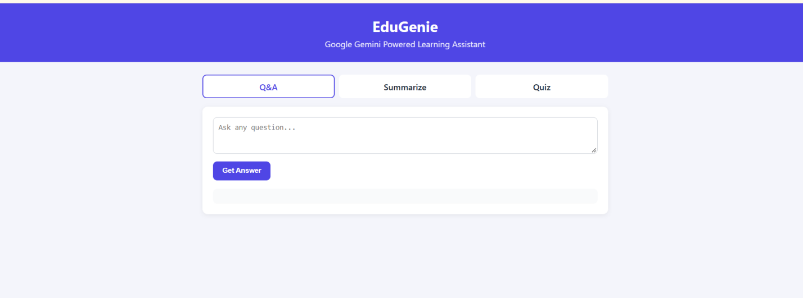
Fig. 3.2 User interface of EduGenie

7. Quiz Answer-Checking Flow
- The backend returns each question with four options and the correct answer.
- The frontend shows the options as radio buttons and adds a Submit Answers button.
- On submit, the selected option is compared with the correct answer for every question.
- The correct option is highlighted green, a wrong choice is highlighted red, and the total score (for example 3 / 5) is displayed.

8. Error Handling and Security Design
Situation | Design Decision
Gemini API fails (invalid key, model not found, quota exceeded) | Backend catches the exception and returns HTTP 500 with the error message; frontend shows it in the result box
Quiz output is not valid JSON | Backend removes code fences and returns "Could not parse quiz JSON" if parsing fails
Empty user input | Frontend does not send a request when the input box is empty
API key safety | Key is read from the GEMINI_API_KEY environment variable, never written in the code
Browser access | CORS middleware is enabled so the frontend can call the backend

