EduGenie
Google Gemini Powered Learning Assistant
Phase 5: Project Development
Field | Details
Project Title | EduGenie: Google Gemini Powered Learning Assistant
Phase | Phase 5: Project Development
Prepared by | Baby kiruthika N
Mentor | Durga D
College / Team ID | Government Arts College(Autonomous) Salem-7
Date | 28/09/2026

1. Development Environment Setup
The application was developed on a Windows laptop using Python, Notepad and Command Prompt (Visual Studio Code was not used). The steps below were followed.
- Installed Python from python.org and verified it with python --version
- Created the project folder EduGenie with two sub-folders: backend and frontend
- Created main.py and requirements.txt inside backend, and index.html inside frontend
- Generated a free Gemini API key from Google AI Studio (aistudio.google.com/app/apikey)
- Installed the libraries and started the server from Command Prompt

Commands used
cd Desktop\EduGenie\backend
python -m pip install -r requirements.txt
set GEMINI_API_KEY=<your-api-key>
python -m uvicorn main:app --reload

requirements.txt contains: fastapi, uvicorn, google-generativeai and pydantic.

2. Project Structure
EduGenie/
backend/
main.py (FastAPI app + Gemini API integration)
requirements.txt (Python libraries)
frontend/
index.html (HTML + CSS + JavaScript interface)

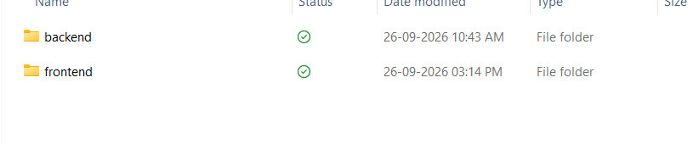Fig. 5.1 Folder structure of EduGenie

3. Backend Development (FastAPI)

3.1 Gemini configuration
The API key is read from the environment variable GEMINI_API_KEY, and the Gemini Flash model is created once when the server starts.
API_KEY = os.getenv("GEMINI_API_KEY", "YOUR_API_KEY")
genai.configure(api_key=API_KEY)
MODEL_NAME = "gemini-flash-latest"
model = genai.GenerativeModel(MODEL_NAME)

3.2 Helper function
All modules call one helper that sends the prompt to Gemini and converts any failure into a readable HTTP 500 error.
def ask_gemini(prompt: str) -> str:
try:
response = model.generate_content(prompt)
return response.text
except Exception as e:
raise HTTPException(status_code=500,
detail=f"Gemini API error: {str(e)}")

3.3 Q&A endpoint
@app.post("/api/qa")
def question_answer(req: QARequest):
prompt = f"Answer this student's question clearly and simply:\n\n{req.question}"
answer = ask_gemini(prompt)
return {"answer": answer}

3.4 Summarize endpoint
Receives a text field, asks Gemini to summarize it in 4-5 short bullet points and returns { "summary": ... }.

3.5 Quiz endpoint
Receives a topic and num_questions, asks Gemini for multiple-choice questions in strict JSON, removes any code fences from the reply and parses it with json.loads(). If parsing fails, a clear error is returned.

3.6 Serving the frontend
The backend serves the frontend/index.html page at the root URL (/) using FileResponse, so only one server is needed.

4. Frontend Development
- index.html contains the header, three tabs (Q&A, Summarize, Quiz) and one panel for each module.
- CSS in the same file gives a clean card-based design with highlighted tabs and buttons.
- JavaScript uses fetch() to send POST requests to /api/qa, /api/summarize and /api/quiz and shows the response in the result box.
- Tabs are switched by adding or removing the active class on the tab and panel.

Quiz answer checking
After the quiz is displayed, a Submit Answers button is added. When it is clicked, the selected option of every question is compared with the correct answer:
if (opt === correctAnswer) label.classList.add("correct"); // green
else if (selected && opt === selected.value)
label.classList.add("wrong"); // red
...
submitBtn.textContent = "Score: " + score + " / " + total;
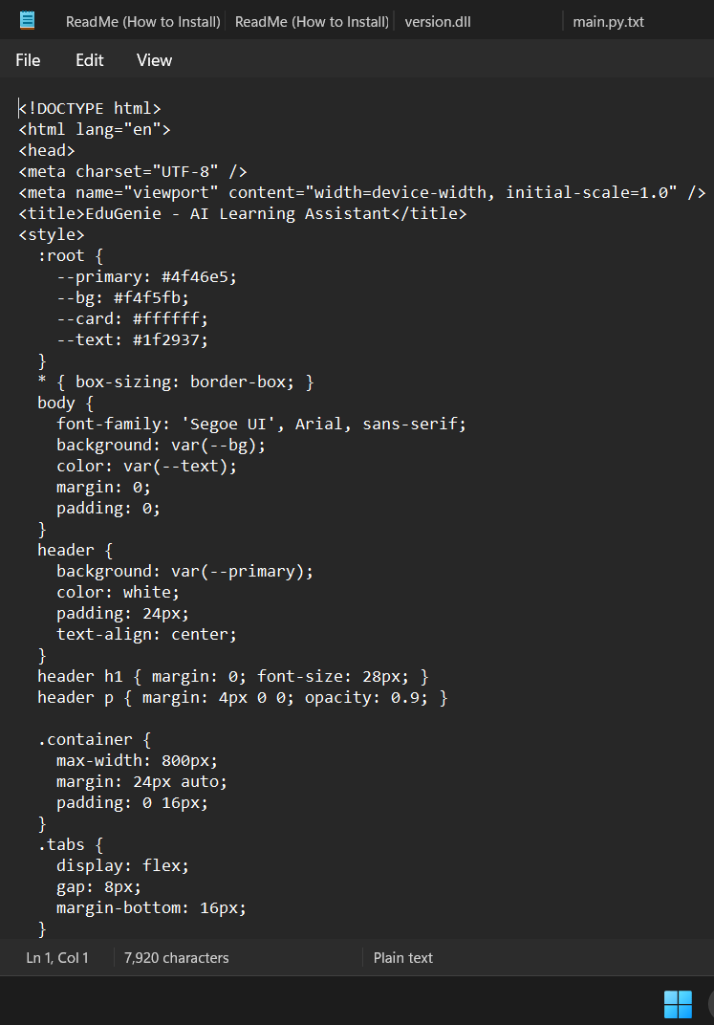
Fig. 5.2 Frontend code (index.html)

5. Challenges Faced and Solutions
No. | Problem | Solution
1 | Python was not installed on the laptop | Installed Python from python.org and verified with python --version
2 | 'pip' is not recognized as a command | Used python -m pip install -r requirements.txt instead
3 | Files were saved as main.py.txt, requirements.txt.txt and index.html.txt | Renamed them with the ren command and checked with dir
4 | SyntaxError (unterminated triple-quoted string) in main.py | Replaced the file with a clean copy of the code
5 | 400 API key not valid | Created a new key in Google AI Studio and set GEMINI_API_KEY
6 | 404 model gemini-1.5-flash not found | Changed MODEL_NAME to gemini-flash-latest
7 | 429 quota exceeded on the free tier | Waited for the retry delay and tested in smaller steps; a new key can also be used
8 | Internal Server Error because index.html was not found | Corrected the file name and location in the frontend folder

6. Running the Application
After the server starts, Command Prompt shows "Uvicorn running on http://127.0.0.1:8000" and "Application startup complete". Opening this address in Chrome displays the EduGenie interface.
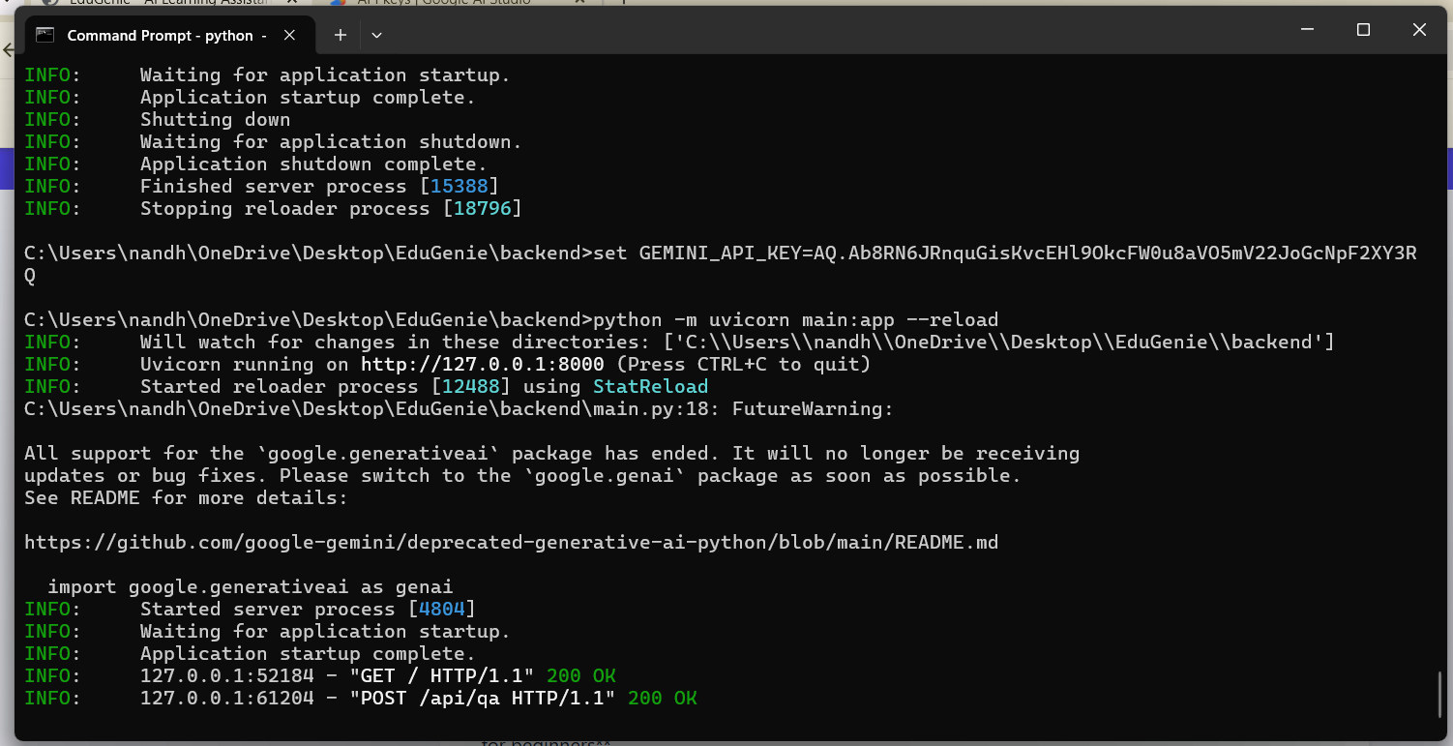
Fig. 5.3 Server running in Command Prompt

