EduGenie
Google Gemini Powered Learning Assistant
Phase 6: Project Testing
Field | Details
Project Title | EduGenie: Google Gemini Powered Learning Assistant
Phase | Phase 6: Project Testing
Prepared by | Baby kiruthika N
Mentor | Durga D
College / Team ID | Government Arts College(Autonomous) Salem-7
Date | 28/09/2026

1. Testing Objective
The objective of testing is to confirm that every module of EduGenie works correctly, that the interface behaves as expected, and that errors from the AI service are handled and shown clearly.

2. Types of Testing Performed
- Functional testing: Q&A, Summarize, Quiz and quiz answer checking
- User interface testing: page loading and tab switching
- Error-handling testing: invalid API key, wrong model name, quota exceeded, missing file

3. Test Environment
Item | Details
Operating System | Windows 10 / 11
Python | 3.14
Browser | Google Chrome
Server | Uvicorn at http://127.0.0.1:8000
AI Model | gemini-flash-latest (Google Gemini API, free tier)

4. Test Cases
ID | Test Scenario | Input / Action | Expected Result | Status
TC01 | Start the server | python -m uvicorn main:app --reload | Shows "Application startup complete" | Pass
TC02 | Open home page | Open http://127.0.0.1:8000 | EduGenie page with Q&A, Summarize and Quiz tabs | Pass
TC03 | Switch tabs | Click Summarize, then Quiz | Panel changes to the selected tab | [ ] Pass [ ] Fail
TC04 | Q&A module | "What is Python?" | A clear AI-generated answer is shown | [ ] Pass [ ] Fail
TC05 | Summarize module | Paste a paragraph on Artificial Intelligence | A short bullet-point summary is shown | [ ] Pass [ ] Fail
TC06 | Quiz generation | Topic: Solar System, 5 questions | 5 MCQs with 4 options each | [ ] Pass [ ] Fail
TC07 | Quiz answer check | Select answers and click Submit Answers | Correct in green, wrong in red, score displayed | [ ] Pass [ ] Fail
TC08 | Empty input | Click Get Answer with an empty box | No request is sent | [ ] Pass [ ] Fail
TC09 | Invalid API key | Run with a wrong key | Message: 400 API key not valid | Pass
TC10 | Wrong model name | MODEL_NAME = gemini-1.5-flash | Message: 404 model not found | Pass
TC11 | Quota exceeded | Send many requests quickly | Message: 429 quota exceeded with retry time | Pass
TC12 | Frontend file missing | index.html not found | Internal Server Error; fixed after correcting file name | Pass
Note: tick Pass or Fail for the remaining cases after running them and adding the screenshots.

5. Test Screenshots
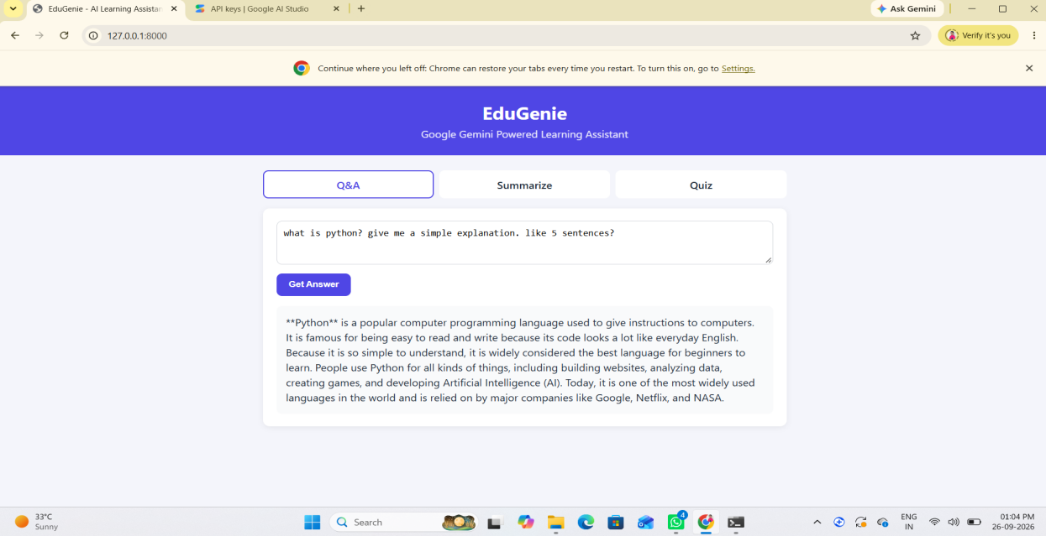
Fig. 6.1 Q&A test result
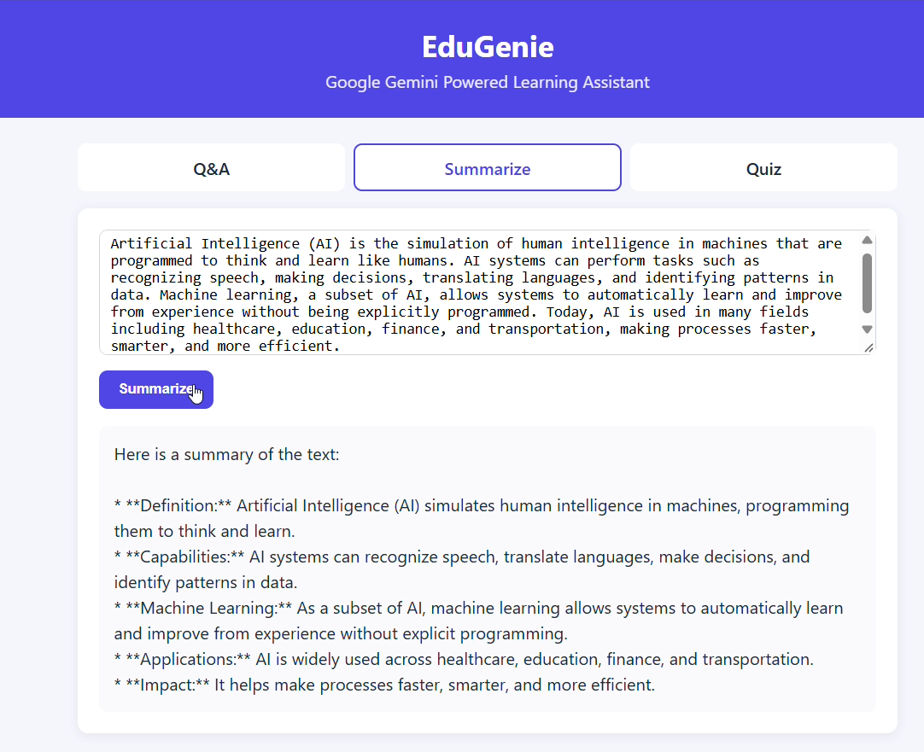
Fig. 6.2 Summarize test result

[ screens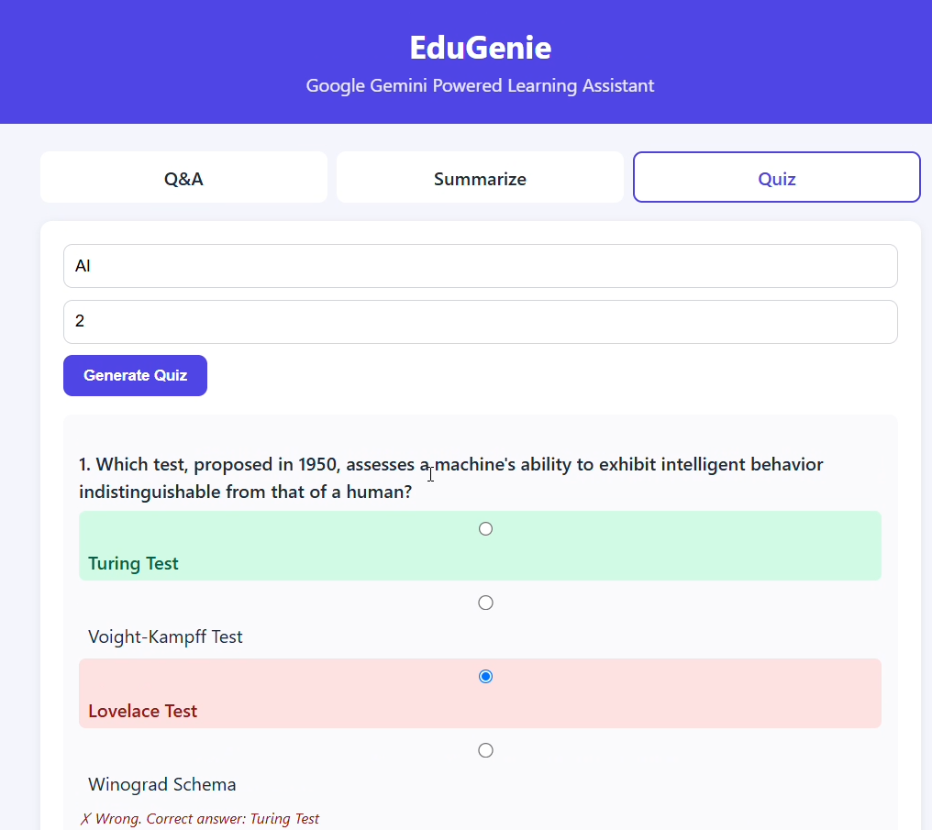
Fig.6.3 Quiz with correct (green) and wrong (red) answers and score

6. Issues Found During Testing
Issue | Cause | Fix
API key not valid (400) | Key was not set in the new Command Prompt window | Set GEMINI_API_KEY again and restart the server
Model not found (404) | gemini-1.5-flash is no longer available for this API version | Changed to gemini-flash-latest
Quota exceeded (429) | Free-tier request limit reached during repeated testing | Waited for the retry time or used a new key
Internal Server Error | index.html missing or saved as index.html.txt | Renamed the file to index.html

7. Test Summary
The server starts correctly, the home page loads, and all AI-service errors are caught and displayed as readable messages. The Q&A, Summarize and Quiz modules were tested with the sample inputs above; results are recorded in the test case table and screenshots. Testing on the free tier requires small, spaced-out requests to avoid the quota limit.

