EduGenie
Google Gemini Powered Learning Assistant
Phase 8: Project Demonstration
Field | Details
Project Title | EduGenie: Google Gemini Powered Learning Assistant
Phase | Phase 8: Project Demonstration
Prepared by | Baby kiruthika N
Mentor | Durga D
College / Team ID | Government Arts College(Autonomous) Salem-7
Date | 28/09/2026

1. Demonstration Objective
The demonstration shows the working EduGenie application to the mentor: how it starts, how each module works, and how errors are handled.

2. Before the Demo: Checklist
Item | Check
Internet connection is on | [ ]
API key is ready (from Google AI Studio) | [ ]
Command Prompt opened in Desktop\EduGenie\backend | [ ]
Key set with: set GEMINI_API_KEY=<your-api-key> | [ ]
Server started and shows "Application startup complete" | [ ]
Chrome open at http://127.0.0.1:8000 | [ ]
Screenshots of all modules saved as backup | [ ]

3. Demo Flow
Step | What to Show | What to Say | Time
1 | Introduce the project | EduGenie is an AI learning assistant that answers questions, summarizes text and creates quizzes | 1 min
2 | Show folder structure and main.py | Backend is FastAPI; frontend is HTML/CSS/JS; the Gemini API generates the responses | 1 min
3 | Show server in Command Prompt | Started with uvicorn; running at 127.0.0.1:8000 | 1 min
4 | Q&A tab: ask "What is Photosynthesis?" | The question goes to FastAPI, then to Gemini, and the answer is shown | 1 min
5 | Summarize tab: paste the AI paragraph | Long text becomes short bullet points | 1 min
6 | Quiz tab: topic Solar System, 5 questions | Gemini returns JSON that the page shows as MCQs | 1 min
7 | Select answers and click Submit Answers | Correct answers turn green, wrong turn red, and the score is shown | 1 min
8 | Explain error handling | API errors such as an invalid key or quota limit are shown as readable messages | 1 min
9 | Conclusion and future scope | Learning paths, multilingual support, voice input and online hosting | 1 min

4. Sample Inputs for the Demo
Module | Input
Q&A | What is Photosynthesis?
Summarize | Artificial Intelligence (AI) is the simulation of human intelligence in machines that are programmed to think and learn like humans. AI systems can recognize speech, make decisions, translate languages and identify patterns in data.
Quiz | Topic: Solar System, Number of questions: 5

5. Demo Screenshots
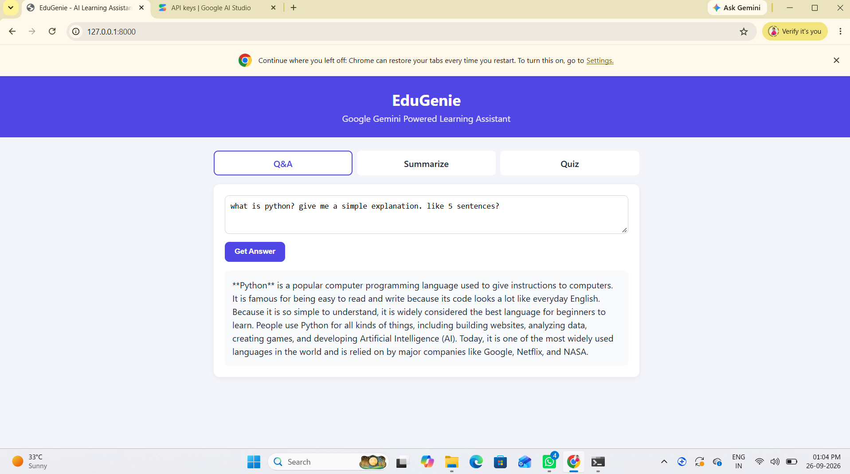
Fig. 8.1 Home page
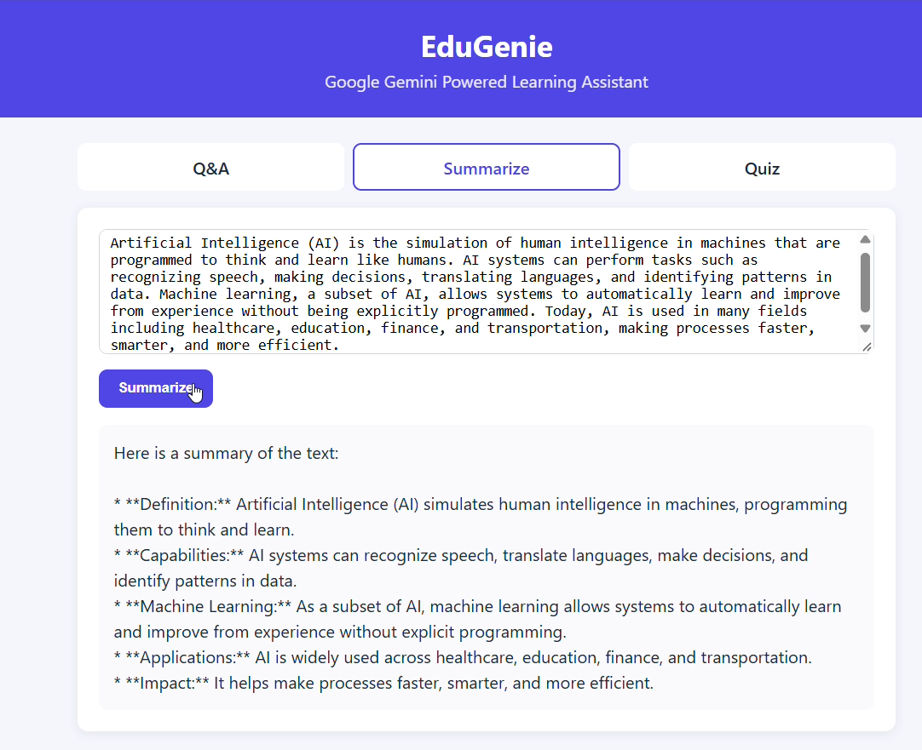
Fig. 8.2 Q&A and Summarize output
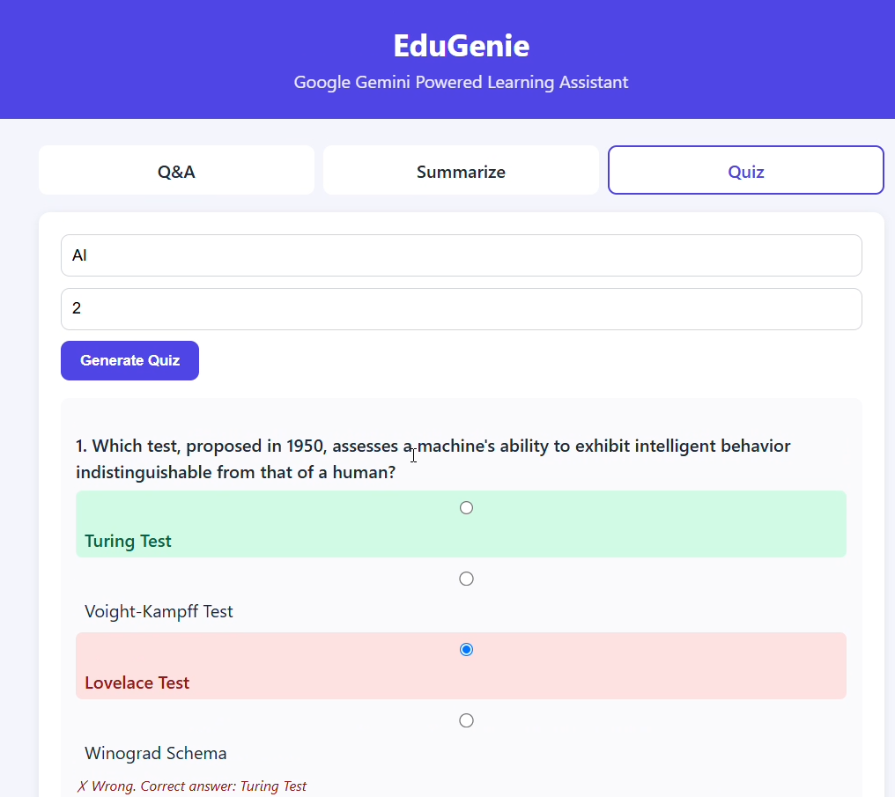
Fig. 8.3 Quiz result with score

6. Possible Questions and Answers
Question | Answer
What is FastAPI? | A modern Python framework used to build the backend API quickly.
What is Uvicorn? | The server that runs the FastAPI application; it was installed with requirements.txt.
Which AI model is used? | Google Gemini Flash, called through the Gemini API using an API key.
How is the API key kept safe? | It is read from the GEMINI_API_KEY environment variable and is not written in the code.
How does the quiz work? | Gemini returns questions in JSON; the page shows them as options and compares the selected answer with the correct one.
Why did you see a 429 error? | The free tier has request limits; waiting for the retry time or using another key solves it.
Why did you change the model name? | gemini-1.5-flash was not available for the API version used, so gemini-flash-latest was used.
What is the future scope? | Personalized learning paths, multilingual support, voice input and online hosting.

7. Backup Plan
- If a quota (429) error appears, wait for the retry time shown in the message and try again.
- If the key is invalid, create a new key at aistudio.google.com/app/apikey and set it again.
- If the internet is not available, present the saved screenshots and explain the working.

8. Conclusion
EduGenie shows how a generative AI model can be turned into a simple, practical study tool with a small backend and an easy web interface. The demonstration covers all three modules, the quiz scoring and the error handling.

