GOLF BAG CARRIER ROBOT
Result Screenshots and Demo Evidence
Screenshots document software outputs only; they do not establish physical robot performance or validated model accuracy.
1. Input / Test Frame
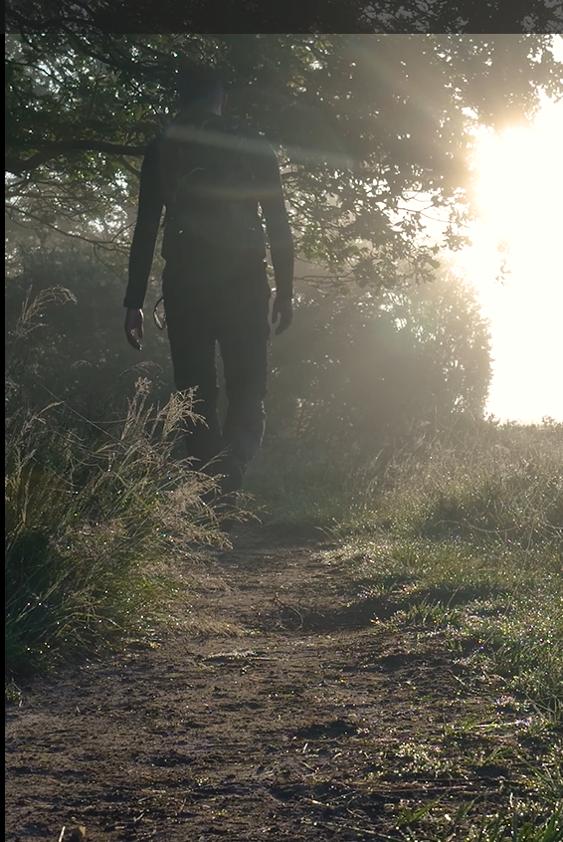
Example input frame used to demonstrate the vision pipeline.

2. Person Detection Output
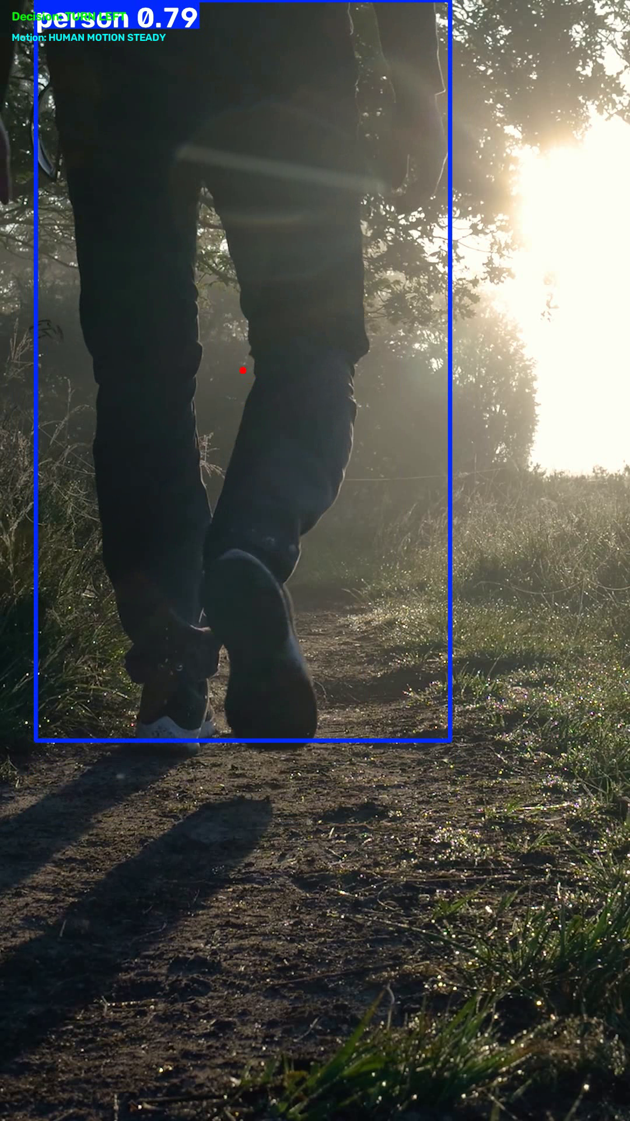
Example object-detection output. Bounding boxes show model predictions, not verified ground-truth labels.

3. Additional Detection Example
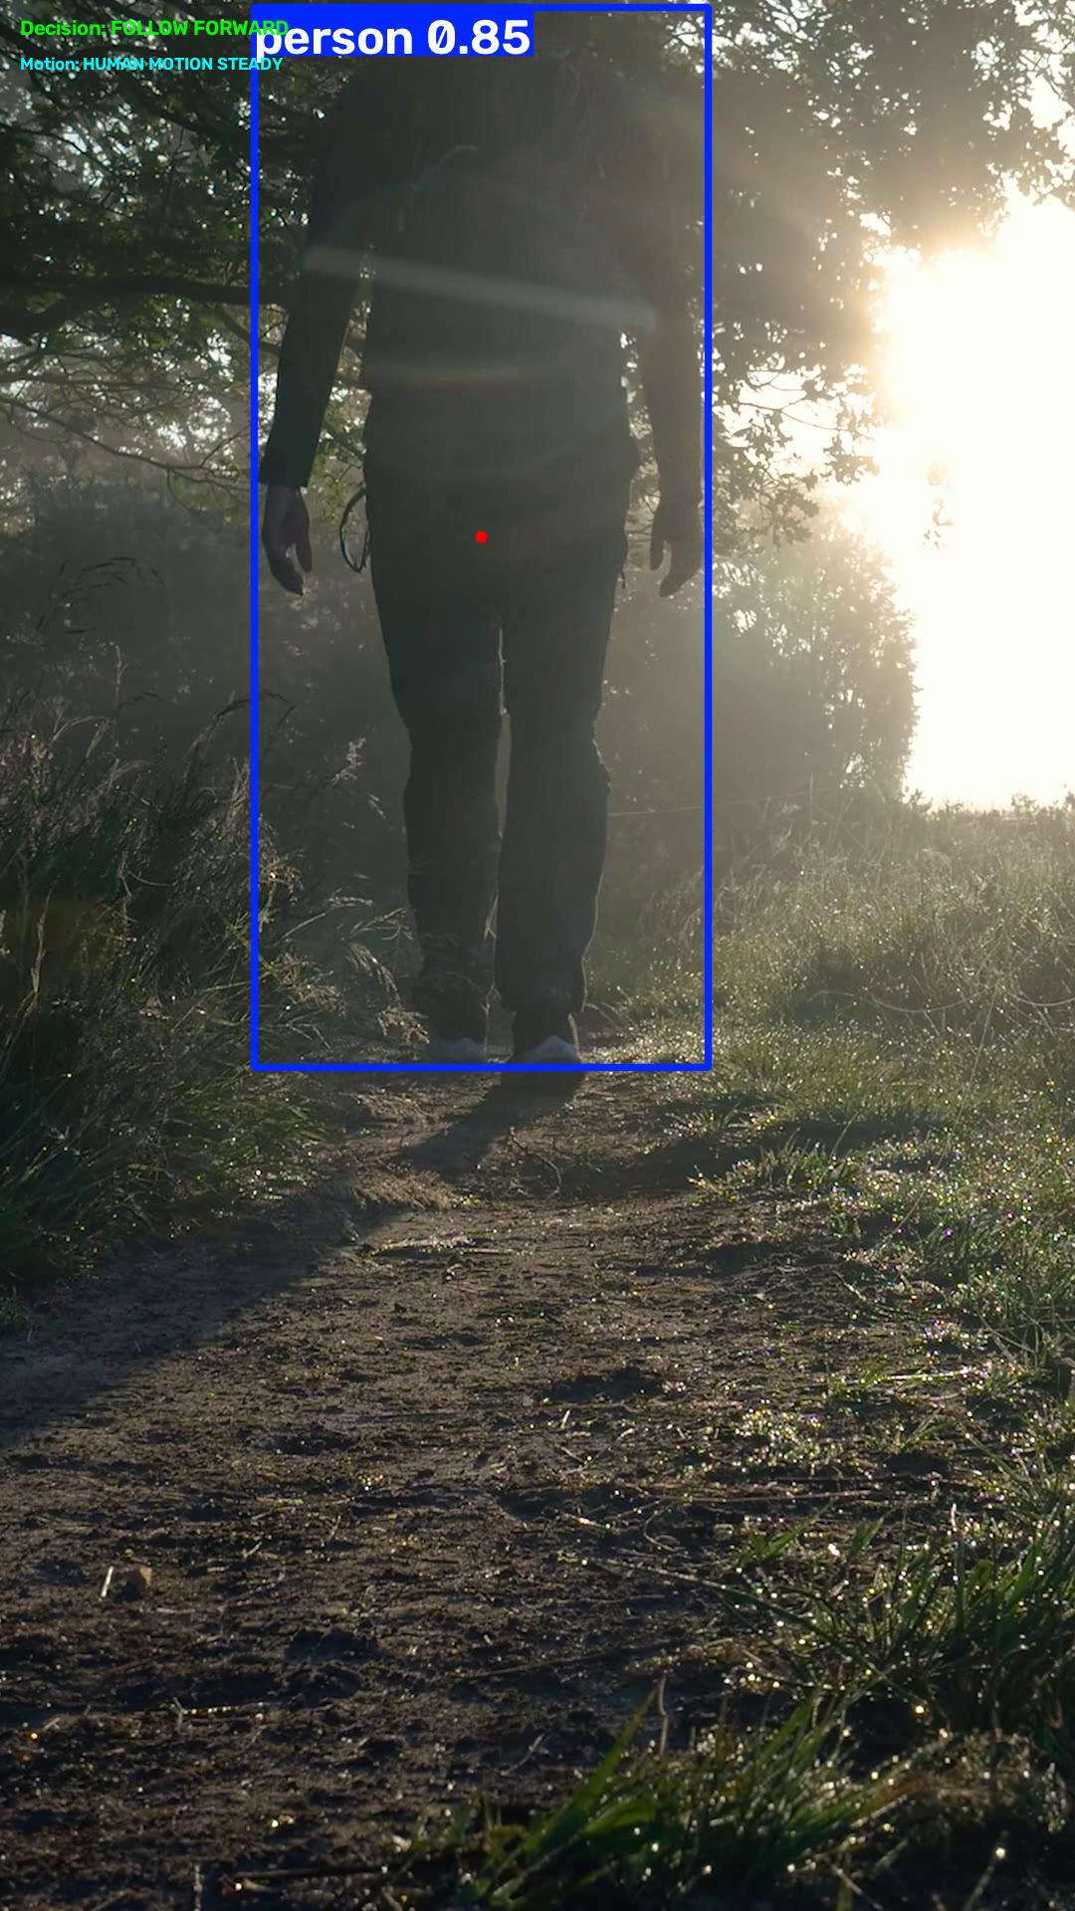
A second detection example from the project review presentation.

4. Segmentation / Scene Output
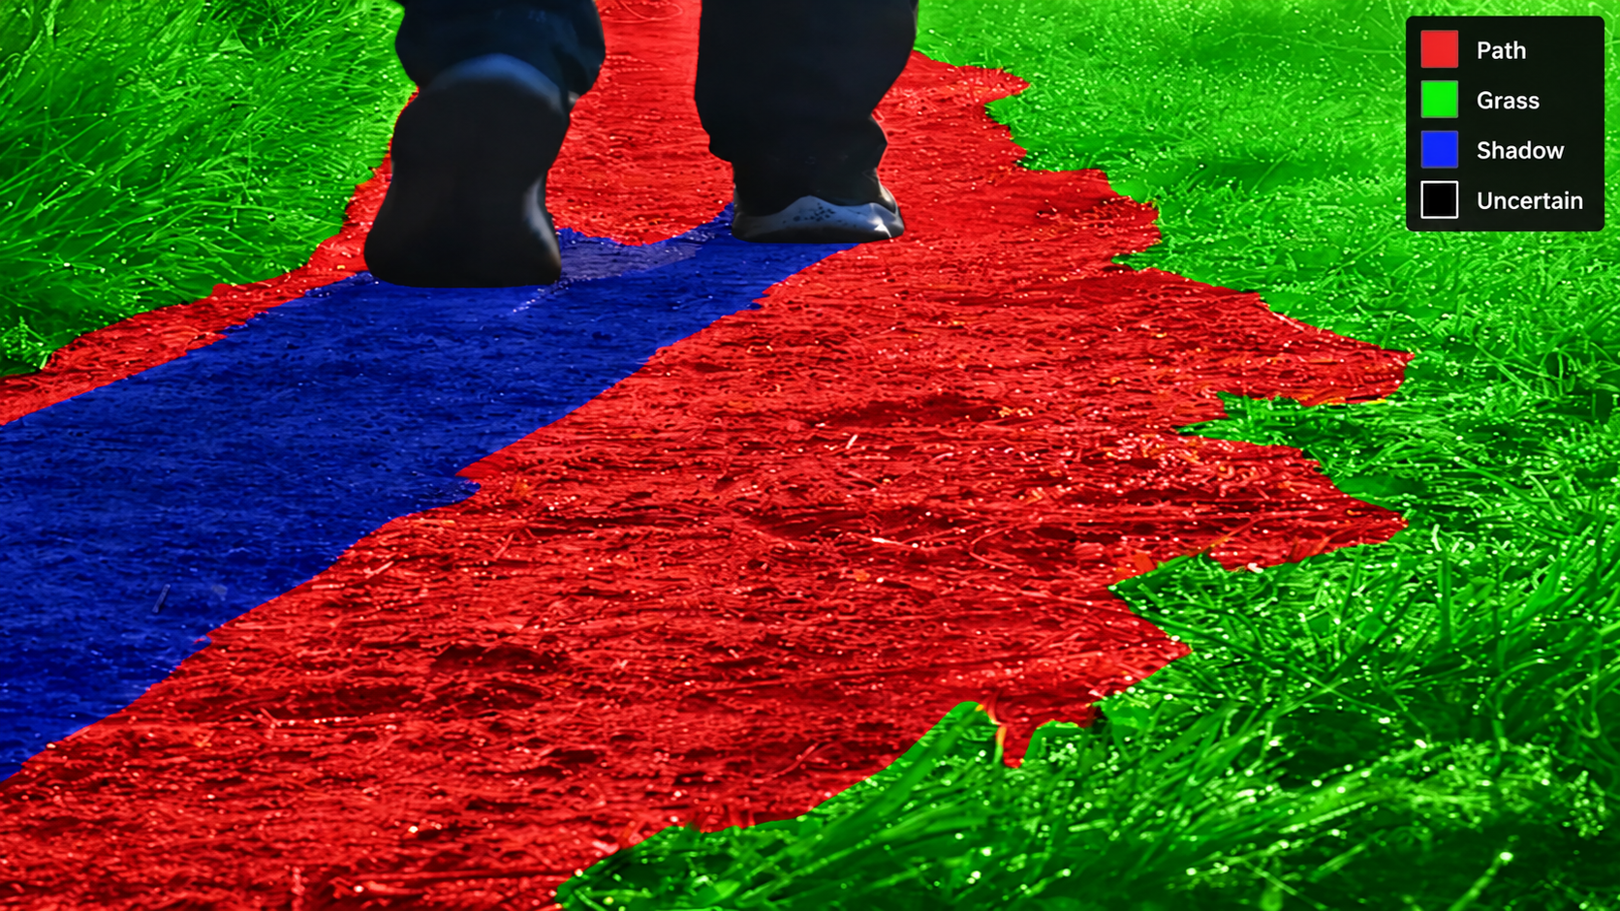
Example segmentation-style output. This is not validated golf-hazard detection.

