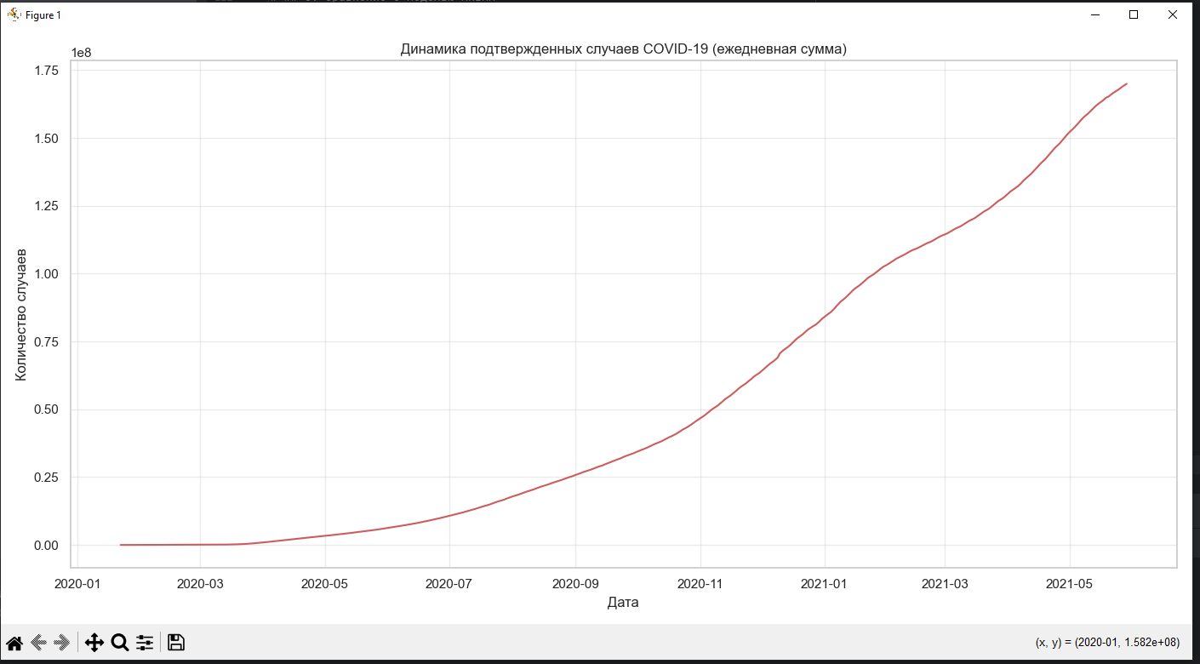

Типы данных:
SNo int64
ObservationDate str
Province/State str
Country/Region str
Last Update str
Confirmed float64
Deaths float64
Recovered float64
dtype: object

Первые 5 строк:
SNo ObservationDate Province/State ... Confirmed Deaths Recovered
0 1 01/22/2020 Anhui ... 1.0 0.0 0.0
1 2 01/22/2020 Beijing ... 14.0 0.0 0.0
2 3 01/22/2020 Chongqing ... 6.0 0.0 0.0
3 4 01/22/2020 Fujian ... 1.0 0.0 0.0
4 5 01/22/2020 Gansu ... 0.0 0.0 0.0

[5 rows x 8 columns]

Пропуски в данных:
SNo 0
ObservationDate 0
Province/State 78103
Country/Region 0
Last Update 0
Confirmed 0
Deaths 0
Recovered 0
dtype: int64

Данные после агрегации:
ObservationDate Confirmed
0 2020-01-22 557.0
1 2020-01-23 1097.0
2 2020-01-24 941.0
3 2020-01-25 1437.0
4 2020-01-26 2118.0

Диапазон дат: 2020-01-22 00:00:00 — 2021-05-29 00:00:00

