Link github: <https://github.com/BacDung/ArchitecturalDesign>

Mục lục

1. Thiết kế giao diện người dùng (User Interface Design) 1

1.1. Tạo các ảnh màn hình 1

1.2. Tạo các dịch chuyển màn hình 5

1.3. Mô tả các màn hình 5

2. Thiết kế giao diện hệ thống (System Interface Design) 10

2.1. Thiết kế Subsystem 10

2.2. Document subsystem elements 11

2.3. Checkpoints 12

3. Bài tập 12

Thiết kế lại Card screen 12

Giao diện Place rush order 13

Thiết kế lại sơ đồ chuyển màn hình 14

# Thiết kế giao diện người dùng (User Interface Design)

### Tạo các ảnh màn hình

### Tạo các dịch chuyển màn hình

### Mô tả các màn hình

1. Card screen

|  |  |  |  |  |  |
| --- | --- | --- | --- | --- | --- |
| AIMS Software | | Date of creation | Approved by | Reviewed by | Person in charge |
| Screen specification | View cart screen | 11/04/2021 |  |  | Nguyễn Văn Dũng |
|  | | Control | Operation | Function | |
| Area for displaying the subtotal | Initial | Display the subtotal | |
| Area for display items in the cart | Initial | Display the media with the corresponding information | |
| Place order button | Click | Display the Delivery form | |
| Delete button | Click | Remove the item from the cart | |

Thuộc tính

|  |  |  |  |  |
| --- | --- | --- | --- | --- |
| Screen name | View cart |  |  |  |
| Item name | Number of digits (bytes) | Type | Field attribute | Remarks |
| Media title | 50 | Numeral | Blue | Left-justified |
| Price | 20 | Numeral | Blue | Right justified |
| Subtotal | 20 | Numeral | Blue | Left-justified |

1. Home screen

|  |  |  |  |  |  |
| --- | --- | --- | --- | --- | --- |
| AIMS Software | | Date of creation | Approved by | Reviewed by | Person in charge |
| Screen specification | Home Screen | 3/11/2021 |  |  | Nguyễn Văn Dũng |
|  | | Cart icon button | Click | Redirect to View cart screen | |
| Input field for searching | None | Place to fill params to search | |
| Button search | Click | Search for media which name contains params | |
| Area for displaying list of book | Initial | Display details of list media | |
| Spinner | Click | Adjust the number of selected media | |
|  | | Add to cart button | Click | Add selected book to Cart | |

Thuộc tính

|  |  |  |  |  |
| --- | --- | --- | --- | --- |
| Screen name | View cart |  |  |  |
| Item name | Number of digits (bytes) | Type | Field attribute | Remarks |
| Media title | 50 | Numeral | Bold, black | Center-justified |
| Price | 24 | Numeral | Inherit, black | Center-justified |
| Avail | 11 | Numeral | Inherit, black | Center-justified |
| Search params | 34 | String | Black | Left-justified |

1. Shipping screen

|  |  |  |  |  |  |
| --- | --- | --- | --- | --- | --- |
| AIMS Software | | Date of creation | Approved by | Reviewed by | Person in charge |
| Screen specification | Shipping Screen | 3/11/2021 |  |  | Nguyễn Văn Dũng |
|  | | Input name field | None | Fill name | |
| Input phone field | None | Fill phone | |
| Combobox province/city field | None | Select province | |
| Input address area | None | Fill address | |
| Input shipping instructions | None | Fill shipping instructions | |
|  | | Confirm delivery buttom | Click | Place order | |

Thuộc tính

|  |  |  |  |  |
| --- | --- | --- | --- | --- |
| Screen name | View cart |  |  |  |
| Item name | Number of digits (bytes) | Type | Field attribute | Remarks |
| Name field | 50 | String | Black | Left-justified |
| Phone field | 24 | String | Black | Left-justified |
| Province/city field | 24 | String | Black | Left-justified |
| Address area | 203 | String | Black | Left-justified |
| Shipping constructions area | 1023 | String | Black | Left-justified |

1. Invoice screen

|  |  |  |  |  |  |
| --- | --- | --- | --- | --- | --- |
| AIMS Software | | Date of creation | Approved by | Reviewed by | Person in charge |
| Screen specification | Invoice Screen | 3/11/2021 |  |  | Nguyễn Văn Dũng |
|  | | Area for displaying shipping details | Initial | Display shipping details | |
| Area for displaying deposit | Initial | Display subtotal, shipping fees, total deposit | |

Thuộc tính

|  |  |  |  |  |
| --- | --- | --- | --- | --- |
| Screen name | View cart |  |  |  |
| Item name | Number of digits (bytes) | Type | Field attribute | Remarks |
| Name field | 53 | String | Black | Left-justified |
| Phone field | 12 | String | Black | Left-justified |
| Province/city field | 23 | String | Black | Left-justified |
| Address area | 200 | String | Black | Left-justified |
| Shipping constructions area | 1012 | String | Black | Left-justified |
| Subtotal | 12 | Numeral | Black | Left-justified |
| Shipping fee | 12 | Numeral | Black | Left-justified |
| Total deposit | 12 | Numeral | Red, bold | Right - justified |

1. Payment screen

|  |  |  |  |  |  |
| --- | --- | --- | --- | --- | --- |
| AIMS Software | | Date of creation | Approved by | Reviewed by | Person in charge |
| Screen specification | Shipping Screen | 2/11/2021 |  |  | Nguyễn Văn Dũng |
|  | | Payment method radio buttons | Click | Choose payment method | |
| Card number field | None | Fill card number | |
| Expiration date field | None | Fill expiration date | |
| Card security code field | None | Fill card security code | |

Thuộc tính

|  |  |  |  |  |
| --- | --- | --- | --- | --- |
| Screen name | View cart |  |  |  |
| Item name | Number of digits (bytes) | Type | Field attribute | Remarks |
| Card number field | 12 | Numeral | Black | Left-justified |
| Card holder name | 34 | String | Black | Left-justified |
| Expiration date | 12 | Timestamp | Black | Left-justified |
| Card security code | 12 | Numeral | Black | Left-justified |

# Thiết kế giao diện hệ thống (System Interface Design)

### Thiết kế Subsystem

### Document subsystem elements

### Checkpoints

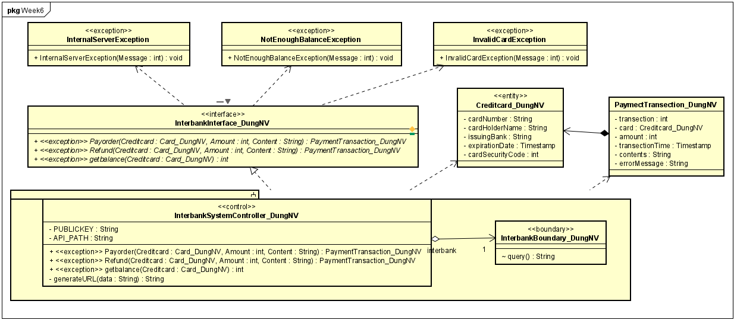

# Bài tập

Hãy thiết kế giao diện (Interface Design) chi tiết cho Use case “Place Rush Order”.

### Thiết kế lại Card screen

### Giao diện Place rush order

### Thiết kế lại sơ đồ chuyển màn hình

Mô tả màn hình

|  |  |  |  |  |  |
| --- | --- | --- | --- | --- | --- |
| AIMS Software | | Date of creation | Approved by | Reviewed by | Person in charge |
| Screen specification | Place rush order | 3/11/2021 |  |  | Nguyễn Văn Dũng |
|  | | Area for displaying the amount | Initial | Display the subtotal, amount and VAT | |
| Place rush order | Click | Place rush order | |
| Cancel button | Click | Return to Place order screen (Cart screen) | |
| Spinner | Click | Adjust the number of selected media | |
| Delete button | Click | Remove the item from the cart | |

Thuộc tính

|  |  |  |  |  |
| --- | --- | --- | --- | --- |
| Screen name | View cart |  |  |  |
| Item name | Number of digits (bytes) | Type | Field attribute | Remarks |
| Price | 34 | Numeral | Blue | Right justified |
| Subtotal | 63 | Numeral | Blue | Left-justified |
| Amount | 65 | Numeral | Blue | Left-justified |