Study

1.

What is Boolean?

Boolean is the type that has only two values that are true and false

3 vd về kiểu boolean

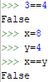



2.

- What is a flow chart?

A flowchart is a type of diagram that represents an algorithm, workflow or process. The flowchart shows the steps as boxes of various kinds, and their order by connecting the boxes with arrows. This diagrammatic representation illustrates a solution model to a given problem.

-Draw flow chart for the following code snippet.

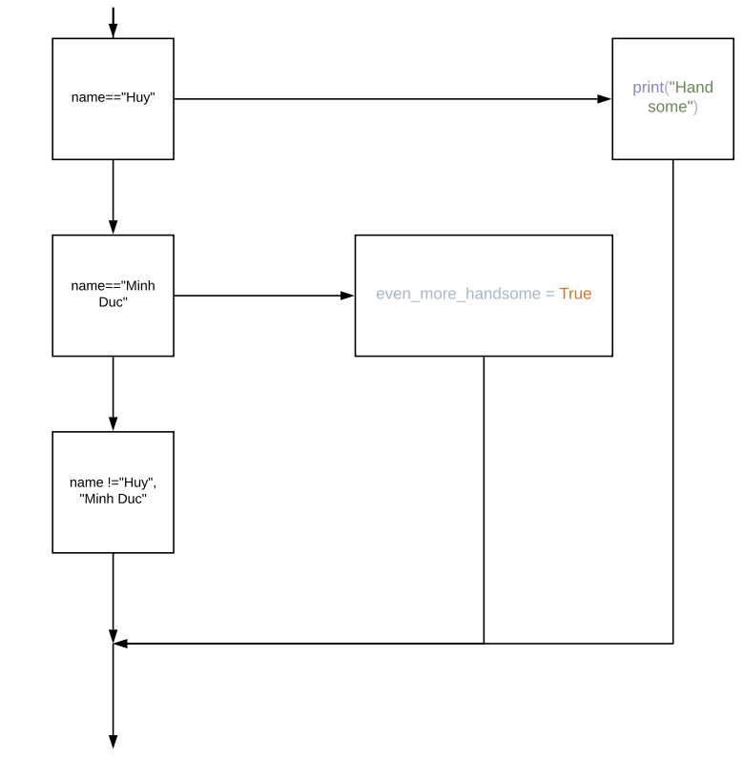

3.

- What is nested conditionals?

The conditional condition is a condition also be nestable.

Write a piece of code that uses nested conditionals

