
LA GRANDEE INTERNATIONAL COLLEGE
Simalchaur, Pokhara, Nepal

A Project Proposal
on
Quick-Bite
Submitted to
Bachelor of Computer Application (BCA) Department
LA GRANDEE International College

In partial fulfillment of the requirements for the degree of Bachelor of Computer Application under Pokhara University

In partial fulfillment of the requirements for the degree of BCA under Pokhara University

Submitted by
Name of the student | Pu Registration No. | Semester
Anup Thapa | 2023-1-53-0364 | BCA-VI
Rabin Thapa | 2023-1-53-0338 | BCA-VI
Monil Ramjali | 2023-1-53-0334 | BCA-VI

Date :5/12/2026

TABLE OF CONTENTS
1. Introduction 1
2. Aim and Scope 2
2.1Aim: 2
2.2Scope: 2
3. Objectives 3
4. Study of the previous system 4
5. Current Problem and Proposed Solution 5
5.1 Current Problems: 5
5.2 Proposed Solution: 5
6. High Level Requirements 6
6.1 Functional Requirements 6
6.2 Non-Functional Requirements 6
6.3 Requirement Prioritization Table 8
7.Design 9
7.1 Er Diagram 9
7.2 Use case Diagram 10
7.3 DFD (Data Flow Diagram) 11
7.4 UML Class Diagram 13
8.Detail Budget 14
8.1 Detail Budget 14
9. Detail Timeline 15
10.Conclusion 16
References 17

LIST OF FIGURES
Figure 7.1.1: Er Diagram 9
Figure 7.2.1: Use Case Diagram 10
Figure 7.3.1: Level-0 DFD 11
Figure 7.3.2: Level-1 DFD 12
Figure 7.4.1: UML Diagram 13
Figure 9.1: Gannt Chart 15

LIST OF TABLES
Table 6.3.1: Requirement Prioritization Table 8
Table 8.1: Detail Budget 14

1. Introduction
A food delivery system is a platform that connects customers with restaurants and delivery services, allowing people to order food online and have it delivered to their location. It can operate through websites or mobile apps, making the ordering process fast and convenient.
At its core, a food delivery system has three main components. First is the customer interface, where users browse menus, place orders, and make payments. Second is the restaurant panel, where restaurants manage menus, receive orders, and prepare food. Third is the delivery management system, which assigns orders to delivery personnel and tracks deliveries in real time.
This proposal outlines the development of a web-based Food Delivery System that connects customers with local restaurants. The system will allow users to browse menus, place orders, track deliveries in real time, and make payments online, while restaurants and delivery personnel manage orders efficiently.

2. Aim and Scope
2.1Aim:
To design and develop a scalable, user-friendly Food Delivery System that streamlines online ordering, order dispatch, and delivery tracking.

2.2Scope:
- Customers:
  - Register, browse restaurants, place orders, make payments, rate orders.
- Restaurants:
  - Manage menu, view orders, update order status.
- Delivery Personnel:
  - Accept delivery requests, update delivery status.
- Admin:
  - Manage users, restaurants, payments, and system settings.

3. Objectives
- Provide a seamless food ordering experience for customers while enabling restaurants to manage orders in real time.
- Generate automated order summaries, invoices, and sales reports for efficient business management.

4. Study of the previous system
Pathao Food is a food delivery service integrated into the Pathao super app, which also provides ride-sharing, parcel, and logistics services. (food.pathao.com, 2015)It was launched in Nepal around 2020, after Pathao had already established its ride-sharing system in 2018.
Strengths:
- Single app for multiple services.
- Easy ordering and tracking.
- Large number of restaurants and delivery partners.
- Operates in cities like Kathmandu, Pokhara, and Chitwan.
- Uses bikes/cycles to reduce traffic delays.
- Emphasis on quick delivery times.
- Restaurants can join instead of building their own delivery system.
- Lower operational cost and higher reach.
Weaknesses:
- Delivery delays during peak hours.
- Rider availability problems in some cities.
- Food prices may be higher compared to restaurants.
- Occasional order errors or missing items.
- Customer support delays reported.
- App usability and tracking sometimes inconsistent.

5. Current Problem and Proposed Solution

5.1 Current Problems:
- Rider Exploitation and Financial Precarity
Many delivery riders face unstable income, low base pay, and high dependency on incentives.
- Poor Customer Service and Rider Conduct
Customers sometimes experience late deliveries, unprofessional behavior, or lack of communication from riders.
- Strategic Overreach: "The Super App Problem"
As Pathao expands into multiple services (rides, food, parcel, payments), it risks losing focus on its core delivery operations.

5.2 Proposed Solution:
- Rethinking Rider Relations
The platform should improve rider compensation models by ensuring fair wages, transparent incentive structures, and support for expenses like fuel.
- Building Accountability for Delivery
Introduce stronger monitoring and feedback systems, including customer ratings, complaint handling, and performance tracking.
- Proactive Communication and Support
Enhance communication between customers, riders, and support teams through real-time updates, in-app messaging, and responsive customer service.

6. High Level Requirements

6.1 Functional Requirements
FR-UM-001: User Registration and Login
- System shall allow Customers, Restaurants, Delivery Personnel, and Admins to register and log in securely.
- System shall validate user credentials before granting access to the system.
- System shall support role-based access control for different user types.
FR-RM-001: Restaurant and Menu Browsing
- System shall allow customers to browse restaurants and available menu items.
- System shall provide search and filter functionality based on restaurant name, category, and menu items.
- System shall display menu details including price, description, and availability status.
FR-OM-001: Cart, Order Placement, and Payment
- System shall allow customers to add, update, and remove items from the cart.
- System shall allow customers to place orders through a secure checkout process.
FR-OM-002: Order Status Updates
- System shall allow restaurants and delivery personnel to update order statuses.
- System shall display order progress statuses including Preparing, Ready, Picked, and Delivered.
FR-AM-001: Admin Dashboard Management
- System shall provide an admin dashboard to manage users, restaurants, and delivery personnel.
- System shall allow admins to monitor and generate system reports.
- System shall provide analytics and order management functionalities for administrators.

6.2 Non-Functional Requirements
NFR-01: Responsive Design
- The system shall provide a fully responsive interface compatible with desktop, tablet, and mobile devices.
- The system shall ensure consistent user experience across different screen sizes and browsers.
NFR-02: Concurrent User Support
- The system shall support multiple users accessing the platform simultaneously without performance degradation.
NFR-03: Security
- The system shall encrypt sensitive user data and securely store passwords using hashing algorithms.
- The system shall implement authentication and authorization mechanisms to prevent unauthorized access.
NFR-04: Data Integrity
- The system shall ensure accuracy and consistency of data during order processing and payment transactions.
- The system shall prevent data loss and maintain transactional integrity within the database.
NFR-05: Maintainability
- The system shall follow modular and scalable architecture for easier maintenance and upgrades.
- The system shall include proper documentation and coding standards to support future development.

6.3 Requirement Prioritization Table
Table 6.3.1: Requirement Prioritization Table
ID | Requirement Name | Priority | Category
FR-UM-001 | User Registration and Login | High (P1) | Core
FR-RM-001 | Restaurant and Menu Browsing | High (P1) | Core
FR-OM-001 | Cart, Order Placement, and Payment | High (P1) | Financial
FR-AM-001 | Admin Dashboard Management | Medium (P2) | Administrative
FR-OM-002 | Order Status Updates | Medium (P2) | Operational
NFR-01 | Responsive Design | Medium (P2) | Usability
NFR-02 | Concurrent User Support | Medium (P2) | Performance
NFR-03 | Security | High (P1) | Infrastructure
NFR-04 | Data Integrity | High (P1) | Database
NFR-05 | Maintainability | Medium (P2) | Development

7.Design

7.1 Er Diagram
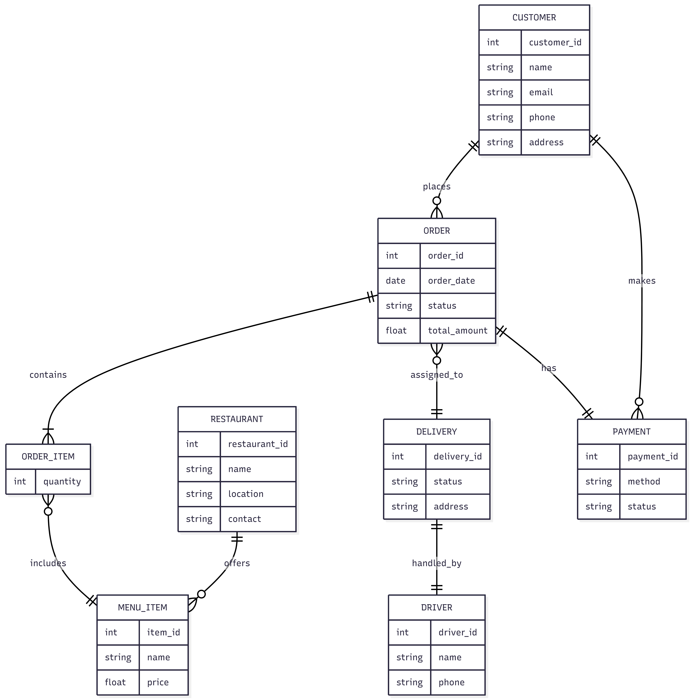
Figure 7.1.1: Er Diagram

7.2 Use case Diagram
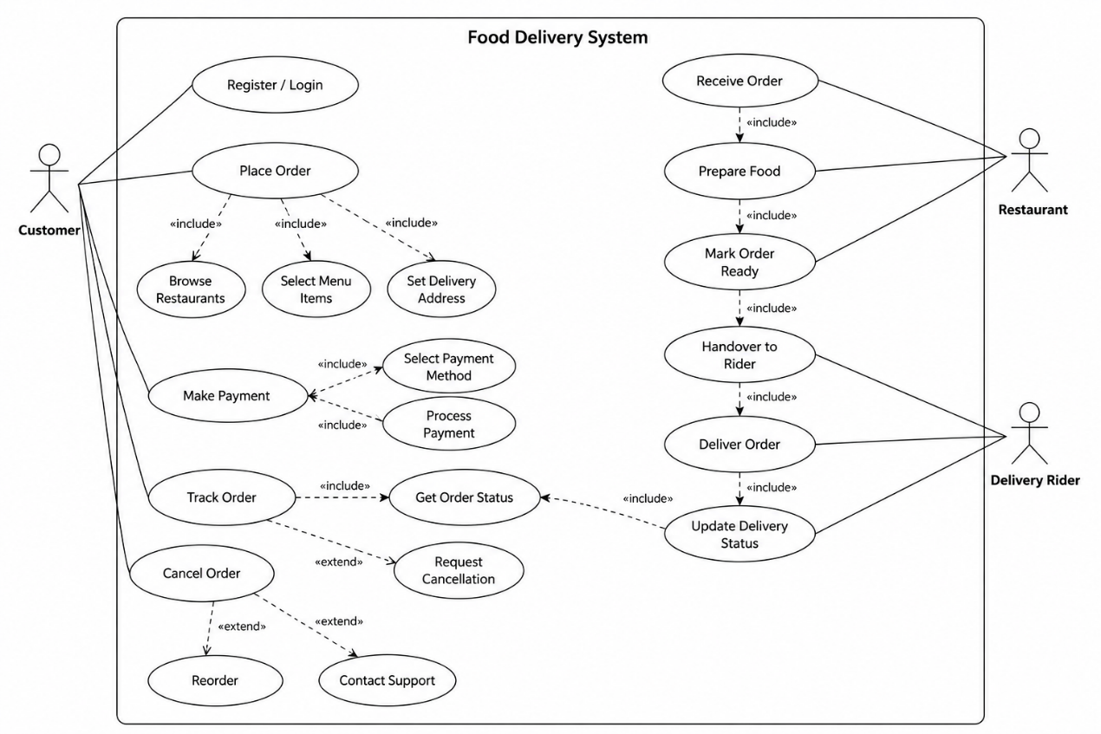
Figure 7.2.1: Use Case Diagram

7.3 DFD (Data Flow Diagram)
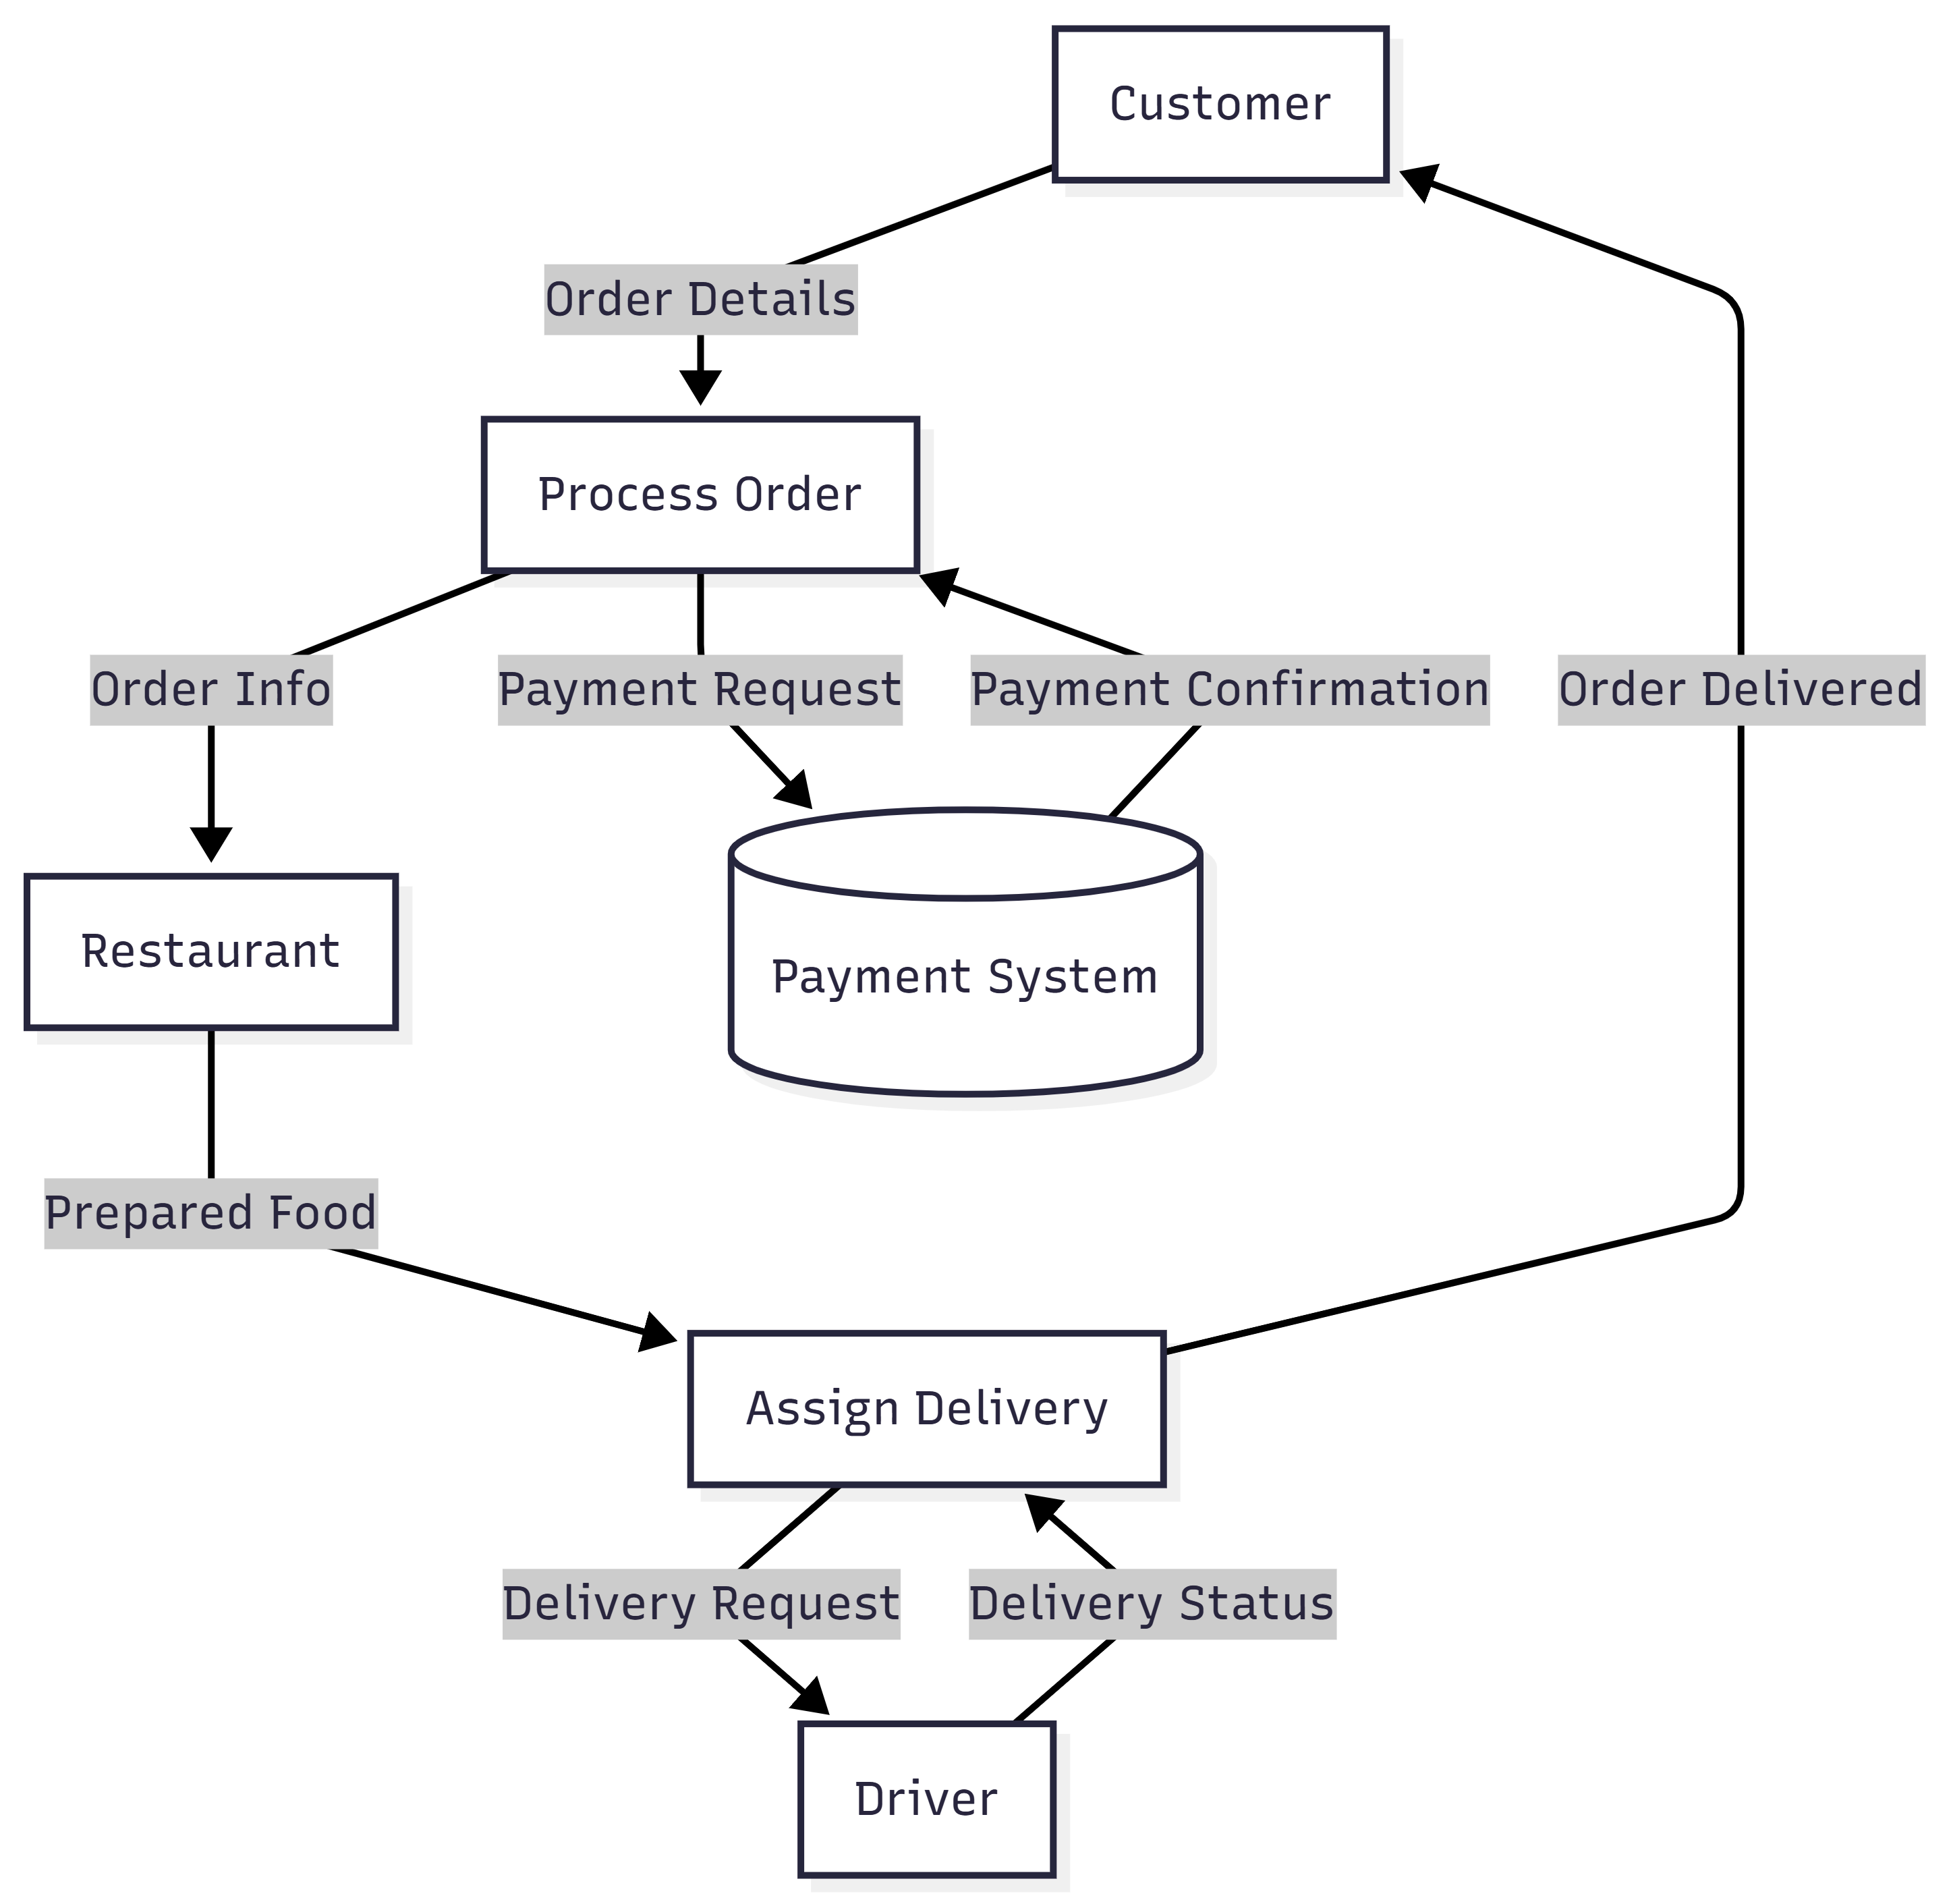
Figure 7.3.1: Level-0 DFD

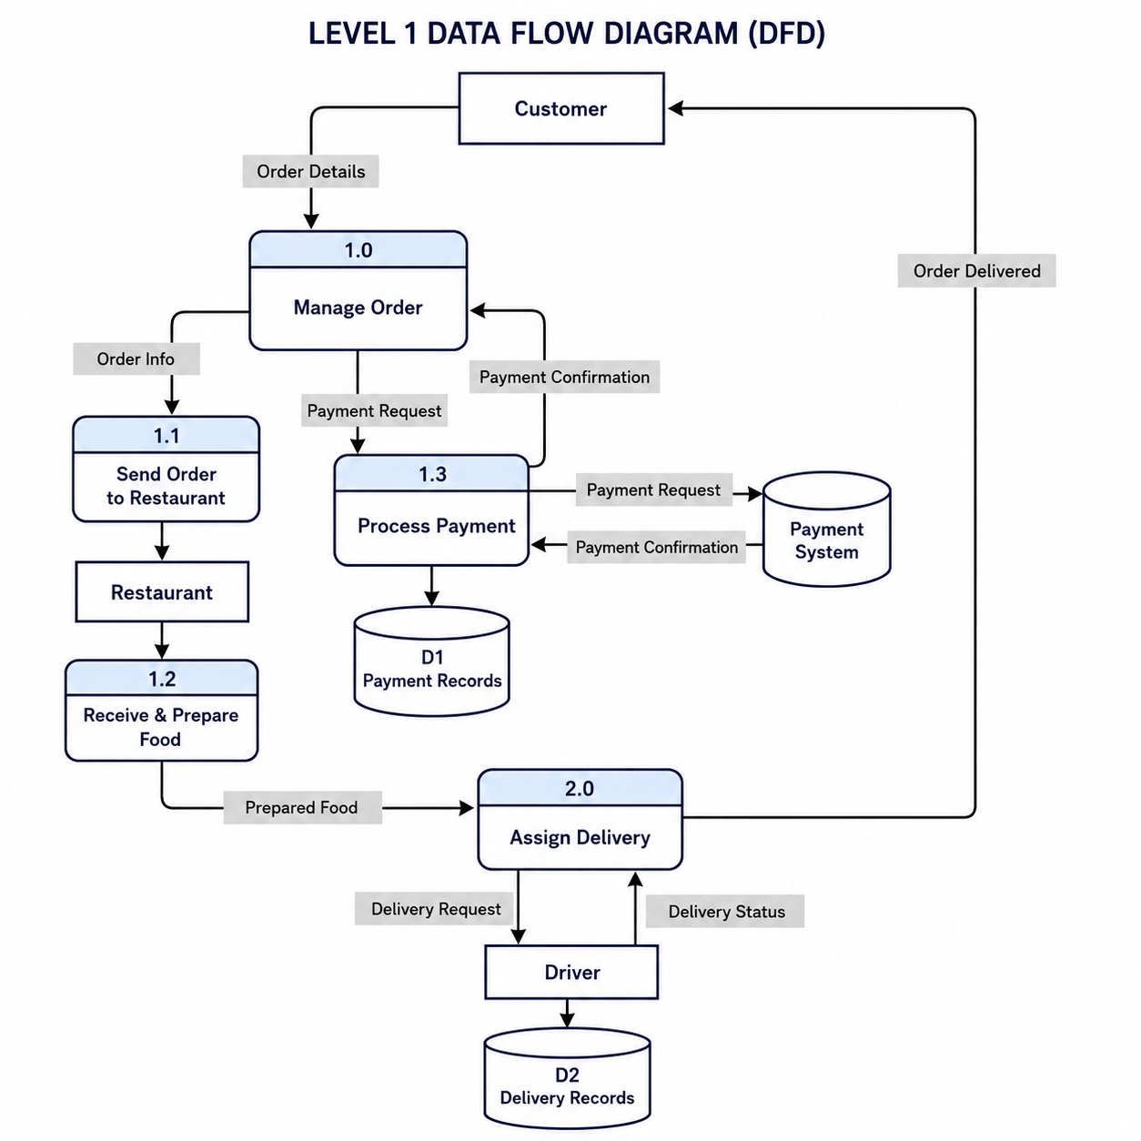
Figure 7.3.2: Level-1 DFD

7.4 UML Class Diagram
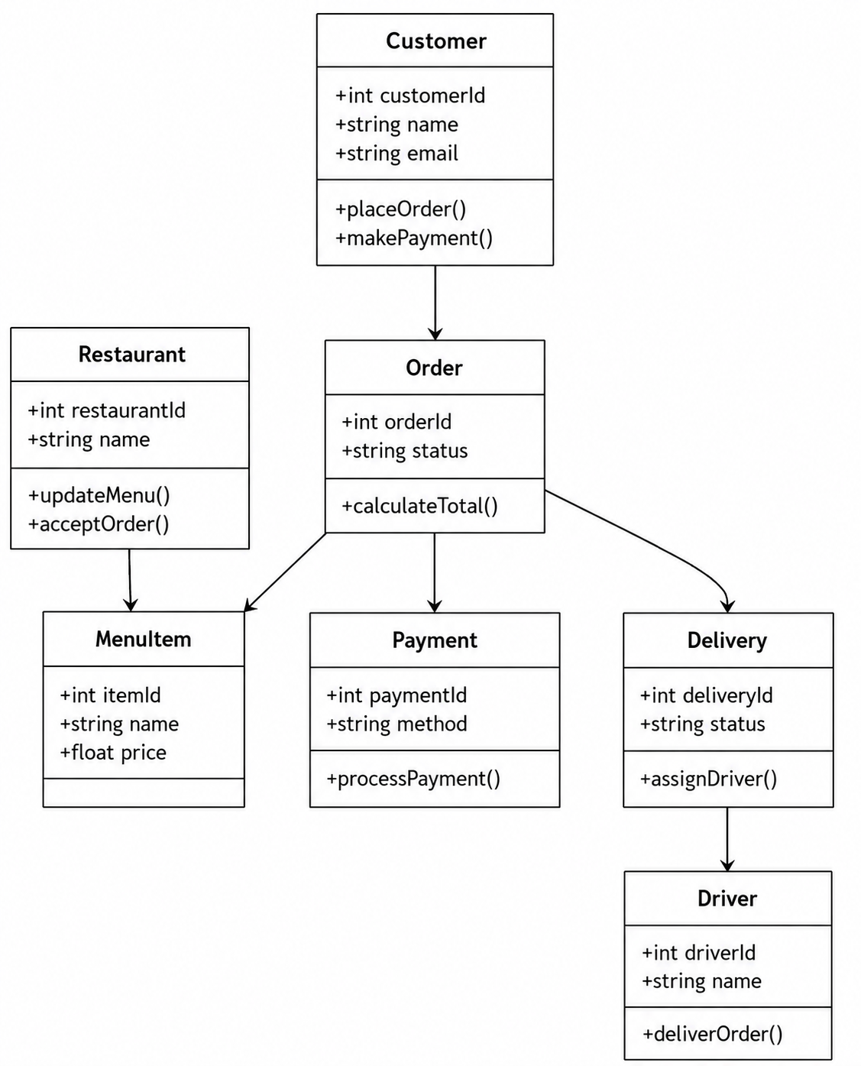
Figure 7.4.1: UML Diagram

8.Detail Budget

8.1 Detail Budget
Table 8.1: Detail Budget
Category | Item | Quantity | Cost | Total
Hosting | Hosting | 12months | 1200 | 1200
Domain | Domain Registration | 1 | 2,000 | 2,000
Security | SSL Certificate | 1 | 2500 | 2500
Tools | Development Tools
API fees | Payment Gateway API | 1 | 4500 | 4500
Total |  |  |  | 9200

9. Detail Timeline

Figure 9.1: Gannt Chart

10.Conclusion
In conclusion, the proposed Food Delivery System is not merely a functional platform but a holistic, robust, and future-ready ecosystem designed to seamlessly bridge the gap between customers, restaurants, and delivery personnel. By integrating a complete suite of features ranging from intuitive user interfaces to complex backend logistics the system establishes a new benchmark for operational excellence in the on-demand food service industry.
One of the primary strengths of this solution lies in its inherent scalability. Whether deployed in a dense urban neighborhood with hundreds of concurrent orders or expanded to cover an entire metropolitan region, the architecture is designed to handle fluctuating demand without compromising performance. This scalability is complemented by a cost-effective model that minimizes overhead for restaurants who no longer need to invest in expensive proprietary delivery infrastructure and reduces delivery fees for customers, thereby making the service accessible to a wider demographic. For delivery personnel, the system offers a transparent and reliable earning structure, ensuring that their time and effort are fairly compensated.
Furthermore, the system directly addresses three critical pain points that have historically plagued food delivery services transparent payments, and role-based access control. Simultaneously, restaurants benefit from optimized dispatch coordination, while delivery personnel gain clear navigation and estimated timeframes, reducing confusion and delays.
Transparent payments further reinforce this trust. By providing an itemized breakdown of costs, platform fees, and delivery charges before an order is confirmed, the system eliminates hidden surprises for customers. Restaurants receive timely, auditable settlements. This financial clarity fosters a fair and accountable economic environment for all parties involved.

References
food.pathao.com. (2015). Retrieved from Pathao.com: https://food.pathao.com/
Grady Booch, J. R. (2005). The Unified Modeling Language User Guide (2nd Edition). Addison-Wesley Professional.
John W. Satzinger, R. B. (2019). Systems Analysis and Design in a Changing World (7th Edition). Cengage Learning.
Maxim, R. S. (2020). Software Engineering: A Practitioner’s Approach (9th Edition). McGraw-Hill Education.
Maxim, R. S. (2020). Software Engineering: A Practitioner’s Approach (9th Edition). McGraw-Hill Education.

