
LA GRANDEE INTERNATIONAL COLLEGE
Simalchaur, Pokhara Nepal
A Final Report
On
“Study-Buddy”
Submitted to:
Bachelor of Computer Application (BCA) Program
In Partial fulfilment of the requirements of the degree of BCA under Pokhara Unviersity
Submitted by:
Name: | Course: | Semester: | P.U. Registration:
Depika Kumari Sharma | BCA | 4th | 2024-1-53-0164
Sampada Pahari | BCA | 4th | 2024-1-53-0184
Prasid Gautam | BCA | 4th | 2024-1-53-0174

Date: 9th July 2026

Student Declaration
We hereby declare that we are the only authors of this work and that no sources other than the listed here have been using in this work. We assure you that the work we present here is unique to ourselves and likenesses to another similar project are purely coincidental.
Student Name 1 (Roll No: XXXXX)
Depika Kumari Sharma( 2024-1-53-0164)
Sampada Pahari (2024-1-53-0184)
Prasid Gautam (2024-1-53-0174)
Program: Bachelor of Computer Application
Semester: 4th Semester
Date: 9/07/2026

Supervisor's Declaration
I hereby recommend that the project entitled Study-Buddy done under my supervision by Depika Kumari Sharma, Sampada Pahari and Prasid Gautam during their 4th semester in partial fulfillment of the requirement for the degree of Bachelor of Computer Application (BCA) under affiliation of Pokhara University is completed to my satisfaction and be processed for final evaluation.

Mr. Suman Devkota
Supervisor
Date:

Letter of Approval
We certify that we have examined this report entitled “Study-Buddy” and are satisfied with the project defence. In our opinion, it is satisfactory in the scope and qualify as project in partial fulfilment of the requirements for the degree of BCA under Pokhara University.

___________________ ___________________ ___________________
Suman Devkota Er. Kiran K.C
Supervisor External Examiner Principal

ACKNOWLEDGEMENT
We are grateful to our project supervisor Mr. Suman Devkota and our BCA coordinator Mr.Ankit Poudyal for the guidance, inspiration and constructive suggestions that helped us in the preparation of this project.
We are also appreciative among each other and understood the teamwork, the designation of the task per the skillset one represents constant synchronisation and monitoring of progress and introducing new knowledge and skill is commanding for the success of any given work.
Sincerely,
Depika Kumari Sharma
Sampada Pahari
Prasid Gautam

Abstract
Study-Buddy is a desktop-based academic resource sharing system developed to improve access to educational materials among students. Many students face difficulties in obtaining lecture notes, assignments, past examination papers, and other study resources due to the lack of an organized platform. Existing methods such as social media groups and messaging applications often result in inefficient resource management and poor accessibility.
The proposed system provides a structured environment where students can upload, search, download, and request academic materials. A dedicated Request Board feature enables users to post requests for specific study resources, allowing other students to contribute and support collaborative learning. The system also includes user authentication, resource categorization, search and filter functionality, comment mechanisms, and administrative controls for managing users and content.
The application is developed using Java for the graphical user interface and application logic, while Microsoft SQL Server is used for database management and secure data storage. The system aims to provide an efficient, secure, and user-friendly platform that enhances resource accessibility, encourages knowledge sharing, and improves the overall learning experience for students.
Keywords: Academic Resource Sharing, Collaborative Learning, Java, MS SQL Server, Request Board, Study Materials Management.

Table Of Contents
1. Introduction 1
1.2. Objectives 2
1.3. Aim, Scope and Applicability 2
1.3.1. Aim 2
2. Study of Previous System 4
2.1 Sakai Learning Management System 4
2.2 OpenOLAT 4
3. Current Problem and Proposed Solution 6
3.1 Current Problem 6
3.2 Proposed Solutions 7
4. Requirement Document 8
4.1 Functional Requirements 8
4.2 Non-Functional Requirements 9
4.3 Requirement Prioritization Table 10
5. System design 11
5.1. Feasibility study 11
5.2. Flowchart 12
5.3. ER Diagram 13
5.4. Use Case Diagram 14
5.5. Data Flow Diagram (DFD) 15
6. Development 18
6.1. Methodology: 18
6.2. Implementation and Testing 19
6.2.1. Implementation Approaches 19
6.2.2. Coding Details and Code Efficiency 19
6.3. Testing Approach 19
6.3.1. Unit Testing 19
6.3.2. Integrated Testing 19
6.3.3. Beta Testing 19
6.4. Modifications and Improvements 19
6.5. Test Cases 19
6.6. Verification and Validation: 19
7. Detail Timeline (Gantt Chart) 22
8. Result 23
9. Conclusion 24
9.1. Conclusion 24
9.2. Significance of the System 24
9.3. Recommendation 24
10. Reference 25

List Of Figure
Figure 1:Use Case Diagram 12
Figure 2 :Agile Model 14
Figure 3:Gantt Chart 15

List of tables
Table 1: Requirement Prioritization 10
Table 2: Detailed Budget 16

List of Abbreviations
CRUD: Create, Read, Update and Delete
DFD: Data Flow Diagram
MS SQL Server: Microsoft SQL Server
UI: User Interface

Introduction

1.1. Background
In the modern digital learning environment, students often face difficulties in finding reliable academic resources such as lecture notes, past examination papers, assignments, and study materials. Many students depend on informal platforms like social media groups and messaging applications for sharing educational content, but these methods are usually unorganized, time-consuming, and inefficient. Due to the lack of a centralized and structured platform, students may struggle to access the required materials when needed.
To address these problems, the proposed project “Study-Buddy” is developed as a desktop-based academic resource sharing system. The system will provide a structured and user-friendly platform where students will be able to upload, search, download, and request academic materials easily. One of the major features of the system will be the Request Board, through which students will be able to post requests for specific study resources, allowing other users to contribute and help fulfill those requests. The system will also promote collaboration and knowledge sharing among students in an organized manner.
The application will be developed using Java for implementing the application logic and graphical user interface, while Microsoft SQL Server (MS SQL Server) will be used for database management and secure storage of user and resource information. The project will focus on creating a secure, efficient, and easy-to-use environment that will improve accessibility to academic resources and support collaborative learning among students.

1.2. Objectives
The primary goal is to develop a functional, user-friendly software application that meets the following specific objectives:
- To develop a structured platform for sharing and accessing study materials easily.
- To allow students to request and provide specific academic content.
- To make learning resources easily searchable and well-organized.

1.3. Aim, Scope and Applicability

1.3.1. Aim
- Action-oriented academic hub
- Study-material management
- Make academic Organized

1.3.2. Scope
- User management system
- Study resource sharing
- Request and upload feature
- Search and organize materials

Applicability
Study-Buddy is applicable to:
- School students
- College and university students

1.4. Achievements
- Successfully designed and implemented a functional Study-Buddy system
- Created an intuitive and user-friendly interface
- Implemented core features such as reminders, planning, and study tracking
- Tested the system for functionality and performance

1.5. Organization of Report
This report is organized into seven chapters covering introduction, technology survey, system analysis, design, implementation and testing, results, and conclusions.

Study of Previous System
Analyzing the existing systems/tools that offer similar functions, especially those with collaboration, learning assistance, or study management features.

2.1 Sakai Learning Management System
Sakai is an open-source Learning Management System developed primarily for higher education institutions. It is built using Java, Spring Framework, and Hibernate, and supports collaborative learning. It is built using Java, Spring Framework, and Hibernate, and supports collaborative learning (www.sakailms.org, 2023).
Key Features:
- Course and content management
- Role-based access (student, instructor, admin)
Strengths:
- Highly scalable and suitable for large institutions
- Open-source and customizable
- Secure and reliable due to Java EE architecture
Weaknesses:
- Complex installation and configuration
- Steep learning curve for developers
- User interface is less intuitive compared to modern apps

2.2 OpenOLAT
OpenOLAT is a Java-based open-source e-learning platform widely used in universities and training organizations (Wikipedia Foundation Inc, 14). It focuses on structured learning and assessment (www.openolat.com, 2024).
Key Features:
- Course authoring tools
- Online tests and evaluations
- Learning paths and progress tracking
Strengths:
- Robust assessment and evaluation modules
- Good performance for concurrent users
- Modular and extensible architecture
- Long-term stability
Weaknesses:
- Limited social or peer-matching features
- Customization requires Java expertise

3. Current Problem and Proposed Solution

3.1 Current Problem
- Limited Accessibility:
Many educational resource platforms provide restricted access to study materials and require subscriptions or special permissions, making it difficult for all students to access necessary academic resources equally.
- Unorganized Resource Sharing:
Students often depend on messaging groups, social media platforms, or shared drives for exchanging study materials. These platforms lack proper organization, categorization, and efficient search functionality, making resource management difficult.
- Lack of Properly Integrated and Student-Focused Features:
Although different systems for academic resource sharing already exist, many of them do not provide all the required features within a single organized platform. Students may need to use multiple applications for sharing materials, requesting resources, communication, and searching study content, which reduces efficiency and convenience.
- Difficulty in Requesting Specific Resources:
Most existing systems mainly focus on sharing materials and do not provide a proper mechanism for students to request specific notes, assignments, or past examination papers when needed.
- Poor Resource Management:
Many existing sharing methods do not maintain proper records, categories, or user management features, which leads to inefficient searching, duplicate resources, and difficulty in maintaining resource quality and security.

3.2 Proposed Solutions
- Centralized Resource Management:
The application provides a single platform where students can upload, store, and access study materials such as notes, assignments, and past exam papers in an organized manner.
- User Authentication and Access Control:
Study Buddy includes a secure login system with user roles (e.g., students and administrators) to ensure authorized access and protect academic resources.
- Organized Categorization and Search:
Resources are categorized based on subject, semester, course, and type. An efficient search functionality allows users to quickly find required materials without browsing through multiple platforms.
- Resource Request System:
Students can submit requests for specific study materials. Other users or administrators can respond by uploading the requested resources, improving collaboration and academic support.
- Efficient Resource Tracking and Management:
The system maintains proper records of uploaded files, users, and categories. This helps prevent duplication, ensures better quality control, and improves overall resource management.
- Improved Accessibility and Collaboration Learning:
Since the application is desktop-based and institution-focused, it ensures equal access to academic resources and encourages peer-to-peer learning in a structured environment.

4. Requirement Document

4.1 Functional Requirements
1. User Authentication & Profiles
- Register users with email and password
- Login users securely into the system
- Create and manage user profiles (name, course, details)
- Store passwords in encrypted form
2. Upload & Resource Management
- Upload study materials (notes, assignments, past papers)
- Add subject and course details
- Search and download resources
- Preview available materials
3. Request Board
- Post requests for specific study materials
- Add subject and description in requests
- Respond to requests by uploading resources
4. Search & Filters
- Search resources using keywords or subjects
- Filter resources by category or type
- Sort results for easy access
5. Resource Interaction
- View and download study materials
- Give comments or grading on resources
- Identify useful content through ratings.
6. Admin Management
- Manage users and uploaded content
- Remove invalid or duplicate resources
- Monitor system activities

4.2 Non-Functional Requirements
1. Performance
- Ensure fast search and response time
- Support smooth system operation
2. Security
- Secure user login system
- Protect data using password encryption
- Restrict access based on user roles
3. Usability
- Design simple and user-friendly interface
- Provide easy navigation for all features
4. Reliability
- Maintain accurate and consistent data
- Store data securely in MS SQL database
5. Maintainability
- Develop modular and well-structured code
- Allow easy updates and modifications

4.3 Requirement Prioritization Table
S. N | Requirement | Priority Level | Description
1 | User Registration and Login | High | Required for identifying users and personalizing study data.
2 | User profile management | High | Allows users to manage personal details, subjects, and goals.
3 | Commenting or grading | Medium | Leave feedback, and receive real-time updates
4 | Logout and exit system | Low | Provides secure session termination.
5 | User-friendly interface | High | Improves usability, navigation, and overall user experience.
6 | File handling (store user data & progress) | High | Ensures permanent storage of user records and study history.
7 | CRUD operations | High | Required for managing users, subjects, and study sessions.

Table 1: Requirement Prioritization

5. System design

5.1. Introduction
The design phase focuses on translating system requirements into a structured solution that ensures usability and efficiency.

5.2. System Design
The system follows a modular architecture consisting of:
- User Interface Module
- Study Management Module
- Reminder Module
- Database Module

5.3. Database Design
The database stores:
- User details
- Study schedules
- Tasks and reminders
- Progress records

5.4. Interface Design

The interface is designed to be:
- Simple and intuitive
- Easy to navigate
- Responsive across devices

5.5. Feasibility study
A feasibility study evaluates whether the proposed system is practical and achievable by analyzing technical, financial, market, and operational aspects.
1. Technical Feasibility
- The system is technically feasible using Java (Swing/JavaFX) and MS SQL Server.
- Supports features like login, resource sharing, and request board.
- Required skills and tools are available.
2. Financial Feasibility
- Minimal cost required
- Uses free and open-source tools and technologies
- No major hardware or software expenses.
- Suitable for student-level development.
3. Market Feasibility
- Provides a centralized system for study materials.
- Students need a structured platform to share and request study materials
- Solves problems of existing platforms: poor organization and limited accessibility
4. Operational Feasibility
- Easy to use, maintain, and manage
- Features: searching, uploading, requesting resources
- Improves user experience and system efficiency
Conclusion
Effectively supports collaborative learning and resource sharing which is practical, achievable, and beneficial for students, can be completed within the available time and resources.

5.6. Flowchart
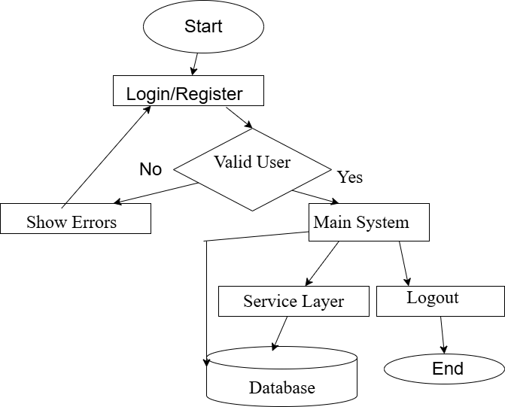

5.7. ER Diagram
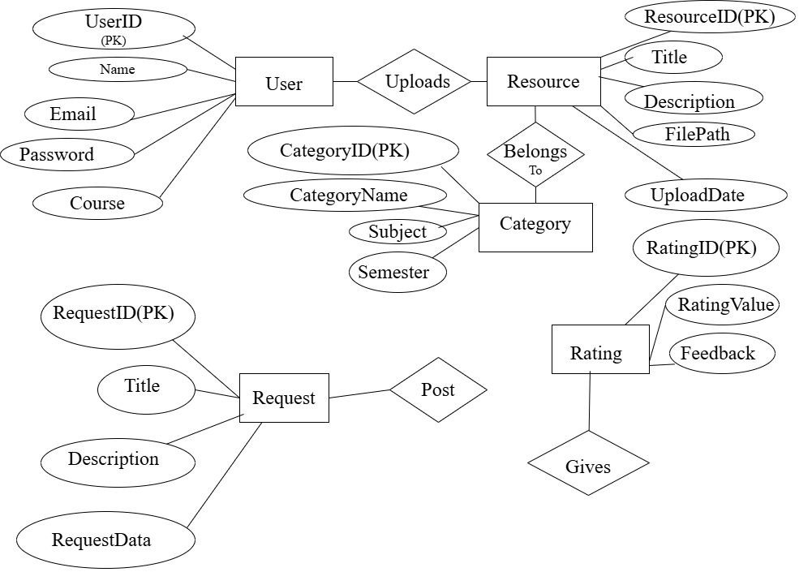

Figure 1: ER Diagram

5.8. Use Case Diagram
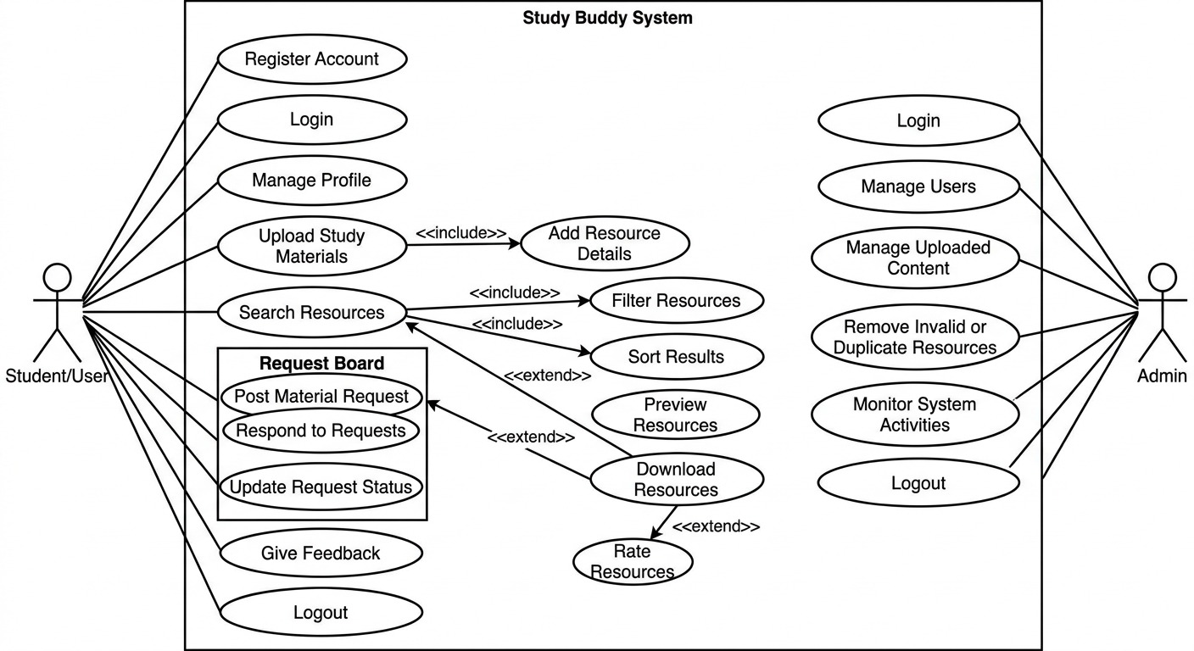

Figure 2:Use Case Diagram

5.9. Data Flow Diagram (DFD)
5.9.1. DFD Level 0-Context Diagram
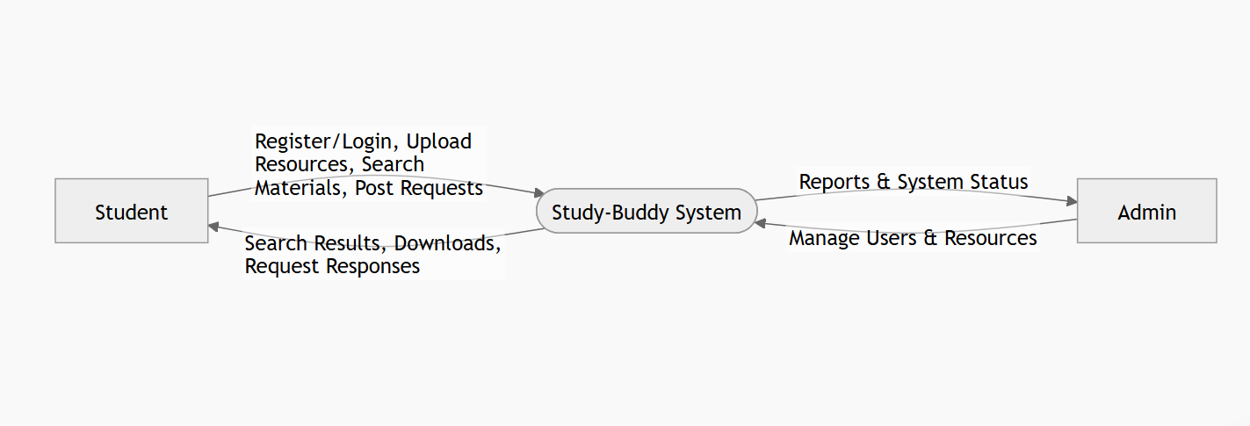

5.9.2. DFD-Level 1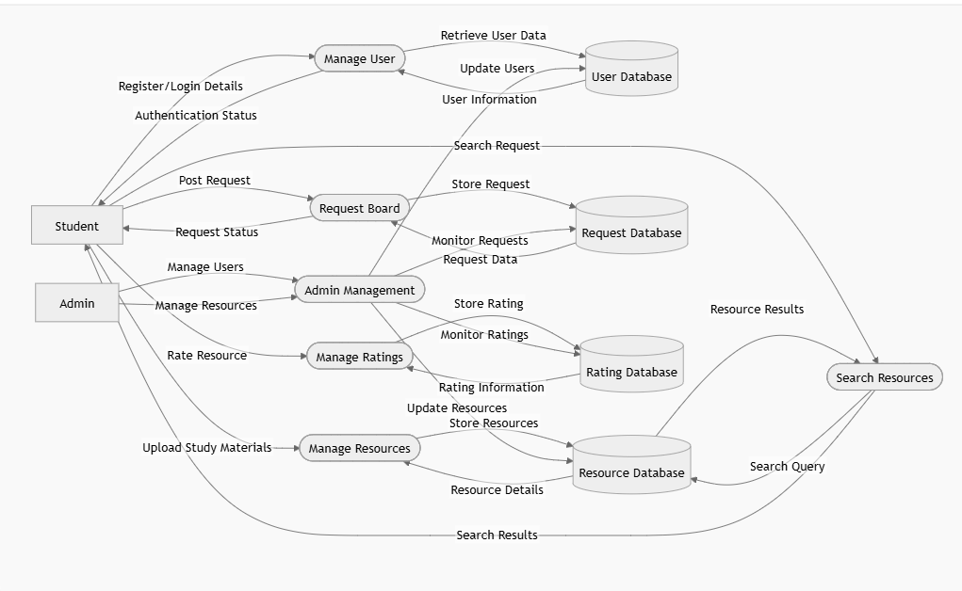

5.9.3. DFD Level 2-Request Board
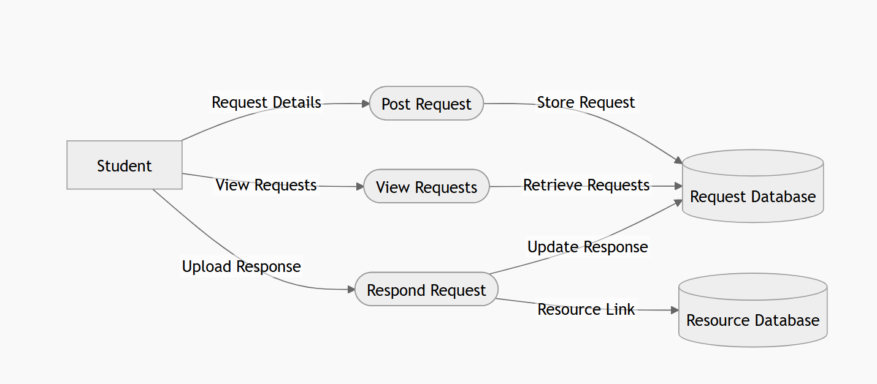

6. Development

6.1. Methodology:
The development of the proposed “Study-Buddy” system will follow a systematic methodology to ensure proper planning, development, testing, and implementation of the project. Information related to the system requirements and features will be collected from academic references, research articles, existing resource-sharing platforms, and internet sources. The collected information will help in understanding the problems faced by students and identifying suitable system features.
The system will be developed using the Agile software development model, where the project will be completed in different phases such as requirement analysis, system design, coding, testing, and improvement. Continuous feedback and regular modifications will be performed during development to improve system functionality and usability.
Java will be used for developing the application logic and graphical user interface, while Microsoft SQL Server (MS SQL Server) will be used for database design and management. Testing and debugging will also be conducted regularly to ensure the system operates correctly, securely, and efficiently.
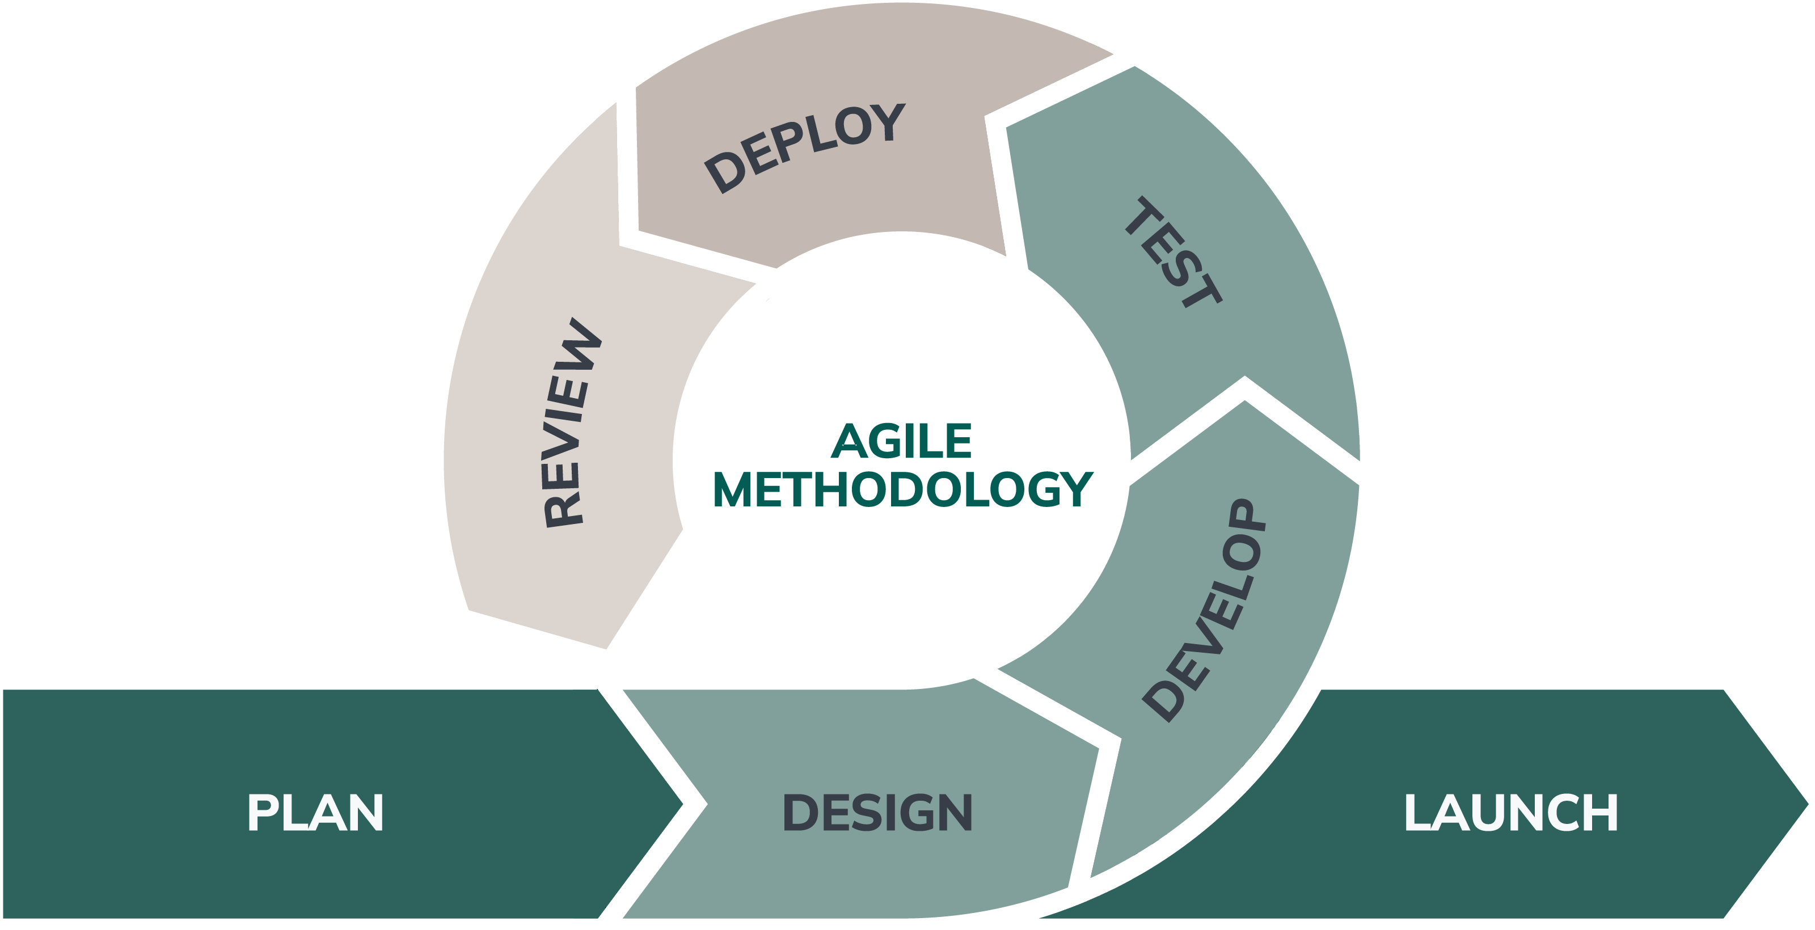

Figure 3 :Agile Model

6.2. Implementation and Testing

6.2.1. Implementation Approaches
The system was implemented using a modular and incremental development approach to ensure flexibility and ease of testing.

6.2.2. Coding Details and Code Efficiency
Efficient coding practices were followed:
• Reusable components
• Optimized database queries
• Error handling and validation

6.3. Testing Approach

6.3.1. Unit Testing
Each module was tested individually to ensure correctness.

6.3.2. Integrated Testing
Modules were combined and tested for proper interaction.

6.3.3. Beta Testing
The system was tested by a group of users to collect feedback and identify improvements.

6.4. Modifications and Improvements
Based on testing feedback:
• UI improvements were made.
• Performance optimizations were implemented.
• Minor bugs were fixed.

6.5. Test Cases

6.6. Verification and Validation:
The verification and validation processes for the Study-Buddy are essential ensure that it is built correctly and meets user expectations. By systematically reviewing requirements, conducting through testing and involving users in the validation process, developers can deliver a high-quality experience (GeeksforGeeks, 2025).
Verification:
The following things are done while verifying:
1. Code reviews: This helps in catching errors early.
2. Unit testing: Here the unit tests are done for individual functions and modules.
Validation:
The following things are done while validating:
1. Functional testing: Verifying that all features work as intended.
2. Performance testing: It is tested under various conditions to ensure it runs smoothly, checking for responsiveness and resource usage.

7. Detail Timeline (Gantt Chart)

Figure 4:Gantt Chart

8. Result
The Study-Buddy system was successfully designed and developed according to the specified requirements. The implemented system provides a platform for students to share, search, download, and request academic resources efficiently.
The following results were achieved:
• User registration and authentication were successfully implemented, allowing secure access to the system.
• Students can upload study materials such as notes, assignments, and past examination papers with proper categorization.
• The search and filtering functionality enables users to locate required resources quickly and efficiently.
• The Request Board feature allows students to post requests for specific academic materials and receive contributions from other users.
• Administrative functions were implemented to manage users, monitor uploaded content, and remove invalid or duplicate resources.
• Data is securely stored and managed using Microsoft SQL Server, ensuring consistency and reliability.
• The graphical user interface provides a simple and user-friendly experience, making navigation and resource management easier for students.
Testing and validation confirmed that the major functionalities operate correctly and meet the project objectives. The system improves accessibility to academic resources, reduces the time required to find study materials, and promotes collaborative learning among students through organized resource sharing and interaction.

9. Conclusion

9.1. Conclusion
The Study Buddy project was designed to address the limitations of traditional and existing digital learning systems by introducing a student-centered, collaborative learning platform. Through the study of previous systems, it was observed that although many learning management and educational applications provide content delivery and assessment features, they often lack personalized peer interaction, intelligent study support, and real-time collaboration.
The proposed Study Buddy system bridges this gap by enabling students to connect with suitable study partners, share learning resources and communicate effectively in a single integrated environment. By leveraging a Java-based backend architecture, the system ensures platform independence, security, scalability, and reliability while supporting future enhancements.

9.2. Significance of the System
- Enhances time management
- Encourages disciplined study habits
- Provides personalized academic support

9.3. Recommendation
Future enhancements may include:
- AI-based study recommendations
- Mobile application version
- Integration with online learning platforms

10. Reference
(2023). Retrieved May 2, 2026, from www.sakailms.org: https://www.sakailms.org/sakaiplus
(2024, October 1). Retrieved May 1, 2026, from www.openolat.com: https://docs.openolat.org/manual_user/about/Information_on_OpenOlat/
Wikipedia Foundation Inc. (14, February 2026). Retrieved May 1, 2026, from www,wikipedia.org: https://en.wikipedia.org/wiki/OpenOLAT

