
LA GRANDEE INTERNATIONAL COLLEGE
Simalchaur, Pokhara Nepal
Final Report
On
“Tic Tac Toe”

Submitted to:
Bachelor of Computer Application (BCA) Program
In partial fulfilment of the requirements for the degree of BCA under
Pokhara University
Submitted by:
Name: | Course | Semester | P.U. Registration Number
Aabishkar Acharya | BCA | 2nd | 2025-1-53-0310
Aakarshan Karki | BCA | 2nd | 2025-1-53-0311
Prakat Baral | BCA | 2nd | 2025-1-53-0338
Date:11/07/2026

ACKNOWLEDGEMENT
The satisfaction that accompanies after the successful completion of any task will be incomplete without mentioning the people whose ceaseless and relentless cooperation, constant guidance and encouragement made this project possible.
We are grateful to our project supervisor Mr Arpan Pokhrel, our faculty teacher Mr. Ramesh Chalise, for the guidance, inspiration and constructive suggestions that helped us in the preparation of this project.
We are also appreciative among each other and have understood that teamwork, the designation of the task per the skillset one portrays, constant synchronisation and monitoring of progress and instilling new knowledge and skill is imperative for the success of any given work.
Sincerely,
Aabishkar Acharya (25530406)
Aakarshan Karki (25530407)
Prakat Baral (25530432)

Declaration For
“Tic Tac Toe”
Student’s Declaration
We hereby declare that we are the only authors of this work and that no sources other than the listed here have been used in this work.
Aabishkar Acharya (25530406)
Aakarshan Karki (25530407)
Prakat Baral (25530432)
BCA, 2nd Semester
Date: 12/07/2026

Supervisor’s Declaration
We hereby recommend that this project entitled "Tic Tac Toe " is done under my supervision by Aabishkar Acharya (25530406), Aakarshan Karki (25530407), and Prakat Baral (25530432) during their 2nd Semester in partial fulfilment of the requirements for the degree of BCA under Pokhara University is completed to my satisfaction and be processed for final evaluation.

____________________________
Mr. Arpan Pokhrel
Date: 12/07/2026

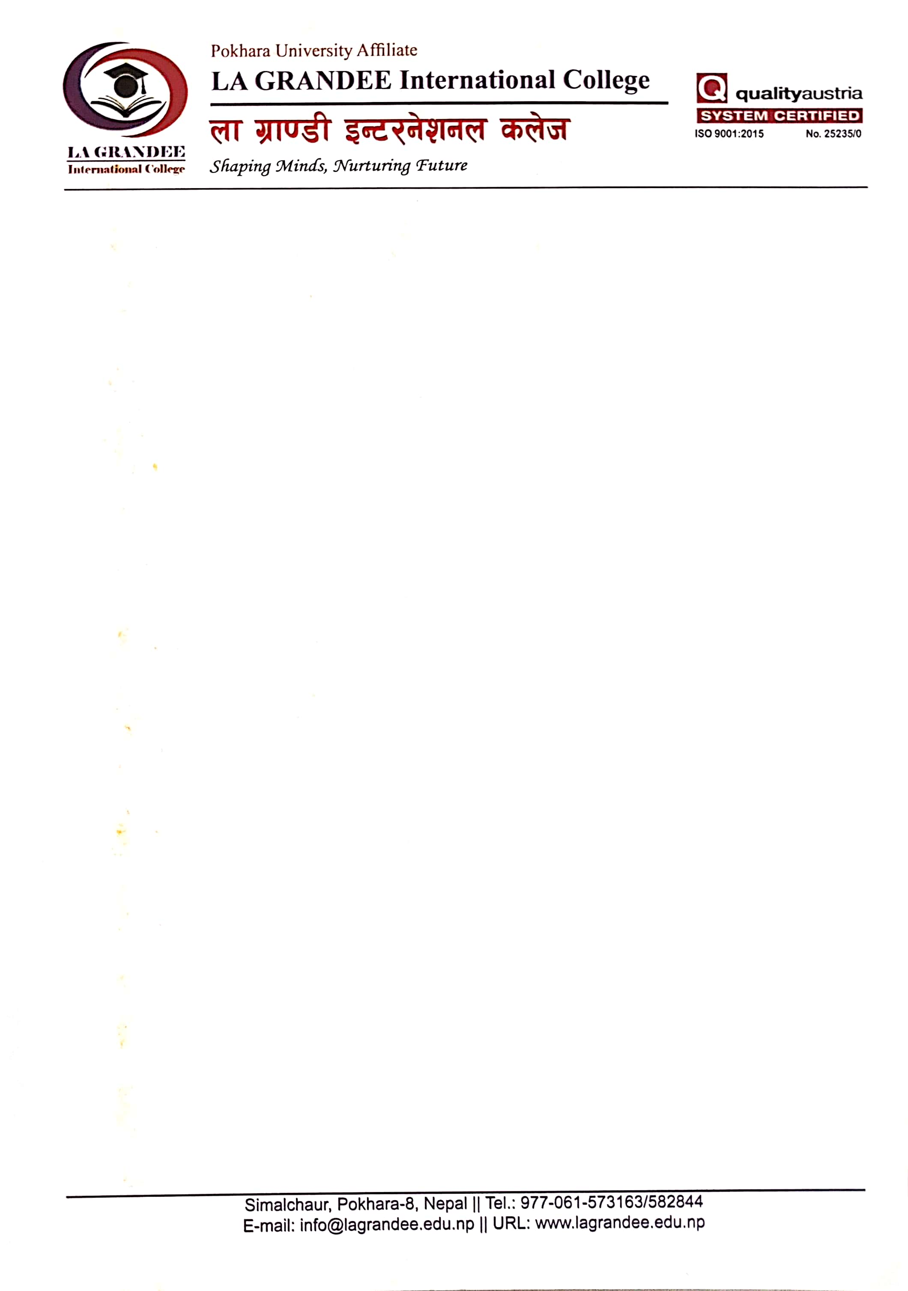

We certify that we have examined this report entitled “Tic Tac Toe” and are satisfied with the project defence. In our opinion it is satisfactory in the scope and qualify as project in partial fulfilment of the requirements for the degree of Bachelor of Computer Application (BCA) under Pokhara University.

______________________  Ankit Paudel  Program Coordinator | ____________________  Er. Dikshan Gurung  Examiner  Date: 12/07/2026 | _____________________  Er. Kiran Kc  Principle

Table of Contents
1. Introduction 1
2. Problem Statement 2
3. Objective 3
4. Background Study 4
5. Requirement Document 5
5.1 Requirement Matrix 5
5.2 User Requirements 6
5.3 Functional Requirements 6
5.4 Non-Functional Requirements 6
6. System Design 8
6.1 Dataflow Diagram 8
6.2 Flowchart 10
6.3 Use Case Diagram 12
7. Development 13
7.1 Work Assignment Chart 13
8. Detail Timeline 14
9. Testing 15
9.1 Test Cases 15
9.2 Requirement Traceability Matrix 17
9.3 User Acceptance Testing 18
10. Project Results 19
11. Future Enhancements 21
12. Conclusion 22
13. Annexures 23
14. References 25

List Of Figures
Figure 6.1: Level 0 DFD of Tic Tac Toe System 8
Figure 6.2: Level 1 DFD of Tic Tac Toe System 9
Figure 6.3: Flowchart of Login/Signup in Tic Tac Toe System 10
Figure 6.4: Flow chart of game logic in Tic Tac Toe System 11
Figure 6.5: Use case diagram 12
Figure 8.1: Gantt Chart 14
Figure 13.1: Signup Window 23
Figure 13.2: Login Window 23
Figure 13.3: Board Window 24
Figure 13.4: Stats Window 24

List Of Tables
Table 5.1:Requirement Matrix 6
Table 7.1:Work Assignment 13
Table 9.1: Requirement Traceability Matrix 17
Table 9.2: User Acceptance Testing 18

Introduction
The Tic Tac Toe game is a classic two player strategy game built using C programming language with the Raylib graphics library. The primary purpose of this project is to create an interactive, graphical version of the traditional Tic Tac Toe game that includes user authentication and match statistics tracking. This system transforms a simple pen and paper game into a digital experience with a complete login/signup system, a visually appealing game board, and persistent match history feature.
This project was developed as part of the BCA curriculum to demonstrate practical programming skills in C, including graphical interface development using Raylib, file handling for user data and game statistics, and modular programming through header files and separate compilation units.
The application features three main screens: a Sign-Up screen for new users, a Login screen for returning users to authenticate, and the Game screen where two players can compete in Tic Tac Toe matches. The game also includes a Statistics Overlay that displays the complete match history with win/loss/draw records for both players.
For our project, the work was divided among team members from the beginning. Documentation and coding were shared among all members.
While developing this project, we learned about graphical programming with Raylib, file I/O operations for data persistence, and modular code organization in C. The game runs at 60 FPS in an 800×600 window, providing a smooth and responsive user experience.
Going digital with a classic game like Tic Tac Toe demonstrates how even simple applications benefit from computerization persistent score tracking, user accounts, and a visual interface enhance the experience far beyond the traditional pen-and-paper version.
In addition to its core gameplay, the project emphasizes simplicity, usability, and reliability. The interface is designed to be easy to navigate, allowing users to quickly create an account, log in, start a new game, and view previous match results. The program validates user inputs and stores account information and game records in text files, ensuring that player data and statistics remain available even after the application is closed. This makes the system more practical and user-friendly while demonstrating the effective use of file handling and data management in C programming. (Brin, n.d.)

Problem Statement
The traditional Tic Tac Toe game played on paper suffers from several limitations that this project aims to address:
- No Score Tracking: In the pen-and-paper version, players have no automated way to track wins, losses, and draws across multiple games. Scores are easily forgotten or disputed.
- No User Identity: There was no way to identify or authenticate players. Anyone can claim to be any player, and there is no accountability.
- Manual Game Management: Players must manually draw the grid, take turns, and verify win conditions leading to potential errors and disputes.
- No Persistent History: Once a paper game ends, the results are typically discarded. There is no long-term record of gameplay statistics.
- Limited Visual Appeal: Paper-based games lack the visual feedback and interactive elements that digital games can provide.
- No Reset Mechanism: Starting a new game on paper requires drawing a new grid each time, which is inconvenient.
Secondary issues identified:
- Data redundancies in manual record keeping
- Lack of security (no authentication)
- No organized storage of game results
- Zero technology adaptation for a classic game
- Limited functionality (no statistics, no user management)
- Unorganized task flow (manual turn management)
To overcome these difficulties, we developed this Tic Tac Toe Game application that provides a complete digital solution with user authentication, automated game logic, visual feedback, and persistent statistics tracking.

Objective
The objectives of this project are clearly defined following the SMART criteria (Specific, Measurable, Achievable, Realistic, and Time-bound):
- To develop a fully functional graphical Tic Tac Toe game using C programming language and the Raylib graphics library.
- To implement a user authentication system (Sign Up and Login) that securely stores credentials in a text file for user identity management.
- To automate the win/lose/draw detection logic.
- To create a persistent match statistics system that records every game outcome to a text file.

Background Study
Tic Tac Toe, also known as Noughts and Crosses, is one of the oldest and most well-known strategy games in the world. The game dates back to ancient Egypt (around 1300 BCE) and has been played in various forms across cultures for centuries. (Jacks, n.d.)
In its traditional form, Tic Tac Toe is played on a 3×3 grid where two players alternate placing their marks (X and O). The first player to align three marks horizontally, vertically, or diagonally wins. If all nine cells are filled without a winner, the game ends in a draw. (Wales, n.d.)
- Current Challenges with Manual Systems: Research into traditional game systems reveals several inherent problems:
- Manual score-keeping is prone to human error and disputes
- Paper-based records are susceptible to damage, loss, and deterioration
- There is no authentication or identity verification in casual games
- Game integrity relies entirely on players' honesty
- Digital Game Development in C: The C programming language, combined with graphics libraries like Raylib, provides an efficient platform for game development. Raylib is an open-source, cross-platform library designed specifically for game programming education. It provides simple APIs for window management, input handling, 2D/3D graphics rendering, and more, making it ideal for educational projects.
- File-Based Data Persistence: For this project, text files serve as a simple yet effective data storage mechanism. The user.txt file stores user credentials, while stats.txt maintains the game history. This approach demonstrates fundamental file I/O operations in C without requiring external database systems.
- Relevance of the Project: This project bridges the gap between theoretical C programming knowledge and practical application development, demonstrating concepts such as:
- Modular programming with header files
- Event-driven programming (mouse clicks, keyboard input)
- File handling (reading, writing, appending)
- State management (screen transitions)

Requirement Document
The requirement document identifies the needs of stakeholders. The requirement gathering process involved identifying the needs of players, developers, and supervisors. These requirements were categorized into user, functional and non-functional requirements.

Requirement Matrix
S.N. | Required Modules, System, and Features | Description | Priority | Remarks
1 | User Registration  (Signup) System | New users can create an account with username and password, stored in users.txt | High | Essential for user management
2 | User Login  (Authentication) System | Existing users can log in with valid credentials to access the game | High | Security gateway to the application
3 | Game Board Rendering | Display a 3×3 Tic Tac Toe grid with X and O markers | High | Core gameplay visual
4 | Turn-Based Gameplay | Two players alternate placing X and O on the board via mouse clicks | High | Core game mechanic
5 | Win Detection Logic | Automatically detect wins across rows, columns, and diagonals | High | Game rule enforcement

6 | Draw Detection Logic | Detect when all cells are filled without a winner | High | Game rule enforcement
7 | Game Reset Mechanism | Allow players to start a new game after completion | High | Continuity of play
8 | Match Statistics Recording | Save each game's outcome (X, O, or Draw) to stats.txt | Moderate | Data persistence
9 | Statistics Overlay Display | Toggle-able overlay showing match history and cumulative stats | Moderate | User information feature
10 | Password Masking | Display asterisks (*) instead of actual password characters during input | Moderate | Security feature
11 | Error Handling for Login | Display error message for incorrect username/  password | Moderate | User experience
12 | Graphical Window (800×600 at 60 FPS) | Smooth, properly sized application window | High | Application foundation

Table 5.1:Requirement Matrix

User Requirements
- Users want to create accounts and log in
- Users want to play Tic Tac Toe against another player
- Users want to see who won and track statistics
- Users want a simple and intuitive interface

Functional Requirements
- User registration and login system
- 3×3 game board with click-based input
- Automated win and draw detection
- Game result recording to file
- Statistics viewing capability
- Game reset without application restart

Non-Functional Requirements
- Application should run at 60 FPS for smooth experience
- Password should be masked during input for security
- Window size of 800×600 pixels for comfortable viewing
- Responsive mouse click detection for gameplay
- File-based storage should be reliable and persistent

System Design
System Design represents the structure and operation of the Tic Tac Toe Game. The design phase converts system requirements into a blueprint for development.

Dataflow Diagram
DFD (Data Flow Diagram) is a graphical representation of how data moves through a system. It shows the flow of information between users, processes, data stores, and external entities without describing the program's internal logic.
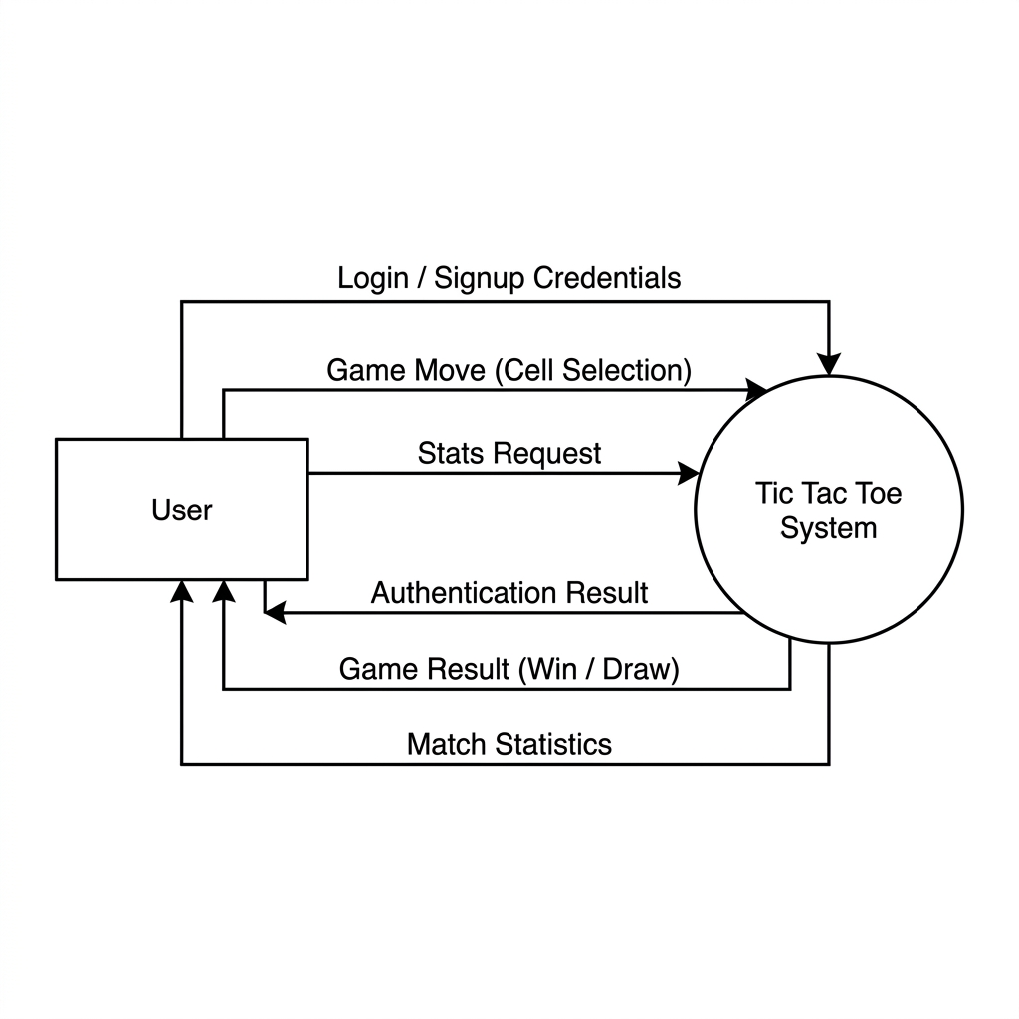Figure 6.1: Level 0 DFD of Tic Tac Toe System

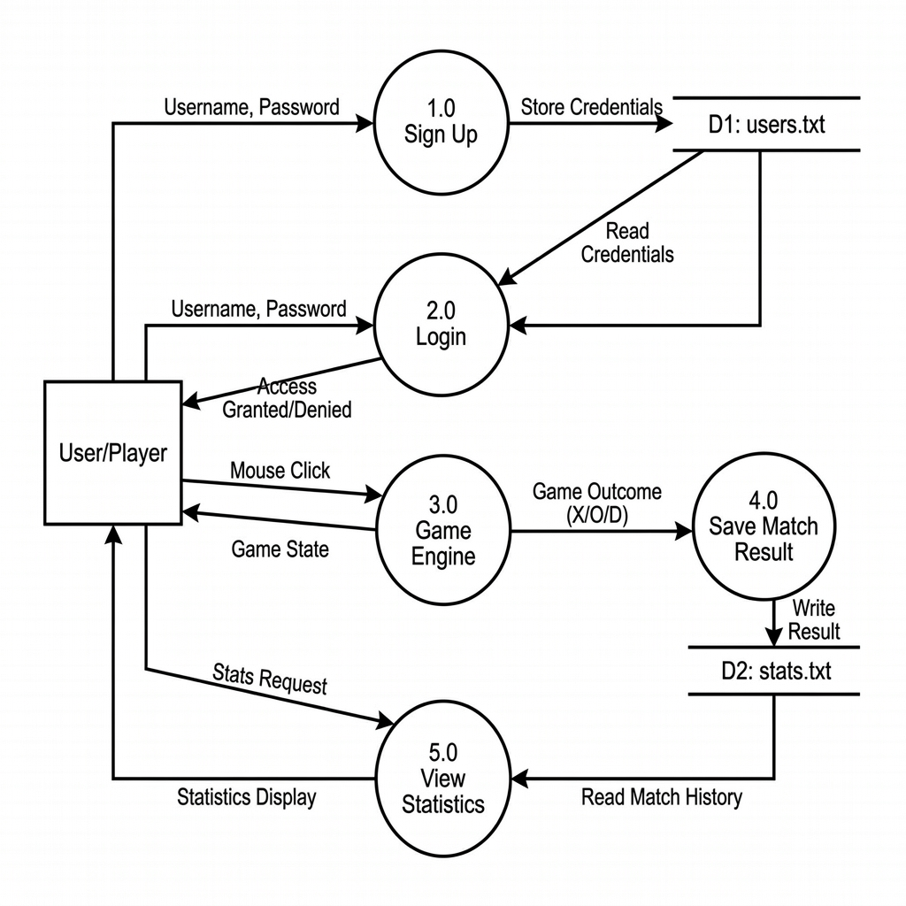
Figure 6.2: Level 1 DFD of Tic Tac Toe System

Flowchart
A Flowchart is a graphical representation of the step-by-step sequence of operations in a program or process. It uses standard symbols connected by arrows to show the order in which tasks are performed and decisions are made.

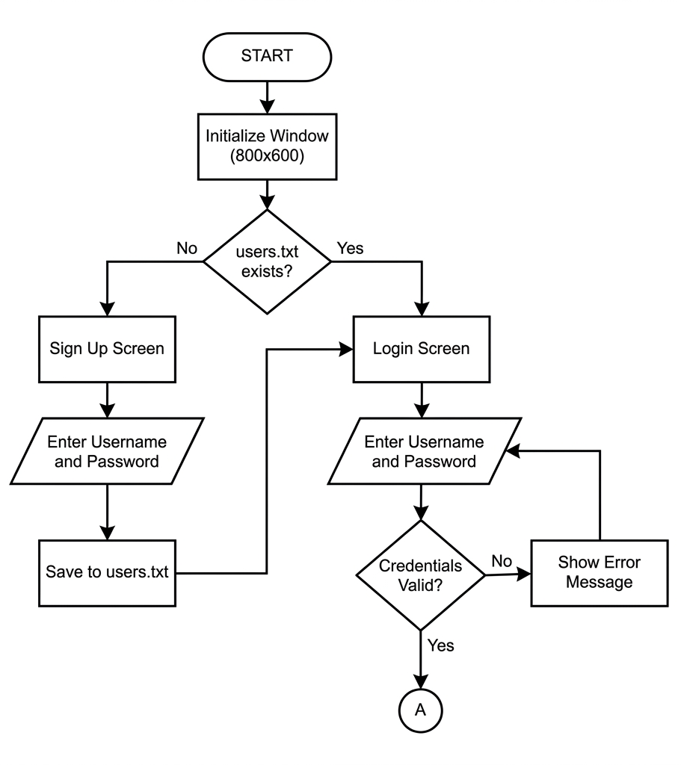
Figure 6.3: Flowchart of Login/Signup in Tic Tac Toe System

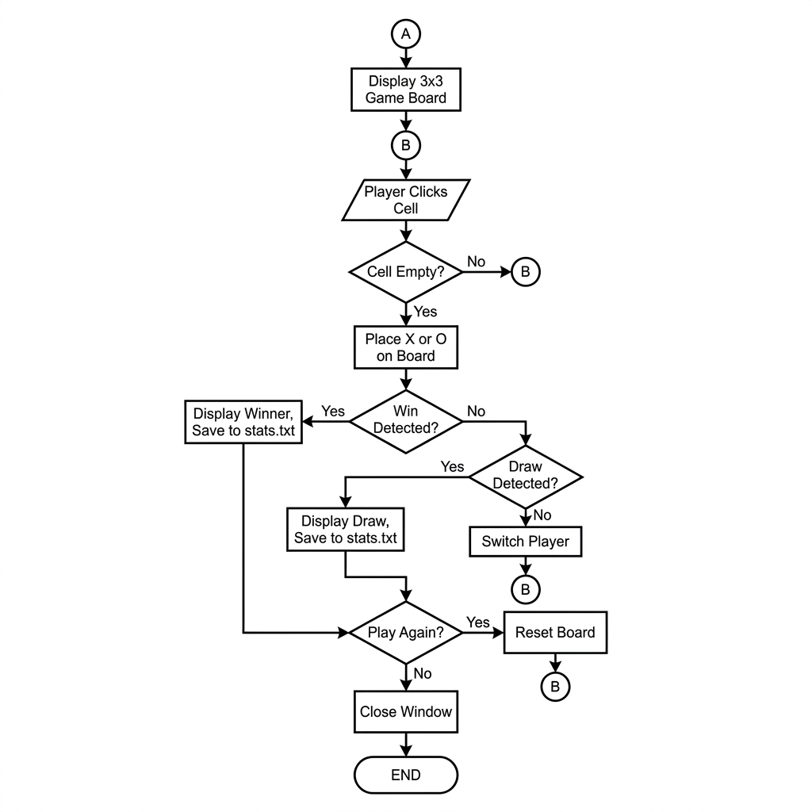

Figure 6.4: Flow chart of game logic in Tic Tac Toe System

Use Case Diagram
A Use Case Diagram is a UML (Unified Modelling Language) diagram that shows how different users (actors) interact with a system. It focuses on what the system does from the user's perspective, not how it does it.
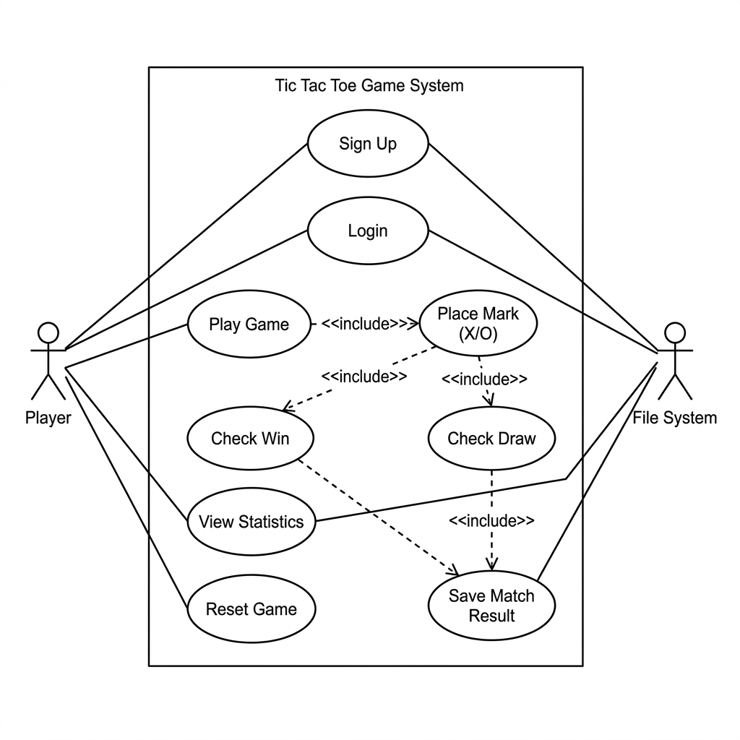
Figure 6.5: Use case diagram

Development
The waterfall model was chosen for the development of the Tic Tac Toe game because it is suitable for small and well-defined projects. The project requirements and features are clearly defined before the development process which made the waterfall approach effective and easy to manage. Unlike complex software projects, this project follows a simple and structured process. Each phase such as requirement analysis, system design, implementation, testing, and maintenance was completed step by step in sequence which helped in proper planning, coding, testing, and documentation.
The Waterfall Model was preferred over other models because:
- The project had fixed and clearly defined requirements.
- The system was small-scale and easy to manage.
- Development was completed phase by phase in an organized manner.
- It was suitable for academic and documentation-based projects.
- The model provided a clear structure and proper documentation for each stage.

Work Assignment Chart
S.N. | Name of the Member | Work Assigned | Remarks
1. | Prakat Baral | Documentation and coding. Game logic. DFD design. Problem identification.
2. | Aabishkar Acharya | Documentation and coding. Login/Signup system. System design support. Flowchart design.
3. | Aakarshan Karki | Documentation and coding. Statistics module. Testing. Support in system design.

Table 7.1:Work Assignment

Detail Timeline
The Gantt chart is a graphical representation of the project schedule that shows the sequence and duration of activities involved in the development of the Tic Tac Toe game. It helps in planning, monitoring, and completing the project within the allocated time frame. Since this project follows the Waterfall Model, the development process is divided into different phases such as requirement analysis, system design, coding, testing, documentation, and final deployment. The chart below illustrates the timeline of each phase from the beginning of the project to the final submission period.

Figure 8.1: Gantt Chart

Testing

Test Cases
Test Case 1: Module Testing of Login Function - Authentication of Users
- TID: TC01, TC02, TC03
- Description: A user should be able to log in with proper username and password
- Precondition: The user must have a username and password that is previously registered in users.txt
Test Steps:
- Open the executable file (game.exe), the login panel is displayed
- Enter valid username "aaku" and valid password "123" [ Expected: Navigate to Game Screen]
- Enter invalid username "wrong" and password "wrong" [ Expected: Display "Wrong username/password" error]
- Enter empty strings and click Login [Expected: Display error message]
- Enter valid username with wrong password [Expected: Display error message]
Test Case 2: Module Testing of Sign-Up Function - User Registration
- TID: TC04, TC05
- Description: A new user should be able to create an account
- Precondition: The users.txt file must be accessible for writing
Test Steps:
- Delete users.txt to trigger the Sign-Up screen
- Enter a new username and password, click "CREATE ACCOUNT"
- Verify the credentials are saved in users.txt
- Verify redirect to Login screen after signup
Test Case 3: Module Testing of Game Logic - Win Detection
- TID: TC06, TC07, TC08
- Description: The game should correctly detect wins in all possible configurations
Test Steps:
- Place X marks in a horizontal row (e.g., top row) [Expected: "Player X WON!" message displayed]
- Place O marks in a vertical column [Expected: "Player O WON!" message displayed]
- Place X marks diagonally [Expected: "Player X WON!" message displayed]
- Verify NEW GAME button appears after win
Test Case 4: Module Testing of Game Logic -Draw Detection
- TID: TC09
- Description: The game should detect a draw when all cells are filled with no winner
Test Steps:
- Fill all 9 cells without creating a winning combination
- Expected: "GAME DRAW!" message displayed in orange
- Verify NEW GAME button appears
Test Case 5: Module Testing of Statistics - Match History
- TID: TC10, TC11
- Description: Game results should be saved and viewable
Test Steps:
- Complete a game (win or draw)
- Click the STATS button
- Verify the game result appears in the overlay
- Verify cumulative Player X, Player O, and Draws counts are correct
- Click STATS again to close the overlay

Requirement Traceability Matrix
S.N. | Requirement Description | Testcase ID | Status | Remarks
101 | Login into the application | TC01, TC02, TC03 | TC01- Pass, TC02- Pass, TC03- Pass | Login with valid credentials works. Invalid credentials show error message correctly.
102 | User Registration (Sign Up) | TC04, TC05 | TC04- Pass, TC05- Pass | New users can create accounts. Credentials are saved to users.txt successfully.
103 | Game Board and Gameplay | TC06, TC07, TC08 | TC06- Pass, TC07- Pass, TC08- Pass | Win detection works for rows, columns, and diagonals.
104 | Draw Detection | TC09 | TC09- Pass | Draw is correctly detected when board is full with no winner.
105 | Match Statistics | TC10, TC11 | TC10- Pass, TC11- Pass | Statistics are saved and displayed correctly.
106 | Password Masking | TC12 | TC12- Pass | Password is displayed as asterisks during input.

Table 9.1: Requirement Traceability Matrix

User Acceptance Testing
No. | Acceptance Requirement (USR) | Critical (DEV) | Test Results (DEV) | Comments (USR)
1. | The login system should ensure security | Yes | Accept | The system masks passwords and validates credentials against stored data.
2. | The game should correctly determine winners and draws | Yes | Accept | All winning conditions (rows, columns, diagonals) and draw conditions are correctly detected.
3. | Match statistics should be accurately recorded | Yes | Accept | Every completed game is recorded to stats.txt with correct outcome.
4. | The interface should be intuitive and easy to use | Yes | Accept | Clear visual layout with distinct screens for signup, login, and gameplay.
5. | The game should allow continuous play | Yes | Accept | The NEW GAME button resets the board for a new match without restarting the application.

Table 9.2: User Acceptance Testing

Project Results
The Tic Tac Toe Game project was conceptualized to provide a digital, interactive version of the classic Tic Tac Toe game with user authentication and persistent statistics tracking. The functions which we visualized during the project were completely achieved.
The problems that have been solved with the project are:
- Manual score tracking is eliminated, all game results are automatically recorded to stats.txt
- User identity is managed through a signup/login system with credential storage in users.txt
- Win and draw conditions are automatically detected, eliminating disputes between players
- Game history is persistently stored, allowing players to review their performance over time
After studying the limitations of paper-based Tic Tac Toe, the following improvements were achieved:
- Our game has automated game logic which eliminates the need for manual verification of wins
- Our game’s password masking provides basic security for user accounts
- The feature statistics overlay gives players instant access to cumulative and individual game records
Technical Achievements:
- The application runs smoothly at 60 FPS in an 800×600 window
- Modular code architecture with separate files for game logic (game.c) and application logic (main.c)
- Proper state management through screen variables (0: initial, 1: signup, 2: login, 3: game)
Starting this project, we were new to C and Raylib's graphical programming. It proved challenging but incredibly rewarding, introducing us to graphics, file handling, and modular code organization. Beyond technical skills, we learned the value of effective teamwork, sharing ideas, and the power of approaching new challenges with passion and patience.

Future Enhancements
The following enhancements can be implemented in future versions of the Tic Tac Toe Game:
- AI Opponent - Implement a single-player mode with an AI opponent using the Minimax algorithm, allowing users to play against the computer at varying difficulty levels.
- Database Integration - Replace text file storage (users.txt, stats.txt) with a proper database system (SQLite) for more reliable and scalable data management.
- Network Multiplayer - Use socket programming to enable two players on different computers to play against each other over a local network or the internet.
- Enhanced GUI - Add animations for piece placement, winning line highlights, sound effects, and a more polished visual design.
- Player Profiles - Display individual player statistics including win rate, total games played, and win streaks.
- Game Replay - Implement a feature to save and replay past games move-by-move.
- Undo/Redo - Allow players to undo their last move during gameplay.
- Variable Board Size - Support larger board sizes (4×4, 5×5) for more complex gameplay.
- Mobile/Web Version - Port the game to mobile platforms or create a web-based version for wider accessibility.

Conclusion
The Tic Tac Toe Game project has been successfully designed, developed, and tested as a graphical desktop application using the C programming language and the Raylib graphics library. The project fulfils all defined objectives, delivering a complete game application with user authentication, automated game logic, and persistent match statistics.
The user authentication system (Sign Up and Login) provides basic identity management, storing credentials in users.txt and validating them during login. The game engine correctly implements all Tic Tac Toe rules, including turn-based gameplay, win detection across rows, columns, and diagonals, and draw detection when the board is full. The statistics module persistently records every game outcome and presents cumulative and individual match records through a toggleable overlay.
Through the development of this project, we gained practical experience in:
- Graphical programming using the Raylib library
- Modular C programming with header files and separate compilation units
- File I/O operations for data persistence
- State machine design for screen management
- Event-driven programming with mouse and keyboard input
- Software testing following STLC methodology
The project demonstrates that even a simple game like Tic Tac Toe can be enhanced significantly through digital implementation, providing features that are impossible in the traditional paper-based format. While the current version fulfils all core requirements, numerous future enhancements have been identified to further improve the application.
Overall, the game project successfully combines fundamental programming concepts with an interactive graphical interface to create an engaging and user-friendly application. It serves as a strong example of applying theoretical knowledge to a practical software development project. The experience gained from designing, implementing, and testing this application has strengthened our understanding of software engineering principles, graphical application development, and problem-solving in C programming. This project also provides a solid foundation for developing more advanced games and desktop applications in the future.

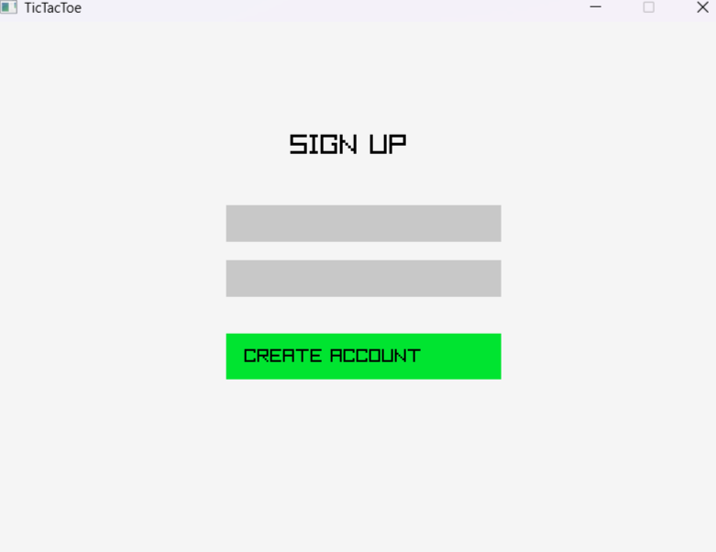
Annexures
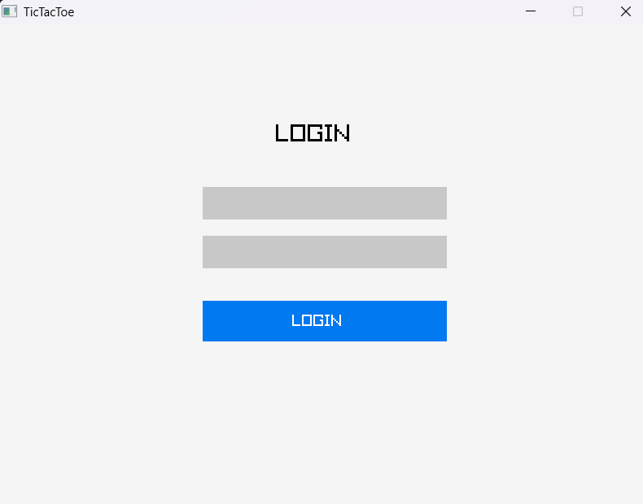
Figure 13.1: Signup Window

Figure 13.2: Login Window

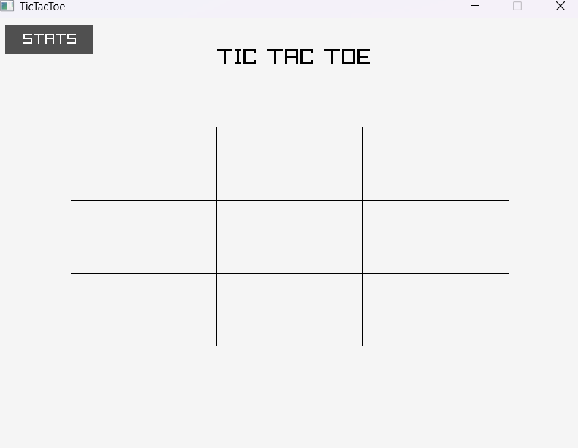

Figure 13.3: Board Window
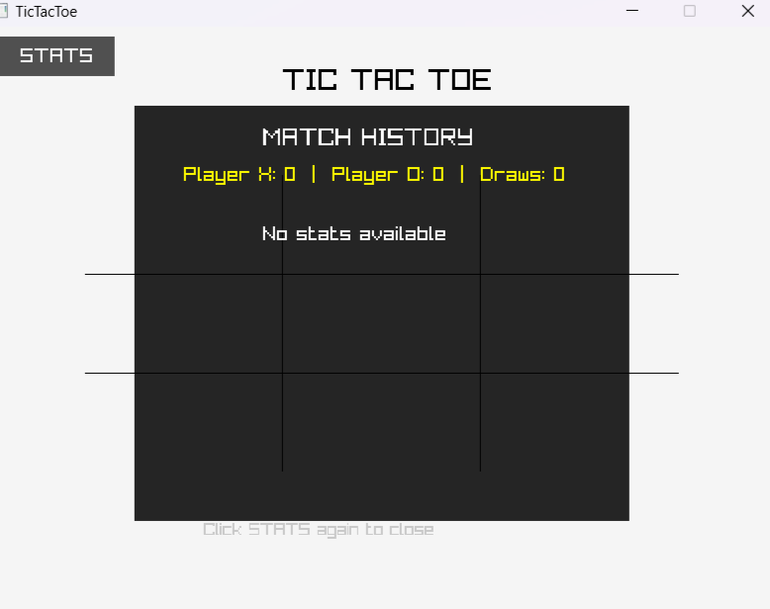

Figure 13.4: Stats Window

References
- Brin, V. M. (n.d.). Retrieved from https://antigravity.google/
- Jacks, C. (n.d.). Retrieved from https://papergames.io/en/tic-tac-toe.
- Wales, J. (n.d.). Retrieved from https://www.wikipedia.org/

