
LA GRANDEE INTERNATIONAL COLLEGE
Simalchaur, Pokhara Nepal
A Project Proposal
On
“Tic Tac Toe”

Submitted to:
Bachelor of Computer Application (BCA) Program
In partial fulfilment of the requirements for the degree of BCA under
Pokhara University
Submitted by:

Name: | Course | Semester | P.U. Registration Number
Aabishkar Acharya | BCA | 2nd | 2019-00-00-0000
Aakarshan Karki | BCA | 2nd | 2019-00-00-0000
Prakat Baral | BCA | 2nd | 2019-00-00-0000
Date:12/05/2026

Acknowledgement
The satisfaction that accompanies after the successful completion of any task will be incomplete without mentioning the people whose ceaseless and relentless cooperation, constant guidance and encouragement made this project possible.
We are grateful to our project supervisor Mr Arpan Pokhrel, our faculty teacher Mr. Ramesh Chalise, for the guidance, inspiration and constructive suggestions that helped us in the preparation of this project.
We are also appreciative among each other and have understood that teamwork, the designation of the task per the skillset one portrays, constant synchronisation and monitoring of progress and instilling new knowledge and skill is imperative for the success of any given work.
Sincerely,
Aabishkar Acharya
Aakarshan Karki
Prakat Baral

Introduction
The Tic Tac Toe game project will be a simple and interactive way to teach basic programming concepts, logical thinking, and interacting with the user. The Tic Tac Toe game is a 2-player game played on a 3 by 3 square grid. Each player takes their turn placing either an 'X' or an 'O' in one of the empty squares on the grid. The first player that has three of their respective letters lined up vertically, horizontally or diagonally will win the game.
The goal of the Tic Tac Toe project is to produce a game program that is fun for users; at the same time, it teaches the person who develops the game how to program since it will require the application of basic programming concepts such as loops, conditional statements, arrays, functions and game logic. The Tic Tac Toe game project will be designed so that both players have an equal chance of winning, when a player has won, they will be notified and a message will display showing who the winner is.
The Tic Tac Toe project can be developed in different programming languages and on different computer systems and will be useful to users of all levels (beginner or advanced) and can be used for instructional purposes. In addition, the Tic Tac Toe project will help improve problem solving skills, critical thinking skills, and knowledge of software development.

Problem Statement
Creating Tic Tac Toe game was difficult since it was our first programming-based task and we had to solve problems such as dealing with player turns, checking for wins, dealing with wrong input data, and ensuring proper game process. Despite a number of mistakes and failures, we were able to solve all of these issues and create the system.
The conventional method of Tic Tac Toe gaming uses paper which leads to lost information, invalid input data, inability to automate the game process, unorganized game process, and others. This system is not flexible, time-consuming, less safe, unable to store properly, less organized, and has poor interactivity. Furthermore, this approach employs outdated traditional methods which cannot easily adapt to new technologies.
Problems
- Data redundancy
- Hardcopies of data
- Lack of proper security
- Problems with storing data
- Unorganized game process
- Invalid input data
- Lack of flexibility
- Outdated approach
- Poor features and functionality
This project was designed to solve these issues by creating an easy, organized, safe, user-friendly Tic Tac Toe game.

Objectives
The importance of project objectives is essential since they indicate the objectives that are accomplished in the course of the project completion process. Project objectives are SMART; thus, they are specified, measurable, attainable, relevant, and time framed. The key emphasis in the project objectives lies on the development of the game and its attributes.
Project Objectives:
- Development of a simple and interactive Tic Tac Toe game system.
- Player turns management at the stage of gaming.
- Invalid or repeating moves recognition.
- Winning or draw situations assessment automatically through programming.
- Game process execution without errors due to coding techniques application.
- Utilization of loops, arrays, conditions, and functions in programming practice.
- Demonstration of an attractive interface for the users' convenience.
- Limitations reduction in comparison with the usual paper Tic Tac Toe game.
- Enhancement of logical reasoning and problem solving due to the project development.
- Success in accomplishment of the assigned task within the specified time period and required resources.

Background Study
The development process for Tic Tac Toe has progressed through multiple stages which established it as both a fun game and an educational resource. The game started as a pure manual game which people played with paper and pencils during the time of ancient Rome when they called it Terni Lapilli. The traditional system offers simple access to users, yet it suffers from higher risk of theft and data loss through various operational hazards because players frequently misplace their papers, which can be torn or water damaged, and they lose track of previous game results according to Adams in his book about board games. The first digital version of OXO appeared in 1950 when A.S. Douglas created the game for EDSAC computer systems, which marked the change from traditional physical gaming to electronic gaming. The system resolved issues regarding data loss and data preservation, but customers needed to pay for costly mainframe systems, which restricted system usage to research facilities. The 1990s and 2000s saw web-based and mobile app systems emerge as the leading technologies, which provided users with unlimited game replay options and tracking capabilities for their scores. The Academic study in Computers & Education, discovered that most existing apps focus on entertainment only, because they lack two design elements: adaptive difficulty and educational feedback, while also failing to provide offline-first design for classrooms which experience poor connectivity.

Requirement Document
A project cannot be implemented without proper requirements being studied. The requirements are mainly directed towards the needs of the project and the expectations of the users. This requirement document for the Tic-Tac-Toe game is prepared to identify the features, functions, and overall system requirements needed for successful development.
The main purpose of this document is to capture the needs of the users and ensure that the game meets the expectations of the stakeholders.
Requirements help define the goals, functions, and limitations of the project. They also provide a clear direction for design, development, testing, and maintenance. Proper requirement analysis helps reduce errors, improve productivity, and complete the project successfully.
The benefits include:
- Alignment: Clear understanding among developers and users.
- Preparation: Better planning for coding and testing.
- Direction: Guidance for design and development.
- Efficiency: Proper planning before implementation.
- Productivity: Less rework and easier maintenance.
A requirement document acts as a guide for the project. It helps the developer understand what features should be included in the system and how the system should behave.
The requirement document should also describe the quality and performance requirements of the system so that the project can be developed efficiently.
The best way to create a requirement document is by using a requirement matrix which prioritizes the requirements.
Types of Requirements
1. Business Requirements
The Tic-Tac-Toe project should provide a simple and interactive gaming system for users. The project should also help students understand programming concepts such as arrays, loops, conditions, and functions.
2. Users’ Requirements
- Users should be able to start the game easily.
- Users should be able to enter moves using keyboard input.
- Users should clearly view the game board after each move.
- Users should receive notifications for winner, draw, or invalid input.
- Users should be able to restart or exit the game.
3. Functional Requirements
The system must:
- Display a 3×3 game board.
- Allow two players to play alternately.
- Accept and process player input.
- Validate entered positions.
- Update the board after every move.
- Detect winner conditions.
- Detect draw conditions.
- Display game results correctly.
- Allow restarting the game.
4. Non-Functional Requirements
- The system should be simple and user-friendly.
- The program should respond quickly to user input.
- The game should run without crashes or infinite loops.
- The code should be easy to maintain and understand.
- The display should be clear and readable.

System Design

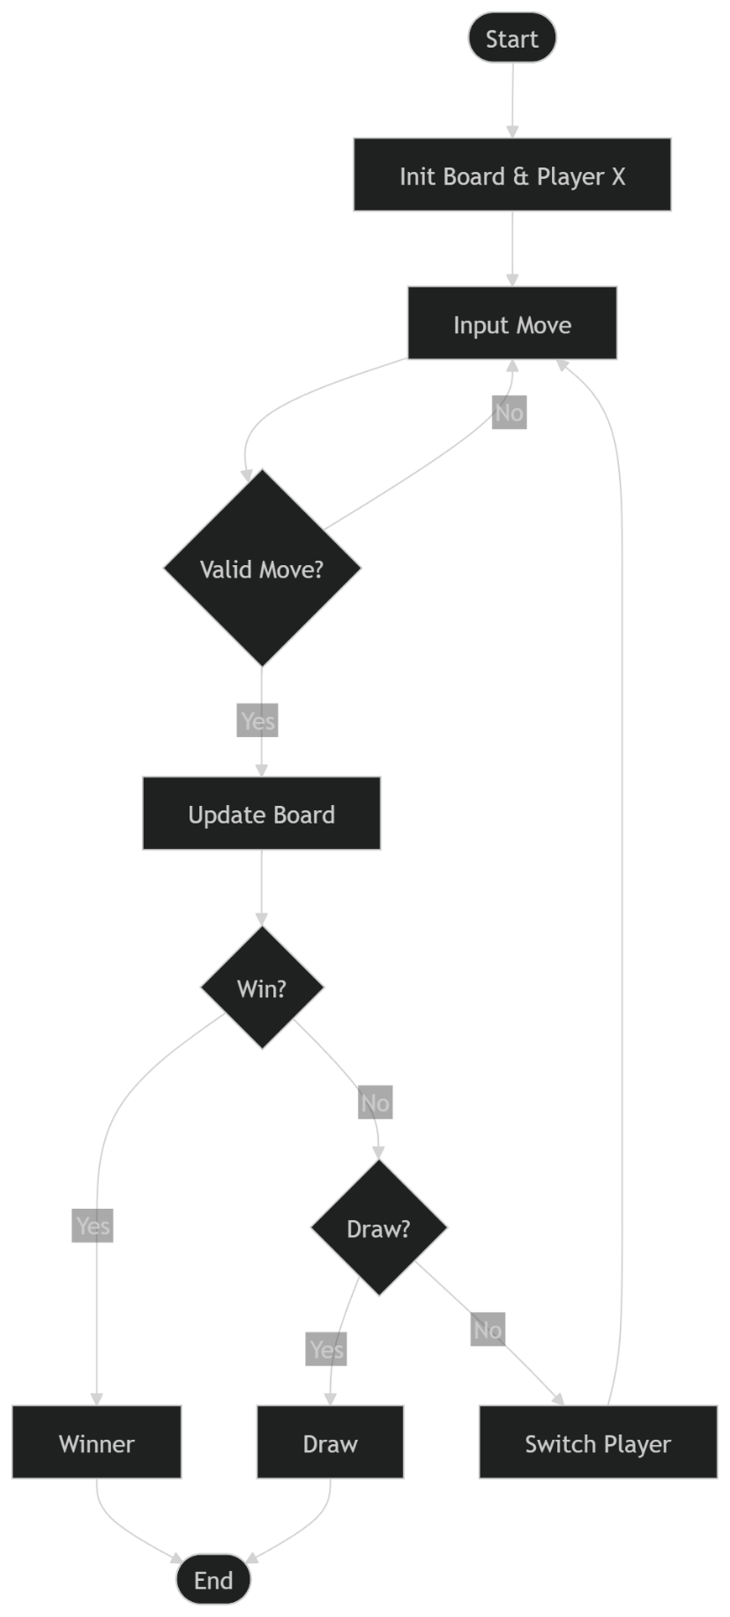
The process starts by initializing the game board and setting the first player as X. The player then enters a move by choosing a position on the board. The system checks whether the move is valid; if it is not, the player is asked to enter another move. If the move is valid, the board is updated with the player’s symbol. After each move, the program checks if the current player has won the game; if a winning condition is met, the game ends and the winner is displayed. If there is no winner, the system checks whether the board is full, which would result in a draw and end the game. If neither condition is met, the turn switches to the other player and the process repeats until the game finishes.

7. Development
The Waterfall Model is a traditional software development model that follows a linear and step-by-step approach. In this model, each phase must be completed before moving to the next phase. The process flows downward like a waterfall, which is why it is called the Waterfall Model. It is simple, organized, and suitable for small projects where the requirements are clearly defined from the beginning. While creating a Tic-Tac-Toe game, the Waterfall Model helps developers complete the project in a structured and systematic way.
- Requirement Analysis
In this stage, all the requirements of the Tic-Tac-Toe game are collected and analyzed. The developer decides what features the game should have. For example, the game should support two players, display a 3×3 board, allow players to take turns using symbols X and O, detect the winner, and show a draw if no player wins. The rules and objectives of the game are clearly defined before starting development.
- System Design
In this phase, the structure of the Tic-Tac-Toe game is planned. The developer designs how the game board will look and how different functions will work. The board may be represented using a 2D array in C programming. Functions such as displaying the board, taking player input, checking the winner, and switching turns are designed. A flowchart or algorithm is also prepared to describe the overall working process of the game.
- Implementation
In this stage, the actual program for the Tic-Tac-Toe game is written in C language. The developer writes code for displaying the board, accepting player moves, checking valid positions, and determining the winner. Each function designed earlier is implemented one by one. After coding, the game becomes functional and players can start interacting with it.
- Testing
In this phase, the Tic-Tac-Toe game is tested to find errors and bugs. Different test cases are checked such as horizontal wins, vertical wins, diagonal wins, draw conditions, and invalid inputs. If any problem is found, it is corrected before moving to the next stage. Testing ensures that the game works properly and produces correct results.
- Deployment
After successful testing, the Tic-Tac-Toe game is released to users. The program can be run on a computer or shared with others. In some cases, the game may also be converted into an executable file so that users can easily play it without needing the source code.
- Maintenance
In this stage, improvements and updates are made to the Tic-Tac-Toe game after deployment. Bugs that appear later are fixed and new features may be added. For example, the developer may improve the user interface, add score tracking, or create a single-player mode with computer AI. Maintenance helps keep the software updated and more user-friendly.
Thus, the Waterfall Model provides a clear and organized method for developing a Tic-Tac-Toe game. Since each phase is completed one after another, the development process becomes easier to manage and understand.

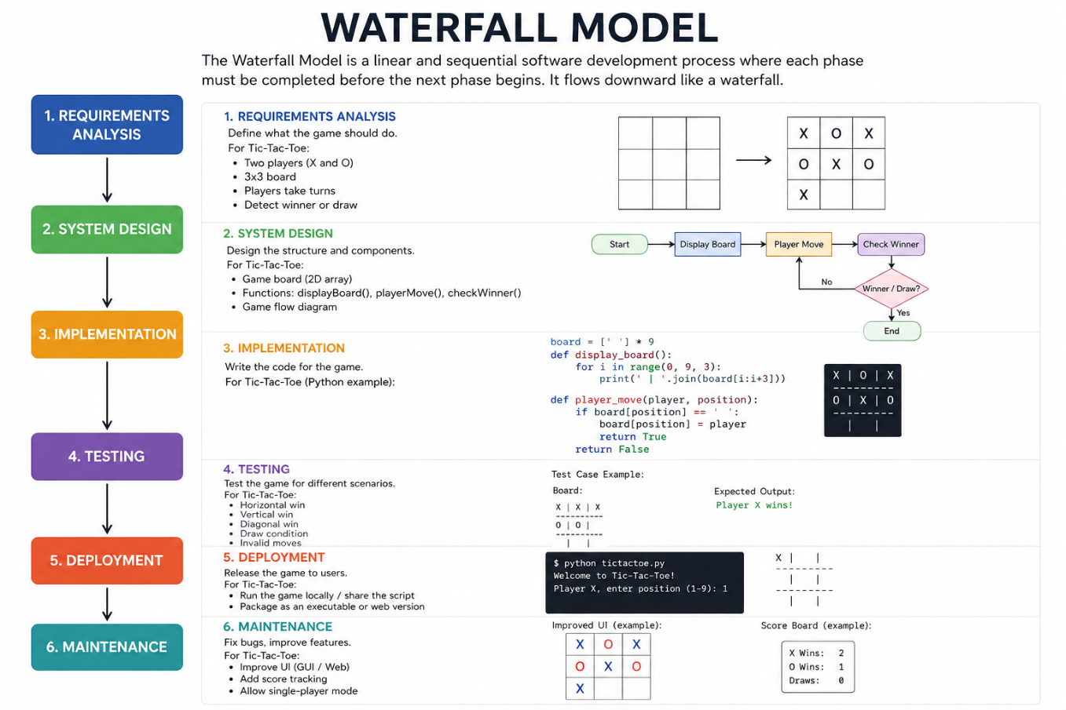
Figure5.1: SDLC model
S.N. | Name of the member | Work assigned | Remarks
1. | Aabishkar Acharya | Documentation and coding.  - DFD  - Problem Identification  - Coding support
2. | Aakarshan Karki | Documentation and coding.  - Gantt Chart  - Coding of login system  - Support in system design.  - Feasibility analysis.
3. | Prakat Baral | Documentation and coding.  - Designed Flowchart.  - Coding for seat selection.  - Support in system design.

