
LA GRANDEE INTERNATIONAL COLLEGE
Simalchaur, Pokhara Nepal
A Project Proposal
On
“Simple Banking System”

Submitted to:
Bachelor of Computer Application (BCA) Program
In partial fulfilment of the requirements for the degree of BCA under
Pokhara University
Submitted by:

Name: | Course | Semester | P.U. Registration Number
Anish giri | BCA | 2nd | 2019-00-00-0000
Ankit Sharma | BCA | 2nd | 2019-00-00-0000
Saugat | BCA | 2nd | 2019-00-00-0000
Date:13/05/2026
Table Contents
1.Introduction 1
2.Aim and Scope 2
3.Objective 2
4.Previous Study 4
5.Current Problems and Purposed Solution 5
6.Requriment 6
7.System Design 7
8.Detail Timeline 8
9.Conclusion 9
10.Reference 10

LIST OF FIGURES
Figure 1: Use Case Diagram 7
Figure 2 : Gantt Chart 8

1.Introduction
A Simple Banking System is a software-based system where users can perform banking activities digitally in an easy and interactive way. The main purpose of this project is to provide users with a simple platform to manage their banking operations while also understanding the concepts of programming, database management, and software development. This system helps to manage user accounts, maintain balance records, process deposits and withdrawals, and store transaction history efficiently.
In the existing traditional method, banking records are often managed manually using registers and paperwork, which can lead to calculation errors, data loss, and difficulties in maintaining records properly. To overcome these problems, this project was selected as it provides a computerized and user-friendly banking environment. The system helps users perform banking tasks smoothly without manual calculation errors and improves the overall banking experience.
This project also helps to reduce manual work and increase accuracy in banking operations. The system can quickly update account balances, record transactions automatically, and provide secure access through login and registration features. Since everything is handled digitally, the chances of mistakes are minimized and the banking process becomes faster, safer, and more reliable.
During the development of this project, different tasks were divided among team members such as documentation, coding, designing flowcharts, testing, and research work. Every member contributed equally to improve the system and make it more effective. Research was also carried out to understand the problems in manual banking systems and to develop suitable solutions using programming concepts.
In today’s digital world, computerized banking systems are more efficient and reliable than manual systems. By developing the Simple Banking System, users can experience a digital banking platform that is fast, accurate, and easy to use. This project also helps beginners improve their programming knowledge, problem-solving skills, and understanding of software development concepts.

2.Aim and Scope
The primary aim of this Simple Banking System is to develop a robust, command-line digital ledger that bridges the gap between theoretical C programming and practical software application. By focusing on the mechanics of financial data processing, the project serves as a functional vehicle for mastering complex logic, specifically through the implementation of file-based data persistence, modular function architecture, and rigorous input validation. Ultimately, it seeks to simulate a secure environment where digital transactions are handled with the same logical precision found in professional banking infrastructures.
The scope of the application is centered on the fundamental lifecycle of personal banking, covering the essential journey from user onboarding to transaction auditing. This includes a secure authentication gateway for registration and login, followed by a suite of core financial services such as real-time balance inquiries, deposits, and withdrawal protocols. Beyond simple arithmetic, the system’s boundaries encompass structural data management, ensuring that every transaction is permanently logged and retrievable via file handling. While currently focused on a streamlined, single-user experience, the system is architected to allow for future scalability into multi-role administrative systems or graphical interfaces.

3.Objective
The main objective of this project is to build a reliable and easy-to-use banking application that automates basic money management. The primary focus is to create a secure gateway where users can register their details and log in to access their personal accounts. By using C programming tools like functions and file handling, the system aims to store all user data and transaction logs permanently, ensuring that information is never lost when the program is closed.
Another key goal is to ensure that all financial operations, such as deposits and withdrawals, are processed with total accuracy through real-time balance updates. The project also focuses on transparency by maintaining a clear history of every transaction and giving users full control over their data, including the ability to delete their account entirely. Ultimately, the objective is to replace manual record-keeping with a digital system that is fast, error-free, and simple for anyone to navigate.

4.Previous Study
Studying earlier banking systems shows how financial tools have evolved from manual ledgers to digital platforms. Initially, banking relied on paper records, which were slow and prone to human error. When the first computer-based systems arrived, they used basic programming logic—like loops and functions—to automate simple tasks like calculating balances and storing account names. These early systems proved that digital tools could make banking much faster and more reliable, but they often struggled with clunky interfaces and a lack of real-time updates.
By looking at these older models, it becomes clear that their biggest weaknesses were poor data validation and a lack of transparency for the user. Many early programs didn't keep a clear history of transactions or allow users to easily manage their own data, such as deleting an account or seeing a full list of past activity. This history of limitations is what makes features like automated file storage, instant transaction logging, and secure login systems so important for a modern application.
For this project, the study of previous systems highlights the need for a design that balances simplicity with accuracy. While those early systems were often difficult to navigate, this project aims to take the core strengths of digital banking—speed and permanent data storage—and combine them with a much simpler, more user-friendly flow. This ensures that basic operations like deposits and withdrawals are not only fast but also recorded correctly in a way that the user can track at any time.

5.Current Problems and Purposed Solution
A major issue with many basic banking programs is that they are often prone to crashes or "logic bugs" that make them frustrating to use. For example, many simple versions don't check for errors properly, allowing users to enter negative numbers or letters where they shouldn't, which can break the whole system. Other programs suffer from "ghost data," where a balance might change but isn't actually saved, or the program gets stuck in a loop and has to be forced to close. These glitches make it hard to trust the system or understand how a real bank actually manages data.
To fix these issues, this Simple Banking System is built with a focus on stability and accuracy. The proposed solution uses a "check-everything" approach to input, ensuring the program only processes valid numbers and authorized accounts. Instead of a one-and-done setup, this system provides a smooth loop that allows the user to complete a task and then choose whether to perform another transaction or exit safely. This prevents the program from ending abruptly and ensures that every action is intentional and logged.
Technically, the solution moves away from messy, unorganized code by using clean functions to handle specific tasks like logins, deposits, and account deletions. By using file-based storage, the system solves the problem of data loss, making sure that every penny is accounted for even after the computer is turned off. The result is a straightforward, reliable tool that handles the core banking lifecycle without the common technical errors found in basic software.

6.Requriment
The program requirements for this Simple Banking System focus on creating a reliable digital environment where multiple users can manage their finances through a text-based interface. At the core, the system requires a multi-user authentication module that allows individuals to register unique credentials and log in securely. To make the data "stick," the program must implement permanent file storage, meaning it needs to read from and write to external files so that account balances and user details aren't wiped out when the software is closed. This ensures that every user has their own private space within the system that persists over time.
Operationally, the system must handle transactional logic with high accuracy, specifically for deposits, withdrawals, and balance inquiries. This involves the program performing real-time math and immediately updating the saved files to reflect the new totals. Additionally, the system is required to maintain a transaction history log, which acts as a digital receipt of all past activity for each specific user. Finally, the program must include a data management feature that allows for the complete deletion of an account, along with safety protocols like input validation to prevent the system from crashing if a user enters incorrect or unauthorized data.

7.System Design
In the use case diagram, the customer interacts with the Banking System by performing different banking operations such as creating an account, depositing money, withdrawing money, and checking account balance. Each transaction triggers the system to validate the entered information and update the customer’s account details automatically. The system then displays the transaction result, such as successful deposit, withdrawal, balance information, or error messages for invalid operations. This process continues as long as the customer performs banking activities. After completing one transaction, the customer can choose another banking service or exit the system.

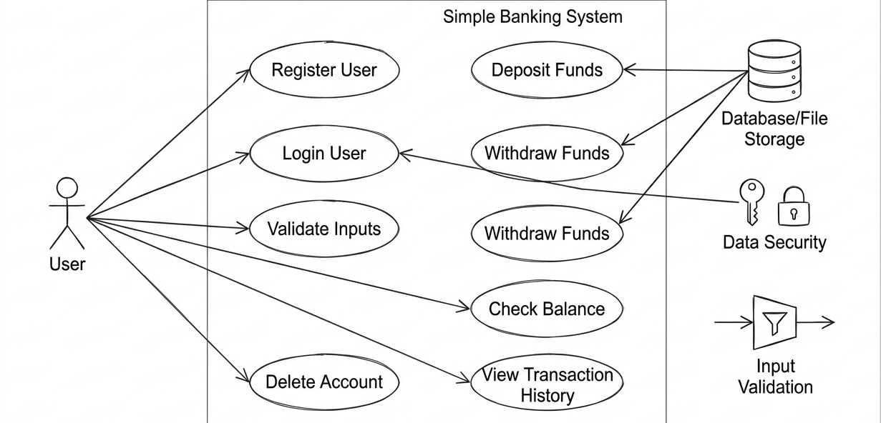
Figure 1 : Use case Diagram

8.Detail Timeline
Figure 2 : Gantt Chart

9.Conclusion
In conclusion, the development of the Simple Banking System using the C programming language is a useful and practical project that helps strengthen fundamental programming skills. This project demonstrates the effective use of basic programming concepts such as arrays, loops, conditional statements, functions, file handling, and logical operations, which are essential in structured programming.
The banking system is simple in design but highly effective in improving problem-solving skills and logical thinking. It also provides an understanding of how a real-world application can be designed, implemented, and executed step by step. Through this project, we learn how customer information is managed, how banking transactions are processed, and how operations such as deposits, withdrawals, and balance checking are handled efficiently.
Additionally, this project highlights the importance of planning and maintaining a proper program structure before coding. It also helps in developing debugging and testing skills by identifying and fixing errors during implementation. Although the Simple Banking System is a basic application, it creates a strong foundation for developing more advanced banking and financial management systems in the future.
Overall, this project not only fulfills academic requirements but also builds confidence in programming and enhances our ability to design secure, efficient, and logical solutions using the C programming language.

10.Reference
- Kernighan, B. W., & Ritchie, D. M. The C Programming Language.
- Furazan, B. A. Computer Science: A Structured Programming Approach Using C.
- Kantar, Y. Let Us C.

