
LA GRANDEE INTERNATIONAL COLLEGE
Simalchaur, Pokhara Nepal
Final defence
On
“Jewelio”

Submitted to:
Bachelor of Computer Application (BCA) Program
In partial fulfilment of the requirements for the degree of BCA under
Pokhara University
Submitted by:
Name: | Course | Semester | P.U. Registration Number
Aakriti Parajuli | BCA | 8th | 2021-1-53-0345
Rebecca Ghimire | BCA | 8th | 2021-1-53-0361
Sambhawi Baral | BCA | 8th | 2021-1-53-0365

Date:07/01/2026

Acknowledgement
We would like to express our gratitude to our BCA coordinator Mr. Kundan Chaudhary, Project supervisor Mr. Ankit Poudyal and LA Grandee International Collage for their support and contributions to the development of our Jewelio.
This project is done for the in partial fulfilment of the requirements for BCA (Bachelor of Computer Application) program under Pokhara University. Our project was made possible by the effort and dedication of our team members. We thank our dedicated team for their hard work and contributions to this app. We are grateful for the guidance and mentorship provided by our respected sir Mr. Ankit Poudyal.
Sincerely,
Aakriti Parajuli
Rebecca Ghimire
Sambhawi Baral

Declaration for
“Jewelio”
Student’s Declaration
We, Aakriti Parajuli, Rebecca Ghimire, and Sambhawi Baral being students of the eight semester at LA GRANDEE International College, Faculty of Science and Technology, Pokhara University, do hereby declare that the project proposal submitted to the aforementioned institution is an original work completed by us in partial fulfilment of the requirements for the Bachelor of Computer Application (BCA) program, under the supervision of Sir Mr. Ankit Poudyal. We further state that no resources other than those specifically listed have been utilized in the completion of this project.

Name: Aakriti Parajuli Name: Rebecca Ghimire
PU-Registration No.: 2021-1-53-0345 PU-Registration No.: 2021-1-53-0361
Semester: 8th Semester Semester: 8th Semester
Date: 07/01/2026 Date: 07/01/2026

Signature: ............... Signature: ...............

Name: Sambhawi Baral
PU-Registration No.: 2021-1-53-0365
Semester: 8th Semester
Date: 07/01/2026

Signature: ...............

Supervisor’s Declaration
I hereby recommend that this project entitled “Jewelio” is done under my supervision by Aakriti Parajuli, Rebecca Ghimire, Sambhawi Baral during their Eight Semester in partial fulfilment of the requirements for the degree of BCA under Pokhara University is completed to my satisfaction and be processed for final evaluation.

____________________________
Mr. Ankit Poudyal
Date:07/01/2026

Letter of Approval
We certify that we have examined this report entitled ‘Jewelio’ and are satisfied with the project defence. It is satisfactory in the scope and qualify as project in partial fulfilment of the requirements for the degree of BCA under Pokhara University.

________________________  Supervisor  Mr. Ankit Poudyal | ________________________  Examiner  Er. Asmit Nepali  Date:07/01/2026 | ______________________  Program Coordinator  Mr. Kundan Chaudhary

Abstract
The rapid growth of mobile technology and e-commerce has significantly transformed consumer shopping behavior, including the jewelry industry. Traditionally, jewelry purchases required physical store visits, which often involved time constraints, limited variety, and geographical barriers. To overcome these challenges, this project focuses on the design and development of a mobile-based jewelry App that provides a convenient, secure, and user-friendly platform for online jewelry shopping.
The proposed application enables users to browse digital jewelry collections, search and filter products by category, view detailed product information, add items to cart, make secure online payments, and track orders in real time. The app aims to enhance customer trust and satisfaction while helping jewelers expand their reach beyond physical stores. By integrating modern features such as real-time stock updates and smooth navigation, the jewelry App offers an efficient and reliable shopping experience. This project contributes to the digital transformation of the jewelry business, especially in regions where online jewelry platforms are still emerging.

TABLE OF CONTENTS
Abstract vi
1. INTRODUCTION 1
2. PROBLEM STATEMENT 2
3. OBJECTIVES 3
4. BACKGROUND STUDY 4
5. REQUIREMENT DOCUMENTATION 5
5.1. Functional Requirements: 5
5.2. Non-Functional Requirements: 6
6. SYSTEM DESIGN 8
6.1 Feasibility Analysis 8
6.2 Er-Diagram 9
6.3 Dataflow Diagram 10
6.4 Flowchart 11
7. DEVELOPMENT 12
7.1 Development methodology 12
7.1.1 Requirement Analysis 12
7.1.2 Design 13
7.1.3 Development 13
7.1.4 Testing 13
7.1.5 Review and Feedback 13
7.1.6 Deployment 13
7.2 Project Gantt Chart 14
8. TESTING 15
8.1 User Acceptance Testing (UAT) 17
9. PROJECT RESULTS 18
10. FUTURE ENHANCEMENTS 19
11. CONCLUSION 20
12. References 21

LIST OF Tables
Table 5.1 1 Requirement matrix 7

Table 8.1. 1 User Acceptance Testing (UAT) 17

List of FIGURES
Figure 7.2. 1 Gantt Chart 13

Figure 6.3. 1 DFD Level 0 10
Figure 6.3. 2 DFD Level 1 10

Figure 7.1. 1Agile Model (nexapp, 2024) 12

Abbreviations
DFD | Data Flow Diagram
DB | Database
TC | Test Cases
UI | User Interface
ER | Entity-Relationship
Etc. | Etcetera

INTRODUCTION
Jewelry has always held a significant place in human civilization, representing beauty, culture, tradition, and social status. From ancient times to the modern era, jewelry items such as rings, necklaces, bangles, and gemstones have been an essential part of personal adornment and ceremonial practices. Traditionally, jewelry shopping has been conducted through physical stores where customers can examine products directly. While this approach provides a tactile experience, it also comes with limitations such as restricted store hours, limited product availability, and the need for physical travel.
With the rapid advancement of information technology and the widespread use of smartphones, the e-commerce industry has expanded across various sectors, including fashion and accessories. Consumers today prefer online platforms that offer convenience, variety, price comparison, and secure transactions. However, despite the growth of online shopping, the jewelry sector—especially demi-fine and local jewelry brands—still faces challenges in fully adopting digital solutions.
In countries like Nepal, although some online jewelry platforms have emerged, many local jewelers continue to depend on traditional business models. Customers often face difficulties such as lack of trust, poor navigation, limited product information, and inefficient customer service while shopping for jewelry online. These issues highlight the need for a dedicated and user-friendly jewelry app.
This project aims to design and develop a mobile-based jewelry app that bridges the gap between traditional jewelry businesses and modern digital commerce. The application focuses on providing a seamless shopping experience with features such as product browsing, secure payments, order tracking, and real-time stock updates. By doing so, the app benefits both customers and jewelers, making jewelry shopping more accessible, transparent, and efficient.

PROBLEM STATEMENT
Despite the growing demand for demi-fine jewelry, customers often face challenges while shopping online.
- Customer Service Issues: Many platforms struggle to handle orders efficiently, provide timely support, and maintain customer satisfaction.
- Poor Navigation: Complicated interfaces make it difficult for users to find products and browse smoothly, leading to a frustrating experience.
- Customers face difficulties in comparing prices, designs, and varieties across different jewelers.
These challenges highlight the need for a user-friendly jewellery app that ensures seamless navigation, efficient customer service, and a satisfying shopping experience.

OBJECTIVES
To design and develop a mobile-based Jewelry App that provides a digital platform
for browsing, selecting, and purchasing jewelry items with ease and trust. The main
objectives of this project are:
- To develop a user-friendly interface for customers to do jewelry shopping.
- To enable customers to browse collections, add to cart, and pay online.
- To provide real-time stock updates and order tracking.
- To deliver a convenient, reliable, and enjoyable shopping experience.

BACKGROUND STUDY
The jewelry industry has traditionally relied on physical showrooms where customers can directly see, touch, and purchase ornaments. However, this model has limitations such as time consumption, restricted product availability, and geographical constraints. With the increasing adoption of smartphones and mobile applications, consumer purchasing habits have changed significantly.
Globally, jewelry e-commerce has been growing steadily as customers seek convenience, wider choices, and transparent pricing. In the context of Nepal (or your region), while online shopping platforms like Palmonas, Meesaa, have gained popularity, the jewelry sector still remains underexplored in digital platforms. Many local jewellers rely only on physical stores and word of mouth marketing. (Yang, 2023)
A Jewelry App can bridge this gap by:
- Showcasing jewelry collections digitally.
- Providing secure transactions and trusted information.
- Connecting jewellers to a broader audience.
- Offering customers convenience, customization, and doorstep delivery.
Thus, the development of a Jewellery App is both timely and relevant, addressing the need for digital transformation in the jewellery business.

REQUIREMENT DOCUMENTATION
Requirement analysis is the process of identifying and defining the needs and expectations of users for the Jewellery App. This ensures that the system meets customer requirements and business objectives. The following requirements have been identified:

Functional Requirements:
- User Management:
• Allow users to register, login, and logout securely.
• Maintain user profiles with personal details and order history.
• Provide secure authentication and authorization.
- Product Management:
• Display jewellery products with images, prices, descriptions, and categories.
• Allow users to browse and search jewellery items.
• Enable filtering by category, price, and design.
- Cart and Order Management:
• Allow users to add, update, or remove items from the cart.
• Enable secure order placement and checkout process.
• Provide real-time order status and tracking.
- Payment Management:
• Support secure online payment methods.
• Generate order confirmations after successful payment.
- Admin Management:
•Allow administrators to add, update, or delete jewellery products.
• Manage inventory and stock availability.
• Monitor orders and customer activity.

Non-Functional Requirements:
- Performance:
• The system should load product data quickly and respond efficiently to user actions.
• Optimize backend services to handle multiple users simultaneously.
- Security:
•Ensure secure handling of user data and payment information.
• Implement authentication, authorization.
- Scalability:
•The system should support future growth in users and product listings.
• Allow easy integration of additional features such as customization and reviews.
- Reliability:
• Ensure consistent system availability with minimal downtime.
• Maintain data accuracy and integrity.
- Usability:
• Provide a simple, attractive, and user-friendly interface.
• Ensure smooth navigation across different devices.
Requirements Matrix:
SN. | Required modules and features | Description | Priority (High, Moderate, low)
1. | Login and security system | Users must login securely to access the app | High
2. | User Registration | Register users with name, email, phone number | High
3. | Product Browsing | View jewellery items with details and images | High
4. | Cart Management | Add, update, and remove products from cart | High
5. | Order and Payment System | Place orders and complete secure payments | Moderate
6. |  | Track order status in real-time | Moderate
  Order Tracking
7. | Admin Panel | Manage products, orders, and inventory | High
Table 5.1 1 Requirement matrix

SYSTEM DESIGN
Er-Diagrams, Dataflow, Algorithm and Flowchart are used for understanding the system's design and its functionalities, and both are important for creating proper documentation.

Feasibility Analysis
A feasibility analysis is carried out to evaluate the practicality, effectiveness, and overall viability of the proposed Jewellery App. The purpose of this analysis is to determine whether the system can be successfully developed and implemented within the given technical, operational, economic, legal, and time constraints. It also helps ensure that the application meets customer expectations while supporting jewellers in expanding their business through digital platforms.
- Technical Feasibility
- The Jewelry App is technically feasible as it can be developed using modern mobile application development technologies. The system requires standard hardware such as smartphones, computers, and internet connectivity, which are widely available.
- The application focuses on essential features such as product browsing, digital catalogues, search and filtering, secure payments, and order tracking. These features can be implemented using commonly used mobile development frameworks and backend systems.
- Additionally, the project does not require complex or specialized hardware, making it suitable for academic development and future real-world implementation. The availability of skilled developers with knowledge of mobile app development, database management, and basic security mechanisms further supports the technical feasibility of the project.
- Operational Feasibility
- It evaluates how well the Jewelry App fits into users’ daily shopping behavior and business operations. The application is designed with a user-friendly interface that allows customers to browse jewelry collections easily, compare products, view details, and place orders without difficulty.
- For jewelers, the app simplifies product showcasing, inventory display, and order management. It reduces dependence on physical stores while improving customer reach and service efficiency.
- The app also addresses common issues such as poor navigation and inefficient customer service by providing smooth navigation, clear product categorization, and transparent order tracking. Therefore, the system is operationally feasible and likely to be accepted by both customers and jewelers.

Er-Diagram
An Entity-Relationship (ER) diagram is a visual representation of a database's structure. It uses entities (objects or concepts) and their relationships to illustrate how data is organized and connected within a database system. ER diagrams are widely used in database design and modelling to help understand and plan data relationships.
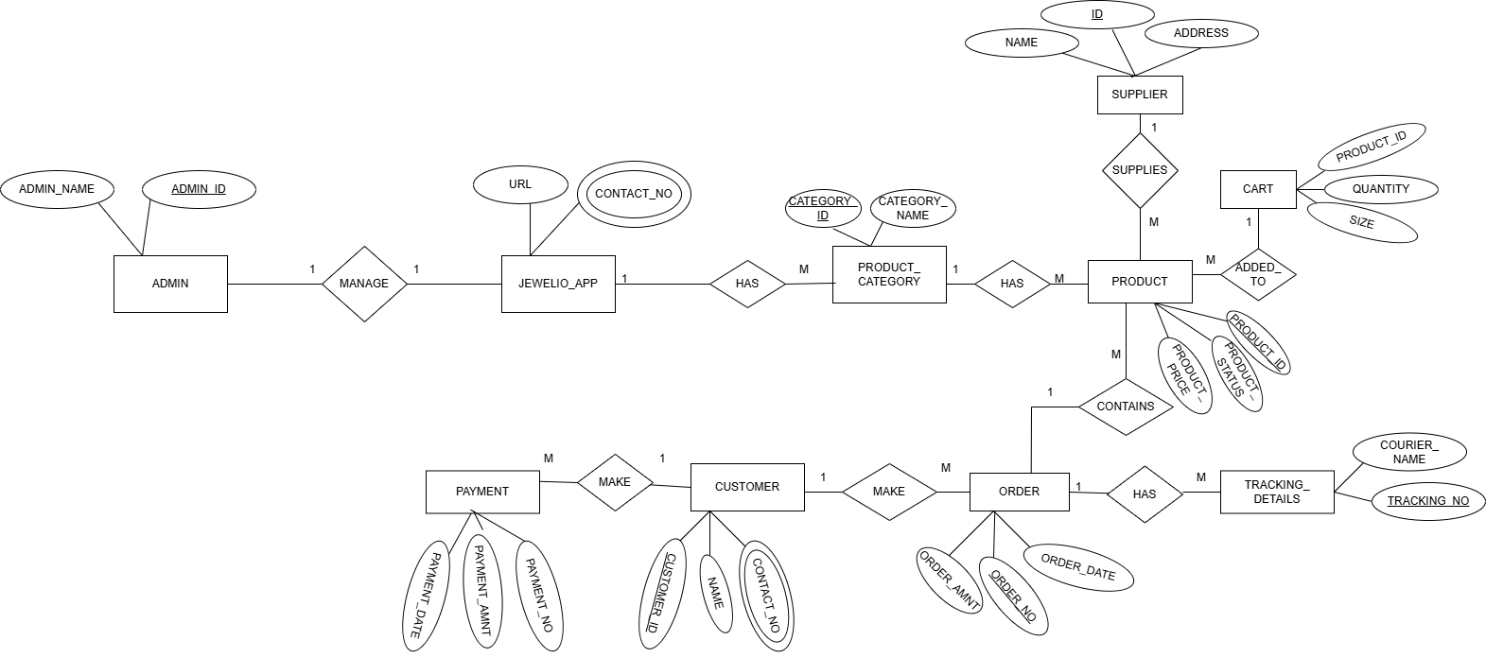
Figure 6.2 Er Diagram

Dataflow Diagram
It is a diagrammatic representation that portrays the flow of data in a system or a process. Helps communicates the general data flow structure of a proposed system to the system designer, programmer, and end-users.
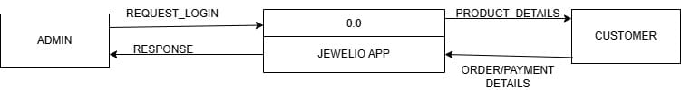
Figure 6.3. 1 DFD Level 0

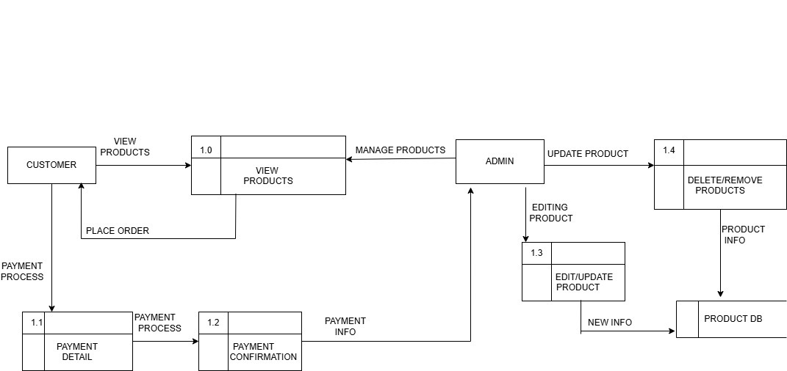
Figure 6.3. 2 DFD Level 1

DEVELOPMENT

Development methodology
The development of the jewelry app follows the Agile Software Development Methodology, which emphasizes flexibility, continuous improvement, and active user involvement throughout the development process. Agile methodology divides the project into small, manageable iterations known as sprints, allowing regular evaluation and enhancement of system features.
Agile is well-suited for mobile application development as it supports frequent changes in requirements, rapid development, and continuous feedback. Since user experience, navigation, and trust are critical factors in online jewelry shopping, Agile methodology helps ensure that the application evolves according to user needs and expectations. 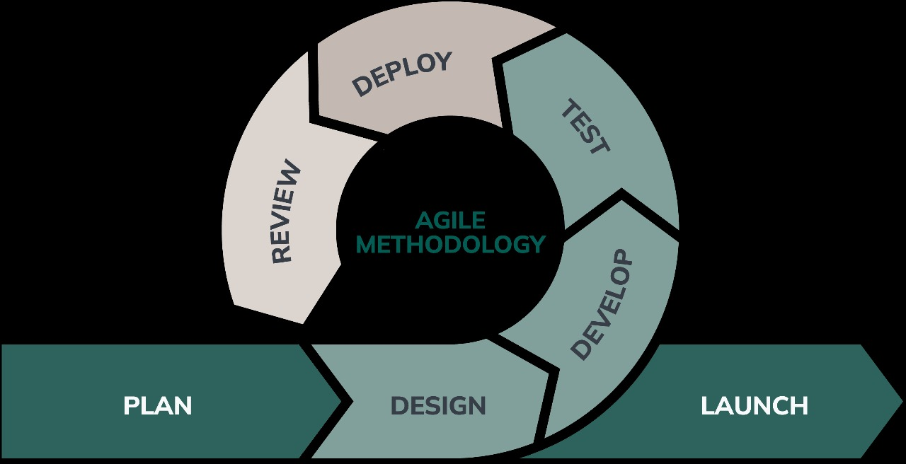
Figure 7.1. 1Agile Model (nexapp, 2024)

Agile Development Phases applied in the Jewellery app: -

Requirement Analysis
User requirements such as product browsing, secure payments, order tracking, and customer support were identified and prioritized. These requirements were documented and added to the product backlog.

Design
The user interface and user experience were designed with a focus on simplicity and ease of navigation. Wireframes and layouts were created for features such as home screen, product details, cart, and checkout.

Development
The development was carried out in multiple sprints. Each sprint focused on implementing specific features such as:
- User authentication
- Product listing and filtering
- Cart and checkout
- Order tracking
At the end of each sprint, a working version of the app was reviewed and improved.

Testing
Testing was performed continuously during each sprint to ensure functionality, usability, and performance. Bugs and errors were identified early and fixed immediately, ensuring system reliability.

Review and Feedback
After each sprint, the developed features were reviewed and feedback was gathered. Improvements were made based on user expectations and performance analysis.

Deployment
Once the core features were completed and tested, the application was deployed for final evaluation and demonstration.

Project Gantt Chart

Figure 7.2. 1 Gantt Chart

TESTING
Testing is an essential phase of the software development process to ensure that the Jewelry App functions as intended and meets user requirements. The main objective of testing is to identify errors, verify functionality, and ensure reliability before deployment. Testing was carried out during different stages of development to validate that the application performs correctly under expected conditions.
A set of test cases were designed and executed to verify the core functionalities such as user authentication, product browsing, cart management, and order processing.

Test Case No.1
Test case ID: TC001, TC002, TC003
Test Priority: High
Module Name: User Registration and Login
Test Titles: Testing User Registration and Login functionality.
Pre- condition: User must have internet access
Description: Verify that users can register and login with valid and invalid inputs.

Step | Test Case ID | Test Cases | Expected Results | Actual Data | Remarks
1 | TC001 | Register with valid details | User registered successfully | Registration successful. | Pass
2 | TC002 | Register with missing fields | Error message displayed | Error message shown | Pass
3 | TC003 | Login with valid credentials | User logged in successfully | Login successful | Pass

Test Case No.2
Test case ID: TC004, TC005
Test Priority: High
Module Name: Product Browsing
Test Titles: Testing product viewing and search functionality
Pre- condition: User must be logged in..
Description: Verify that users can view and search jewellery products.

Step | Test Case ID | Test Cases | Expected Results | Actual Data | Remarks
4 | TC004 | View jewellery products | Product list displayed | Products displayed | Pass
5 | TC005 | Search product by category | Filtered products shown | Filter applied | Pass

Test Case No.3
Test case ID: TC006, TC007
Test Priority: High
Module Name: Cart and Order Management
Test Titles: Testing cart and order placement
Pre- condition: User must be logged in and products available
Description: Verify cart operations and order placement.

Step | Test Case ID | Test Cases | Expected Results | Actual Data | Remarks
6 | TC006 |  | Product added to cart | Added successfully | Pass
  Add product to cart
7 | TC007 | Place order | Order placed successfully | Order placed | Pass

Test Case No.4
Test case ID: TC008
Test Priority: Moderate
Module Name: Order Tracking
Test Titles: Testing order tracking functionality
Pre- condition: Order must be placed
Description: Verify that order status is displayed correctly.

Step | Test Case ID | Test Cases | Expected Results | Actual Data | Remarks
8 | TC008 | Track order status | Order status displayed | Status displayed | Pass

User Acceptance Testing (UAT)
User Acceptance Testing (UAT) was conducted to ensure that the Jewellery App meets user expectations and can be accepted for use. The testing focused on usability, navigation, and overall shopping experience.
No. | Acceptance requirement | Test Results | Comments
1. | User login should be secure | Accept | System feels secure
2. | Product browsing should be easy | Accept | Navigation is smooth
3. |  | Accept | Checkout is simple
  Cart and checkout process should work properly
4. | Order tracking should be clear | Accept | Order status visible
5. |  | Accept | User-friendly design
  Overall app usability
Table 8.1. 1 User Acceptance Testing (UAT)

PROJECT RESULTS
The jewelry App was successfully designed and developed to address the challenges associated with traditional and online jewelry shopping. The application provides a digital platform where customers can browse jewelry collections, view detailed product information, compare designs and prices, and place orders securely from their mobile devices.
The project achieved its primary objectives by delivering a user-friendly interface that ensures smooth navigation and easy access to different jewelry categories such as rings, necklaces, bangles, and gemstones.
The application also enabled essential e-commerce functionalities including cart management, secure online payments, and order tracking, which improved transparency and customer trust.
From a business perspective, the jewelry App provided jewelers with an effective digital solution to showcase their products beyond physical stores. It supported wider market reach, better product visibility, and improved customer engagement without geographical limitations.
Overall, the project demonstrated that a well-designed mobile application can successfully modernize jewellery shopping by offering convenience, accessibility, and reliability. The results confirm that the Jewellery App effectively meets user expectations while supporting the digital transformation of the jewellery industry.

FUTURE ENHANCEMENTS
- Product Customization Feature: Customers can be allowed to customize jewellery designs by selecting size, material, gemstone, or engraving options before placing an order.
- Customer Reviews and Ratings: A review and rating system can be added so users can share feedback on products, helping new customers make better purchasing decisions and increasing trust.
- Order Tracking: It can be added so that customers can track down their orders providing more convenience.

CONCLUSION
In conclusion, the jewelry app project successfully addresses the growing need for a digital platform in the jewelry industry. By leveraging mobile technology, the application overcomes the limitations of traditional jewelry shopping and provides customers with a convenient, reliable, and enjoyable online shopping experience. Features such as easy navigation, secure payments, product filtering significantly enhance customer satisfaction and trust.
For jewelers, the app serves as an effective tool to expand market reach, improve customer engagement, and adapt to the evolving digital landscape. The project highlights the importance of adopting technology in traditional industries and demonstrates how mobile applications can drive business transformation.
In conclusion, the development of this jewelry app is timely and relevant, offering a practical solution to existing challenges in online jewelry shopping. With further enhancements such as advanced customization options and AI-based recommendations, the application has strong potential for future expansion and real-world implementation.

References

- nexapp. (2024, march 25). Retrieved from https://www.nexapp.ca/en/blog/agile-software-development
- Kale, P. D., Kumari, N., Oswal, S., Salunke, A., & Patil, P. (2024). JStar: Jewellery E-commerce App Through Mobile Technologies. IRJMETS.
- Wadia, A. K., Shah, K., Rawal, N., Mehta, K., & Verma, N. (2024). Adoption of Artificial Intelligence in Online Jewellery Retail Industry. Korea Review of International Studies.
- Yang, H. (2023, june). ResearchGate. Retrieved from https://www.researchgate.net/publication/381543957_Analysis_on_the_Marketing_Advantages_of_Customized_Jewelry_under_the_Background_of_Internet

