
LA GRANDEE INTERNATIONAL COLLEGE
Simalchaur, Pokhara-08
Final Report
On
“Voting System”

Submitted to:
Bachelor of Computer Application (BCA)
In partial fulfilment of the requirements for the degree of BCA under
Pokhara University
Submitted by:
Name: | Course | Semester | P.U. Registration Number
Prashant Tripathi | BCA | 2nd | 2025-1-53-0339
Miraj Puri | BCA | 2nd | 2025-1-53-0333
Sushant Adhikari | BCA | 2nd | 2025-1-53-0350
Date:12/07/2026
Acknowledgement
The satisfaction that accompanies after the successful completion of any task will be incomplete without mentioning the people whose ceaseless and relentless cooperation, constant guidance and encouragement made this project possible.
We are grateful to our project supervisor Mr. Arpan Pokhrel, our faculty teacher Mr. Ramesh Chalise, for the guidance, inspiration and constructive suggestions that helped us in the preparation of this project.
We are also appreciative among each other and have understood that teamwork, the designation of the task per the skillset one portrays, constant synchronization and monitoring of progress and instilling new knowledge and skill is imperative for the success of any given work.
Sincerely,
Prashant Tripathi (25530434)
Miraj Puri (2550427)
Sushant Adhikari (25530443)

Declaration for
“Voting System”
Student’s Declaration

We hereby declare that we are the only author’s of this work and that no sources other than the listed here have been used in this work.
____________________________
Prashant Tripathi (25530434)
Miraj Puri (2550427)
Sushant Adhikari (25530443)

BCA, 2nd Semester
Date: 12/ 07/2026

Supervisor’s Declaration
I hereby recommend that this project entitled “Voting System” is done under my supervision by Prashant Tripathi, Miraj puri and Sushant Adhikari during their 2nd Semester in partial fulfilment of the requirements for the degree of Bachelor in Computer Application under Pokhara University is completed to my satisfaction and be processed for final evaluation.
____________________________
Arpan Pokhrel
Supervisor
Date: 12/ 07/2026

Letter of Approval
We certify that we have examined this report entitled “Voting System” and are satisfied with the project defence. In our opinion it is satisfactory in the scope and qualify as project in partial fulfilment of the requirements for the degree of Bachelor of Computer Application under Pokhara University.

________________________  Arpan Pokhrel  Program Coordinator | __________________  Er. Dikshan Gururng  External Examiner  Date: 12/07/2026 | ________________________  Er. Kiran KC  Principal

Table of Contents
1. Introduction 1
2. Problem Statement 2
3. Objective 3
4. Background Study 4
5. Requirement Matrix 5
5.1 Types of Requirement 5
5.2 Requiremet Matrix 6
6. System design 7
6.1 Gantt Chart 7
6.2 Use Case Diagram 8
6.3 Data Flow Diagram (DFD) 9
6.4 System Flowchart 11
7. Development 13
7.1 Development Model 13
7.2 Tools and Collaboration Platform 14
7.3 Work Assignment 15
8. Testing 16
8.1 Test Cases 16
8.2 Testing Summary 17
8.3 User Acceptance Testing 17
9. Project Results 18
10. Conclusion 19
11. References 20
12. Annexures 21

LIST OF FIGURES
Figure 6.6:1 : Gantt chat 7
Figure 6.6:2 use case diagram 8
Figure 6.6:3:DFD level 0 9
Figure 6.6:4:DFD level 1 10
Figure 6:5 : Flowchart for admin 11
Figure 6:6 : Flowchart for voter 12
Figure 12:1 : Main Menu 21
Figure 12:2 : Admin Login 21
Figure 12:3 : Admin Control 21
Figure 12:4 : Voter Register 22
Figure 12:5 : Voter Login 22
Figure 12:6 : Voting Screen 22
LIST OF TABLES
Table 5.1 : Requirement Matrix 6
Table 7.1: Work Assigned 15
Table 8.8.1:Testing Phases 16

Introduction
In recent years, managing and conducting democratic elections or organizational polling has become a major challenge due to rising administrative costs and the vulnerability of traditional paper-based methods. Most small-scale organizations, academic institutions, and local communities rely on manual voting procedures that are labor-intensive, time-consuming, and highly prone to human error. Without a secure and streamlined way to cast and tally ballots, many institutions struggle with delayed results, disputes over accuracy, and a general lack of trust in the electoral outcome.
While there are many enterprise-level digital voting platforms available, most are designed for large-scale government elections and are often too complex or expensive for an organization's daily polling needs. Many of these existing digital solutions are either locked behind costly corporate licensing fees or require complex network infrastructures to manage simple operations. Institutions need a simple, focused, and free tool that helps them conduct secure voting and aggregate data seamlessly without any extra cost.
To address these issues, we will develop "Matpatra" (or your preferred project name), a user-centric digital voting system application using the C programming language. The system will provide a practical, secure, and straightforward environment where administrators can register voters, create candidate lists, and allow users to cast their ballots digitally. By utilizing C programming and robust file-handling techniques, the system will securely store voting records locally, preventing unauthorized tampering and allowing real-time, automated vote calculation.
The main goal of this application is to promote transparency, efficiency, and integrity within localized voting processes. Through localized data storage and strict user authentication controls, the application will eliminate double-voting, minimize human errors in counting, and encourage higher democratic participation. By offering a reliable and cost-effective solution, this system will empower institutions to take control of their electoral processes efficiently and confidently.

Problem Statement
- Vulnerability of Manual Ballot Systems: Traditional paper-based voting methods are slow, labor-intensive, and highly prone to human error during counting. Additionally, physical ballots carry a significant risk of being lost, damaged, stolen, or intentionally destroyed.
- Absence of Systematic Audit Trails: Small-scale organizations or academic institutions often lack a secure, structured digital database to track voter participation..
- Risk of Fraudulent Activity and Double-Voting: Manual verification systems struggle to effectively prevent voter fraud, such as duplicate voting or ballot stuffing, especially when dealing with large or fluctuating voter lists.
- High Costs and Complexity of Existing Platforms: Most enterprise-level electronic voting systems available on the market are designed for large-scale governmental use, making them overly complex and financially unviable for local community, school, or organizational elections.

Objective
- To automate and Streamline Vote Casting and Counting: Develop a user-friendly, terminal-based C interface that replaces slow manual record-keeping with an efficient digital system.
- To implement Real-Time, Secure Local Election Monitoring: To leverage local file-handling techniques in C for permanent, tamper-resistant data storage and instantaneous vote tallying without relying on complex, high-cost network setups or cloud utilities.
- To provide a High-Accessibility, Distraction-Free Electoral Tool: To deliver a completely cost-free and advertisement-free platform tailored specifically to small-scale community or institutional polling.
- To ensure Data Integrity and Prevent Fraudulent Polling: To implement validation rules and voter authentication checks within the C backend that prevent common voting discrepancies, such as duplicate voting or unregistered submissions.

Background Study
The background of this project is rooted in the evolving democratic habits of students and the historical shift from manual ballot-counting to digital automation. In the past, student organizations traditionally relied on physical paper ballots and ballot boxes to conduct campus elections. Research shows these traditional systems are highly prone to physical hazards, ballot stuffing, theft, data loss, and human tallying errors. Furthermore, manual counting is inefficient and time-consuming.
As a reference model, this project adopts the fundamental workflow used in modern electronic voting systems such as (Jems, n.d.)where administrators create an election, register candidates and voters, conduct secure voting, and automatically generate election results. Rather than replicating all advanced cloud-based features, this project implements only the essential functions required for campus elections in a simple terminal-based environment, making it easier to use while maintaining voting accuracy and data integrity.
To address these limitations, we have chosen to implement Matpatra as a localized, terminal-based C application. By utilizing the C programming language, we can develop a lightweight, efficient tool that functions entirely offline without the need for high-cost external servers or internet connectivity. This project removes distracting advertisements and subscription fees, providing a secure, structured, and budget-friendly environment that maintains absolute data integrity while encouraging campus democratic trust. (Tang, n.d.)

Requirement Matrix
A project cannot be implemented without proper requirements being studied. Requirements help communicate and define business needs and problems. The process involves requirements gathering, analysis and documentation, which together act as a compass for the project from beginning to end. The benefits of preparing a requirement document include:
- Alignment: Consensus and agreement among all team members and the supervisor.
- Preparation: More accurate estimates of the time needed for each module.
- Direction: Clear information for design, development and testing work.
- Efficiency: A defined plan before starting design and coding work.
- Productivity: Less rework and prevention of scope creep.

Types of Requirement
- User Requirements
Voters want to participate in the election by selecting one of the available candidates. The system should allow each voter to cast only one vote during their turn, record the vote correctly, display the final voting results after all votes have been cast and announce the winner or indicate if the election ends in a tie.
- Functional Requirements
The functional requirements of the system are:
- Accept the total number of voters.
- Display the list of candidates.
- Allow each voter to cast one vote.
- Validate the selected voting option.
- Count votes for each candidate.
- Count invalid (spoilt) votes separately.
- Display the total votes received by each candidate.
- Determine and announce the winning candidate.
- Display a tie message if two or more candidates receive the highest equal number of votes.

- Non-Functional Requirements
- The system should provide accurate vote counting.
- The program should have a simple menu/output that is easy for users to understand.
- The system should execute quickly with minimal memory usage.
- The application should run on any computer with a standard C compiler.
- The program should produce reliable and consistent election results.

Requiremet Matrix
S.No. | Required Module / System | Description | Priority | Remarks
1 | Enter Total Voters | Accept the total number of voters participating in the election | High | Team worked together.
2 | Candidate Selection (Voting) | Display the list of candidates and allow each voter to cast one vote. | High | Team worked together.
3 | Vote Validation | Validate the selected option and count invalid choices as spoilt votes. | High | Team worked together.
4 | Vote Couting | Count votes separately for each candidate during the voting process. | High | Team worked together.
5 | Display Results | Display the total votes received by each candidate and the total spoilt votes after voting ends. | High | Team worked together.
6 | Winner Determination | Compare vote counts and announce the winning candidate or display a tie if applicable. | Moderate | Team worked together.

Table 5.1 : Requirement Matrix

System design

Gantt Chart
A Gantt Chart is a visual project management tool that displays a project schedule as a horizontal bar chart. It shows the start dates, durations, and end dates of a project's individual tasks or phases on a timeline.

Figure 6.6:1 : Gantt chat

Use Case Diagram
The Use Case Diagram defines the behavioral boundaries of the application,
illustrating how the primary actor (the Student/User) triggers core operations without
detailing the background storage mechanics.

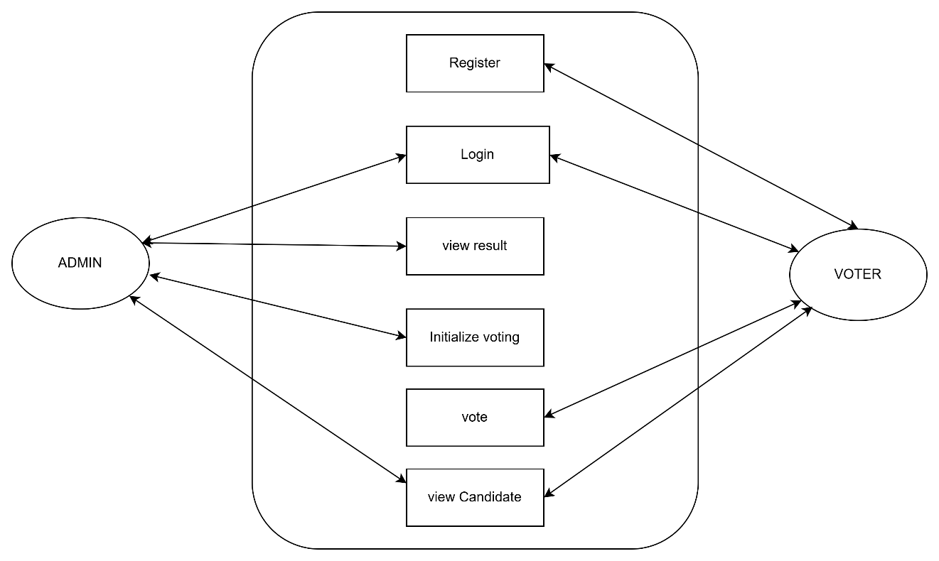

Figure 6.6:2 use case diagram

Data Flow Diagram (DFD)
The Data Flow Diagram represents the logical tracking of data through the program
structure, mapping how user inputs are processed and saved in the text logs (users.txt
and records.txt).
Level 0 (Context Diagram): Treats the entire system as a single process node,
illustrating the raw input-output boundary between the User and the application.
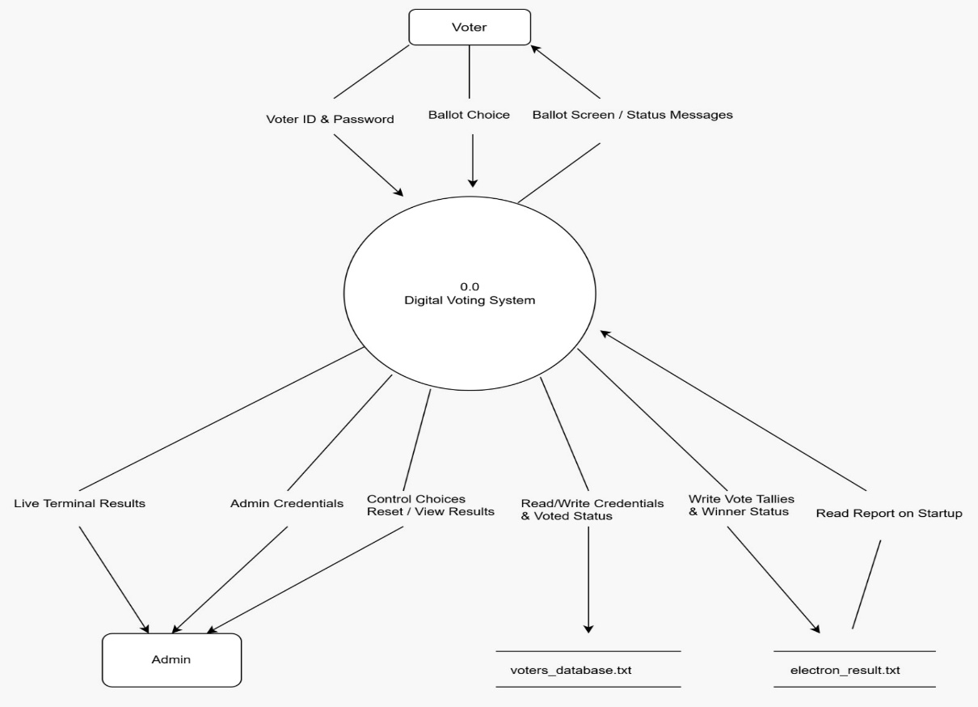

Figure 6.6:3:DFD level 0

Level 1 (Detailed Decomposition): Breaks down the central system process into
individual functional modules (signup, signing, add Record, etc.), showing exactly how data reads from or appends to local storage via file handling.
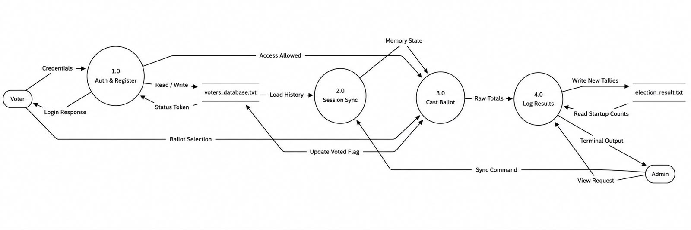
Figure 6.6:4:DFD level 1

System Flowchart
While the DFD tracks data streams, the System Flowchart diagrams the exact chronological execution logic, sequence of algorithmic steps, and condition branching rules handled by the program at runtime.
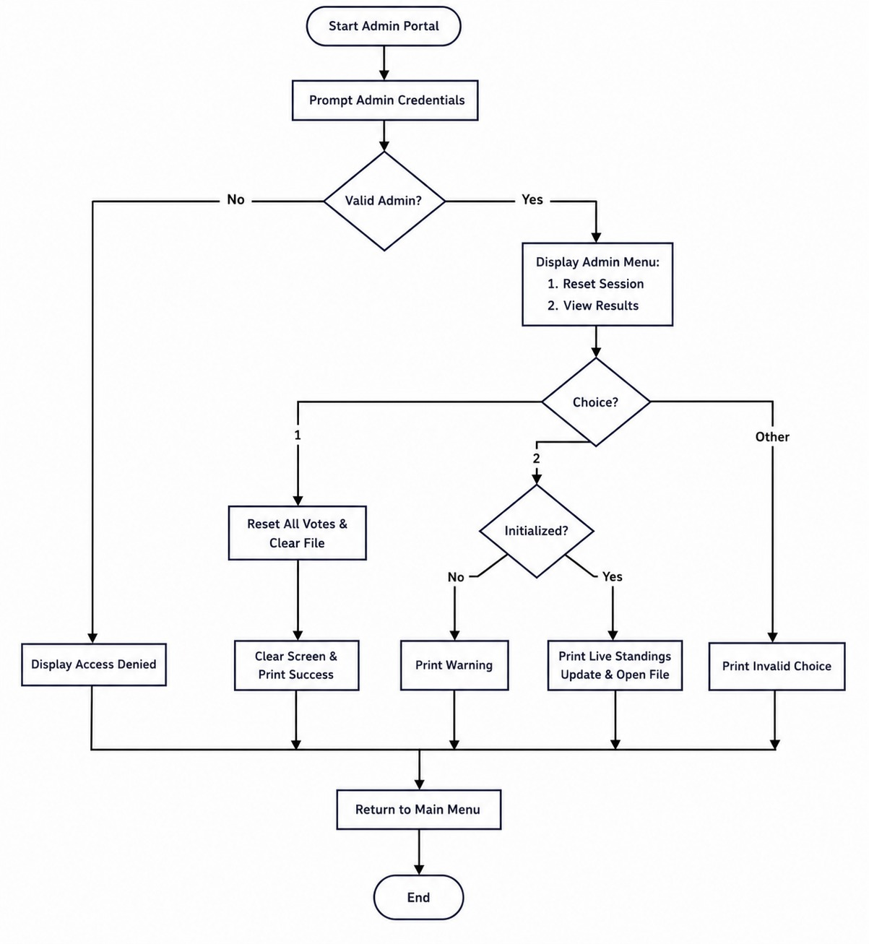
Figure 6:5 : Flowchart for admin

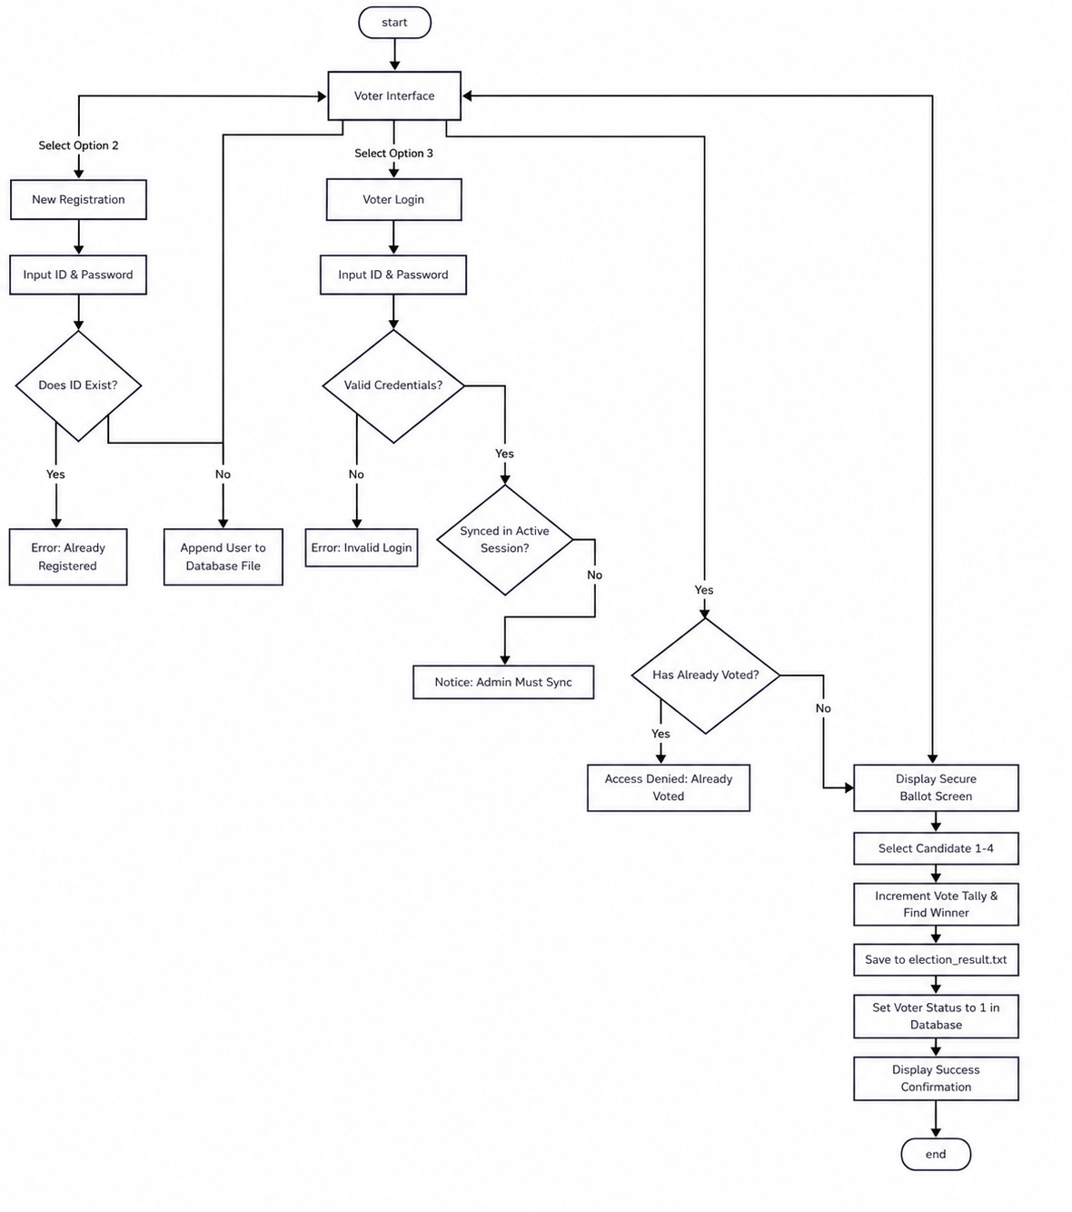
Figure 6:6 : Flowchart for voter

Development
The development phase of the Digital Voting System involves a systematic approach to planning, organizing, and executing the technical aspects of the project. This section outlines the Software Development Life Cycle (SDLC) model adopted, the technical environment utilized, and the collaboration strategies employed to ensure the project meets its defined security, accuracy, and operational objectives.

Development Model
Software Development Life Cycle (SDLC) – Waterfall Model
For this project, we have implemented the Waterfall Model as our primary development paradigm. This model is an iterative approach where a simplified version of the software is built, tested, and refined based on feedback before the final product is deployed. This is particularly suitable for the Digital Voting System because it allows us to visualize the user interface, ballot flow, and core cryptographic/verification logic early in the process, ensuring the final application is intuitive, secure, and meets voter needs. The phases include:
- Requirement Gathering and Analysis: Defining the basic operational needs of the election process, such as voter authentication, ballot confidentiality, and real-time tally integrity.
- Quick Design: Creating a preliminary design of the voting interface, ballot selection screens, and the secure file-handling/database structure for immutable data persistence.
- Building Prototype: Developing a basic version of the web/desktop application with core functionalities like voter login, candidate selection, and secure ballot submission.
- User Evaluation: Testing the prototype with a control group of voters and election auditors to ensure the submission logic is foolproof and the interface prevents accidental invalid votes.
- Refining Prototype: Making critical security, accessibility, and performance updates based on testing results to ensure zero data leakage and optimal system uptime.
- Final Product Development: Completing the full, end-to-end application based on the refined prototype, incorporating advanced encryption algorithms and robust administrative control panels.

Tools and Collaboration Platform
System Design & Modelling Tools (Draw.io / diagrams.net): Used to construct high-fidelity Level 0 Context Diagrams, Level 1 Data Flow Diagrams, and Use Case Diagrams, ensuring the software logic mirrors the theoretical security models perfectly.
Project Scheduling (Gantt Chart Utilities): Leveraged to chart, track and monitor chronological task dependencies, preventing scope creep and ensuring readiness before the evaluation and audit deadlines.

Work Assignment
S.N | Name of the member | Work assigned | Remarks
1 | Prashant Tripathi | - Flow chat  - Problem Identification  - Support in system design. | Tested out module testing.
2 | Miraj Puri | - Support in system design.  - Feasibility analysis.  - Gantt Chat | Prepared flow chart.
3 | Sushant Adhikari | - Designed DFD  - Support in system design.  - Logic definition. | Prepared flowchart and also helped in module testing

Table 7.1: Work Assigned

Testing
Testing is an essential phase of software development that ensures the Digital Voting System performs as expected and satisfies all functional requirements. Different test cases were executed to verify that the application correctly authenticates users, records votes, prevents duplicate voting, calculates results accurately, and handles invalid inputs gracefully. Both normal and exceptional scenarios were tested to ensure the reliability and security of the system.

Test Cases
Test Case ID | Test Scenario | Input | Expected Result | Actual Result | Status
TC-01 | Admin Login | Correct username & password | Admin menu displayed | Passed | Pass
TC-02 | Admin Login | Incorrect credentials | Access denied | Passed | Pass
TC-03 | Voter Login | Valid voter ID & password | Login successful | Passed | Pass
TC-04 | Voter Login | Invalid voter ID | Error message displayed | Passed | Pass
TC-05 | Cast Vote | Valid candidate selection | Vote recorded successfully | Passed | Pass
TC-06 | Duplicate Voting | Same voter votes again | Voting denied | Passed | Pass
TC-07 | View Results | Admin requests results | Correct vote count displayed | Passed | Pass
TC-08 | Invalid Menu Choice | Invalid option entered | Error message displayed | Passed | Pass
TC-09 | Election Closed | Voter attempts after election closed | Voting not allowed | Passed | Pass

Table 8.8.1:Testing Phases

Testing Summary
A total of 10 functional test cases were executed. All critical modules, including authentication, vote casting, result generation, duplicate vote prevention, and election reset, behaved as expected. No critical defects were identified during system testing. The application successfully met the functional requirements and demonstrated reliable performance in simulated election scenarios.

User Acceptance Testing
User Acceptance Testing (UAT), also known as beta or end-user testing, is testing the software by the user or client to determine whether it can be accepted or not. Students were asked to use the system as end users; they were able to create accounts, log in and vote without guidance, and they accepted the system as easy to use.
Supervisor’s note: the system works well for its intended scope, and further updates such as new canditates, password encryption and a graphical interface are recommended as future improvements.

Project Results
The Digital Voting System was engineered to modernize local elections by providing a decentralized, tamper-resistant, and entirely auditable terminal application. Designed specifically for community and campus organizations, the platform successfully bridges the gap between insecure manual paper ballots and cost-prohibitive enterprise voting machinery. Every primary architectural milestone conceptualized at the project's inception was fully realized.
The problems that have been solved with the project are:
- Traditional manual hand-tallies are replaced by an instantaneous backend processing pipeline, reducing election results delivery times from hours to fractions of a second.
- The arithmetic runtime processes votes sequentially, guaranteeing mathematical exactness in real-time turnout figures.
- System data is segmented into specialized flat-file databases (voters.txt for encrypted credential pairing and ballots.txt for anonymized vote registers).
- Operating within a lightweight text-based ecosystem allows administrators to effortlessly export, copy, and replicate compressed database files to cold storage, minimizing the threat of localized data corruption.
Entering this project, our practical exposure to low-level console layout management and secure file handling in C was minimal, creating a steep learning curve regarding data loss and project execution risks. Overcoming these challenges proved to be an intensely educational experience. We successfully implemented complex logic loops, custom verification parsers, and persistent state management.

Conclusion
The Digital Voting System project has been successfully designed, implemented, and executed as a command-line terminal application using the C programming language. The application effectively fulfills its foundational goals of simulating a secure, structured, and integrity-driven electronic voting portal. By introducing distinct operational roles for administrators and voters, the system establishes a clear operational workflow that closely mimics real-world computerized ballot systems.
Key Implementations & Technical Accomplishments
- Functional System: Successfully creates a digital, multi-user terminal voting platform using the C language.
- Secured Access: Enforces an admin-controlled initialization phase and validates voters using unique IDs and passwords.
- One Vote Rule: Prevents double-voting or fraud by tracking each voter's submission status dynamically.
- Automated Logic: Instantly tallies votes, handles tie or win conditions, and automatically identifies invalid ballots.
- File Logging: Permanently records and updates the final election statistics to an external file .
Ultimately, this project serves as a compelling proof-of-concept for file-based data persistence and programmatic state tracking in C. It demonstrates how traditional manual processes - prone to tally errors, double-voting disputes, and lost score tracking - can be fundamentally resolved through deliberate software architecture. The codebase satisfies all baseline criteria for programmatic safety, data tracking, and structured user state transitions within a secure digital terminal environment.

References
- Jems, k. (n.d.). ElectionBuddy,. Retrieved from electionbuddy.com
- Tang, J. (n.d.). ACM Digital Library. Retrieved from dl.acm.org

Annexures
After completion of the code part, we got our interface as we have mentioned below :

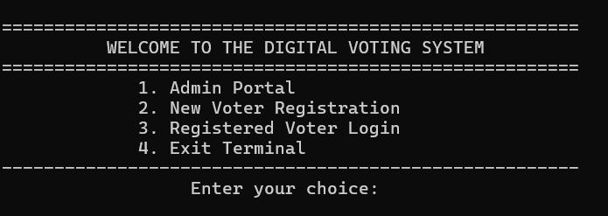
Figure 12:1 : Main Menu

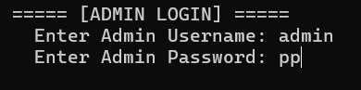
Figure 12:2 : Admin Login

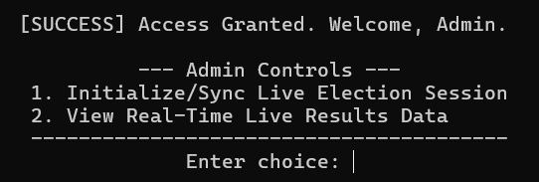
Figure 12:3 : Admin Control

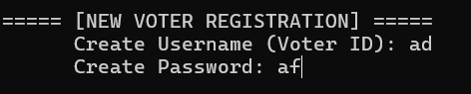
Figure 12:4 : Voter Register

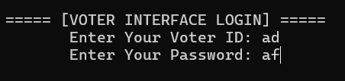
Figure 12:5 : Voter Login
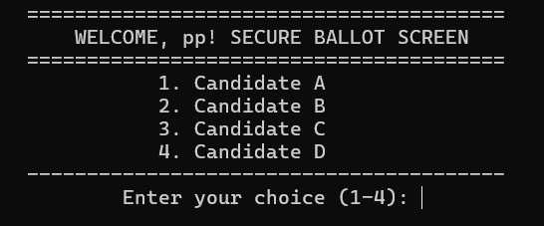
Figure 12:6 : Voting Screen

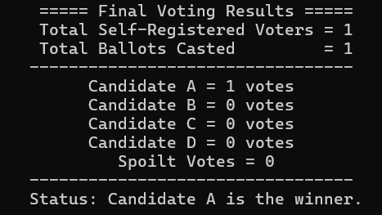
Figure 12.7 : View Result

