
LA GRANDEE INTERNATIONAL COLLEGE
Simalchaur, Pokhara Nepal
Final Report
On
“Voting System”

Submitted to:
Bachelor of Computer Application(BCA) Program
In partial fulfilment of the requirements for the degree of BCA under
Pokhara University
Submitted by:
Name: | Course | Semester | P.U. Registration Number
LENOVO | BCA | 2nd | 2025-1-53-0350
Miraj Puri | BCA | 2nd | 2025-1-53-0333
Prashant Tripathi | BCA | 2nd | 2025-1-53-0340
Date:
Acknowledgement
The satisfaction that accompanies after the successful completion of any task will be incomplete without mentioning the people whose ceaseless and relentless cooperation, constant guidance and encouragement made this project possible.
We are grateful to our project supervisor Mr. Arpan Pokhrel, our faculty teacher Mr. Ramesh Chalise, for the guidance, inspiration and constructive suggestions that helped us in the preparation of this project.
We are also appreciative among each other and have understood that teamwork, the designation of the task per the skillset one portrays, constant synchronization and monitoring of progress and instilling new knowledge and skill is imperative for the success of any given work.
Sincerely,
Prashant Tripathi
Miraj Puri
Sushant Adhikari

Declaration for
“Voting System”
Student’s Declaration

We hereby declare that we are the only author’s of this work and that no sources other than the listed here have been used in this work.
____________________________
Name of the Students
Prashant Tripathi 2025-1-53-0339
Miraj Puri 2025-1-
Sushant Adhikari

BCA, 2nd Semester
Date: 05/ 07 / 2026

Supervisor’s Declaration

I hereby recommend that this project entitled “Voting System” is done under my supervision by Prashant Tripathi, Miraj puri and Sushant Adhikari during their 2nd Semester in partial fulfilment of the requirements for the degree of Bachelor in Computer Application under Pokhara University is completed to my satisfaction and be processed for final evaluation.

Er. Dikshan Gurung
Name of the Supervisor
Date: 05/ 07 / 2026

Letter of Approval
We certify that we have examined this report entitled “Voting System” and are satisfied
with the project defence. In our opinion it is satisfactory in the scope and qualify as
project in partial fulfilment of the requirements for the degree of Bachelor in Computer Application under Pokhara University.

_____________________ _____________________
___
Supervisor
Arpan Pokhrel
___
Examiner

Date:____ / ____ /
________

_____________________
___
Program Coordinator

Table of Contents
1. Introduction 8
2. Objective 9
3. Problem statement 10
4. Background Study 11
5. System design 12
5.1 Gantt Chart 12
5.2 Use Case Diagram 13
5.3 Data Flow Diagram (DFD) 14
Level 0 (Context Diagram): 14
Level 1 (Detailed Decomposition): 15
5.4 System Flowchart 16
6. Development 18
7. Testing 21
8. Project Results 22
9. Future Enhancements 24
10. Reference 25

List of figures
Figure 1 : Gantt chat 12
Figure 2 use case diagram 13
Figure 3:DFD level 0 14
Figure 4:DFD level 1 15
Figure 5:flowchat for admin 16
Figure 6: flow chat for voter 17
List of Table

Introduction
In recent years, managing and conducting democratic elections or organizational polling has become a major challenge due to rising administrative costs and the vulnerability of traditional paper-based methods. Most small-scale organizations, academic institutions, and local communities rely on manual voting procedures that are labor-intensive, time-consuming, and highly prone to human error. Without a secure and streamlined way to cast and tally ballots, many institutions struggle with delayed results, disputes over accuracy, and a general lack of trust in the electoral outcome.
While there are many enterprise-level digital voting platforms available, most are designed for large-scale government elections and are often too complex or expensive for an organization's daily polling needs. Many of these existing digital solutions are either locked behind costly corporate licensing fees or require complex network infrastructures to manage simple operations. Institutions need a simple, focused, and free tool that helps them conduct secure voting and aggregate data seamlessly without any extra cost.
To address these issues, we will develop "Matpatra" (or your preferred project name), a user-centric digital voting system application using the C programming language. The system will provide a practical, secure, and straightforward environment where administrators can register voters, create candidate lists, and allow users to cast their ballots digitally. By utilizing C programming and robust file-handling techniques, the system will securely store voting records locally, preventing unauthorized tampering and allowing real-time, automated vote calculation.
The main goal of this application is to promote transparency, efficiency, and integrity within localized voting processes. Through localized data storage and strict user authentication controls, the application will eliminate double-voting, minimize human errors in counting, and encourage higher democratic participation. By offering a reliable and cost-effective solution, this system will empower institutions to take control of their electoral processes efficiently and confidently.

Objective
- Automate and Streamline Vote Casting and Counting: To develop a user-friendly, terminal-based C interface that replaces slow manual record-keeping with an efficient digital system. This allows eligible voters to cast their ballots seamlessly while managing fluid databases of local candidates and voter registration details.
- Implement Real-Time, Secure Local Election Monitoring: To leverage local file-handling techniques in C for permanent, tamper-resistant data storage and instantaneous vote tallying without relying on complex, high-cost network setups or cloud utilities. This backend architecture ensures real-time vote consolidation while preventing critical issues like double-voting.
- Provide a High-Accessibility, Distraction-Free Electoral Tool: To deliver a completely cost-free and advertisement-free platform tailored specifically to small-scale community or institutional polling. By eliminating expensive subscription structures and data-privacy risks associated with free online forms, the application ensures a transparent and highly trusted environment for electoral management.
- Ensure Data Integrity and Prevent Fraudulent Polling: To implement validation rules and voter authentication checks within the C backend that prevent common voting discrepancies, such as duplicate voting or unregistered submissions. By structuring a clean, rule-bound logic, the application guarantees that each eligible user gets exactly one vote, preserving the democratic fairness of the election.

Problem statement
- Vulnerability of Manual Ballot Systems: Traditional paper-based voting methods are slow, labor-intensive, and highly prone to human error during counting. Additionally, physical ballots carry a significant risk of being lost, damaged, stolen, or intentionally destroyed.ss
- Absence of Systematic Audit Trails: Small-scale organizations or academic institutions often lack a secure, structured digital database to track voter participation. Without automated, real-time logging, it is difficult for administrators to verify voter credentials or provide a transparent audit trail in case of disputes.
- Risk of Fraudulent Activity and Double-Voting: Manual verification systems struggle to effectively prevent voter fraud, such as duplicate voting or ballot stuffing, especially when dealing with large or fluctuating voter lists.
- High Costs and Complexity of Existing Platforms: Most enterprise-level electronic voting systems available on the market are designed for large-scale governmental use, making them overly complex and financially unviable for local community, school, or organizational elections.

Background Study

The background of this project is rooted in the evolving democratic habits of students and the historical shift from manual ballot-counting to digital automation. In the past, student organizations traditionally relied on physical paper ballots and "ballot boxes" to conduct campus elections. Research shows these traditional systems are highly prone to physical hazards, ballot stuffing, theft, data loss, and human tallying errors. Furthermore, manual counting is inefficient and time-consuming.
With the rise of technology, digital voting tools like ElectionBuddy and OpaVote emerged to handle ballot logging and candidate categorization. However, many of these platforms were developed for corporate or national governance and are overly complex for simple student needs. Additionally, current findings indicate that existing free applications are heavily cluttered with advertisements or require expensive subscription models to unlock essential features like secure data backups and cryptographic auditing. This creates a significant barrier for student bodies operating on limited institutional budgets.
To address these limitations, we have chosen to implement [Project Name, e.g., Matpatra] as a localized, terminal-based C application. By utilizing the C programming language, we can develop a lightweight, efficient tool that functions entirely offline without the need for high-cost external servers or internet connectivity. This project removes distracting advertisements and subscription fees, providing a secure, structured, and budget-friendly environment that maintains absolute data integrity while encouraging campus democratic trust

System design

Gantt Chart
A Gantt Chart is a visual project management tool that displays a project schedule as a horizontal bar chart. It shows the start dates, durations, and end dates of a project's individual tasks or phases on a timeline.

Figure 1 : Gantt chat

Use Case Diagram
The Use Case Diagram defines the behavioral boundaries of the application,
illustrating how the primary actor (the Student/User) triggers core operations without
detailing the background storage mechanics.

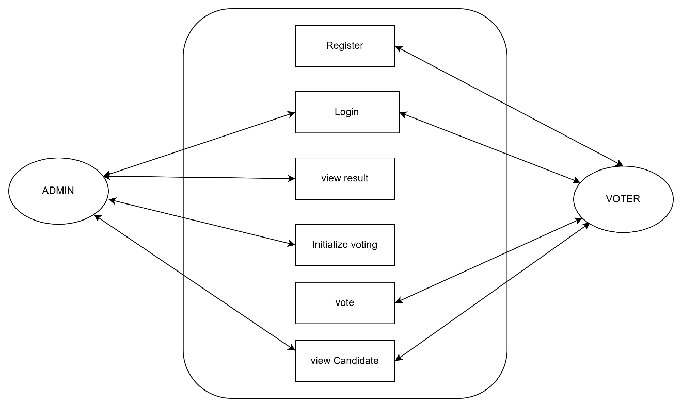
Figure 2 use case diagram

Data Flow Diagram (DFD)
The Data Flow Diagram represents the logical tracking of data through the program
structure, mapping how user inputs are processed and saved in the text logs (users.txt
and records.txt).
Level 0 (Context Diagram): Treats the entire system as a single process node,
illustrating the raw input-output boundary between the User and the application.
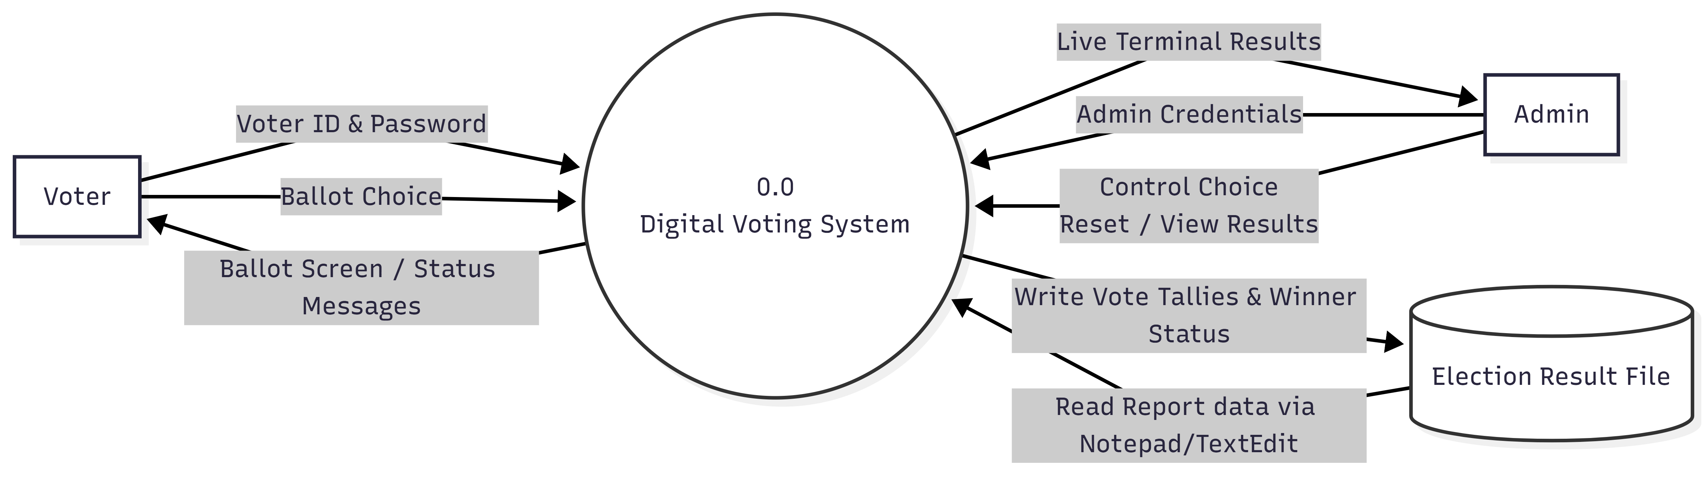
Figure 3:DFD level 0

Level 1 (Detailed Decomposition): Breaks down the central system process into
individual functional modules (signup, signing, add Record, etc.), showing exactly how
data reads from or appends to local storage via file handling.
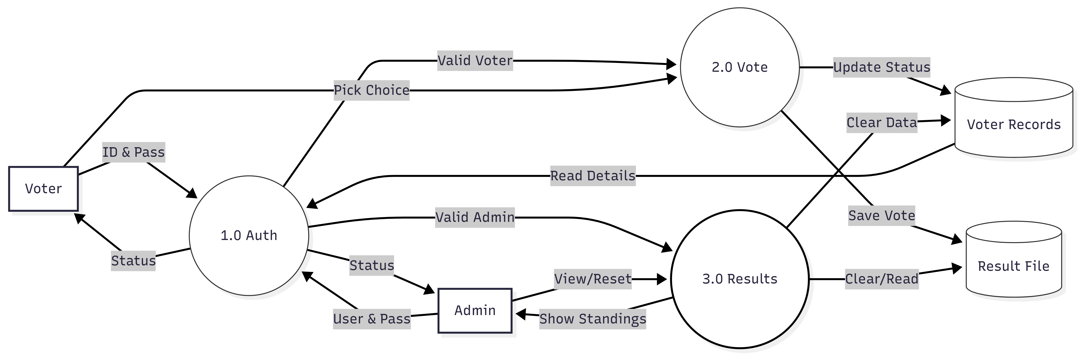
Figure 4:DFD level 1

System Flowchart
While the DFD tracks data streams, the System Flowchart diagrams the exact chronological execution logic, sequence of algorithmic steps, and condition branching rules handled by the program at runtime.
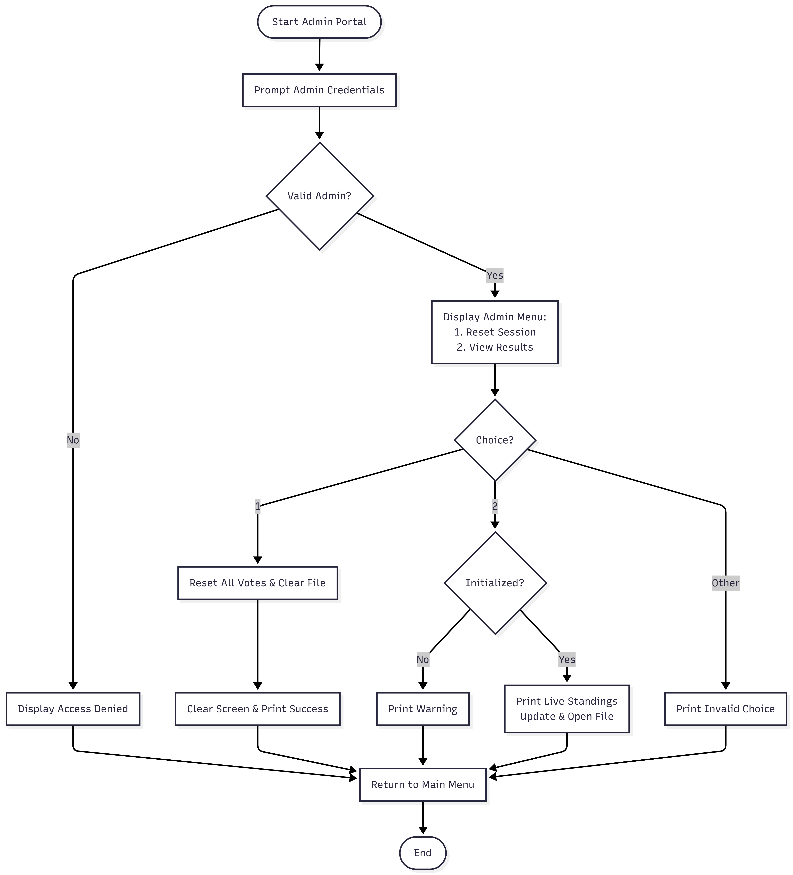
Figure 5:flowchat for admin

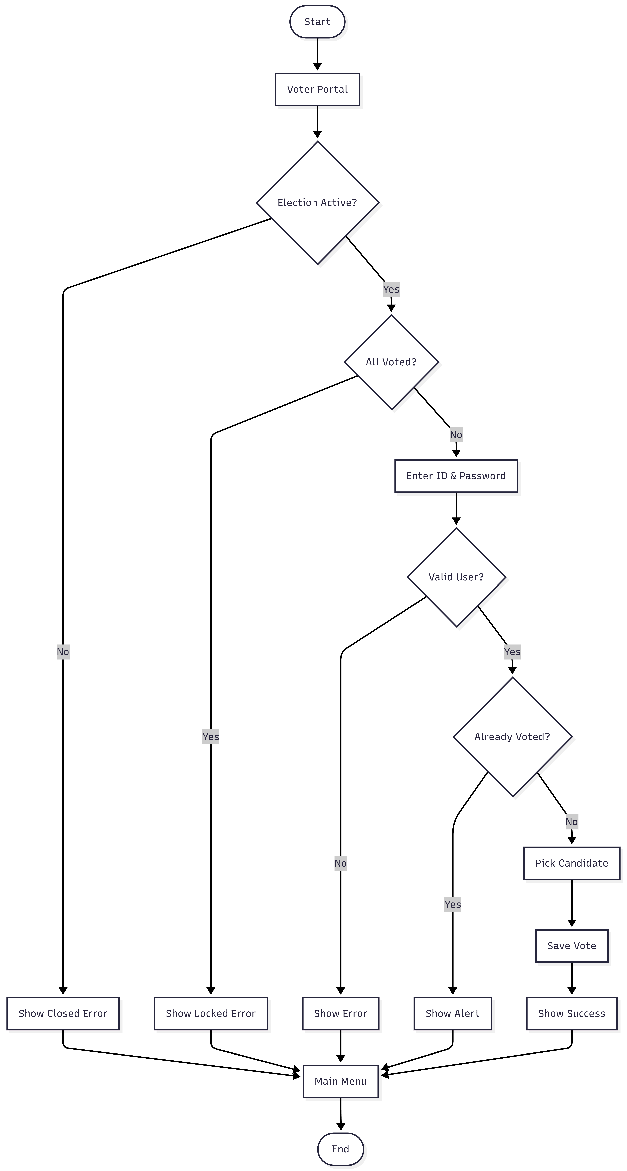
Figure 6: flow chat for voter

Development
The development phase of the Digital Voting System involves a systematic approach to planning, organizing, and executing the technical aspects of the project. This section outlines the Software Development Life Cycle (SDLC) model adopted, the technical environment utilized, and the collaboration strategies employed to ensure the project meets its defined security, accuracy, and operational objectives.
Software Development Life Cycle (SDLC) – Prototype Model
For this project, we have implemented the Prototype Model as our primary development paradigm. This model is an iterative approach where a simplified version of the software is built, tested, and refined based on feedback before the final product is deployed. This is particularly suitable for the Digital Voting System because it allows us to visualize the user interface, ballot flow, and core cryptographic/verification logic early in the process, ensuring the final application is intuitive, secure, and meets voter needs. The phases include:
Requirement Gathering and Analysis: Defining the basic operational needs of the election process, such as voter authentication, ballot confidentiality, and real-time tally integrity.
Quick Design: Creating a preliminary design of the voting interface, ballot selection screens, and the secure file-handling/database structure for immutable data persistence.
Building Prototype: Developing a basic version of the web/desktop application with core functionalities like voter login, candidate selection, and secure ballot submission.
User Evaluation: Testing the prototype with a control group of voters and election auditors to ensure the submission logic is foolproof and the interface prevents accidental invalid votes.
Refining Prototype: Making critical security, accessibility, and performance updates based on testing results to ensure zero data leakage and optimal system uptime.
Final Product Development: Completing the full, end-to-end application based on the refined prototype, incorporating advanced encryption algorithms and robust administrative control panels.
Development Environment and Tools
To maintain absolute compliance with systemic architecture designs and strict security baselines, specific development, documentation, and scheduling platforms were selected based on stability and performance:
Primary IDE & Toolchain (VS Code / DEV C++ / Modern Web Stack): Selected for its extensible environment, allowing for precision line-by-line debugging of voter authentication modules, encryption protocols, and secure session management without heavy system overhead.
Documentation & Report Compilation (Microsoft Word / Google Docs): Used to maintain formal styling, version control, and team validation over technical specifications and compliance documentation.
System Design & Modelling Tools (Draw.io / diagrams.net): Used to construct high-fidelity Level 0 Context Diagrams, Level 1 Data Flow Diagrams, and Use Case Diagrams, ensuring the software logic mirrors the theoretical security models perfectly.
Project Scheduling (Gantt Chart Utilities): Leveraged to chart, track, and monitor chronological task dependencies, preventing scope creep and ensuring readiness before the evaluation and audit deadlines.

Collaboration and Communication Channels
Due to the critical technical requirements of collaborative security implementation and strict timeline synchronization, a unified communication stack was deployed:
Microsoft Teams: Utilized as the primary interface for formalized alignment meetings with the project supervisor and security auditors. This channel ensured structured milestone check-ins, architectural reviews, and rapid feedback loop adjustments.
WhatsApp Workspace Groups: Deployed for internal peer-to-peer developer coordination. This permitted instant, real-time code snippet debugging, error log sharing, and rapid synchronization of cryptographic sub-module tasks.
Finally, most importantly, the chart of work assignment.
S.N | Name of the member | Work assigned | Remarks
1 | Prashant Tripathi | - Flow chat  - Problem Identification  - Support in system design.
2 | Miraj Puri | - Support in system design.  - Feasibility analysis.  - Gantt Chat
3 | Sushant Adhikari | - Designed DFD  - Support in system design.  - Logic definition.

7. Testing
Testing is an essential phase of software development that ensures the Digital Voting System performs as expected and satisfies all functional requirements. Different test cases were executed to verify that the application correctly authenticates users, records votes, prevents duplicate voting, calculates results accurately, and handles invalid inputs gracefully. Both normal and exceptional scenarios were tested to ensure the reliability and security of the system.

7.1 Testing Methodology
- Unit Testing: Individual modules such as login, voting, and result calculation were tested independently.
- Integration Testing: Interaction between different modules was tested to ensure smooth data flow.
- System Testing: The complete application was tested as a whole under realistic voting scenarios.
- User Acceptance Testing (UAT): Multiple users tested the system to verify usability and correctness.

7.2 Test Cases
Test Case ID | Test Scenario | Input | Expected Result | Actual Result | Status
TC-01 | Admin Login | Correct username & password | Admin menu displayed | Passed | Pass
TC-02 | Admin Login | Incorrect credentials | Access denied | Passed | Pass
TC-03 | Voter Login | Valid voter ID & password | Login successful | Passed | Pass
TC-04 | Voter Login | Invalid voter ID | Error message displayed | Passed | Pass
TC-05 | Cast Vote | Valid candidate selection | Vote recorded successfully | Passed | Pass
TC-06 | Duplicate Voting | Same voter votes again | Voting denied | Passed | Pass
TC-07 | View Results | Admin requests results | Correct vote count displayed | Passed | Pass
TC-08 | Reset Election | Admin resets election | Vote counts become zero | Passed | Pass
TC-09 | Invalid Menu Choice | Invalid option entered | Error message displayed | Passed | Pass
TC-10 | Election Closed | Voter attempts after election closed | Voting not allowed | Passed | Pass

7.3 Testing Summary
A total of 10 functional test cases were executed. All critical modules, including authentication, vote casting, result generation, duplicate vote prevention, and election reset, behaved as expected. No critical defects were identified during system testing. The application successfully met the functional requirements and demonstrated reliable performance in simulated election scenarios.

Project Results
The Digital Voting System was engineered to modernize local elections by providing a decentralized, tamper-resistant, and entirely auditable terminal application. Designed specifically for community and campus organizations, the platform successfully bridges the gap between insecure manual paper ballots and cost-prohibitive enterprise voting machinery. Every primary architectural milestone conceptualized at the project's inception was fully realized.
The problems that have been solved with the project are:
- Mitigation of Ballot Counting Latency: Traditional manual hand-tallies are replaced by an instantaneous backend processing pipeline, reducing election results delivery times from hours to fractions of a second.
- Elimination of Tabulation and Arithmetic Skew: Human counting fatigue and split-ticket accounting errors are completely neutralized. The arithmetic runtime processes votes sequentially, guaranteeing mathematical exactness in real-time turnout figures.
- Structured, Isolated Ledger Architecture: System data is segmented into specialized flat-file databases (voters.txt for encrypted credential pairing and ballots.txt for anonymized vote registers). This separation enforces strict data isolation and protects voter privacy.
- Simplified Disaster Recovery and Portability: Operating within a lightweight text-based ecosystem allows administrators to effortlessly export, copy, and replicate compressed database files to cold storage, minimizing the threat of localized data corruption.
By analyzing the logistical roadblocks inherent to physical ballot boxes, we integrated custom system constraints that fulfill vital institutional demands:
- Democratization of Secure Voting Software: Small organizations can now host robust, authentic elections without relying on bloated, enterprise-level vendor software that requires proprietary hardware.
- Distraction-Free, Zero-Telemetry Environment: Operating entirely within a local console window ensures a highly secure environment free from marketing algorithms, third-party cookies, intrusive ads, or licensing paywalls.
- Live Operational Transparency: Administrators retain real-time insight into voter turnout matrices and cryptographic system logs without prematurely compromising the hidden ballot counts before the election concludes.
- Data Sanitization and Identity Enforcement: Custom string-boundary validation and strict input handling during registration stop buffer issues and duplicate ballot fraud, ensuring that every identity maps to exactly one structured record line.
- High-Throughput Console Cycling: The interface triggers targeted screen refreshes following every cast ballot. This prevents sluggish execution loops and gives consecutive voters a clean, uncompromised screen for private voting.
Entering this project, our practical exposure to low-level console layout management and secure file handling in C was minimal, creating a steep learning curve regarding data loss and project execution risks. Overcoming these challenges proved to be an intensely educational experience. We successfully implemented complex logic loops, custom verification parsers, and persistent state management.
Ultimately, this development lifecycle redefined our understanding of collaborative engineering. We learned to distribute tasks dynamically based on individual strengths, establish continuous version alignment, and debug as a single unit. We emerged from this project not only with a functional cryptographic voting platform but with a profound appreciation for methodical teamwork, patience under technical stress, and a significantly tighter peer alignment.

Future Enhancements
The following enhancements can be implemented in future versions of the Digital Voting System:
- Database Integration — Replace plain text file storage (election_result.txt) and fixed code arrays (voter Users, voter Passes) with a proper database system (e.g., SQLite) to store unlimited voter records and handle data more reliably.
- Password Hashing — Implement a hashing algorithm (e.g., SHA-256) instead of saving the admin password (pp) and voter passwords in plaintext within the source code to improve system security.
- Dynamic Voter Registration — Add an admin control feature to add, remove, or modify registered voters dynamically during execution instead of restricting the loop to a hardcoded limit of 3 voters (total Voters = 3).
- Enhanced GUI or Web Version — Transition from the basic command-line interface (printf/scanf) and OS-specific scripts (system("notepad")) to a web-based portal or desktop application for cleaner layouts and global compatibility.
- Multi-Position Ballots — Expand the voting logic to handle multiple independent categories or positions (e.g., President, Vice President, and Secretary) in a single voting session instead of just a single pool of four candidates.
- Advanced Tie-Breaking Logic — Upgrade the basic string assignment logic (winnerMessage) to dynamically handle automatic runoff voting or secondary tallies when two or more candidates finish with identical vote counts.

Conclusion
The Digital Voting System project has been successfully designed, implemented, and executed as a command-line terminal application using the C programming language. The application effectively fulfills its foundational goals of simulating a secure, structured, and integrity-driven electronic voting portal. By introducing distinct operational roles for administrators and voters, the system establishes a clear operational workflow that closely mimics real-world computerized ballot systems.
Key Implementations & Technical Accomplishments
- Functional System: Successfully creates a digital, multi-user terminal voting platform using the C language.
- Secured Access: Enforces an admin-controlled initialization phase and validates voters using unique IDs and passwords.
- One Vote Rule: Prevents double-voting or fraud by tracking each voter's submission status dynamically.
- Automated Logic: Instantly tallies votes, handles tie or win conditions, and automatically identifies invalid ballots.
- File Logging: Permanently records and updates the final election statistics to an external file (election_result.txt).
Ultimately, this project serves as a compelling proof-of-concept for file-based data persistence and programmatic state tracking in C. It demonstrates how traditional manual processes—prone to tally errors, double-voting disputes, and lost score tracking—can be fundamentally resolved through deliberate software architecture. The codebase satisfies all baseline criteria for programmatic safety, data tracking, and structured user state transitions within a secure digital terminal environment.

Reference

