

LA GRANDEE INTERNATIONAL COLLEGE
Simalchaur, Pokhara Nepal
A Final Project Report
On
“ QuickServe”
“Order Management System”
Submitted to:
LA Grandee International College
Bachelor of Computer Application (BCA) Program
In partial fulfilment of the requirements for the degree of BCA under
Pokhara University
Submitted by:
Name of the student | PU Registration Number | Semester
Aska Godar | 2023-1-53-0324 | BCA-VI
Dikshya Chhetri | 2023-1-53-0326 | BCA-VI

May, 2026

Abstract
The Order Management System (OMS) is a web-based application designed to simplify and automate the process of managing customer orders from placement to delivery. The system provides a centralized platform where customers can browse products, place orders, track order status, and view their order history. At the same time, administrators can efficiently manage products, customers, inventory, and orders through an easy-to-use dashboard.
The primary objective of this project is to reduce manual work, improve order processing speed, minimize human errors, and enhance customer satisfaction. The system maintains accurate records of orders and inventory, allowing businesses to monitor stock levels, process payments, and generate reports efficiently. It also supports secure user authentication to ensure that customer and business data remain protected.
The Order Management System is developed using modern web technologies, with a frontend that provides an interactive user interface, a backend that handles business logic and APIs, and a database that securely stores user, product, and order information. This architecture ensures scalability, reliability, and efficient data management.

Table of Contents
1. Introduction 1
1.1 Background 1
2. Aim and Scope 2
2.1 Aim 2
2.2 Scope 2
3. Objectives 3
4. Study of the Previous System 4
4.1 Anytime Flavours 4
5. Current Problem and Proposed Solution 5
5.1 Problem Statement 5
5.2 Proposed Solution 5
6. High level requirements 6
6.1 Functional Requirements 6
6.1.1 User Management Module 6
6.1.2 Restaurant & Menu Module 6
6.1.3 Order and Delivery Module 6
6.2 Non- Functional Requirement 7
6.3 Requirement Prioritization Table 7
7. Design 8
7.1 ER Diagram (Entity Diagram) 8
7.2 Use Case Diagram 9
7.3 DFD (Data Flow Diagram) 10
7.4 UML 12
8 Detail Budget 13
8.1 Budget Breakdown 13
9. Detail Timeline 14
10. Conclusion 15
11. References 16

List of Figure
Figure 1Order Management System ER Diagram 11
Figure 2 Order Management System Usecase 12
Figure 3Order Management System DFD 0 13
Figure 4Order Management System DFD 1 14
Figure 5Order Management System UML 15
Figure 6 Gantt Chart 17
List of Table
Table 1: Requirement Prioritization Table 11
Table 2: Estimated Development Cost 17

Introduction

1.1 Background
QuickServer is a order management system developed for a single restaurant to manage online food orders and delivery services efficiently. The system allows customers to browse the restaurant menu, place food orders, and receive deliveries quickly and conveniently, Traditional food ordering methods mainly depend on phone calls and manual record keeping, which can create confusion, delays, and order mistakes. QuickServer solves these problems by providing a digital platform that automates order management, billing, and delivery tracking.
The system helps the restaurant manage customer orders, menu items, payments, and delivery operations in an organized manner. It reduces manual work, improves order accuracy, saves time, and enhances customer satisfaction through faster and more reliable service. QuickServer is designed to make restaurant food delivery easier, smarter, and more efficient for both customers and restaurant staff.
The system provides a user-friendly interface that allows customers to easily register, log in, browse food categories, view detailed menu items, add products to their cart, place orders, and monitor the status of their orders. This digital process minimizes the chances of incorrect orders and provides customers with a smooth and convenient ordering experience. Additionally, customers can view their order history, making it easier to reorder their favorite meals in the future. From the restaurant's perspective, QuickServer provides administrators with a powerful dashboard to manage all business operations from a single platform. Restaurant staff can add, update, or remove menu items, manage customer information, process incoming orders, verify payments, and assign deliveries efficiently. The system also maintains organized records of transactions and customer orders, reducing paperwork and making daily operations more manageable. By automating these processes, the restaurant can improve productivity, reduce operational costs, and provide better customer service.

Aim and Scope

Aim
The main aim of this project is to design and develop a scalable, secure, and user-friendly order delivery system that enables customers to order food online easily while helping the restaurants manage orders efficiently.

Scope
The system will serve three main users:
Customer Interface
- User registration/login (email, phone, OTP)
- Browse restaurants and menus
- Add items to cart and place orders
- Real-time order tracking
- Payments
Restaurant Panel
- Manage menu items (Add, Update, Delete)
- View incoming orders
- Update order status (Preparing, Ready, Delivered)
- Sales dashboard and analytics.
Admin Panel
- Manage users and restaurants
- Monitor system activities
- Handle payments
- Resolve disputes

Objectives
The main objective of a Order Management System is to connect customers with restaurants and ensure fast, convenient, and efficient delivery of food. It aims to digitize the traditional ordering process, reduce manual effort, and enhance overall user experience for both customers and businesses.
- Simplify Food Ordering Process : The system provides a user-friendly interface where customers can easily browse menus, select food items, and place orders within a few clicks. Features like search options, filters, and “add to cart” make the ordering process quick and hassle-free.
- Efficient Restaurant Management: It helps restaurants digitally manage their operations, including menu updates, pricing, order handling, and availability of items. Restaurants can track incoming orders in real time, reduce manual errors, and improve service efficiency. This leads to better organization and increased productivity.
- Real-Time Order Tracking: Customers can track their orders live, from preparation to delivery. The system provides status updates such as order placed, preparing, out for delivery, and delivered. This increases transparency and builds trust, as customers always know the progress of their order.
- Enhance Customer Satisfaction: Provide fast service, accurate delivery, and easy ordering, the system improves overall customer satisfaction. Features like reviews, ratings, and feedback allow continuous improvement in service quality.

Achievements (Mid-Term Progress)
As of the mid-term stage, the following progress has been achieved:
- Designed and implemented user authentication system
- Signup functionality
- Login functionality
- Developed and connected backend API
  - RESTful APIs for user registration and login
  - Secure password handling
  - Database integration completed for user module
- Created database structure for user module
  - User table implemented with necessary fields
  - Data validation and storage working properly
- Developed basic frontend static pages
- User profile page
- Basic navigation structure

Organization of Report
This mid-term report is organized into the following sections:
- Introduction: Provides background, objectives, and scope of the project.
- Survey of Technologies: Reviews similar systems and technologies used.
- Requirements and Analysis: Defines system requirements and planning.
- Design: Explains system architecture and database design.
- Implementation and Testing: Describes coding progress and testing approach.
- Results and Discussion: Shows current outputs and system evaluation.
- Conclusion: Summarizes progress and future scope of the project.

Study of the Previous System
Analyzing existing order delivery systems in Nepal provides important insights into customer behavior, delivery efficiency, and system limitations, helping in the development of a more localized, reliable, and user-friendly order delivery solution.

Anytime Flavours
Anytime Flavours is a local food delivery service that operates 24/7, providing convenient access to food at any time of the day or night. The system mainly relies on a direct communication model, where customers place orders through phone calls or messages. It uses a local delivery network to ensure quick service within the Pokhara area.
Strengths:
- 24/7 service availability
- Fast delivery within local area
- Direct communication with customers (call/message)
- Simple and easy ordering process
- Suitable for non-technical users
- Flexible handling of customer requests
Weaknesses:
• No automated system
• No real-time order tracking
• High chance of human errors
• Limited to small/local area
• No proper digital record of orders

Current Problem and Proposed Solution

Problem Statement
The following issues have been identified in the current food delivery system landscape in Nepal, particularly in regional markets like Pokhara:
- Limited Digital Accessibility: Many existing platforms require restaurants to use complex apps or dashboards. Small and local food vendors with limited technical knowledge face difficulties in managing menus, updating items, and handling online orders efficiently.
- Lack of Real-Time Order Tracking: Some local delivery services do not provide live tracking features. Customers are unable to monitor order status, which creates uncertainty and reduces overall trust in the service.
- Lack of Centralized Data and Order Management: Many local systems operate manually without proper data storage. This makes it difficult to track orders, analyze performance, or improve service efficiency over time.

Proposed Solution
The proposed Order Management System addresses the identified challenges through the following technical implementations:
Simplified Restaurant Dashboard: To reduce technical complexity, the system provides a user-friendly, mobile-first dashboard for restaurants. It includes simple menu management, easy order notifications, and minimal input requirements, making it accessible for small and local food vendors with limited technical knowledge.
Real-Time Order Tracking System: To improve transparency, the system offers live order tracking, where customers can see the status of their order (placed, preparing, out for delivery, delivered). This enhances user confidence and reduces uncertainty during the delivery process.
Integrated Communication System: To minimize miscommunication, the platform includes in-app messaging or call features between customers, restaurants, and delivery personnel. This ensures clear coordination regarding order details and delivery instructions.

High level requirements
The following requirements outline the detailed functional and non-functional specifications of the Order Management System.

Functional Requirements

User Management Module
FR-UM-001: Customer Registration
- System shall allow customers to register using email or phone number.
- System shall verify the email/phone number via a 6-digit OTP (One Time Password).
FR-UM-002: Profile Management
- System shall allow users to update personal information (name, contact details).
- System shall allow users to save multiple delivery addresses.

Restaurant & Menu Module
FR-RM-001: Menu Management
- System shall allow restaurants to Create, Read, Update, and Delete (CRUD) food items.
- System shall support adding images, price, and food descriptions.
FR-RM-002: Food Discovery and Search
- System shall provide a search feature to find food items.
- System shall allow filtering by category (e.g., veg, non-veg, fast food), price, and rating.

Order and Delivery Module
FR-OM-001: Cart and Checkout
- System shall allow users to add food items to a cart.
- System shall provide a simple checkout process (Address → Payment → Confirmation).
FR-OM-002: Payment Integration
- System shall support online payment system an Cash on Delivery (COD) as an alternative method.
FR-OM-003: Order Tracking
- System shall allow users to track order status (Order Placed, Preparing, Out for Delivery, Delivered).
- System shall notify restaurants and delivery personnel upon receiving a new order.

Non- Functional Requirement
NFR-01: Performance
- The system shall load the homepage within 3 seconds on a standard 4G network.
- System shall utilize image optimization (WebP format) to minimize data consumption.
NFR-02: Security
- System shall hash all user passwords using the Bcrypt algorithm before database storage.
- System shall implement JWT (JSON Web Token) for stateless and secure session management.
NFR-03: Scalability
- The backend architecture shall support horizontal scaling to accommodate up to 500 concurrent users.
NFR-04: Usability
- The interface shall be fully responsive and optimized for mobile devices .

Requirement Prioritization Table
Table 1: Requirement Prioritization Table
ID | Requirement Name | Priority | Category
FR-UM-001 | Customer Registration | High | Core
FR-UM-002 | Profile Management | High | Core
FR-RM-001 | Menu Management | High | Core
FR-RM-002 | Food Discovery and Search | Medium | Usability
FR-OM-001 | Cart and Checkout | High | Core
FR-OM-002 | Payment (COD) | High | Financial
FR-OM-003 | Order Tracking | Medium | Operational
NFR-01 | System Performance | High | Infrastructure
NFR-02 | System Security | High | Infrastructure
NFR-03 | Scalability | Medium | Infrastructure

Design

ER Diagram (Entity Diagram)

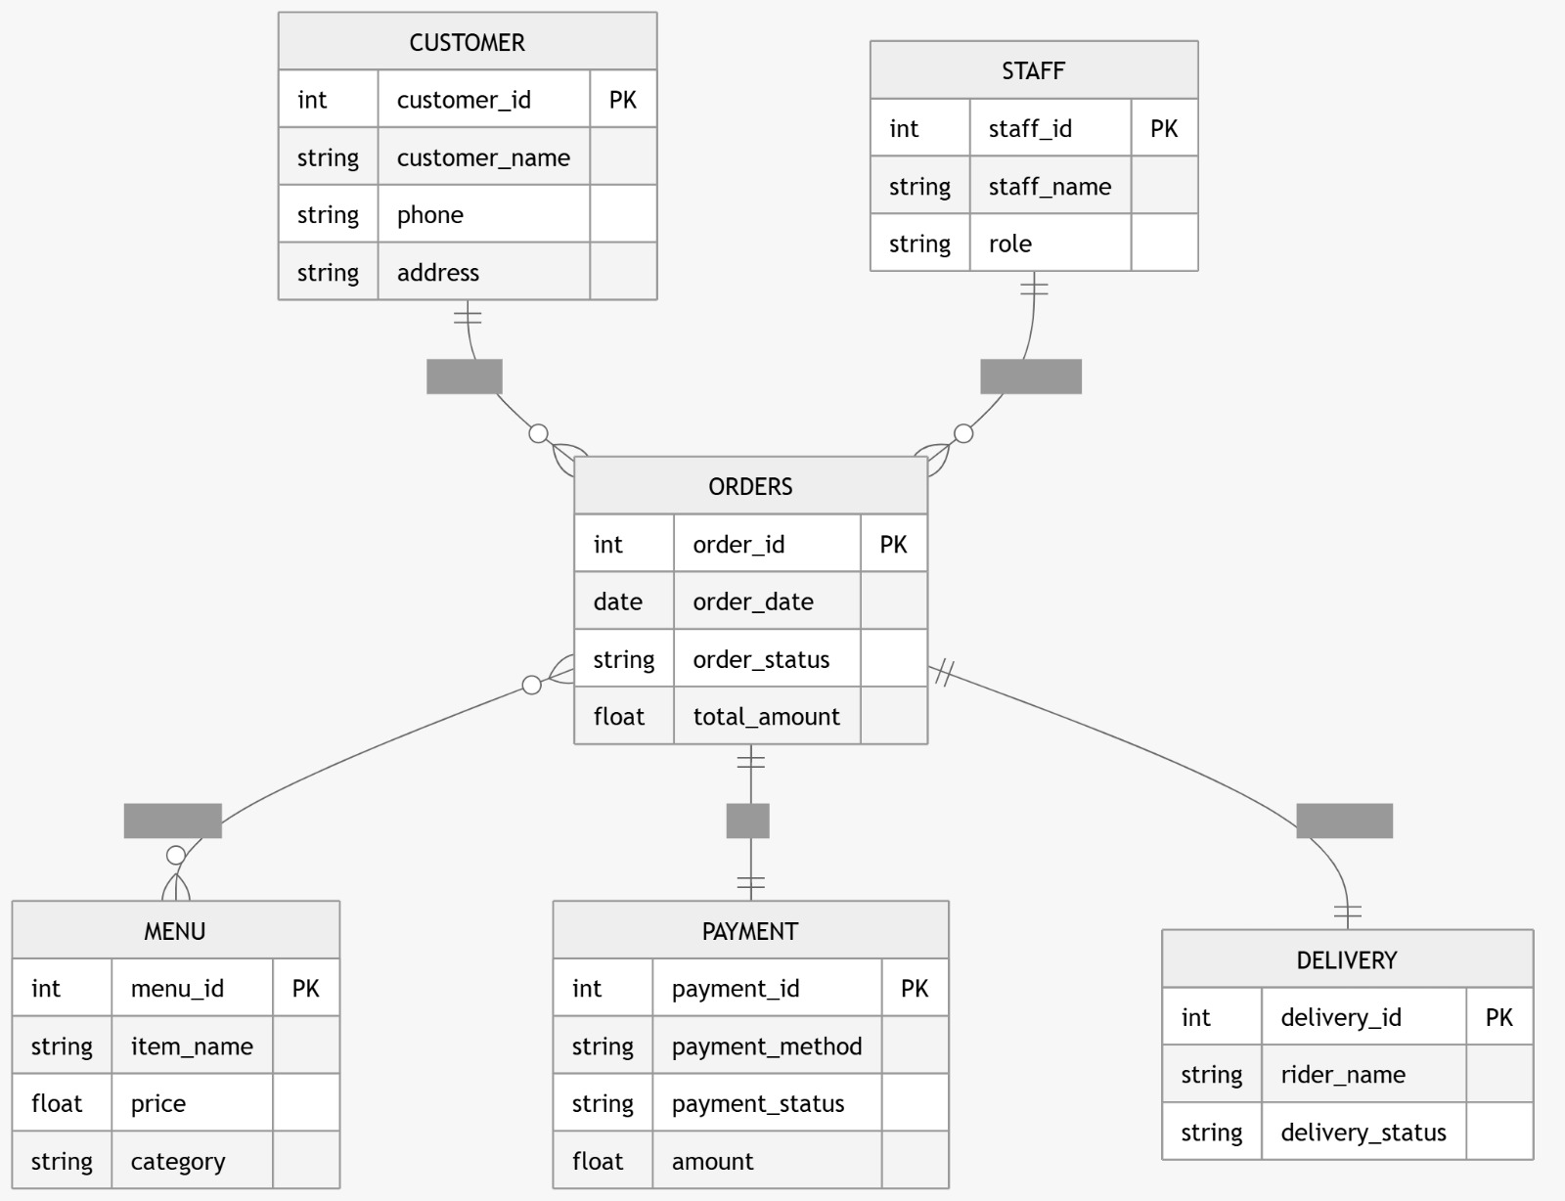
Figure 1Order Management System ER diagram

Use Case Diagram

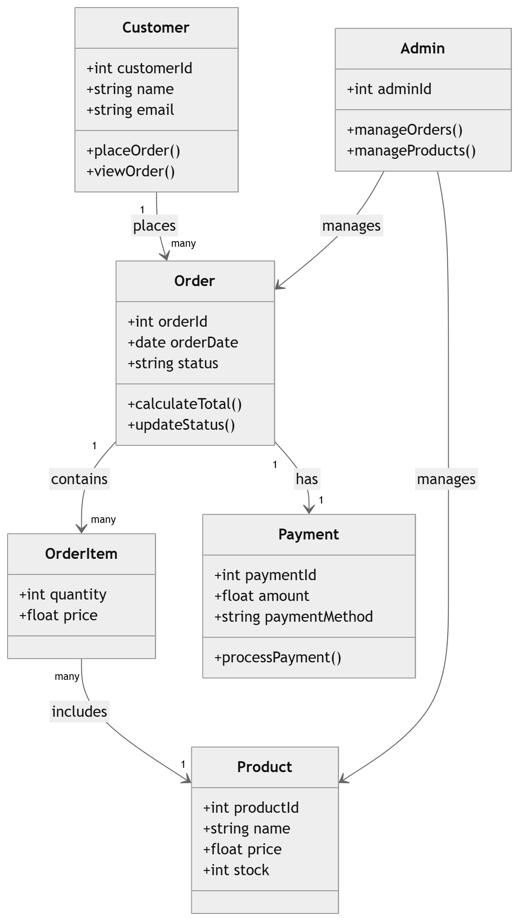

Figure 2 Management System Use Case diagram

DFD (Data Flow Diagram)

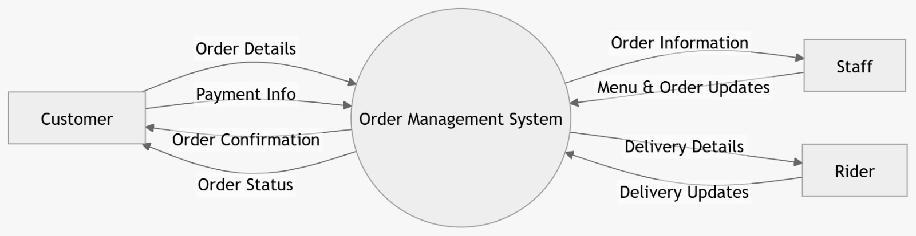
Figure 3Order Management System DFD level 0
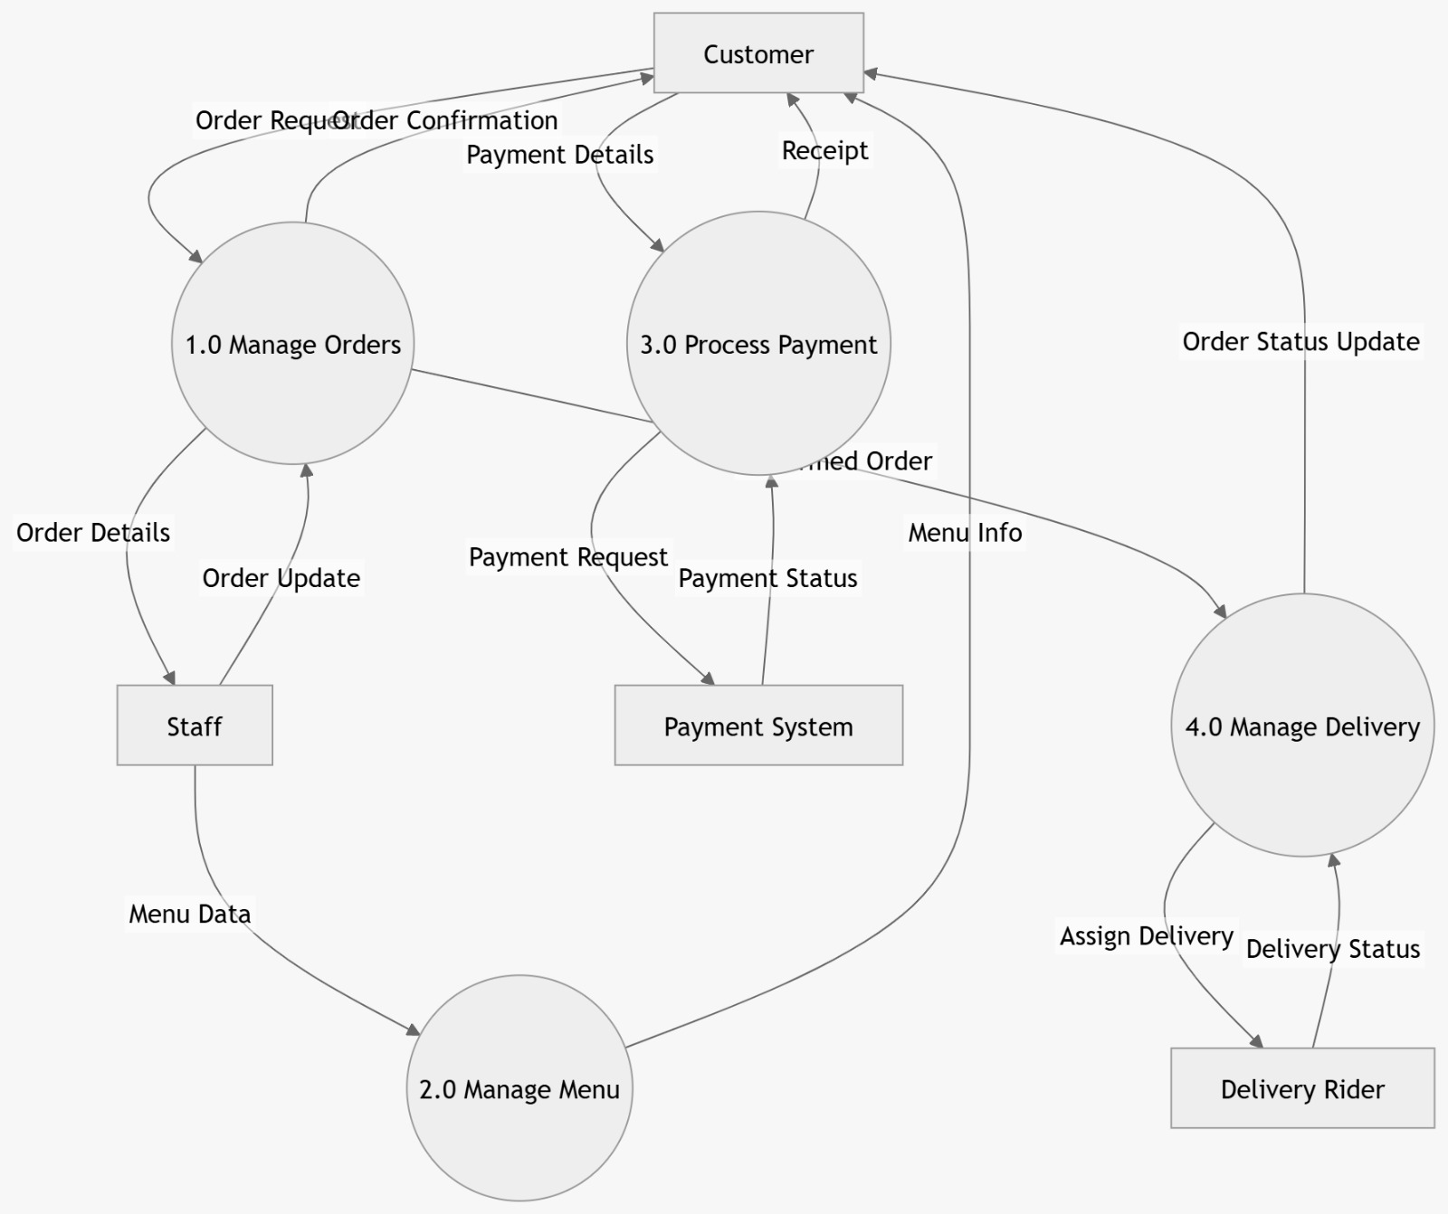
Figure 4Order Management System DFD level 1

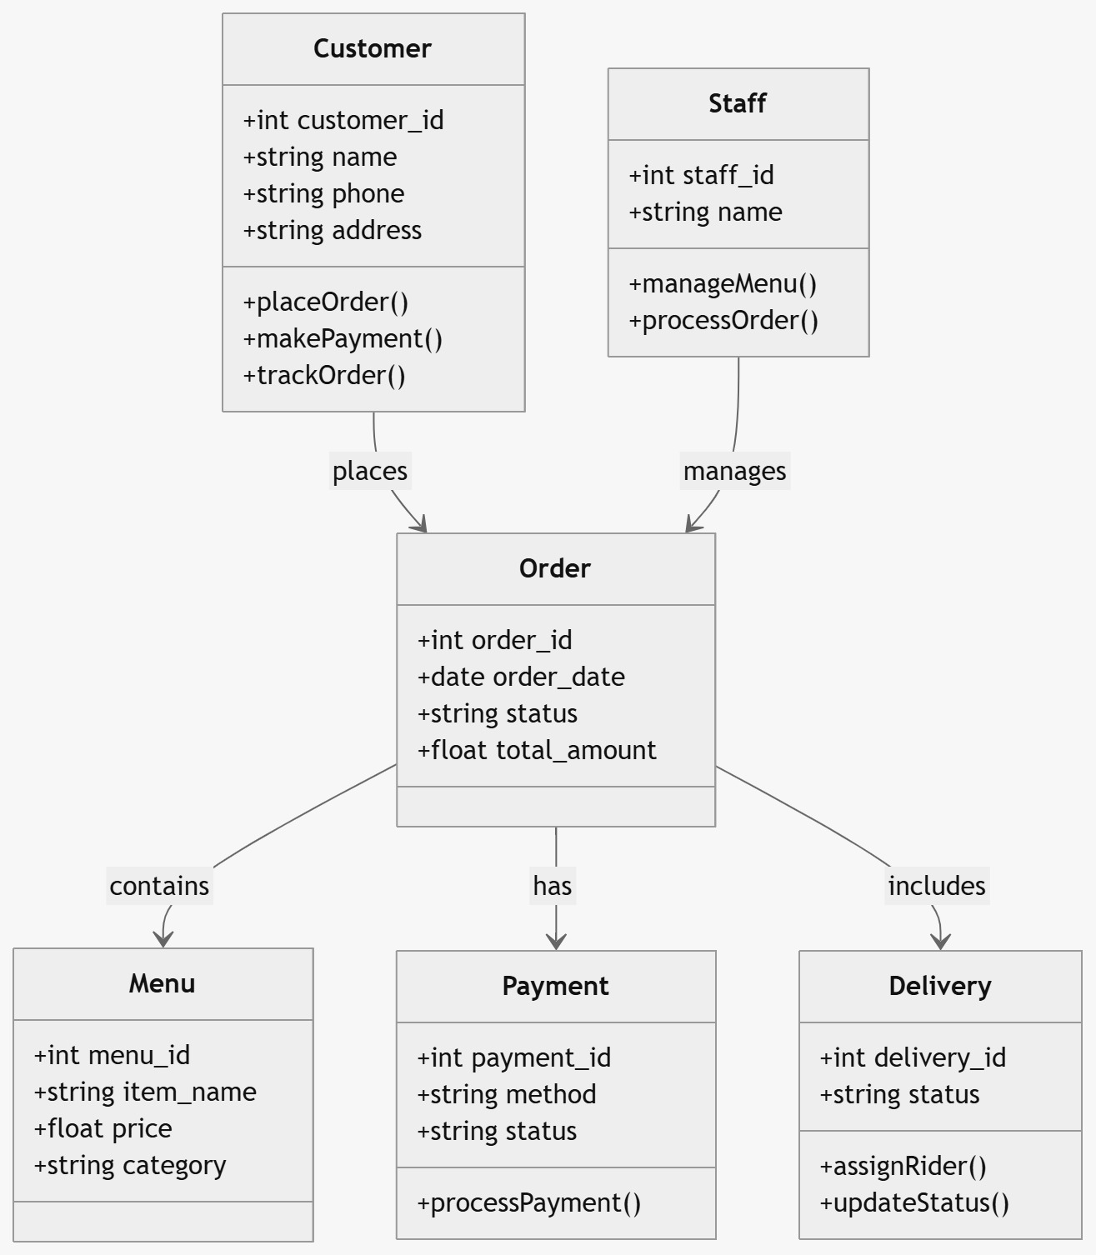
UML
Figure 5Order Management System UML

Detail Budget

Budget Breakdown
Table 2: Estimated Development Cost
Category | Item | Quantity | Cost (NPR) | Total (NPR)
Hosting | Cloud Server (Food Delivery Platform) | 12 Months | 1,100 | 13,200
Domain | .com.np Registration | 1 | Free | 0
Security | SSL Certificate | 1 Year | 2,500 | 2,500
API Fees | SMS Gateway (Order & OTP Alerts) | 5000 SMS | 1.5/SMS | 7,500
Tools | UI Design & Food App Icons | - | 3,000 | 3,000
Delivery | Order Management Setup | - | 2,000 | 2,000
Devlopment Cost | System Development and coding | - | 50,000 | 50,000
Total |  |  |  | 78,200

Detail Timeline
PROCESS | April |  | May |  |  |  |  | June |  |  |  |  | July
 | 4W  2-24 | 5  W  25-31 | 1W  1-5 | 2W  6-12 | 3W  13-19 | 4W  20-26 | 5W  27-31 | 1W  1-5 | 2W  6-12 | 3W  13-19 | 4W  20-26 | 5W  27-31 | 1  W  1-7 | 2  W  8-14
Planning
Documentation
Design
Development
Testing
Deployment
Figure 6 Gantt Chart

Conclusion
The Order Management System is an efficient digital solution that connects customers with restaurants, making the process of ordering food simple, fast, and convenient. It allows users to browse menus, place orders, and receive food at their doorstep while enabling restaurants to manage orders effectively. The system improves service quality through features like easy checkout, order tracking, and organized delivery management. By addressing common issues such as delivery delays and lack of coordination, it enhances overall customer satisfaction and operational efficiency. Thus, the Order Management system plays a vital role in modernizing traditional food services and offers strong potential for future improvements and scalability.

References
Kotler, P., & Keller, K. L. (2016). Marketing Management (15th ed.). Pearson Education.
Laudon, K. C., & Laudon, J. P. (2020). Management Information Systems: Managing the Digital Firm (16th ed.). Pearson.
Pressman, R. S. (2014). Software Engineering: A Practitioner’s Approach (8th ed.). McGraw-Hill Education.
Sommerville, I. (2016). Software Engineering (10th ed.). Pearson Education.
Foodmandu. (n.d.). Retrieved from https://www.foodmandu.com
Pathao Food. (n.d.). Retrieved from https://pathao.com/np/food
Bhojdeals. (n.d.). Retrieved from https://www.bhojdeals.com
W3Schools. (n.d.). Web Development Tutorials. Retrieved from https://www.w3schools.com
TutorialsPoint. (n.d.). Software Development Tutorials. Retrieved from https://www.tutorialspoint.com
Mozilla Developer Network (MDN). (n.d.). Web Docs. Retrieved from https://developer.mozilla.org

