**CONTENTS**

**CONTENTS**

**`**

1. **INTRODUCTION----------------------------------------------------------4**
   1. INTRODUCTION TO PROJECT -----------------------------------------5
   2. EXISTING SYSTEM & ITS DISADVANTAGES --------------------5
   3. PROPOSED SYSTEM & ITS ADVANTAGES ------------------------5
2. **SYSTEM ANALYSIS-------------------------------------------------------06**
   1. STUDY OF THE SYSTEM ------------------------------------------------------7
   2. INPUT & OUTPUT REPRESENTATION ----------------------------7
   3. PROCESS MODELS USED WITH JUSTIFICATION -------------11
   4. SYSTEM ARCHITECTURE -----------------------------------------------19
3. **FEASIBILITY STUDY-----------------------------------------------------20**
   1. TECHNICAL FEASIBILITY --------------------------------------------------21
   2. OPERATIONAL FEASIBILITY ----------------------------------------------21
   3. ECONOMIC FEASIBILITY ---------------------------------------------------22
4. **REQUIREMENT SPECIFICATIONS---------------------------------23**
   1. FUNCIONAL REQUIREMENTS --------------------------------------------24
   2. PERFORMANCE REQUIREMENTS ---------------------------------------24
   3. SOFTWARE REQUIREMENTS ---------------------------------------------25
   4. HARDWARE REQUIREMENTS ---------------------------------------------25
      1. INTRODUCTION TO JAVA -----------------------------------------25
      2. SERVLETS/JSP ----------------------------------------------------------26
      3. JDBC ------------------------------------------------------------------------27
      4. ORACLE -------------------------------------------------------------------29
      5. HTML -----------------------------------------------------------------------32
      6. JAVA SCRIPT -------------------------------------------------------------34
5. **SYSTEM DESIGN ---------------------------------------------------------35**
   1. . INTRODUCTION ----------------------------------------------------------------36
   2. DATA FLOW DIAGRAMS ------------------------------------------------------36
   3. UML DIAGRAMS ------------------------------------------------------------------37
   4. E-R DIAGRAM ---------------------------------------------------------------------42
   5. NORMALIZATION ---------------------------------------------------------------43
   6. DATA DICTIONARY ------------------------------------------------------------44
6. **SYSTEM TESTING -------------------------------------------------------46**
   1. INTRODUCTION TO TESTING ---------------------------------------47

6.2 TESTING STRATEGIES ---------------------------------------------------47

1. **OUTPUT SCREENS ------------------------------------------------------50**
2. **SYSTEM SECURITY -----------------------------------------------------66**

8.1 INTRODUCTION -------------------------------------------------------------67

8.2 SECURITY IN SOFTWARE -------------------------------------------------67

**9. CONCLUSION -------------------------------------------------------------68**

**BIBLIOGRAPHY -------------------------------------------------------------71**

**CHAPTER-1**

**INTRODUCTION**

SVU COLLEGE OF CM&CS

HOSTEL FEES MANAGEMENT SYSTEM

**1.1 Introduction**

SVU College of CM&CS Hostel Fees Management System software is prepared to maintain the monthly operations in a leading hostel office. This software help them to maintain the student details records and mess bill information. So the maintain becomes easier.

**1.2 Existing System**

At present in hostel office all records maintained manually. There are thousands of students joining each year. As the years goes then number of students also get increases, for the staff to maintain all these students records is very tedious and time consuming. Update fee, test marks, test result all these need to be done in time to achieve college management need to be recruit more peoples. To solve this problem this project is prepared which help the management to maintain the records accurately.

**1.3 Proposed System**

In the proposed system all the parameter are considered to maintain neat and easier solutions. In college to maintain all student records they need have more staff and also place to maintain the records. Even maintained properly whenever required they are not available. To solve this problem this program is designed. It serve the purpose of maintain records. Collecting fee. Announcing the test-results.

**CHAPTER-2**

**SYSTEM ANALYSIS**

**2.1 STUDY OF THE SYSTEM**

To provide flexibility to the users, the interfaces have been developed that are accessible through a browser. The GUI’S at the top level have been categorized as

1. Administrative user interface
2. The operational or generic user interface

The ‘administrative user interface’ concentrates on the consistent information that is practically, part of the organizational activities and which needs proper authentication for the data collection. These interfaces help the administrators with all the transactional states like Data insertion, Data deletion and Date updation along with the extensive data search capabilities.

The ‘operational or generic user interface’ helps the end users of the system in transactions through the existing data and required services. The operational user interface also helps the ordinary users in managing their own information in a customized manner as per the included flexibilities

**2.2 INPUT & OUTPOUT REPRESENTETION**

Input design is a part of overall system design. The main objective during the input design is as given below:

* To produce a cost-effective method of input.
* To achieve the highest possible level of accuracy.
* To ensure that the input is acceptable and understood by the user.

**INPUT STAGES:**

The main input stages can be listed as below:

* Data recording
* Data transcription
* Data conversion
* Data verification
* Data control
* Data transmission
* Data validation

**INPUT TYPES:**

It is necessary to determine the various types of inputs. Inputs can be categorized as follows:

* External inputs, which are prime inputs for the system.
* Internal inputs, which are user communications with the system.
* Operational, which are computer department’s communications to the system?
* Interactive, which are inputs entered during a dialogue.

**INPUT MEDIA:**

At this stage choice has to be made about the input media. To conclude about the input media consideration has to be given to;

* Type of input
* Flexibility of format
* Speed
* Accuracy
* Verification methods
* Rejection rates
* Ease of correction
* Storage and handling requirements
* Security
* Easy to use
* Portability

Keeping in view the above description of the input types and input media, it can be said that most of the inputs are of the form of internal and interactive. As Input data is to be the directly keyed in by the user, the keyboard can be considered to be the most suitable input device.

**OUTPUT DESIGN:**

In general are:

* External Outputs whose destination is outside the organization.
* Internal Outputs whose destination is with in organization and they are the User’s main interface with the computer. Outputs from computer systems are required primarily to communicate the results of processing to users. They are also used to provide a permanent copy of the results for later consultation. The various types of outputs
* Operational outputs whose use is purely with in the computer department.
* Interface outputs, which involve the user in communicating directly with the system.

**OUTPUT DEFINITION**

# The outputs should be defined in terms of the following points:

* + - Type of the output
    - Content of the output
    - Format of the output
    - Location of the output
    - Frequency of the output
    - Volume of the output
    - Sequence of the output

It is not always desirable to print or display data as it is held on a computer. It should be decided as which form of the output is the most suitable.

For Example

* Will decimal points need to be inserted
* Should leading zeros be suppressed.

**OUTPUT MEDIA:**

In the next stage it is to be decided that which medium is the most appropriate for the output. The main considerations when deciding about the output media are:

* The suitability for the device to the particular application.
* The need for a hard copy.
* The response time required.
* The location of the users
* The software and hardware available.

Keeping in view the above description the project is to have outputs mainly coming under the category of internal outputs. The main outputs desired according to the requirement specification are:

The outputs were needed to be generated as a hard copy and as well as queries to be viewed on the screen. Keeping in view these outputs, the format for the output is taken from the outputs, which are currently being obtained after manual processing. The standard printer is to be used as output media for hard copies.

**2.3 PROCESS MODEL USED WITH JUSTIFICATION**

**SDLC (Spiral Model):**

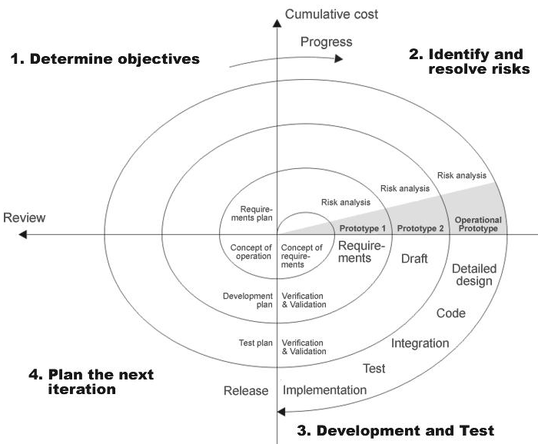

**Figure 2.3.1. SPIRAL MODEL**

SDLC is nothing but Software Development Life Cycle. It is a standard which is used by software industry to develop good software.

**Stages in SDLC:**

* Requirement Gathering
* Analysis
* Designing
* Coding
* Testing
* Maintenance

**Requirements Gathering** **stage:**

The requirements gathering process takes as its input the goals identified in the high-level requirements section of the project plan. Each goal will be refined into a set of one or more requirements. These requirements define the major functions of the intended application, define

operational data areas and reference data areas, and define the initial data entities. Major functions include critical processes to be managed, as well as mission critical inputs, outputs and reports. A user class hierarchy is developed and associated with these major functions, data areas, and data entities. Each of these definitions is termed a Requirement. Requirements are identified by unique requirement identifiers and, at minimum, contain a requirement title and

textual description.

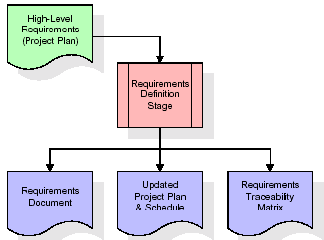

These requirements are fully described in the primary deliverables for this stage: the Requirements Document and the Requirements Traceability Matrix (RTM). The requirements document contains complete descriptions of each requirement, including diagrams and references to external documents as necessary. Note that detailed listings of database tables and fields are *not* included in the requirements document.

The title of each requirement is also placed into the first version of the RTM, along with the title of each goal from the project plan. The purpose of the RTM is to show that the product components developed during each stage of the software development lifecycle are formally connected to the components developed in prior stages.

In the requirements stage, the RTM consists of a list of high-level requirements, or goals, by title, with a listing of associated requirements for each goal, listed by requirement title. In this hierarchical listing, the RTM shows that each requirement developed during this stage is formally linked to a specific product goal. In this format, each requirement can be traced to a specific product goal, hence the term *requirements traceability*.

The outputs of the requirements definition stage include the requirements document, the RTM, and an updated project plan.

* Feasibility study is all about identification of problems in a project.
* No. of staff required to handle a project is represented as Team Formation, in this case only modules are individual tasks will be assigned to employees who are working for that project.
* Project Specifications are all about representing of various possible inputs submitting to the server and corresponding outputs along with reports maintained by administrator

**Analysis Stage:**

The planning stage establishes a bird's eye view of the intended software product, and uses this to establish the basic project structure, evaluate feasibility and risks associated with the project, and describe appropriate management and technical approaches.

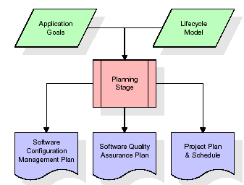

The most critical section of the project plan is a listing of high-level product requirements, also referred to as goals. All of the software product requirements to be developed during the requirements definition stage flow from one or more of these goals. The minimum information for each goal consists of a title and textual description, although additional information and references to external documents may be included. The outputs of the project planning stage are the configuration management plan, the quality assurance plan, and the project plan and schedule, with a detailed listing of scheduled activities for the upcoming Requirements stage, and high level estimates of effort for the out stages.

**Designing Stage:**

The design stage takes as its initial input the requirements identified in the approved requirements document. For each requirement, a set of one or more design elements will be produced as a result of interviews, workshops, and/or prototype efforts. Design elements describe the desired software features in detail, and generally include functional hierarchy diagrams, screen layout diagrams, tables of business rules, business process diagrams, pseudo code, and a complete entity-relationship diagram with a full data dictionary. These design elements are intended to describe the software in sufficient detail that skilled programmers may develop the software with minimal additional input.

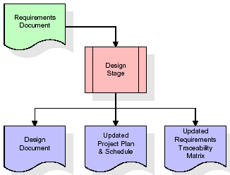

When the design document is finalized and accepted, the RTM is updated to show that each design element is formally associated with a specific requirement. The outputs of the design stage are the design document, an updated RTM, and an updated project plan.

**Development (Coding) Stage:**

The development stage takes as its primary input the design elements described in the approved design document. For each design element, a set of one or more software artifacts will be produced. Software artifacts include but are not limited to menus, dialogs, data management forms, data reporting formats, and specialized procedures and functions. Appropriate test cases will be developed for each set of functionally related software artifacts, and an online help system will be developed to guide users in their interactions with the software.

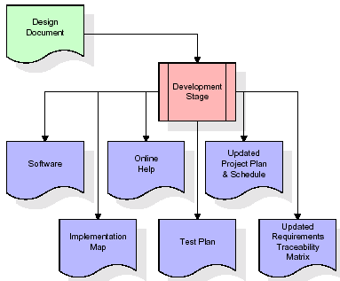

The RTM will be updated to show that each developed artifact is linked to a specific design element, and that each developed artifact has one or more corresponding test case items. At this point, the RTM is in its final configuration. The outputs of the development stage include a fully functional set of software that satisfies the requirements and design elements previously documented, an online help system that describes the operation of the software, an implementation map that identifies the primary code entry points for all major system functions, a test plan that describes the test cases to be used to validate the correctness and completeness of the software, an updated RTM, and an updated project plan.

**Integration & Test Stage:**

During the integration and test stage, the software artifacts, online help, and test data are migrated from the development environment to a separate test environment. At this point, all test cases are run to verify the correctness and completeness of the software. Successful execution of the test suite confirms a robust and complete migration capability. During this stage, reference data is finalized for production use and production users are identified and linked to their appropriate roles. The final reference data (or links to reference data source files) and production user list are compiled into the Production Initiation Plan.

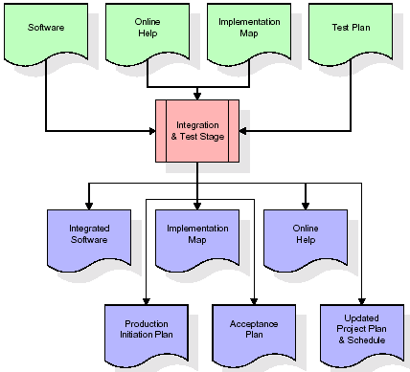

The outputs of the integration and test stage include an integrated set of software, an online help system, an implementation map, a production initiation plan that describes reference data and production users, an acceptance plan which contains the final suite of test cases, and an updated project plan.

* **Installation & Acceptance Test:**

During the installation and acceptance stage, the software artifacts, online help, and initial production data are loaded onto the production server. At this point, all test cases are run to verify the correctness and completeness of the software. Successful execution of the test suite is a prerequisite to acceptance of the software by the customer.

After customer personnel have verified that the initial production data load is correct and the test suite has been executed with satisfactory results, the customer formally accepts the delivery of the software.

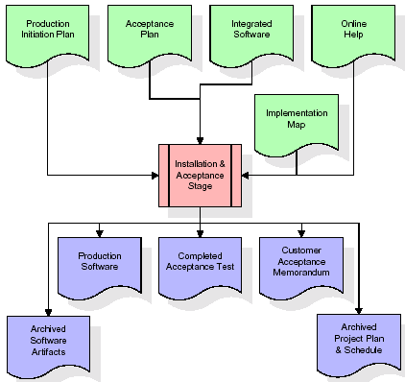

The primary outputs of the installation and acceptance stage include a production application, a completed acceptance test suite, and a memorandum of customer acceptance of the software. Finally, the PDR enters the last of the actual labor data into the project schedule and locks the project as a permanent project record. At this point the PDR "locks" the project by archiving all software items, the implementation map, the source code, and the documentation for future reference.

**Maintenance:**

Outer rectangle represents maintenance of a project, Maintenance team will start with requirement study, understanding of documentation later employees will be assigned work and they will under go training on that particular assigned category.

**2.4 SYSTEM ARCHITECTURE**

**Architecture flow:**

Below architecture diagram represents mainly flow of requests from users to database through servers. In this scenario overall system is designed in three tires separately using three layers called presentation layer, business logic layer and data link layer. This project was developed using 3-tire architecture.

**Business Logic Layer**

Presentation Layer

**Request**

**Response**

Data Link

Layer

**Data Base**

Figure 2.4. Architecture

**CHAPTER-3**

**FEASIBILITY STUDY**

**Feasibility Study:**

Preliminary investigation examines project feasibility; the likelihood the system will be useful to the organization. The main objective of the feasibility study is to test the Technical, Operational and Economical feasibility for adding new modules and debugging old running system. All systems are feasible if they are given unlimited resources and infinite time. There are aspects in the feasibility study portion of the preliminary investigation:

* Technical Feasibility
* Operation Feasibility

Economic Feasibility

**3.1 TECHNICAL FEASIBILITY**

The technical issue usually raised during the feasibility stage of the investigation includes the following:

* Does the necessary technology exist to do what is suggested?
* Do the proposed equipments have the technical capacity to hold the data required to use the new system?
* Will the proposed system provide adequate response to inquiries, regardless of the number or location of users?
* Can the system be upgraded if developed?

Are there technical guarantees of accuracy, reliability, ease of access and data security?

**3.2 OPERATIONAL FEASIBILITY**

**OPERATIONAL FEASIBILITY**

**User-friendly**

Customer will use the forms for their various transactions i.e. for adding new routes, viewing the routes details. Also the Customer wants the reports to view the various transactions based on the constraints. Theses forms and reports are generated as user-friendly to the Client.

**Reliability**

The package wills pick-up current transactions on line. Regarding the old transactions, User will enter them in to the system.

**Security**

The web server and database server should be protected from hacking, virus etc

**Portability**

The application will be developed using standard open source software (Except Oracle) like Java, tomcat web server, Internet Explorer Browser etc these software will work both on Windows and Linux o/s. Hence portability problems will not arise.

**Availability**

This software will be available always.

**Maintainability**

The system called the ewheelz uses the 2-tier architecture. The 1st tier is the GUI, which is said to be front-end and the 2nd tier is the database, which uses My-Sql, which is the back-end.

The front-end can be run on different systems (clients). The database will be running at the server. Users access these forms by using the user-ids and the passwords.

**3.3 ECONOMIC FEASILITY**

The computerized system takes care of the present existing system’s data flow and procedures completely and should generate all the reports of the manual system besides a host of other management reports.

It should be built as a web based application with separate web server and database server. This is required as the activities are spread through out the organization customer wants a centralized database. Further some of the linked transactions take place in different locations.

Open source software like TOMCAT, JAVA, Oracle 10g and windows xp is used to minimize the cost for the Customer.

**CHAPTER-4**

**REQUIREMENT SPECIFICATION**

**4.1 FUNCTIONAL REQUIREMENTS SPECIFICATION**

This application consists following modules.

1. **Administrator Module**
2. **Student Module**
3. **Administrator Module:**

In this system admin is the super user. The admin maintains the details of the students like attendance, results,updates,delete.

The admin also maintence the faculty details.

1. **Student Module:**

This student module having the registration. so the student can register the svu college of cm&cs student management system and we their reports like attendance report and result report and student report.

**4.2 PERFORMANCE** **REQUIREMENTS**

Performance is measured in terms of the output provided by the application. Requirement specification plays an important part in the analysis of a system. Only when the requirement specifications are properly given, it is possible to design a system, which will fit into required environment. It rests largely with the users of the existing system to give the requirement specifications because they are the people who finally use the system. This is because the requirements have to be known during the initial stages so that the system can be designed according to those requirements. It is very difficult to change the system once it has been designed and on the other hand designing a system, which does not cater to the requirements of the user, is of no use.

The requirement specification for any system can be broadly stated as given below:

* The system should be able to interface with the existing system
* The system should be accurate
* The system should be better than the existing system

The existing system is completely dependent on the user to perform all the duties.

**4.3 Software Requirements:**

Operating System :Microsoft Windows 8.1

Front End : java with JSP

Back End : Oracle 10g

Data Base : JDBC

Server : Tomcat8

**4.4** **Hardware Requirements:**

Processor : Intel core i3

Ram : 4GB

Hard disk : 1 TB

**4.4.1. INTRODUCTION TO JAVA**

**About Java**:

Initially the language was called as “oak” but it was renamed as “java” in 1995.The primary motivation of this language was the need for a platform-independent (i.e. Architecture neutral) language that could be used to create software to be embedded in various consumer electronic devices.

* Java is a programmer’s language
* Java is cohesive and consistent
* Except for those constraint imposed by the Internet environment. Java gives the programmer, full control

Finally Java is to Internet Programming where c was to System Programming.

**Importance of Java to the Internet**

Java has had a profound effect on the Internet. This is because; java expands the Universe of objects ssssthat can move about freely in Cyberspace. In a network, two categories of objects are transmitted between the server and the personal computer. They are passive information and Dynamic active programs. in the areas of Security and probability. But Java addresses these concerns and by doing so, has opened the door to an exciting new form of program called the Applet.

**Applications and applets***.* An application is a program that runs on our Computer under the operating system of that computer. It is more or less like one creating using C or C++ .Java’s ability to create Applets makes it important. An Applet I saw application, designed to be transmitted over the Internet and executed by a Java-compatible web browser. An applet I actually a tiny Java program, dynamically downloaded across the network, just like an image. But the difference is, it is an intelligent program, not just a media file. It can be react to the user input and dynamically change.

**Java Architecture**

Java architecture provides a portable, robust, high performing environment for development. Java provides portability by compiling the byte codes for the Java Virtual Machine, which is then interpreted on each platform by the run-time environment. Java is a dynamic system, able to load code when needed from a machine in the same room or across the planet.

# **Compilation of code**

## *When you compile the code, the Java compiler creates machine code (called byte code)for a hypothetical machine called Java Virtual Machine(JVM). The JVM is supposed t executed the byte code. The JVM is created for the overcoming the issue of probability. The code is written and compiled for one machine and interpreted on all machines .This machine is called Java Virtual Machine*.

**Compiling and interpreting java source code.**

**Source code**

**Pc compiler**

**Macintosh compiler**

**SPARC Compiler**

**Java Byte code**

**Platform independent**

**Java interpreter**

**Java interpretermacintosh**

**)))**

**Java interpreter(SPARC)**

During run-time the Java interpreter tricks the byte code file into thinking that it is running on a Java Virtual Machine. In reality this could be an Intel Pentium windows 95 or sun SPARCstation running Solaris or Apple Macintosh running system and all could receive code from any computer through internet and run the Applets.

**Simple**:

Java was designed to be easy for the Professional programmer to learn and to use effectively. If you are an experienced C++ Programmer. Learning Java will oriented features of C++ . Most of the confusing concepts from C++ are either left out of Java or implemented in a cleaner, more approachable manner. In Java there are a small number of clearly defined ways to accomplish a given task.

### Object oriented

Java was not designed to be source-code compatible with any other language. This allowed the Java team the freedom to design with a blank state. One outcome of this was a clean usable, pragmatic approach to objects. The object model in Java is simple and easy to extend, while simple types, such as integers, are kept as high-performance non-objects.

* + 1. **JDBC**

**What is JDBC?**

Any relational database. One can write a single program using the JDBC API,and the JDBC is a Java Api for executing SQL,Statements(As a point of interest JDBC is trademarked name and is not an acronym; nevertheless,Jdbc is often thought of as standing for Java Database Connectivity. It consists of a set of classes and interfaces written in the Java Programming language.JDBC provides a standard API for tool/database developers and makes it possible to write database applications using a pure Java API

Using JDBC, it is easy to send SQL statements to virtually program will be able to send SQL .statements to the appropriate database. The Combination of Java and JDBC lets a programmer writes it once and run it anywhere.

**What Does JDBC Do?**

**Simply put,JDBC makes it possible to do three things**

* Establish a connection with a database
* Send SQL statements
* Process the results
* JDBC Driver Types
* The JDBC drivers that we are aware of this time fit into one of four categories
* JDBC-ODBC Bridge plus ODBC driver
* Native-API party-java driver
* JDBC-Net pure java driver
* Native-protocol pure Java driver

An individual database system is accessed via a specific JDBC driver that implements the java.sql.Driver interface. Drivers exist for nearly all-popular RDBMS systems, through few are available for free. Sun bundles a free JDBC-ODBC bridge driver with the JDK to allow access to a standard ODBC,data sources, such as a Microsoft Access database, Sun advises against using the bridge driver for anything other than development and very limited development.

JDBC drivers are available for most database platforms, from a number of vendors and in a number of different flavours. There are four driver categories

**Type 01-JDBC-ODBC Bridge Driver**

Type 01 drivers use a bridge technology to connect a java client to an ODBC database service. Sun’s JDBC-ODBC bridge is the most common type 01 driver. These drivers implemented using native code.

**Type 02-Native-API party-java Driver**

Type 02 drivers wrap a thin layer of java around database-specific native code libraries for Oracle databases, the native code libraries might be based on the OCI(Oracle call Interface) libraries, which were originally designed for **c/c++** programmers, Because type-02 drivers are implemented using native code. in some cases they have better performance than their all-java counter parts. They add an element of risk, however, because a defect in a driver’s native code section can crash the entire server

**Type 03-Net-Protocol All-Java Driver**

Type 03 drivers communicate via a generic network protocol to a piece of custom middleware. The middleware component might use any type of driver to provide the actual database access. These drivers are all java, which makes them useful for applet deployment and safe for servlet deployment

**Type-04-native-protocol All-java Driver**

Type o4 drivers are the most direct of the lot. Written entirely in java, Type 04 drivers understand database-specific networking. protocols and can access the database directly without any additional software

**JDBC-ODBC Bridge**

If possible use a Pure Java JDBC driver instead of the Bridge and an ODBC driver. This completely eliminates the client configuration required by ODBC.It also eliminates the potential that the Java VM could be corrupted by an error in the native code brought in by the Bridge(that is, the Bridge native library, the ODBC driver manager library, library, the ODBC driver library, and the database client library)

**WHAT IS The JDBC-ODBE Bridge ?**

The JDBC-ODBC Bridge is a Jdbc driver, which implements JDBC operations by translating them into ODBC operations. To ODBC it appears as a normal application program. The Bridge is implemented as the sun.jdbc.odbc Java package and contains a native library used to access ODBC.The Bridge is joint development of Intersolv and Java Soft

* + 1. **Oracle**

Oracle is a relational database management system, which organizes data in the form of tables. Oracle is one of many database servers based on RDBMS model, which manages a seer of data that attends three specific things-data structures, data integrity and data manipulation.

With oracle cooperative server technology we can realize the benefits of open, relational systems for all the applications. Oracle makes efficient use of all systems resources, on all hardware architecture; to deliver unmatched performance, price performance and scalability. Any DBMS to be called as RDBMS has to satisfy Dr.E.F.Codd’s rules.

**Features of Oracle:**

**Portable**

The Oracle RDBMS is available on wide range of platforms ranging from PCs to super computers and as a multi user loadable module for Novel NetWare, if you develop application on system you can run the same application on other systems without any modifications.

**Compatible**

Oracle commands can be used for communicating with IBM DB2 mainframe RDBMS that is different from Oracle, which is Oracle compatible with DB2. Oracle RDBMS is a high performance fault tolerant DBMS, which is specially designed for online transaction processing and for handling large database applications.

**Multithreaded Server Architecture**

Oracle adaptable multithreaded server architecture delivers scalable high performance for very large number of users on all hardware architecture including symmetric multiprocessors (sumps) and loosely coupled multiprocessors. Performance is achieved by eliminating CPU, I/O, memory and operating system bottlenecks and by optimizing the Oracle DBMS server code to eliminate all internal bottlenecks.

Oracle has become the most popular RDBMS in the market because of its ease of use

* Client/server architecture.
* Data independence.
* Ensuring data integrity and data security.
* Managing data concurrency.
* Parallel processing support for speed up data entry and online transaction processing used for applications.
* DB procedures, functions and packages.

**Dr.E.F.Codd’s Rules**

These rules are used for valuating a product to be called as relational database management systems. Out of 12 rules, a RDBMS product should satisfy at least 8 rules + rule called rule 0 that must be satisfied.

**RULE 0: Foundation Rule**

For any system to be advertised as, or claimed to be relational DBMS should manage database with in it self, with out using an external language.

**RULE 1: Information Rule**

All information in relational database is represented at logical level in only one way as values in tables.

**RULE 2: Guaranteed Access**

Each and every data in a relational database is guaranteed to be logically accessibility by using to a combination of table name, primary key value and column name.

**RULE 3: Systematic Treatment of Null Values**

Null values are supported for representing missing information and inapplicable information. They must be handled in systematic way, independent of data types.

**RULE 4: Dynamic Online Catalog based Relation Model**

The database description is represented at the logical level in the same way as ordinary data so that authorized users can apply the same relational language to its interrogation as they do to the regular data.

**RULE 5: Comprehensive Data Sub Language**

A relational system may support several languages and various models of terminal use. However there must be one language whose statement can express all of the following:

Data Definitions, View Definitions, Data Manipulations, Integrity, Constraints, Authorization and transaction boundaries.

**RULE 6: View Updating**

Any view that is theoretical can be updatable if changes can be made to the tables that effect the desired changes in the view.

**RULE 7: High level Update, Insert and Delete**

The capability of handling a base relational or derived relational as a single operand applies not only retrieval of data also to its insertion, updating, and deletion.

**RULE 8: Physical Data Independence**

Application program and terminal activities remain logically unimpaired whenever any changes are made in either storage representation or access method.

**RULE 9: Logical Data Independence**

Application programs and terminal activities remain logically unimpaired whenever any changes are made in either storage representation or access methods.

**RULE 10: Integrity Independence**

Integrity constraints specific to particular database must be definable in the relational data stored in the catalog, not in application program.

**RULE 11: Distributed Independence**

Whether or not a system supports database distribution, it must have a data sub-language that can support distributed databases without changing the application program.

**RULE 12: Non Sub-Version**

If a relational system has low level language, that low language cannot use to subversion or by pass the integrity rules and constraints expressed in the higher level relational language.

**Oracle supports the following Codd’s Rules**

Rule 1: Information Rule (Representation of information)-YES.

Rule 2: Guaranteed Access-YES.

Rule 3: Systematic treatment of Null values-YES.

Rule 4: Dynamic on-line catalog-based Relational Model-YES.

Rule 5: Comprehensive data sub language-YES.

Rule 6: View Updating-PARTIAL.

Rule 7: High-level Update, Insert and Delete-YES.

Rule 8: Physical data Independence-PARTIAL.

Rule 9: Logical data Independence-PARTIAL.

Rule 10: Integrity Independence-PARTIAL.

Rule 11: Distributed Independence-YES.

Rule 12: Non-subversion-YES

* + 1. **HTML**

Hypertext Markup Language(HTML), the languages of the world wide web(WWW), allows users to produces web pages that included text, graphics and pointer to other web pages (Hyperlinks).

HTML is not a programming language but it is an application of ISO Standard 8879,SGML(Standard Generalized Markup Language),but

Specialized to hypertext and adapted to the Web. The idea behind Hypertext one point to another point. We can navigate through the information based on out interest and preference. A markup language is simply a series of items enclosed within the elements should be displayed.

Hyperlinks are underlined or emphasized works that load to other documents or some portions of the same document.

Html can be used to display any type of document on the host computer, which can be geographically at a different location. It is a versatile language and can be used on any platform or desktop

HTML provides tags(special codes) to make the document look attractive.

HTML provides are not case-sensitive. Using graphics,fonts,different sizes, color, etc.. can enhance the presentation of the document. Anything

That is not a tag is part of the document it self.

**Basic Html Tags**:

<!-- --> Specific Comments.

<A>………</A> Creates Hypertext links.

<B>………</B> Creates hypertext links.

<Big>……..</Big> Formats text in large-font

<Body>…….</Body> contains all tags and text in the Html-document

<Center>……</Center> Creates Text

<DD>………..</DD> Definition of a term.

<TABLE>……</TABLE> creates table

<Td>………..</Td> indicates table data in a table.

<Tr>………..</Tr> designates a table row

<Th>……….</Th> creates a heading in a table.

##### ADVANTAGES:-

* + A HTML document is small and hence easy to send over the net.It is small because it does not include formatted information.
  + HTML is platform independent

HTML tags are not case-sensitive.

* + 1. **JAVA SCRIPT**

The Java Script Language

JavaScript is a compact , object-based scripting language for developing client and server internet applications. Netscape Navigator 2.0 interprets JavaScript statements embedded directly in an HTML page. and Livewire enables you to create server-based applications similar to common gateway interface(cgi) programs.

In a client application for Navigator, JavaScript statements embedded in an HTML Page can recognize and respond to user events such as mouse clicks form

Input, and page navigation.

For example, you can write a JavaScript function to verify that users enter valid information into a form requesting a telephone number or zip code . Without any network transmission, an Html page with embedded Java Script can interpret the entered text and alert the user with a message dialog if the input is invalid or you can use JavaScript to perform an action (such as play an audio file, execute an applet, or communicate with a plug-in) in response to the user opening or exiting a page.

**CHAPTER-5**

**SYSTEM DESIGN**

**5.1 INTRODUCTION**

Systems design

**Introduction: Systems design** is the process or art of defining the architecture,

components, modules, interfaces, and data for a system to satisfy specified requirements. One

could see it as the application of systems theory to product development. There is some

overlap and synergy with the disciplines of systems analysis, systems architecture and

system engineering.

**5.2 DATA FLOW DIAGRAMS**

A graphical tool used to describe and analyze the moment of data through a system manual or automated

including the process, stores of data, and delays in the system. Data Flow Diagrams are the tool and the

basis from which other components are developed. DFD is also know as a data flow graph or a bubble

chart.

**Dataflow:**  Data move in a specific direction from an origin to a destination.

**Process:** People, procedures, or devices that use or produce (Transform) Data. The physical

Component is not identified.

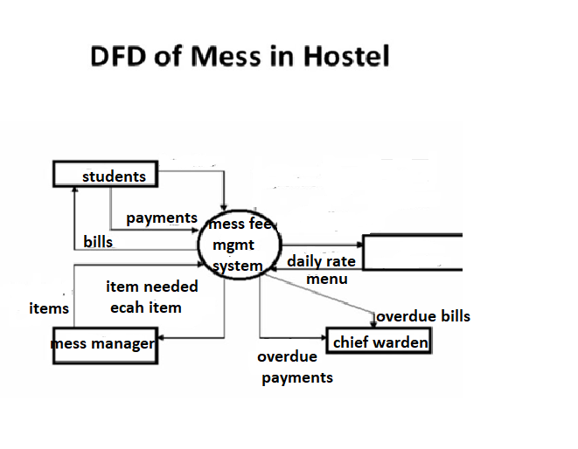

Figure 5.2. Data flow diagram

**5.3 UML DIAGRAMS**

**Unified Modeling Language**:

The Unified Modeling Language allows the software engineer to express an analysis model using the modeling notation that is governed by a set of syntactic semantic and pragmatic rules.

A UML system is represented using five different views that describe the system from distinctly different perspective. Each view is defined by a set of diagram, which is as follows.

* + User Model View
    1. This view represents the system from the users perspective.
    2. The analysis representation describes a usage scenario from the end-users perspective.
  + Structural model view
    1. In this model the data and functionality are arrived from inside the system.
    2. This model view models the static structures.
* 4Behavioral Model View

It represents the dynamic of behavioral as parts of the system, depicting the interactions of collection between various structural elements described in the user model and structural model view.

* Implementation Model View

In this the structural and behavioral as parts of the system are represented as they are to be built.

* Environmental Model View

In this the structural and behavioral aspects of the environment in which the system is to be implemented are represented.

UML is specifically constructed through two different domains they are:

* UML Analysis modeling, this focuses on the user model and structural model views of the system.
* UML design modeling, which focuses on the behavioral modeling, implementation modeling and environmental model views.

Use case Diagrams represent the functionality of the system from a user’s point of view. Use cases are used during requirements elicitation and analysis to represent the functionality of the system. Use cases focus on the behavior of the system from external point of view.

Actors are external entities that interact with the system. Examples of actors include users like administrator, bank customer …etc., or another system like central database.

**UML DIAGRAMS**

**Use case Diagram of hostel fees manegment:-**

Admin

Student details

Student fees details

Student list (new)

Figure 5.3.1. Use Diagram of administrator

**Use case Diagram of Student:**

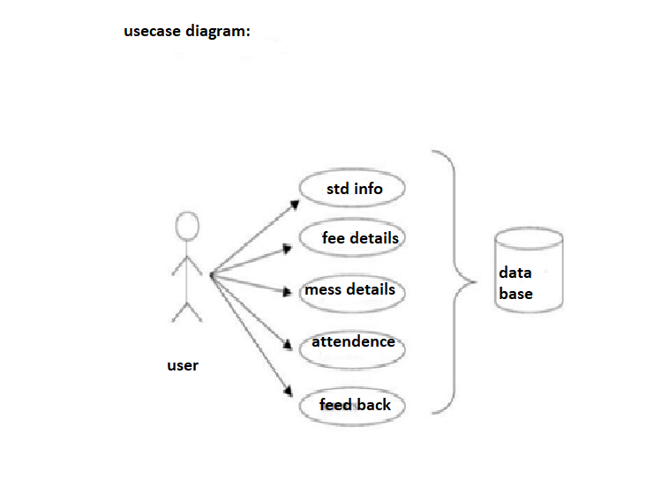

Figure 5.3.2. Use Diagram of user

Sequence diagram of admin:

result

admin

Login

Bill entry

Reports

login details

verify

Bill upload

Upload succesful

Check result

Verfy result

Request for Reports

Reports Generated

**Figure 5.3.3. Sequence Diagram for admin**

Sequence diagram for student:

‑

:student

login

registrationt

View details

Reports

Logout

login Details

verify

login Succed

Request registration

sRegistration successful

Request for Updation

Update successfull

Requsting for Reports

Generate reports

Reques for Logout

Logout Success

**Figure 5.3.4. Sequence Diagram of student**

**Class diagram:**

Student Reg

Admn no

Name

Course

Dob

Department

Email id

Mobile

Password

address

Entry

Name

Adm no

Month

Days

Leave days

Non_veg

Scholarship

Paid

ADMIN

Name

Password

Total bill

Name

Admn no

C_paid

Scholarship

Total bill

Due balance

Student list

Admno

Name

Course

**Figure 5.3.5 Class Diagram**

**5.5. NORMALIZATION**

A Database is a collection of interrelated data stored with a minimum of redundancy to serve many applications. The database design is used to group data into a number of tables and minimizes the artificiality embedded in using separate files. The tables are organized to:

* Reduced duplication of data.
* Simplify functions like adding, deleting, modifying data etc..,
* Retrieving data
* Clarity and ease of use
* More information at low cost

# Normalization

Normalization is built around the concept of normal forms. A relation is said to be in a particular normal form if it satisfies a certain specified set of constraints on the kind of functional dependencies that could be associated with the relation. The normal forms are used to ensure that various types of anomalies and inconsistencies are not introduced into the database.

**First Normal Form:**

A relation R is in first normal form if and only if all underlying domains contained atomic values only.

**Second Normal Form:**

A relation R is said to be in second normal form if and only if it is in first normal form and every non-key attribute is fully dependent on the primary key.

**Third Normal Form:**

A relation R is said to be in third normal form if and only if it is in second normal form and every non key attribute is non transitively depend on the primary key.

**5.6. DATA DICTI0NARY**

1. ADMIN TABLE

|  |  |  |
| --- | --- | --- |
| ATTRIBUTE | DATATYPE | CONSTRAINT |
| NAME | VARCHAR2(20) |  |
| PASSWORD | VARCHAR2(20) |  |

2. STUDENT TABLE

|  |  |  |
| --- | --- | --- |
| ATTRIBUTE | DATATYPE | CONSTRAINT |
| ADMN NO | NUMBER(10) | NOT NULL |
| NAME | VARCHAR2(20) |  |
| COURSE | VARCHAR2(20) |  |
| HOSTEL | VARCHAR2(20) |  |
| GENDER | VARCHAR2(20) |  |
| MOBILE | VARCHAR2(20) |  |
| DEPT | VARCHAR2(20) |  |
| EMAIL | VARCHAR2(20) |  |
| PASSWORD | VARCHAR2(20) |  |

3. ENTRY TABLE:

|  |  |  |
| --- | --- | --- |
| ATTRIBUTE | DATATYPE | CONSTRAINT |
| ADMIN NO | NUMBER | NOT NU LL |
| NAME | VARCHAR2(20) |  |
| COURSE | VARCHAR2(20) |  |
| MONTH | VARCHAR2(20) |  |
| DAYS | NUMBER(10) |  |
| NON VEG | NUMBER(10) |  |
| LEAVE DAYS | NUMBER(10) |  |
| SCHOLARSHIP | NUMBER(8,2) |  |
| PAID | NUMBER(8,2) |  |

|  |  |  |
| --- | --- | --- |
| ATTRIBUTE | DATA TYPE | CONSTRAINT |
| ADMIN_NO | NUMBER(10) | NOTNULL |
| NAME | VARCHAR2(20) |  |
| C_PAID | NUMBER(8,2) |  |
| SCHOLARSHIP | NUMBER(8,2) |  |
| TOTAL | NUMBER(8,2) |  |
| REMAIN | NUMBER(8,2) |  |

4. TOTAL BILL

5. STUDENT LIST (NEW)

|  |  |  |
| --- | --- | --- |
| ATTRIBUTE | DATATYPE | CONSTRAINT |
| NAME | VARCHAR2(20) |  |
| ADMN NO | NUMBER(10) | NOT NULL |
| COURSE | VARCHAR2(20) |  |

**CHAPTER-6**

**SYSTEM TESTING**

**6.1 INTRODUCTION TO TESTING**

**Introduction to Testing:**

Testing is a process, which reveals errors in the program. It is the major quality measure employed during software development. During software development. During testing, the program is executed with a set of test cases and the output of the program for the test cases is evaluated to determine if the program is performing as it is expected to perform.

**6.2 TESTING IN STRATEGIES**

In order to make sure that the system does not have errors, the different levels of testing strategies that are applied at differing phases of software development are:

**Unit Testing:**

Unit Testing is done on individual modules as they are completed and become executable. It is confined only to the designer's requirements.

**Each module can be tested using the following two Strategies:**

**Black Box Testing:**

In this strategy some test cases are generated as input conditions that fully execute all functional requirements for the program. This testing has been uses to find errors in the following categories:

* Incorrect or missing functions
* Interface errors
* Errors in data structure or external database access
* Performance errors
* Initialization and termination errors.

In this testing only the output is checked for correctness. The logical flow of the data is not checked.

**White Box testing:**

In this the test cases are generated on the logic of each module by drawing flow graphs of that module and logical decisions are tested on all the cases. It has been uses to generate the test cases in the following cases:

* Guarantee that all independent paths have been Executed.
* Execute all logical decisions on their true and false Sides.
* Execute all loops at their boundaries and within their operational bounds
* Execute internal data structures to ensure their validity.

**Integrating Testing :**

Integration testing ensures that software and subsystems work together a whole. It tests the interface of all the modules to make sure that the modules behave properly when integrated together.

**System Testing :**

Involves in-house testing of the entire system before delivery to the user. It's aim is to satisfy the user the system meets all requirements of the client's specifications.

**Acceptance Testing :**

It is a pre-delivery testing in which entire system is tested at client's site on real world data to find errors.

#### Test Approach :

**Testing can be done in two ways:**

* Bottom up approach
* Top down approach

**Bottom up Approach:**

Testing can be performed starting from smallest and lowest level modules and proceeding one at a time. For each module in bottom up testing a short program executes the module and provides the needed data so that the module is asked to perform the way it will when embedded with in the larger system. When bottom level modules are tested attention turns to those on the next level that use the lower level ones they are tested individually and then linked with the previously examined lower level modules.

**Top down approach:**

This type of testing starts from upper level modules. Since the detailed activities usually performed in the lower level routines are not provided stubs are written. A stub is a module shell called by upper level module and that when reached properly will return a message to the calling module indicating that proper interaction occurred. No attempt is made to verify the correctness of the lower level module.

**Validation:**

The system has been tested and implemented successfully and thus ensured that all the requirements as listed in the software requirements specification are completely fulfilled. In case of erroneous input corresponding error messages are displayed

**CHAPTER-7**

**OUTPUT SCREENS**

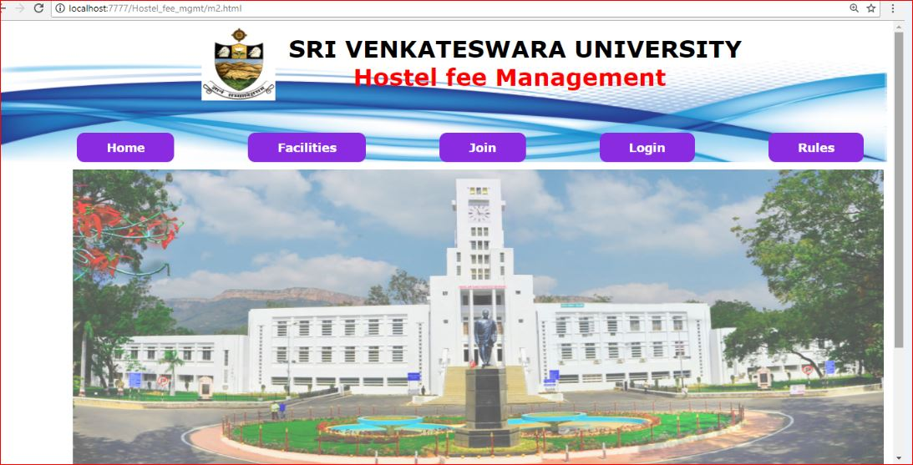

7.1 HOME PAGE OF HOSTEL FEES MANAGEMENT SYSTEM

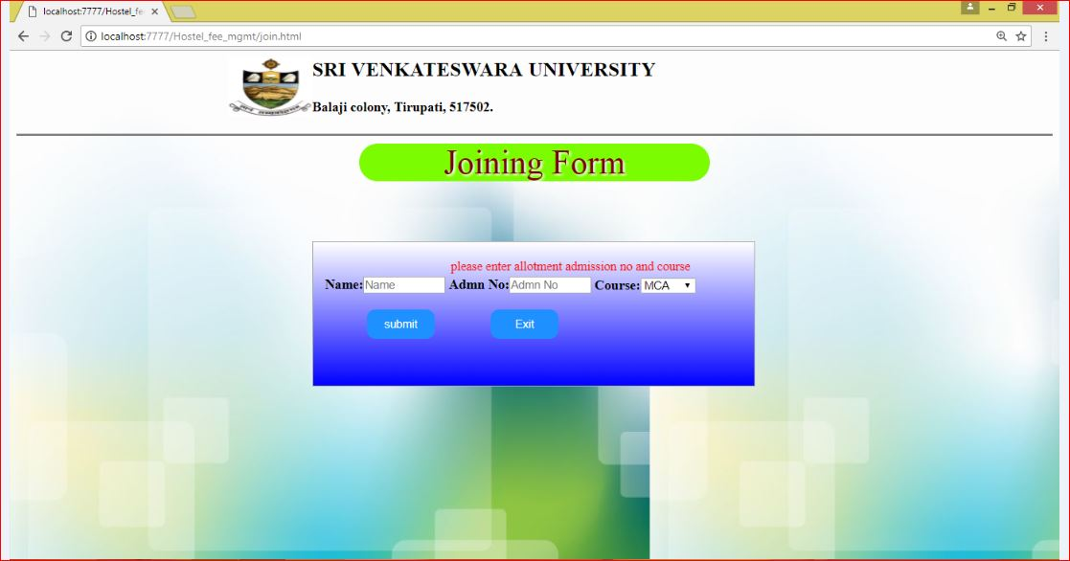

7.2 JOINING FORM OF HOSTEL FEES MANAGEMENT SYSTEM

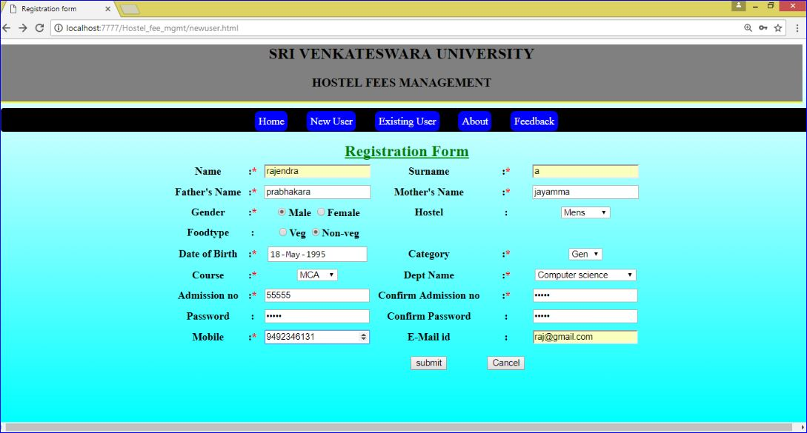

7.3 REGISTRATION FORM OF HOSTEL FEES MANAGEMENT SYSTEM

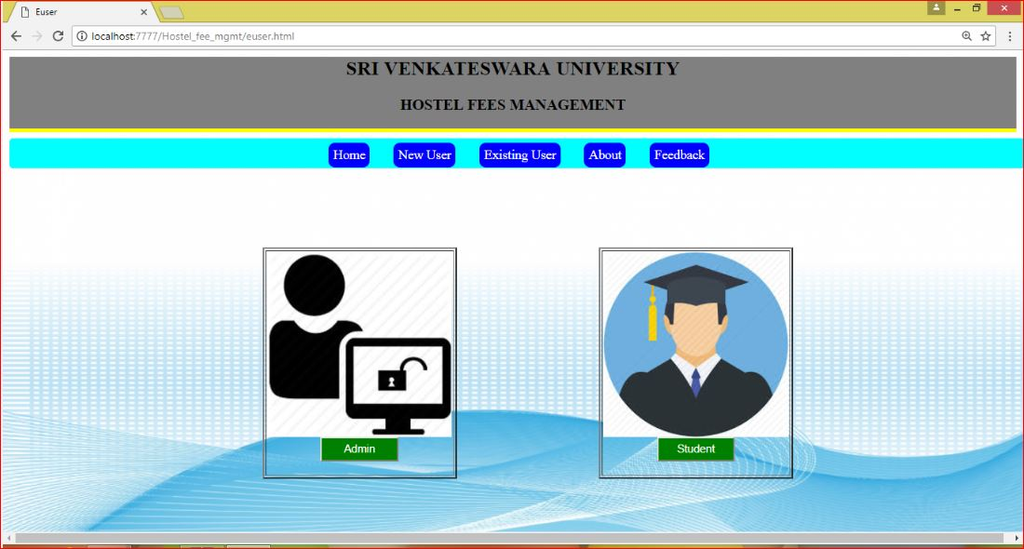

7.4 LOGIN FORM OF HOSTEL FEES MANAGEMENT SYSTEM

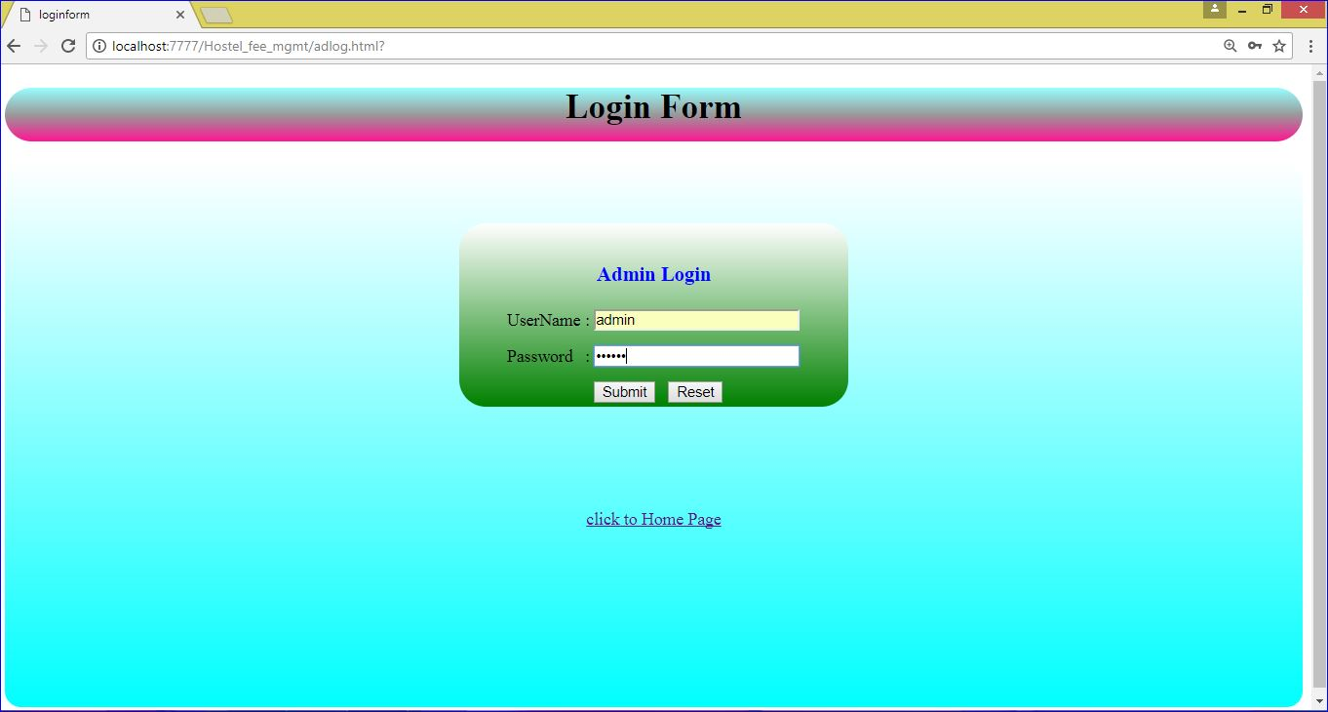

7.5 ADMIN LOGIN OF HOSTEL FEES MANAGEMENT SYSTEM

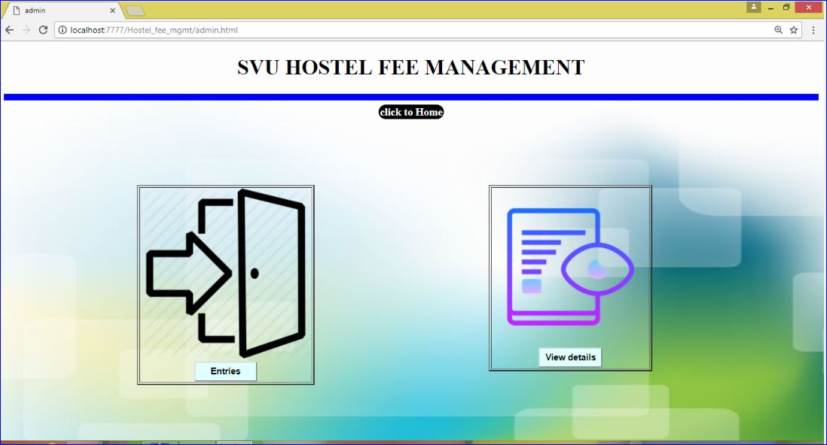

7.6 ADMIN PAGE OF HOSTEL FEES MANAGEMENT SYSTEM

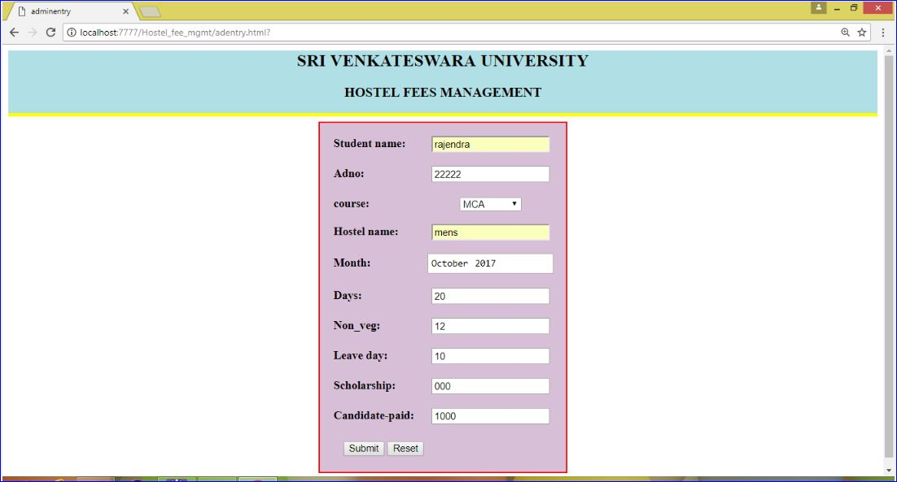

7.7 ENTRY PAGE OF HOSTEL FEES MANAGEMENT SYSTEM

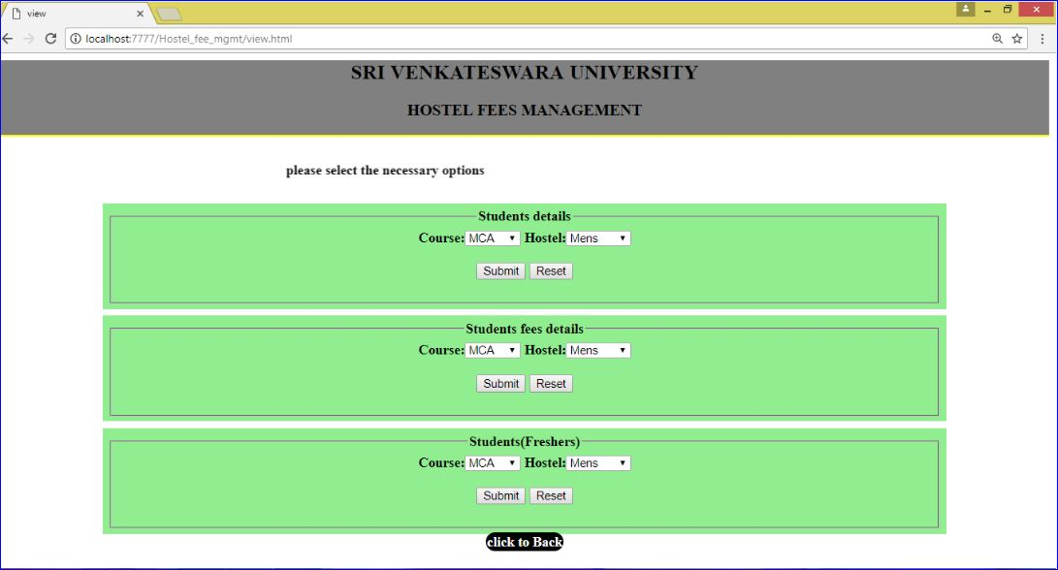

7.8 VIEW PAGE OF HOSTEL FEES MANAGEMENT SYSTEM

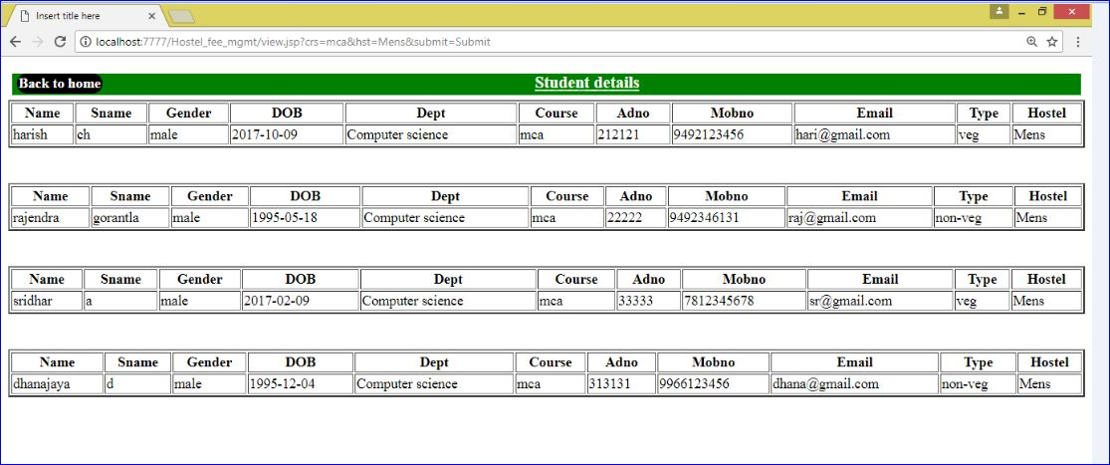

7.9 STUDENT DETAILS OF HOSTEL FEES MANAGEMENT SYSTEM

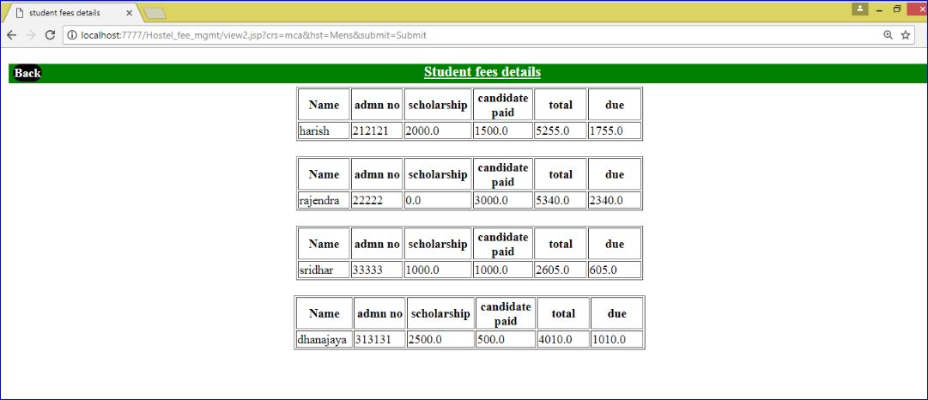

7.10 STUDENT FEES DETAILS OF HOSTEL FEES MANAGEMENT SYSTEM

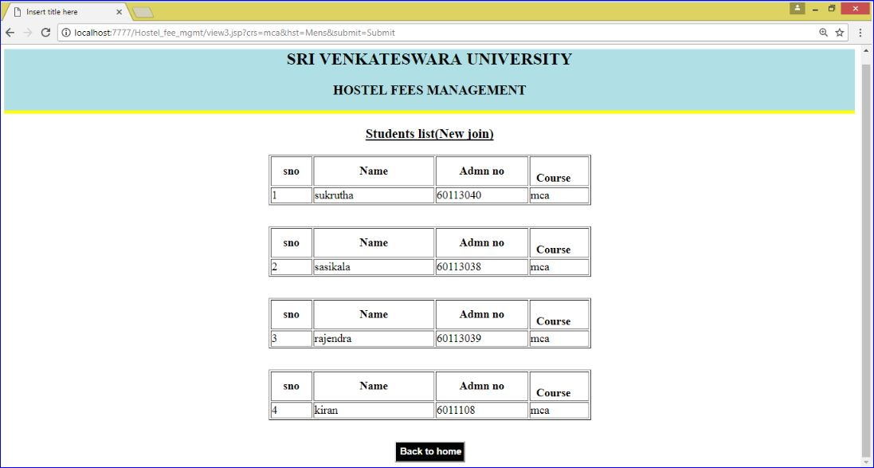

7.11 STUDENT LIST(NEW) OF HOSTEL FEES MANAGEMENT SYSTEM

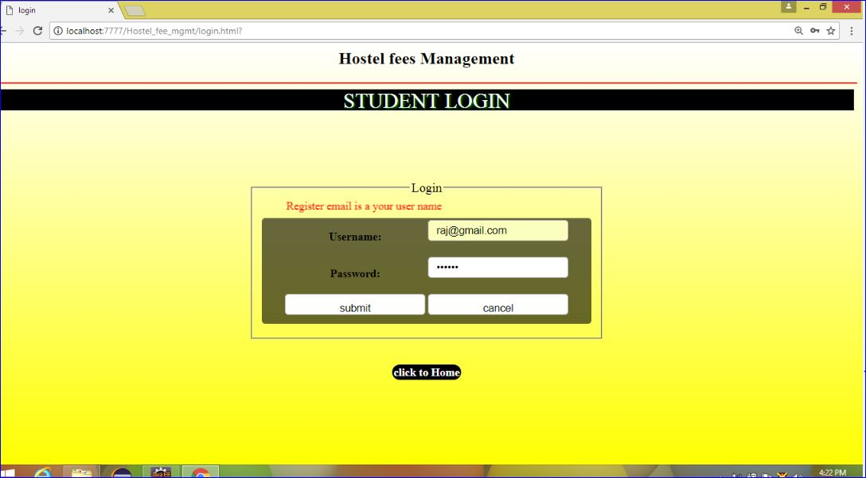

7.12 STUDENT LOGIN OF HOSTEL FEES MANAGEMENT SYSTEM

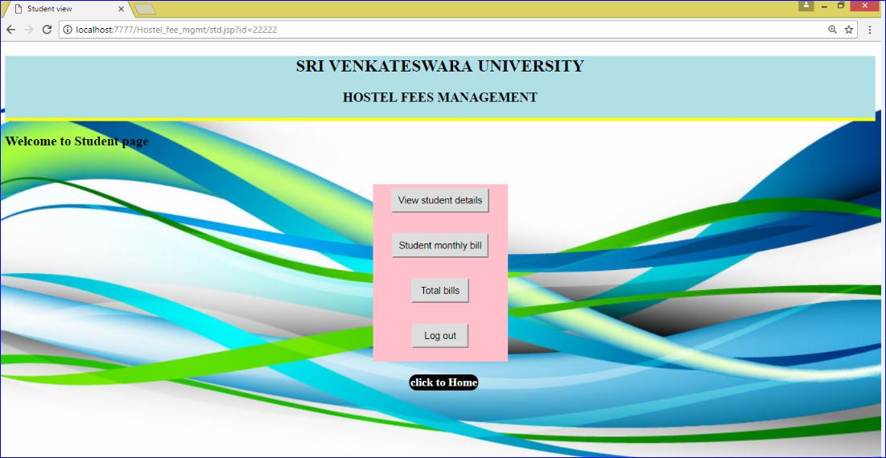

7.13 STUDENT PAGE OF HOSTEL FEES MANAGEMENT SYSTEM

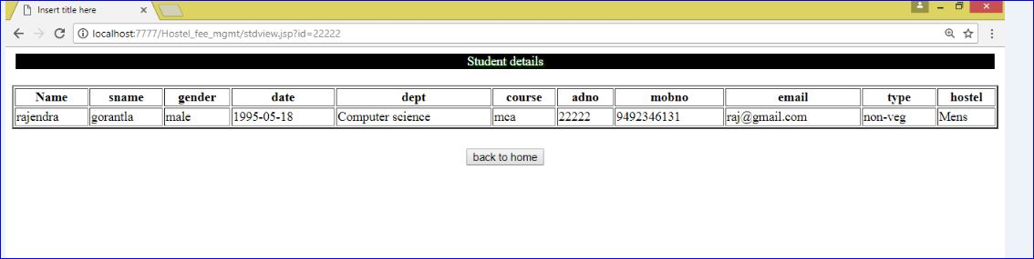

7.14 STUDENT DETAILS OF HOSTEL FEES MANAGEMENT SYSTEM

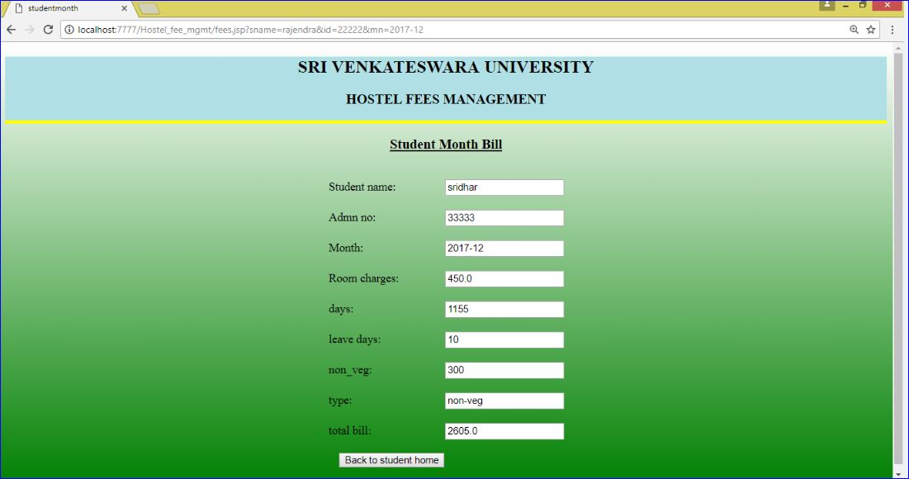

7.15 MONTHLY BILL OF HOSTEL FEES MANAGEMENT SYSTEM

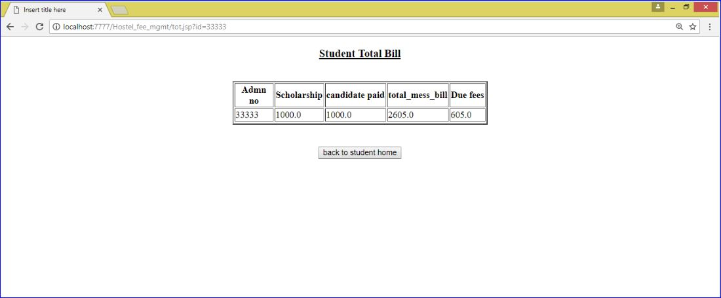

7.16 STUDENT TOTAL BILL OF HOSTEL FEES MANAGEMENT SYSTEM

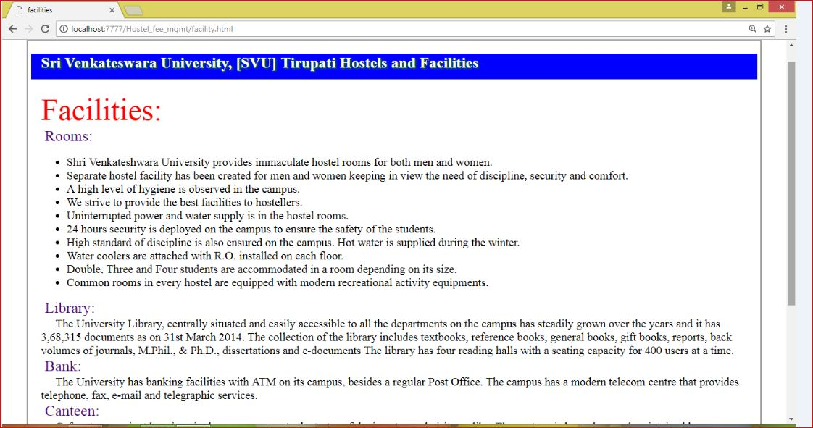

7.17 FACILITIES OF HOSTEL FEES MANAGEMENT SYSTEM

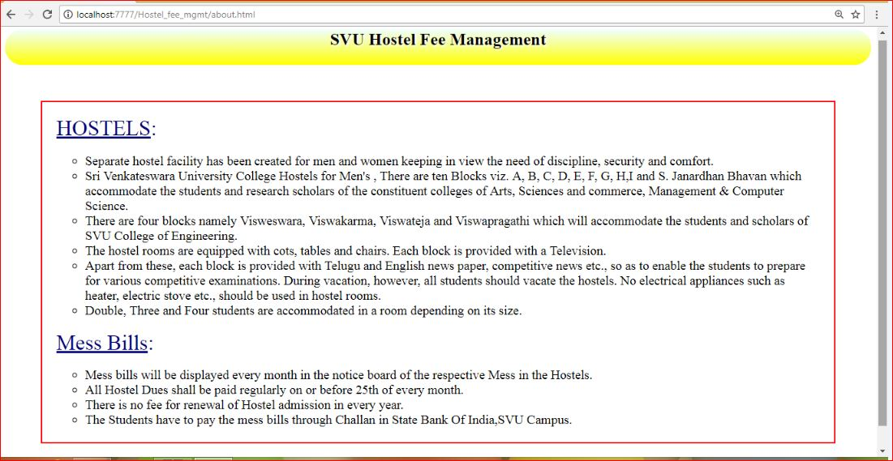

7.18 ABOUT OF HOSTEL FEES MANAGEMENT SYSTEM

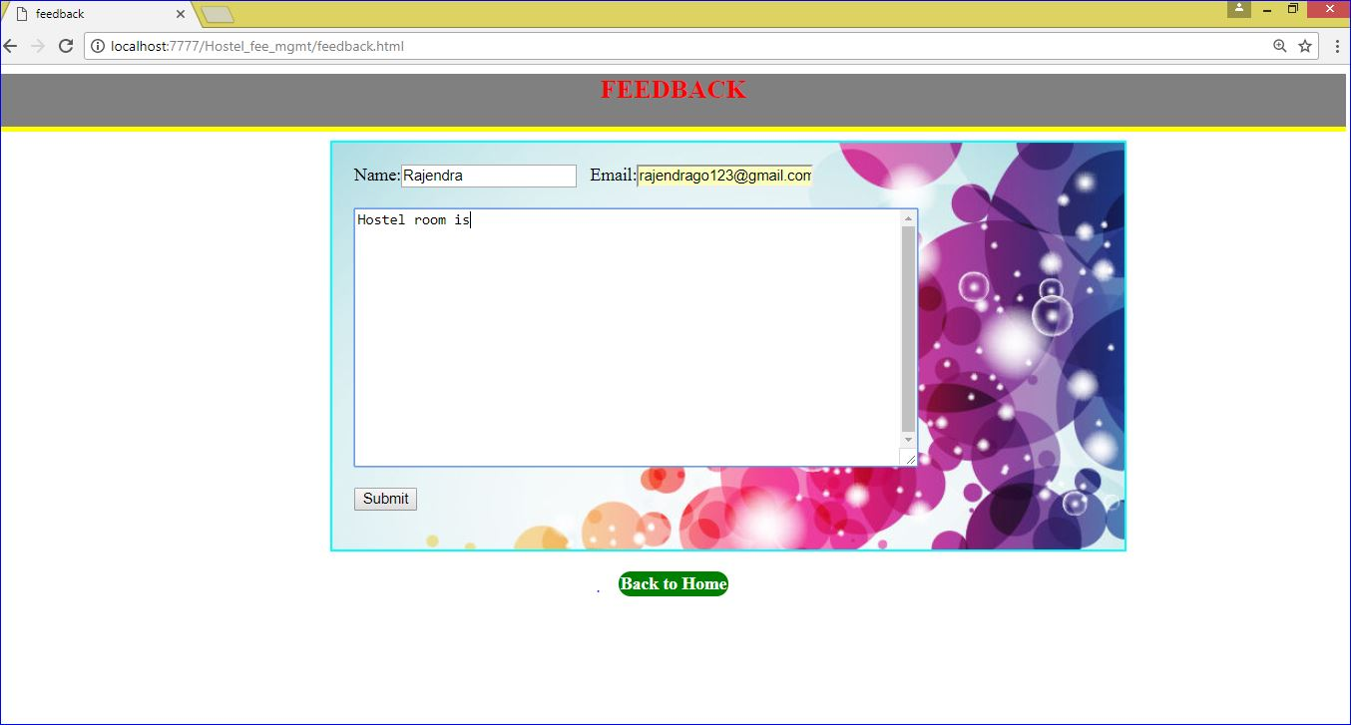

7.19 FEEDBACK OF HOSTEL FEES MANAGEMENT SYSTEM

**CHAPTER-8**

**SYSTEM SECURITY**

**8.1 INTRODUCTION**

System Security:

Setting Up Authentication for Web Applications

Introduction:

To configure authentication for a Web Application, use the <login-config> element of the web.xml deployment descriptor. In this element you define the security realm containing the user credentials, the method of authentication, and the location of resources for authentication.

**8.2 SECURITY IN SOFTWARE**

To set up authentication for Web Applications:

1. Open the web.xml deployment descriptor in a text editor or use the Administration Console. Specify the authentication method using the <auth-method> element. The available options are: **BASIC**
2. Basic authentication uses the Web Browser to display a username/password dialog box. This username and password is authenticated against the realm.
3. **FORM**
4. Form-based authentication requires that you return an HTML form containing the username and password. The fields returned from the form elements must be: j_username and j_password, and the action attribute must be j_security_check. Here is an example of the HTML coding for using FORM authentication:
5. <form method="POST" action="j_security_check">

   <input type="text" name="username">  
   <input type="password" name="password"> </form>

The resource used to generate the HTML form may be an HTML page, a JSP, or a servlet. You define this resource with the <form-login-page> element.

The HTTP session object is created when the login page is served. Therefore, the session.isNew() method returns FALSE when called from pages served after successful authentication.

**CHAPTER-9**

**CONCLUSION**

**CONCLUSION**

* **WORK DONE:**

The **“SVU COLLEGE OF CM &CS STUDENT MANAGEMENT SYSTEM” “ on INTERNERT SYSTEM”** was successfully designed and is tested for accuracy and quality.

During this project we have accomplished all the objectives and this project meets the needs of the organization. The developed will be used in uploading , retrieving and generating information for the concerned requests.

* **GOALS**
  + Reduced entry work.
  + Easy retrieval of information
  + Reduced errors due to human intervention
  + User friendly screens to enter the data
  + Portable and flexible for further enhancement
  + Web enabled.
  + Fast finding of information requested

**Future Enhancements**

It is not possible to develop a system that makes all the requirements of the user. Some of the future enhancements that can be done to this system are:

* As the technology emerges, it is possible to upgrade the system and can be adoptable to desired environment.
* Because it is based on object-oriented design, any further changes can be adaptable easily.
* Based on the future security issues, security can be improved using emerging technologies like single sign-on.
* Develop an android application for this **svu college of cm&cs student management system** and access data and check their information through mobiles.

**BIBLIOGRAPHY**

**9. BIBLIOGRAPHY**

References for the Project Development Were Taken From the following Books and Web Sites.

JAVA Complete Reference By Herbert Shield

Java Script Programming By Yehuda Shiran

J2EE Professional by Shadab Siddiqui

JAVA server pages by Larne Pekowsley

HTML Black Book by Holzner

Java Database Programming with JDBC By Patel Moss

Software Engineering By Roger Pressman

Wikipedia, URL: http://www.wikipedia.org