Requirement / Design Document – MTB Review

Phase 1 Development:
- Designing main page where it fetches all the patient data and puts it as a scrollable table.
- Patients can be searchable using search box.
- Creating New Patient button to add patients to table
Phase 2 Development:
On clicking patient data row( All patient data rows are clickable), it should open a dashboard below the table, and it should have tabs below.
Patient Information, Family History of Cancer, Genetic Counseling, Diagnosis Records, Genetic counseling Genes.
These tabs can be side by side or one after other(like below wireframe screenshot). Patient tab will be open by default when clicking the patient data row. Refer to the screenshot which is the page after clicking on row of patient data.
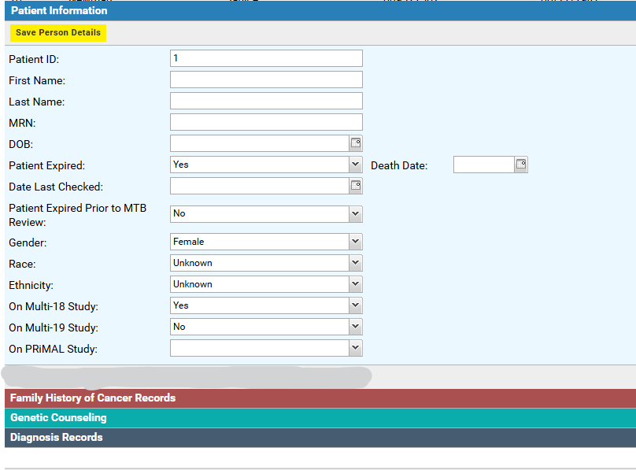

Stage 1: Developing Patient Information Tab:
On Clicking the patient information tab, it displays the details of the patient in text boxes in editable format. It should have a Save button at the end to save the editing and save the data in ‘patientdata’ table.
Fields and Field type in Patient Information Tab:
Patient ID: number – Not Editable
First Name: string
Last Name: string
MRN: number
DOB: date
Patient Expired: Yes/No – dropdown
Death Date : date
Date Last Checked: date
Patient Expired Prior to MTB Review: Yes/No dropdown
Gender: Male, Female, Transgendered female to male, Transgendered male to female - dropdown
Race: White, Black or African American, American Indian or Alaska Native, Asian, Native Hawaiian or Other Pacific Islander, Spanish American, Middle Eastern, Biracial, Unknown, NA, Refuse - dropdown
Ethnicity: Unknown, Hispanic or Latino, Non-Hispanic – dropdown
On Multi-18 Study: Yes/No – dropdown
On Multi-19 Study : Yes/No – dropdown
On PriMal Study: Yes/No – dropdown
Wireframe:
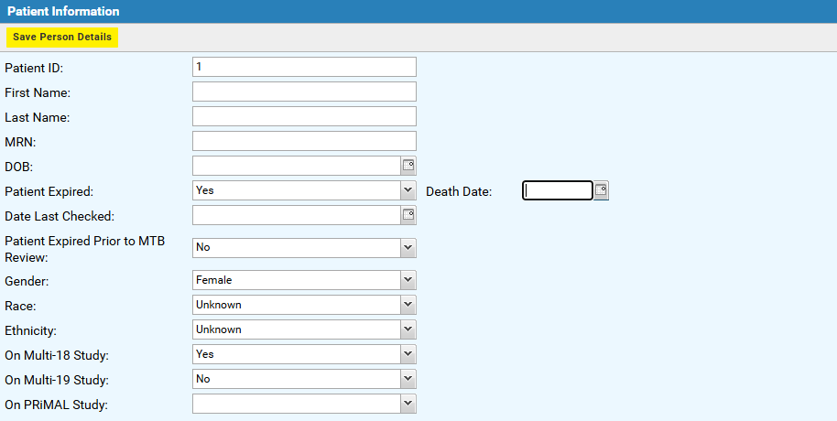

Stage 2: Developing Family History of Cancer Tab:
On clicking Family History tab, it should display family history of the patient from table ‘familyhistorydata’. This table should display the columns Relation, Other Relation, Family Side, Site, Histology.
Wireframe:
This tab should contain below two buttons
- New Family History : On click it should open a form to enter family history. It should have a save button below to save data to table ‘familyhistorydata’. This form should contain the fields below.

Relation: Mother, Father, Son, Daughter, Sister, Brother, Grandmother, Grandfather, Aunt, Uncle, Cousin, Niece, Nephew, Half-Sibling, Unspecified, Other – dropdown
Specify Other(if applicable): string
Family Side(if applicable): Maternal, Paternal – dropdown
Site:
Histology:

Wireframe:
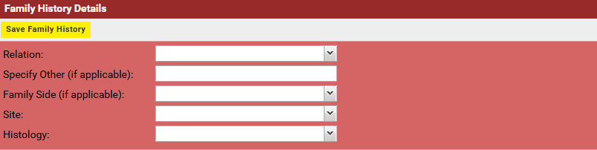

- Delete Family History: This is a button, on click it should delete the family history records associated with patient from the table ‘familyhistorydata’.

Stage 3: Developing Genetic Counseling Tab:
On clicking Genetic Counseling tab, it should display Genetic Counseling of the patient from the table ‘geneticcounselingdata’. The table should display the columns Referral Date, Seen Date, Testing Ordered, Germline Results and Reason No Germline Testing.
Wireframe:
In this tab there are two buttons
- New Genetic Counseling Record: This button is to add new genetic counseling record to the patient. On click it should open a form which takes the input and saves the data to ‘geneticcounselingdata’ table. This form contains the below fields

Referral Date: date
Seen Date: date
Testing Ordered: String
Germline Results: Positive, Negative, VUS – dropdown
Reason for no germline testing: string

Wireframe:
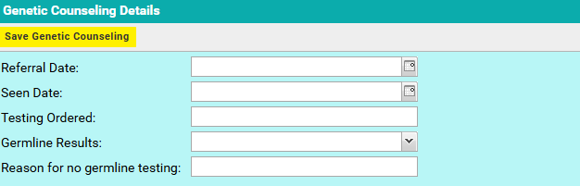

- Delete Genetic Counseling: This is a button, on click it should delete the genetic counseling records associated with patient from the table ‘geneticcounselingdata’.

Stage 4: Developing Genetic Counseling Genes Tab:
On clicking Genetic Counseling Genes tab, it should display Genetic Counseling Genes of the patient from the table ‘geneticcounselinggenedata’. The table should display the columns Gene and Mutation.
Wireframe:
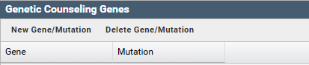
- New Gene/mutation: This button is to add new genetic counseling genes record to the patient. On click it should open a form which takes the input and saves the data to ‘geneticcounselinggenedata’ table. This form contains the below fields

Gene:
Mutation:

- Delete Gene/Mutation: This is a button, on click it should delete the genetic counseling gene records associated with patient from the table ‘geneticcounselinggenedata’.

Stage 5: Developing Diagnosis Records Tab:
On clicking Diagnosis Records tab, it should display the diagnosis records of the patients by fetching them from the table ‘diagnosisdata’. The table should display these columns from the table – Site, Histology, Stage, Recurrence Date, Diagnosis Date, Age at Diagnosis.
Wireframe:
In this tab there are two buttons
- New Diagnosis: This button is to add new diagnosis to the patient. On clicking this button, it should open up a form which takes the diagnosis details as input and save it to ‘diagnosisdata’ table using Save button. The form contains the input fields below.

Site
Histology
Stage
Diagnosis Date
Year Only
Diagnosis Year
Age at Diagnosis

Wireframe:
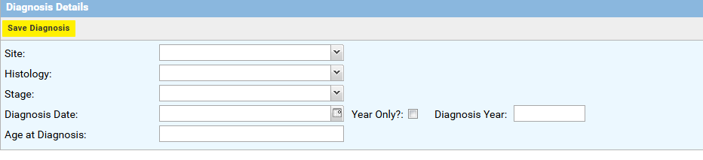

- Delete Diagnosis: This is a button, on click it should delete the diagnosis details records associated with patient from the table ‘diagnosisdata’.

Phase 3 Development:
Stage 1: Diagnosis Details Dashboard
On clicking the row of diagnosis record data table, it should open up a dashboard below which has two tabs one after the other.
- Diagnosis Details tab: In this tab an editable form should be open with the details of the row clicked with save button. On save it should save the values to table ‘diagnosisdata’

Wireframe:

- MTB Reviews: In this tab, it should display the data records from the ‘mtbreviewdata’ table. This table should contain the columns like Batch, Submitting Physician, Submitting Facility, Case Type, Submission Date, Reviewed by MTB, Review Type, Review Date, Case Number, Current Therapy.

Wireframe:
In this tab there are two buttons
1. New MTB Review: This button is to add new MTB review to the diagnosis record. On clicking this button, it should open up a form which takes the MTB Review details as input and save it to ‘mtbreviewdata’ table using Save button. The form contains the input fields below.
Batch
Submitting Physician : string (Drop Down with list of values )
Submitting Facility : string (Drop Down with List of Values)
Case Type :string (Drop Down – Adult, Pediatric)
Submission Date : Date
Reviewed by MTB: string (Drop Down – Yes, No)
Review Type: string ( Drop Down – MTB Meeting, Administrative)
Review Date: date
Case Number: number
Current Therapy: string
Age at MTB Review: number
Therapy Outcomes: string (Drop Down – list of values)

Wireframe:
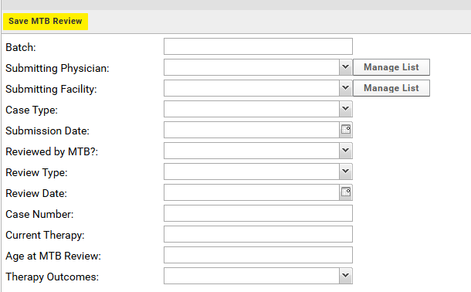

2. Delete MTB Review: This is a button, on click it should delete the MTB review record from the table ‘mtbreviewdata’.

Stage 2: MTB Review Dashboard( Nested inside Diagnosis Details Dashboard)
This is a nested dashboard in diagnosis details dashboard. On clicking the data record of MTB Review it should show up a dashboard with three tabs.
Tab1: MTB Review Details: In this tab, an editable form should be opened with the values of the clicked MTB Reviews data record of the table ‘mtbreviewdata’. There is a save button, which saves the record to table.
Note: Use the same form used for New MTB Review.
Tab 2: MTB Review Test Types: In this tab, it should display the data records from ‘mtbreviewtesttypes’ table associated with the MTB Review Data record selected. It should contain columns like Test Type, Report Date, Collection Date, Specimen Type.
Wireframe:
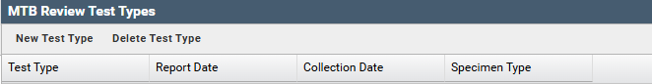

In this tab, on selecting the data record, it should open up an editale form with the values populated of the selected data record. Upon save it should save the values in the table.
In this tab there are two buttons
- New Test Type: This form is to add new test type to the table ‘mtbreviewtesttypes’ . On click opens a form with the following fields and saves the data to the table on clicking save button.

Genomic Test Type: string (Drop down with values)
Other Genomic Test Type: String
Report Date: Date
Collection Date: Date
Specimen Type: string (Drop Down – Blood, Tissue)

Wireframe:
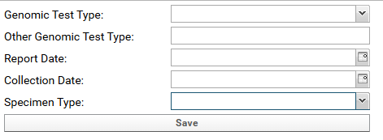
- Delete Test Type: This button will delete the selected MTB Review Test Types record from the table ‘mtbreviewtesttypes’
Tab 3: Recommendations: In this tab, it should display the data record from the table ‘recommendationdata’ which is associated with MTB Review record. This table contains the columns like Recommendation Type, Test for Gene, Evidence Level, Targeted Trail, NCT, UK Trail, Recommendation, Function, Other Recommendation, Recommendation Notes.
Wireframe:
In this tab there are two buttons
- New Recommendation: This is to add the new recommendation to the ‘recommendationdata’ table. On click it will open a from with the below fields and upon clicking save button it saves the data to the table.
Recommendation Type: string (Drop Down with values)
Evidence Leve: string (Drop Down with values)
Recommendation Timepoint: string (Drop Down with values)
Germline Recommendation Reason: string (Drop Down with values)
Test for Gene: string (Drop Down – Yes, No)
Targeted Trail: string (Drop Down – Yes, No)
NCT : string
UK Trail: string (Drop Down – Yes, No)
Recommendation : string
Function: string
Other Recommendation: string
Recommendation Notes: string

Wireframe:
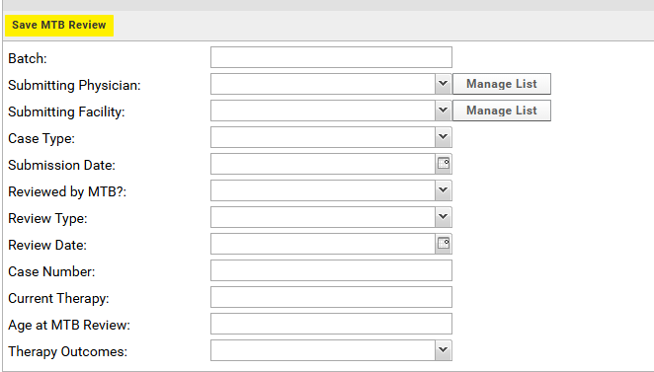
- Delete Recommendation: Onclick deletes the data record from the ‘recommendationdata’ table

Note: Onclicking the data record of the recommendation table, it should display the dashboard with two tabs. This will be developed in next stage

Stage 3: Recommendations Dashboard (Nested inside MTB Reviews Dashboard)
In this stage, on clicking the data record of recommendations table from ‘recommendationsdata’ it should display the recommendation dashboard with two tabs side by side open at the same time(no switching).
Tab1 RecommendationForm:
It should contain an editable form with the values of the record selected. Should be able to edit the values and save them to the table ‘recomendationdata’. For this use the same form that is used for New Recommendation.
Tab 2 Recommendation Genes:
This tab should display the data records form the table ‘recommendationgenedata’ associated with the selected record of ‘recommendationdata’. table. This table should contains columns like Gene, Mutation and Biomarker Score.
Wireframe:
In this tab, on selecting the data record, it should open up an editale form with the values populated of the selected data record. Upon save it should reflect the vales in the table.
In this tab there are two buttons,
- New Gene/Mutation: This button is to add the new gene associated with recommendations to the table ‘ recommendationgenedata’. On clicking the button it should open up a form with the below fields. On save it should save the record to the ‘recommendationgenedata’ table.

Gene:
Mutation Name:
Biomarker Score:
- Delete Gene/Mutation: on click it should delete the selected data record from the ‘recommendationgenedata’ table.

Modifications:
All tables/grids
- Allow column sorting
All Forms
- Use a column layout, like what you have implemented with Patient Information. If possible you can use 2 columns of fields? Might need to reduce the spacing between field label and field. This will mostly help reduce the vertical length of the app.

Patient Dashboard

I remember discussing the Horizontal Tabs and I think these work. The only tricky thing is when you navigate off the Patient Information tab, it’s easy to lose track of which patient you’re working on. This is more apparent when working on a smaller screen. Of course we’re able to scroll around the patient list until we are able to see the selected record, but it’s a bit inefficient.

One solution would be to add the patient name (Last, First) - MRN - DOB under the form title of Patient Dashboard. This text object would of course also need to update whenever the Patient Information form is saved.

Family History
- can’t save records
- when adding records and adding a site, no sites appear

Genetic Counseling
- Can’t save genetic counseling records

Diagnosis Records

No button to add a new diagnosis record
Can’t update existing records

The Diagnosis Details title appears to be in wrong place
Recommendation
If I select a reported gene on a recommendation, then select a different recommendation, the gene form stays there with the information from the previously selected recommendation. basically whenever a new recommendation is selected the recommendation gene form needs to clear and hide. might need to check if the data has been edited.
Maybe put the form for editing the info on the recommendation under the recommendation gene list, so things are moving/shifting around a bunch.
Look at patient 319, they have a lot of recommendations on their MTB review

