IoT Aeroponics

N.M.Sai Krishna1, R.Priyakanth2, B.Sathwika3, D.Bhashitha4 , A.Sonika5 , M.Jaya Keerthana6

*1,2,3Department of Electronics and Communication Engineering*

*BVRIT Hyderabad College of Engineering for Women, Hyderabad, Telangana, India*

1saikrishnakumar.n@bvrithyderabad.edu.in

2priyakanth.r@bvrithyderabad.edu.in

321wh1a0472@bvrithyderabad.edu.in

421wh1a0474@bvrithyderabad.edu.in

521wh1a04b0@bvrithyderabad.edu.in

621wh1a04c7@bvrithyderabad.edu.in

Abstract— Aeroponics agriculture is an efficient method of growing crops without soil by delivering nutrients directly to plant roots in the form of a solution. To enhance its accuracy and effectiveness, the system integrates Internet of Things (IoT) sensors that monitor key environmental factors such as temperature, humidity, CO₂ concentration, pH, and nutrient levels in real time. The collected data is sent to a centralized processing system, where it is analyzed to ensure optimal growing conditions, and based on these monitored parameters, the system automatically dispenses the required nutrient solution to maintain an ideal environment for plant development. The user interface enables farmers to access real-time data, receive practical recommendations, and be alerted to any deviations from optimal conditions, allowing informed decision-making and automatic adjustments to controls for stable and effective crop growth. With continuous monitoring, real-time insights, and automation, this IoT-enabled aeroponics system significantly enhances resource efficiency, productivity, and sustainability in modern agriculture.

Keywords—**Soil Health, Macro Nutrients, IoT, Automation, Real-time data**

1. **Introduction**

The increasing demand for sustainable and efficient agricultural practices has driven innovation in soilless cultivation techniques, among which **aeroponics** becoming a highly promising method. Aeroponics involves growing plants in an air or mist environment without the use of soil or an aggregate medium [1-4]. By delivering a nutrient-rich mist directly to the plant roots, this technique promotes faster growth, better nutrient absorption, and significant water savings compared to traditional farming.

However, maintaining optimal conditions in an aeroponic system is complex and requires constant monitoring of environmental parameters such as **temperature, humidity, carbon dioxide (CO₂) levels, pH,** and **nutrient concentration**. Any fluctuation can impact plant health and yield. To address this challenge, the integration of the **Internet of Things (IoT)** has emerged as a transformative solution [4-8].

IoT-based aeroponics systems utilize a network of sensors to continuously collect real-time data from the environment and root zone. These sensors are used to monitor data and to identify anomalies, and provide better information. This not only enhances the precision of environmental control but also enables to forecasting of crop performance and optimizes resource utilization.

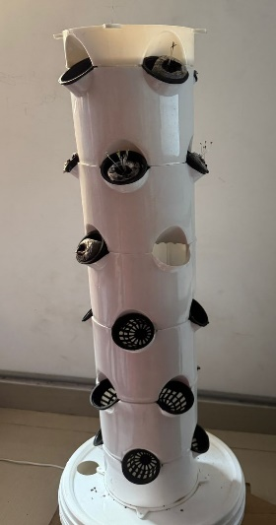

Fig 1. Aeroponics system

In addition, a **user-friendly interface** ensures that farmers and system operators can easily interpret the data, receive alerts, and make informed decisions or trigger automated responses. This integration of **sensor technology, data analytics, and user interaction** transforms aeroponics into a smart, data-driven agricultural solution, improving both productivity and sustainability.

This paper explores the core components of such a system, including sensor integration, data processing, decision-making mechanisms, and the role of predictive analytics in improving crop yield and operational efficiency.

**II. Literature Survey**

The convergence of Internet of Things (IoT) technology and precision agriculture has been the subject of extensive research in recent years. In particular, the application of IoT in **aeroponics farming systems** has shown significant potential for enhancing food production efficiency, reducing resource consumption, and enabling real-time monitoring and control. Several studies have highlighted the impact of IoT on traditional and modern agricultural systems. According to Zhang et al. (2017), IoT enables the collection of granular environmental data, which can be used for decision-making and automation in farming operations. Similarly, Wolfert et al. (2017) discussed how digital agriculture platforms improve productivity through data integration and predictive analytics.  
 Research by Stoner and Clawson emphasized that aeroponics systems use up to 95% less water than conventional soil-based farming and offer faster plant growth rates due to direct nutrient delivery. The absence of soil reduces disease spread and supports cleaner and controlled crop production. The role of **environmental sensors** in modern agriculture is critical. Studies by Kumar et al. (2019) and Mishra et al. (2020) demonstrated how sensors for temperature, humidity, pH, and nutrient levels can continuously monitor and regulate optimal plant growth conditions. These sensors, integrated with microcontrollers and communication modules, allow real-time data collection and remote monitoring. Machine learning and predictive models have been increasingly applied in agriculture to anticipate plant needs and forecast yields. Patel et al. (2021) used historical environmental data and growth patterns to predict optimal nutrient delivery schedules and yield outputs. Their work showed that AI-driven models enhance crop planning and reduce wastage. The effectiveness of IoT systems also depends on their usability. Work by Lee and Park (2018) emphasized the importance of intuitive dashboards and mobile interfaces that allow farmers to receive alerts, visualize trends, and take corrective action. Their study found that well-designed interfaces increased system adoption and decision-making efficiency.

Despite the potential, challenges in IoT-based aeroponics systems include sensor calibration, data accuracy, system scalability, and cost. However, recent advancements in **low-power communication protocols (e.g., LoRa, Zigbee)** and **edge computing** offer promising solutions for scalable and efficient deployment.

**III. Proposed method**

The proposed method integrates Internet of Things (IoT) technology with intelligent automation to optimize crop cultivation in an aeroponics setup. This system is structured into five main components: Data Acquisition, Data Processing & Analysis, Control and Automation, Decision Support & Forecasting, and Anomaly Alert Mechanism. The goal is to achieve precision agriculture by continuously monitoring environmental parameters and dynamically adjusting system operations based on real-time insights. The system continuously monitors water quality parameters (TDS and pH) using sensors connected to an ESP32 microcontroller. It sends real-time data to cloud platforms (ThingSpeak and Blynk) for live monitoring and analysis. When nutrient levels exceed a preset threshold, the system automatically activates a solenoid valve to dispense nutrient solution, maintaining optimal conditions for plant growth. Alerts are also sent via the Blynk app to notify users of any abnormal readings.

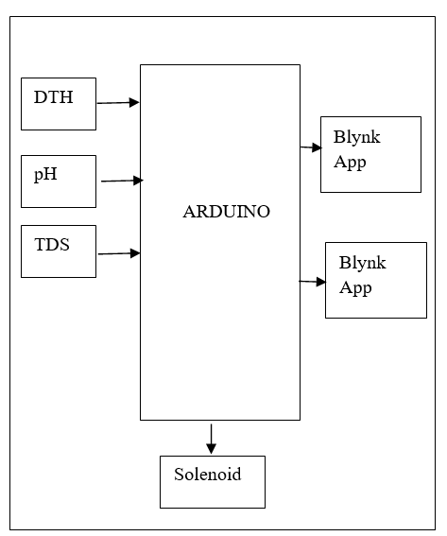

Fig 2. Block Diagram

The ESP32 is an open-source development board powered by a dual-core microcontroller, widely used for hardware automation projects. It features built-in Wi-Fi and Bluetooth capabilities, making it highly versatile for IoT applications and interfacing with various sensors, modules, and external circuits. The board includes multiple digital and analog I/O pins, allowing for flexible integration in numerous projects. Programming is done through the Arduino Integrated Development Environment (IDE) or MicroPython, and communication with a computer is established using a USB interface. Additionally, the ESP32 supports the use of expansion boards and libraries that extend its functionality for tasks such as wireless communication, motor control, and real-time data processing.

1. **Initialization and Wi-Fi Connection**

When the system is powered on, the ESP32 microcontroller first initializes its serial communication to allow data debugging and status messages to be displayed on the serial monitor. It then attempts to connect to the predefined Wi-Fi network using the provided SSID and password credentials. Establishing a stable internet connection is crucial because it enables the device to communicate with cloud platforms such as ThingSpeak and Blynk. Once the ESP32 successfully connects to Wi-Fi, it authenticates with the Blynk IoT platform using the assigned authorization token. This connection allows the system to send sensor data remotely and receive commands or alerts from the user interface.

1. **Sensor Data Collection**

The core function of the system revolves around collecting environmental data relevant to nutrient solution quality. Two sensors—one for measuring Total Dissolved Solids (TDS) and another for pH—are connected to specific analog input pins on the ESP32. These sensors continuously measure electrical signals that correlate with the nutrient concentration and acidity level of the water solution. The ESP32 reads these analog signals as raw digital values through its analog-to-digital converter (ADC). This raw data serves as the foundation for calculating meaningful, real-world measurements such as ppm for TDS and pH units for acidity.

1. **Data Conversion and Calibration**

Raw sensor readings in digital format need to be translated into understandable units. The ESP32 converts the raw ADC values into voltage levels by considering the reference voltage and the ADC resolution. For the TDS sensor, this voltage is further multiplied by a calibration factor, converting it into parts per million (ppm), which indicates the total concentration of dissolved solids in the nutrient solution. Similarly, the pH sensor’s voltage is mapped linearly to the pH scale ranging from 0 (highly acidic) to 14 (highly alkaline). Proper calibration ensures that the sensor outputs accurately reflect the real chemical conditions of the solution, making the data reliable for monitoring and control.

1. **Data Transmission to Cloud and Mobile App**

After converting sensor data into usable values, the system uploads this information to cloud platforms for real-time monitoring and long-term storage. ThingSpeak, a popular IoT analytics platform, receives the TDS and pH readings via HTTP requests and logs them in corresponding fields, allowing users to analyze historical trends and export data if needed. Concurrently, the system sends the same data to the Blynk platform, which provides an interactive mobile or web application interface. Farmers can access this interface remotely to visualize live data, monitor system status, and receive alerts, enabling proactive management of crop nutrient levels.

1. **Automated Nutrient Dispensing Control**

One of the key advantages of the system is its ability to automatically regulate nutrient levels without manual intervention. The program continuously compares the measured TDS value against a predefined threshold (for example, 500 ppm). When the TDS exceeds this cutoff, indicating an overly concentrated nutrient solution, the system activates a solenoid valve via a relay or similar actuator. This valve dispenses additional water or nutrient solution to dilute or balance the concentration appropriately. The pH values are also monitored, and although the current setup mainly triggers alerts for out-of-range pH, the system can be expanded to adjust pH automatically by dispensing pH modifiers, ensuring the solution remains optimal for plant health.

1. **Alert Notification**

To keep farmers informed about the nutrient solution’s condition, the system incorporates an alert mechanism that notifies users when critical thresholds are crossed. If the TDS level is too high or the pH drifts outside the acceptable range (e.g., below 6.5 or above 8.0), the system logs an event in the Blynk platform, triggering notifications via the Blynk app. These instant alerts enable quick responses to prevent potential damage to the crop caused by nutrient imbalance or unsuitable pH levels. Additionally, alerts are printed to the serial monitor for onsite monitoring or troubleshooting during development. The entire process runs inside an infinite loop on the ESP32 microcontroller, continuously performing sensor readings, data processing, transmission, control actions, and alert checks. After each iteration, the system pauses for a short delay to balance responsiveness with power efficiency and network bandwidth usage. This continuous cycle ensures that the nutrient solution conditions are constantly tracked and automatically maintained, enabling a smart, reliable, and efficient nutrient management system for aeroponic farming setups.

**IV.SOFTWARE AND HARDWARE REQUIREMENTS**

To effectively monitor and maintain optimal growing conditions in an aeroponic farming setup, a combination of environmental and solution quality sensors is essential. These sensors continuously collect vital data that enables real-time analysis and automated control of the growing environment. In this system, three key sensors are deployed: the DHT22 for temperature and humidity measurement, the pH sensor to monitor the acidity level of the nutrient solution, and the TDS sensor to track the concentration of dissolved nutrients. Each sensor plays a crucial role in ensuring that plants receive the ideal conditions necessary for healthy growth and high yield

The DHT22 is a digital temperature and humidity sensor commonly used in environmental monitoring. It provides accurate and reliable readings of the surrounding air’s temperature and relative humidity. In the context of aeroponic farming, monitoring these parameters is essential because temperature and humidity directly affect plant transpiration, nutrient absorption, and overall growth.

Fig 3. DHT22 Sensor

The sensor outputs digital signals, making it easy to interface with microcontrollers like the ESP32.

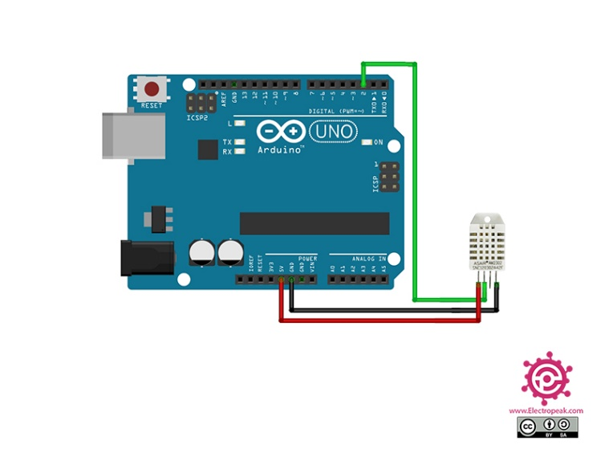

Fig 4. DHT22 Interface

Its high precision and fast response help maintain an optimal growing environment by informing the control system to adjust fans, heaters, or humidifiers if necessary.

The pH sensor measures the acidity or alkalinity level of the nutrient solution used in the aeroponic system. pH is a crucial factor because it influences nutrient availability; certain nutrients become less soluble or unavailable to plants if the pH is too high or too low. The pH sensor typically consists of a glass electrode that produces a voltage proportional to the hydrogen ion concentration in the solution. This voltage is read by the ESP32’s analog input and converted into a pH value. By continuously monitoring the pH, the system can alert the farmer or automatically adjust the solution by adding acid or base to keep the pH within the ideal range for the crops.

Fig 5. pH Sensor

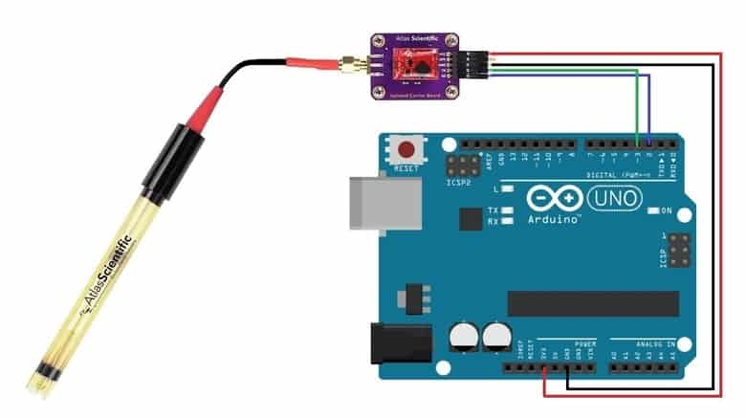

Fig 6. Ph sensor Interface

The Total Dissolved Solids (TDS) sensor used here is to measure the concentration of dissolved substances such as salts, minerals, and nutrients in the water or nutrient solution. This measurement is essential for maintaining the nutrient balance within the aeroponic system. The TDS sensor works by passing an electrical current through the solution and measuring its conductivity; higher conductivity indicates a higher concentration of dissolved solids.

Fig 7. TDS Sensor

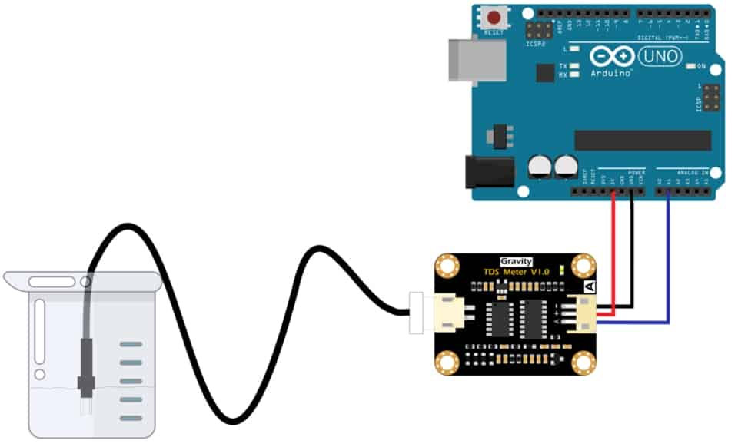

Fig 8. TDS Sensor interface

The sensor outputs an analog voltage that the ESP32 converts to parts per million (ppm), representing the nutrient concentration. If the TDS level rises above a certain threshold, the system can activate solenoid valves to dispense water or nutrient solution, automatically correcting the concentration and ensuring optimal plant growth.

**V. Methodology**

The working methodology of the aeroponic monitoring and automatic nutrient dispensing system begins with the deployment of three key sensors: the DHT22 sensor for measuring ambient temperature and humidity, the pH sensor for assessing the acidity or alkalinity of the nutrient solution, and the TDS sensor to determine the concentration of dissolved solids representing nutrient strength. These sensors are strategically placed within the aeroponic environment and nutrient reservoir to continuously collect real-time data essential for maintaining optimal plant growth conditions. The sensors output analog and digital signals corresponding to their respective physical parameters, which are fed into the ESP32 microcontroller. The microcontroller reads these signals using its ADC (Analog-to-Digital Converter) channels and applies calibration formulas to convert raw voltage values into standardized units—degrees Celsius and relative humidity from the DHT22, pH values scaled between 0 and 14, and TDS levels converted into parts per million (ppm) to reflect nutrient concentration.

Once calibrated, the system compares these sensor readings against predefined thresholds critical for healthy plant development. The pH is monitored to remain between 6.5 and 8.0, ensuring that the nutrient solution is neither too acidic nor too alkaline, which could inhibit nutrient uptake. The TDS sensor threshold is set at 500 ppm; surpassing this value signals an overly concentrated nutrient solution that could harm plant roots. If the TDS reading exceeds this cutoff, the ESP32 automatically activates a solenoid valve connected via a relay module to dispense either fresh water or a nutrient balancing solution, diluting the reservoir to bring the concentration back to the desired level. This automated control loop eliminates the need for manual intervention, improving precision and responsiveness.

Simultaneously, the system establishes Wi-Fi connectivity to transmit all processed sensor data to cloud-based IoT platforms, specifically ThingSpeak and Blynk. The data transmission is performed using HTTP GET requests to ThingSpeak’s API, allowing historical data storage, trend visualization, and further analysis of the environmental and nutrient parameters over time. Meanwhile, the Blynk platform provides a user-friendly mobile interface where live sensor readings are displayed in real-time dashboards, and alerts are pushed instantly if any parameters exceed safe limits. This alert system ensures that farmers are notified immediately of any abnormalities such as a sudden spike in TDS or pH outside the optimal range, enabling prompt corrective action. The entire monitoring, control, and communication cycle is executed in a loop every 10 seconds, striking a balance between timely response and resource efficiency. Through this continuous feedback and control mechanism, the system maintains an ideal aeroponic environment, optimizing plant growth and yield while reducing labor and the risk of human error.

**VI. RESULTS**

The proposed methodology measures the parameters of the soil health like Nitrogen, Phosphorus, and Potassium (macro-nutrients), pH, moisture content, and electrical conductivity and these parameters are mapped to that specific location where the soil sample is collected.

|  |  |  |
| --- | --- | --- |
| **Reading No.** | **TDS (ppm)** | **pH** |
| 1 | 148.28 | 14.00 |
| 2 | 232.49 | 14.00 |
| 3 | 205.90 | 14.00 |
| 4 | 290.92 | 14.00 |
| 5 | 249.41 | 14.00 |
| 6 | 444.84 | 14.00 |
| 7 | 457.33 | 14.00 |

Table 1. TDS, PH readings

The serial monitor displayed real-time readings of TDS and pH values collected by the sensors. The output format followed a pattern such as: “TDS: 148.28 | pH: 14.00” followed by “Data sent to ThingSpeak,” indicating successful data transmission to the cloud. Several readings were captured with TDS values ranging from around 148 to 457 ppm, while the pH consistently showed 14.00. These results confirm that the TDS sensor is functioning correctly, detecting changes in the nutrient solution. This type of monitoring is essential for **aeroponics,** where maintaining optimal nutrient levels and pH is critical for healthy plant growth. The successful data transfer to ThingSpeak further supports remote monitoring and automation in such systems

Fig 9. Sensor values

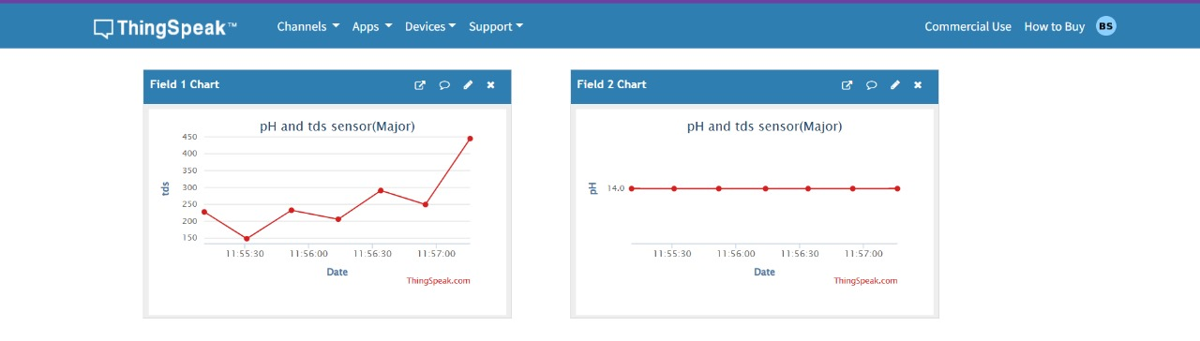

Fig 10. IOT display

The data collected from the sensors was successfully uploaded and visualized on the ThingSpeak platform. The TDS values, shown in the Field 1 chart, varied between approximately 150 ppm and 450 ppm, indicating that the TDS sensor was actively detecting changes in the water's dissolved solids. This fluctuation is important in systems like aeroponics, where nutrient concentration must be monitored closely. In contrast, the pH values displayed in the Field 2 chart remained constant at 14.00 throughout the test. Overall, the system demonstrated the ability to read sensor data and transmit it to the cloud in real time, which is a key requirement for remote monitoring in precision agriculture applications.

**VII.CONCLUSION**

In conclusion, the implementation of an IoT-based monitoring and control system in aeroponic farming marks a significant advancement toward precision agriculture. This system leverages the integration of multiple sensors—measuring critical parameters such as temperature, humidity, pH levels, and nutrient concentration—combined with real-time data processing and cloud connectivity to provide continuous and accurate monitoring of the crop environment. By automating the nutrient solution dispensing based on sensor feedback, particularly using TDS thresholds to regulate solenoid valves, the system ensures that plants receive the optimal balance of nutrients without human intervention, reducing the risk of over- or under-fertilization. The integration with cloud platforms like ThingSpeak and Blynk facilitates live data visualization, historical data logging, and remote monitoring, empowering farmers to make informed decisions backed by actionable insights. Furthermore, the real-time alert mechanisms enhance system reliability and crop safety by enabling immediate responses to any deviations from optimal conditions. This holistic approach not only maximizes crop yield and quality but also optimizes resource usage, minimizes labor, and reduces environmental impact, making aeroponic farming more sustainable and scalable. Overall, the system demonstrates how IoT and automation technologies can transform traditional farming into a smart, efficient, and highly productive practice that addresses the challenges of modern agriculture.

**VIII. REFERENCES**

1. Hati, A.J.; Singh, R.R. Smart Indoor Farms: Leveraging Technological Advancements to Power a Sustainable Agricultural Revolution. *AgriEngineering* 2021, *3*, 728–767. [[Google Scholar](http://scholar.google.com/scholar_lookup?title=Smart+Indoor+Farms:+Leveraging+Technological+Advancements+to+Power+a+Sustainable+Agricultural+Revolution&author=Hati,+A.J.&author=Singh,+R.R.&publication_year=2021&journal=AgriEngineering&volume=3&pages=728%E2%80%93767&doi=10.3390/agriengineering3040047)] [[CrossRef](http://doi.org/10.3390/agriengineering3040047" \t "_blank)]
2. Hassan, S.I.; Alam, M.M.; Illahi, U.; Al Ghamdi, M.A.; Almotiri, S.H.; Su’ud, M.M. A Systematic Review on Monitoring and Advanced Control Strategies in Smart Agriculture. *IEEE Access* 2021, *9*, 32517–32548. [[Google Scholar](http://scholar.google.com/scholar_lookup?title=A+Systematic+Review+on+Monitoring+and+Advanced+Control+Strategies+in+Smart+Agriculture&author=Hassan,+S.I.&author=Alam,+M.M.&author=Illahi,+U.&author=Al+Ghamdi,+M.A.&author=Almotiri,+S.H.&author=Su%E2%80%99ud,+M.M.&publication_year=2021&journal=IEEE+Access&volume=9&pages=32517%E2%80%9332548&doi=10.1109/ACCESS.2021.3057865)] [[CrossRef](http://doi.org/10.1109/ACCESS.2021.3057865" \t "_blank)]
3. Maraveas, C.; Bartzanas, T. Application of Internet of Things (IoT) for Optimized Greenhouse Environments. *AgriEngineering* 2021, *3*, 954–970. [[Google Scholar](http://scholar.google.com/scholar_lookup?title=Application+of+Internet+of+Things+(IoT)+for+Optimized+Greenhouse+Environments&author=Maraveas,+C.&author=Bartzanas,+T.&publication_year=2021&journal=AgriEngineering&volume=3&pages=954%E2%80%93970&doi=10.3390/agriengineering3040060)] [[CrossRef](http://doi.org/10.3390/agriengineering3040060" \t "_blank)]
4. National Agricultural Planning 2017–2030. SAGARPA. Available online: <https://www.gob.mx/cms/uploads/attachment/file/255627/Planeaci_n_Agr_cola_Nacional_2017-2030-_parte_uno.pdf> (accessed on 27 June 2022).
5. Agriculture, INIFAP and Proaces-Conacyt Agree on Technical Collaboration in Favor of the Agricultural Field. Available online: <https://www.gob.mx/agricultura/prensa/convienen-agricultura-inifap-y-proaces-conacyt-colaboracion-tecnica-e-favor-del-campo?idiom=es> (accessed on 27 June 2022).
6. Khan, M.M.; Akram, M.T.; Janke, R.; Qadri, R.W.K.; Al-Sadi, A.M.; Farooque, A.A. Urban Horticulture for Food Secure Cities through and beyond COVID-19. *Sustainability* 2020, *12*, 9592. [[Google Scholar](http://scholar.google.com/scholar_lookup?title=Urban+Horticulture+for+Food+Secure+Cities+through+and+beyond+COVID-19&author=Khan,+M.M.&author=Akram,+M.T.&author=Janke,+R.&author=Qadri,+R.W.K.&author=Al-Sadi,+A.M.&author=Farooque,+A.A.&publication_year=2020&journal=Sustainability&volume=12&pages=9592&doi=10.3390/su12229592)] [[CrossRef](http://doi.org/10.3390/su12229592" \t "_blank)]
7. Wimmerova, L.; Keken, Z.; Solcova, O.; Bartos, L.; Spacilova, M.A. Comparative LCA of Aeroponic, Hydroponic, and Soil Cultivations of Bioactive Substance Producing Plants. *Sustainability* 2022, *14*, 2421. [[Google Scholar](http://scholar.google.com/scholar_lookup?title=Comparative+LCA+of+Aeroponic,+Hydroponic,+and+Soil+Cultivations+of+Bioactive+Substance+Producing+Plants&author=Wimmerova,+L.&author=Keken,+Z.&author=Solcova,+O.&author=Bartos,+L.&author=Spacilova,+M.A.&publication_year=2022&journal=Sustainability&volume=14&pages=2421&doi=10.3390/su14042421)] [[CrossRef](http://doi.org/10.3390/su14042421" \t "_blank)]
8. Lakhiar, I.A.; Gao, J.; Syed, T.N.; Chandio, F.A.; Buttar, N.A. Modern plant cultivation technologies in agriculture under controlled environment: A review on aeroponics. *J. Plant Interact.* 2018, *13*, 338–352. [[Google Scholar](http://scholar.google.com/scholar_lookup?title=Modern+plant+cultivation+technologies+in+agriculture+under+controlled+environment:+A+review+on+aeroponics&author=Lakhiar,+I.A.&author=Gao,+J.&author=Syed,+T.N.&author=Chandio,+F.A.&author=Buttar,+N.A.&publication_year=2018&journal=J.+Plant+Interact.&volume=13&pages=338%E2%80%93352&doi=10.1080/17429145.2018.1472308)] [[CrossRef](http://doi.org/10.1080/17429145.2018.1472308" \t "_blank)]
9. Chen, C.-H.; Jeng, S.-Y.; Lin, C.-J. Fuzzy Logic Controller for Automating Electrical Conductivity and pH in Hydroponic Cultivation. *Appl. Sci.* 2022, *12*, 405. [[Google Scholar](http://scholar.google.com/scholar_lookup?title=Fuzzy+Logic+Controller+for+Automating+Electrical+Conductivity+and+pH+in+Hydroponic+Cultivation&author=Chen,+C.-H.&author=Jeng,+S.-Y.&author=Lin,+C.-J.&publication_year=2022&journal=Appl.+Sci.&volume=12&pages=405&doi=10.3390/app12010405)] [[CrossRef](http://doi.org/10.3390/app12010405" \t "_blank)]
10. Domingues, D.S.; Takahashi, H.W.; Camara, C.A.; Nixdorf, S.L. Automated system developed to control pH and concentration of nutrient solution evaluated in hydroponic lettuce production. *Comput. Electron. Agric.* 2012, *84*, 53–61. [[Google Scholar](http://scholar.google.com/scholar_lookup?title=Automated+system+developed+to+control+pH+and+concentration+of+nutrient+solution+evaluated+in+hydroponic+lettuce+production&author=Domingues,+D.S.&author=Takahashi,+H.W.&author=Camara,+C.A.&author=Nixdorf,+S.L.&publication_year=2012&journal=Comput.+Electron.+Agric.&volume=84&pages=53%E2%80%9361&doi=10.1016/j.compag.2012.02.006)] [[CrossRef](http://doi.org/10.1016/j.compag.2012.02.006" \t "_blank)]
11. Velazquez-Gonzalez, R.S.; Garcia-Garcia, A.L.; Ventura-Zapata, E.; Barceinas-Sanchez, J.D.O.; Sosa-Savedra, J.C. A Review on Hydroponics and the Technologies Associated for Medium- and Small-Scale Operations. *Agriculture* 2022, *12*, 646. [[Google Scholar](http://scholar.google.com/scholar_lookup?title=A+Review+on+Hydroponics+and+the+Technologies+Associated+for+Medium-+and+Small-Scale+Operations&author=Velazquez-Gonzalez,+R.S.&author=Garcia-Garcia,+A.L.&author=Ventura-Zapata,+E.&author=Barceinas-Sanchez,+J.D.O.&author=Sosa-Savedra,+J.C.&publication_year=2022&journal=Agriculture&volume=12&pages=646&doi=10.3390/agriculture12050646)] [[CrossRef](http://doi.org/10.3390/agriculture12050646" \t "_blank)]
12. Li, Q.; Li, X.; Tang, B.; Gu, M. Growth Responses and Root Characteristics of Lettuce Grown in Aeroponics, Hydroponics, and Substrate Culture. *Horticulturae* 2018, *4*, 35. [[Google Scholar](http://scholar.google.com/scholar_lookup?title=Growth+Responses+and+Root+Characteristics+of+Lettuce+Grown+in+Aeroponics,+Hydroponics,+and+Substrate+Culture&author=Li,+Q.&author=Li,+X.&author=Tang,+B.&author=Gu,+M.&publication_year=2018&journal=Horticulturae&volume=4&pages=35&doi=10.3390/horticulturae4040035)] [[CrossRef](http://doi.org/10.3390/horticulturae4040035" \t "_blank)] [[Green Version](https://www.mdpi.com/2311-7524/4/4/35/pdf)]
13. Koukounaras, A. Advanced Greenhouse Horticulture: New Technologies and Cultivation Practices. *Horticulturae* 2021, *7*, 1. [[Google Scholar](http://scholar.google.com/scholar_lookup?title=Advanced+Greenhouse+Horticulture:+New+Technologies+and+Cultivation+Practices&author=Koukounaras,+A.&publication_year=2021&journal=Horticulturae&volume=7&pages=1&doi=10.3390/horticulturae7010001)] [[CrossRef](http://doi.org/10.3390/horticulturae7010001" \t "_blank)]
14. Lucero, L.; Lucero, D.; Ormeno-Mejia, E.; Collaguazo, G. Automated aeroponics vegetable growing system. Case study Lettuce. In Proceedings of the IEEE ANDESCON, Quito, Ecuador, 13–16 October 2020; pp. 1–6. [[Google Scholar](http://scholar.google.com/scholar_lookup?title=Automated+aeroponics+vegetable+growing+system.+Case+study+Lettuce&conference=Proceedings+of+the+IEEE+ANDESCON&author=Lucero,+L.&author=Lucero,+D.&author=Ormeno-Mejia,+E.&author=Collaguazo,+G.&publication_year=2020&pages=1%E2%80%936&doi=10.1109/ANDESCON50619.2020.9272180)] [[CrossRef](http://doi.org/10.1109/ANDESCON50619.2020.9272180" \t "_blank)]
15. Negrete, J. Internet of things in Mexican agriculture; a technology to increase agricultural productivity and reduce rural poverty. *Res. Anal. J.* 2018, *1*, 40–52. [[Google Scholar](http://scholar.google.com/scholar_lookup?title=Internet+of+things+in+Mexican+agriculture;+a+technology+to+increase+agricultural+productivity+and+reduce+rural+poverty&author=Negrete,+J.&publication_year=2018&journal=Res.+Anal.+J.&volume=1&pages=40%E2%80%9352)]
16. Parkash, V.; Singh, S. A review on potential plant-based water stress indicators for vegetable crops. *Sustainability* 2020, *12*, 3945. [[Google Scholar](http://scholar.google.com/scholar_lookup?title=A+review+on+potential+plant-based+water+stress+indicators+for+vegetable+crops&author=Parkash,+V.&author=Singh,+S.&publication_year=2020&journal=Sustainability&volume=12&pages=3945&doi=10.3390/su12103945)] [[CrossRef](http://doi.org/10.3390/su12103945" \t "_blank)]
17. Kumar, N.; Poddar, A.; Shankar, V.; Ojha, C.S.P.; Adeloye, A. Crop water stress index for scheduling irrigation of Indian mustard (Brassica juncea) based on water use efficiency considerations. *J. Agron. Crop Sci.* 2020, *206*, 148–159. [[Google Scholar](http://scholar.google.com/scholar_lookup?title=Crop+water+stress+index+for+scheduling+irrigation+of+Indian+mustard+(Brassica+juncea)+based+on+water+use+efficiency+considerations&author=Kumar,+N.&author=Poddar,+A.&author=Shankar,+V.&author=Ojha,+C.S.P.&author=Adeloye,+A.&publication_year=2020&journal=J.+Agron.+Crop+Sci.&volume=206&pages=148%E2%80%93159&doi=10.1111/jac.12371)] [[CrossRef](http://doi.org/10.1111/jac.12371" \t "_blank)]
18. Gong, X.; Wang, S.; Xu, C.; Zhang, H.; Ge, J. Evaluation of Several Reference Evapotranspiration Models and Determination of Crop Water Requirement for Tomato in a Solar Greenhouse. *HortScience* 2020, *55*, 1–7. [[Google Scholar](http://scholar.google.com/scholar_lookup?title=Evaluation+of+Several+Reference+Evapotranspiration+Models+and+Determination+of+Crop+Water+Requirement+for+Tomato+in+a+Solar+Greenhouse&author=Gong,+X.&author=Wang,+S.&author=Xu,+C.&author=Zhang,+H.&author=Ge,+J.&publication_year=2020&journal=HortScience&volume=55&pages=1%E2%80%937&doi=10.21273/HORTSCI14514-19)] [[CrossRef](http://doi.org/10.21273/HORTSCI14514-19" \t "_blank)] [[Green Version](https://journals.ashs.org/downloadpdf/journals/hortsci/55/2/article-p244.pdf)]
19. Jackson, R.D.; Idso, S.; Reginato, R.; Pinter, P. Canopy Temperature as a Crop Water Stress Indicator. *Water Resour. Res.* 1981, *17*, 1133–1138. [[Google Scholar](http://scholar.google.com/scholar_lookup?title=Canopy+Temperature+as+a+Crop+Water+Stress+Indicator&author=Jackson,+R.D.&author=Idso,+S.&author=Reginato,+R.&author=Pinter,+P.&publication_year=1981&journal=Water+Resour.+Res.&volume=17&pages=1133%E2%80%931138&doi=10.1029/WR017i004p01133)] [[CrossRef](http://doi.org/10.1029/WR017i004p01133" \t "_blank)]
20. Amitrano, C.; Rouphael, Y.; Pannico, A.; De Pascale, S.; De Micco, V. Reducing the Evaporative Demand Improves Photosynthesis and Water Use Efficiency of Indoor Cultivated Lettuce. *Agronomy* 2021, *11*, 1396. [[Google Scholar](http://scholar.google.com/scholar_lookup?title=Reducing+the+Evaporative+Demand+Improves+Photosynthesis+and+Water+Use+Efficiency+of+Indoor+Cultivated+Lettuce&author=Amitrano,+C.&author=Rouphael,+Y.&author=Pannico,+A.&author=De+Pascale,+S.&author=De+Micco,+V.&publication_year=2021&journal=Agronomy&volume=11&pages=1396&doi=10.3390/agronomy11071396)] [[CrossRef](http://doi.org/10.3390/agronomy11071396" \t "_blank)]