# Exercises: Data Formats

Exercise problems for the ["Back-End Technologies Basics"](https://softuni.bg/trainings/4398/back-end-technologies-basics-january-2024) Course @ SoftUni.   
You can check your solutions in [Judge](https://judge.softuni.org/Contests/4628/JS-Basics-Exercises).

## JSON

### Books

### Extract information and create a JSON

You are given a **table of five books.**

Each book has the following attributes: **title (string), author (string), released (int), pages (int), ISBN (string).**

|  |  |  |  |  |
| --- | --- | --- | --- | --- |
| **Title** | **Author** | **Released** | **Pages** | **ISBN** |
| In Search of Lost Time | Marcel Proust | 1913 | 4215 | 978-0-307-70075-2 |
| Ulysses | James Joyce | 1922 | 730 | 978-0-679-72276-2 |
| Pride and Prejudice | Jane Austen | 1813 | 432 | 978-1-85326-000-2 |
| Moby Dick | Herman Melville | 1851 | 635 | 978-0-14-243724-7 |
| Harry Potter and the Sorcerer's Stone | J.K. Rowling | 1997 | 309 | 978-0-590-35342-7 |

**Convert** the table of books data into a **structured JSON format manually:**

* **Use a text or a code editor** to write the JSON document. We recommend **Notepad++ or VS Code**.
* **Extract relevant details** from each book's description.
* **Organize the data** into a structured JSON format:
* **Each book** should be a **separate object within an array**.
* **Include** the following keys: **title**, **author**, **released**, **pages**, **ISBN**.

**Example:**

|  |
| --- |
| **Books.json** |
| [  {  "title": "In Search of Lost Time",  "author": "Marcel Proust",  "released": 1913,  "pages": 4215,  "ISBN": "978-0-307-70075-2"  },  {  "title": "Ulysses",  "author": "James Joyce",  "released": 1922,  "pages": 730,  "ISBN": "978-0-679-72276-2"  }  // ... other books ...  ] |

### Use the Provided JSON Parser to Parse the Books

You are provided with a [**JSON** **parser application**](https://softuni.bg/downloads/svn/qa-profession/Back-End-Test-Automation/January-2024/01.Back-End-Technologies-Basics/03.Exercise-Data-Formats/JsonParser.zip). Use it to **parse and validate** the JSON file you have created.

* **Open** the **parser** application **using Visual Studio**. This application is pre-configured to read JSON files from a specific directory.
* **Within the parser project**, locate the **Datasets folder**. You will find **empty Books.json** file here.
* Open the **existing Books.json** file.
* **Replace the content of Books.json** with the JSON data you created.
* After pasting your JSON data into the coresponding JSON file, **make sure to save any changes**.
* **Run the parser** application within your IDE.
* **The application will ask you which file you would like to use. Type books.**

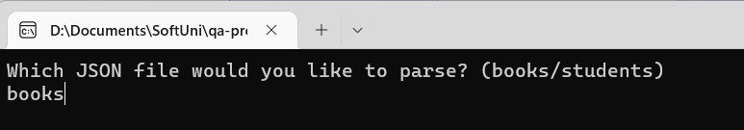

* **The parser will process the chosen JSON file** and display the extracted data **in the console**.
* Carefully review the output in the console.
* If the parser displays an error message, check your JSON file for any syntax errors or formatting issues.
* Ensure all required keys are present and correctly named.
* Confirm that your JSON structure aligns with the examples provided in the assignment.
* **Copy the results from the console into the Judge System (Problem 01. Books)**.

*Use Ctrl + C to copy from the console.

### Students

### Extract information and create a JSON

You are given a **list of 5 students**, each described with details like **name**, **age**, and a **list of courses** they are enrolled in. The details are **presented in a sentence format**:

1. "**Alice Johnson**, **20** years old, is enrolled in **Introduction to Computer Science** and **Web Development**."
2. "**Brian Smith**, **22** years old, takes courses in **Machine Learning**, **Artificial Intelligence**, **Computational Theory**, and **Robotics**."
3. "**Charlotte Brown**, **19** years old, studies **Graphic Design** and **Digital Marketing**."
4. "**David Wilson**, **21** years old, focuses on **Cybersecurity**, **Network Infrastructure**, **Cloud Computing**, and **Data Privacy**."
5. "**Ella Davis**, **23** years old, is pursuing **Advanced Mathematics** and **Quantum Mechanics**."

Each student has the following attributes: **name (string), age (int), courses (list of courses);**

Each course has a **name (string).**

**Convert the list of students' data into a structured JSON format manually:**

* **Use a text or code editor** to create your JSON document. We recommend using **Notepad++ or Visual Studio Code** for better formatting and syntax highlighting.
* **Extract** relevant details **from each student's description**.
* **Organize the data** into a structured JSON format:
* **Each student** should be a **separate object within an array**.
* **Include** the following keys: **name**, **age**, **courses**.
* **Each course** should be represented as an **object with key: name,** within the **courses array**.

**Example:**

|  |
| --- |
| **Students.json** |
| [  {  "name": "Alice Johnson",  "age": 20,  "courses": [  {"name": "Introduction to Computer Science"},  {"name": "Web Development"}  ]  },  {  "name": "Brian Smith",  "age": 22,  "courses": [  {"name": "Machine Learning"},  {"name": "Artificial Intelligence"},  {"name": "Computational Theory"},  {"name": "Robotics"}  ]  }  ... other students ...  ] |

### Use the Provided JSON Parser to Parse the Students

Using the same **parser application**. **Parse and validate** the JSON data you have created.

* **Open** the **parser** application **using Visual Studio**. This application is pre-configured to read JSON files from a specific directory.
* **Within the parser project**, locate the **Datasets folder**. You will find an **empty Students.json** file here.
* Open the **existing Students.json** file.
* **Replace the contents of Students.json** with the JSON data you created.
* After pasting your JSON data into the corresponding JSON file, **make sure to save any changes**.
* **Run the parser** application within your IDE.
* The application will ask you **which file you would like to use**. **Type students**.

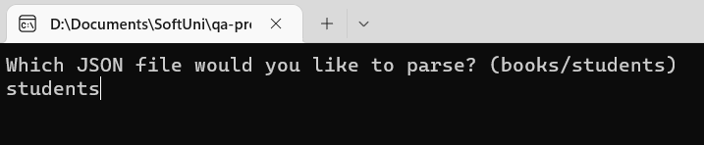

* The parser will process the chosen JSON file and display the extracted data in the console.
* Carefully review the output in the console.
* If the parser displays an error message, check your JSON file for any syntax errors or formatting issues.
* Ensure all required keys are present and correctly named.
* Confirm that your JSON structure aligns with the examples provided in the assignment.
* **Copy the results from the console into the Judge System (Problem 02. Students).**

*Use Ctrl + C to copy from the console.

## YAML

### Orders

### Extract information and create a YAML file

You are given a **table of six orders**, each with **order_id (int)**, **customer (string)**, **item (string)**, **quantity (int)**, and **total_amount (float)**.

|  |  |  |  |  |
| --- | --- | --- | --- | --- |
| **Order ID** | **Customer** | **Item** | **Quantity** | **Total Amount** |
| 1001 | John Doe | Wireless Mouse | 3 | 29.97 |
| 1002 | Emily Clark | 16GB USB Drives | 2 | 31.96 |
| 1003 | Alex Johnson | External Hard Drive | 1 | 89.99 |
| 1004 | Sarah Smith | Smartphone Cases | 4 | 39.96 |
| 1005 | Michael Lee | Digital Camera | 1 | 120.50 |
| 1006 | Karen Thompson | Bluetooth Speakers | 2 | 58.00 |

**Convert** the table of orders data into a **structured YAML format manually:**

* **Use a text or a code editor** to write the YAML. We recommend **Notepad++ or Visual Studio Code**.
* **Extract relevant details** from each order's description.
* **Organize** the data into a **structured YAML format**. **Each order** should be a **separate entry in the list**.
* Include **keys**: **order_id**, **customer**, **item**, **quantity**, and **total_amount**.

**Example:**

|  |
| --- |
| **Orders.yaml** |
| - order_id: 1001  customer: John Doe  item: Wireless Mouse  quantity: 3  total_amount: 29.97  - order_id: 1002  customer: Emily Clark  *#continue with the rest* |

### Parse the Orders from YAML to HTML

You are provided with **[YAML to HTML parser application](https://softuni.bg/downloads/svn/qa-profession/Back-End-Test-Automation/January-2024/01.Back-End-Technologies-Basics/03.Exercise-Data-Formats/YamlToHtml.zip)**. **Parse and validate** the YAML data you have created.

* **Open** the **parser** application **using Visual Studio**. This application is pre-configured to read YAML files from a specific directory.
* **Within the parser project**, locate the **Datasets folder**. You will find the **empty Orders.yaml** file here.
* Open the **existing Orders.yaml** file.
* **Replace the content of Orders.yaml** with the YAML data that you created.
* After pasting your YAML data into the corresponding YAML file, **make sure to save any changes**.
* **Run the parser** application within your IDE.
* The application will ask you **which file you would like to use**. **Type orders**.

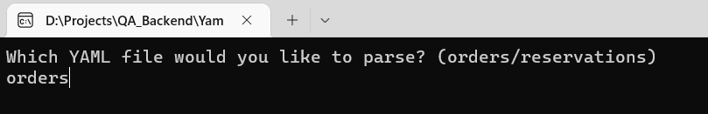

* The parser **will process the chosen YAML file** and display the extracted data in **your default browser**.   
  **\* If asked if you're allowing to open the output in the browser, choose yes.**
* If the parser displays an error message, check your YAML file for any syntax errors or formatting issues.
* Ensure all required keys are present and correctly named.
* Confirm that your YAML structure aligns with the examples provided in the assignment.
* Carefully review the output in the browser.
* **Copy the results from the browser into the Judge System (Problem 03. Orders).**

### Reservations

### Extract information and create a YAML file

You are given a **table of 5 reservations**, each with **reservation_id**, **guest_name**, **and** list of **services**. Each service has **type, date and time**.

Each reservation has **reservation_id (int)**, **guest_name (string)**, list of **services**.

Each service has **type (string), date (string), time (string)**

|  |  |  |
| --- | --- | --- |
| **Reservation ID** | **Guest Name** | **Services** |
| 101 | Emma Johnson | **Spa**  June 15th  2 PM  **Dinner**  June 16th  8 PM |
| 102 | John Davis | **Golf**  June 17th  10 AM  **Wine Tasting**  June 18th  5 PM |
| 103 | Sophia Lee | **Yoga Class**  June 19th  8 AM  **Brunch**  June 20th  11 AM |
| 104 | Michael Brown | **Cooking Workshop**  June 21st  4 PM  **Movie Night**  June 22nd  9 PM |
| 105 | Olivia Smith | **Deep Sea Fishing**  June 23rd  7 AM  **Evening Cruise**  June 24th  6 PM |

**Convert** the list of reservations data into a **structured YAML format manually:**

* **Use a text or a code editor** to write the YAML. We recommend **Notepad++ or Visual Studio Code**.
* **Extract relevant details** from each reservation's description.
* **Organize** the data into a **structured YAML format**. **Each reservation** should be a **separate entry   
  in the list**.
* Include **keys**: **reservation_id**, **guest_name**, and **services**.
* **Each service** should be represented as an **object within the services array**.
* Each service has the following keys: **type, date, time**

**Example:**

|  |
| --- |
| **Reservations.yaml** |
| - reservation_id: 101  guest_name: Emma Johnson  services:  - type: Spa  date: June 15  time: 2 PM  - type: Dinner  date: June 16  time: 8 PM  - reservation_id: 102  guest_name: John Davis   *#continue with the rest* |

### Parse the Reservations from YAML to HTML

Using the same YAML to HTML parser application. **Parse and validate the YAML data** you have created.

* **Open** the **parser** application using **Visual Studio**. This application is pre-configured to read YAML files from a specific directory.
* **Within** the **parser project**, locate the **Datasets folder**. You will find the empty **Reservations.yaml** file here.
* Open the existing **Reservations.yaml**.
* Replace the content of **Reservations.yaml** with the YAML data you created. Be sure to overwrite any existing content if the files are not empty.
* After pasting your YAML data into the corresponding YAML file, make sure to **save any changes**.
* Run the parser application within your IDE.
* The application will ask you which file you would like to use. **Type reservations.**

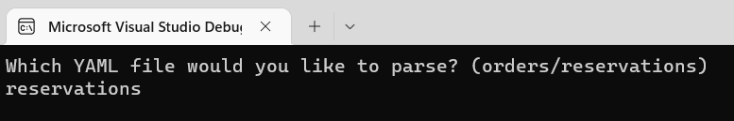

* The **parser will process** the chosen **YAML file** and display the extracted data **in your default browser.   
  * If asked if you’re allowing to open the output in the browser, choose yes.**
* If the parser displays an error message, check your JSON file for any syntax errors or formatting issues.
* Ensure all required keys are present and correctly named.
* Confirm that your YAML structure aligns with the examples provided in the assignment.
* Carefully review the output in the browser.
* **Copy the results from the browser into the Judge System (Problem 04. Reservations).**

## XML

### Devices

### Extract information and create an XML

You are given a **table with five devices**, each with **type**, **brand**, **specs**, and **price.**

|  |  |  |  |
| --- | --- | --- | --- |
| **Type** | **Brand** | **Specs** | **Price** |
| Laptop | Dell XPS 13 | 13.4-inch display | 1200 |
| Smartphone | Apple iPhone 12 | 64GB storage | 799 |
| Tablet | Samsung Galaxy Tab S7 | 11-inch screen | 650 |
| Headphones | Bose QuietComfort 35 II | Noise-cancelling | 299 |
| Camera | Canon EOS Rebel T7 DSLR | 24.1 MP | 449 |

**Convert** the list of orders data into a **structured XML format manually:**

* Write the **XML document** using a text or a code editor. We recommend using **Notepad++ or Visual Studio Code** for better formatting and syntax highlighting.
* Carefullyread each device's description and **identify key information.** You should **extract** the  **following details:**
* **Type of device** (e.g., Laptop, Smartphone)
* **Brand** (e.g., Dell XPS 13, Apple iPhone 12)
* **Specs** (e.g., screen size, processor, storage)
* **Price**
* **Create an XML document** where **each device** is represented as a **separate entry.** Structure your XML with **appropriate tags.**

**Example:**

|  |
| --- |
| **Devices.xml** |
| <devices>  <device>  <type>Laptop</type>  <brand>Dell XPS 13</brand>  <specs>13.4-inch display </specs>  <price>200</price>  </device>  *<!-- More device entries here -->*  </devices> |

### Parse Devices from XML to JSON

You are provided with [**XML to JSON parser**](https://softuni.bg/downloads/svn/qa-profession/Back-End-Test-Automation/January-2024/01.Back-End-Technologies-Basics/03.Exercise-Data-Formats/XmlToJson.zip). **Parse and validate** the XML data you have created.

* **Open** the **parser** application **using Visual Studio**. This application is pre-configured to read XML documents from a specific directory.
* **Within the parser project**, locate the **Datasets folder**. You will find an **empty Devices.xml** file here.
* Open the **existing** **Devices.xml**.
* **Replace the content of Devices.xml** with the XML data you created.
* After pasting your XML data into the corresponding XML file, **make sure to save any changes**.
* **Run the parser** application within your IDE.
* The application will ask you **which file you would like to use**. **Type devices**.

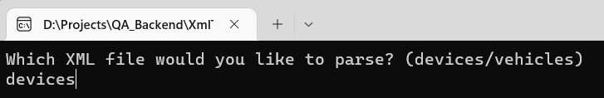

* The parser **will process the chosen XML file** and display the extracted data in **JSON format on the console.**
* If the parser displays an error message, check your XML for any syntax errors or formatting issues.
* Ensure the required XML structure and the **appropriate tags.**
* Confirm that your XML structure aligns with the examples provided in the assignment.
* Carefully review the output in the console.
* **Copy the results from the console into the Judge System (Problem 05. Devices).**

### Vehicles

### Extract information and create an XML

You are given a **list of five vehicles**, each with **type**, **model**, **specs**, and **color**.

1. "**Car**: **Tesla Model 3; Electric sedan**; **red**"
2. "**Motorcycle**: **Harley-Davidson**; **V-twin engine**; **black**"
3. "**Bicycle**: **Giant Escape 3**; **Aluminum frame**; **black**"
4. "**Scooter**: **Vespa Primavera**; **50cc engine**; **white**"
5. "**Boat**: **Bayliner Element**; **18-foot length**; **black**"

**Convert** the list of orders data into a **structured XML format manually:**

* Write the **XML document** using a text or a code editor. We recommend using **Notepad++ or Visual Studio Code** for better formatting and syntax highlighting.
* Carefullyread each device's description and **identify key information.** You should **extract** the  **following details:**
* **Type** (e.g., Car, Bicycle)
* **Model** (e.g., Harley-Davidson)
* **Specs** (e.g., Electric sedan)
* **Color** (e.g., red)
* **Create an XML document** where **each device** is represented as a **separate entry.** Structure your XML with **appropriate tags.**

**Example:**

|  |
| --- |
| **Vehicles.xml** |
| <vehicles>  <vehicle>  <type>Car</type>  <model>Tesla Model 3</model>  <specs>Electric sedan</specs>  <color>red</color>  </vehicle>  *<!-- More vehicle entries here -->*  </vehicles> |

### Parse the Vehicles from XML to JSON

Using the same **XML to JSON parser**. **Parse and validate** the XML data you have created.

* **Open** the **parser** application **using Visual Studio**. This application is pre-configured to read XML documents from a specific directory.
* **Within the parser project**, locate the **Datasets folder**. You will find **Vehicles.xml** file here.
* Open the **existing Vehicles.xml** file.
* **Replace the content of Vehicles.xml** with the XML data you created.
* After pasting your XML data into the corresponding XML file, **make sure to save any changes**.
* **Run the parser** application within your IDE.
* The application will ask you **which file you would like to use**. **Type vehicles**.

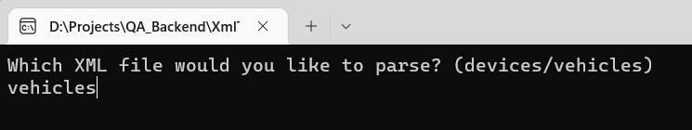

* The parser **will process the chosen XML file** and display the extracted data in **JSON format on the console.**
* If the parser displays an error message, check your XML for any syntax errors or formatting issues.
* Ensure the required XML structure and the **appropriate tags.**
* Confirm that your XML structure aligns with the examples provided in the assignment.
* Carefully review the output in the console.
* **Copy the results from the console into the Judge System (Problem 06. Vehicles).**