**Test not robust (hardware side):**

J loop not tested

State s110 takes “some” cycle times

Expected data of KgrpsNewReal, KgrpsNewImag not tested up

**Related codes:**

s110 : begin

qq = pp - i;

nn = {qq[16],qq[15:0] * kk[14:0]};

tp = (nn % kk);

qres = qq + 1;

tempReal = KgrpsReal [ qq ];

tempImag = KgrpsImag [ qq ];

//double 1 11 52

longdoubletp = WReal [ tp[14:0] ][62:0] * KgrpsReal[ qres[15:0] ][62:0];

signal = WReal[ tp[14:0] ][63] * KgrpsReal[ qres[15:0] ][63];

temp2Real = {signal, longdoubletp[114:52] };

longdoubletp = WImag [ tp[14:0] ][62:0] * KgrpsImag[ qres[15:0] ][62:0];

signal = WImag [ tp[14:0] ][63] * KgrpsImag[ qres[15:0] ][63];

temp2Imag = {signal, longdoubletp[114:52] };

…

end

**solutions:**

fulfill all the tests for the listed bugs

State s110 convert into several states that each must take at most one cycle

make up test data using the software side application

**Too many I/O ports (hardware side):**

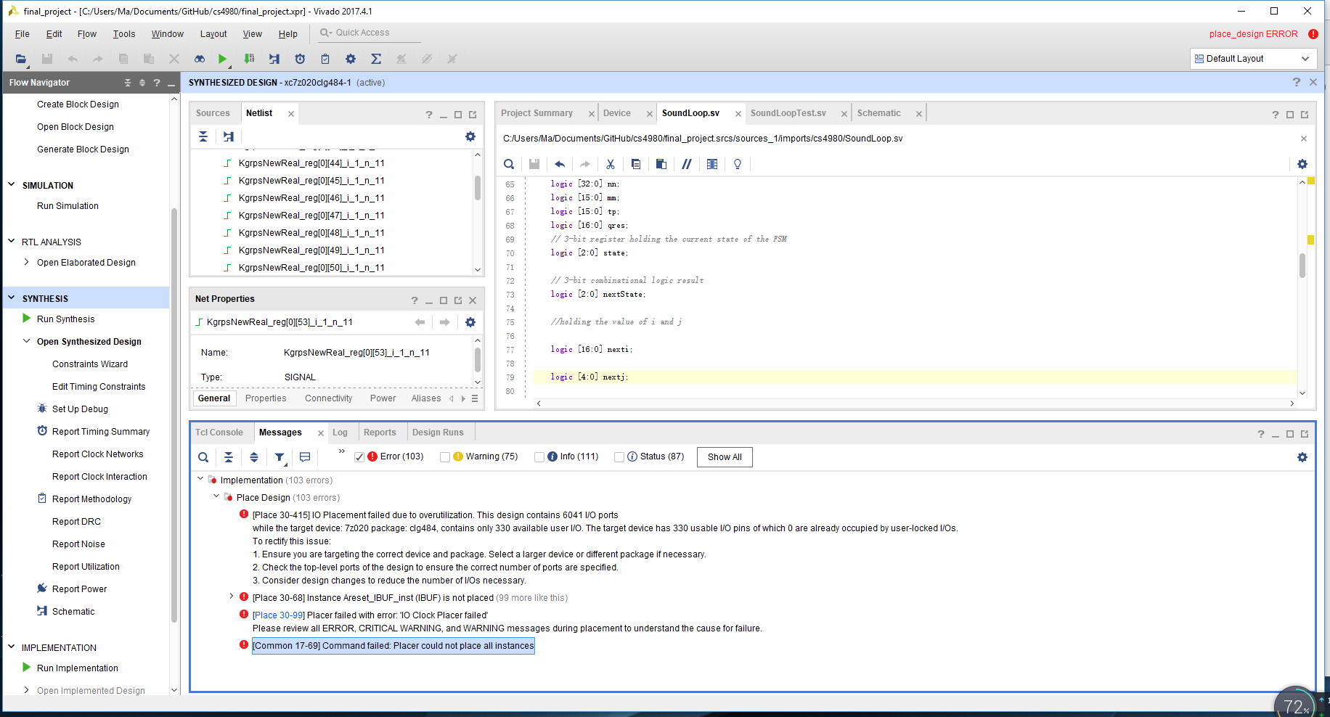

**Related codes:**

input [WIDTH - 1 :0] KgrpsReal [15:0],

input [WIDTH - 1 :0] KgrpsImag [15:0],

input [WIDTH - 1 :0] WReal [14:0],

input [WIDTH - 1 :0] WImag [14:0],

input In,

input Clock,

input Areset,

output logic [16:0] i,

output logic [4:0] j,

output logic [WIDTH - 1 :0] KgrpsNewReal [15:0],

output logic [WIDTH - 1 :0] KgrpsNewImag [15:0]

**Possible solutions:**

Memory map I/O

Read Kgrps, W through files

Assign arrays for Kgrps, W

// make sure each cycle will read only 2 Kgrp data into it and 1 new Kgrp data outputs

module state110 #(parameter WIDTH=64)(

logic [WIDTH - 1 :0] KgrpsReal [0:15],

input wire [3:0] readKR1,

input wire [3:0] readKR2,

logic [WIDTH - 1 :0] KgrpsImag [0:15],

input wire [3:0] readKI1,

input wire [3:0] readKI2,

logic [WIDTH - 1 :0] WReal [0:14],

logic [WIDTH - 1 :0] WImag [0:14],

input In,

input Clock,

input Areset,

output logic [16:0] i,

output logic [4:0] j,

output wire [WIDTH - 1 :0] KgrpsNewReal,

output wire [WIDTH - 1 :0] KgrpsNewImag

);

assign KgrpsNewReal = Operation1( KgrpsReal[readKR1], KgrpsReal[readKR2],

KgrpsImag[readKI1], KgrpsImag[readKI2] );

assign KgrpsNewImag = Operation2( KgrpsReal[readKR1], KgrpsReal[readKR2],

KgrpsImag[readKI1], KgrpsImag[readKI2] );

**Data not match:**