**Before reading:**

Since I messed up with an earlier version of my bash script that misuse > that overwrite the result files every time after running for 5 hours and half, some data may be not have time to record in the excels and graphs, here is my github link to show the process and all the data my homework went through:

<https://github.com/BackBeing/cse560mhw3>

Also, there may be some display issue of the excel table I paste here due to the long data, please refer to the original excel in github for the most accurate data.

**Analysis:**

sim_seconds’s data is quite interesting, through observation, we can see that the data doesn’t vary for different numPhysFloatRegs.

The data of fp_rename_lookups didn’t change, so I don’t choose this.

ROBFullEvents is another argument I choose, since it should not be affected by numPhysFloatRegs, but after I went through all the data, I found that it behaves just like I predicted.

The data of miss_rate does not vary much, so I don’t choose this.

**Tables for sim_seconds:**

|  |  |  |  |  |  |  |  |  |
| --- | --- | --- | --- | --- | --- | --- | --- | --- |
| pf:256 | 4 | 8 | 16 | 32 | 64 | 128 | 256 | rob |
| 4 | 0.017686 | 0.011179 | 0.010527 | 0.010527 | 0.010527 | 0.010527 | 0.010527 |  |
| 8 | 0.017686 | 0.009978 | 0.006824 | 0.006509 | 0.006509 | 0.006509 | 0.006509 |  |
| 16 | 0.017686 | 0.009978 | 0.006344 | 0.004974 | 0.00492 | 0.00492 | 0.00492 |  |
| 32 | 0.017686 | 0.009978 | 0.006344 | 0.004741 | 0.00422 | 0.00422 | 0.00422 |  |
| 64 | 0.017686 | 0.009978 | 0.006344 | 0.004741 | 0.003867 | 0.003777 | 0.003777 |  |
| 128 | 0.017686 | 0.009978 | 0.006344 | 0.004741 | 0.003867 | 0.003761 | 0.003751 |  |
| 256 | 0.017686 | 0.009978 | 0.006344 | 0.004741 | 0.003867 | 0.003761 | 0.003751 |  |
| iq |  |  |  |  |  |  |  |  |

|  |  |  |  |  |  |  |  |  |
| --- | --- | --- | --- | --- | --- | --- | --- | --- |
| pf:512 | 4 | 8 | 16 | 32 | 64 | 128 | 256 | rob |
| 4 | 0.017686 | 0.011179 | 0.010527 | 0.010527 | 0.010527 | 0.010527 | 0.010527 |  |
| 8 | 0.017686 | 0.009978 | 0.006824 | 0.006509 | 0.006509 | 0.006509 | 0.006509 |  |
| 16 | 0.017686 | 0.009978 | 0.006344 | 0.004974 | 0.00492 | 0.00492 | 0.00492 |  |
| 32 | 0.017686 | 0.009978 | 0.006344 | 0.004741 | 0.00422 | 0.00422 | 0.00422 |  |
| 64 | 0.017686 | 0.009978 | 0.006344 | 0.004741 | 0.003867 | 0.003777 | 0.003777 |  |
| 128 | 0.017686 | 0.009978 | 0.006344 | 0.004741 | 0.003867 | 0.003761 | 0.003751 |  |
| 256 | 0.017686 | 0.009978 | 0.006344 | 0.004741 | 0.003867 | 0.003761 | 0.003751 |  |
| iq |  |  |  |  |  |  |  |  |

…… and so are the other 3 tables

**Tables for ROBFullEvents:**

|  |  |  |  |  |  |  |  |  |
| --- | --- | --- | --- | --- | --- | --- | --- | --- |
| pf:256 | 4 | 8 | 16 | 32 | 64 | 128 | 256 | rob |
| 4 | 12008632 | 5194210 | 23 | 2 | 0 | 0 | 0 |  |
| 8 | 12008643 | 7815962 | 1586391 | 13 | 0 | 0 | 0 |  |
| 16 | 12008643 | 7815963 | 4575073 | 324384 | 3 | 0 | 0 |  |
| 32 | 12008643 | 7815963 | 4575073 | 2874071 | 56 | 4 | 0 |  |
| 64 | 12008643 | 7815963 | 4575073 | 2874071 | 1030341 | 3528 | 0 |  |
| 128 | 12008643 | 7815963 | 4575073 | 2874071 | 1030341 | 829365 | 0 |  |
| 256 | 12008643 | 7815963 | 4575073 | 2874071 | 1030341 | 829365 | 398323 |  |
| iq |  |  |  |  |  |  |  |  |

|  |  |  |  |  |  |  |  |  |
| --- | --- | --- | --- | --- | --- | --- | --- | --- |
| pf:512 | 4 | 8 | 16 | 32 | 64 | 128 | 256 | rob |
| 4 | 12008632 | 5194210 | 23 | 2 | 0 | 0 | 0 |  |
| 8 | 12008643 | 7815962 | 1586391 | 13 | 0 | 0 | 0 |  |
| 16 | 12008643 | 7815963 | 4575073 | 324384 | 3 | 0 | 0 |  |
| 32 | 12008643 | 7815963 | 4575073 | 2874071 | 56 | 4 | 0 |  |
| 64 | 12008643 | 7815963 | 4575073 | 2874071 | 1030341 | 3528 | 0 |  |
| 128 | 12008643 | 7815963 | 4575073 | 2874071 | 1030341 | 829365 | 0 |  |
| 256 | 12008643 | 7815963 | 4575073 | 2874071 | 1030341 | 829365 | 398323 |  |
| iq |  |  |  |  |  |  |  |  |

…… and so are the other 3 tables

**Graphs:**

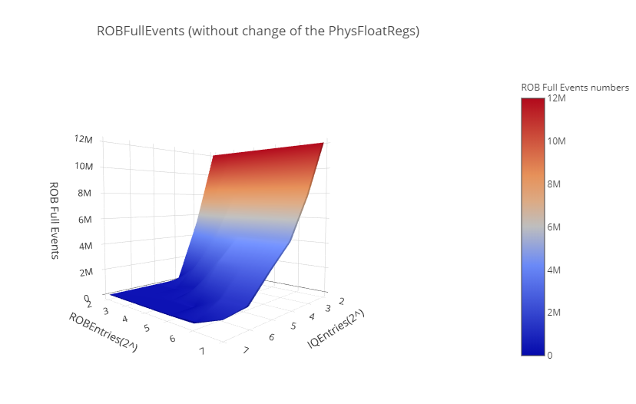

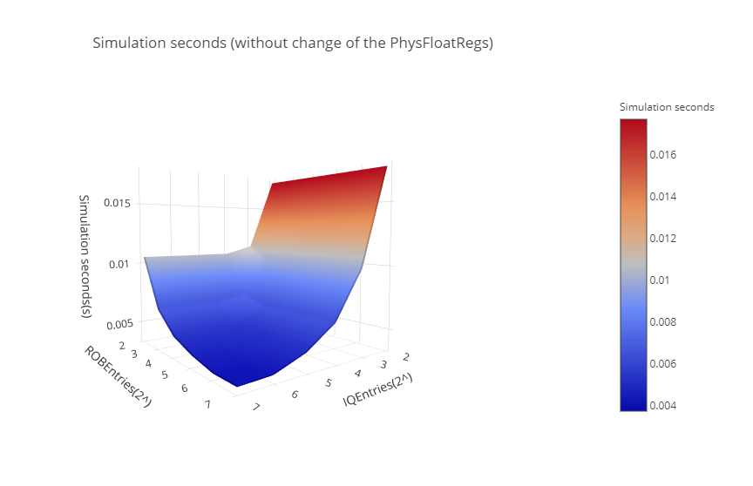

**Hw3opts.py:**

from m5 import fatal

import m5.objects

from textwrap import TextWrapper

#add options for number of ROB entries, IQ entries, and number of physical

#floating point registers

def addHW3Opts(parser):

parser.add_option("--rob_num", type="int", default=192)

parser.add_option("--iq_num", type="int", default=64)

parser.add_option("--pf_num", type="int", default=256)

#set parameters taken in from options on command line

def set_config(cpu_list, options):

for cpu in cpu_list:

# set parameters for each thing

cpu.numROBEntries = options.rob_num

cpu.numIQEntries = options.iq_num

cpu.numPhysFloatRegs = options.pf_num

s.sh:

#!/bin/bash

for pf in 256 512 # 1024 2048 4096

do

for iq in 4 8 16 32 64 128 256

do

for rob in 4 8 16 32 64 128 256

do

$GEM5/build/ARM/gem5.opt hw3config.py -c $GEM5/../test_progs/daxpy/daxpy_arm_big --cpu-type="DerivO3CPU" --caches --l2cache --pf_num=$pf --rob_num=$rob --iq_num=$iq

printf "%-5s %-4s %-4s\n" $pf $rob $iq >> sim_seconds.txt

printf "%-5s %-4s %-4s\n" $pf $rob $iq >> fp_rename_lookups.txt

printf "%-5s %-4s %-4s\n" $pf $rob $iq >> iq_rate.txt

printf "%-5s %-4s %-4s\n" $pf $rob $iq >> IdleCycles.txt

printf "%-5s %-4s %-4s\n" $pf $rob $iq >> ROBFullEvents.txt

printf "%-5s %-4s %-4s\n" $pf $rob $iq >> miss_rate.txt

grep -E 'sim_seconds' m5out/stats.txt >> sim_seconds.txt

grep -E 'system.cpu.rename.fp_rename_lookups' m5out/stats.txt >> fp_rename_lookups.txt

grep -E 'system.cpu.iq.rate' m5out/stats.txt >> iq_rate.txt

grep -E 'system.cpu.rename.IdleCycles' m5out/stats.txt >> IdleCycles.txt

grep -E 'system.cpu.rename.ROBFullEvents' m5out/stats.txt >> ROBFullEvents.txt

grep -E 'system.l2.overall_mshr_miss_rate::total' m5out/stats.txt >> miss_rate.txt

done

done

done