llm-agent-guardrails
Architecture Document

1. Overview
llm-agent-guardrails is a local-first safety layer for LLM agents built on LangGraph and LangChain. It enforces schema validation, action allowlisting, and deterministic overrides around any agent node, traces every decision via self-hosted Langfuse, and measures guardrail effectiveness automatically through a DeepEval red-team suite running in CI. The entire stack runs on free, local tools via Ollama — no paid APIs or cloud spend required.

2. Problem Being Solved
LLM agents are increasingly trusted to take real actions — calling APIs, writing to databases, triggering workflows — not just answer questions. This introduces real risk:
- Malformed or hallucinated tool output reaching downstream systems
- Unauthorized actions — an agent calling a tool it was never meant to use
- Inconsistent handling of edge cases that a deterministic rule would handle more safely
- No visibility into what an agent was about to do when something goes wrong
This project formalizes the guardrail pattern into a reusable, measurable, open-source library.

3. Architecture Diagram
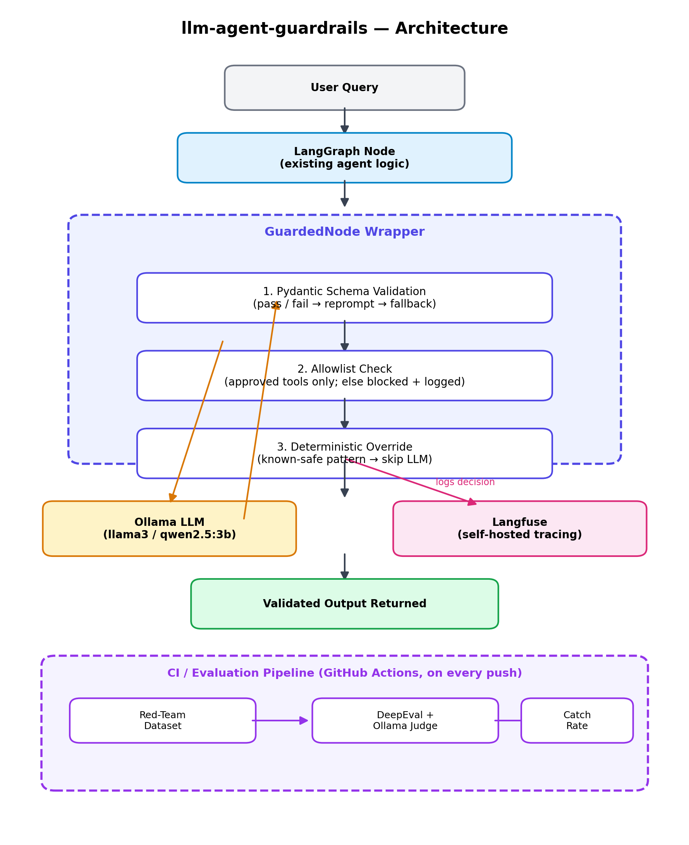

4. Component Breakdown

4.1 LangGraph Node
The existing agent logic, unchanged. The guardrail layer wraps this node rather than replacing it, so it drops into any existing LangGraph graph.

4.2 GuardedNode Wrapper
The core of the framework. Intercepts the wrapped node's output and runs it through three sequential checks before anything is allowed to proceed:
- Pydantic Schema Validation — output must match an expected schema; on failure, the agent is reprompted once with the validation error, then falls back to a safe default.
- Allowlist Check — only pre-approved tools/functions may be called; anything else is blocked and logged.
- Deterministic Override — known-safe input patterns bypass the LLM call entirely, for speed, cost savings, and predictability.

4.3 Ollama (LLM Layer)
Serves all model inference locally. Two models are used deliberately: llama3 (8B) as the primary agent model, and qwen2.5:3b-instruct as a smaller, less reliable model used specifically to stress-test the guardrail layer.

4.4 Langfuse (Observability)
Self-hosted via Docker. Every guardrail decision is logged as a trace — what the LLM proposed, what was blocked, and what was overridden — making guardrail behavior inspectable and debuggable after the fact, not just a black box.

4.5 Evaluation Pipeline
A red-team dataset of deliberately malformed and off-policy prompts is run through the guarded agent on every push. DeepEval, using Ollama as the judge model, scores the guardrail catch rate. GitHub Actions fails the build if the catch rate regresses, treating guardrail effectiveness as a tested, protected property of the codebase rather than a one-time claim.

5. Tech Stack
Layer | Tool | Role
Orchestration | LangGraph + LangChain | LangGraph runs the agent as a state machine; guardrails hook in at node boundaries. LangChain supplies the LLM client plumbing.
LLM | Ollama | Local, free inference (llama3 8B, qwen2.5:3b-instruct).
Schema validation | Pydantic | Validates every tool call/output against a defined schema before execution.
Vector store (optional) | FAISS | Lightweight local retrieval if the demo agent needs grounding.
Observability | Langfuse (self-hosted) | Traces every guardrail decision: proposed, blocked, or overridden.
Evaluation | DeepEval + Ollama-as-judge | Scores guardrail catch rate against a red-team dataset.
CI/CD | GitHub Actions | Runs the eval suite on every push/PR; fails the build if catch rate regresses.

6. Request Flow (Step by Step)
- 1. A user query enters the existing LangGraph node.
- 2. The GuardedNode wrapper intercepts the node's output before it is finalized.
- 3. Pydantic validates the output against the expected schema.
- 4. The allowlist check confirms the requested action is permitted.
- 5. The deterministic override layer checks whether this input matches a known-safe pattern and can skip LLM involvement entirely.
- 6. Every decision made in steps 3–5 is logged to Langfuse.
- 7. The validated output is returned to the caller.
- 8. Independently, on every push, the CI pipeline runs the red-team suite through the same guarded path and reports the catch rate.

7. Security Mapping (OWASP Top 10 for LLM Applications)
- Schema validation → mitigates Insecure Output Handling
- Action allowlisting → mitigates Excessive Agency
- Deterministic overrides → reduce Prompt Injection attack surface by bypassing the LLM for known-safe inputs

8. Roadmap
- v1.1: Prompt-injection detection module, SECURITY.md, CI matrix builds across models, secrets scanning
- v2: Semantic caching of guardrail decisions, scale/concurrency considerations, optional Terraform module, Grafana dashboard for catch rate over time

