1-ERD
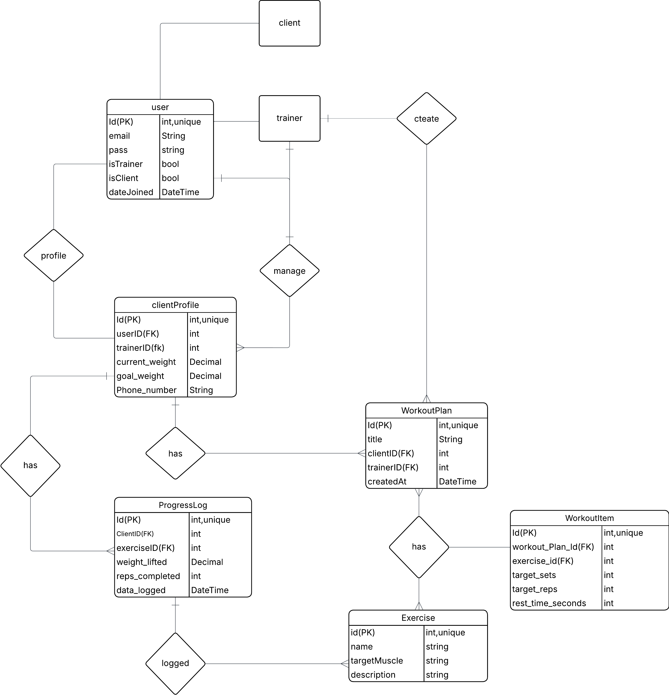
2-The Relationships
- User ↔ ClientProfile (One-to-One): * One User (if is_client=True) has exactly One ClientProfile. This keeps authentication separate from profile data.
- User (Trainer) ↔ ClientProfile (One-to-Many): * One Trainer can manage Many Clients. (The trainer_id in the ClientProfile table makes this connection).
- User (Trainer) ↔ WorkoutPlan (One-to-Many):
  - One Trainer can create Many Workout Plans.
- ClientProfile ↔ WorkoutPlan (One-to-Many):
  - One Client can receive Many Workout Plans over time.
- WorkoutPlan ↔ Exercise (Many -to-Many):
  - WorkoutItem acts as the Junction Table that creates a Many-to-Many relationship between WorkoutPlans and Exercises
- ClientProfile ↔ ProgressLog (One-to-Many):
  - One Client creates Many Progress Logs as they work out over time.
- Exercise ↔ ProgressLog (One-to-Many):
  - One Exercise can be logged Many times by different clients.

