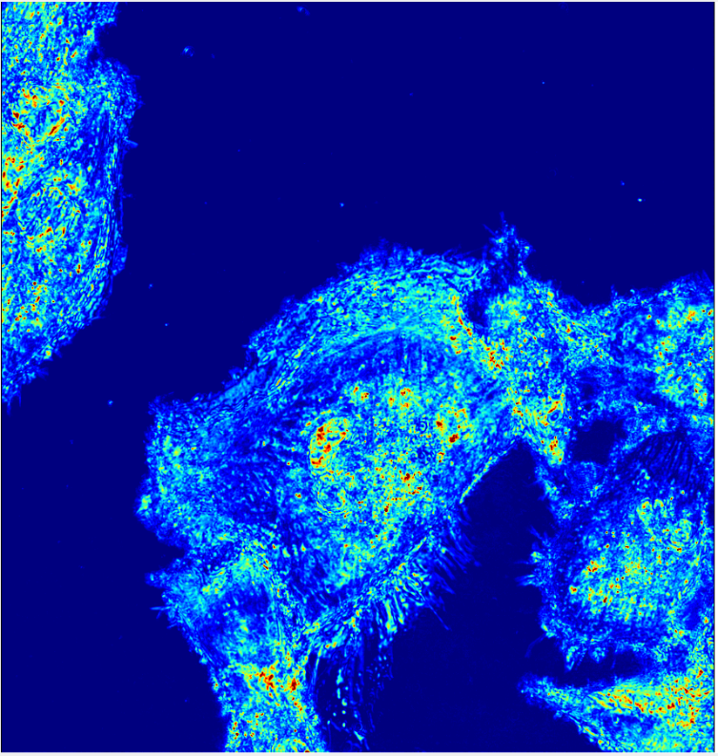

**B:**

**A:**

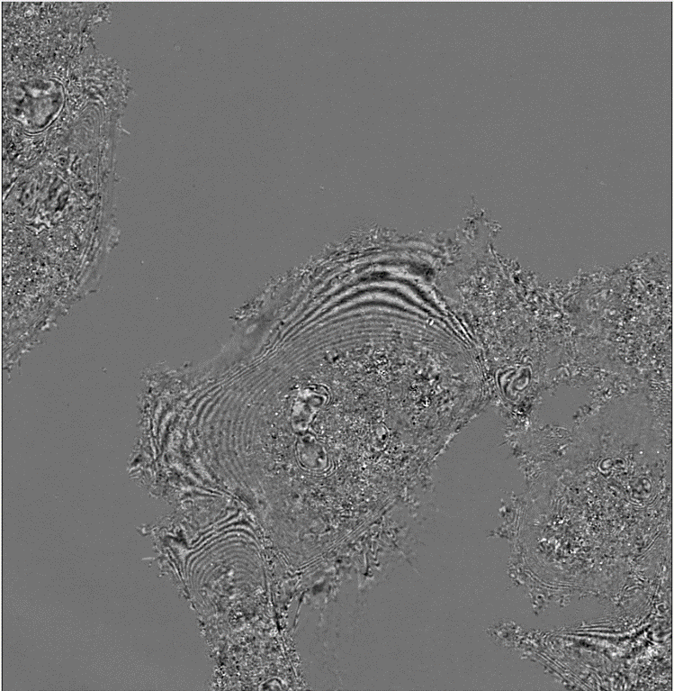

**A:** “Σ-map” of a cluster of live BJ cells adherent to a glass coverslip. Corresponds to macromolecular structural heterogeneity.

**B:** A reflectometry measurement of the same cell cluster indicating the average reflectance across a 500nm to 700nm measurement range. Values range from 0.2% to 0.8% reflectance.

**C:** An interferogram showing sample reflectance at 600nm with the contribution of average sample reflectance normalized out.

**C:**

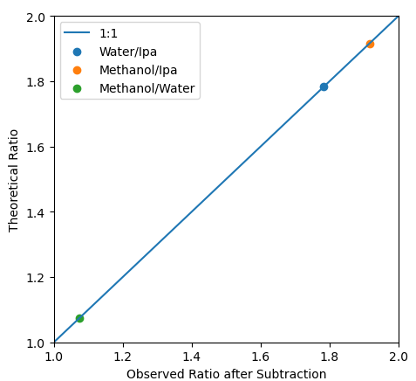

**B:**

**A:**

**C:**