TEST CASES AND OUTPUT

<Internal commands >

$ cd and pwd commands -

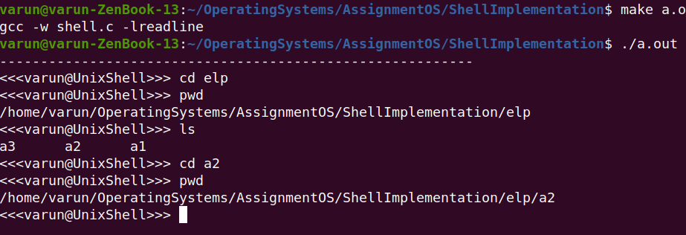
$ echo command -

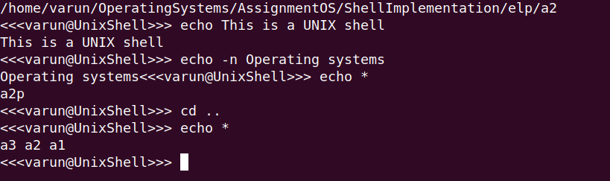
$ history -

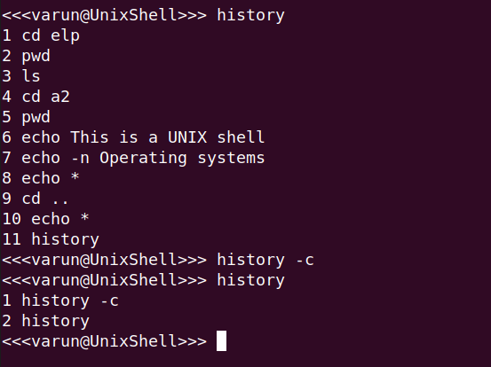

$ exit -

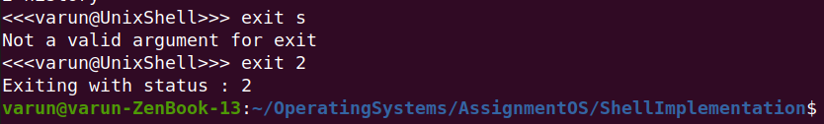
<External commands>

$ ls -

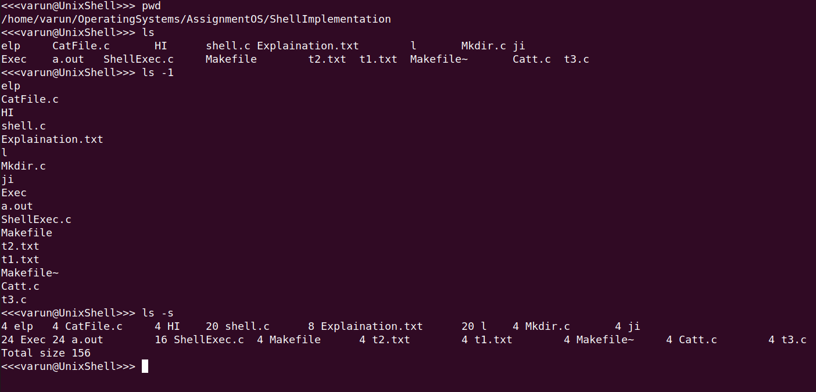
$ rm -

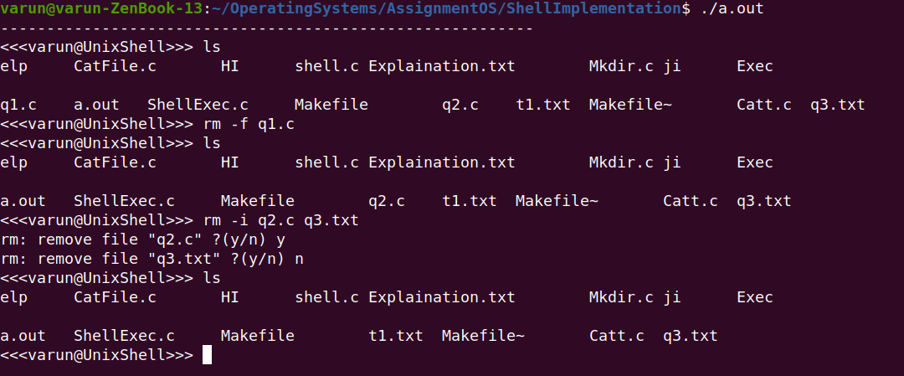

$ mkdir -

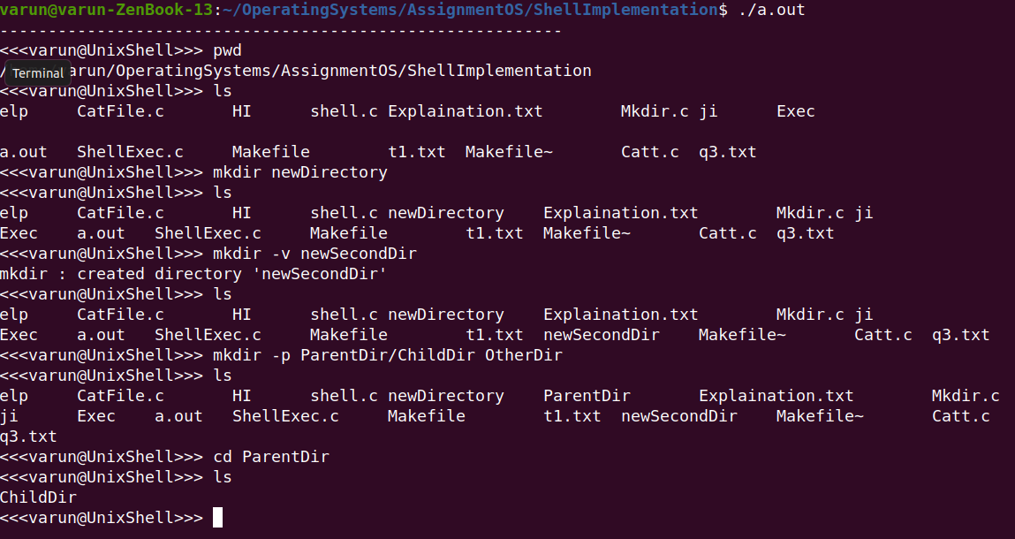

$ cat -

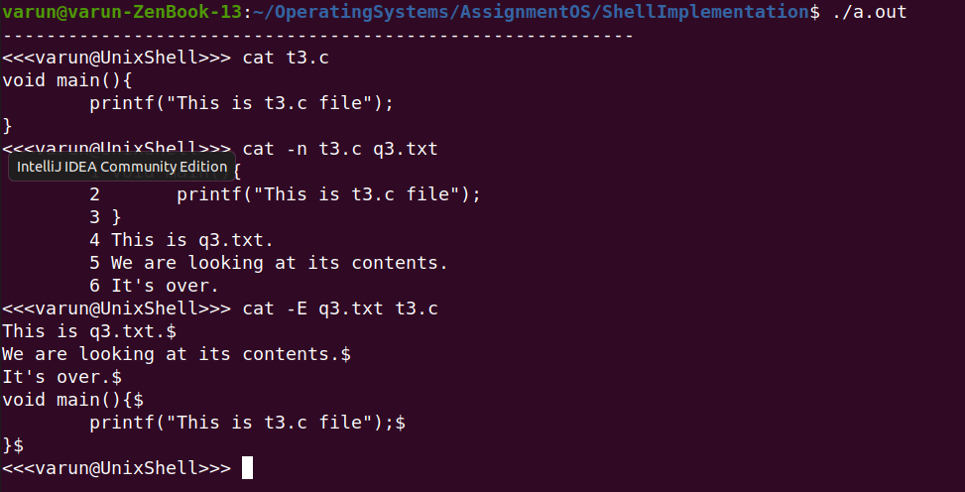

$ date -

