A3-A4 Integrated XFSearch Installation and usage guide.

Installation guide.

A3-A4 Integrated XFSearch consists of two web applications:
- Forge A semantic search, which context root is qualipso
- Forge B semantic search, which context root is ospilauq.

The prototype zip file linked above is required to install both applications. That zip file comprises two Eclipse projects:
- Forge A semantic search project named A3-A4_XFSearch_Qualipso
- Forge B semantic search project named A3-A4_XFSearch_oSPilauQ

To install and use both applications is required the previous installation of:
- Eclipse Europa/Ganimede IDE
- Eclipse Web Tools Platform (WTP)
- Tomcat 5.x/6.x

The installation procedure is the following:
- Import both projects into an Eclipse workspace.
- Create a server runtime configuration:
  - Open servers view: Menu Window/Show View/Others... select Server/Servers.
  - Right click on Servers view, select New/Server...Follow instructions to point at your local Tomcat installation. See WTP User’s Guide accessible through Menu Help/Help Contents… for further information.
- Configure both web applications:
  - In A3-A4_Integrated_XFSearch project, src/main/resources directory open the following files and update all the absolute file paths to your local workspace location (only the first part of the path till the workspace should be updated, respecting the the remaining part):
    - qualipso.properties. Update paths in properties: org.qualipso.advdoc.rdf.file, org.qualipso.advdoc.lucene.indexes.dir, org.qualipso.advdoc.storage.dir
    - ontologies.properties. Update paths in properties: org.qualipso.advdoc.ontologies.foaf.file, org.qualipso.advdoc.ontologies.doap.file, org.qualipso.advdoc.ontologies.sioc.file, org.qualipso.advdoc.ontologies.beatle.file, org.qualipso.advdoc.ontologies.qualipso_sc.file, org.qualipso.advdoc.ontologies.qualipso_doc.file, org.qualipso.advdoc.ontologies.qualipso_ml.file, org.qualipso.advdoc.ontologies.qualipso_vc.file, org.qualipso.advdoc.ontologies. qualipso_rs.file
    - xfsearch.properties: Update path in properties oSPiluaQ(Remote).mapping.X
  - In A3-A4_XFSearch_oSPilauQ project, go to the WebContent/WEB-INF/classes directory and proceed to reconfigure the same property files as described in the previous bullet.
- On Servers view, right click on the created Tomcat server, and select “Add and remote projects”. Add both projects (A3-A4_XFSearch_QualiPSo and A3-A4_XFSearch_oSPilauQ) and accept.
- Run Tomcat server through the Servers view toolbar.
- Access the application at the following URL: http://localhost:8080/qualipso

Usage Guide

To test the prototype, proceed as follows (see snapshots below):
- Click on “Semantic Search” and accept an empty access account in the next page.
- In Semantic Search GUI page:
  - In “Where” section mark “Search cross forge” and select both available forges.
  - In What section select project. We are going to search for projects in both inhomogeneous forges.
  - In “What fields of project do you want to see?” click on “EDIT” and check “category”
  - Click on the search icon in the right panel.
- See results organised by the forge they were obtained in the next page.

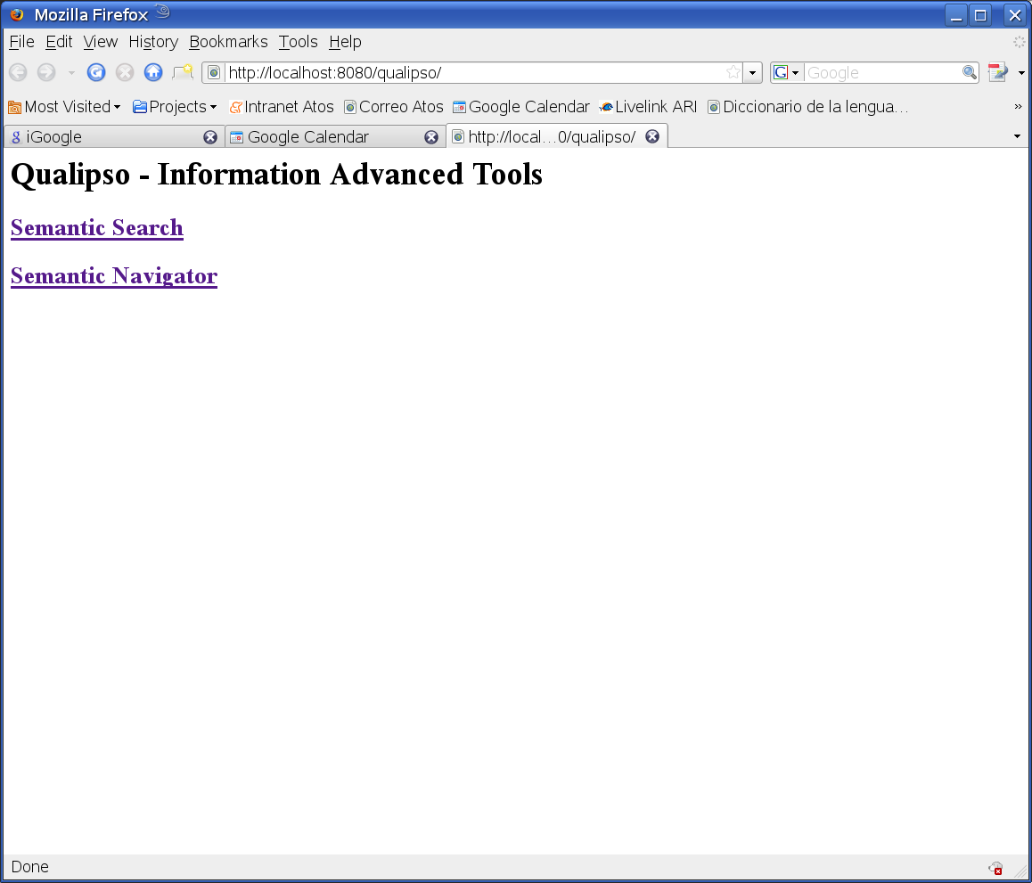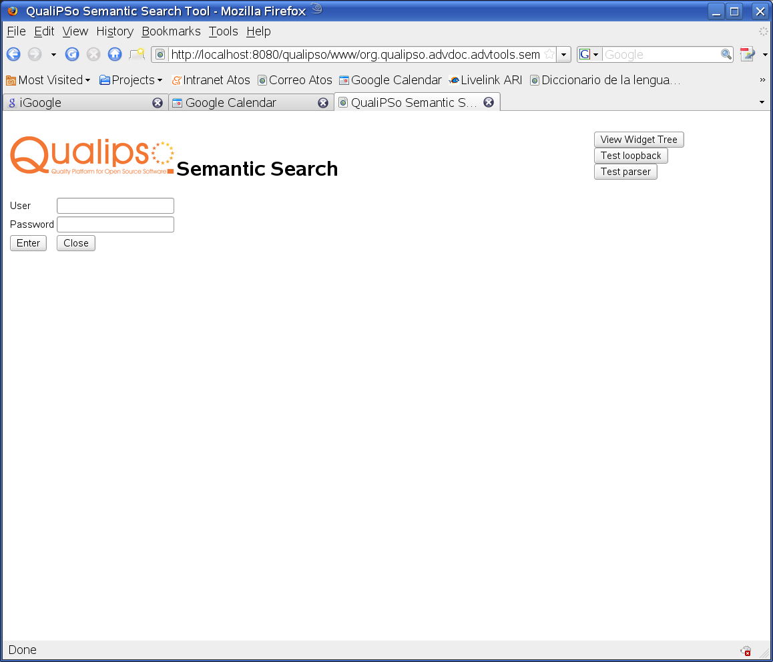

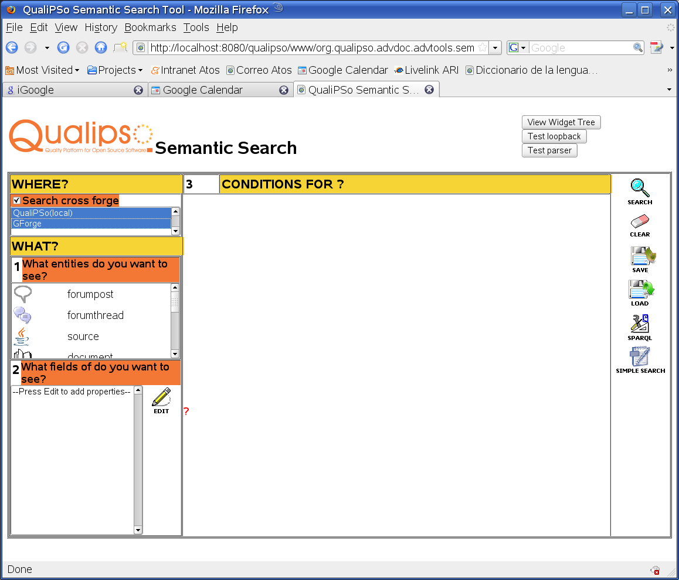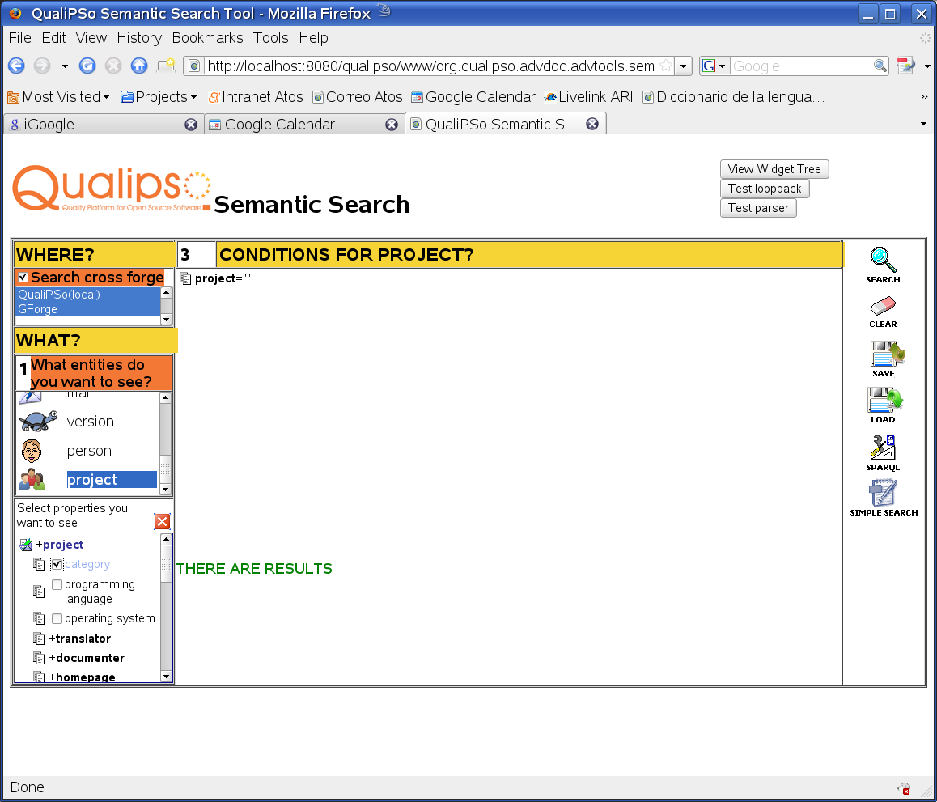

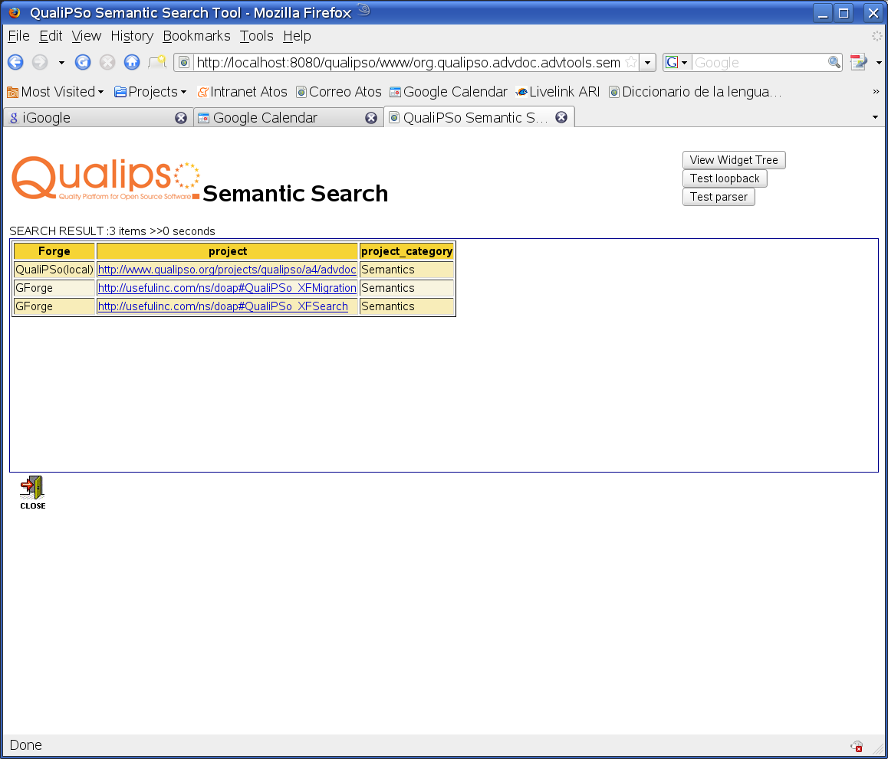
Figure 1 A3-A4 Integrated XFSearch (A4 GUI) example of usage

